BONE AS A TOOL IN FUTURISTIC BIOTECHNOLOGY.
Annapurna Majhi, M.Sc, Dr P C Rout M.Sc., M.Phil., Ph.D£ & Dr Shaikh N. Hossian Ph.D¥.
£Model Degree College, Deogarh, Odisha, India 768108.
¥Regional institute of Biotechnology, Bhubaneswar, Odisha, India 751016.

ABSTRACT
DNA extraction from bone samples is greatly useful for forensic applications but it is more difficult to be conducted compared with extracting DNA from other tissues due to rigid structure of the bones and contamination from the environment, such as ,bacteria colonization with bone tissues. DNA can be isolated from a variety of human bone samples sources. Human identification techniques are constantly developing. Before the discovery of DNA, anthropology accompanied with odontology was the most applicable technique for human identification with the new era of molecular biology and the revolution of DNA and PCR technique, DNA profiling has become the core of the human forensic identification process. Different types of samples can be exploit in forensic DNA analysis. In some extreme cases, bone samples are the only accessible samples of DNA due to the bad conditions of putrefaction or degradation of other biological materials and tissues. Two extraction methods were compared, the standard organic ( Phenolic : Chloroform : Isoamyl alcohol ) and automated extraction using magnetic beads coated with silica.
Key words: osteology, odontology, Forensic biotechnology, anthropology. RFLP, VNTR, STR, PCR.
INTRODUCTION : DNA in bone samples can provide important information for forensic sciences. Bone is a complex, highly organized, and specialized connective tissue with high levels of calcium. The majority of DNA in bone is located in the osteocytes.(Barbaro et al., 2021). In missing persons identification cases, efficient storage of bones is needed to ensure stability of sample over time for retesting using new markers and new technologies. DNA fingerprinting is used in a variety of situations, such as criminal investigations, other forensic purposes and paternity testing. In these situations, one aims to “match” two DNA fingerprints with one another, such as a DNA sample from a known person and one from an unknown person. DNA fingerprinting is a widespread method to distinguish between human beings at a genetic level. The test itself is widely used for determining blood relationships between two people, tracing diseases, and aiding in criminal investigations. A fingerprint, unlike common belief, is not used to obtain the individuals DNA.
DNA fingerprinting uses chemicals to separate strands of DNA and reveal the unique parts of your genome. The results show up as a pattern of strips that can be matched against other samples.
AIM AND OBJECTIVES:-
Aim:-This research aimed to determine a sample and cost-effective protocol for extracting DNA from bone fragments. Bones were used as samples and human bone Glceraldehyde-3-phosphste dehydrogenase (GAPDH) gene-specific primers were used to confirm successful DNA extraction through PCR. We developed a protocol that was able to extract DNA from “fresh” as well as “old” bones that had been buried in soil or stored underwater in a pond for three months. Although the effectiveness decreased in the old bones, this protocol only requires common devices and chemicals readily available in general molecular laboratories and can be completed in less than 24 hours, offering an alternative lower-cost and less time intensive method for forensic research. (Chomdej et al., 2015).
Objective:-DNA isolation from bone sample. Analysis of the DNA quality and stability on agarose gel electrophoresis. Basically if can be isolated from any living or dead organism. Common sources for DNA isolation include whole bone, blood, hair, sperm, nails, tissues, blood stains, saliva, buccal swabs, epithelial cells, urine, paper cards used for sample collection, bacteria, animal tissues, or plants.
MATERIALS AND METHODS:
Bone powder (0.3g) is with 1.5ml of 0.5M EDTA-Solution(PH-8.3) in a 2ml reaction tube, and incubated for 24hrs. in a shaking water bath at 20⁰c and constant shaking.
- The powders are pelleted by centrifugation at 3000rpm for 5min.the supernatant 1.3ml are transferred to a 15ml tube.
- The aqueous supernatants are mixed with 1.3 to 1.8ml of distilled water and incubated with 20 micro liter proteinase K solution at 60⁰c for 90mins.
- Two volumes (2x supernatant volume) of PCI. The suspension is constantly shaken for 6mins.at room temperature.
- The process phase separation is performed at 60⁰c for 8mins. And the phenolic layer removed.. The aqueous phase is mixed with 4.0 to 5.3ml of Chloroform (100%) and the resulting suspension shaken for 6mins.at room temperature.
- The suspension can be separated by centrifugation at 4500rpm for 10mins. DNA precipitation takes place in the presence of 64 to 120 micro liter of 2M sodium acetate buffer (Ph-4.5) and 2.8 to 3.8ml of isopropanol at room temperature.
- The mixture can be separated by centrifugation at 4500rpm for 10mins.Supernatant discard and add the 70%ethanol 500micro liter. Centrifugation at 4000 rpm for 5mins.
- The air dry and add 1X TE buffer solution 30 micro liter. Stored in- 20⁰c.
a) AGAROSE GEL ELECTROFORESIS:-
- Forty mili liters of 1.2% agarose gel was prepared and kept in a microwave oven at power level 800 V for 2 minutes for proper dissolving and to get a clear transparent solution.
- The agarose solution was allowed to cool at room temperature and 5μl of ethidium bromide was dissolved in it.
- The gel casting tray, chamber and combs were wiped and cleaned with 70% ethanol.
- The boundaries of the tray were sealed with 'cello tape' carefully.
- The agarose gel was poured into the tray, comb was placed properly and the gel was allowed to solidify for about 20-30 minutes.
- After solidification the comb and tape were removed carefully.
- The loading samples were prepared by mixing 10 μl of the extracted DNA and 5 μl of loading dye.
- The samples were loaded in the corresponding wells made by removing the comb.
- The gel was allowed to run for 45 minutes to 1 hour at 100 volts.
The size of the DNA fragments to be separated determines the amount of agarose in a gel, with typical gels comprising between 0.5 and 2percent agarose. The solution is placed on to a casting tray after cooling to roughly 55 oC to make wells.
When the gel has formed, it is submerged in a buffer-filled electrophoresis chamber with a positive electrode (anode) on one end and a negative electrode (cathode) on the other. The buffer volume should not be more than 1/3 the capacity of the electrophoresis chamber. TAE(40mM Tris-acetate, 1mM EDTA) and TBE (40mM Tris-acetate, 1mM EDTA) (40mM Tris-borate,1mM EDTA).To load the samples on the gel, combine 20 litres of DNA with 3.3 litres of loading dye. The electrophoresis apparatus is connected to a direct current power source and electrical current is applied after it has been loaded. The sample's charged molecules pass through the well walls and in to the gel. Negatively charged molecules gravitate toward the positive electrode. The gel is illuminated with a UV transilluminator to see the DNA bands, which are recorded in the gel doc.(Devaraju et al., 2014).

b) PCR:-
Polymerase chain reaction (PCR) is a widely used method for rapidly producing millions to billions of copies ( full or partial )of a specific DNA sample, allowing scientists to take a small sample of DNA and amplify it (or a portion of it) to a big enough amount to investigate indepth.In1983, American biochemist Kary Mullis of Cetus Corporation devised PCR; in 1993, Mullis and biochemist Michael Smith, who had pioneered other crucial methods of modifying DNA, shared the Nobel Prize in Chemistry. The polymerase chain reaction (PCR) is a typical laboratory technique for making multiple copies of a specific area of DNA (millions or billions!). This DNA region can be whatever the research her wants it to be. It may be a gene that a researcher wants to learn more about, or a genetic marker that forensic scientists use to link crime scene DNA with suspects. The stability of the DNA isolates was analyzed by PCR amplification. To set up their action first a master mix was prepared without the template DNA. The purpose of PCR is usually to create enough of the target DNA area to be examined or used in another way. For example, PCR-amplified DNA can be sequenced, visualized through gel electrophoresis, or cloned into a plasmid for further research.PCR is utilized in a variety of fields in biology and medicine, including molecular biology, medical diagnostics, and even some aspects of ecology.DNA or RNA is found in the majority of viruses and other diseases. PCR assays, unlike many other tests, can detect disease even in the early stages of infection. Because there aren't enough viruses, bacteria, or other pathogens in the sample, or your body hasn't had enough time to generate an antibody response, other tests may miss early indication so disease. Antibodies are proteins produced by your immune system to fight external in vaders like viruses and bacteria. When there is only a minimal number of pathogens in your body, PCR test scan detect disease.
c) Preparation of the Master mix:-
To prepare the master mix, the following reagent were added in a sterile PCR tube and mixed in the order as mentioned bellow. Then the master mix was spun down for 30 seconds andusingpipette9.5µlfromthemastermixwasdispensedinto16PCRtubeslabelledas B8toL3.Subsequently,0.5µloftheDNAsamplefromdifferenttreatmentconditionswasaddedtoeachthe labelled PCR tubes individually. Then the content was mixed and placed on the PCR machine.
10XstandardTaqreactionbuffer 10µl 10mMmMdNTPs 3.0
10µMForwardPrimer 3.0
10µMReversePrimer 3.0
Taq DNA Polymerase 1.875
Nuclease-free water 116.6

Column1 | Onereaction | 16reactions | Column4
Component | 10μlreaction | 160μlreaction | Final Concentration
10XStandardTaqReactionBuffer | 1.0 μl | 16 μl | 1X
10mM dNTPs | 0.2µl | 3.2 μl | 200µM
10µMForwardPrimer | 0.2µl | 3.2 μl | 0.2µM
10µMReversePrimer | 0.2µl | 3.2 μl | 0.2µM
Template DNA | 0.5µl | 8.0 μl | 100 ng
TaqDNAPolymerase | 0.125µl | 2.0µl | 1.25 units/50 µl PCR
Nuclease-freewater | 7.775µl | 124.4µl | ----
Total | 10µl | 160µl | ----

d) Thermal cycle condition

STEP | Temperature | Time
Initial Denaturation | 95 °C | 30seconds
35Cycles | Denaturation:95°C | 30seconds
 | Annealing:56°C | 30seconds
 | Extension:72°C | 1 minute
Final Extension | 72 °C | 5 minutes
Hold | 4 °C | Infinite

RESULTS AND DISCUSSION:
- DNA EXTRACTION FROM VARIOUS BONE SAMPLES:
Genomic DNA was extracted from various bone samples such as fresh animal bone, human bone, preserved human bone. Major hurdle in the extraction process was demineralization of bone samples. We have used 1fresh animal bone (Chicken), and two other preserved human bone samples for DNA extraction. All the samples gave DNA bands while visualizing on agarose gel. Intensity of DNA bands for fresh chicken bone sample were very prominent (Figure 4, Lane 2 and lane 3). For human preserved bone sample, intensity of the bands was very less. Preserved human bone samples were also chemically treated, that would have affected the outcome of the genomic DNA. even Though amount of DNA samples were less than compared to usual amount of DNA from other tissue samples, sample integrity was retained with minimal degradation.
1
2
3
4
5
6
7
8

Figure 1: Agarose gel electrophoresis of genomic DNA extracted from bone samples. 1: 1kb DNA ladder, 2: Control sample without DNA, 3: DNA from fresh chicken bone A, 4: DNA from fresh chicken bone B. 5: DNA from preserved human bone A, 6: DNA from preserved human bone B, 7: DNA from preserved human bone C. 8: Positive control sample of Blood genomic DNA.
- AMPLIFICATION OF DNA SAMPLE USING DRD4 MARKER GENE BY PCR:
After successful extraction of genomic DNA from various bone samples, we have amplified the dopamine receptor gene (DRD4) by PCR amplification using DRD4 gene specific primer. Except one ( preserved bone C) all other DNA samples resulted amplification band when samples after PCR amplification were run on agarose gel (figure 4). Multiple bands on gel indicates the Varable Number Tandom Repeat (VNTR) among different individuals. As the bone samples were from different individuals, we have obtained different amplification pattern. DNA sample that did not give any amplification could be due to the absence of DNA sample which can be confirmed by the agarose gel for genomic DNA (Figure 3, lane 7). We have also seen amplification of DRD4 gene in DNA samples that were very faint in agarose gel, this indicates that very minute amount of DNA is required for the PCR amplification
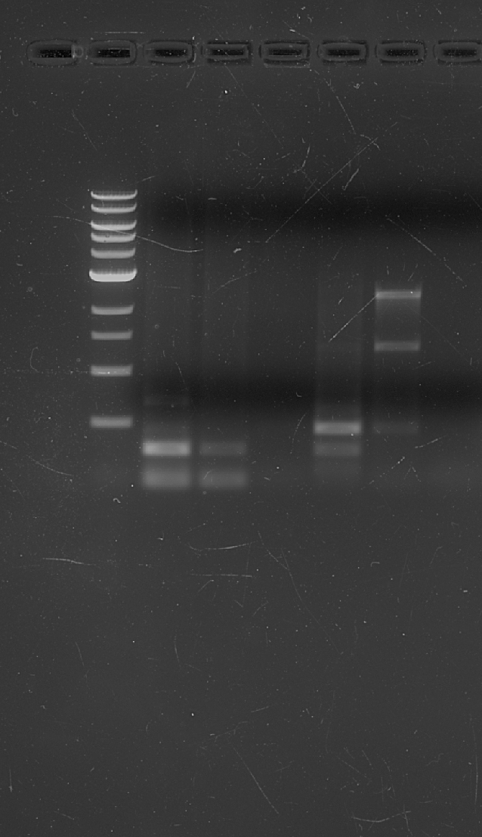
1
2
3
4
5
1kb
6

Figure 2. Agarose gel electrophoresis of PCR amplified samples. 1: Preserved human bone A, 2: Preserved human bone B, 3: Preserved human bone C, 4: Fresh chicken bone A, 5: Fresh chicken bone B, 6: Control
CONCLUSION: In this study we have demonstrated that bone samples can be used for extraction of genomic DNA, even after long preservation process. Our bone samples were more than 2 years old, which have undergone chemical treatment process. Though preservation process has affected the yield of DNA, it has no effect on PCR amplification of specific genes which can be used for molecular identification of individuals along with differentiation among individuals. These optimized DNA extraction process can be utilized further for critical samples from forensic investigation field.
REFERENCES:
- Abuidrees, A. S., Alhamad, N. A., & Alsaadany, K. (2016). A Suitable Method for DNA Extraction from Bones for Forensic Applications: A Case Study. Arab Journal of Forensic Sciences and Forensic Medicine, August. https://doi.org/10.12816/0026468
- Barbaro, A., Samar, S., Falcone, G., & La Marca, A. (2021). Highly efficient and automated extraction of DNA from human remains using a modified EZ1 protocol. Forensic Sciences Research, 6(1), 59–66. https://doi.org/10.1080/20961790.2020.1848138
- Chomdej, S., Tasena, H., Kongtung, P., & Nganvongpanit, K. (2015). Simple Protocol to Extract DNA from Bone Fragments-A Preliminary Study. Chiang Mai Veterinary Journal, 13(1), 51–57.
- Compston, J. E. (2002). Bone marrow and bone : a functional unit. 387–394.
- Devaraju, R. R., Gantala, R., Ambati, M., Vemula, A., Kubbi, J. R., & Gotoor, S. G. (2014). DNA detection in tooth exposed to different temperatures: An in vitro study. Journal of Indian Academy of Oral Medicine and Radiology, 26(4), 393. https://doi.org/10.4103/0972-1363.155681
- DNA Fingerprinting Technology - Its Success and Future | Council of Scientific & Industrial Research | CSIR | GoI. (n.d.). Retrieved August 10, 2022, from https://www.csir.res.in/dna-fingerprinting-technology-its-success-and-future
- DNA Forensics Problem Set. (n.d.). Retrieved August 12, 2022, from http://www.biology.arizona.edu/human_bio/problem_sets/dna_forensics_2/06t.html
- Grdina, S., Friš, E. L., Podovšovnik, E., Zupanc, T., & Zupanič Pajnič, I. (2019). Storage of Second World War bone samples: Bone fragments versus bone powder. Forensic Science International: Genetics Supplement Series, 7(1), 175–176. https://doi.org/10.1016/J.FSIGSS.2019.09.068
- Jakubowska, J., Maciejewska, A., & Pawłowski, R. (2012). Comparison of three methods of DNA extraction from human bones with different degrees of degradation. International Journal of Legal Medicine, 126(1), 173–178. https://doi.org/10.1007/S00414-011-0590-5
- Jonsson, B., & Jonsson, N. (2011). Development and Growth. Ecology of Atlantic Salmon and Brown Trout, 137–209. https://doi.org/10.1007/978-94-007-1189-1_4
- Steps of DNA Fingerprinting - DNA FINGERPRINTING. (n.d.). Retrieved August 10, 2022, from https://allaboutdnafingerprinting.weebly.com/steps-of-dna-fingerprinting.html

