Multidisciplinary approaches of Nuclear Medicines in diagnosis and treatment of Diseases

Aarti Anant Varne^{1*}
Department of Pharmaceutical Chemistry
Anandi Pharmacy College, Kalambe Tarf Kale, Kolhapur
Email Id- aarti.varne@gmail.com

Prianka Shashikant Lad²
Department of Pharmaceutics
Anandi Pharmacy College, Kalambe Tarf Kale, Kolhapur

Neeta Sunil Gaonkar³
Department of Pharmaceutical Analysis
Anandi Pharmacy College, Kalambe Tarf Kale,
Kolhapur

Vibha Shivajirao Patil⁴
Department of Pharmaceutical Analysis
Anandi Pharmacy College, Kalambe Tarf Kale, Kolhapur

ABSTRACT

Nuclear medicines mostly employ radiopharmaceuticals, which are useful for various diseases diagnosis as well as treatments. The nuclear medicine involved the use very small amount of radioactive material for diagnosis and to treat diseases. This article focused on different nuclear medicines techniques in diagnosis and treatment. The recent development in nuclear medicine involved PET (Positron Emission Tomography), Single Photon Emission Computerized Tomography (SPECT), Computed tomography-PET (PET-CT), Micro-computerized axial tomography (micro-CAT), Micro-PET (with ultra-high resolution). This study also involved the application of nuclear medicine in varios types of disorder including Cancer, Thyroid cancer, Neuroendocrine neoplasms, Bone metastases, Prostate cancer, Infection, Neurology, Cardiology.

Keywords: Nuclear medicine, Radiopharmaceuticals, Nuclear imaging, PET, SPECT.

I. INTRODICTION

Nuclear medicine (NM) is a discipline that includes all medical uses of radioactive materials in diagnosis, treatment, and medical research, with the exception of the use of sealed sources of radiation in radiotherapy, according to the World Health Organization (WHO). Nuclear medicine is a field of medicine which uses mostly radioactive substances for treatment as well as diagnosis in different types of health condition like heart diseases , neurological, cancer. There are increases the chronic diseases in world like heart diseases and cancer therefore there is need to discover new research call ‘molecular imaging’. The molecular imaging enables the characterization , visualization, quantification of biological processes involved in cellular level in human body[1]. In the field of medicine known as nuclear medicine, patients are given radioactive chemicals (to be ingested) in order to diagnose or treat illnesses. This is different from conventional radiology and radiotherapy methods, which typically apply radiation from external source.Radioactive isotopes are used in the medical speciality of nuclear medicine to diagnose and cure disease [2].
Nuclear medicine is the practice of performing medical treatments using radioactive material. The most typical way to do this is by injecting, eating, or breathing radioactive substances into the body. These radiotracers emit gamma rays, which are radioactive signals that can be followed by specialized cameras as they move through the body. The least amount of gamma radiation is administered to reduce the body’s exposure to radiation, despite the fact that it can be hazardous.
Nuclear medicine examines cellular processes to ascertain how the body is operating. 1. Discover sickness in its earliest stages. 2. Concentrate treatment on particular cells 3. Keep track of treatment outcomes The most popular ways to give radionuclides are orally, intravenously, or, less frequently, intra-arterially, into the peritoneum, joint space, or CSF regions. In order to construct a radiopharmaceutical and enable preferential localization to organs of interest, these radionuclides are frequently chelated (labeled or tagged) with other molecules that give them their physiological features. In order to identify pathology and direct treatment, specialized cameras are employed to monitor the radiation emission from these unstable atoms. Managing interruptions may improve patient safety in nuclear medicine because it’s likely that they lead to poor administrations, especially while doing delicate work like making radiopharmaceuticals. On some general hospital wards, “quiet zones” and other interruption control techniques have been tested, although the proof of their effectiveness is scant. Additionally, there can be negative effects because certain signals or interruptions from equipment or other staff members may increase safety in specific situations .The main distinction between radiopharmaceuticals and conventional drugs is that the former has a therapeutic impact while the latter does not. Additionally, due to their quick disintegration, radiopharmaceuticals have a limited half-life. Because of this, radiopharmaceuticals must be prepared just before being administered. Therefore, it Is crucial for operator and patient protection that radiopharmaceuticals be prepared and used in a safe and knowledgeable manner [3].

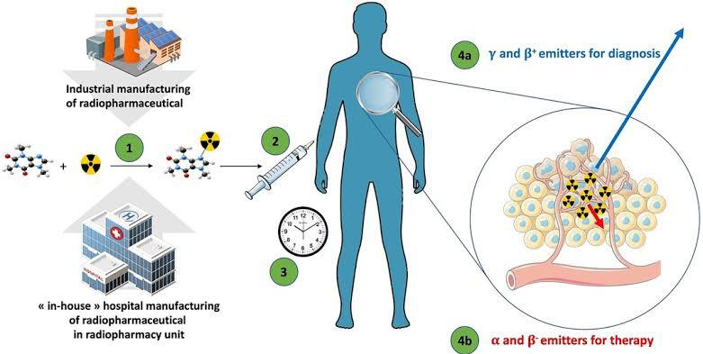

Fig No.1: Radiopharmaceuticals in diagnosis and therapy

A. Nuclear Imaging

Small amounts of radioactive material are used in nuclear medicine, a subspecialty of medical imaging, to diagnose or treat a wide range of illnesses, such as various cancers, heart conditions, and other abnormalities of the body. Nuclear imaging analyzes the function of the organ, tissue, or bone to identify the root cause of the medical issue. Radionuclide imaging techniques, often known as nuclear medicine procedures, are non-invasive and typically painless medical examinations that aid doctors in the diagnosis of medical disorders. Radiopharmaceuticals or radiotracers, which are radioactive substances, are used in these imaging scans.

B. Nuclear medicine techniques
Diagnostic techniques in nuclear medicine use radioactive tracers that emit gamma radiation from within the body. The camera constructs an image from the points where the radiation is emitted. This image is magnified on a computer and it can be observed on a monitor that indicates the anomalies.

Nuclear Medicine Techniques

Computed tomography-PET (PET-CT)
Positron Emission Tomography (PET)
Single Photon Emission Computerized Tomography (SPECT)

Micro-PET (with ultra-high resolution)
Micro-computerized axial tomography (micro-CAT)

Fig No.2: Types of Nuclear Medicine techniques Radiopharmaceuticals in diagnosis and therapy

C. The Role of Radiotracers in Molecular Imaging Techniques
Radiopharmaceuticals and radiotracers are chemicals that mimic the behavior of certain biological processes. They are also utilized for flow visualization through various medical imaging modalities, including Computed Radioactive Particle Tracking (CARPT), Single Photon Emission Computed Tomography (SPECT), and Positron Emission Tomography (PET).

D. Radiotracers used in the investigation of metabolic pathways fall into two categories:
• To quantitatively assess the metabolic process, radioisotopes of the parent chemical, such as ¹¹C-palmitate and ¹¹C-glucose, follow the same metabolic fate.
• Because they are typically maintained by tissue and improve imaging, analogues of the original molecule, such as [2-18F]-2-fluoro-2-deoxyglucose [FDG] and [123I]-BMIPP (-methyl-iodophenyl-pentadecanoic acid), provide qualitative assessments of metabolism.

Table No. 1: Common PET tracer in oncology [4,5]

Isotope | Radiotracers | Targets
¹¹C | [¹¹C] Choline | Phosphocholine
 | 2-[11C]thymidine | DNA synthesis. Tumour cell proliferation.  Drug pharmacokinetics
 | l-Methyl-[11C]methionine | Amino acid transporter
¹²⁴I | Na[¹²⁴I] | Gene expression
¹⁵O | [¹⁵O]H₂O | Perfusion
 | [¹⁵O]CO | Blood volume

E. Common SPECT tracer

A radionuclide having a pure gamma emitter and a 6 h half-life is ^{99m}Tc. By means of an isomeric transition, it degrades into ⁹⁹Tc (at energies between 140.5 and 142.6 keV). It can be easily extracted as a [^{99m}Tc(VII)]-O4 solution from ⁹⁹Mo/99mTc generators. The actual Being a pure gamma emitter ensures no additional radiation burden on the patient, and the versatility of ^{99m}Tc chemistry allows for the development of a variety of simple-to-prepare compounds through the introduction of cold labelling kits. These characteristics make ^{99m}Tc nearly ideal for SPECT and planar scintigraphy imaging. The most popular imaging agents in nuclear medicine are technetium-labeled radiopharmaceuticals, which have a wide range of uses: thyroid, bone, renal, myocardial perfusion, gastrointestinal, hepatic, cerebral, and other imaging.

F. Single photon emission computed tomography (SPECT)

Nuclear imaging techniques like single-photon emission computed tomography (SPECT) are frequently employed in diagnostic medicine. It enables the clinician to evaluate the functionality and perfusion of particular tissues. The fundamentals of single-photon emission computed tomography imaging are reviewed in this activity, along with the underlying imaging mechanism, indications, and contraindications, the technique used and the personnel needed, complications, and the clinical importance of this imaging modality in medicine.
Imaging societies create SPECT imaging indications, some of which are significant and are listed here. These signs consist of:
- Assessing persons suspected of having dementia
- Locating the epileptic foci before surgery
- Detection of encephalitis
- Following a subarachnoid hemorrhage, vascular spasm is being monitored and evaluated.
- During surgical operations, brain perfusion maps are created.
- Evaluation and detection of cerebrovascular illness
- Predicting a patient’s prognosis after a traumatic brain injury
- The clinical appearance of brain death being supported
- This page lists a number of oncology-related indications.[6]
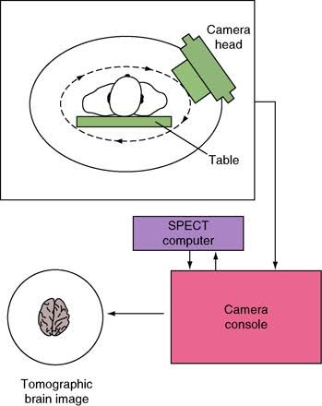
Fig No 3- SPECT imaging

G. Uses of Nuclear Medicine and Molecular Imaging.

In patient care, medical study, and drug discovery, nuclear medicine and molecular imaging are becoming more and more significant. For almost all of the body’s major organ systems, nuclear and molecular diagnostic imaging tests are now readily available. Nuclear medicine-based treatments for cancer and other diseases are becoming more and more common. Patients with cancer, cardiovascular disease, and brain diseases receive crucial care from nuclear medicine and molecular imaging:
- Nuclear and molecular imaging can significantly alter the course and results of patient care in a wide range of cancer types, including lymphoma, esophageal, colon, and lung cancer.
- Nuclear imaging now offers imaging agents that successfully identify early changes in the brain associated with Alzheimer’s disease in addition to helping doctors diagnose dementia.
- Myocardial perfusion imaging, a form of nuclear medicine, offers a very accurate test for diagnosing coronary artery disease in patients who may be at risk for a heart attack.
Scientists from a range of fields are improving their understanding of the molecular mechanisms and pathways of disease in the laboratory with the use of nuclear medicine and molecular imaging technology. Nuclear medicine and molecular imaging also contribute to the expedited creation of new and more effective pharmaceuticals by assisting researchers in promptly evaluating potential therapies.

H. Applications of nuclear medicines

a. Thyroid cancer
In resent studies SPECT used for management of differentiated thyroid cancer (DTC). The selection of patients for post-surgical radioiodine (RAI) ablation is based on clinical and histopathologic risk stratification . RAI whole-body scintigraphy (WBS) at the completion of ablation can change the risk stratification. In this ¹²⁴I-iodide PET/CTPretreatand posttherapy SPECT/CT.

b. Neuroendocrine neoplasms
Neuroendocrine neoplasms (NENs) are a heterogeneous group of tumours originate from neuroendocrine cells, located in the GI tract and lungs, pituitary, thyroid and parathyroid glands, adrenal medulla. To identify functionally active lesions potential Scintigraphy of tumour somatostatin receptor (SSR) expression or catecholamine uptake is main target for the assessment of SSR – positive NENs Radiolabelled octreotide is used with the addition, of PET/CT with ⁶⁸Ga-labelled somatostatin analogues. Catecholamine metabolism is assessed with ¹²³I-metaiodobenzylguanidine (mIBG), ¹⁸FDOPA, and [¹¹C]5-hydroxytryptophan (5-HTP).

c. Bone metastases
Bone metastases are associated with more prognosis and decreased survival. Bone scintigraphy (BS) detects metastases in the presence of a reactive increase in bone formation. It is can also be detected using FDG PET/CT, an imaging modality that plays an important role in assessing skeletal involvement in cancer, especially in the case of lesions with a predominantly osteolytic than osteoblastic pattern.

d. Prostate cancer
Recently PET radioligands development used against prostate-specific membrane antigen (PSMA) has diagnostic workup of prostate cancer . SPECT/CT with ^{99m}Tc-MIP 1404 (PSMA-ligand subtype) used for the detection of small LNs or additional metastases.

e. Infection
Infectious process is based on clinical and laboratory data, localization can be difficult. For Infection seeking tracers labelled with single-photon-emitting radionuclides include autologous leukocytes (WBCs) labelled with ¹¹¹In-oxine or ^{99m}Tc-hexamethylpropyleneamine oxime and ^{99m}Tcubiquicidin 29-41 were used. ⁶⁷Ga-citrate is still used in a few scenarios such as osteomyelitis (OM) of the spine or sternum. SPECT/CT used for both early diagnosis of infection and precise localization [6].

f. Neurology
^{99m}Tc-HMPAO or ^{99m}Tc-ethyl cysteinate dimer (ECD) is used for SPECT imaging of brain perfusion which is performed in cases of dementia and epilepsy. Parathyroid diseases - ^{99m}Tc-sestamibi (MIBI) SPECT/CT is used in the workup of patients with hyperparathyroidism (HPT). Variable acquisition protocols are used, including single-tracer dual-phase studies and subtraction imaging following^{99m}Tcpertechnetate or ¹²³I-iodide administration.

g. Cardiology
Cardiology places a high value on myocardial perfusion imaging with SPECT, particularly in the diagnosis and risk assessment of coronary artery disease (CAD). Currently, three SPECT imaging substances are being used in therapeutic settings: ²⁰¹Tl-Cl, 99mTc(I)-sestamibi, and ^{99m}Tc(V)-tetrofosmin. Due to restrictions on the [²⁰¹Tl]-Cl’s extended half-life, attenuation artifacts brought on by the low characteristic X-ray emission in the region of 69 to 81 keV, and administered dose restrictions brought on by radiation load, it is employed less frequently than Tc counterparts[ 7].

i. FDG-PET Radiotracers: A Widely Used Tool for Cancer Diagnosis and Staging
Because it cannot be biochemically confused with glucose, the PET radiotracer [1-11C] glucose can track the precise course of glucose during metabolism. This process causes the radiotracer to be taken up, retained, and excreted from the heart as well as release cardiomyocytes as 11CO2. In the alternative scenario, because the carbohydrate structure has changed from glucose to deoxyglucose, FDG is taken up and phosphorylated by hexokinase without going through any additional metabolic processes in the cardiomyocyte. FDG is consequently imprisoned in the cell. On the basis of a kinetic study of the time-activity curves for FDG, glucose absorption and phosphorylation can be predicted initially. Regarding the oxidative destiny of glucose, this mechanism offers little information, and kinetic analysis shows irreversible trapping in contrast to the buildup and removal of other radiotracers. The irreversible radiotracers that are “trapped” in the cardiac substrate result in:
• Details on a certain metabolic process’s component;
• The relationship between the tracer and detection can change under various metabolic settings;
• Differences in the structure of the parent compound and the radiotracer will affect how accurately the tracer detects the utilisation of the parent molecule. [8]
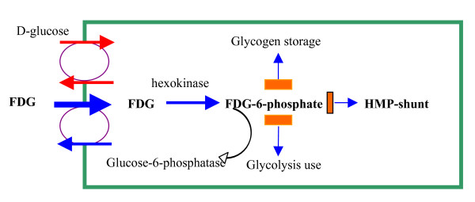
Fig no. 4 : Mechanism of Glucose trapping in FDG-PET

Conclusion
Nuclear medicine is the practice of performing medical treatments using radioactive material. There are different radioactive materials are used in very small quantity for diagnosis and treatment of diseases. In this review the a special mention rescent developments in Nuclear medicines loke PET, SPECT, Micro PET, etc. It also include multidisciplinary approach of nulear medicine in diseases diagnosis and treatment mostly including different types of cancer- Thyroid cancer, Bone metastases, Neuroendocrine neoplasms, Prostate cancer, cardiac disorders, infections. This is beneficial for the development of new research in nuclear medicines.

References
[1] Rafaela Monteiro, Pedro Costa“Survey on the knowledge of Portuguese society about Nuclear Medicine: A snapshot of the reality in the beginning of the decade” Journal of Medical Imaging and Radiation Sciences Volume 53, Issue 4, , Pages 571-579, December 2022

[2] Badawi, Ramsey “Nuclear medicine” Physics Education. 36. 452. (2001).

[3] Christopher Muscato “Nuclear medicine is a growing field of research and treatment. History of Nuclear Medicine.

[4] Leung K. [11C]Choline. 2004 Oct 1 [Updated 2011 Feb 7] “In: Molecular Imaging and Contrast Agent Database (MICAD)” Bethesda (MD): National Center for Biotechnology Information (US); 2004-2013.

[5] Mankoff D .A., Shields A..F, Link J.M., Graham M.M., Muzi M., Peterson L.M., Eary J.F., Krohn K.A. “Kinetic analysis of 2-[11C]thymidine PET imaging studies: validation studies” J Nucl Med.40(4):6, 14-24,1999

[6] Israel O, Pellet O, Biassoni L, De Palma D, Estrada-Lobato E, Gnanasegaran G, Kuwert T, la Fougère C, Mariani G, Massalha S, Paez D, Giammarile F. “Two decades of SPECT/CT – the coming of age of a technology: An updated review of literature evidence.” Eur J Nucl Med Mol Imaging, 46(10):1990-2012
.
[7] Crisan G., Moldovean- Cioroianu N.S, TimaruD.-G.; AndriesG., Cainap C., ChisV. “Radiopharmaceuticals for PET andSPECT Imaging: A Literature ReviewOver the Last Decade” Int. J. Mol. Sci. 23, 5023, 2022.

[8] Miele E., Spinelli G., Tomao F., Zullo A., De MarinisF., Pasciuti G.,Tomao, S. “Positron Emission Tomography (PET) radiotracers in oncology – utility of 18F-Fluoro-deoxy-glucose (FDG)-PET in the management of patients with non-small-cell lung cancer (NSCLC)” Journal of Experimental & Clinical Cancer Research, 27(1), 52., 2008.

