ECO MATERIALS
INTRODUCTION
Eco materials are referred to as "environmentally friendly materials" or "environmentally preferable". These are the materials that, while maintaining dependable performance, encourage environmental improvement throughout their complete life cycle. Eco-materials improve efficiency and the ability of materials to be recycled while lowering their harmful effects on the environment.
PROPERTIES
Eco-materials are considered superior to conventional materials as they poses the following properties:
- Reusability, which enables the reuse of collected goods for similar purposes.
- Recyclability, which enables the use of collected waste as a raw resource.
- Structural dependability will be based on its dependable mechanical attributes.
- Long-term usage without chemical deterioration due to chemical stability.
- The ability of biological safety to be employed without harming the ecological system.
- The ability to substitute other materials for "bad" ones.
- A perk that makes the workplace comfortable

Eco-Material: Need for the material
- Non-renewable resources are necessary for the building industry's extraordinary growth.
- The production of construction materials has harmful and lasting environmental effects. The distribution of urban growth has significant effects on the need for resources, the state of the environment, the advancement of technology, and world trade in construction.
- Transferring resource management programmes and low-pollution production techniques to emerging nations like India is one of the most crucial steps towards lowering the worldwide environmental effect of the production and use of construction materials.

Eco-Material: Classification
- Cyclic materials
- Materials for ecology and environmental protection
- Materials for social justice, society and human health
- Energy – Producing materials based on their origins and functions
These four main categories are further classified to ten sub-categories (Table 1):

Sub Categories | Examples
Recyled Material | green cement. Bricks made of coal ash, scrap glass and ceramics, plastics that have been reprocessed, silica fertilizer, and marine blocks.
Renewable Material | Biodegradable plastic derived from vegetable matter, wood-based materials, soil-based ceramics, and wood-based ceramics
Material for efficeincy | materials for waste reduction, alloys and metals resistant to wear, and steel and alloys painted before.
Material for waste treatment | membranes for the separation of exhausted gases, ion-exchange resins, microbiological enzymes, and absorbent materials for the removal of grease and oil.
Material for reduction of environmental load | Materials for fuel cells, carbon fiber composites, photocatalyst coatings, and catalysts as well as biological membranes.
Material for easy disposal | Functionally graded materials, asbestos-replacement colorbetos, biodegradable polymers, and TSOP
Hazaradous free material | non-halogen flame-retardant polymers, lead-free solder, and adhesive free of volatile organic compounds and chromium. polyesters devoid of heavy metals
Materials for reducing human health impacts | bone cream for orthopedic and brain surgery, soundproof panels, antibacterial coating materials, and steel sheets that reduce vibration.
Material for energy efficiency | High magnetic induction steel sheets, ultra-lightweight Al-Mg alloy steels, heat-resistant alloys for turbines, and highly endothermic steel with chromophobic fibers heat mirrors for energy-efficient homes
Material for green energy | Premium silicon for solar cells, thermoelectric materials, and carefully chosen transparent glass with exceptionally robust solar cell sealing sheets
Table 1 Category of Eco-Materials

Benefits of Eco-Friendly Materials:

Saves Energy

Energy is saved because environmentally friendly items like solar panels harness energy from the sun. They act as a substitute for fossil fuels in the generation of power. They don't use resources like coal, gas, or oil because they are non-renewable.

Low-Maintainance
Eco-friendly structures require less upkeep since they operate more efficiently. For instance, a green building makes extensive use of windows to encourage natural illumination.It leads to energy conservation and a decline in the use of artificial lighting.

Saves Water
By utilising these resources, green construction fosters water conservation, ensures that future generations will continue to have access to plentiful and clean water, as well as allows alternative water sources like rainwater and promotes water recycling.

Costs Less
Water and energy can be saved by adopting eco-friendly materials in green buildings.Construction may be more expensive up front, but it will save money on operations and upkeep in the long run.

Improves Environment

The indoor environment is improved by eco-friendly items. Going for architectural designs that allow for natural lighting, ventilation, and air quality is becoming more and more popular today.The atmosphere is made bright and inviting by these elements.

Decrease Carbon Footprint
Environmental protection is the benefit of eco-friendly packaging that is most obvious. Eco-friendly packaging typically uses recycled and biodegradable materials, reducing the waste of raw materials in the manufacturing process.Additionally, the manufacturing process is typically more effective, using less precious resources overall and lowering the environmental harm that enterprises cause.

Bio-Degradable
Green packaging offers lasting benefits that extend beyond its use in transportation, not only reducing carbon emissions and environmental harm. These eco-friendly material options maintain a minimal environmental footprint due to their recyclability and biodegradability.

Eco-Friendly Materials:

Bamboo

The best environmentally friendly alternative to wood is bamboo, member of the grass family. Depending on the variety and region, bamboo can grow up to 3 feet every day, making it one of the planet's fastest-growing plants. More than only its quick growth, bamboo is sustainable. Bamboo is becoming more and more popular, which will help forests regenerate. Bamboo is used in a wide range of products, including tiles, trim and flooring, wood, countertops, and decks.

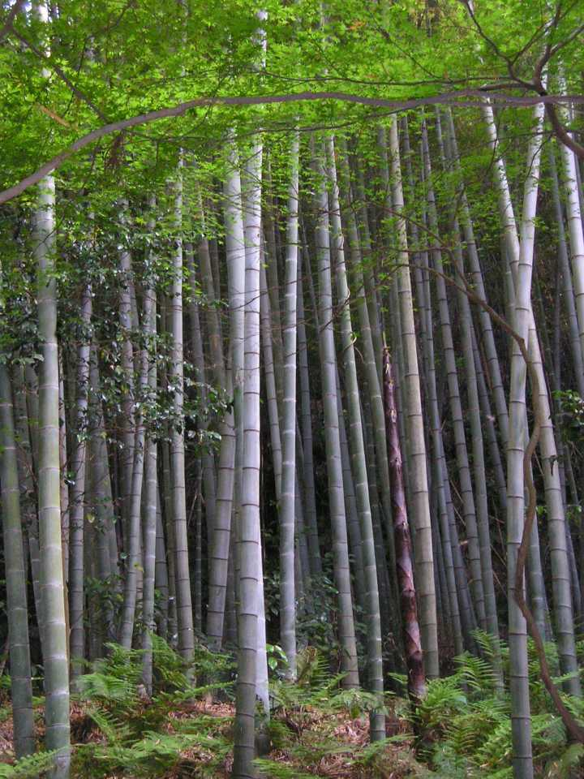 Fig 1: Bamboo

Recycled Metal

Steel requires a lot of energy to mine, heat, and shape, but it may be more sustainably produced by appropriately and efficiently reusing or recycling it into new products. Because it is robust, recycled metal doesn't need to be replaced frequently. It is ideal for roofing, building facades, and structural support because it doesn't burn or wrap. Recycled steel is moisture and insect resistant.

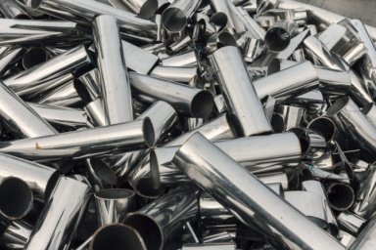 Fig 2: Recycled Metal

Sheep's Wool Insulation:

Sheep's wool serves as an excellent alternative to insulation filled with chemicals. It is manufactured with lower energy consumption and offers insulation that is equally effective as traditional insulation materials. The utilization of sheep's wool can enhance the energy efficiency and soundproofing capabilities of your building. Compared to materials like straw and certain natural insulators such as cotton, sheep's wool is more readily available, easier to harvest, and has a faster regeneration rate. Furthermore, it exhibits a slower decomposition rate compared to substances like straw. However, it may not be the most cost-effective insulator and often requires treatment to deter flies and prevent fungal growth. The environmental friendliness of sheep's wool insulation depends on the specific chemicals used in this treatment process.

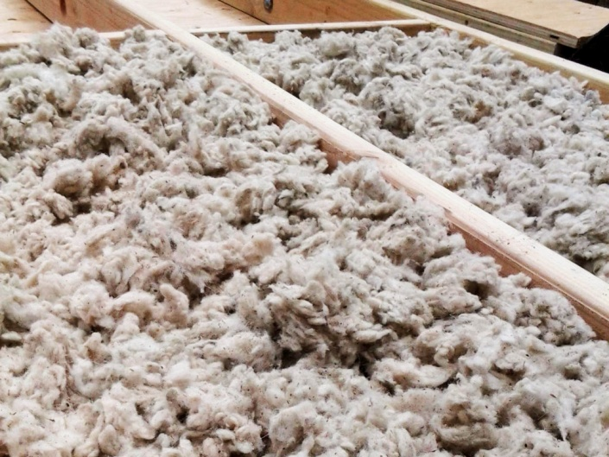 Fig 3: Sheep's Wool Insulation

AAC Blocks
In the construction industry, autoclaved aerated concrete, or AAC, blocks are rapidly replacing conventional bricks. Because AAC bricks can weigh up to three times less than traditional bricks, they are incredibly easy to handle and work with.
The thermal efficiency of these AAC blocks is one of their main advantages. They keep the house cozy all year round while reducing the demand for heating and cooling. The blocks are more fireproof than ordinary blocks. These bricks weigh as little as three times as much as conventional clay or cement blocks. The construction is completed sooner as a result. 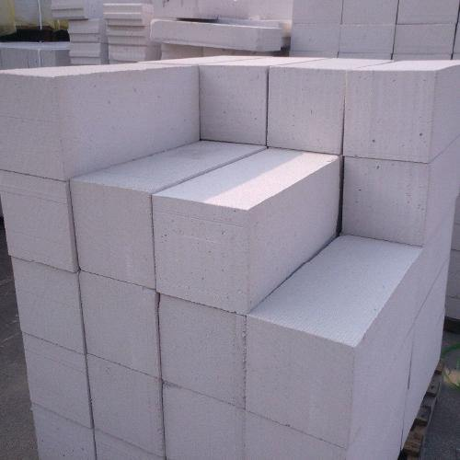 Fig 4: AAC Blocks

Timber Crete

Construction is done with this unusual building material, which is made of concrete and sawdust. It is lighter than concrete and produces fewer transportation emissions.

Sawdust contributes to waste recycling and serves as a substitute for certain labor- and energy-intensive elements found in conventional concrete. Wood-based concrete can be molded into standard forms such as pavers, bricks, and blocks. It offers superior insulation compared to brick, clay, or traditional concrete, and it possesses exceptional durability and resistance to fire.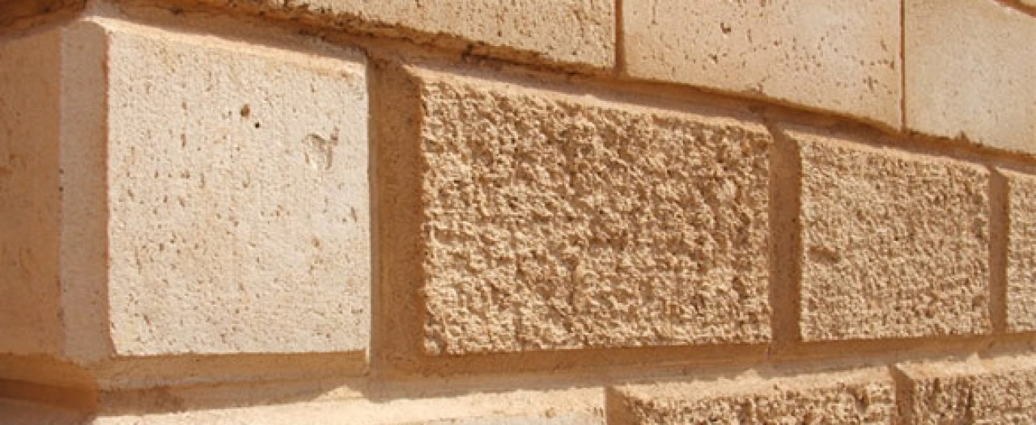 Fig 5: Timber Crete

Straw Bales

Another eco-friendly building material that can be used for framing is this one. They have good insulating properties and can be used as soundproofing materials. Because it prevents air from passing through, which may have some properties that make it fire-resistant, it can also be utilized as fill material between columns and in beam frameworks.

Straws can be easily harvested and replanted without harming the environment. Straw baling also has a negligible effect. In order to keep the house warmer in the winter and cooler in the summer, they can also be hung from walls, ceilings and attics.

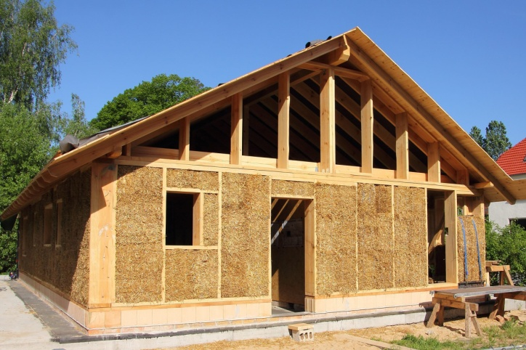 Fig 6 : Straw Bales

Cork
Similar to bamboo, cork expands quite quickly. It can be extracted from a living tree that is still generating new cork and growing. Even after being sustained under pressure, the cork maintains its flexibility and toughness and resumes its former shape. It is often used in floor tiles because of its durability and toughness.
It is also ideal for insulating sheets and subflooring due to its remarkable stress absorption capabilities. It does a great job at dampening sound as well.

Because it doesn't produce any harmful gases when it burns and resists fire, especially if left untreated, it is also an excellent thermal insulator. Cork does not decay or absorb water since it is nearly impermeable.

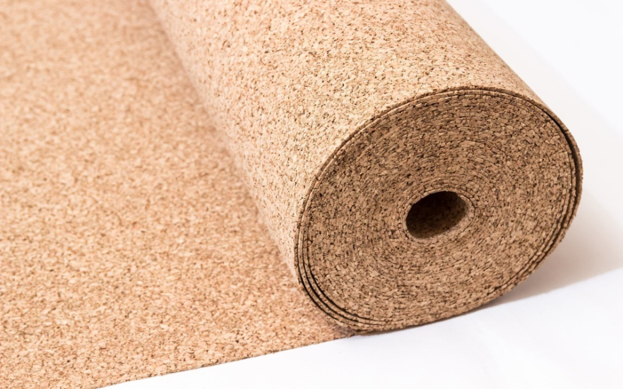 Fig 7 : Cork

Stabilized Mud Blocks
On earth, soil is fairly prevalent. Additionally, dirt has strong, good thermal insulating qualities. In order to provide chipper construction and increase building strength, the earth is used as a construction material. Additionally, enhance building thermal control and offer users excellent efficiency. The issue, though, is where soil is used in building. Therefore, soil is used in mud blocks thanks to science.
This stabilised mud wall is used to simulate the space between a reinforced beam and column. This block is used in a variety of ways. Mud brick is another name for this stabilised mud block.

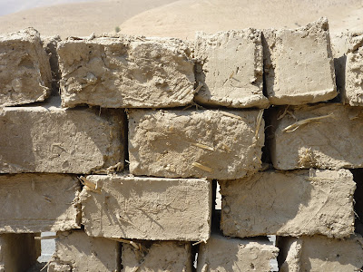 Fig 8 : Stabilized Mud Blocks

Plant-Based Polyurethane Rigid Foam
In construction, rigid foam is a commonly employed insulation material comprised of kelp, hemp, and bamboo. Its stiffness and immobility make it suitable for insulation purposes. It provides thermal resistance, soundproofing capabilities, and safeguards against pests and mold.
Hempcrete
In order to create a strong, environmentally friendly building material, lime or mud cement is combined with hemp shives, which are tiny fragments of wood from the plant's stalk. Hempcrete can be integrated with conventional building construction methods while being lightweight and non-structural. Similar to conventional concrete, it can be prefabricated into building materials .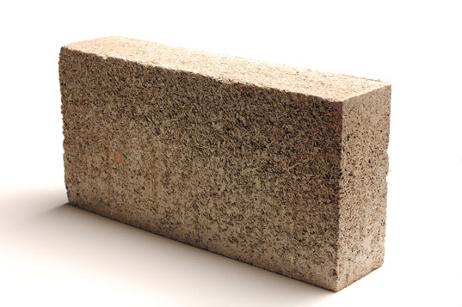 Fig 9 : Hempcrete

Conclusion
Using ecologically friendly building materials is good for the environment and people's health. I really hope that the data on this list has been instructive and useful in helping you make ecologically conscious decisions in the future.

