Leukemia Disease Classification and Detection in Blood Microscopic Images using Deep Learning Techniques

Vimala Vinnarasi
Assistant Professor & Head, Department of Computer Science, Idhaya College of Arts and Science for women, Puducherry is affiliated to Pondicherry University, Puducherry 605008.
vimjoe08@gmail.com

S.Karthi
Assistant Professor
Department of IT
St Joseph college of Engineering,
Chennai., India
karthisjce@gmail.com

Dr. R. Manivannan
Assistant professor
Department of CSE, School of Computing,
Vel Tech Rangarajan Dr.Sagunthala R&D Institute of Science and Technology, (Deemed to be university)Avadi, Chennai, India.
manichandran1692@gmail.com

Dr. M.P Vaishnnave
Assistant professor
Department of computer science and Engineering,
School of computing, Sathyabama Institute of Science and Technology
(Deemed to be university) in Chennai, Tamil Nadu
Email: Vaishnnave03@gmail.com

ABSTRACT
The early identification and diagnosis of leukaemia is a key challenge in the field of sickness diagnostics. This challenge entails making an accurate differentiation between healthy and cancerous leukocytes in the early stages of the disease while keeping expenses to a minimum. In spite of the widespread occurrence of leukaemia, there are only a limited number of flow cytometers, and the diagnostic procedures followed in laboratories are time-consuming. Cancer of the blood-forming tissues, sometimes known as leukaemia, can affect the lymphatic system as well as the bone marrow. If it is discovered at an earlier stage, treatment may be more successful. As a result of this research, a new classification model for blood microscopic images was established. This model makes a distinction between images unaffected by leukaemia and those that are afflicted by leukaemia. The detection times and accuracy of machine learning and deep learning methods are far higher than those of human analysts.
In order to address this scenario, we have used deep learning based Leukemia disease classification and detection in blood microscopic images. This is by comparing two models, namely traditional CNN and deep CNN model (Alex Net and VGG-16 Net model). According to the C-NMC 2019 dataset, a total of 11,154 blood microscopic images were collected for the purpose of evaluating our proposed approach. Based on our study findings, it has been noted that the performance of a VGG-16 Net model, surpasses that of other two models such as the Traditional CNN and Alex Net model. The optimal performance of the model is achieved by the utilization of VGG-16 Net model as a feature extractor, and Soft-max as the classifier. This configuration yields an accuracy of 97.44, precision of 97.5, recall of 97.5, and F1-score of 97.5.

Keywords—leukaemia disease; disease prediction; deep learning; blood microscopic images; Alex Net model; VG-16 Net model ;

INTRODUCTION

Cancer is a significant public health problem that impacts individuals all over the world and, in many instances, is the primary reason for a person's passing away. Blood cancer is one of the most severe forms of the disease, and it progresses to a point where it poses a significant threat to the patient [1]. Leukaemia is a form of cancer that affects the blood and causes the body to produce blast cells. These blast cells (RBC) are responsible for controlling the formation of both white blood cells (WBC) and red blood cells (RBC). It is currently uncertain, from a medical perspective, what exactly causes leukaemia; nonetheless, the disease might be brought on by both hereditary and environmental factors. There will be around 67,410 new cases of leukaemia diagnosed in the United States in the year 2020 [2]. It is estimated that around 9500 new cases of leukaemia are diagnosed each year in the United Kingdom [3]. In the same vein, around 10,000 instances of children leukaemia are recorded in India each and every year. In addition, the Indian Association of Blood Cancer and Allied Diseases notes that leukaemia, which is a kind of cancer that affects white blood cells, accounts for one-third of all cases of paediatric cancer that are severe and have the potential to result in death [4]. Figure 1 illustrates the morphological alterations that distinguish leukaemia blood cells from normal cells. These modifications underscore the fact that leukaemia blood cells are not normal cells.
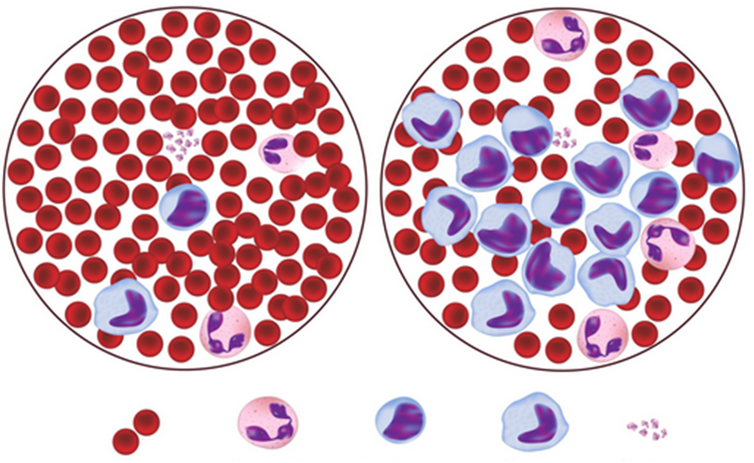
Normal Blood
Leukemia
Erythrocyes
Neutrophil
Lymphocyte
Monocyte
Platelets
Figure 1: Normal vs. Leukemia Blood Cells
In general, leukaemia was categorised according to the rate at which it progressed and the sorts of cells involved. Acute leukaemia and chronic leukaemia make up the two subtypes that fall under the first category of leukaemia categorization [5], which is based on the course of the leukaemia illness. The fast growth of aberrant blood cells (immature blood cells) that are unable to carry out their typical duties is one of the defining characteristics of acute leukaemia. There are two main categories of chronic leukaemia: those that produce an abnormally high number of cells and those that create an abnormally low number of cells. In contrast to acute leukaemia, chronic leukaemia attacks fully developed blood cells. The second form of leukaemia, which may be divided into lymphocytic leukaemia and myelogenous leukaemia depending on the type of white blood cell that is afflicted, is known as lymphocytic leukaemia. Lymphocytic leukaemia, also known as lymphoblastic leukaemia, is a kind of leukaemia that attacks the lymphocytes found in the bone marrow. Myelogenous leukaemia, sometimes known simply as myeloid leukaemia, is a subtype of leukaemia that targets myeloid cells [6]. Myeloid cells are responsible for the production of red blood cells, white blood cells, and platelets. According to Table 1, leukaemia may be broken down into four primary subtypes that are distinguished by the degree of severity as well as the kind of infected cells: acute lymphoblastic leukaemia (ALL), acute myeloid leukaemia (AML), chronic lymphocytic leukaemia (CLL), and chronic myeloid leukaemia (CML) [7].

Table 1: Types of Leukemia
 | Lymphocytic Leukemia | Myelogenous Leukemia
Acute | Acute Lymphoblastic Leukemia (ALL) | Acute Myeloid  Leukemia (AML)
Chronic | Chronic Lymphocytic  Leukemia (CLL) | Chronic myeloid  Leukemia (CML)
The examination of blood cells under a microscope is one of the most reliable methods for detecting and diagnosing leukaemia illness [8]. In general, researchers, medical professionals, and haematologists have struggled with the difficulty of making an early diagnosis of leukaemia. Symptoms of leukaemia include lymph node enlargement, pallor, fever, and weight loss; however, these symptoms can also be caused by other disorders [9]. Leukaemia symptoms include lymph node enlargement. It is challenging to get a correct diagnosis of leukaemia in its earlier stages since the symptoms are usually rather mild. Although microscopic analysis of PBS is the approach that is most commonly used to diagnose leukaemia, the method that is considered to be the gold standard for diagnosing leukaemia simply entails acquiring and evaluating samples of bone marrow [10]. Traditional methods of image processing have been combined with machine learning methodologies to create a number of different ways that have been deployed to address these difficulties. Despite this, they were not successful in attaining accuracy, effectiveness, or precision in their learning operations [11].
The remaining parts of the paper are organized in the following way: In the next section, we will conduct a literature review on the subject of automated detection systems for the identification and classification of leukaemia. In section 3, we will also discuss related initiatives, with a particular focus on leukemia disease prediction and classification systems. We go over the process of collecting datasets and evaluated performance metrics and also present state of research on deep learning techniques is discussed in Section 4, and the conclusions drawn from this study as well as its potential applications in the future are discussed in Section 5.

LITERARTURE SURVEY
Over the course of the last several decades, numerous researchers have created categorization and detection methods for leukaemia illnesses based on machine learning. These methods make use of microscopic pictures. For instance, Paswan et al.[12] used Support Vector Machine (SVM) and k-Nearest Neighbour (k-NN) to identify and classify AML leukaemia kinds illnesses with an accuracy of 83%. In a similar manner, SVM was utilised by Patel et al. [13] to accurately diagnose ALL leukaemia kinds illness. The classification accuracy was 93%. Karthikeyan et al. [14] extracted WBC from the background using support vector machines (SVM) and c-mean clustering, and they reached a 90% accuracy rate. In [15], the author makes a suggestion for a method that may be used to determine if lymphoblast cells are normal or pathological. The procedure consisted of two steps: first, the white blood cells and other blood cells were separated, and then, lymphocytes were extracted from the blood. The Grey Level Co-occurrence Matrix (GLCM) and the Support SVM are both utilised by the system in order to identify haematological illnesses. The retrieved feature map is then classified using the Support SVM. Dasariraju et al. [16] presented a random forest approach, sometimes known as an RFA, for the purpose of leukaemia identification and classification. In order to segment the nucleus and the cytoplasm, respectively, morphological processes, multi-Otsu thresholding, and the conversion of picture formats are utilised.
Based on images of peripheral blood smears, Hegde et al. [17] suggested an automated decision support system for the diagnosis of leukaemia. Leukaemia is diagnosed when white blood cells take on an abnormal appearance for no apparent reason. The researchers obtained a total of 1159 images from Leishman stained peripheral blood smears, each of which included a unique combination of colour tones and degrees of brightness. An SVM classifier is used to do an efficient job of categorising the leukemic WBCs as belonging to the abnormal class. The overall accuracy of the classification is brought up to 88.8% thanks to the utilisation of both NN and SVM classifiers [18].
Other researchers [19] created a method for sorting white blood cells using a technique called feature weight adaptive K-means clustering. This method was a combination of conventional and machine learning strategies. After that, the colour space was broken up into its component parts, and the histogram distribution was used to determine the first clustering centre. Second, we were successful in segmenting the picture by employing a mix of K-mean clustering and colour space decomposition. After then, the watershed method was utilised in order to differentiate between different types of white blood cells. After that, a convolutional neural network was utilised to sort the white blood cells into their respective categories.
In order to facilitate crowdsourcing, Chen et al. [20] suggested using a mechanism called label augmented and weighted majority voting (LAWMV). By obtaining an accuracy of 82.89%, this model surpassed other state-of-the-art models that were being used. Voting by the majority is a straightforward and efficient strategy for integration. Rehman et al. [21] developed a tool called the m6A-Neural Tool for the purpose of predicting and identifying m6A locations. On each of the model's three sub-architectures, majority voting was utilised. These designs extracted the most relevant information from the input by utilising a series of convolutional layers. This model achieved a higher level of precision than any of the other models that were previously available. It had an accuracy of 83.9% when identifying A. thaliana species, 91.5% when identifying M. musculus species, and 92% when identifying H. sapiens species. In their study [22], Singh et al. presented a hybrid classification approach for analysing photographs of skin lesions. It was determined how well the model performed in comparison to other methods. With the help of majority voting, principal component analysis, and factor analysis, the hybrid model was able to reach an accuracy of 89.80 percent.
The problem of over-segmentation methodologies and machine learning models not obtaining sufficient results in terms of accuracy is the most prevalent disadvantage that has been observed in a variety of surveys and research done by a number of different researchers. In addition, a manual diagnosis of leukaemia illness requires a significant amount of time and does not produce trustworthy findings. Deep learning is the model that needs to be used in order for us to construct an automatic leukaemia illness categorization and detection system so that we can address the concerns.

PROPOSED SYSTEMS

This study aims to explore the use of the VGG-16 transfer learning model in the classification and prediction of leukemia disease in blood microscopic images. The VGG-16 deep convolutional neural network (CNN) architecture was developed by the Visual Geometry Group (VGG) at Oxford University [23]. The 2014 ImageNet Large Scale Visual Recognition Challenge (ILSVRC) garnered significant attention and impressed judges due to its exceptional performance in computer vision tasks, particularly in the domain of image categorization. As shown in Figure 2, the architecture of the VGG-16 Net consists of a series of layers, which can be described as follows:
- Inclusion of input images for both training and testing purposes
- Extraction of features through the convolutional layer
- Application of non-linearity function to enhance the model's capacity
- Reduction of features via the down-sampling layer
- Flattening of the data and utilisation of fully connected layers
- Implementation of soft-max classifiers for classification task
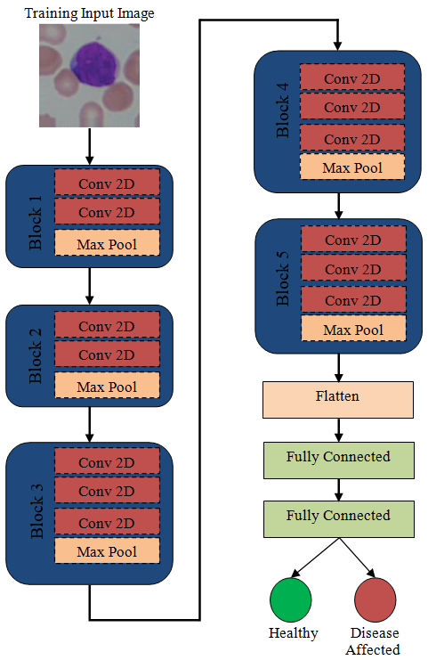
Figure 2: Architecture of leukemia disease Prediction and Classification Systems

Input Layer: The VGG-16 network commences with an input layer that accepts images of a standardized size, conventionally 224x224 pixels.
Convolutional Layers: VGG-16 consists of a stack of convolutional layers. These layers utilize small 3x3 convolutional filters with a stride of 1. The convolutional layers are interspersed with max-pooling layers employing 2x2 windows and a stride of 2, reducing the spatial dimensions.
Layer Depth: In total, VGG-16 has 16 layers, with 13 of them being convolutional layers. The convolutional layers are designed to extract progressively more complex features as you go deeper into the network.
Filter Sizes and Strides: The initial layers use 64 filters, followed by 128 filters, then 256, and finally 512 in later layers. The 3x3 filter size is a key architectural choice, which allows VGG-16 to capture fine details and maintain a relatively small receptive field.
Activation Function: Rectified Linear Unit (ReLU) activation functions follow each convolutional and fully connected layer. ReLU introduces non-linearity and accelerates training.
Fully Connected Layers: VGG-16 culminates with three fully connected layers, each comprising 4,096 neurons, followed by the output layer. These layers integrate high-level features from the convolutional layers and map them to the number of output classes (e.g., 1,000 for ImageNet classification).
Dropout: To combat overfitting, dropout layers are sometimes incorporated before the first two fully connected layers.
Output Layer: The final layer is typically a softmax layer, which produces class probabilities for image classification.
Training and Optimization: VGG-16 is trained on large labeled datasets, such as ImageNet, employing optimization techniques like stochastic gradient descent (SGD) with weight decay.
Transfer Learning: The VGG-16 architecture has proven to be exceptionally useful for transfer learning. It can be fine-tuned for various image recognition tasks, leveraging pre-trained weights learned from ImageNet data. In the realm of computer vision, VGG-16 has left a significant mark due to its blend of simplicity and performance. Researchers and practitioners frequently utilize VGG-16 as a benchmark model and a starting point for a variety of visual recognition tasks. Its effectiveness in image classification and feature extraction has made it an enduring staple in deep learning.

EXPERIMENTAL RESULTS AND DISCUSSIONS

In this section, the findings of the created model in a variety of experimental settings are discussed, and then they are followed by debates and comparisons. In addition, the aforementioned model was created with Python and the Keras deep learning framework and each and every simulation was carried out on Google Colab utilizing a 12GB NVIDIA Tesla K80 GPU. The experimental design consists of two datasets, and performance is evaluated both on its own and in conjunction with the other dataset. The technique of trial and error is used to define all of the parameters, and the findings are summarized with the optimal parameter values.

Dataset
The C-NMC 2019 dataset comprises a total of 15,114 lymphocyte images obtained from 118 subjects [24,25]. These images are organised into three distinct folders: "C-NMC training data," which consists of 10,661 cells, including 7,272 malignant cells from 47 subjects and 3,389 healthy cells from 26 subjects; "CNMC test preliminary phase data," which contains 1,867 cells; and "C-NMC test final phase data," which contains 2,586 unlabeled cells from 17 subjects. The files include single-cell photographs of malignant and benign lymphocytes that have been previously recognised by oncologists with expertise in the field. Figure 3 displays a representative subset of the dataset.
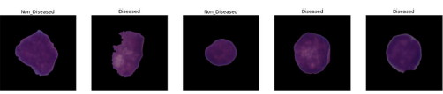

Figure 3: Sample Dataset images Healthy and Disease affected images

Performance Metrics

The following metrics will be used to develop the criteria that will be used to evaluate the performance of the model that has been proposed:
Accuracy: This statistic determines the overall number of classes that the trained model correctly predicted out of the entire number of categories, such as an Acute Lymphoblastic Leukaemia (ALL) and not an Acute Lymphoblastic Leukaemia (ALL). This metric represents the percentage of patients who are diagnosed with leukaemia as well as the percentage of patients who are not diagnosed. (e the model will be more accurate the higher the value of accuracy that is used. The following equation displays the accuracy equating formula:
Accuracy=(TP+TN)/(TP+TN+FP+FN) (1)
Precision: This statistic quantifies the ratio of genuine positives among all positive instances. In the context of leukaemia, the model's capacity to effectively identify individuals with leukaemia is of paramount importance. Mathematically, the concept in question is formally defined by the use of the following equation:
Precision=TP/(TP+FP) (2)
Recall: This statistic quantifies the ratio of genuine positives among all positive instances [72]. In the context of leukaemia, the model's capacity to effectively identify individuals with leukaemia is of paramount importance. Mathematically, the concept in question is formally defined by the use of the following equation:
Recall=TP/(TP+FN) (3)
F1 Score: This statistic assesses the overall efficiency of the model by combining the values of both recall and accuracy in order to determine the overall efficiency.
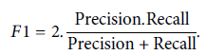 (4)

Results and Discussions
First, in order to classify and predict leukaemia disease in Blood Microscopic Images, we have independently trained and assessed two distinct CNN Models. These CNN Models include the standard CNN and the Alex Net model. We came to the conclusion that the Alex Net model attained the maximum degree of accuracy conceivable and was the strategy that was the most effective based on the data that are presented in Table 2 and Figure 4. On the other hand, the accuracy rate of the CNN model was just 91.65% of the time.

Table 2: Performance Comparison of base models

S. No. | Model | Accuracy | Precision | Recall | F1- Score
1. | Traditional CNN | 91.65 | 92.5 | 91.5 | 91.75
2. | Alex Net Model | 94.6 | 94.5 | 94.5 | 94.5
3. | VGG-16 Net Model | 97.44 | 97.5 | 97.5 | 97.5

Figure 4: Performance analysis of proposed AD model
In order to further increase the prediction accuracy, we have used the further level deep CNN model namely VGG-16 Net model. The VGG-16 Net model has more number trainable parameters rather than the traditional CNN and Alex Net model. Because of the findings that are presented in Table 2 and Figure 7, we were able to determine that the VGG-16 Net was the most efficient technique, as it produced the highest level of accuracy, which was 97.44%. The confusion matrix was utilised in the calculation of a variety of performance evaluation metrics, all of which are displayed in Figure 5.
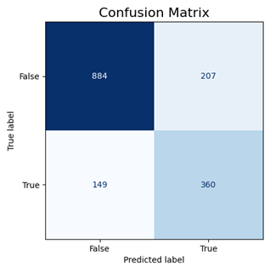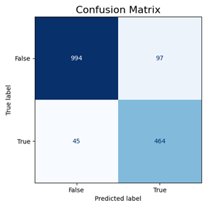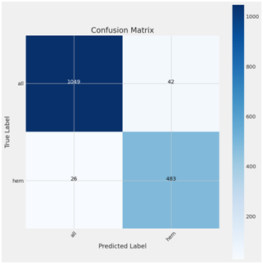
Figure 5: Confusion Matrix of traditional CNN, Alex Net and VGG-16 Net model
Figures 6–8 depict the outcomes of a comparative analysis conducted to evaluate the VGG-16 Net model against the base models, namely the traditional CNN and the Alex Net model. The evaluation was based on standard metrics, including trained accuracy, validated accuracy, trained loss, and validated loss. The analysis was conducted over a span of 15 epochs, incorporating dropout, resulting in an VGG-16 Net model. The computation of these parameters is conducted to get an estimation of the trained models, utilising a learning rate of 0.00001 and employing SGD optimisation. The computation of these parameters aims to offer an assessment of the extent to which the training models have experienced overfitting.
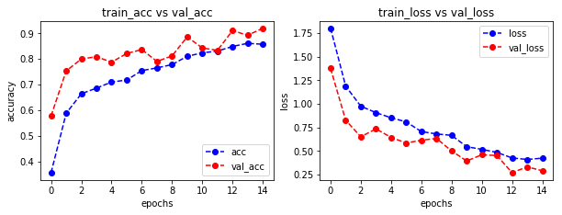
Figure 6: Train, validate accuracy and Train, Valide loss of CNN Model
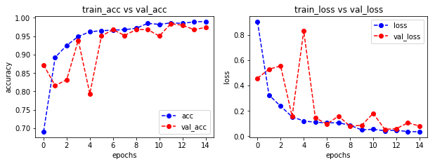
Figure 7: Train, validate accuracy and Train, Validate loss of Alex Net Model
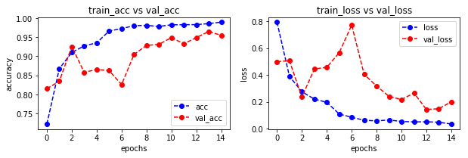
Figure 8: Train, validate accuracy and Train, Validate loss of VGG-16 Net Model

CONCLUSIONS AND FUTURE ENHANCEMENTS
Leukaemia refers to the precise differentiation of malignant leukocytes at a low cost during the first phases of the illness. Despite the high frequency of leukaemia, the availability of flow cytometer equipment is limited, and the procedures employed at laboratory diagnosis centres are labor-intensive. The early detection of leukaemia has been shown to enhance the efficacy of treatment interventions. The present study presents a novel classification model for blood microscopic images, aimed at differentiating between images depicting individuals free from leukaemia and those depicting individuals afflicted by leukaemia. The methodology outlined in this study comprises three primary components, namely Image Preprocessing, Feature Extraction, and Classification. The utilisation of an Deep convolutional neural network (VGG-16 Net model) is employed for the purpose of identifying and categorising an image as either "normal" or "abnormal." According to the outcomes of our investigation, it has been seen that the performance of the VGG-16 Net model exceeds that of two other models, namely the Traditional CNN and Alex Net model. The attainment of the most favourable performance of the model is accomplished by the use of the VGG-16 Net model as a feature extractor, coupled with the employment of Soft-max as the classifier. The aforementioned setup demonstrates an accuracy of 97.44%, precision of 97.5%, recall of 97.5%, and F1-score of 97.5%.
In subsequent developments, more precision might be achieved by the utilisation of alternative amalgamations of deep learning and machine learning algorithms. Additionally, it is possible to generate a hybrid dataset and conduct research using it.

REFERENCES

- M. Saraswath, K.V. Arya, Automated microscopic image analysis for leukocytes identification: a survey. Micron, Vol. 6(5), pp. 20–33, 2014.
- The Leukemia & Lymphoma Society, New York, https://www.ils.org/facts-and-statistics [Accessed 16 November 2019].
- Cancer Research UK, http://www.cancerresearchuk.org [Accessed 16 November 2019.
- Biji, G., and S. Hariharan, An efficient peripheral blood smear image analysis technique for leukemia detection. In 2017 International Conference on I-SMAC (IoT in Social, Mobile, Analytics and Cloud)(I-SMAC), pp. 259–264, 2017.
- O. Wolach and R. M. Stone, “Mixed-phenotype acute leukemia,” Current Opinion in Hematology, vol. 24, no. 2, pp. 139–145, 2017.
- F. Xing and L. Yang, “Robust nucleus/cell detection and segmentation in digital pathology and microscopy images: a comprehensive review,” IEEE Reviews in Biomedical Engineering, vol. 9, pp. 234–263, 2016.
- V. Ehrenstein, H. Nielsen, A. B. Pedersen, S. P. Johnsen, and L. Pedersen, “Clinical epidemiology in the era of big data: new opportunities, familiar challenges,” Clinical Epidemiology, vol. 9, pp. 245–250, 2017.
- Mohapatra, S, Patra, D, Satpathi, S., Image analysis of blood microscopic images for acute leukemia detection. In Proceedings of the 2010 International Conference on Industrial Electronics, Control and Robotics, Orissa, India, 27–29 December 2010; IEEE: Piscataway, NJ, USA; pp. 215–219, 2010.
- Garrett, K. M., Hoffer, F. A., Behm, F. G., Gow, K. W., Hudson, M. M., & Sandlund, J. T., Interventional radiology techniques for the diagnosis of lymphoma or leukemia. Pediatric Radiology, Vol. 2, pp. 653–660, 2002.
- J. Schmidhuber, Deep learning in neural networks: An overview, Journal of Neural Network, Vol. 61, pp. 85–117, 2015.
- Shijie, J.; Ping, W.; Peiyi, J.; Siping, H. Research on data augmentation for image classification based on convolution neural networks. In Proceedings of the Chinese Automation Congress (CAC), Jinan, China, 20–22 October 2017; pp. 4165–4170.
- Paswan, S.; Rathore, Y.K. Detection and Classification of Blood Cancer from Microscopic Cell Images Using SVM KNN and NN Classifier. Int. J. Adv. Res. Ideas Innov. Technol., Vol. 3, pp. 315–324, 2017.
- N. Patel, and A. Mishra, Automated leukemia detection using microscopic images. Procedia Comput. Sci. Vol. 58, pp. 635–642, 2015.
- Karthikeyan, T.; Poornima, N. Microscopic Image Segmentation Using Fuzzy C Means for Leukemia Diagnosis. Int. J. Adv. Res. Sci. Eng. Technol., Vol. 4,pp. 3136–3142, 2017.
- Lin L, Wang W, Che B, Leukocyte recognition with convolutional neural Network, Journal of Algorithms Comput. Technol, Vol. 1(3), pp. 1-10, 2018.
- Dasariraju, S., Huo, M., & McCalla, S., Detection and classification of immature leukocytes for diagnosis of acute myeloid leukemia using random forest algorithm. Bioengineering, Vol. 7(4), pp. 10-20, 2020.
- Hegde, Roopa B., Keerthana Prasad, Harishchandra Hebbar, Brij Mohan Kumar Singh, and Ilanthodi Sandhya, Automated Decision Support System for Detection of Leukemia from Peripheral Blood Smear Images, Journal of Digital Imaging, pp. 1–14, 2019.
- Rawat J, Singh A, Bhadauria HS, Virmani J. Computer aided diagnostic system for detection of leukemia using microscopic images, Procedia Comput. Sci., Vol. 70, pp.748–756, 2015.
- Donida Labati, R.; Piuri, V.; Scotti, F. ALL-IDB: The acute lymphoblastic leukemia image database for image processing. In Proceedings of the 2011 IEEE International Conference on Image Processing (ICIP 2011), IEEE, 2011, pp. 2045–2048.
- Chen, Z.; Jiang, L.; Li, C. Label augmented and weighted majority voting for crowdsourcing. Inf. Sci. 2022, 606, PP. 397–409.
- Zhang, Y.; Jiang, L.; Li, C. Attribute augmentation-based label integration for crowdsourcing. Front. Comput. Sci. 2021, 17, PP. 1–11.
- Singh, L.; Janghel, R.R.; Sahu, S.P. A hybrid feature fusion strategy for early fusion and majority voting for late fusion towards melanocytic skin lesion detection. Int. J. Imaging Syst. Technol. 2021, 32, 1231–1250.
- K. Simonyan, A. Zisserman, Very deep convolutional networks for large-scale image recognition, arXiv 2014, arXiv:1409.1556.
- The American Society of Hematology. Available online: http://www.hematology.org (accessed on 15 October 2018).
- Gupta, A.; Gupta, R. ALL Challenge Dataset of ISBI 2019 [Data Set]. Cancer Imaging Arch. 2019. Available online: https://wiki.cancerimagingarchive.net/pages/viewpage.action?pageId=52758223 (accessed on 15 May 2023).

