Earthquake Resistant Materials & Construction Technologies for Housing
Author - Prof. Shilpa Nagapurkar
MIT Art, Design & Technology University, School of Architecture, Loni Kalbhor, Pune – 412201
shilpa.nagapurkar@mituniversity.edu.in Contact no : 9890282138

Summery:
Today the buildings and cities all over world are facing destructive forces and diverse challenges due to fast urbanization, natural disasters like flooding, earthquake, storm, etc. This causes more damages to the building structures, and cities. To overcome such damages due to disasters, the resilient structure is adopted.
In India, many cities/regions come under earthquake prone zones and facing the problem that leads to destruction of buildings and cities. This brought the need of resilience in the buildings from earthquake. Some of the core cities faces the problem with conventional way of construction, also being developing country, there is a need of rapid construction with resilience.
This chapter identifies the advanced construction materials and technologies used for earthquake resilient housing construction.

Introduction
In India many cities face problems during earthquake, major damages to the buildings effects the livelihood of the people. To overcome such problems, the resilient strategies in construction should be used. The resilience in building makes it more safe and sound. There is no need to argue on the vulnerability of buildings to understand the necessity to build resilience in all components of the construction technology.

The challenges faced by environmental everyday by the effects of change in climate, population growth and environmental degradation. These challenges came be overcome by making smatter, better and in more resilient ways. This study aims the need to promote the concept of resilience in architecture through learning the materials and advanced technologies.
By adapting the advanced technologies, can help us build resilient cities in an affordable cost in different seismic zones. India being developing country the advanced technology advantages in the faster construction in an economical solution.

Advanced Technologies for Earthquake Resilient structures
- Pre-fabricated sandwich panel system
The pre-fabricated sandwich panel system are more environmentally friendly building materials which enhances the building with required strength. When applied to low-rise buildings, these technologies allow to obtain a cellular structure composed of cast in situ sandwich squat concrete walls sustains the load of gravity and act as shear walls to resist the lateral loads. This method also provides designer to use different type of materials preferably lightweight materials.
In this construction process the site is cleaner and dust free as the cement panels are manufactured in industries under controlled conditions and then dispatched on the site. Also, the erection process which is a headache part, is reduced in this system. Aim of this technology is to make building more ecofriendly, hazard resilient and more importantly to make it sustainable. This technology speeds the construction process with better quality and are cost-effective.
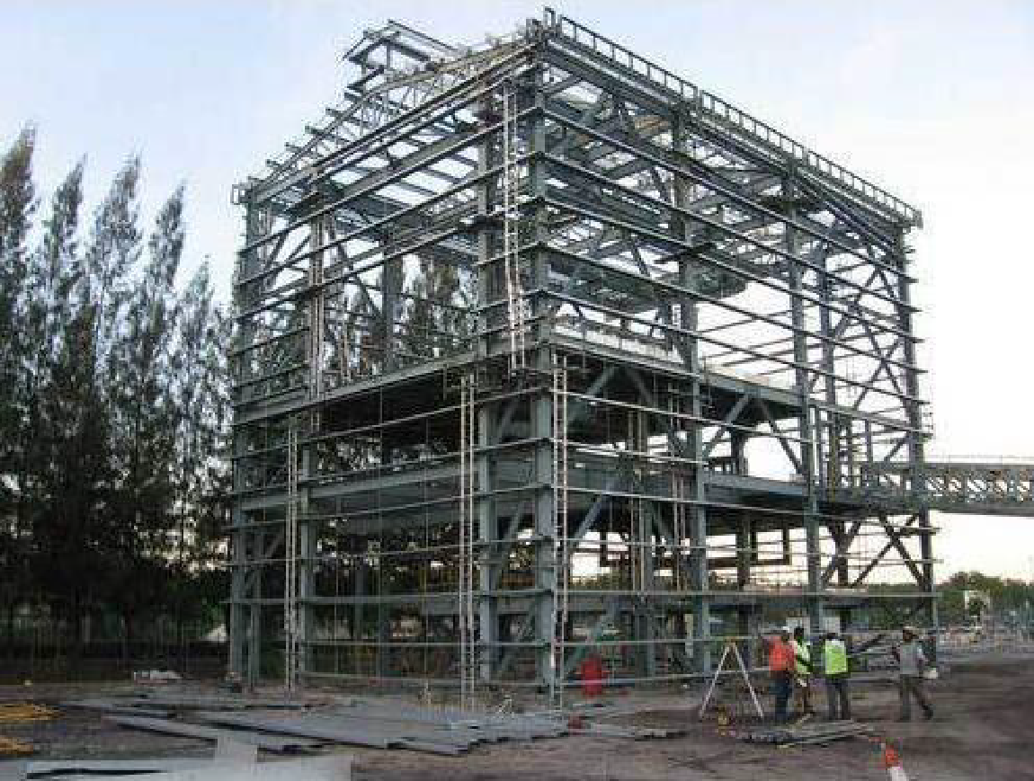
Fig 1: Steel structure installation
Source: Prefabricated sandwich panel system in India
https ://ijaers.com/uploads/issue_files/4IJAERS-07202147-Prefabricated.pdf

- Light gauge steel structural systems
Steel is a building material widely used as a building material all over the world. The steel is considered to be uneconomical for landed properties, whereas we see use of timber, structural brickwork and reinforced concrete structures are preferable. The economical steel frame is developed through cold framed process and is used in various countries.
It is an advanced technology building material, designed for the construction of prefabricated buildings and structures. LGSF technology uses high quality galvanized steel profiles in load bearing wall, inner walls, floors slabs roofing frames, it facilitates maximum utility space. The manufacturers produce a light weight but high tensile steel sheets as the light gauge steel is developed without the use of heat through the clod formed process. These steel sheets are made by processing the metallic scrap and then undergoing the process of a cold-formed. The steel is shaped by guiding thin sheets of the steel through a series of rollers (of changing shapes), resulting in the c or s-shaped sections. The sheet surface is then coated with a zinc alloy that completely covers and makes it corrosion resistant. The steel frame structures are durable and can last up to 50 year of time.

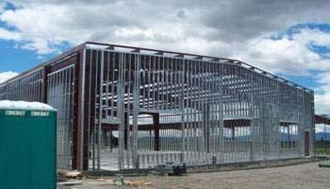
Fig 2: Example of structural design for LGSF Construction
Source: Light Gauge Steel Frame Building Construction
https ://theconstructor.org/structural-engg/light-gauge-steel-frame/37722/

- Monolithic tunnel formwork
This system is a type of formwork system in which the RCC slab and walls are constructed in a continuous poring of concrete. For medium to high ride buildings with same plans repeating due to effective performance during calamities like earthquake, industrialized, modular construction technique, low cost and time saving. Recent studies show that the current seismic codes and guidelines do not provide sufficient requirements for the seismic design of these structures. In this methodology, the fundamental period and the proposed behavior factor (R factor) are used to compute the design base shear of a structure.

Fig. 3: Tunnel formwork
Source: Introduction to advanced TUNNEL Formwork system - IRJET
https ://www.irjet.net/archives /V4/i3/IRJET-V4I397.pdf

The tunnel formworks consist of 2 half cells, l shaped that are made of steel that are joined together to form a cell unit. The main components of this system are walls and flat plate slabs, where in-situ concrete is poured into two half-tunnel forms to shape load-bearing walls and floor slabs simultaneously. With this technology the rapid constructions are done, the units can be casted within 24 hours. The two functions of the walls in tunnel form buildings are that they resist lateral loads as well as they carry vertical loads. Due to monolithic slab and walls the structure becomes more seismic resistant. Due to reduced number of joist, the water tightness in improved.
Construction is a complex and risky process requiring extensive planning, engineering and construction management. When all of these activities operate in concert with each other, the result is a successful project. Formwork is key component of any structure; quality of construction is directly depending on formwork used. There are various types of aluminum formwork used in construction industry from conventional formwork to special forms. Real estate construction industry has a reputation of not begin very technologically worldwide, generally lagging in new innovation, advanced construction techniques & management. But now a day’s lot of research is carried out in this sector, advanced tunnel formwork is good examples of this innovation.

Discussion
The essential development and land use policies that protect individual, build economy, enhance community and enrich environment now need to be adapted due to the change in environmental and social conditions. To overcome damages, to protect the cities from the hazards that are occurred due to climatic change there is need of resilience. By adapting principles of resilience, balance can be achieved in the sustainable aspects with respect to ecological system and human settlement. To incorporate the urban resilience either the conventional construction principles should be improvised or the implementation of advanced technologies should be adapted. In Indian context various calamities hitting the cities brought a need of impactful technologies, which have already been tested and applied in various other countries. The technologies and materials which are effective for earthquake that are used in various other countries are monolithic tunnel formwork, prefabricated sandwich panel system, light gauge steel frame system.

Considering the advantages of advanced technologies like affordable, time saving, easy installation, easy material transportation and better than conventional construction system, it is seen to be used successfully in India. The regions where conventional construction system in a hard, the advanced technologies can be useful. The developing region where there is a need of fast construction these technologies can be helpful. Using these technologies, the structure gains modern aesthetics. These technologies and materials are more recommended in seismic zones in India.

Acknowledgement: This study has been carried out with the help of Fourth Year students (B. Arch Batch 2019-2023) Ms. Nakshatra Kale & Ms. Shrusti Nandankar.

References:

Manual Hazard Resistant Construction in India - Assam ...
http://sdmas sam.nic.in/pdf/publication/undp/manual _hazard_resistant_construction_in_india.pdf

Types of Disasters
https ://sdma.goa.gov.in/types-of-disasters

Prefabricated Sandwich Panel System in India - IJAERS
https ://ijaers.com/uploads/issue_files/4IJAERS-07202147-Prefabricated.pdf

Seismic Behaviour of Tunnel Form Concrete Building Structures
https ://www.iitk.ac.in/nicee/wcee/article/14_05 -03-0175.PDF

Resilience to Adaptation | Architect Magazine
https ://www.architectmagazine.com/aia-architect/aiafeature/resilience-to-adaptation_o

Sutapa Das, Parthasarathi Mukhopadhyay, Multi-hazard disaster resilient housing with bamboo -based system, Procedia Engineering,2018

Role of Architects in Creating Building and Urban Resilience
https ://res earchleap.com/role-architects-creating-building-urban-resilience/

Introduction to advanced TUNNEL Formwork system - IRJET
https ://www.irjet.net/archives /V4/i3/IRJET-V4I397.pdf

Nivedita G. Gogate, Pratap M. Raval, Identifying objectives for sustainable stormwater management in urban Indian perspective: a case study, International Journal of Environmental Engineering,2015

What Is Tunnel Formwork System | Advantages | Process | PPT
https ://www.civilengineeringweb.com/2021/01/tunnel-formwork-sys tem.html

The role of perception of local government officials on climate ...
https ://www.emerald.com/insight/content/doi/10.1108/IJDRBE-01-2020-0003/full/html

Light Gauge Steel Frame Building Construction - The ...
https ://theconstructor.org/structural-engg/light-gauge-steel-frame/37722/

