RECENT ADVANCES IN DIAGNOSTIC ORAL MEDICINE
CONTENTS
1. Advances in Detection Of Oral Lesions
  - Chemiluminescence
  - Optical Spectroscopy
1.3 Brush Biopsy
1.4 Salivary Genomics And Proteomics Biomarkers
2. Advanced Caries Detection Techniques
2.1 Fiber-Optic Transillumination (Foti)
2.2 Laser Fluorescence System- Diagnodent
3. Advances In Periodontal Disease Diagnosis
3.1 Microbial Tests
3.2 Biochemical Tests
3.3 Molecular Biology Tests
4. Nanodiagnostics
INTRODUCTION
In the ever-evolving field of dentistry, diagnostic oral medicine plays a crucial role in the early detection and management of various oral conditions. Recent advancements in diagnostic techniques have paved the way for more accurate, efficient, and non-invasive methods for identifying oral lesions, caries, and periodontal diseases. These breakthroughs have revolutionized oral healthcare, enabling dentists to provide timely interventions and personalized treatment plans, ultimately leading to improved patient outcomes.
This chapter explores the cutting-edge advancements in diagnostic oral medicine, focusing on novel approaches that have transformed the way oral conditions are diagnosed and managed. By delving into these recent developments, oral healthcare professionals can gain a comprehensive understanding of the tools and techniques at their disposal. Embracing these advancements empowers dentists to deliver more personalized, evidence-based, and effective care to their patients, ultimately leading to improved oral health and quality of life.

1. ADVANCES IN DETECTION OF ORAL LESIONS
1.1 CHEMILUMINESCENCE
Chemiluminescence, the mesmerizing emission of light from a chemical reaction, has intrigued scientists for centuries. From ancient Chinese literature documenting bioluminescence in fireflies to the pioneering work of Henning Brand in 1669, this captivating phenomenon has now found diverse applications in various fields, including oral oncology. In the pursuit of early cancer detection, chemiluminescence has emerged as a promising optical technique, offering a non-invasive and real-time approach to identify dysplastic and neoplastic tissues in the oral cavity.
WORKING PRINCIPLE
The technique involves rinsing the mouth with a 1% acetic acid solution, which acts as a cytoplasmic dehydration agent, removing debris and disrupting the glycoprotein barrier on the epithelial surface. Following this preparation, the Vizilite capsule, composed of aspirin or acetyl salicylic acid and hydrogen peroxide, is activated by flexing the outer flexible plastic capsule. It has an inner fragile glass vial containing hydrogen peroxide breaks which upon activation, leading to a chemical reaction that produces blue-white light (430-580 nm) for approximately 10 minutes. Under the chemiluminescent light, normal mucosa appears blue, while dysplastic and neoplastic tissues exhibit a distinct “acetowhite” appearance due to altered light refractile properties.
ADVANTAGES
- Early Detection: Chemiluminescence allows for early detection of dysplastic and neoplastic tissues, facilitating prompt intervention and potentially improving patient outcomes.
- Non-Invasive and Real-Time: The technique is non-invasive, making it well-tolerated by patients, and provides real-time results during the examination, streamlining the diagnostic process
- Easy to Use: Chemiluminescence is a chair-side test that is easy to perform, enabling wider implementation in clinical settings.
- Limited Operator Variability: The technique shows limited operator variability, reducing the potential for inconsistent results across different clinicians.
LIMITATIONS
- Costly: Chemiluminescence-based devices and their consumables can be relatively expensive, which may limit their widespread adoption in certain healthcare settings.
- Darkened Environment Requirement: To achieve accurate visualization, chemiluminescence requires a darkened environment, which might not always be feasible or practical.
- Biopsy Site Indication: The technique lacks the ability to precisely indicate the biopsy site, necessitating further investigations to confirm cancerous lesions.
APPLICATIONS
- Oral Cancer Screening: The technique is used as an adjunct to conventional oral mucosal examination to improve the identification, evaluation, and monitoring of oral lesions with an increased risk of cancer development.
- Visualization and Marking: Vizilite Plus combines chemiluminescent technology with the toluidine blue marking system, enhancing visualization and delineation of suspicious lesions for subsequent biopsy procedures.
- Medical Device Assisted Detection: Chemiluminescence has been integrated into medical devices to detect cervical cancer and pre-cancer, highlighting its potential in broader oncological applications.
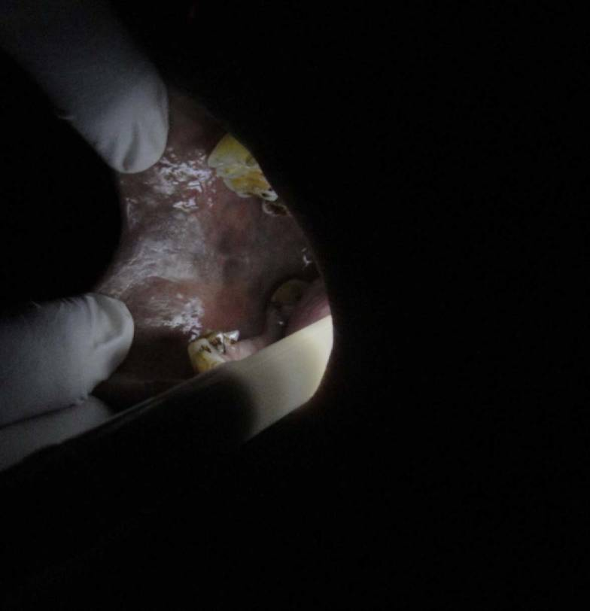
Aceto-white appearance seen on commissure of lip, on ViziLite testing

1.2 OPTICAL SPECTROSCOPY
Optical spectroscopy is a remarkable technique that offers real-time, non-invasive, and in situ tissue diagnosis. By analysing the optical spectrum of tissues, valuable information about their histological and biochemical composition can be obtained. Photo diagnosis, a vital application of optical spectroscopy, plays a pivotal role in detecting dysplasia and malignancy, guiding biopsies, monitoring haemoglobin tissue perfusion, and assessing therapeutic drug levels during chemotherapy and photodynamic therapy.

WORKING PRINCIPLE
Optical spectroscopy relies on the characteristic optical properties of tissues, such as fluorescence, elastic scattering, and Raman scattering. These properties provide valuable insights into the histological and biochemical makeup of the tissue, enabling the differentiation between normal and abnormal tissues.
Three main techniques used for detecting oral dysplasia and malignancies are:
Fluorescence Spectroscopy: It can be autofluorescence or laser-induced fluorescence and is caused by the presence of fluorophores like NADPH, collagen, elastin, and cofactors. An increase in red/green fluorescence is indicative of dysplasia and malignancy. VELscope, a portable device based on narrow-emission tissue fluorescence (400-460 nm), highlights normal mucosa in pale green autofluorescence, while suspicious tissue appears dark.
Elastic Scattering Spectroscopy (ESS): This technique generates a wavelength-dependent spectrum that reflects both scattering and absorptive properties of tissues. ESS is sensitive to criteria for establishing malignancy, such as nuclear size, chromatin content, nuclear-cytoplasmic ratio, and cellular crowding.
Raman Spectroscopy: It occurs due to a shift in the frequency of incident excitation light and provides accurate information. However, the signals may be weak.

ADVANTAGES
- Real-Time and Non-invasive: Optical spectroscopy enables immediate and non-invasive tissue analysis, reducing patient discomfort and facilitating prompt clinical decisions.
- In Situ Diagnosis: The technique allows direct tissue analysis in its natural location (in situ), preserving tissue architecture and biochemical composition for accurate diagnosis.
- Objective and Quantitative: Optical spectroscopy provides objective measurements, reducing diagnostic subjectivity, and offers quantitative data for better disease assessment and monitoring.
LIMITATIONS
- Weak Signals: Some spectroscopic techniques, like Raman spectroscopy, may generate weak signals, potentially reducing sensitivity in specific situations.
- Complex Data Interpretation: Analysis of optical spectra requires expertise and may be complex, necessitating specialized training for accurate interpretation.
APPLICATIONS
- Cancer Detection: Optical spectroscopy aids in detecting oral dysplasia and malignancies, facilitating early cancer diagnosis and prognosis.
- Guided Biopsy: Photo diagnosis assists in guiding biopsy procedures, ensuring targeted tissue sampling and improving diagnostic yield.
- Monitoring Treatment : The technique monitors haemoglobin tissue perfusion in free flaps, therapeutic drug levels during chemotherapy, and photodynamic therapy responses.
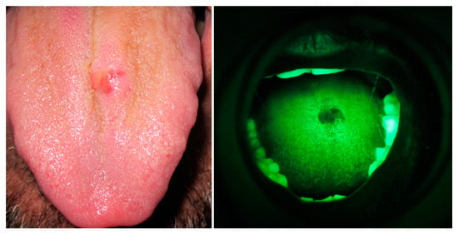
VELscope® results before a tongue biopsy.
  - BRUSH BIOPSY
Brush biopsy, also known as oral brush cytology or Oral CDx, is a non-invasive diagnostic technique used to detect oral mucosal lesions that may be precancerous or malignant. It involves using a specialized brush to collect cells from the oral epithelium, which is then analysed for abnormalities. Brush biopsy is a valuable tool for early detection and screening of oral cancer, especially in high-prevalence areas like developing countries.
WORKING PRINCIPLE
The brush biopsy technique utilizes a specially designed stiff bristle brush that can penetrate the thickness of the oral mucosa. The brush is placed on the suspicious lesion and rotated until it produces haemorrhagic spots or reddening. This ensures that a representative sample of cells from the entire epithelium, including the basal, intermediate, and superficial layers, is collected. The collected sample is then fixed and sent to the laboratory for analysis using computer-based imaging systems. Results can be reported as negative (without abnormalities), atypical (uncertain changes), positive (evidence of dysplasia or carcinoma), or inadequate (incomplete sample).

Negative | Without Abnormalities
Atypical | Uncertain Changes
Positive | Evidence Of Dysplasia Or Carcinoma
Inadequate | Incomplete Sample
Table: 1 Result
ADVANTAGES
- Non-Invasive: Brush biopsy is a non-invasive procedure, making it well-accepted by patients and less painful compared to other biopsy techniques.
- Early Detection: It can aid in the early detection of oral cancer and precancerous lesions, leading to better treatment outcomes and improved survival rates.
- Simple and Painless: The procedure is relatively simple and easy to perform chair-side, requiring minimal time and training for oral health professionals.
- Reduced Bleeding: Brush biopsy causes less bleeding during the procedure compared to traditional scalpel biopsies.
- Cost-Effective: It can be a cost-effective alternative to surgical biopsies, especially in cases where patients are at low risk.
LIMITATIONS
- Two-Step Process: In cases where the results are atypical or positive, a second procedure like a scalpel biopsy may be required for definitive diagnosis.
- Delayed Diagnosis: The need for additional testing may lead to delays in obtaining a final diagnosis.
- Indeterminate Results: Brush biopsy may not provide a definitive diagnosis in some cases, necessitating further investigation.
- Technical Limitations: The technique may have certain limitations in diagnosing certain lesions, requiring expertise in cytological interpretation.
APPLICATIONS
- Early Detection of Oral Cancer: Brush biopsy is valuable for detecting oral cancers and precancerous lesions at an early stage, increasing the chances of successful treatment.
- Screening High-Risk Patients: It can be used to screen patients with red or white spots, chronic ulcers, or other abnormal epithelial surface lesions who are at high risk of developing oral cancer.
- Evaluation of Small Lesions: Brush biopsy can help evaluate small and suspicious-looking oral abnormalities that may not be obvious during clinical examination.
- Monitoring Precancerous Lesions: It is useful for monitoring and evaluating changes in precancerous lesions over time, guiding treatment
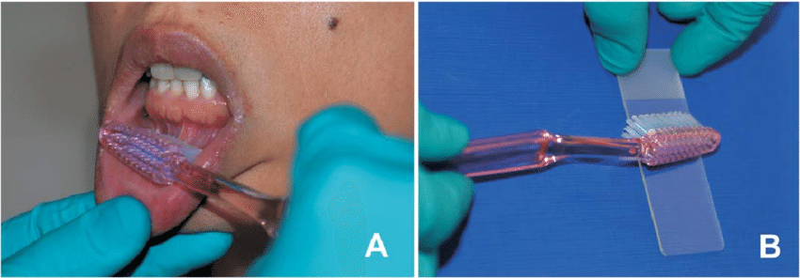
Oral brush biopsy procedure using tooth brush.
A .Using moderate pressure, the tooth brush is brushed in one direction over the entire lesion multiple times.
B. The material from the brush is spread on the two thirds of a clean, dried glass slide

1.4 SALIVARY GENOMICS AND PROTEOMICS BIOMARKERS
Salivary genomics and proteomics biomarkers offer significant potential as non-invasive and cost-effective diagnostic tools for oral cancer. Their ease of collection and early detection capabilities make them invaluable in identifying high-risk individuals, guiding treatment decisions, and monitoring therapeutic responses. While further research and validation are needed to establish their clinical utility, the advancements in this field hold promise to transform oral cancer diagnosis and improve patient outcomes significantly.

WORKING PRINCIPLE
Salivary genomics and proteomics biomarkers in oral cancer rely on the analysis of genetic material (DNA, RNA) and protein levels present in saliva. The saliva, being in direct contact with oral cancer lesions, contains biomolecules that can indicate the presence and progression of the disease. Various analytical techniques, such as mass spectrometry and electrochemical sensors, are employed to detect specific genetic and protein alterations associated with oral cancer in saliva samples.
ADVANTAGES
- Non-Invasive: Saliva collection is a simple, non-invasive procedure, which reduces patient discomfort and anxiety during diagnostic screening.
- Early Detection: Salivary biomarkers offer the potential for early detection of oral cancer, providing opportunities for timely intervention and improved patient outcomes.
- Cost-Effectiveness: Saliva-based diagnostics are cost-effective compared to traditional imaging and tissue-based diagnostic methods, making them more accessible to the population.
- Multiplexing Capabilities: Salivary genomics and proteomics enable the simultaneous detection of multiple biomarkers, enhancing diagnostic accuracy and efficiency.
LIMITATIONS
- Cultural Perceptions: Some cultural and behavioral perceptions may present barriers to adopting saliva-based diagnostics in certain populations.
- Research and Validation: Extensive research and validation are required to identify and establish specific salivary biomarkers that accurately indicate oral cancer presence and progression.
APPLICATIONS
- Early Screening: Salivary biomarkers can be used as primary screening tests for high-risk groups and individuals with premalignant lesions, facilitating early detection and intervention.
- Prognostication: Salivary genomics and proteomics biomarkers can aid in predicting disease progression and patient outcomes, guiding treatment decisions.
- Treatment Monitoring: Salivary analysis can be used to monitor treatment responses and assess post-treatment therapeutic efficacy.
- Multiplex Assays: Electrochemical sensors and mass spectrometry allow for multiplexing, enabling simultaneous detection of multiple biomarkers for more accurate diagnostics.
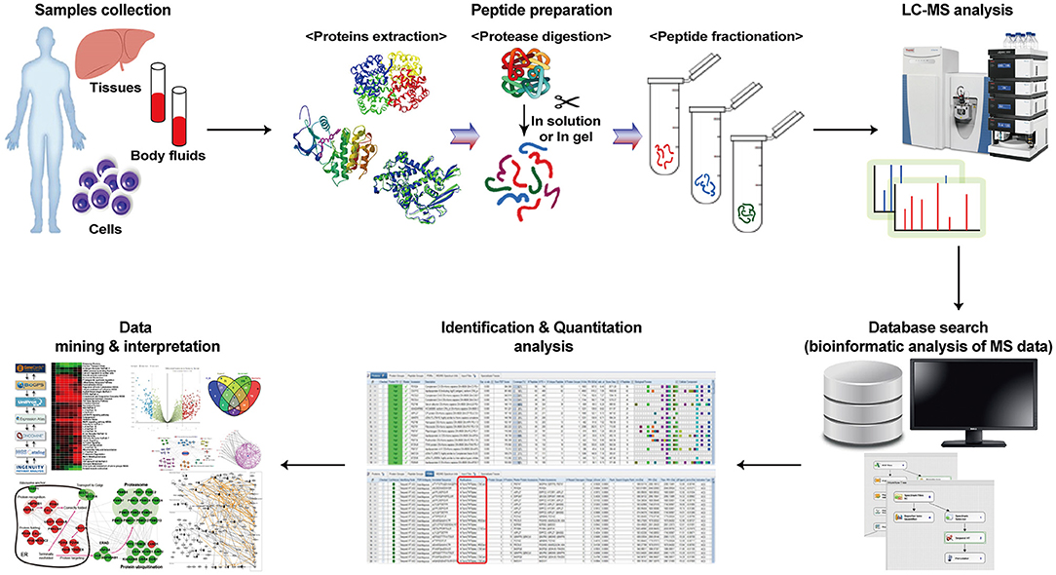
Workflow of the proteomics investigation.
Proteomics exhibit many proteins by peptide preparation, analysis using mass spectrometry, and interpretation of peptide data through existing databases.
2. ADVANCED CARIES DETECTION TECHNIQUES
Advanced caries detection techniques offer a promising future for the early and accurate diagnosis of dental caries. By combining their unique capabilities, dentists can implement effective preventive strategies and provide personalized care to maintain optimal oral health for their patients. As these techniques continue to evolve, they have the potential to revolutionize caries detection and improve overall dental care outcomes.
2.1 FIBER-OPTIC TRANSILLUMINATION (FOTI)
Fiber-optic transillumination (FOTI) is a well-established and valuable adjunctive diagnostic tool in dentistry, offering a wide range of clinical applications. Primarily associated with caries diagnosis, FOTI has been extensively researched and found to be a valid indicator of the histological presence or absence of bacterially infected tooth structure.
WORKING PRINCIPLE
- FOTI utilizes flexible, thin cylindrical fibers of high-optical-quality glass or plastic known as fiber optics.
- The principle is based on Total Internal Reflection (TIR), where light rays are reflected back into the fiber core due to differences in refractive indices between the core and cladding materials.
- By directing a narrow beam of bright white light across the facial and interproximal surfaces of the tooth, FOTI illuminates the translucent tooth structure, allowing for visualization of various characteristics.
ADVANTAGES
- Non-invasive and pain-free procedure.
- Does not expose patients to ionizing radiation, making it safe for repeated use during routine dental examinations.
- High sensitivity and specificity equivalent to or better than radiographs for caries diagnosis.
- Effective in visualizing anterior and posterior interproximal caries, occlusal caries, calculus, stained margins of composite resins, cusp fractures, and cracked teeth.
- Valuable in illuminating endodontic access and root canal orifices, improving the evaluation of soft-tissue lesions, and assessing all-ceramic restorations for fractures before cementation.
LIMITATIONS
- Cannot replace conventional clinical examinations and radiographs, which remain critical for accurate diagnosis of various dental pathologies.
- Effectiveness may be limited in cases where caries are not visually accessible, especially on posterior proximal surfaces.
- Requires specialized light sources with small apertures to achieve optimal visualization, as conventional curing lights can pose a risk of "blue light hazard."
APPLICATIONS
- Supplemental diagnostic aid for anterior and posterior interproximal caries and occlusal caries diagnosis.
- Detection of calculus.
- Evaluation of stained margins of composite resins and assessment of cusp fractures and cracked teeth.
- Exploration tool for illuminating endodontic access and root canal orifices.
- Improved evaluation of soft-tissue lesions.
- Clinical evaluation of fracture and craze lines in existing all-ceramic restorations and natural teeth.
- Evaluation of the depth and quality of extrinsic staining to determine appropriate treatment recommendations.
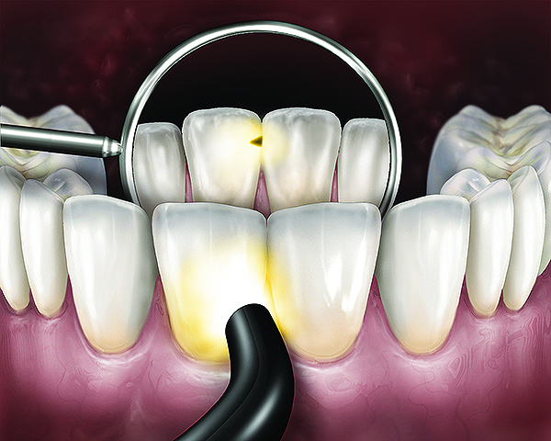
Technique to visualize anterior caries.
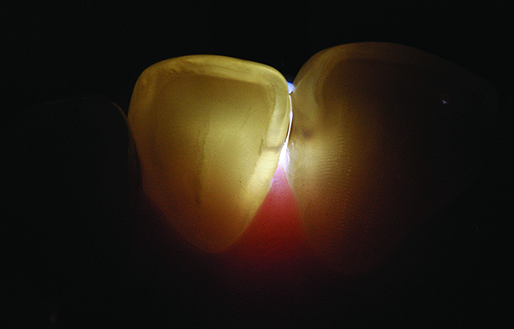
Lingual FOTI position reveals caries on mesial surface of mandibular incisor.
2.2 LASER FLUORESCENCE SYSTEM (DIAGNODENT - KAVO, BIBERACH, GERMANY)
Caries prevalence has declined in recent decades, but the occlusal surface has become the most affected area due to changes in lesion behaviour. Traditional diagnostic methods using a dental mirror and probe have limitations and bitewing radiographs' accuracy for occlusal caries diagnosis is questioned. A new method based on fluorescence measurements using a laser device has been gaining popularity.
WORKING PRINCIPLE OF LASER FLUORESCENCE DEVICE
- The laser device emits red light that is absorbed by organic and inorganic substances in dental tissues and metabolites from oral bacteria.
- Carious tissue emits more fluorescent light than healthy tissue due to the presence of metabolites like porphyrins produced by oral bacteria.
- This fluorescence difference enables the device to detect and distinguish carious lesions from healthy structures.
ADVANTAGES
- High sensitivity and specificity: The laser method shows good diagnostic accuracy in detecting non-cavitated occlusal caries in dentin.
- Non-invasive: It provides a non-invasive means of detecting carious lesions, reducing the need for explorers that can damage enamel.
- Early detection: The device allows for early caries detection, enabling timely intervention and preventive care.
LIMITATIONS
- False positive results: The device can produce false positive results, leading to unnecessary treatments.
- Recommended as an adjunct method: Due to the potential for false positives, it is suggested to use the laser method alongside visual inspection to improve accuracy.

APPLICATIONS
- Diagnosis of non-cavitated occlusal caries: The laser method is particularly useful for detecting caries in occlusal surfaces, which can be challenging with traditional methods.
- Early intervention and preventive care: The device enables early detection of caries, allowing for timely intervention and preventive measures.
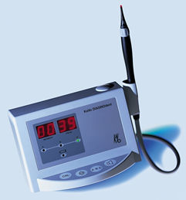
The Diagnodent caries detection instrument.
2.3 ELECTRICAL CONDUCTIVITY MEASUREMENTS - CarieScan PRO TM
In modern dentistry, the early and accurate detection of dental caries (tooth decay) is crucial for effective treatment and prevention. Advancements in technology have introduced electrical conductance and resistance-based methods as valuable tools for caries detection. This technique measures the electrical conductance in teeth, where demineralization creates a conductive pathway for electric current. It has shown superior results in detecting non-cavitated occlusal lesions of posterior teeth compared to visual examination and radiographs
WORKING PRINCIPLE
The principle of electrical conductance for caries detection is based on the fact that sound enamel has little porosity and a low amount of fluid, making it a poor conductor of electricity. On the other hand, when caries lesions develop, there is an increase in porosity and fluid content, leading to higher electrical conductance. This forms the foundation for various electrical conductance-resistance-based devices developed in recent decades.
CarieScan PRO TM, utilizes AC impedance to assess the electrical behaviour of dental tissues. By measuring impedance at a range of AC frequencies through electrical impedance spectroscopy, a more comprehensive understanding of the tissue being studied is obtained. The CarieScan PRO is a point system that provides real-time readings at a specific spot during scanning. It generates a score and colour reading between 0 (green = sound) and 100 (red = lesion cavitation) to identify different stages of non-cavitated lesions.

ADVANTAGES
- Non-invasive method: The electrical conductance-resistance approach provides a non-invasive means of detecting caries.
- Early caries detection: The method allows for early detection of non-cavitated lesions before cavitation occurs.
- Differentiation of lesion stages: The scoring system provides colour readings that indicate different stages of non-cavitated lesions.
- Applicability to occlusal and smooth surfaces: The probe can be used on areas with direct access, such as occlusal and smooth surfaces.
LIMITATIONS
- Limited applicability to certain lesions: The method cannot detect cavitated, root caries, or secondary caries lesions.
- Scale applicability: The scoring system's applicability to primary teeth may be limited as it is based on in vitro research with permanent teeth.
- Interference potential: The instrument may interfere with some dental materials, affecting accuracy in certain cases.
- Restricted use with specific medical conditions: The instrument should not be used on patients with fitted cardiac pacemakers due to potential risks.
APPLICATIONS
- Early caries detection: The method is useful for detecting non-cavitated lesions in the early stages before significant damage occurs.
- Monitoring caries progression: The electrical conductance-resistance approach can aid in monitoring the progression of non-cavitated lesions over time.
- Assessment of enamel maturity: The method can assess the maturity of enamel based on its electrical conductivity.
- Detection on accessible tooth surfaces: The probe is suitable for use on occlusal and smooth surfaces where direct access is possible.
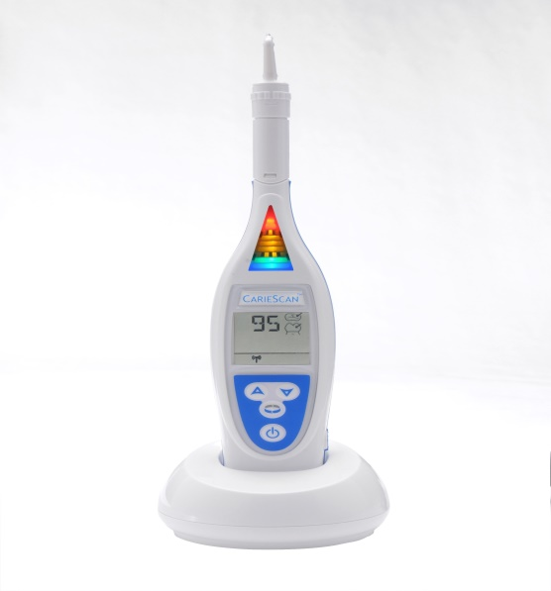
CarieScan PRO
3. ADVANCES IN PERIODONTAL DISEASE DIAGNOSIS
Periodontal disease and salivary gland disorders are common oral health conditions that require accurate diagnosis for effective management. Diagnosis plays a crucial role in identifying and treating periodontal diseases effectively. Conventional clinical and radiographical methods have limitations in detecting early disease activity. To overcome these limitations, advanced diagnostic tools and techniques have been developed, offering non-invasive and more accurate methods for diagnosing and monitoring these conditions.
3.1 MICROBIOLOGICAL TESTS
Microbiological test kits play a crucial role in periodontal research by enumerating and identifying the microflora present in the periodontal pocket. These tests aid in diagnosing various forms of periodontal disease, assessing disease initiation and progression, and determining sites at higher risk for active destruction.
Tests | Omnigene | Evalusite | PERIOSCAN
Advantages | •Quick test results provided within hours to days.  •Identifies known periodontal pathogenic bacteria. | •Detects three putative periodontal pathogens (Aa, Pg, Pi).  •Rapid chairside test. | •Very sensitive in detecting small quantities of pathogens.  •Comparable to other diagnostic methods for detecting specific species.
Limitations | •Acceptance in the dental community has been slower than anticipated. | •Multistage test with a subjective calorimetric endpoint.  • No permanent record of the result. | •Lack of quantitative data.  •Cannot identify other pathogens not producing trypsin-like enzymes.
Applications | •Monitoring periodontal pathogen levels in patients.  •Supporting optimal care for periodontitis patients. | •Chairside detection of periodontal pathogens. | •Assessment of oral halitosis.  •Detecting three specific periodontal pathogens in subgingival plaque.
 | 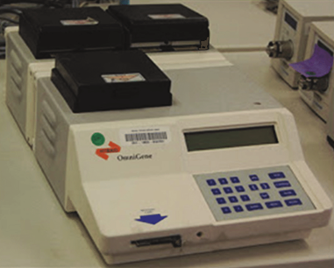 | 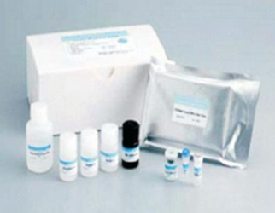 | 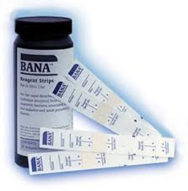
Table:2 MICROBIOLOGICAL TESTS
WORKING PRINCIPLE
3.1. A OMNIGENE
Omnigene Diagnostics developed DNA probe systems for eight periodontal pathogens. Subgingival plaque samples are collected from patients and sent to the clinical reference laboratory. The test detects species-specific DNA probes for pathogens like Porphyromonas gingivalis, Prevotella intermedia, Actinobacillus actinomycetem-comitans, and others.
3.1. B EVALUSITE (KODAK)
Evalusite is a membrane immunoassay that detects three periodontal pathogens (Aa, Pg, Pi) using antigen-antibody reactions. A patient's plaque sample reacts with specific membrane-bound antibodies. Enzyme-labelled second antibodies and coloured enzyme substrates reveal antigen-antibody complexes.
3.1. C PERIOSCAN
PerioScan utilizes the BANA (N-benzoyl-DL-arginine-2 naphthylamide) hydrolysis reaction to detect bacterial trypsin-like proteases in subgingival plaque. It identifies three periodontal pathogens (T. denticola, P. gingivalis, B. forsythus).
3.2 BIOCHEMICAL TESTS
Biochemical test kits used in periodontics analyze the gingival crevicular fluid (GCF) to provide early signs of alterations in periodontal tissues. These kits evaluate constituents such as host-derived enzymes, inflammation mediators, and extracellular matrix components present in the GCF.
WORKING PRINCIPLE
3.2. A PERIO 2000
Perio 2000 is a periodontal probe that combines advanced ion selective electrode technology with the standard "Michigan O" style probe. It measures probing depths, evaluates bleeding or probing, and detects the presence of sulfides in periodontal pockets. The system includes disposable sensor tips with sulfide sensors, an electronic control unit for real-time feedback, and a probe handle with a foot switch.
3.2. B PROGNOS-STIK
Prognos-Stik detects elevated levels of MMPs (elastases) in GCF. GCF collected on a filter paper strip with a fluorescent indicator substrate reacts with elastase, releasing a visible indicator under fluorescent light. Elevated elastase levels in GCF may indicate active disease sites.
3.2.C PerioCheck
Periocheck detects the presence of neutral proteases associated with collagen breakdown in periodontal disease. Crevicular fluid is collected on filter paper strips and placed on a collagen dye-labeled gel matrix. The reaction of neutral proteases with the gel forms soluble dye-labeled fragments of collagen, resulting in a blue colour.
3.2.D PerioGard
PerioGard is based on detecting the enzyme aspartate aminotransferase (AST) released from the cell upon cell death. Elevated total AST levels in GCF have been associated with disease-active sites.
3.2. E PerioWatch
PerioWatch analyzes Asparate amino Transferase (AST) at the chairside. AST catalyzes the transfer of an amino group in the presence of pyridoxal phosphate, leading to the release of inorganic sulfite, which reacts with malachite green, resulting in color change.

TEST | PERIO 2000 | PROGNOS-STIK | PerioCheck | PerioGard | PerioWatch
Advantages | •Provides real-time bacterial activity feedback for diagnosis.  •Used during initial patient screening, supportive periodontal therapy, and maintenance intervals.  •Aids in patient education and motivation. | •May indicate active disease sites and disease activity.  •Provides insights into the severity of gingival inflammation | •Rapid chairside test for neutral proteases like elastases, proteinases, and collagenases. | •Potential marker for early periodontal tissue destruction.  •Positive association with disease-active sites. | •Provides a simple method to analyze AST levels at the chairside.
Limitations | •Limited to specific parameters and may not cover all aspects of periodontal disease. | •The relationship between elastase levels and periodontal disease activity requires further clinical trials. | •The test is qualitative and not specific for specific enzymes. | •Complex procedure involving multiple steps. | •May have poor differentiation between colours.
Applications | •Assessing oral health status during patient screening.  •Monitoring patients during and after routine periodontal therapy.  •Educating patients and motivating them to maintain oral health. | •Monitoring disease activity and gingival inflammation | •Identifying sites with increased levels of neutral proteases associated with active periodontal disease. | •Identifying early periodontal tissue destruction and disease-active sites. | •Measuring AST levels to assess periodontal health.
Table:3 Biochemical Tests
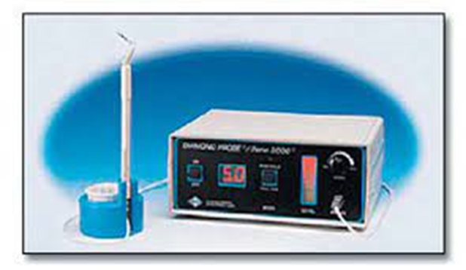
PERIO 2000
3.3 GENETIC TEST KITS FOR PERIODONTAL DISEASE
Genetic test kits have emerged as valuable diagnostic aids for periodontal disease. Certain gene polymorphisms have been linked to an increased risk of initiating or progressing periodontal disease. Researchers have identified an association between the polymorphisms in genes encoding for interleukin-1α and interleukin-1β and the severity of periodontitis. Advances in genetic testing have made it possible to detect these genetic variations using chairside kits.
WORKING PRINCIPLE
The GenoType® PST® is a genetic susceptibility test that analyzes two IL-1 genes for specific variations associated with an individual's predisposition to overexpression of inflammation and their risk for periodontal disease. The test identifies two polymorphisms within the IL-1 gene cluster, namely Interleukin 1A gene, position -889, and Interleukin 1B gene, position +3953. These genes can carry different alleles, with allele 1 harboring a cytidine (C) and allele 2 carrying a thymidine (T). Patients with both genes carrying allele 2 are more likely to experience a strong over-production of interleukin-1, leading to aggressive bone resorption.
ADVANTAGES
- Personalized Risk Assessment: The GenoType® PST® test allows clinicians to evaluate an individual's specific periodontitis risk based on their genetic profile.
- Early Detection: By identifying genetic susceptibility to periodontal disease, the test enables early detection and intervention, potentially preventing severe disease progression.
- Treatment Planning: The test helps tailor individualized therapy plans for patients with aggressive and therapy-resistant periodontitis, improving treatment outcomes.
- Risk Assessment for Relatives: Testing relatives of PST®-positive patients provides valuable insights into their risk for periodontal disease, guiding preventive measures and recall intervals.
LIMITATIONS
- Limited Scope: Genetic test kits like PST® focus on specific genetic markers associated with interleukin-1 overproduction, but there may be other genetic factors influencing periodontal disease that are not covered by this test.
- Cost: Genetic testing can be relatively expensive, which may limit its accessibility to some patients.
APPLICATIONS
- Individualized Therapy Planning: The GenoType® PST® test is beneficial for patients with aggressive and therapy-resistant periodontitis, aiding in creating personalized treatment strategies.
- Disease Progress Assessment: The test is valuable for patients with established periodontitis and loss of attachment, helping monitor disease progression.
- Risk Assessment for Relatives: Testing relatives of PST®-positive patients helps identify their risk of developing periodontal disease, leading to targeted preventive measures.
4. NANODIAGNOSTICS
Nanodiagnostics, a field of nanotechnology applied to diagnostic purposes, holds great promise in advancing oral medicine by enhancing diagnostic capabilities. It involves the use of nanoscale structures and materials to improve the sensitivity, accuracy, and cost-effectiveness of diagnostic tests. Nanodiagnostics in oral medicine have the potential to revolutionize disease detection and management, providing non-invasive and highly sensitive diagnostic tools. By utilizing nanoscale structures and materials, oral healthcare can benefit from increased sensitivity, specific targeting, and multiplexing capabilities. While challenges in research complexity and cost exist, continued advancements in nanotechnology will pave the way for innovative and efficient diagnostic tools in oral medicine, ultimately improving patient outcomes and oral health.
WORKING PRINCIPLE
Nanodiagnostics in oral medicine rely on nanomaterials, such as quantum dots, gold nanoparticles, and nanoscale cantilevers. These nanoscale structures offer unique properties like high photostability, tunable emission, and precise detection capabilities. When combined with specific biomolecules, they can selectively bind to disease markers, enabling early identification of oral mucosal lesions and infectious agents.
ADVANTAGES
- Enhanced Sensitivity: Nanodiagnostics can detect disease-specific biomarkers with high sensitivity, enabling early disease detection and intervention.
- Specific Targeting: Nanomaterials can be functionalized to target specific oral disease markers, allowing for precise and selective detection.
- Multiplexing Capabilities: Nanodiagnostics can perform multiplexed assays, simultaneously detecting multiple disease markers in a single sample, leading to efficient and comprehensive diagnostic outcomes.
- Non-Invasive and Patient-Friendly: Nanodiagnostics in oral medicine can offer non-invasive and patient-friendly diagnostic tests, reducing discomfort and stress for patients.

LIMITATIONS
- Research Complexity: Developing nanotechnology-based diagnostic tools requires significant research and development to optimize their performance and safety.
- Cost: Implementing Nanodiagnostics may initially involve higher costs due to specialized equipment and materials.
- Technical Expertise: Nanodiagnostics may require skilled professionals with expertise in nanotechnology and diagnostic techniques.
APPLICATIONS
- Oral Cancer Detection: Nanodiagnostics can aid in the early detection of oral cancer by identifying specific biomarkers associated with premalignant and malignant lesions.
- Infectious Disease Detection: Nanotechnology can be used to detect infectious agents in oral mucosal samples, facilitating the diagnosis and management of oral infections.
- Nanoscale Imaging: Nanodiagnostics can enable high-resolution imaging of oral tissues and cells, providing valuable insights into disease pathology.
- Point-of-Care Diagnostics: The development of portable Nanodiagnostics devices could lead to point-of-care testing, allowing for rapid and accurate diagnostics in dental clinics and remote areas.
CONCLUSION
Advances in Detection of Oral Lesions have explored various cutting-edge techniques and technologies that have revolutionized the field of oral healthcare. From chemiluminescence to optical spectroscopy, brush biopsy, and salivary genomics and proteomics biomarkers, these advancements have significantly improved the accuracy and efficiency of detecting oral lesions, potentially aiding in early diagnosis and improved treatment outcomes. The integration of these advanced detection methods promises to reshape the future of oral healthcare, enhancing the overall patient experience and improving oral health outcomes. As technology continues to evolve, these techniques will likely play a pivotal role in transforming the way oral lesions, caries, and periodontal diseases are diagnosed and managed, ultimately promoting better oral health and overall well-being. Embracing these advancements and fostering on-going research in this domain will further accelerate progress, paving the way for a brighter and healthier future in dentistry.

REFERENCES
- Swinson, B. et al. "Optical techniques in diagnosis of head and neck malignancy." Oral Oncology, vol. 42, no. 3, 2006, pp. 221-228, doi:10.1016/j.oraloncology.2005.05.001.
- Kumar, Puneet, and Chandni Batra. "Modern Advances in Oral Diagnostic Medicine." International Journal of Food and Nutritional Sciences, vol. 11, no. 11, Nov 2022, pp. 1271, ISSN PRINT 2319-1775. Online 2320-7876.
- Shashidara, Raju et al. "Chemiluminescence: a diagnostic adjunct in oral precancer and cancer: a review." Journal of cancer research and therapeutics, vol. 10, no. 3, 2014, pp. 487-491, doi:10.4103/0973-1482.138215.
- Vashisht, Neha et al. "Chemiluminescence and Toluidine Blue as Diagnostic Tools for Detecting Early Stages of Oral Cancer: An invivo Study." Journal of clinical and diagnostic research : JCDR, vol. 8, no. 4, 2014, pp. ZC35-8, doi:10.7860/JCDR/2014/7746.4259.
- Swinson B, Jerjes W, El-Maaytah M, Norris P, Hopperl C. "Optical techniques in diagnosis of head and neck malignancy." Oral Oncology, 2006, vol. 42, pp. 221-228.
- Cicciù, Marco, et al. "Early Diagnosis on Oral and Potentially Oral Malignant Lesions: A Systematic Review on the VELscope® Fluorescence Method." Dentistry Journal, vol. 7, 2019, pp. 93, doi:10.3390/dj7030093.
- Bhosale, Satish, and Tarun Vyas. "Application of Oral CDx Brush Biopsy in Oral Cancer Detection." Journal of Dental Dental and Practice, July 2019.
- Shah, Franky D et al. "A review on salivary genomics and proteomics biomarkers in oral cancer." Indian journal of clinical biochemistry : IJCB, vol. 26, no. 4, 2011, pp. 326-334, doi:10.1007/s12291-011-0149-8.
- Woo, Kwon Yang, et al. "Application of Proteomics in Cancer: Recent Trends and Approaches for Biomarkers Discovery." Frontiers in Medicine, vol. 8, 2021, doi:10.3389/fmed.2021.747333.
- Yılmaz, Hülya, and Sultan Keles. "Recent Methods for Diagnosis of Dental Caries in Dentistry." Meandros Medical and Dental Journal, vol. 19, 2017, pp.
- Strassler, Howard E., and Mark L. Pitel. "Using Fiber-Optic Transillumination as a Diagnostic Aid in Dental Practice." Compendium, vol. 35, no. 2, Feb. 2014.
- Pretty, I.A. & Ellwood, R.P.. "The caries continuum: Opportunities to detect, treat and monitor the re-mineralization of early caries lesions." Journal of Dentistry, vol. 41, 2013, pp. S12-S21, doi:10.1016/j.jdent.2010.04.003.
- Costa, Ana Maria et al. "Use of Diagnodent for diagnosis of non-cavitated occlusal dentin caries." Journal of applied oral science : revista FOB, vol. 16, no. 1, 2008, pp. 18-23, doi:10.1590/s1678-77572008000100005.
- Pitts, Nigel et al. "Diagnostic Accuracy of an Optimised AC Impedance Device to Aid Caries Detection and Monitoring." Caries Research, vol. 42, 2008, p. 185.
- Pajnigara, Natasha G., et al. "Chairside Diagnostic Kits in Periodontics." International Dental Journal of Student’s Research, vol. 4, no. 1, April 2016, pp. 26-30.
- Mani, Amit, et al. "Diagnostic kits: An aid to periodontal diagnosis." Journal of Dental Research and Review, vol. 3, 2016, pp. 107, doi:10.4103/2348-2915.194837.
- Ivaturi, Meghana Sri Sai, et al. "Advanced Chairside Diagnostic Aids for Periodontal Diagnosis - A Review." Journal of Clinical and Diagnostic Research, vol. 15, no. 9, September 2021, pp. ZE17-ZE22, DOI: 10.7860/JCDR/2021/50417.15407.
- George, Saranya. “Nanotechnology in Dentistry- A Review.” IOSR Journal of Dental and Medical Sciences (IOSR-JDMS), vol. 16, no. 1, Ver. VII, January 2017, pp. 90-95, DOI: 10.9790/0853-1601079095, www.iosrjournals.org.

