**Carbon nanotube Bio-conjugate: Applications**

Sanjay D. Mhaske, *aDepartment of Chemistry, WilsonCollege,University of Mumbai , Mumbai - 400 007, India*

Pramod K Yadav, *Department of Life Sciences and Biotechnology, Chhatrapati Shahu Ji Maharaj University, Kanpur, UP, 208024, India*

Nandkumar Borade, *Department of Chemistry, Fergussion College,Savitribai Phule Pune University , Pune - 400 007, India*

\***Authors for correspondence:**

**Dr. Sanjay Mhaske**

Assistant Professor

Department of Chemistry, Wilson College,

University of Mumbai, Mumbai - 400 007, India

E-mail:   [sanjay.mhaske@wilsoncollege.edu](mailto:sanjay.mhaske@wilsoncollege.edu)

**Abstract**

A novel family of nanowires is carbon nanotubes (CNTs), which exhibit metallic or semi conductive characteristics depending on the folding modes of the nanotube walls. Diverse approaches to separate conductive and semi conductive CNTs have been created, and synthetic methods to chemically alter the side walls or tube ends with molecular or bimolecular components have been documented. Customizing hybrid systems made of CNTs and biomolecules (proteins, DNA and other biomolecule) has grown quickly and received a lot of research attention. The utilization of hybrid systems as active field-effect transistors or biosensor devices (enzyme electrodes, immunosensors, or DNA sensors) is made possible by the immobilization of biomaterials with CNTs. Moreover, the combination of CNTs with biomolecules has made it possible to create intricate nanostructures and Nano circuit with regulated characteristics and functions. This chapter focuses on application of CNT Bio-conjugate in different field.

**Keywords**- carbon nanotube, bioconjugate, biosensor, vaccine, gene,Immunosensors.

.

**Introduction**

Rapid advancements in nanotechnology and Nano science have sparked a scientific revolution that includes the synthesis of Nano scale materials, imaging of nanostructures, and the construction of useful Nano scale devices[1][2]. The finding unique optical[3], photo physical[1], electrical[4], catalytic[5][6], and photo physical properties of nanoparticles or nanorods made of semiconductors (such as CdS, TiO2, CdSe) or metals (such as Ag, Au, or Cu). Nanoscale building blocks have been established for the creation of useful nanostructures and gadgets[2].

The creation of two-dimensional or three-dimensional composite nanostructures on surfaces has been made possible by the chemical functionalization of nanoparticles or nanorods[1]. Functional devices have been disclosed, including single-electron transistors[7][8], nanoparticle-based switches, systems with tunable electro chemiluminescence [9]or enhanced photo electrochemistry, and specialized sensors[1][10]. The utilization of hybrid biomaterial-nanoparticle systems for biosensor, bioelectronics, and circuitry applications has significantly advanced within these broader operations, and these initiatives have spawned the quickly emerging fields of Nano bioelectronics and Nano-biotechnology[11].For instance, the development of electrochemical or optical biosensors has resulted from the combination of metallic nanoparticles with enzymes[12],nucleic acids[13][14]or antigens/antibodies[15][16].

Nanostructures with higher complexity and hierarchical functionality have been assembled by altering nanowires or nanotubes[17].Carbon nanotubes [18](CNTs) were found shortly after the successful laboratory production of full-erenes [19], and since they have received significant theoretical and experimental interest. One-dimensional molecular wires with a diameter of about 0.2 nm, single-walled carbon nanotubes (SWCNTs)[18] exhibit special structural features and distinctive electronic properties that have drawn attention to their potential use as active components in solid-state optoelectronics[20]and Nano electronics[21][22][23][24].

Over the past few years, various techniques for creating, isolating, and purifying CNTs have been developed[25][26][27][28].By using ultrasonic agitation to break up CNTs into smaller pieces in concentrated acid mixtures, chromatography can separate the fragmented CNTs into tubes with specific length distributions. Aligned CNT assemblies with adjustable length and density have been produced. Chemical techniques have been developed to adjust the electronic characteristics of nanotubes. The assembly of CNTs in devices is made possible by the selective functionalization of SWCNTs (e.g., with thiol groups) and their attachment to preorganized surfaces (e.g., gold). Most importantly, low-resistance contacts between CNTs and other electronic components are made possible. With these methods in hand, CNTs ought to find use in the development and utilization of novel Nano scale devices like biosensors, fuel cells, and molecular electronics. Although the delocalized p-system of nanotubes will inevitably change as a result of graphitic sidewall functionalization, this can still provide a practical and controllable method of tethering molecular species [29]. Additionally, biomaterial-functionalized CNTs are anticipated for use in biomedical applications[20].Functionalized CNTs can accumulate in the cytoplasm, penetrate the nucleus, and cross cell membranes without causing cytotoxicity [30]. CNTs may therefore serve as carriers for delivering other bioactive components into cells. In fact, cells have been immunized and their ability to produce antibodies has been enhanced by the efficient delivery of biomolecules into cells[31].The use of SWCNTs as atomic force microscopy (AFM) imaging tips of bio macromolecules, including antibodies, DNA, and b-amyloid protofibrils has been reported in groundbreaking studies[32].

Biomaterials, such as proteins, enzymes, antibodies, or DNA, can be combined with CNTs to create new hybrid systems that combine their conductive or semi conductive properties with their catalytic or recognition abilities. New bioelectronics systems such as biosensors, field-effect transistors, or template nanocircuitry could result from this. Numerous difficult problems are involved in the development of this research topic, including the synthesis of site-specific and structurally defined biomaterial–CNT hybrids, enhanced techniques for the separation and characterization of conductive and semi conductive CNTs, the ordered and controlled assembly of addressable biomaterial–CNT systems on surfaces, and the development of microscopic imaging techniques to characterize the structures and functions of the Nano scale development.

**Properties of Carbon Nano Tube**

Researchers from various fields have been inspired to conduct extensive research on CNTs because of their many magnificent properties such as mechanical[33][34], electrical[35], thermal[36], chemical, and biological aspects[37]. When one single layer of graphite is wrapped around itself and the resulting edge is joined, a single-walled carbon nanotube (SWCNT) is created. Based on their diameters and helical arrangement, SWCNTs can either be metallic or semiconducting. The band structure of a two-dimensional graphite sheet (Fig 1) and periodic boundary conditions along the circumference direction determine whether a SWCNT is metallic or semiconducting.

**Fig.1 Single Walled (SWCNT) and Multiwall carbon Nanotubes (MWCNT).**

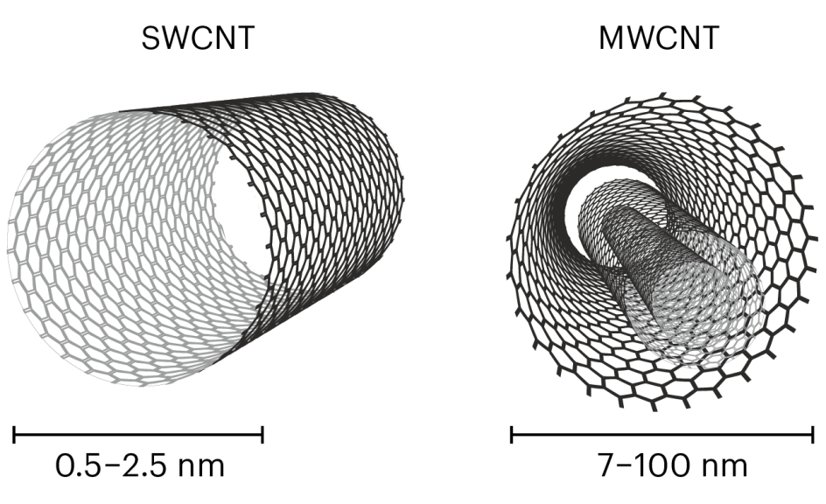

With several graphitic layers encircling a central tubule of nanometric diameter and spaced apart by roughly 3.4–3.6A, CNTs can have multiple walls. Multiwalled carbon nanotubes (MWCNTs), which were historically the first to be discovered[18][38], have a more complex structure than SWCNTs, and as a result, they are typically used as a bulk material in applications where the ordered structuring of the systems is less important. Because of their exceptional structural fluidity and flexibility, CNTs can be bent, collapsed, or deformed into a variety of shapes, including buckles, rings, or fullerene onions. This allows the nanostructures to have a wide range of shape-controlled physical properties. In addition to them, the small size of nanotubes results in numerous unique advantages.

**Functionalization of CNTs**

On the surfaces of CNTs, functional groups are created through functionalization. These functional groups (Fig.2) contribute to a reduction in the long-range van der Waals forces of attraction, increase the interaction between the CNTs and the matrix or solvent, and produce a homogeneous dispersion or cause the solubilization of the CNTs[39][40].

As a result, functionalization increases the reactivity and solubility of CNTs and opens up possibilities for additional chemical modifications like ion adsorption, metal deposition, grafting reactions, etc. The functional groups can also be used as anchor groups to bind two moieties together and to derivatives compounds further through chemical interactions with other functional groups. Numerous modeling studies have been conducted to predict the characteristics of functionalized CNTs and their effects on other biomolecules, taking into account the benefits that functionalization of CNTs offers[41][42].Functionalized CNTs has immense application medical science, drug delivery, electrochemistry, water treatment  *etc.*[43][44][45][46][47]*.*

**Fig.2 Functionalization of Carbon Nanotubes (CNTs)**

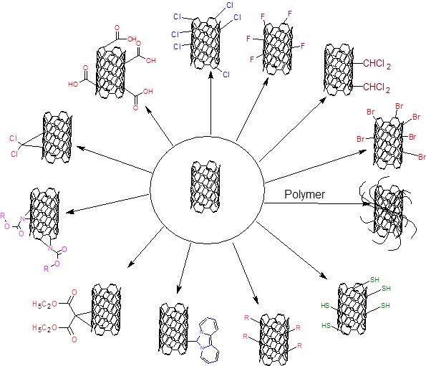

**Applications of CNT Bio conjugate:**

Functionalization make CNTs water soluble as a result Biomolecule like protein, enzyme, DNA, peptides etc. can be conjugated to the carbon nanotubes. Herein we are going to see the different application of CNT bio conjugate.

**Vaccine Delivery**

Covalently linked Peptide-carbon nanotubes (NTs) have been synthesized using two alternative approaches, based on fragment condensation and selective chemical ligation. Single-walled nanotubes (SWNTs) were covalently attached to a model pentapeptide and an antigenic epitope from the foot-and-mouth disease virus (FMDV) (Fig. 3). With the aid of 2D NMR spectroscopy and transmission electron microscopy, a thorough structural characterization has been completed. The FMDV peptide Carbon NT conjugate's antigenicity was then demonstrated via an ELISA test and a surface plasmon resonance study. Both studies results indicated that the peptide linked to the NT support adopted the proper secondary conformation required for antibody recognition. Moreover, an in vivo investigation has demonstrated that the FMDV peptide-NT is similarly immunogenic.

**Fig.3 Synthesis of Peptide carbon nanotube by a) Peptide fragment condensation b) Chemo selective ligation**

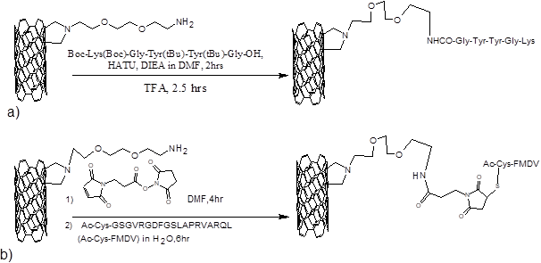

This research highlights the potential diagnostic use of peptide-carbon NT conjugates and opens the door to their use in vaccine administration. It can be said that functionalized carbon NTs make excellent scaffolds for the multivalent presentation of compounds that are used to control ligand-receptor interactions[48].

**Genomic Research/DNA Analysis**

Using azide units as photoactive components, the sidewalls of vertically oriented MWCNTs have been functionalized with nucleic acids (Fig.4). The photo adduct was created when the azidothymidine photochemically (UV irradiation) interacted with MWCNTs arranged in a straight line on a solid substrate. Following the conventional DNA synthesis of the oligonucleotides on the MWCNT sidewalls, the nucleic acid was deprotected to produce the DNA-modified MWCNTs. In principle, this technique allows for the photolithographic patterning of various DNA sequences on the CNTs as well as the creation of novel DNA chips for genomic study or DNA analysis[49].

**Fig.4 In situ DNA synthesis on sidewalls of carbon nanotubes photoetched with azidothymidine**

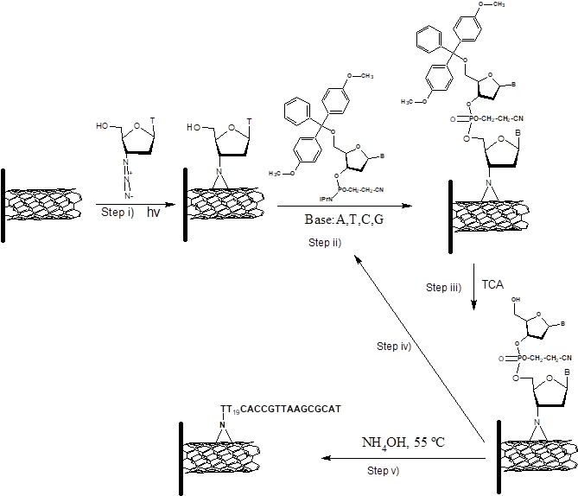

**Biosensors**

**1] Glucose Sensor**

GOx was cross-linked with a CNT/Pt.-nanoparticle hybrid layer or covalently connected to carboxylic groups at the ends of short CNTs using carbodiimide coupling to produce amperometric glucose sensors based on H2O2 sensing [50][51] Coaxial nanowires with an ultrathin layer of polypyrrole coated on aligned carbon nanotubes in a concentric layer have served as a template for the construction of glucose sensors that contain a significant amount of GOx that has been electrochemically trapped[52]. The covalent attachment of the SWCNTs to the electrode surfaces has enabled the oriented assembly of short SWCNTs normal to the electrode surfaces[53][54][55].The association of redox-active components to the carbon nanotubes and the examination of charge transport through the SWCNT are made possible by the structural alignment of the SWCNTs. Recent advances in the structural alignment of enzymes on the ends of SWCNTs organized as an array on a conductive surface have made it possible to directly electrically connect redox enzymes, such as glucose oxidase and electrodes[56]. Covalently joining SWCNTs with carboxylic acid functionalization to a gold electrode with cystamine monolayer functionalization allowed researchers to create an array of perpendicularly oriented SWCNTs on a gold electrode. The carboxylic groups at the free ends of the standing SWCNTs were covalently coupled to the amino-derivative of the FAD cofactor (flavin adenine dinucleotide; 10). Experiments using cyclic voltammetry showed that the FAD units were electrically connected to the electrode surface. A quasireversible cyclic voltammogram with E0 = -0.45 V versus saturated calomel electrode (SCE) at pH 7.4 is shown by the FAD units connected to the SWCNTs. The FAD redox-wave and quartz crystal microbalance (QCM) experiments' coulometric assays revealed that the average FAD surface coverage was approximately 1.5 x 10-10 mol cm-2. Then, the FAD units connected to the ends of the standing SWCNTs were reconstituted with apo-glucose oxidase (apo-GOx) (Fig.5). AFM measurements confirmed the apo-GOx's reconstitution on the functionalized electrode surface.

**Fig.5 Assembly of SWCNT electrically connected Glucose Oxidase electrode**

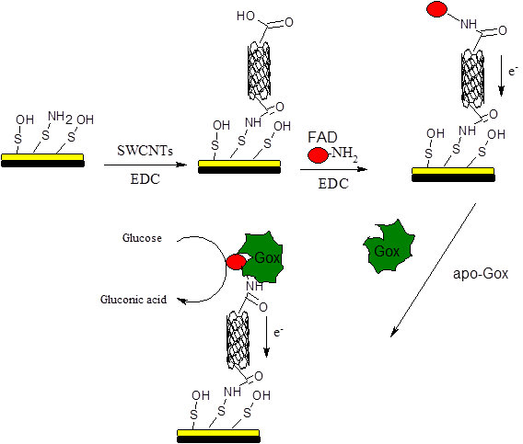

For systems that use shorter SWCNTs as connectors, the electron transfer barrier between the FAD-center and the electrode is lower. The results unmistakably show that electrons are transported through the SWCNT along a distance of 220 nm from the active center to the electrode, despite the fact that the mechanism of SWCNT-length controlled electrical contacting of the enzyme redox center and the electrode is currently not fully understood.

**2]Oganophosphrous Sensor**

Amperometric detection of organophosphorus pesticides and neurotoxins was performed using screen-printed biosensors based on co-immobilized acetylcholinesterase (AChE), choline oxidase(CHO), and CNTs[57] (Fig.6).

**Fig. 6 Immobilization of Enzyme (CHO/AChE) on Carbon Nanotube Electrode**

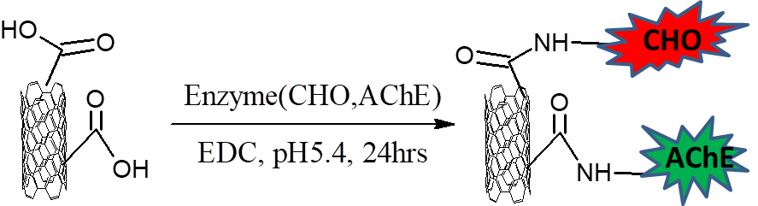

The primary reaction involves the biocatalytic acetylcholinesterase hydrolysis of acetylcholine and the formation of choline. The secondary reaction involves the oxidation of in situ generated choline with oxygen by biocatalytic choline oxidase and the concomitant formation of H2O2. The latter product was electro catalytically analyzed using a CNT-modified electrode. The first-order reaction was inhibited in the presence of organophosphorus pesticides or nerve agents, leading to attenuation of the electrochemical signal and allowing quantitative analysis.

**3]Anticancer drug Biosensor**

The ability to identify various anti-cancer drugs(Cyclophosphamide) using a biosensor based on cytochrome P450 (CYP1A2, CYP2B6, and CYP3A4) and carbon nanotubes has been demonstrated by C. B Rossi etal [58] (Fig.7), offering a creative solution for point-of-care drug monitoring.

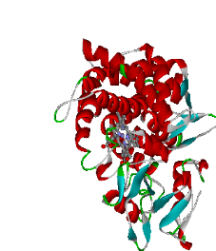

2e-

**Fig. 7 Drug detection mechanism promoted by Carbon Nano Tubes**

The findings indicate sensitivities between 8 and 925 nA/M. They could carry out a selective electrochemical detection of drugs in their therapeutic window thanks to these high sensitivities. They demonstrated how proteins organize themselves into a monolayer on the surface of carbon nanotubes, and they used Monte Carlo simulations and SEM analysis to confirm this behavior. The lack of specificity for a single substrate typical of cytochrome P450 can be overcome by the use of three different CYP isoforms to provide specific drug detection. They conduct a preliminary investigation in this work in preparation for the implementation of an array-sensor based on cytochrome P450. The main objective was to show that the sensor was suitable for detecting anti-cancer medications in human serum within the pharmacological range. Additionally, they show that simultaneous detection of two drugs is possible when the correct enzyme probe is chosen based on the drugs to be detected.

**DNA sensing**

CNTs are incredibly desirable for electrochemical sensors due to their distinctive electrical, chemical, and mechanical capabilities. The majority of the research on CNT sensing has been on how surface-confined CNTs might encourage the electron-transfer processes needed for bio catalytic devices. In present new bio affinity tests, CNTs play a dual amplification function in both the recognition and transduction activities, serving as carriers for various enzyme tags and for collecting the reaction product (Fig.8).

**Fig. 8 A) Electrochemical DNA sensing and B) Immunosensing using the alkaline phosphatase-functionalized CNTs as the bio catalytic amplifying tags.**

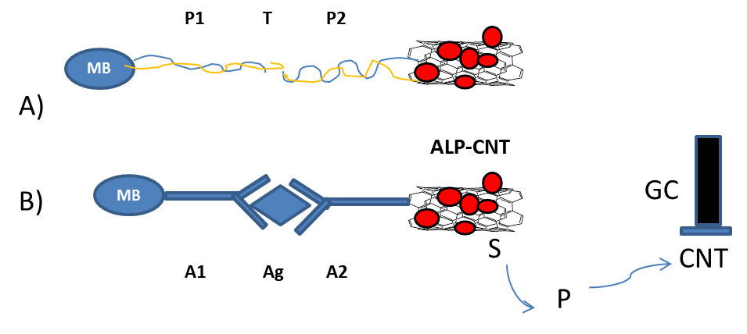

Using the enzyme tracer alkaline phosphatase (ALP), these novel support and pre-concentration activities of CNTs are demonstrated. These functions are a reflection of their enormous specific surface area (15). This combining of various CNT-derived amplification methods yields the lowest detection limit for electrical DNA detection that has been recorded to date[59].

As carriers for numerous enzyme tags and for accumulating the α-naphthol product of the enzymatic reaction, CNT played a dual amplification role in both the recognition and transduction events in these procedures. The estimated coverage for each CNT (i.e., binding event) was 9600 enzyme molecules. With the ability to detect DNA and proteins down to 1.3 and 160 zmol, respectively, in 25- to 50μL samples, this CNT-derived double-step amplification pathway (of both the recognition and transduction events) shows great promise for PCR-free DNA analysis**.**

**Immunosensors**

J.F Russling etal. recently fabricated multi-label CNT bioconjugates for electrochemical immunosensors. CNTs were covalently conjugated to secondary antibodies (Ab2) for prostate specific antigen (PSA) along with multiple horseradish peroxidase (HRP) labels.[60].

**Fig. 9 Schematic of Immunosensor after treating with HRP-CNT-Ab2 to obtain amplification.**

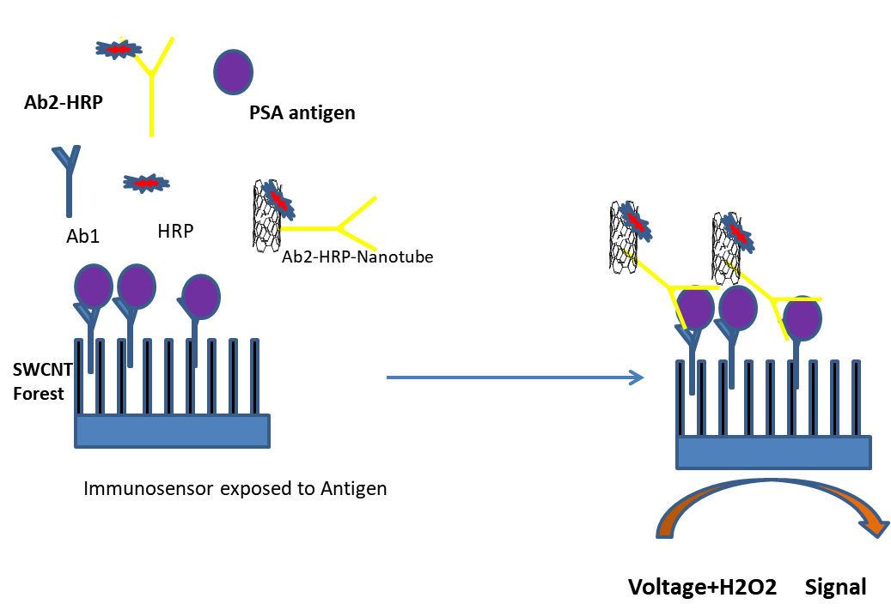

These Ab2-CNT-HRP nanoparticles were used with single-wall carbon nanotube (SWNT) forest platforms [55]in sandwich immunoassays for prostate cancer biomarker PSA in human serum and tissue lysates (Fig 9). Capture antibodies (Ab1) were attached to the SWNT forests to bind PSA in the sample. The Ab2-CNT-HRP bio conjugates were then added to bind to the antigen on the sensor surface, and PSA was detected by the amperometric signal generated from enzyme-catalyzed electrochemical reduction of hydrogen peroxide by the HRP. This amplification procedure provided detection of PSA in undiluted calf serum at a detection limit of ~4 pg mL−1 (100 aM) PSA. Quantitative detection of PSA in lysates of approximately 1000 prostate cancer cells was also demonstrated.

**Therapy**

Utilizing oxidized SWCNT functionalized with epidermal growth factor (EGF) and the anticancer medication cisplatin, targeted drug delivery was also demonstrated in vivo[62].

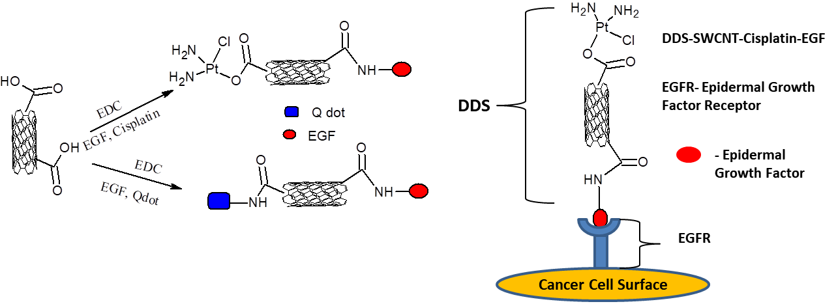

**Fig.10 (A) Schematic of chemical reactions used to attach EGF, cisplatin, and Qdots onto carboxylated SWNTs using EDC as the coupling agent. (B) Schematic showing SWNT bundles bioconjugated with EGF and cisplatin targeting the cell surface receptor EGFR on a single HNSCC cell.**

**A**

**B**

The EGF-SWCNT conjugated nanoparticles targeted the overexpressed EGF receptors on the tumor cells after being injected into mice with head and neck squamous carcinoma tumors, resulting in slowed tumor growth (Fig.10).

**References:**

[1] A.N. Shipway, E. Katz, I. Willner, Nanoparticle arrays on surfaces for electronic, optical, and sensor applications., Chemphyschem. 1 (2000) 18–52. https://doi.org/10.1002/1439-7641(20000804)1:1<18::AID-CPHC18>3.0.CO;2-L.

[2] M.-C. Daniel, D. Astruc, Gold Nanoparticles:  Assembly, Supramolecular Chemistry, Quantum-Size-Related Properties, and Applications toward Biology, Catalysis, and Nanotechnology, Chem. Rev. 104 (2004) 293–346. https://doi.org/10.1021/cr030698+.

[3] P. Mulvaney, Surface Plasmon Spectroscopy of Nanosized Metal Particles, Langmuir. 12 (1996) 788–800. https://doi.org/10.1021/la9502711.

[4] H. Grabert, M.H. Devoret, M. Kastner, Single Charge Tunneling: Coulomb Blockade Phenomena in Nanostructures, Phys. Today. 46 (1993) 62–63. https://doi.org/10.1063/1.2808874.

[5] L.N. Lewis, Chemical catalysis by colloids and clusters, Chem. Rev. 93 (1993) 2693–2730. https://doi.org/10.1021/cr00024a006.

[6] R. Schlögl, S.B. Abd Hamid, Nanocatalysis: mature science revisited or something really new?, Angew. Chemie Int. Ed. 43 (2004) 1628–1637.

[7] D.L. Feldheim, C.D. Keating, Self-assembly of single electron transistors and related devices, Chem. Soc. Rev. 27 (1998) 1–12.

[8] T.W. Kim, D.C. Choo, J.H. Shim, S.O. Kang, Single-electron transistors operating at room temperature, fabricated utilizing nanocrystals created by focused-ion beam, Appl. Phys. Lett. 80 (2002) 2168–2170. https://doi.org/10.1063/1.1458685.

[9] W. Chen, D. Grouquist, J. Roark, Voltage tunable electroluminescence of CdTe nanoparticle light-emitting diodes, J. Nanosci. Nanotechnol. 2 (2002) 47–53.

[10] M. Lahav, A. N. Shipway, I. Willner, Au-nanoparticle–bis-bipyridinium cyclophane superstructures: assembly, characterization and sensoric applications, J. Chem. Soc. Perkin Trans. 2. (1999) 1925–1931. https://doi.org/10.1039/A902763G.

[11] E. Katz, I. Willner, Integrated nanoparticle-biomolecule hybrid systems: synthesis, properties, and applications., Angew. Chem. Int. Ed. Engl. 43 (2004) 6042–6108. https://doi.org/10.1002/anie.200400651.

[12] Y. Xiao, F. Patolsky, E. Katz, J.F. Hainfeld, I. Willner, “Plugging into Enzymes”: nanowiring of redox enzymes by a gold nanoparticle., Science. 299 (2003) 1877–1881. https://doi.org/10.1126/science.1080664.

[13] R. Elghanian, J.J. Storhoff, R.C. Mucic, R.L. Letsinger, C.A. Mirkin, Selective colorimetric detection of polynucleotides based on the distance-dependent optical properties of gold nanoparticles., Science. 277 (1997) 1078–1081. https://doi.org/10.1126/science.277.5329.1078.

[14] J. Wang, D. Xu, A.-N. Kawde, R. Polsky, Metal Nanoparticle-Based Electrochemical Stripping Potentiometric Detection of DNA Hybridization, Anal. Chem. 73 (2001) 5576–5581. https://doi.org/10.1021/ac0107148.

[15] O.D. Velev, E.W. Kaler, In Situ Assembly of Colloidal Particles into Miniaturized Biosensors, Langmuir. 15 (1999) 3693–3698. https://doi.org/10.1021/la981729c.

[16] S. Schultz, D.R. Smith, J.J. Mock, D.A. Schultz, Single-target molecule detection with nonbleaching multicolor optical immunolabels., Proc. Natl. Acad. Sci. U. S. A. 97 (2000) 996–1001. https://doi.org/10.1073/pnas.97.3.996.

[17] N.I. Kovtyukhova, T.E. Mallouk, Nanowires as building blocks for self‐assembling logic and memory circuits, Chem. Eur. J. 8 (2002) 4354–4363.

[18] S. Iijima, Helical microtubules of graphitic carbon, Nature. 354 (1991) 56–58. https://doi.org/10.1038/354056a0.

[19] W. Krätschmer, L.D. Lamb, K. Fostiropoulos, D.R. Huffman, Solid C60: a new form of carbon, Nature. 347 (1990) 354–358. https://doi.org/10.1038/347354a0.

[20] Liming Dai, Pingang He, Sinan Li, Functionalized surfaces based on polymers and carbon nanotubes for some biomedical and optoelectronic applications, Nanotechnology. 14 (2003) 1081. https://doi.org/10.1088/0957-4484/14/10/305.

[21] K. Tsukagoshi, N. Yoneya, S. Uryu, Y. Aoyagi, A. Kanda, Y. Ootuka, B.W. Alphenaar, Carbon nanotube devices for nanoelectronics, Phys. B Condens. Matter. 323 (2002) 107–114.

[22] H. Dai, J. Kong, C. Zhou, N. Franklin, T. Tombler, A. Cassell, S. Fan, M. Chapline, Controlled chemical routes to nanotube architectures, physics, and devices, J. Phys. Chem. B. 103 (1999) 11246–11255.

[23] W. Hoenlein, F. Kreupl, G.S. Duesberg, A.P. Graham, M. Liebau, R. Seidel, E. Unger, Carbon nanotubes for microelectronics: status and future prospects, Mater. Sci. Eng. C. 23 (2003) 663–669. https://doi.org/https://doi.org/10.1016/j.msec.2003.09.153.

[24] P. Petit, A. Loiseau, Carbon nanotubes: from science to applications, Comptes Rendus Phys. 4 (2003) 967–974. https://doi.org/https://doi.org/10.1016/j.crhy.2003.10.021.

[25] K.K. Singh, S.K. Chaudhary, R. Venugopal, A. Gaurav, Bulk synthesis of multi-walled carbon nanotubes by AC arc discharge method, Proc. Inst. Mech. Eng. Part N J. Nanomater. Nanoeng. Nanosyst. 231 (2017) 141–151. https://doi.org/10.1177/2397791417712836.

[26] K.L. Strong, D.P. Anderson, K. Lafdi, J.N. Kuhn, Purification process for single-wall carbon nanotubes, Carbon N. Y. 41 (2003) 1477–1488. https://doi.org/https://doi.org/10.1016/S0008-6223(03)00014-9.

[27] K. Anazawa, K. Shimotani, C. Manabe, H. Watanabe, M. Shimizu, High-purity carbon nanotubes synthesis method by an arc discharging in magnetic field, Appl. Phys. Lett. 81 (2002) 739–741. https://doi.org/10.1063/1.1491302.

[28] Z. Shi, Y. Lian, F.H. Liao, X. Zhou, Z. Gu, Y. Zhang, S. Iijima, H. Li, K.T. Yue, S.-L. Zhang, Large scale synthesis of single-wall carbon nanotubes by arc-discharge method, J. Phys. Chem. Solids. 61 (2000) 1031–1036. https://doi.org/https://doi.org/10.1016/S0022-3697(99)00358-3.

[29] J.L. Bahr, J.M. Tour, Covalent chemistry of single-wall carbon nanotubes, J. Mater. Chem. 12 (2002) 1952–1958. https://doi.org/10.1039/B201013P.

[30] D. Pantarotto, J.-P. Briand, M. Prato, A. Bianco, Translocation of bioactive peptides across cell membranes by carbon nanotubes, Chem. Commun. (2004) 16–17. https://doi.org/10.1039/B311254C.

[31] W. Wu, S. Wieckowski, G. Pastorin, M. Benincasa, C. Klumpp, J.-P. Briand, R. Gennaro, M. Prato, A. Bianco, Targeted Delivery of Amphotericin B to Cells by Using Functionalized Carbon Nanotubes, Angew. Chemie Int. Ed. 44 (2005) 6358–6362. https://doi.org/https://doi.org/10.1002/anie.200501613.

[32] S.S. Wong, E. Joselevich, A.T. Woolley, C.L. Cheung, C.M. Lieber, Covalently functionalized nanotubes as nanometre-sized probes in chemistry and biology., Nature. 394 (1998) 52–55. https://doi.org/10.1038/27873.

[33] M.F. Yu, B.S. Files, S. Arepalli, R.S. Ruoff, Tensile loading of ropes of single wall carbon nanotubes and their mechanical properties., Phys. Rev. Lett. 84 (2000) 5552–5555. https://doi.org/10.1103/PhysRevLett.84.5552.

[34] B.I. Yakobson, C.J. Brabec, J. Berhnolc, Nanomechanics of carbon tubes: Instabilities beyond linear response., Phys. Rev. Lett. 76 (1996) 2511–2514. https://doi.org/10.1103/PhysRevLett.76.2511.

[35] S.J. Tans, A.R.M. Verschueren, C. Dekker, Room-temperature transistor based on a single carbon nanotube, Nature. 393 (1998) 49–52. https://doi.org/10.1038/29954.

[36] J. Hone, M.C. Llaguno, M.J. Biercuk, A.T. Johnson, B. Batlogg, Z. Benes, J.E. Fischer, Thermal properties of carbon nanotubes and nanotube-based materials, Appl. Phys. A. 74 (2002) 339–343. https://doi.org/10.1007/s003390201277.

[37] J. Chen, S. Chen, X. Zhao, L. V Kuznetsova, S.S. Wong, I. Ojima, Functionalized single-walled carbon nanotubes as rationally designed vehicles for tumor-targeted drug delivery., J. Am. Chem. Soc. 130 (2008) 16778–16785. https://doi.org/10.1021/ja805570f.

[38] S. Iijima, Carbon nanotubes: past, present, and future, Phys. B Condens. Matter. 323 (2002) 1–5. https://doi.org/https://doi.org/10.1016/S0921-4526(02)00869-4.

[39] C.A. Dyke, J.M. Tour, Overcoming the Insolubility of Carbon Nanotubes Through High Degrees of Sidewall Functionalization, Chem. – A Eur. J. 10 (2004) 812–817. https://doi.org/https://doi.org/10.1002/chem.200305534.

[40] J. Zhu, J. Kim, H. Peng, J.L. Margrave, V.N. Khabashesku, E. V Barrera, Improving the Dispersion and Integration of Single-Walled Carbon Nanotubes in Epoxy Composites through Functionalization, Nano Lett. 3 (2003) 1107–1113. https://doi.org/10.1021/nl0342489.

[41] M. Noordadi, F. Mehrnejad, R.H. Sajedi, M. Jafari, B. Ranjbar, The potential impact of carboxylic-functionalized multi-walled carbon nanotubes on trypsin: A Comprehensive spectroscopic and molecular dynamics simulation study., PLoS One. 13 (2018) e0198519. https://doi.org/10.1371/journal.pone.0198519.

[42] P. Wolski, K. Nieszporek, T. Panczyk, Pegylated and folic acid functionalized carbon nanotubes as pH controlled carriers of doxorubicin. Molecular dynamics analysis of the stability and drug release mechanism, Phys. Chem. Chem. Phys. 19 (2017) 9300–9312. https://doi.org/10.1039/C7CP00702G.

[43] S. Merum, J.B. Veluru, R. Seeram, Functionalized carbon nanotubes in bio-world: Applications, limitations and future directions, Mater. Sci. Eng. B. 223 (2017) 43–63. https://doi.org/https://doi.org/10.1016/j.mseb.2017.06.002.

[44] B. V Basheer, J.J. George, S. Siengchin, J. Parameswaranpillai, Polymer grafted carbon nanotubes—Synthesis, properties, and applications: A review, Nano-Structures & Nano-Objects. 22 (2020) 100429. https://doi.org/https://doi.org/10.1016/j.nanoso.2020.100429.

[45] R. Alshehri, A.M. Ilyas, A. Hasan, A. Arnaout, F. Ahmed, A. Memic, Carbon Nanotubes in Biomedical Applications: Factors, Mechanisms, and Remedies of Toxicity., J. Med. Chem. 59 (2016) 8149–8167. https://doi.org/10.1021/acs.jmedchem.5b01770.

[46] C. Pennetta, G. Floresta, A.C.E. Graziano, V. Cardile, L. Rubino, M. Galimberti, A. Rescifina, V. Barbera, Functionalization of Single and Multi-Walled Carbon Nanotubes with Polypropylene Glycol Decorated Pyrrole for the Development of Doxorubicin Nano-Conveyors for Cancer Drug Delivery., Nanomater. (Basel, Switzerland). 10 (2020). https://doi.org/10.3390/nano10061073.

[47] A.A. Farghali, H.A. Abdel Tawab, S.A. Abdel Moaty, R. Khaled, Functionalization of acidified multi-walled carbon nanotubes for removal of heavy metals in aqueous solutions, J. Nanostructure Chem. 7 (2017) 101–111. https://doi.org/10.1007/s40097-017-0227-4.

[48] D. Pantarotto, C.D. Partidos, R. Graff, J. Hoebeke, J.-P. Briand, M. Prato, A. Bianco, Synthesis, Structural Characterization, and Immunological Properties of Carbon Nanotubes Functionalized with Peptides, J. Am. Chem. Soc. 125 (2003) 6160–6164. https://doi.org/10.1021/ja034342r.

[49] M.J. Moghaddam, S. Taylor, M. Gao, S. Huang, L. Dai, M.J. McCall, Highly Efficient Binding of DNA on the Sidewalls and Tips of Carbon Nanotubes Using Photochemistry, Nano Lett. 4 (2004) 89–93. https://doi.org/10.1021/nl034915y.

[50] H. Xue, Single-wall carbon nanotubes as immobilization material for glucose biosensor, Synth Met. 135 (2003) 831–832.

[51] Y. Lin, F. Lu, Y. Tu, Z. Ren, Glucose Biosensors Based on Carbon Nanotube Nanoelectrode Ensembles, Nano Lett. 4 (2004) 191–195. https://doi.org/10.1021/nl0347233.

[52] M. Gao, L.M. Dai, G.G. Wallace, Glucose sensors based on glucose-oxidase-containing polypyrrole/aligned carbon nanotube coaxial nanowire electrodes, (2003).

[53] B. Wu, J. Zhang, Z. Wei, S. Cai, Z. Liu, Chemical Alignment of Oxidatively Shortened Single-Walled Carbon Nanotubes on Silver Surface, J. Phys. Chem. B. 105 (2001) 5075–5078. https://doi.org/10.1021/jp0101256.

[54] Z. Liu, Z. Shen, T. Zhu, S. Hou, L. Ying, Z. Shi, Z. Gu, Organizing single-walled carbon nanotubes on gold using a wet chemical self-assembling technique, Langmuir. 16 (2000) 3569–3573.

[55] D. Chattopadhyay, I. Galeska, F. Papadimitrakopoulos, Metal-Assisted Organization of Shortened Carbon Nanotubes in Monolayer and Multilayer Forest Assemblies, J. Am. Chem. Soc. 123 (2001) 9451–9452. https://doi.org/10.1021/ja0160243.

[56] F. Patolsky, Y. Weizmann, I. Willner, Long-Range Electrical Contacting of Redox Enzymes by SWCNT Connectors, Angew. Chemie Int. Ed. 43 (2004) 2113–2117. https://doi.org/https://doi.org/10.1002/anie.200353275.

[57] Y. Lin, F. Lu, J. Wang, Disposable Carbon Nanotube Modified Screen-Printed Biosensor for Amperometric Detection of Organophosphorus Pesticides and Nerve Agents, Electroanalysis. 16 (2004) 145–149. https://doi.org/https://doi.org/10.1002/elan.200302933.

[58] C. Baj-Rossi, G. De Micheli, S. Carrara, Electrochemical Detection of Anti-Breast-Cancer Agents in Human Serum by Cytochrome P450-Coated Carbon Nanotubes, Sensors. 12 (2012) 6520–6537. https://doi.org/10.3390/s120506520.

[59] J. Wang, G. Liu, M.R. Jan, Ultrasensitive Electrical Biosensing of Proteins and DNA:  Carbon-Nanotube Derived Amplification of the Recognition and Transduction Events, J. Am. Chem. Soc. 126 (2004) 3010–3011. https://doi.org/10.1021/ja031723w.

[60] X. Yu, B. Munge, V. Patel, G. Jensen, A. Bhirde, J.D. Gong, S.N. Kim, J. Gillespie, J.S. Gutkind, F. Papadimitrakopoulos, Carbon nanotube amplification strategies for highly sensitive immunodetection of cancer biomarkers, J. Am. Chem. Soc. 128 (2006) 11199–11205.

[61] N. Fakhri, A.D. Wessel, C. Willms, M. Pasquali, D.R. Klopfenstein, F.C. MacKintosh, C.F. Schmidt, High-resolution mapping of intracellular fluctuations using carbon nanotubes, Science (80-. ). 344 (2014) 1031–1035. https://doi.org/10.1126/science.1250170.

[62] A.A. Bhirde, V. Patel, J. Gavard, G. Zhang, A.A. Sousa, A. Masedunskas, R.D. Leapman, R. Weigert, J.S. Gutkind, J.F. Rusling, Targeted Killing of Cancer Cells in Vivo and in Vitro with EGF-Directed Carbon Nanotube-Based Drug Delivery, ACS Nano. 3 (2009) 307–316. https://doi.org/10.1021/nn800551s.