Emerging Trends in Targeted Drug Delivery System for Neurological Disorders: A Review

Priyanka A. Bobade¹ & Bushra S. Sayyed²

- Research Scholar, Department of Pharmaceutics, PRES’s, College of Pharmacy (For Women), Chincholi, Nashik, MH, India-422102
E-mail: priyankabobade82@gmail.com
- Assistant Professor, Department of Pharmaceutics, PRES’s, College of Pharmacy (For Women), Chincholi, Nashik, MH, India-422102
E-mail: bushrasayyed97@gmail.com

Abstract
CNS diseases and neurological conditions often coexist. Targeted drug delivery to the brain using nanoparticles has been chosen to reduce drug toxicity and boost treatment effectiveness. Delivery of drug to CNS remain significant challenge in treating neurological disorders, mostly as a result of the blood-brain barrier (BBB), which limits drug delivery to the brain. This study aids researchers in the field of neurological disorders by selecting most suitable and effective methods for targeted delivery. Nanotechnology has an immense amount of potential to improve the treatment of neurological ailments including stroke, tumors in the brain, dementia, and Alzheimer’s illness. And Parkinson’s disease. The significance of this research lies in exploring emerging trends for investigating targeted drug delivery in neurological disorders through diverse approaches, including nanotechnology, gene therapy, non-invasive techniques and biomaterial-based approaches.

Keywords: Neurological disorder, BBB, CNS, targeted drug delivery, nanotechnology.

I. INTRODUCTION

In the field of research and advancements, targeting the brain is recognized as a challenging endeavour. Brain tumor, dementia, Alzheimer’s illness, autoimmune diseases, ischemic attacks, seizure or epilepsy, psychosis, migrane, injuries to the brain, CNS an infection, and Parkinson’s disease are some of those that is well-known central nervous system (CNS) maladies, as well as various psychological disorders such as depression, anxiety and many others[1]. Especially in biomedical research and the pharmaceutical industry, it is crucial to focus on developing delivery systems capable of modifying the distribution, uptake in tissues, pharmacokinetics and pharmacodynamics of therapeutic agents [2]. The primary catalyst behind the rapid advancements in research and technology in this domain is recognition that signifies enhancing current therapies required utilization of therapeutic approaches that facilitate efficient and targeted delivery of medications to diseased or damaged tissues [3]. The BBB presents a limitation where only tiny molecules with a molecular weight of less than 400 Da and lipid solubility can pass through. The brain endothelium is impermeable to the majority of macromolecules, making the BBB an obstruction, about 95% of compounds are disqualified from consideration for medication development as a result. According to recent research, the blood-brain barrier (BBB) controls how chemicals from the blood enter the brain [4].
At primary stage in treating neural diseases is the diffusion of medications through the BBB is the first step in treating neurological disorders. To assure the safe, appropriate, and targeted distribution of medicinal molecule to the central nervous system, as it holds the potential to yield optimal therapeutic results in the fight against neurological diseases [4]. Nanotechnology has arisen the purpose of overcoming challenges in drug delivery and accomplishing precise, site-targeted drug administration. In past few decades, it has played a significant role in the advancement of nanocarriers used for treating several different diseases [5, 6].
Presented here discusses various strategies and advancements in drug targeting for neurological disorders specifically in brain. The most recent advancements in drug delivery methods are based on nanocarriers, such as liposomal systems, dendrimers, polymers micelles, polymerized nanocarriers, quantum dots and gold nanoparticles (AU-NPs). Furthermore, the review explores different approaches and therapeutic implications of using targeted drug delivery systems for neurological disorders.
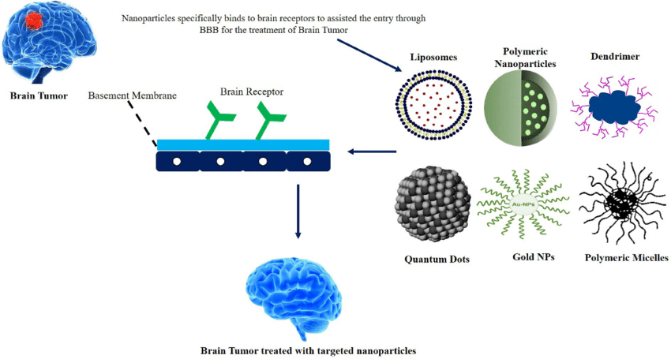
Figure No. 1:” Novel nanocarriers and their penetration through BBB for brain targeting” [7]

II. NANOTECHNOLOGY–BASED APPROACHES

Liposomes
Liposomes are spherical vesicles having aqueous compartments made of phospholipid bilayers in either natural or synthesized form. They can be classified as either multilamellar or unilamellar vesicles. Both passive and active methods are capable of targeting liposomes. Additionally uses different macromolecules, which include antibiotics, peptides, aptamers, polymers, or polysaccharides, to enable medication delivery to the brain. The talk highlights the main liposomal drugs and brain-targeting compounds to improve liposomal affinity [8].

Polymeric particles
Polymer nanoparticles (NPs) consist of a polymer core that typically contains dispersed medication. Many of these products are broken down within the body. Polylactides (PLA), polyglycolide (PGA), polylactic-co-glycolic acid (PLGA) and polycarprolactone are a few of the often utilized ones. Studies have shown that polymer nanoparticles exhibit enhanced efficacy in crossing the blood-brain barrier, lowering inflammation, oxidative stress, and the formation of plaque.
They have proven effective in delivering curcumin for treatment for Alzheimer’s disease and promoting doxorubicin absorption in human glioma cells, resulting in cytotoxic effects on cancer cells [9].

Polymeric micelles
Polymeric micelles have a particle size ranging from 10 to 100nm. These micelles are formed spontaneously in solution containing amphiphilic copolymers and they exhibit a shell-core structure. L, D-lactine polycaprolactone and other hydrophobic block polymers make up the core, while the shell consists of hydrophilic block polymers, typically PEGs. The loaded medicine is released from the micelle once it contacts its target cell by a diffusion mechanism [10] [11].

Gold nanoparticles
A variety of biological and theranostic applications use gold nanoparticles. These nanocarriers are widely used in imaging, therapeutics, and drug delivery systems due to their malfunctional nature.
AuNps are remarkable in that they can have tunable nanomaterial features, such as porosity or optical responsiveness. The attachment of various targeted ligands is made possible by the relatively wide surface area, increasing their specificity for various purposes. AuNps exhibit low toxicity and are biocompatible, making safe use in biological systems. They are ideal for medical imaging because of their high atomic number and high X-ray absorption coefficient. Advantage is the ease of synthesis and they are cost effective compared to other nanomaterial’s [12] [13].

Quantum dots
GQDs (grapheme quantum dots) are type of carbon-based nanoparticles that hold promise for delivering medicinal products across the BBB, making then valuable in tumor-specific treatments. To address these challenges, Gao and his team created a brain imaging device using poly (ethylene glycol) and poly (lactic acid) nanoparticles covered with quantum dots (QDs) to overcome these difficulties. These nanoparticles administered through nasal route, resulting in water-soluble, stable particle with brain targeting and imaging capabilities. These nanoparticles surfaces, which have PEG functional terminal groups, enable the conjugation of different biological ligands and the creation of customized imaging agents for various CNS applications [14].

Dendrimers
The three-dimensional structures of dendrimers are clearly defined, monodisperse, and highly branching. Their surface may be easily functionalized in a regulated manner, and they have a spherical form. Dendrimers are a great choice for use as drug delivery systems due to these characteristics. There are two ways to synthesis dendrimers: the initial method involves starting the formation of the dendrimer from its core and then extending it outward. The second approach, called the convergent method, begins the synthesis from the outside of the dendrimer and works towards the core [15].
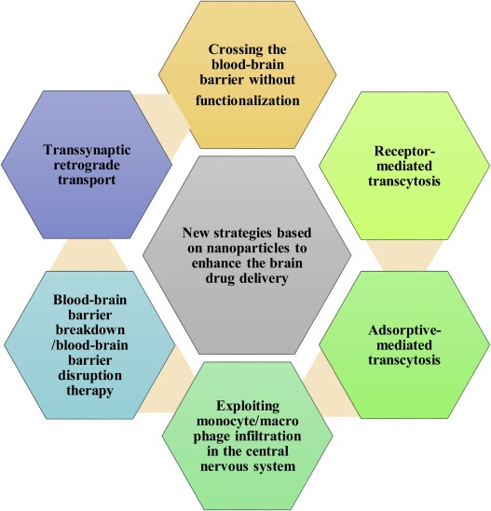
Figure 2:” Development of new strategies based on NPs technology for drug delivery to brain” [16]

III. GENE THERAPY FOR NEUROLOGICAL DISORDER

Delivery of Genes using Viral Vectors:
Nanoparticles with a diameter of less than or equal to 100nm are called viral vectors. They are capable of delivering their genetic material into nucleus, where the desired gene can be transcribed. Treatment of cancer and neurological disorders with retrovirus, lentivirus, adenovirus, and adeno-associated virus gene transfer [17]. Adenoviruses are among these vectors that are frequently utilized in human gene therapy. Both animal models and human clinical studies have been used to evaluate the efficacy and possible risks of these viral nanoparticles. For instance, a genetically modified viral named ONYX-015 was examined in a phase 2 clinical trial. In 58% of patients with advanced head and neck cancers having the p53 mutations, this virus may replicate in and kill p53-deficient cancer cells, leading to highly selective destruction of tumor tissue and considerable tumor regression [18].
Therapeutics based on viral vectors are still not approved by the Food and Drug Administration (FDA). This is because, although having a high transfection yield, viral gene delivery techniques have a number of disadvantages intrinsic to them, such as immunogenicity, oncogenicity, and probable virus recombination problems. There have been recent cases of people with severe immunodeficiency leukemia dying after receiving retroviral vector therapy. Concerns about gene transfer mediated by viral vectors were also raised by the adenovirus therapy trial [19].

Nanoparticles for Non-viral Gene Delivery:
Interest in nonviral gene delivery has been growing. While compared to viral vector-mediated gene transfer, the efficacy of DNA transfection is still a significant concern, nonviral vectors provide a number of benefits. They are relatively easy to prepare, pose lower risks of causing immune responses and oncogenic effects and eliminate the possibility of virus recombination. Additionally, they can be easily changed to effectively transmit genetic information to target cells and are not limited in the amount of the transferred gene. Intriguing vectors for nonviral gene transfer stand out as nanoparticles (NPs). For both in vitro [20] and in vivo gene delivery, they have undergone effective testing [21].
Due to their high surface area to volume ratio, nanoparticles (NPs) are ideal for nonviral gene transfer. The NPs can contain or have attached to their surface genetic elements like DNA, RNA, siRNA, and plasmids [22].
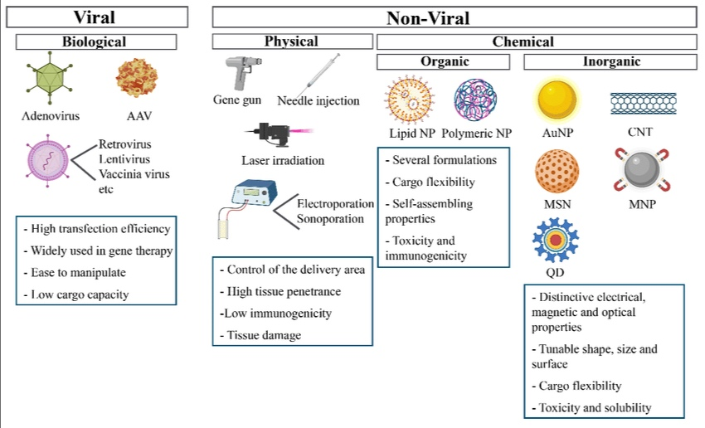Figure 3:” Representation of viral and non-viral delivery systems” [23]

IV.TARGETED DELIVERY WITH NON-INVASIVE TECHNIQUES

Focused Ultrasound-Induced Brain Vascular Permeability Increase:
A barrier called the blood-brain barrier (BBB) prevents about 98% of small molecule medications from getting to the brain parenchyma. However, the use of focused ultrasound (FUS) in conjugation with intravenous micro bubbles (MBs) has demonstrated a promising ability to temporarily and reversibly increase BBB permeability in non-invasive way, potentially opening up prospects for medication delivery to the brain [24].
As a result, this method enables treatments to a mass in the sonicated zones over a predetermined period of time. Currently, focused ultrasound (FUS) and magnetic resonance imaging (MRI) can be utilized in conjunction to precisely pinpoint the desired problematic locations. Surgical implanting the transducer through a hole in the skull beneath the skin enables the ultrasonic beam to be focused on the tumor site. This is another invasive method [25].
Typically, when we talk about “broadband emissions”, we’re talking about tiny bubbles collapsing, which causes tiny streams and tiny jets to influence the tissues around them, rupturing blood vessels and causing irreversible tissue damage. Micro bubbles and ultrasound interact to create physical stressors that alter biological processes [26].
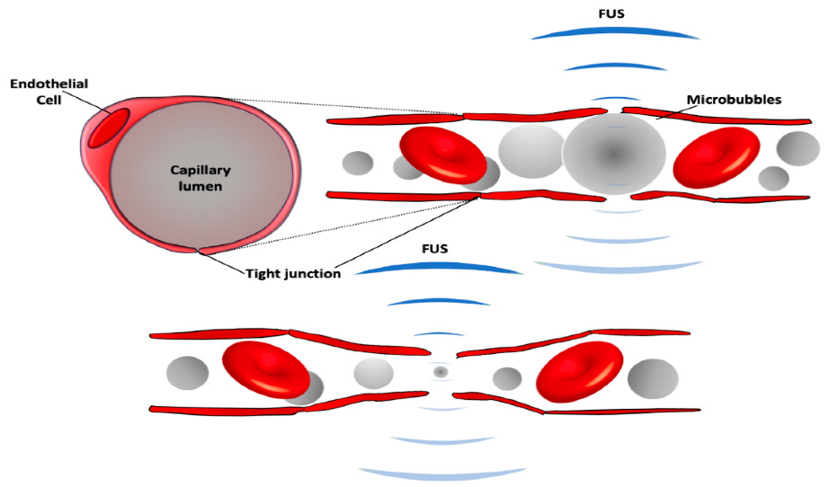
Figure 4: “A schematic of BBB modulation following focused ultrasound (FUS) with intravenous injection of microbubbles” [27]

Delivery of Drug Using Magnetic Nanoparticles:
Drug delivery using magnetic nanoparticles (MNPs) has become a popular stratergy for getting to the brain, which is the most difficult organ to reach. MNPs have the potential to become magnetized when subjected to a magnetic field, allowing for controlled and targeted distribution to a particular area. His accomplishments led to increased absorption at the desired target location, which improves therapy efficacy with lower dosages and less off-target side effects.
Magnetic Nanoparticles (MNPs) can be created mechanically or chemically for use in biological applications. It is feasible to attain uniformity in size and shape by using chemical synthesis. Among the different chemical synthesis techniques available, co precipitation is particularly favored due to its straightforward implementation [28].
Imaging techniques the original purpose of supermagnetic iron oxide Nanoparticles (SPIONS) was as contrast materials for Magnetic Resonance Imaging (MRI). However, ongoing research is focused on creating new formulations that combine multiple imaging components with MNPs to be utilizes in integrated systems [29].

Biomaterial-based approaches:
Biomaterial plays crucial roles in treating neurodegenerative diseases. Specifically, nanoparticles have extensively utilized in research and development. Within the realm of nanoparticles, various biomaterials have undergone thorough investigation to explore their respective benefits and drawbacks [30]. The research focused on a variety of nanoparticles, including solid lipid nanoparticles (SLNs), polymeric nanoparticles, liposomes, and extracellular vehicles (EVs) [31]. Other types of nanoparticles studied included metal and metalloid nanoparticles, polymeric nanoparticles. Regarding the naming of nanoparticles, there is, nevertheless, a lot of misunderstanding. As a broad word, “nanoparticle” refers to drug delivery particles of a size between 10 and 1000nm. Names for several types of nanoparticles, including nanocubes, nanoplates, nanorods, nanosphers, nanotrapods, nanoprisms, and nanobelts, can be driven from their distinctive shapes [32].
Functional biomaterials come in three different varieties: magnetic biomaterials, photoactive biomaterials, and electroactive biomaterials. These biomaterials can react to outside stimuli including magnetic, electric, and light fields. They are able to modify their connections with nerve cells and control cellular activity as a result. Often times immune-suppresed illnesses such melancholy, motor dysfunctions, and lethargy are misinterpreted as neurological disorders that display a mix of cognitive, motor, and behavioral abnormalities [33].

Biodegradable NPs Drug Delivery:
The delivery of diagnostic or therapeutic agents to particular sites has been focus of research into nanoparticles like PGA, PLA, and PLGA. Lower medicinal dosages, higher absorption at the target site, and fewer lateral side effects are benefits of focused administration. Production and use of functionalized nanoparticles that can penetrate the BBB and release medications to treat neurological illnesses have received a lot of attention. They first evaluate how well functionalized NPs might traverse the BBB. Because of their adaptability, these nanoparticles can have their surfaces altered during manufacture to improve how well they interact with various BBB components [34].

Preclinical and clinical advances
Clinical trials are increasingly more common and include a variety of strategies, including artificial polymer particles, liposome formulations, micellar nanoparticles, nanocrystals, and pharmacological or biologic combinations. Researchers are experimenting with various nanoparticle types to deliver precise dosages of medications to particular cells, such as cancer or tumor cells, while sparing healthy cells. Undoubtedly, the future of research and development will centre on nanomedicine and nano-drug delivery devices. .
This is because there are still a lot of crucial details that are unknown in this area of science, which is relatively new with only about two decades of serious investigation. Finding fundamental markets in sick issues, including important biological markers that permit targeting without interfering with regular cellular functions, is one of the main topics of future study [35].
There are now 27 RNA-based therapies in clinical trials, and seven of these medications are being used commercially to treat neurological and neuromuscular conditions such familial amyloid polyneuropathy (FAP) and Duchenne muscular dystrophy (DMD). These treatments go after particular gene mutations that cause gain of function (GOF), loss of function (LOF), or a mix of both effects. When a LOF mutation is linked to the pathogenic mechanism, the therapeutic strategy focuses on replacing the affected gene to restore the expression of the damaged protein product. On the other hand, in the instance of a GOF mutation, the objective is to use gene silencing methods to lower the expression of the protein product [36].

V. FUTURE PERSPECTIVE AND CHALLENGES

Despite the progress in the use of medical equipment and facilities, there has been an ongoing struggle in clinical trials to discover a permanent cure for CNS diseases. In the future, there will be further developments in the regulatory mechanisms for nanomedicines, particularly concerning safety and toxicity assessment. Nanomedicines has already brought about a revolution in how medications are found and delivered to the body’s biological system.
As more studies focus on exploring the combination of novel nanocarriers and drug targets, the potential for their synergistic effect in treating CNS diseases is expected to improve in the future. In order to make progress and speed up the treatment of CNS-related diseases, a blend of expertise in biomedical sciences, materials science and pharmaceuticals is essential.
The key to enhancing the clinical translation of neurological disorders lies in discovering biomarkers and creating nanomedicine specifically designed to target these biomarkers. This approach will help clinicians overcome current constraints and improve the treatment of such disorders.

VI. CONCLUSION

This review explores recent strategies for delivering drugs to the brain. To create an effective drug delivery system for brain diseases, understanding the BBB disruption is essential. It is anticipated that new delivery methods will improve the accuracy of brain illness diagnosis. To create effective delivery systems for diverse brain illnesses, more study on BBB delivery is required. Nanomaterials show promise in diagnosing and precisely delivering drugs to specific targets. The regulated release, bioavailability, and solubility of drugs are improved through nanotechnology. Low toxicity, biodegradability, and biocompatibility are all characteristics of natural biomaterials. Among the current therapeutic approaches, nanomeicines-based strategies have led to innovative nanoscale targeting techniques that deliver active agents with favorable pharmacokinetics to improve treatment outcomes. Nanomedicines have been optimized to efficiently bind to targets, allowing for controlled release and improved clinical results.

REFERENCE

1] Agrawal M, Saraf S, Saraf S, et al. Recent advancements in the field of nanotechnology for the delivery of anti-Alzheimer drug in the brain region. Expert Opin Drug Deliv. 2018; 15(6): 589-617.
2] Moses MA, Brem H, Langer R. Advancing the field of drug delivery: Taking aim at cancer. Cancer Cell 2003; 4:337-341.
3] Kabanov AV, Batrakova EV. New technologies for drug delivery across the blood brain barrier. Current Pharm Design 2004; 10:1355-1363.
4] Banks WA. From blood-brain barrier to blood-brain interface: new opportunities For CNS drug delivery. Nat Rev Drug Discov. 2016; 15:275–92.
5] Patra J.K., Das G., Fraceto L.F., Campos E.V.R., Rodriguez-Torres M.D.P., Acosta-Torres L.S., Diaz-Torres LA., Grillo R., Swamy M.K., Sharma S., et al. Nano based drug delivery systems: Recent developments and future prospects. J. Nanobiotechnol. 2018; 16: 71.
6] Somwanshi S.B., Dolas R.T., Siddheshwar S.S, Merekar A.N., Godge R.K. and S. R. Pattan, Nanomedicine Drug Delivery System. Asian Journal of Biomedical and Pharmaceutical Sciences. 2013; 3(22): 9-15.
7] Badriyah Shadid Alotaibi, Manal Buabeid, Nihal Abdalla Ibrahim, Zelal Jaber Kharaba, Munazza Ijaz, Sobia Noreen & Ghulam Murtaza. Potential of Nanocarrier-Based Drug Delivery Systems for Brain Targeting: A Current Review of Literature. International Journal of Nanomedicine, 7517-7533, DOI: 10.2147/IN.S333657.
8] Riaz MK, Riar MA. Zhang X, et al. Surface functionalization and targeting strategies of liposomes in solid tumor therapy: a review. Int J Mol Sci. 2018:191-195.
9] Barbara R, Belletti D, Pederzoli F. et al. Novel Curcumin loaded nanoparticles engineered for Blood-Brain Burrier crossing and Able to disrupt Abeta aggregates. Int J Pharm. 2017: 526/1- 21: 413 424.
10] Somwanshi SB, Dolas RT, Siddheshwar SS, Merekar AN, Nanoscale Drug Delivery Technologies: Introduction and Recent Developments. Journal of Pharmaceutical and Scientific Innovation. 2013; 2(4): 18-23.
11] Z. Ahmad, et al.Polymeric micelles as drug delivery vehicles RSC Adv. 2014; 4(33): 17028- 17038
12] Meola A, Rao J, Chaudhary N, Sharma M, Chang SD. Gold nanoparticles for brain tumor imaging: a systematic review. Front Neurol. 2018; 9: 328.
13] Siddique S, Chow JC. Gold nanoparticles for drug delivery and cancer therapy. App Sci. 2020; 10(11):3824.
14] Gao X, Chen J, Chen J, Wu B, Chen H, Jiang X. Quantum dots bearing lectin-functionalized nanoparticles as a platform for in vivo brain imaging. Bioconjug Chem. 2008; 19 (11):2189-2195. Doi:10.1021/bc8002698
15] Zhu J, Shi X. Dendrimer-based nanodevices for targeted drug delivery applications. J Mater Chem B. 2013; 1:4199-211
16] Masserini M, Nanoparticles for brain drug delivery. ISRN Biochem. 2013; 2013: 238428.
17] Feng, X: Eide, F. F. Jiang, H: Reder, A. T. Adeno-associated viral vector-mediated Apol expression in Alzheimer’s disease Mice: low CNS immune response, long term expression, and astrocyte specificity. Front. Bioset, 2004; 9:1540-154
18] Nemunaitis J, Khuri P, Ganly I, Arseneau J, Pher ET. AL., Phase II trial of intratumoral administration of ONYX-015, a replication-selective adenovirus, in patients with refractory head and neck cancer. J Clin Oncol. 2001; 19(2): 289-98.
19] Mastrobattista, E; van der Aa, M. A: Hennink, W. E: Commelin,D. 1. Antificial viruses a nanotechnological approach to gene delivery. Nat Rev Drug Dacerery 2006; 3 (21): 115-121
20] Tan, W.; Wang, K: He, X: Zhao, X. J.; Drake, T., Wang, L: Bagwe, R. P. Binaechology haved on silica nanoparticles. Med Res Res. 2004; 24 (5): 621-638
21] Singh, M: Brines, M.: On, G: O’Hagan, D. Cationic micro Particles: A potem delivery system for DNA vaccines, Proc. Natl Acad Sci USA. 2000; 97 (2): 811-816.
22] Kneer, C: Sameti, M.; Halter, E. G.; Schiestel. T: Schinta, H.; Schmidt, H: Lehr, C. M. Silica nanoparticles modified with Amisilanes as carriers for plasmid DNA. Int. J. Pharm 2000; 196 (2): 257-261
23] Sofía Mirón-Barroso, Elena B. Domènech, Sonia Trigueros. Nanotechnology-Based Strategies to Overcome Current Barriers in Gene DeliveryNanotechnology-Based Strategies to Overcome Current Barriers in Gene Delivery.International Journal of Molecular Sciences 2021;22(16):8537.
24] Hynynen, K.; McDannold, N., Vykhodtseva, N.; Jolesz, F.A. Noninvasive MR imaging guided focal opening of the blood- brain barrier in rabbits. Radiology 2001; 220:640-646.
25] Carpentier, A., Canney, M., Vignot, A., Reina, V, Beccaria, K.; Horodyckid, C.; Karachi, C.; Leclercq, D. Lafon, C: Chapelon, J-Y.; et al. Clinical trial of blood-brain barrier disruption by pulsed ultrasound. Sci. Trans! Med 2016; 8: 343re2
26] O’Reilly, M.A. Hynynen, K. Blood-brain barer: Real-time feedback-controlled focused ultrasound disruption by using an acoustic emissions-based controller. Radiology 2012; 263: 96- 106
27] Shang-Kai Wu 15,Chia-Lin Tsai 123 Yuexi Huang and Kullervo Hynynen 1.2.4. Focused Ultrasound and Microbubbles-Mediated Drug Delivery to Brain Tumor. Pharmaceutics 2021; 13(1): 15:
28] Fahima Dilnawaz Sanjeeb Kumar Sahoo. Therapeutic approaches of magnetic nanoparticles for the central nervous System. Drug Discovery Today. 2015; 20(10):1256-1264.
29] Omid Veiseh, Jonathan W. Gunn, Migin Zhang. Design and fabrication of magnetic nanoparticles for targeted drug delivery and imaging. Advanced Drug Delivery Reviews. 2010; 62(3): 284-304.
30] Li Y., Liu R., Ji W., Li Y., Liu L, Zhang X. Delivery systems for theranostics in Neurodegenerative diseases. Nano Res. 2018; 11: 5535-5555.
31] Vissers C., Ming GL, Song H. Nanoparticle technology and stem cell therapy Team up against neurodegenerative disorders. Adv. Drug Deliv. Rev. 2019; 148:239-251.
32] Ramanathan S., Archunan G., Sivakumar M., Tamil Selvan S., Fred A.L., Kumar S., Gulyás B., Padmanabhan P. Theranostic applications of nanoparticles in neurodegenerative disorders. Int. J. Nanomed. 2018, 13:5561-5576.
33] Dingying Shan, Chuying Ma, Jian Yang. Enabling biodegradable functional biomaterials for the management of neurological disorders. Advanced Drug Delivery Reviews. 2019; 148:219-238
34] Liu, M.; Li, H.; Luo, G. Liu, Q.; Wang, Y. Pharmacokinetics and biodistribution of surface modification polymeric nanoparticles. Arch. Pharm. Res. 2008;31: 547-554
35] Anja Holm, Stine N. Hansen, Henrik Klitgaard & Sakari Kauppinen. Clinical advances of RNA therapeutics for treatment of neurological and neuromuscular diseases. RNA Biology ,2022;19(1):594-608.
36] Nertiyan Elangkovan and George Dickson, Gene Therapy for Duchenne Muscular Dystrophy. Journal of Neuromuscular Diseases. 2021; 8: S303–S316.

