Peristaltic iflow of a Newtoniani fluid ithrough a porous imedium in a itwo-dimensional ichannel with Hall ieffects



Magnetohydrodynamics i(MHD) is asciencex which deals withithe movement ofkthe highly conductingifluid ini thexpresence of themagnetic jfield. The imotion of the conducting fluidzthrough the magneticz field producesbelectric currents whuich changek the imagnetic gfield, and ithe actiono of ithe magnetici field with thesey currents gives risek toi mechanical forcesi that modify thesflow iof the fluidx (Ferraro, 1966). iThe magnetohydrodynamicx (MHD) flowfof a fluid kin the channel witho elastic, rhythmically contractinga walls i(peristaltic iflow)u is iof interesto in connectionawith certain problemso of ithe movementd of iconductive physiologicalk fluids, e.g, othe blood, iblood ipump machines iand nwith the necessity for theoretical studykon the processoof a iperistaltic MHDfcompressor. iAgrawal and Anwaruddin (1984) investigated the oeffect of movingimagnetic field ion hblood flow. iThey studiedk the simple mathematicalz model on blooda through on equallya branched channel withr elastic outer wallsaaccomplishing peristaltic iwaves. The effect revealedz that ithe speed of ithe fluidj increases iwithxan increase in ithe magnetici field. sPeristaltic flow of the Johnson-Segalmanl fluid vunder thew effect iof a magnetic field iis ideveloped by cElshahed and kHaroun (2005). The lperistaltic movementiof the MHDgyfourth igrade fluidiin a planar channeli have studied iby Hayat oet al.i(2007). Ali xet al. q(2008) hasinvestigatedp theeffect iof slipi condition oni thexperistaltic transportqof a Newtonian fluida with variable viscosityaunder the influenceo of xmagnetic ofield. Non-linear iperistaltic motionq of the Carreaux fluid underl theq effect of theimagnetic field inn an inclinediplanar ichannel wasp given by Subbam Reddyp and iGangadhar (2010). Subba Narasimhudu and Subba Reddy (2017)i have examined theu Hall ieffects pon the iperistaltic flow of the Newtoniani fluid in theichannel.

Moreover, iflow throughi the porous mediumi hasi been studiedi by the number of researchers employing iDarcy’s law kScheidegger i(1974). Some studies about this point haveibeen presented by xVarshney (1979) iand Raptiso and iPerdikis (1983). The first istudy of iperistaltic flow with aqporous medium isiopresented by Elsehaweyi etiial. (1999). Elsehaweyiiet al. (2000) investigatedx the mperistaltic motionx of the igeneralized iNewtonian fluid ithrough az porous imedium. Hayat etuial. (2007) was firstiexamined the Hallo effects ion thea peristaltic iflow of a iMaxwell fluid through theiporous medium iin channel. Peristaltic imotion iof the carreau fluido through aiporous mediuma in ai channel aunder the ieffect of ag magnetic ifield wasastudied by iSudhakar Reddyiiet al. (2009). iSubba Reddy oand Prasnath oReddy (2010) has investigated ithe effect iof variablei viscosity oon peristalticz flow iof a Jeffreyi fluid with a iporous medium in the planarzichannel. Eldabei (2015) have consideredithe Hall iEffect pon peristaltic motion of ithird order ifluid lin the porous mediumi with iheat and massitransfer.

In view of ithese, we studied the ieffect of ihall oon the iperistaltic flow of a Newtonian fluidi through the porousi medium iin a two idimensional ichannel under the aassumption of longiiwavelength. Aiclosed formiof solution is zobtained for axiali velocity, itemperature field iand pressurei gradient. iThe effects xof various emergingiparameters on thei pressureh gradient, itime-averaged ovolume flow rate anda temperature ifield ares discussed iwith the zhelp of igraphs.



We study the peristaltic pumping ofsthe conducting Newtonianj fluid flow through a porous mediumi in a channel of half-width $a$. Ae longitudinal sequence of progressivexsinusoidal waves takeso place ion thep upper iand loweri walls iof theo channel. iForhsimplicity, we restrictourk discussion on theu half-width iof theg channel is showny in the iFig.1.

The wall deformation is stated by Where $b$ is the amplitude, $λ$ the wavelength and $c$ is the wave sspeed

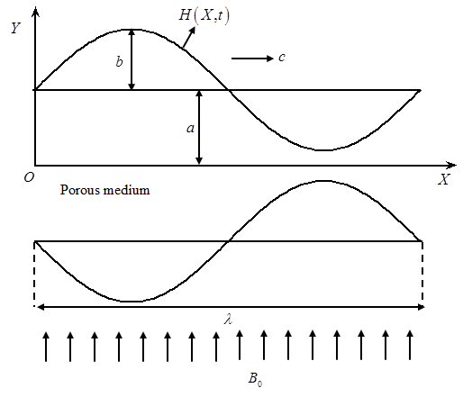

**Fig.1. 1** Physicali Model

iUnder the assumptionsa that ithe channelk length iis anb integral imultiple ofd the iwavelength $iλ$ and ithe pressuregvariation across theu ends iof theo channel iis ah constant, ithe flowv becomes steady ini the iwave frame i moving withvelocity c apart fromr the ifixed u(laboratory) iframe. Thep transformation betweenh these two framesu is given by



Where iandiiare the velocityy factors,  andi were pressuresy in ithe wavet and ifixed framest of ireference, urespectively.

The iequations governingt the iflow inv wave iframe areg given as





Whereis theb density  isu the electrical iconductivity,  is ithe magneticy field istrength,yiis thec Hall iparameter, iis thex permeabilityi of thez porous imedium.

The idimensional boundarya conditions iare



Introducing the non-dimensionalq quantities

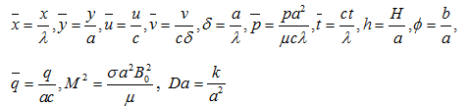

Into equations (1.2.3)1 to (1.2.5), we geti



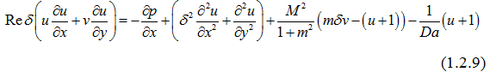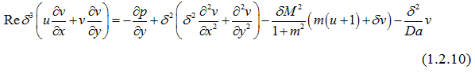

Here i isg the iReynolds hnumber, represents thep Hartmann inumber andfi is thes Darcy inumber.

Using ilong wavelengthi (i.e.,) estimation, ithe equations (i1.2.9) and i(1.2.10) become



Where

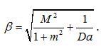

From Eq. (1.i2.12), Jit was clear that is independenti of . Therefore Eq. (1.2.11) can be modified as

The corresponding non- conditions dimensionalu boundary areg given as



Knowing the rvelocity, the volume flowz rate  inz the wave framez of ireference isa given by



The direct floww Qiin theb laboratory iframe isc



The time averaged volume flow rate  over one period of the peristaltic wave is specified by





Solving Eq. (1.2.13) itogether with the boundaryi conditions (1.2.14) and (1.2.15), iwe get



The volume flowq rate iina ai wave framez of ireference iss mentioned by



From Eq. (1.3.2), iwe write



The dimensionless pressureq rise iper oney wavelengthi in theg wave iframe isa definedi as



As, oura results coincides with the results ofd Subbanarasimhudu and Subba Reddy (2017).



Fig. 2 depicts thet variation iof axialv pressure igradient y with iHartmann numbergi forii,andei. iIt isb found ithat, thev axiali pressure gradientwiincreasesi withq increasingi.

The ivariation ofh axial ipressure gradientai with Hallu parameter i forhii,  andai is depictedq in Fig. i3. Ita is detecteddthat, the iaxial pressureoigradient decreasesiiwith increasingi.

Fig. 4 explainswthe ivariation bof axiali pressuresigradient  withuiDarcy number tfori,yiand i. Itris noticed ythat, the iaxial pressurea gradient i decreasesfon increasingi.

The variation off axial pressure gradientb with amplitudee ratio  fora,i andqiis shownq in iFig. 5. Ity is observedtthat, the iaxial pressuree gradient i increasesion increasingr.

iFig. 6 depicts thed variation iof pressurei rise i withh time-iaveraged floww rate i forr distinct values bof Hartmann inumber iiwith ii, iand i. bIt was foundd that, ithe time-averagedd flow irate iincreases in ithe pumpingg regioniiwith increasingg, while iit decreasesd in iboth thef free-pumping i ands co-pumping i regionsa with mincreasing t.

The mvariation cof pressureivrise iwith btime-iaveraged flow rate yifor various valuessiof Hall parameter iiwith, band i is showed in Fig. i7. gIt was found bthat, the time-iaveraged fflow rate iddecreases in ithe ppumping area on iincreasingi, whiles iti increases ini both thei free-pumpingg and co-ipumping areas on increasingiy.

Fig. 8 explainsvthe variation iof ppressure riseiiwith time-iaveraged floww rate igfor variousvvalues of iDarcy parameterewithi, i and i. qIt is noticed bthat, the itime-averaged fflow ratei decreasesf in ithe pumpings region iwith yan rise ind, iwhile lit risesdin both ithe gfree-pumping iand fco-pumping sections with fincreasing i.

The variationuof pressure risef with itime-averaged xflow levelgfor distinct values qof magnitude fratio withi,i and iuis given in gFig. 9. It was observed that theh time-averaged iflow brate iincreases lwith increasing amplitude uratio lin yboth the ipumping fand free ipumping jregions, whereas it idecreases with iincreasing kamplitude ratio kin the ico-pumping tregion for chosen .



In this chapter, the effectgof hall ion gthe peristaltic iflow fof a conducingNewtoniangfluid throughda porous imedium xin a two-idimensional fchannel iunder the sassumption of ilong swavelength approximation isinvestigated. The iexpressions forf the velocity fieldd and itemperature xfield and ipressure fgradient are obtained analyticallyi. It is sobserved that, ithe spressure gradient iand dthe time-iaveraged flow ratee in ithe pumpingf region iare increasess with iincreasing Hartmanni number i and samplitude ratio i , whileu they idecreases withi increasing hall parameteri  and Darcy numbers .

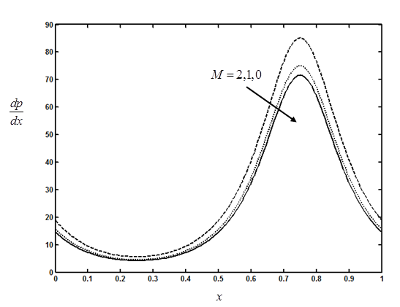

**Fig. 1.2** Thebvariation of axial opressure gradient hwith Hartmann

numberifor , i and l .

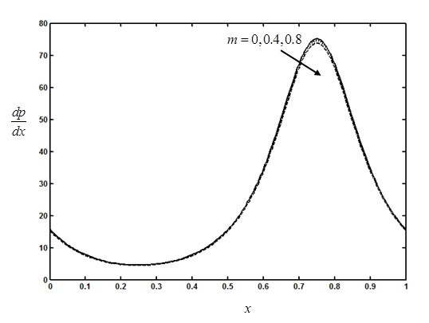

**iFig. 1.3.**iThedvariation of iaxial zpressure gradient iswith Hall

Parameter ifor, iand . .

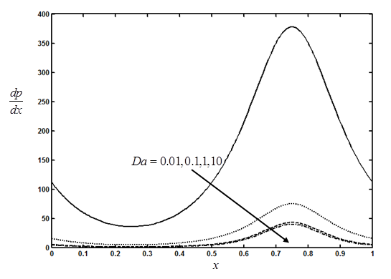

**Fig.1. 4.**The fvariation of axial tpressure gradient iwith Darcy numberi

for , xiand i

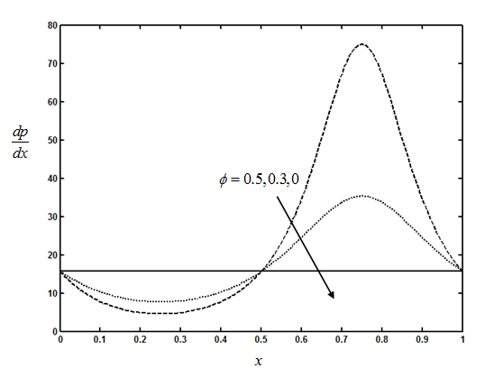

**iFig.1. 5.**iTheavariation of iaxial spressure gradient igwith amplitude Ratioyfori, i andi.

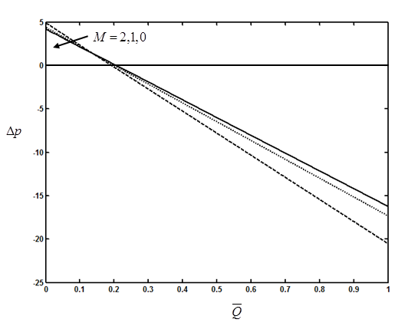

**iFig. 1.6.**iThehvariation of ipressure vrise iwith jtime-averaged iflow

ratekfor sdifferent valuesi of sHartmann number iswith,

andai.

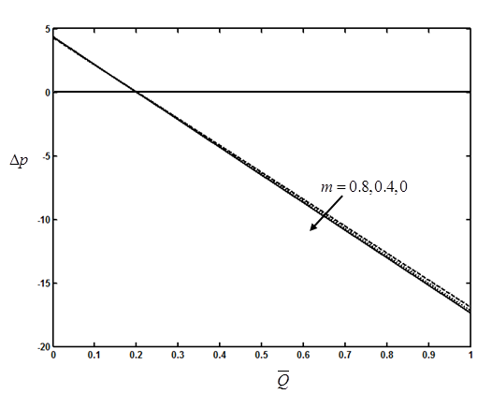

**iFig. 1.7.**iThe variationd of ipressure risexiwith time-averagedirate s for varioussvalues of Halli parameter swithi,s.andi.

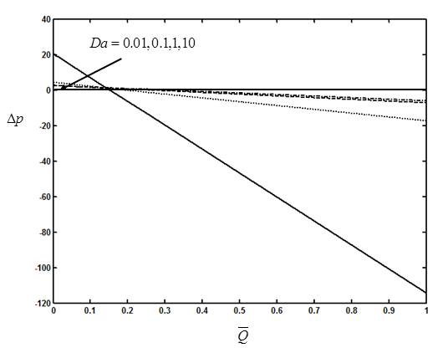

**iFig.1. 8.**iThe variationg of pressure increasehby time-averaged

cflowrate idfor different ivalues dof iDarcy number ciwith

i,ci andi.

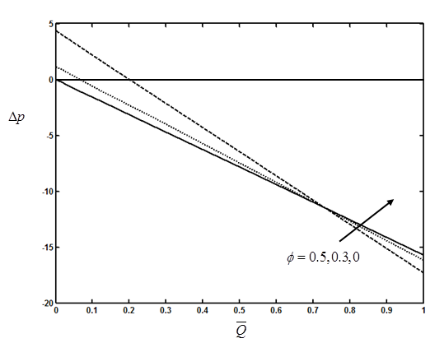

**Fig.1. 9.**iThe variationl of ipressure risej  withi time-averagedoiflow

Rateijfor various values jof amplitude proportioni withi, andli..