Cell Fusion: Mechanisms and Biological Implications

Dr. Kumara Wodeyar D.S¹ Dr. Ananth Krishna.L.R ², Dr.Ramesh.D^{3*}, Dr.Yathish.H.M⁴, Dr. Anil Gattani⁵

1. Assistant Professor, Department of Veterinary Physiology and Biochemistry, Veterinary College Gadag, KVAFSU, Karnataka, India

2. Associate Professor and Head Department of Veterinary Physiology and Biochemistry, Veterinary College Gadag, KVAFSU, Karnataka, India.

3. Assistant Professor Department of Veterinary Physiology and Biochemistry, Veterinary College Hassan, KVAFSU, Karnataka-573202, India.

4. Assistant Professor Department of Animal Genetics and Breeding, Veterinary College Bengaluru, KVAFSU, Karnataka, India

5. Associate Professor Department of Veterinary Biochemistry, College of veterinary Science and Animal Husbandry, Jabalpur India.

*Corresponding Author

Assistant Professor Department of Veterinary Physiology and Biochemistry, Veterinary College Hassan, KVAFSU, Karnataka-573202, India. Email-drrameshd@gmail.com Mobile-8277522429.
Abbreviations used | Expansion
cAKA | Cyclic Adenosine-Dependent Protein Kinase-A
MAPK | Mitogen-Activated Protein Kinase
BMDCs | Bone Marrow-Derived Cells
HAP2/ GCS1 | Hapless 2/Generative Cell-Speciﬁc Protein 1
T-SNARE | Target-Soluble N-Ethylmaleimide-Sensitive Factor Attachment Protein Receptor
V-SNARE | vesicular-SNARE
HERV | Human Endogenous Retrovirus
SU | Surface Subunit
TM | Transmembrane Subunit
Asct-2 | Sodium-Dependent Type 2 Neutral Amino Acid Transporter
GCM1 | Glial Cell Missing 1
β-HCG | β-Human Chorionic Gonadotropin
GRP78 | Glucose-Regulatory Protein 78 kDa
Ig | Immunoglobulin
DC-STAMP | Dendritic Cell- Speciﬁc Transmembrane Protein
OC-STAMP | Osteoclast- Stimulating Transmembrane Protein
HA | Hemagglutinin
cAMP/PKA | Cyclic Adenosine-dependent Protein Kinase A
ZO-1 | zona occludens-1
Wnt | wingless/integrase-1
PEG | Polyethylene Glycol
JNK | c-Jun N-Terminal Kinase
NIR | Near Infrared Laser
The cell fusion process involves the merging a number of uninucleate cells results in the formation of a multinucleate cell called syncytium. The cell fusion includes membranes fusion, cytoplasmic mixing and fusion of nuclei. It is a fundamental step for maturation of cells as well as the maintenance of their specific functions during growth. Also cell fusion occurs in various pathological and physiological processes like embryogenesis, morphogenesis and tissue repair, immunological response and also in cancer development. Various proteins and signaling pathways, including syncytin-1, syncytin-2, galectin-1, glial cell missing-1, and additional proteins such as annexins, myomaker, and myomerger, exert control over it.
I. Introduction
Cell fusion encompasses both physiological and pathological processes. Depending on the types of cells involved, cell fusion can be classified as homogeneous or heterogeneous. Furthermore, considering the contents of the cells when they merge, cell fusion can be categorized as complete fusion or hemifusion. The process involves the membrane fusion followed by cytoplasmic mixing and nuclear fusion which can leads to development of heterokaryon (multinuclear cells) or synkaryons (mononuclear cells).Daughter cells in synkaryons have all the chromosomes of the closely related cells and are created via recombination, nuclear membrane separation, and cell division. The hybrid cell transforms into a polyploidy with more than two sets of chromosomes in its genome and adopts on a new phenotype. In numerous physiological or pathological stages, including those associated with growth, development, aging, stress, cancer, and other diseases, polyploidy cells can be seen. The heteromorphic cell fusion has a crucial effect on growth of tissues and disease progression.
II. Types of Cell Fusion
Cell union can be of the homotypic or heterotypic type. Homotypic cell fusion happens when cells of the similar kind come together. The osteoclasts or myofibers fusion involves homotypic fusion. Heterotypic cell fusion take places among cells of dissimilar types for example fusion of the integration of bone marrow-derived cells (BMDCs) with the parenchymal organs.
III. The Progression of Cell Fusion
The fusion of membranes begins when separate membrane vesicles or compartments are brought close to together. Initiation requires overcoming two main forces: an attractive hydrophobic force between the hydrocarbon interiors of the bilayers and a repulsive hydration force brought on by water that is tightly linked to the hydrophilic lipid head groups, cell fusion includes both an integration of the internal components of the cells and also a morphological restoration of the cell membrane.
Under specific circumstances, proteins from fused cells are released, allowing them to communicate with their surroundings and the fusion target. It has been discovered that the group of proteins known as "fusogens" which are necessary to trigger cell fusion via several different methods. Cell fusions can be regulated by a particular fusogen or involve multiple proteins cooperating to accomplish or regulate the fusion process. For instance, myomaker and myomerger function as solitary fusogens in myoblast fusion, while HAP2/GCS1 becomes active during later stages of gamete fusion. In Caenorhabditis elegans, EFF-1 and AFF-1 operate independently to initiate auto-fusion.
The entire fusion process involves in three phases. The initial step starts with preparation of cells for fusion by cell-cell recognition followed by membrane approach mediated by fusogens and in final stage new cells formed by lipidic rearrangements (Fig:1).
The initial phase of cell fusion relies primarily on receiving extracellular signals designed for cell differentiation, making cell-cell recognition and interaction indispensable. When cells are fewer than 10 nm apart from one another, they begin to tightly adhere to one another, and then fusogens work in the last approach between membranes. The cell fusogens mediates in morphological changes includes dehydration, hemifusion, pore opening and spreading out cell membranes with the intention of the union of experiences. The final phase encompasses the merging of cell membranes into a single, contiguous structure that encompasses all cytoplasm and genetic material. However, on occasion, the process terminates abruptly before pore opening and extension transpire, resulting in the cell reaching the hemifusion stage, where its cellular components are unable to make contact and exchange with each other.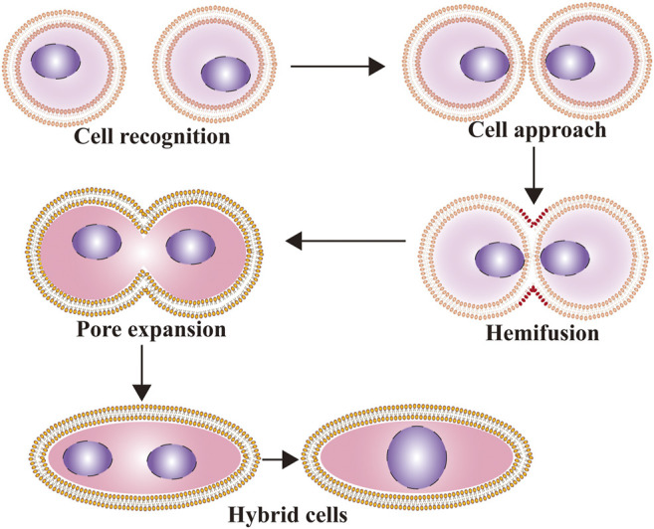
FIGURE 1: Cell fusionprogessioncan be divided into 3 steps 1.preparation for fusion, 2. membrane approach under the accomplishment of fusogens, and 3. Constitution of new cells by means of lipidic rearrangements. (Source:Hao Zhang et al., 2021)

IV. Cell Fusion Associated Proteins
Fusogenic proteins and actin-driven membrane protrusions play a crucial role in the initial phase of cell-cell fusion. For instance, the helix fusion process necessitates the presence of syncytin-1 and syncytin-2., T-SNARE (Target-soluble N-ethylmaleimide-sensitive factor attachment protein receptor) and V-SNARE (Vesicular-SNARE) are the components of the helical fusion mechanism that facilitate intracellular membrane fusion by forming -helical bundles that result in membrane fusion.
The membrane glycoprotein known as syncytin-1, which is encoded by the ENV gene of the HERV (human endogenous retrovirus) W family, was the initial fusion-promoting protein identified in syncytiotrophoblast cell formation. Syncytin-1 is expressed in the placenta and consists of surface subunit (SU) and transmembrane subunit (TM) components. The SU portion of syncytin-1 interacts with a type D retrovirus receptor called sodium-dependent type 2 neutral amino acid transporter (ASCT-2). This interaction induces a conformational change in the TM, leading to a close association of the phospholipid bilayers of the two trophoblast cells. Syncytin-1 primarily facilitates the fusion of mononuclear trophoblast cells into multinuclear syncytiotrophoblast cells. Additionally, syncytin-1 plays a role in myoblast fusion and osteoclast formation.
Syncytin-2, a endogenous retrovirus gene product and a fusion protein plays a role in arrangement of placental syncytiotrophoblast cells andplacenta formation, is involved osteoclast and macrophage fusion.
GCM1 is a transcription factor containing zinc finger domains, and it is specifically found in embryos, with prominent expression in placental trophoblast cells. Its main role involves regulating the expression of syncytin-1 and facilitating the differentiation of mononuclear trophoblast cells into multinuclear syncytiotrophoblasts.
Galectin-1, a soluble lectin, plays a role in cell fusion and is associated with the expression of syncytin-2. Additionally, it has been linked to trophoblast cell fusion.
The fusion process involves various proteins specific to different cell types. For instance, during fertilization, oocyte tetrasomal proteins CD9 and CD81 play a crucial role. Glucose-regulatory protein 78 kDa (GRP78), an endoplasmic reticulum protein present on trophoblast cells' surface, contributes to enhancing cell fusion. Immunoglobulin-like cell adhesion molecules are essential for both cell-cell fusion and recognition in myoblasts. Proteins such as CD47, CD200, DC-STAMP (dendritic cell-specific transmembrane protein), and OC-STAMP (osteoclast-stimulating transmembrane protein) are vital for macrophage fusion in osteoclasts. Myomaker (Tmem8c), a muscle-specific protein located on the plasma membrane, is involved in myoblast fusion. Additionally, annexins, molecules with multiple Ca2+-binding sites, mediate the fusion reaction or induce a conformational change in fusogenic proteins.
V. Cell Fusion Related Signaling Pathways
Syncytin-1 expression is regulated by a number of signaling pathways throughout embryonic development, including the wingless/integrase-1 (Wnt), cyclic Adenosine-dependent Protein Kinase A (cAMP/PKA), Mitogen-Activated Protein Kinase (MAPK), and c-Jun N-terminal kinase (JNK) signaling pathways. Syncytin-1 is increased as a result of the cAMP pathway being activated. TGF-β1 and TGF-β3 are major negative regulators of cell fusion.
VI. Cell Fusion during Embryonic Development
The growth of syncytiotrophoblasts in the placenta and the process of sperm/egg fertilization during sexual reproduction both involve cell fusion. Sperm's IZUMO proteins play a crucial role in fertilization through dynamic cell fusion. Failure to express these proteins leads to sterility due to the inability of sperm and egg to fuse. Placental formation, which occurs through cell fusion, consists of two distinct phases (Figure 2). In the initial phase, cytotrophoblast cells merge to form multinuclear syncytiotrophoblast cells. These cells then migrate and infiltrate the mother's uterus, serving as a conduit for the exchange of oxygen, nutrients, and metabolic waste between the embryo and the mother. In the second stage, cytotrophoblasts and syncytiotrophoblasts collaborate in tissue repair processes.
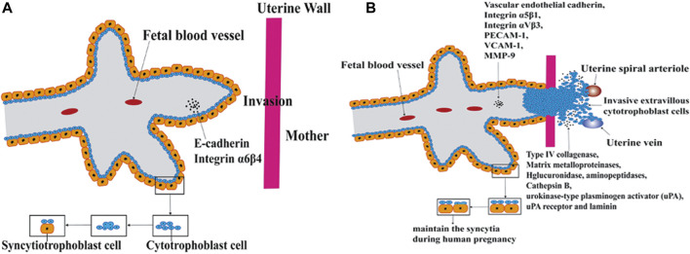

2. Fig 2: The arrangement of the placenta is accompanied by cell fusion and is separated into two phases according to the diverse functions in the fusion process. A. In the ﬁrst phase, cytotrophoblasts and syncytiotrophoblasts fuse for tissue regeneration (B) In the second phase cytotrophoblasts and syncytiotrophoblastscombine for tissue regeneration.(Source:Hao Zhang et al., 2021)

VII. Cell Fusion Techniques
The various cell fusion procedures offer an effective tool for new discoveries in the realm of genetic and epigenetic studies of the genome.
Electrical Cell fusion employs dielectrophoresis as a technique to bring two cells into contact using high-frequency alternating current. Once the cells are united, a pulsed voltage is applied. This voltage pulse induces permeability in the cell membranes, allowing them to merge and facilitate cell fusion. Subsequently, an alternating voltage is applied for a brief duration to ensure the stabilization of the fusion process, ultimately resulting in the complete fusion of cell membranes and cytoplasmic mixing.
Polyethylene Glycol (PEG) is the simplest, However, it is the most toxic method for cell fusion. In this process, PEG serves as a dehydrating agent, inducing the fusion of plasma and intracellular membranes. PEG promotes cell agglutination through cell-to-cell contact. Unfortunately, the use of PEG can lead to uncontrolled cell fusions, resulting in the formation of large polykaryons. This form of cell fusion is commonly utilized in generating somatic cell hybrids and for nuclear transfer in mammalian cloning.
Sendai virus induced Cell fusion proceeds through four distinct phases. The initial stage transpires within 10 minutes, during which virus adsorption takes place. The adsorbed virus can be inhibited by viral antibodies. In the subsequent 20 minutes, there is a pH-dependent phase where the addition of viral antiserum can still diminish the eventual fusion process. The viral envelope components remain observable on the cell surface during the antibody-resistant stage. Finally, in the fourth stage, cell fusion becomes evident, with fusion characteristics gradually diminishing.
Thermoplasmonics induced The cell fusion technique relies on the utilization of a near-infrared laser (NIR) and a plasmonic nanoparticle. A minuscule plasmonic particle is subjected to exceedingly high temperatures within a confined region using a laser, primarily serving as an optical trap. This optical trapping effect takes place at the boundary between two membrane vesicles or two cells, resulting in prompt fusion, which is confirmed through both content and lipid mixing. Importantly, this method offers the advantage of enabling fusion with various types of cells and can occur in a wide range of buffer environments.
VIII. Applications of Cell Fusion
Biologists have started thinking about the possibility of therapeutic make use of cell fusion due to the lack of organs and tissue available for transplantation. Cell fusion finds applications in investigating cell division, gene expression, malignant changes, viral replication, genetic mapping, monoclonal antibody production via hybridoma formation, induced stem cell generation, and assessing protein movement through a technique referred to as heterokaryon fusion.

IX. Conclusion
Cell fusion functions as a link between the discussed proteins and pathways. Nevertheless, several challenges must be addressed to harness cell fusion for therapeutic purposes. These challenges encompass the selection of suitable cells for reparative fusion, devising effective methods for introducing these cells into the target tissue, enhancing the occurrence of cell fusion, and ensuring that the resultant fusion products perform their intended functions. If these challenges can be overcome, cell fusion holds therapeutic potential.

References:
1. Hao Zhang, Hong Ma, Xiaohui Yang, Linlin Fan, Shifeng Tian, Rui Niu, Man Yan, Minying Zheng, and Shiwu Zhang.(2021). Cell Fusion-Related Proteins and Signaling Pathways,and Their Roles in the Development and Progression of Cancer. Front Cell Dev Biol., 9: 809668. (doi: 10.3389/fcell.2021.809668)
2. William Wickner and Randy Schekman (2008). Membrane fusion. Nat Struct Mol Biol. 15(7): 658–664.
3. Chernomordik LV, Kozlov MM. (2008). Mechanics of membrane fusion. Nat Struct Mol Biol.15:675–683.
4. Chen YA, Scheller RH. (2001). SNARE-mediated membrane fusion. Nat Rev Mol Cell Biol. 2:98–106.
5. https://en.wikipedia.org/wiki/Cell_fusion

