MANIPURI NATA-SANKIRTANA: A PERFORMING ART FORM

Dr. Leitanthem Santosh Singh
Assistant Professor, Department of Teacher Education
The Ideal Teachers’ Training Academy
Sajiwa, Imphal East-795010, Manipur, India
Email: leitanthem.santosh859@gmail.com

ABSTRACT
Manipur is a place situated in the north-eastern part of India. It is well known for its diverse art and culture around the whole world. A particular mentioned can be made of the famous performing art form, Manipuri Nata-Sankirtana. Manipuri Nata-Sankirtana is a unique type of performing art form where Manipuri male musicians or artistes sing Sankirtana using musical instruments such as Pung (a Manipuri percussion musical instrument) by Pungyeiba (Pung player), Kartal (a Manipuri cymbal) by Eshei-sakpa (singers or vocalist) and Moibung (Conch Shell) by Moibungkhongba (conch blower or conch sound producer) by following its prescribed sequence. This paper has the following objectives 1) To understand Manipuri Nata-Sankirtana as a ritualistic performance 2) To know Nata-Sankirtana as an entertainment or stage performance form. It uses descriptive method to study the topic in detail. This article utilizes the tools and techniques of interview and observation (both participant and non-participant of the researcher). So, this particular study will bring out the different aspects of Manipuri Nata-Sankirtana as a performing art form. It has started with the ritualistic performance. At present, both ritualistic and stage performance is being carried out by the performers in another creative and innovative developmental manner.
Key words: Cholom, Guru-Shishya parampara, Manipuri Nata-Sankirtana, Performing art

I. Introduction
Manipur is a land situated in the north-eastern part of India. It is well known throughout the world for its unique art and culture. Mention can be made of Manipuri Ras Leela (an Indian Classical dance form) and Manipuri Nata-Sankirtana. Manipuri Nata-Sankirtana (Figure 1) is a performing art form which is included in UNESCO’s Intangible Cultural Heritage list of Humanity on 4th December, 2013 as Sankirtana- ritual singing, drumming and dancing of Manipur.
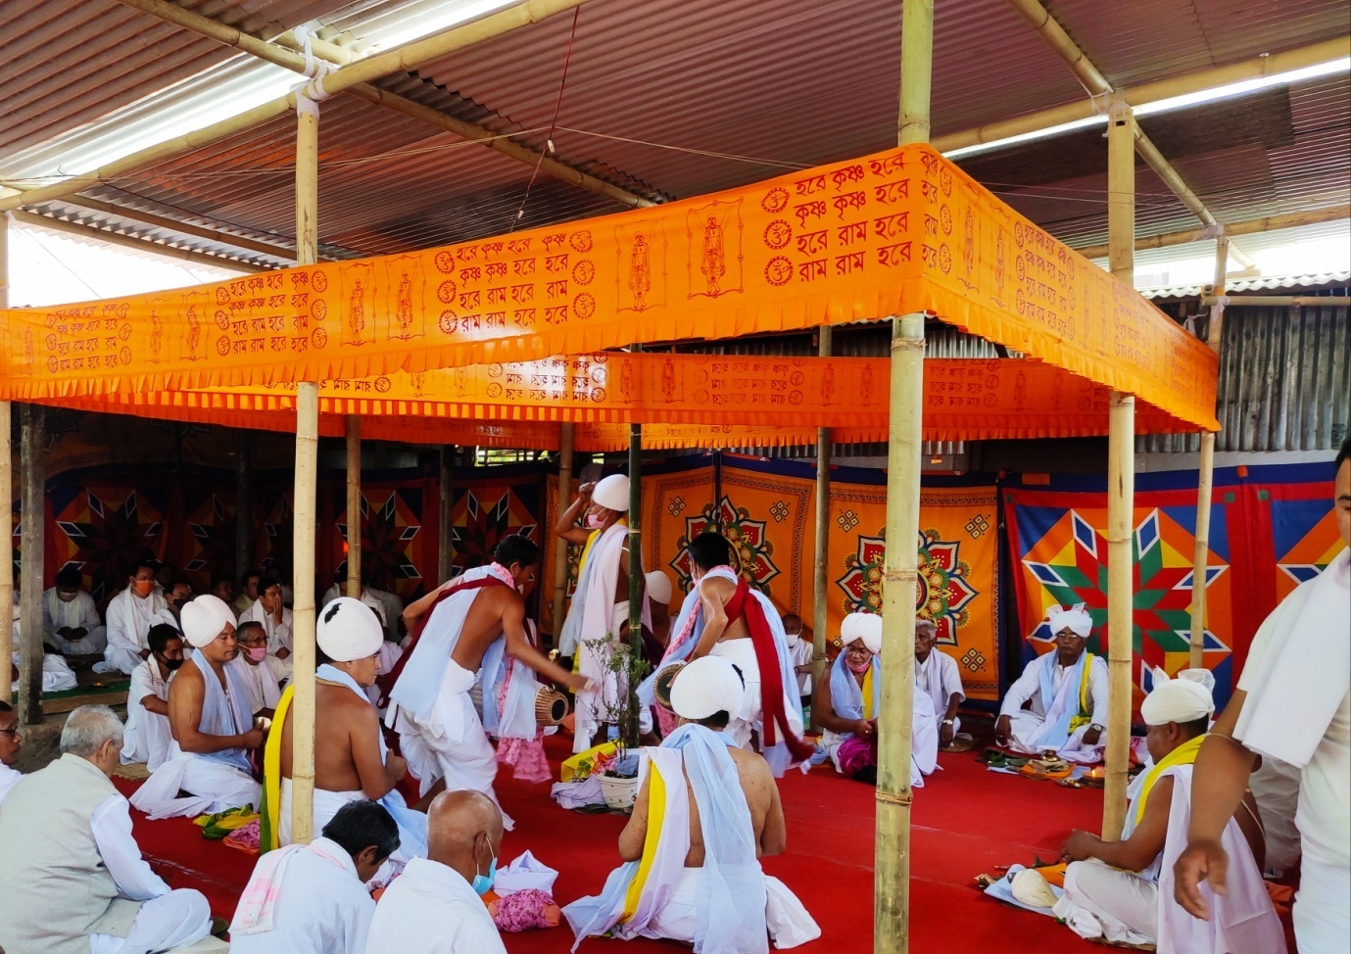
Manipuri Nata-Sankirtana is a unique type of performing art form where Manipuri male musicians or artistes sing Sankirtana using musical instruments such as Pung (a Manipuri percussion musical instrument) (Figure 2) by Pungyeiba (Pung player), Kartal (a Manipuri cymbal) (Figure 3) by Eshei-sakpa (singers or vocalist) and Moibung (Conch Shell) (Figure 4) by Moibungkhongba (conch blower or conch sound producer) by following its prescribed sequence. It is developed under the Guru-Shishya parampara tradition where pupils stay at the house of Guru or come from their respective places everyday. Bhakti, true service and discipline are the most important qualities of such unique art form. There is no exact date about the introduction of Manipuri Sankirtana though some probable years are obtained through research on historical records. But from the historical evidence, the exact date and time can be traced about the use of the term Nata-Sankirtana performance for first time.
Figure 1: A Ritualistic Nata-Sankirtana Performance

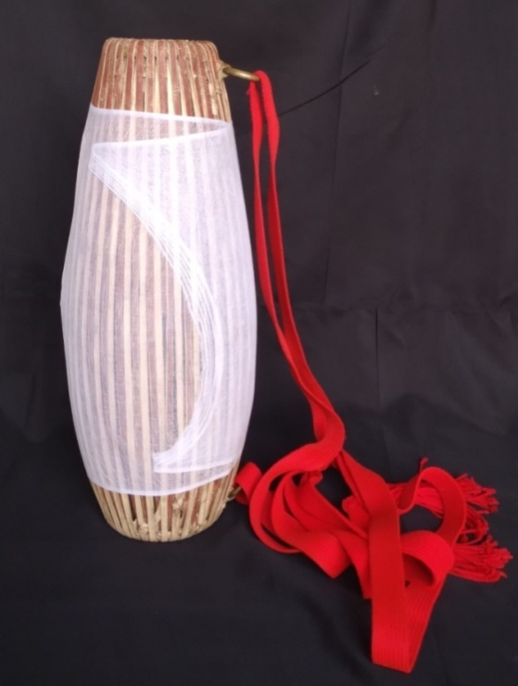

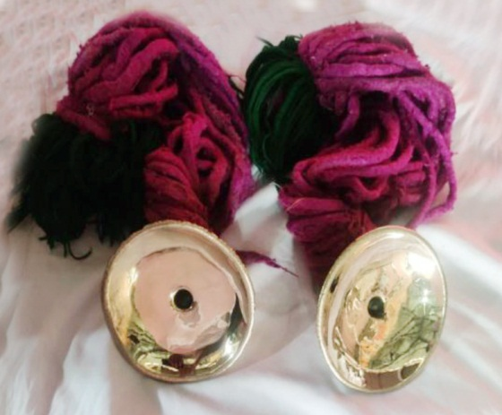

Figure 3: Kartal
Figure 2: Manipuri Pung

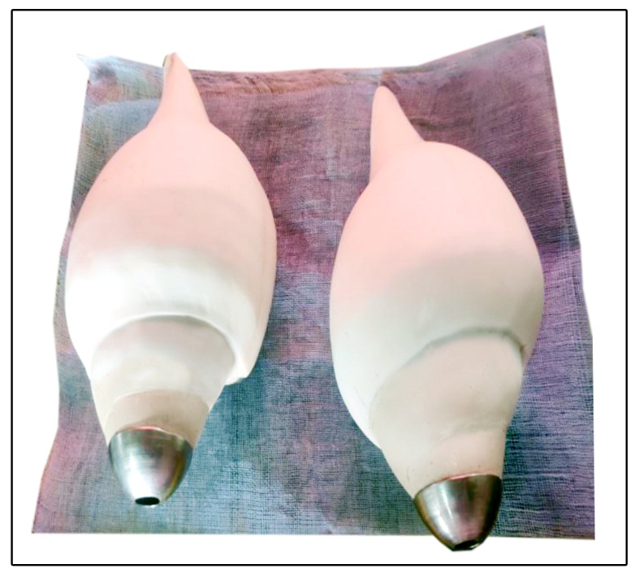

Figure 4: Moibung

A. Origin and Development of Manipuri Nata-Sankirtana
The origin and development of Manipuri Nata-Sankirtana can be seen in the following different stages:-
- Vishnu Puja was done during the reign of King Kiyamba (1467-1508) by offering prayer. An idol of God Vishnu was given to him as a gift by Pong King Choupha Kikhomba, his royal kingly friend in the form of Vishnu Chakkra (the idol standing on a Garura about five inches). This led to the start of Hindu praying style in Manipur.
- Manipuri Kirtan singing was first started during the reign of King Khagemba (1597-1652). Vishnu as a Godhead was recognised during his time. Aarti was offered to the God with devotional songs. Brahman Bhabaninath did the Puja and three other Kirtanyas (those who sang Kirtan) namely; Jadavdas, Devidas and Gouridas sang devotional songs for a month. The singing style of Bangla Kirtana was fused with Manipuri tunes.
- King Charairongba (1697-1709) took the initiation of sacred thread in 1704 which was a clear indication of starting Hinduism in Manipur.
(Parratt, The Religion of Manipur) “In the year 1626 sak (1704 A.D) the month of Sajibu (March/April) began on a Saturday. On the 5th day, a Wednesday, King Charairongba and those who were to take the sacred thread fasted on that very same day. They took the sacred thread on a subsequent day.” (p. 142)
It was at this time that for first time, temples dedicated to Hindu deities were erected. In 1707, a Vishnu temple was established which clearly indicated the acceptance of Vaishnavite faith by royal king. Brahman Raibanmali was his Guru. So, Hinduism had got the royal support. Singing of Kirtan was started in the birth and death related rituals.
(Ibungohal and Khelchandra) “In the year 1629 sak (1707 A.D.) the month of Kalen (April/May), 29th Friday started the erection of Krishna Kiyong (temple).” (p. 114)
- Under the rule of King Garibniwaz (1709-1748), Hinduism was accepted as a state religion. He took Upanayana towards the end of Mera (Septembar/October) in 1717 from Guru Gopal Das. A temple of Krishna was also made and dedicated in1732. Many customary rituals were performed with Sankirtan in the service to the God. In 1776, Sanitdas Gosai, a Ramandi cult follower from Narsingha Tilla in Sylhet along with his associates Bhagavan Das and Narayan Das arrived at Manipur from a passage called Ngaprum Chingjen. He made Garibniwaz a devotee of Ramandi religion and introduced Ramandi religion in Manipur. He along with other followers, 300 in number took initiation into the new religion in 1737. He also made the King to install the idol of Ram named Ramji Prabhu at Wangkhei Ningthem Pukhri Mapal which is still there at present time too.
An amalgamation of Hindu culture and original Manipuri culture could be seen clearly at this period which led to a new Manipuri Gaudiya Vaishnavism. So, a new Sankirtana singing style (Bangdesh), dance and music, cholom, culture, custom and tradition were evolved. Santidas made to use the name of God Rama in the raga singing of Bangdesh Pala Sankirtana, the first and oldest Manipuri Sankirtana performance style. The ritual of Sankirtana performance at that time was very simple. Instead of using Pung and Kartal brought by Kirtanyas from outside, newly designed Manipuri Pung (Ariba Pung) and Kartal were used. The King consulting the renowned Gurus of that time, a new pattern, form and manner for performing Sankirtana was introduced.
(Nilakanta, Manipuri Performing Art) During the reign of Great Manipuri King Garibniwaz (1707-1748) who adopted Ramandi cult, an old school of Kirtana singing under the style of Bangdesh/Ariba pala became popular and is still reserved and practised at the royal palace and some other centre of Manipur.
(Ibungohal and Khelchandra) “In the year 1666 sak (1746 A.D.) the month of Ingngel (July/August), 24th Wednesday, Kirtan was sung on the Phiroi (first death anniversary) of Sija Khuraileima Punyabati.” (p. 114)
There is another evidence of performing Sankirtana in dead Shradha ceremony of King Garibniwaz by his son, King Bharat Sai in 1752.
There were people who did not want to mix Ramandi religion with the Hindu Vaishnav religion. This led to the formation of two religious paths, one the Ramandi religion and the other Manipuri Vaishnav Sampradai of Vishnu. So, two different ways of Sankirtana singing viz. Vishnu Upasak and Ramandi religion had been introduced.
According to K.B. Singh (1963), there were three distinct stages which marked the introduction of Vaishnavism in Manipur. In 1704, the first emissaries of the new faith arrived. These were of the school of Nimbarka and the missionary involved had the same name as the sect’s founder, Nimandi sect. King Charairongba and his family were initiated into this. The second one is the Ramandi cult. A Brahmin, Santidas Gosai came to Manipur from Sylhet and introduced the worship of Ram and Hanuman. He became the Guru of King Garibniwaz and the Ramandi School replaced that of Nimbarka. The third one is the school of Chaitanya. King Bhagyachandra replaced the earlier two schools. The Kirtan is one important aspects of this faith which became very significant in Manipur leading to the development of unique Manipuri Nata-Sankirtana performing art form. Wearing Pheijom ( a way of putting Manipuri dhoti), sacred thread (Luggun), tulsi beads (Urik) and putting sectarian marks (Chandan), etc. are its significant qualities.
- The new Gaudiya Vaishnavite religion in Manipur reached its zenith during the reign of King Bhagyachandra (1759-1798). His time was a golden era in the history of Manipuri culture. All the past events were assimilated with the charm of new culture and practices. He again confirmed Chaitanyaite Vaishnavism as the state religion and introduced different kinds of innovative art forms into the religious life. So, Vaishnavite forms of worship continued and Sankirtana were also held in many ritualistic activities. Bhagyachandra was a committed Krishna devotee in the cult of Chaitanya Mahaprabhu. He took initiation from Rupa Parmananda in the lineage of Narottam Das Thakur.
The most significant contribution of the King was the introduction of Manipuri Jagoi Ras (an Indian Classical dance) and creation of more refined Manipuri Sankirtana form. On 12th of Hiyanggei (November/December), Friday, 1776, the idol of Shree Govinda was installed at the palace of Langthabal in Canchipur. After this, again in 1779, he introduced Jagoi Ras performance for the first time. The Ras dance lasted for five days upto Hiyanggei Purnima (full moon day). Before the start of this dance, male artistes performed Manipuri Nata-Sankirtana (the first use of the term) as Purvaranga. This was the first ever Nata-Sankirtana performance which we witness in the present day too. The Bangdesh Pala which was introduced during King Garibniwaz, making some changes in Pung, Kartal, costumes and singing style, King Bhagyachandra gave the name Nata-Sankirtana to this unique performance. From that onwards, Nata-Sankirtana performance was done in different services to Gods and Goddesses, ritualistic activities and ceremonies related from birth to death of Manipuri Vaishnavite society. Bhagyachandra had put his stamp on Manipuri religion by bringing his own particular genius into the Vaishnavite worship of Krishna. He destined to re-establish Sankirtana Mahayajna, the religion of the Kali yuga, in Manipur.
- During the reign of King Nara Singh (1844-1850), a separate pala consisting of only females of King’s clan Jalakeli Pala was introduced. It was given the name Raseshori Pala. Other developments were also made in Nata-Sankirtana ritualistic performance.
- A more refined and complete form of ritualistic Manipuri Nata-Sankirtana performance developed during the reign of King Chandrakriti (1850-1886).
- Nata-Sankirtana songs were sung in Bengali and Sanskrit languages. But during the reign of King Churachand (1891-1941), the singing in Manipuri language in Bengali script was introduced. It was fully utilised during the time of King Bodhachandra (1941-1955). So, under the great and dedicated support of the royal clans, the ritualistic Manipuri Nata-Sankirtana performance flourished and developed in the true service of renowned and scholar Gurus. It has been brought forward in such Guru-Shishya tradition.
(Chatterji, 1950) stated that Manipur Hinduism gradually became a synthesis of the old Meitei religion with its gods and goddesses and myths, its own legends and traditions, its social customs and usages, and its priests and ceremonials, and of Brahminical Hinduism with its special worship of Radha and Krishna. It is this synthesis which is today the essence of the religion of Manipur.
So, the Vaishnavism practised in Manipur became a peculiarly Manipuri Vaishnavism in form, adopting aspects of Meitei culture and being modified by it.
Nata-Sankirtana performance is a performing art form which is a composite version of music and body movements. The artistes use their whole body from head to toe to perform. At present, Manipuri Nata-Sankirtana performance can be considered in two different aspects, the one which is associated as a ritualistic performance and the other as an entertainment or stage performance. So, this particular paper is going to discuss and analyse these two areas in detail.
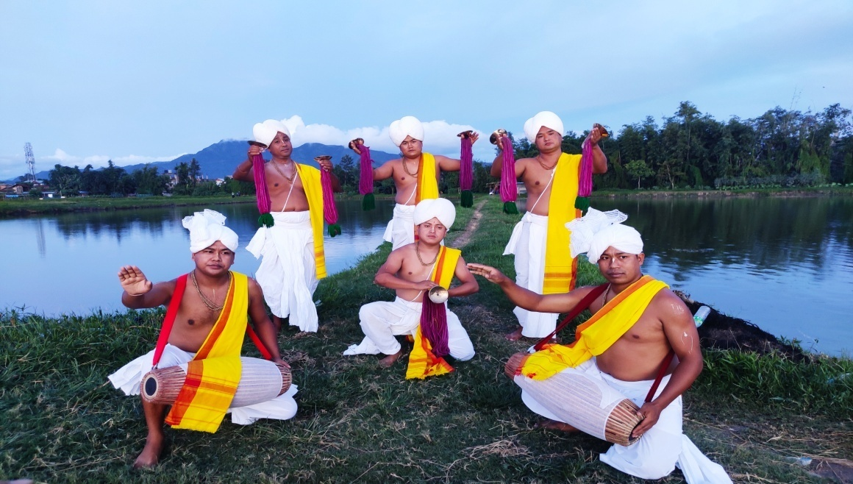

Figure 5: Nata-Sankirtana Cholom for Stage Performance

II. Objectives of the study
The following are the objectives of the present study:-
- To understand Manipuri Nata-Sankirtana as a ritualistic performance
- To know Nata-Sankirtana as an entertainment or stage performance form
III. Methodology of the study
- Method- Descriptive method is used in the present study
- Tools and Techniques- The tools and techniques of interview and observation (both participant and non-participant of the researcher) is being used in the present study
IV. Results and Discussion
Using interview and observation, the researcher identifies the different aspects of Manipuri Nata-Sankirtana performance. First one is the sacred original ritualistic Nata-Sankirtana performance and another one is Nata-Sankirtana performance for stage presentation or as a Show.
In ritualistic event, the Nata-Sankirtana which was performed as a Purvaranga before the start of first Manipuri Raas Leela in 1779, during the reign of King Bhagyachandra, is the very beginning of such kind in Manipur. The five head performers in that ritualistic performance were
- King Bhagyachandra- Pungyeiba (head Pung performer)
- Guru Premananda- Pung Tunginba (accompanied Pung performer)
- Guru Ngoubram Sai- Esheisakpa (head vocalist)
- Guru Dhara Sai- Duhar (head repeater vocalist)
- Guru Sidhanta- Khonpangba (head helper singer)
Being a form of worship and prayer, a Mahayajna, the requirements for doing Nata-Sankirtana ritualistic performance are:-
- The performance place (Mandap)- The performance area is temporarily constructed on the courtyard of the house where the ritual is going to be held or uses a permanently built one which is attached to temples. The temporary made Mandap has 9 pillars, jatra (the foundation pillar) at the centre and remaining 8 pillars forming a square demarcation. It has 2 entrances or exits. If the Mandap is attached to a temple, then it has 12 pillars without foundation pillar at the centre. It has only one entrance or exit. The central portion of the Mandap is called Mandali. At this place, a plantain leaf with a piece of cloth is kept as a symbol of seat (ashana). Other Puja materials such as incense sticks (dhup), light (thaomei), fruits (heiruk), betel nut and leaf (kwa tangga) are placed in front of the ashana as doing Mandali Puja.
- The performing artistes Pung performers (Pungyeiba) who use Pung percussion instrument and Singers (Esheisakpa) who use Kartal instrument which are together called Nata-Pala. They are the main performers of this ritualistic Nata-Sankirtana performance. Along with them, there is another artiste called Conch shell sound producer or blower (Moibung khongba).
- Arrangers (Arangpham)- They will make arrangement and preparation for all the required materials, customs and formalities associated with ritualistic Nata-Sankirtana performance to be done.
- The Presiding Brahmin (Mandap Mapu)- He is the person who is going to chant Hari Dhwani (the announcement of Lord’s victory) to start the ritualistic performance process. He is responsible for all the outcome of the process, to make correction if there is any wrong or unwanted situation occurs. So, he needs to be well educated who has full knowledge of Veda, Shastra, Nata-Sankirtana taal, rhythm, etc.
- Viewers or audience- They are an important part in the successful conduct of the ritualistic Nata-Sankirtana performance. They are also taking part in the worshipping process.
The traditionally constructed 7 different parts or sequences of ritualistic Nata-Sankirtana performance are:-
- Raga- The very beginning of Nata-Sankirtana starts with Hari Dhwani by Mandap Mapu playing Pung Raga, conch sound and kartal sound and then by Raga of song. This is invocatory and spiritualistic in nature calling Gouranga Maha Prabhu or Radha-Krishna in the Mandali Ashana to enter the sacred place of worship.
- Raga Taba or Goura Chandrika- It highlights the life of Lord Gourangga at Nabadweep. It is prayer to Gourachandra Maha Prabhu.
- Mel- It signifies the union and synchronization of song, Pung and Kartal playing simultaneously with body movements bringing a complete whole in its fullest. It is the climax portion of Nata-Sankirtana performance. In another sense, it is the process of Lord Gourangga imbibing Radha-Krishna bhava. It is the union or consummation of Radha-Krishna through symbolic representation. It is also doing Puja to Ista Devata.
- Tanchap- It is the resting or bishram bhava and invocation of Gourangga who is devoted to the love of Sri Radha-Krishna.
- Menkup- It is the expression of Radhika’s thought which is absorbed in the love of Sri Krishna. It is also the destination of her thought process, showing madhur prem (among affairs) and her adoration.
- Swadhin- It is the end of divine merry making and again resting. Here, different types of songs can be brought up as freedom is given here, the real Shastra Puja process ends in the previous stage.
- Vijai- it is the end part of the ritualistic Nata-Sankirtana performance. Nityai Pad, chanting the names and glory of Nityainanda and Chaitanya is performed. The invocated spirit which was called at the beginning of the process is again sent back to the heaven, the abode of Lord. In this way, the ritualistic performance completes.
So, the life of the people of Manipuri Gaudiya Vaishnavism is associated by Nata-Sankirtana ritualistic performance at various stages starting from birth (Swasthi Puja on the sixth day). Karnavedha (ear piercing ceremony or Jeigya), Upanaya or taking of sacred threads ceremony (Lugun thangba), marriage ceremony (Luhongba), death related ceremonies like cremation, Asti Sanchaya, Shraddha, Feroi (first death anniversary), etc. This is also performed in consecration of temple (Mandir hongba), inauguration of pond (Pukhri hongba), regeneration of trees (U-hongba), etc. Different religious festivals and ceremonies are also done along with Nata-Sankirtana ritualistic performance at different seasons of the year. Such process can be truly witnessed at Shree Shree Govindaji Temple situated at King’s palace, Imphal where asthakal seva (service) is being performed everyday.
There is another ritualistic Nata-Sankirtana performance called Dhrumel which is the highest and biggest form of Hari Sankirtana Mahayajna. It is a very unique form of Nata-Sankirtana. In it, there are 14 Pung percussionists with or without singers. The same sequence of ritualistic process is also followed here but with some complicated formalities added to it. There are four types of Dhrumel which were introduced by different Kings for different occasions and events. They are 1) Maha Dhrumel 2) Goura Dhrumel 3) Nityai Dhrumel 4) Devi or Lairembi Dhrumel. It was belived that sins committed by Manipuri Kings in the battlefield were cleansed and for the welfare of the land, Dhrumel was conducted.
- Maha Dhrumel was composed during the reign of King Bhagyachandra. But it was presented on the death anniversary of the King by his son King Labanyachandra (1798-1800).
- Goura Dhrumel was composed during King Gambhir Singh’s rule. But it was presented on the death anniversary of the King by King Nara Singh.
- Nityai Dhrumel was presented by King Chaurajit at Langthabal palace but started by King Marjit which was performed at Cachar due to Seven Years Devastation (1819-1926).
- Devi Dhrumel was offered to Durga Devi by King Chandrakriti. So, it is performed only for Goddess Durga during Durga Puja and Basantri Puja. The other three Dhrumel always accompany singers in Nata-Sankirtana performance but Devi Dhrumel can be performed only by 14 Pung percussionists without singers or along with singers.
Apart from the ritualistic Nata-Sankirtana performance at Mandap, Nata-Sankirtana performance on stage for entertainment and functions is also witnessed which is different from the ritualistic one. It has got different forms like Pung Cholom (solo or group), Kartal Cholom (solo or group), Pung-Kartal Cholom in group, Nata-Sankirtana performance taking some sequences from the ritualistic performance and presenting on stage with or without singing, etc. This is also another aspect of Nata-Sankirtana performance. There are certain rules, tradition and formalities to be maintained in ritualistic performance. But when it comes to stage presentation, what makes the audience satisfy and fruitful, is composed creatively and innovatively. Here making the viewers more pleasing and enchanting is the utmost priority. It is more on commercialization. But this is also another way to showcase the rich cultural heritage, the unique performing art form Manipuri Nata-Sankirtana to the outside world. Cholom is the body movements and gestures performed by the Nata-Sankirtana artistes by using music of Pung and Kartal with or without the accompaniment of songs in a specific time measures and rhythm.
- Pung Cholom- The Cholom done by Pung Performing Percussionist using Pung instrument to the punglons or drum beats. It can be performed solo or as a group. In such stage performance, singers can be used as an accompanist on the backstage or can be done without singers.
- Kartal Cholom- The Cholom done by Singers using Kartal with or without songs. Here also, solo or group performance can be done. The Pung percussionist is used as an accompanist on the back stage. The artiste(s) may or may not sing songs.
- Pung-Kartal Cholom- This is a combined performance of both Pung Percussionists and Singers together. The singers may or may not sing songs. The basic foundation of creative composition for all these three types can be any part(s) from sequences of ritualistic Nata-Sankirtana performance. So, different varieties of innovative compositions are created for stage presentation.
- By using only the sequence of ritualistic Nata-Sankirtana performance and dropping all other formalities, the artistes can present a frame of Nata-Sankirtana performance on stage. But the traditionally constructed different stages of the ritualistic performance process are to be strictly followed and maintained. This can be done with or without singing songs by Singers. Many creative or acrobatic body movements can be inserted in between different portions which is the freedom obtained for creative stage presentation.
V. Conclusion
Manipuri Nata-Sankirtana as a performing art form can be considered in two different aspects. The one which is associated as a ritualistic Nata-Sankirtana performance for the people of Manipuri Gaudiya Vaishnavism from birth to death related rituals and other ceremonies and festivals and on the other way is the used of different parts of ritualistic Nata-Sankirtana performance for stage presentation which is having different types and names based on the manner in which it is being performed. Though this unique performing art form is being developed under the Guru-Shisya parampara originating from the home of the Guru, in order to preserve it and showcase to the outside world for doing research, many formal institutions are being set up in Manipur. Mention can be made of Jawaharlal Nehru Manipur Dance Academy, Imphal which is a constituent unit of Sangeet Natak Akademi was established in 1954. It offers Foundation, Diploma and Post Diploma courses on Nata-Sankirtana. It mainly tries to preserve the ritualistic Nata-Sankirtana performances going on the process of Guru-Shishya parampara. Another one is Manipur University of Culture which was established in 2016 under Manipur Satate Government. It offers Graduation, Post Graduation and Research courses focusing mainly on formal and academic aspect to deal with Nata-Sankirtana performances. Some areas of Nata-Sankirtana is also included in the curriculum of Graduation and Post Graduation of Dance courses of Department of Dance and Music, Manipur University which is under Central Government. Apart from these, there are many institutions which are established under Art and Culture department of Manipur State Government and Ministry of Culture, Government of India to preserve Manipuri Nata-Sankirtana. Thus, in the arena of performing art forms, Manipuri Nata-Sankirtana which is based on bhakti, occupies a unique place which is truly cherished by the whole world.

References

A. Chitreswar Sharma, A Collection of Nata Sankirtan and Its Related Forms, Imphal: JN Manipur Dance Academy, 2012.
A. Chitreswar Sharma, Manipuri Nata Sankirtana Vichar (Anisuba Saruk), Imphal: Aribam Chitreswar Sharma (Financial Assistance CIIL), 2002.
E. Chaobhal, Cholom, Imphal: Laihui Publishers, 2002.
E. Nilakanta, Aspects of Indian Culture, Imphal: JN Manipur Dance Academy, 1982.
E. Nilakanta, "Manipuri Performing Art." A Vaishnavite Approach: Manipur Past and Present. Ed. Naorem Sanajaoba. Vol. 2. Delhi: Mittal Publication, 1991, pp. 258.
E. Radharani, "A Study on Nata Sankirtana of Manipur," unpublished.
L. Dhaka, Manipuri Nata Sankirtana Eshei Sheirol, Thoubal: Dhaka Publications, 2007.
L. Ibungohal, and N. Khelchandra, Cheitharol Kumbaba, Imphal: Manipuri Sahitya Parishad, 1989.
M. Thoiba Singh, "Manipuri Nata Sankirtana as a Mahayajna," Voice of Research 5.3, 2016, pp. 12-15.
M. Thoiba Singh, Facets of Manipuri Culture, Imphal: Yaibiren Communications, 2014, pp. 47-60.
P. Ashis Sengupta, Facets of Tabla Playing, New Delhi: Kanishka Publishers, 2011.
R. Waikhom, "A Historical Study of Traditional Manipuri Theatre (From Ancient Times to 1947)," unpublished
Rk. Danisana, Manipuri Dances [A Panorama of Indian Cultures], New Delhi: Rajesh Publications, 2012.
S. Gopal, MRIDANGAM An Indian Classical Percussion Drum, Delhi: B.R. Rhythms, 2004.
S. Nalini Parratt, The Religion of Manipur, Calcutta: Firma KLM Private Limited, 1980.

