Role of Artificial Intelligence in Remote Area Medical Services

1. Ajay Ganesh J, MBBS
Junior Resident
Department of Physiology
Lala Lajpat Rai Memorial Medical College, Meerut
2. Snehlata Verma, MD, FIACM, FUPDA
Associate Professor
Department of Medicine
Lala Lajpat Rai Memorial Medical College, Meerut

Introduction
India as an aspiring nation has made big strides in the healthcare sector in recent years showing its strength to the world in pharma, telemedicine, and traditional medicine. Although India achieved them, the services are yet to reach everyone within the nation as shown by the Economic Survey. A study by Global Burden of Disease Study 2016 found out that India lacks accessibility and quality of healthcare and was ranked only 145th out of 180 nations(1). With advancements in new futuristic technologies, India can leverage the latest developments to make healthcare services feasible and accessible to millions of citizens.
Medical Manpower in India
India is on the right foot for making highly trained manpower in the ever-expanding healthcare sector with 4.7 million workers as of 2021(2). That is a huge improvement from 0.83 million healthcare professionals to over 1.3 million in November 2021 according to data in national and state medical council’s registered allopathic doctors with recognised medical qualifications. India has an abundance of highly trained medical professionals to its competitive advantage. As of 2021 India now has around 4.7 million workers making the healthcare industry one of the largest employment provider. A study by the Aspire Circle India could reach its healthcare sector worth USD 7 Billion by 2030 by generating better accessibility to health insurance, health awareness, healthy lifestyle and more income(3). India’s attractive investment packages and low labour costs are driving todays foreign businesses and researches. A highly skilled pool of Doctors and hospitals have already made India an attraction for medical tourism and have a significant role in the field for upcoming years. The low medical care costs have certainly attracted people all over the world coming to India for treatment options. India’s massive population, growing supply chains, a strong start-up ecosystem with easy access to venture capital along with aspirational entrepreneurs will provide the backbone for Indian healthcare Industry to reach new milestones in the coming years.
Drawbacks
Even though India made large strides in healthcare it still suffers from some serious drawbacks. They are inadequate healthcare capacity building like infrastructure, accessibility to health services, quality of healthcare services, health spending and quality health insurance. One of the major concern is Government’s lack of sufficient financing options for research and development in major institutes. The GDP spend on healthcare on 2021-22 budget was a mere 2.1 percent compared to the might of 10 percent in Japan, Canada and France(4). India’s preventive healthcare measures even though proven very effective have had a lot of patient dissatisfaction and suffered monetary loss. Even with a large pool of healthcare workers it’s still behind WHO’s recommended levels of doctor to patient ratio. In that sense India is still behind six hundred thousand Doctors(5). In one of the studies of a minister of Parliament India was short of a lot of doctors. In a world where private healthcare is getting more and more expensive, public healthcare is lacking essential services, underdeveloped health insurance ecosystem one must look forward into futuristic technologies that could end these weaknesses.
National Initiatives
India has taken the foremost and essential steps to apply futuristic technology in healthcare by launching a national digital health mission. It Introduced a digital health identifier to save the patient data that could aid targeted policymaking. The data could also help private firms to bring innovative health insurance ecosystem. The strategic spending by private firms on health market could bring easier access to rural people for affordable healthcare insurance schemes. This also opens door for multiple innovative flagship solutions like Internet of Things in medicine, immersive augmented and virtual reality treatment modalities, autonomous monitoring of patient data, cloud computing and it’s electronic management of big data(6). The tricking down approach will be highly effective due to rural programmes like AKSHAYA initiative, ANGANWAADI programme and primary healthcare centres. Linking private practitioners to national health grid would also prove an inclusive and accessible approach to digital health services and monitoring.
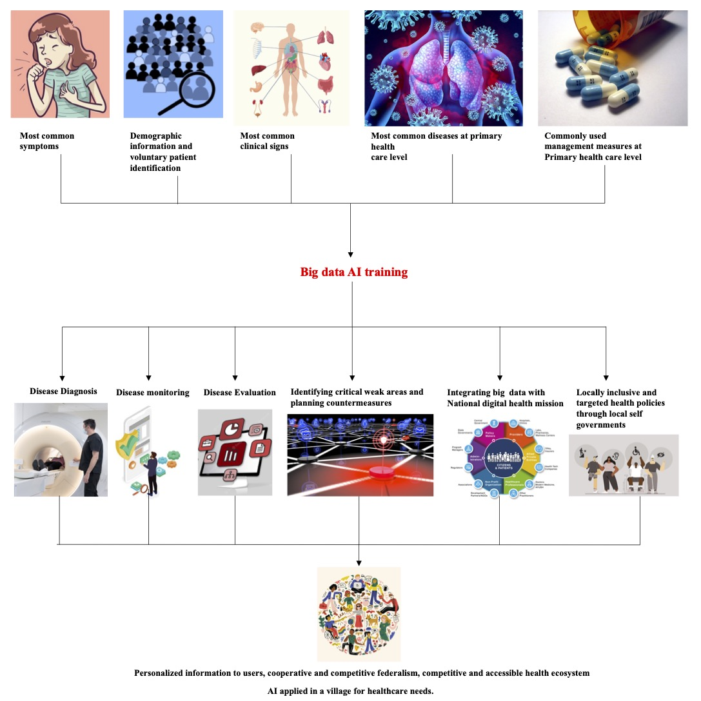
The Internet of Things
The Internet of Things can be used to produce products that require less or no human involvement to offer health care services, as India might still fall short of the WHO-recommended doctor-population ratio of 1:1,000 by 2030. With connected medical devices, equipment and infrastructure numerous applications are now feasible like automatic disinfection, artificial intelligence diagnostic methods and remote area patient care. A combination of sensory data, automatic processing and connected network enables real time diagnosis, monitoring, health tracking and appropriate management solutions(7). Even at a primary healthcare level this can bring unique experiences in notification of drug usage, staying alert with recent announcements of healthcare centre and monitoring progress for the patient at their fingertips.
AR and VR
There is a rising trend among Indians for mental health disorders and lifestyle diseases. Families have been devastated by the disease’s effects. India still lacks the infrastructure necessary for these people to receive proper treatment and rehabilitation. Applications for VR range from helping with physical and cognitive rehabilitation to exposure treatment for anxiety disorders(8). It is also worth noting that augmented and virtual reality will be effective in training doctors and other healthcare professionals, especially in the field of surgical procedures. This will be greatly beneficial for healthcare professionals for remote area training purposes to get updated with new developments in healthcare and management protocols.
Telemedicine
Telemedicine and remote diagnostic developments have given rise to the treatment of patients using online tools, platforms, and communications(9). Due to the growing number of highly skilled doctors, India has enormous potential in this sector. In India, the telemedicine market was estimated to be worth close to 830 million dollars in 2019. The market was worth $647 million the previous year. Since 2010, the country's telemedicine market has been steadily expanding, and from 2020 to 2025, it is projected to increase at a CAGR of 31%. Telemedicine, teleradiology, telepathology, and teleconsultation are examples of implementations. As time goes on, it is anticipated that telemedicine will become more prevalent as a way to close the public health gaps and help the government achieve its goal of creating a "Digital India." By reducing the load on the current healthcare systems, doctors will be able to consult with patients easily and issue prescriptions remotely using digital platforms. This also establishes a distinct line between critical and non-critical illnesses: whereas patients with critical conditions must visit hospitals, those with non-critical illnesses can receive expert advice from the comfort of their homes, relieving pressure on hospital staff and cutting down on travel time.
Artificial intelligence (AI) is already influencing how we live our daily lives, thus it can no longer be regarded as science fiction. AI is becoming more adept at performing human tasks, but it does so more quickly, efficiently, and affordably. The use of AI in healthcare has immense promise, and its use is improving patient care and outcomes all across the world. Digital health innovations during the Covid-19 pandemic revolutionised how millions of people received medical care, accelerating the adoption of digital tools including telehealth platforms, mobile symptom monitors, and autonomous remote monitoring. According to CB Insights, India saw funding for the AI industry to increase by 108% in 2021, with healthcare accounting for nearly a fifth of the total funding(10). AI algorithms are now being used in healthcare for early disease identification, drug development trials, accurate patient monitoring, and self-care. According to statistics, India would invest US$11.78 billion in its primary sector AI by 2025, increasing its GDP by US$1 trillion by 2035. This is already becoming a reality thanks to new firms like HealthifyMe, DocTalk, Tricog and others(11).
Cloud Computing and Data Digitisation
To bridge the gap in the disparity of accessibility of healthcare services in rural areas compared to urban areas, cloud computing enables medical practitioners to set up technical health services. Access and identity management are integrated with network, security, billing, monitoring, and warnings. The reports are accessible to patients at any time and from any location in their mobile devices. With the new services, patients can receive the proper care more quickly and efficiently while also being monitored by doctors in real-time. Additionally, it performs clinical data analysis, offers insightful clinical information and offers interactive dashboards for remote and digital healthcare services in India. Medical institutions will inevitably need data scientists in the future as massive data will be produced by the digitization of medical records. Big data enables healthcare providers to save and keep more patient data. Many corporate hospitals are already enjoying the fundamental advantages of medical records, which motivates the improvement of electronic data administration. More patient information could be saved because to electronic data management. Such easily accessible data could be the raw material for rapid increase in clinical researches. Electronic management also makes it possible to organise information more effectively and to repurpose narratives for diagnoses and treatment strategies. As India’s children still suffers from malnourishment these technologies could be ground-breaking for better health awareness to rural people
Conclusion
The healthcare sector is always evolving thanks to the creation of new ideas, technology, and methods for giving people better treatment. We can anticipate numerous changes in the healthcare sector as technology advances. To benefit the most from the industry's advancements it may not require for anyone to seek an expensive private centre anymore. It could be in a nearby public primary healthcare centre. As everyone getting more and more equipped with digital devices the experiences could now be accessible to all at their fingertips. Let’s hope that India can leverage these new technologies and bring a new generation of healthy citizens in the near future.

References
1. Global, regional, and national incidence, prevalence, and years lived with disability for 328 diseases and injuries for 195 countries, 1990–2016: a systematic analysis for the Global Burden of Disease Study 2016. Lancet Lond Engl. 2017 Sep 16;390(10100):1211–59.
2. EconomicSurvey2023Q44O.pdf [Internet]. [cited 2023 Jul 17]. Available from: https://static.pib.gov.in/WriteReadData/userfiles/file/EconomicSurvey2023Q44O.pdf
3. Inc42_Edtech_Report_updated.pdf [Internet]. [cited 2023 Jul 17]. Available from: https://aspirecircle.org/wp-content/uploads/2021/04/Inc42_Edtech_Report_updated.pdf
4. dgsum.pdf [Internet]. [cited 2023 Jul 17]. Available from: https://www.indiabudget.gov.in/doc/eb/dgsum.pdf
5. Hitting the road to alleviate India’s rural doctor shortage - PMC [Internet]. [cited 2023 Jul 17]. Available from: https://www.ncbi.nlm.nih.gov/pmc/articles/PMC2679820/
6. National Digital Health Mission | Make In India [Internet]. [cited 2023 Jul 17]. Available from: https://www.makeinindia.com/national-digital-health-mission
7. Javaid M, Khan IH. Internet of Things (IoT) enabled healthcare helps to take the challenges of COVID-19 Pandemic. J Oral Biol Craniofacial Res. 2021;11(2):209–14.
8. Donnelly MR, Reinberg R, Ito KL, Saldana D, Neureither M, Schmiesing A, et al. Virtual Reality for the Treatment of Anxiety Disorders: A Scoping Review. Am J Occup Ther. 2021;75(6):7506205040.
9. Chellaiyan VG, Nirupama AY, Taneja N. Telemedicine in India: Where do we stand? J Fam Med Prim Care. 2019 Jun;8(6):1872–6.
10. CB Insights Research [Internet]. [cited 2023 Jul 17]. Understanding Generative AI’s Potential in Healthcare. Available from: https://www.cbinsights.com/research/briefing/generative-ai-in-healthcare/
11. Leading AI Healthcare Startups in India - Analytics Drift [Internet]. [cited 2023 Jul 17]. Available from: https://analyticsdrift.com/leading-ai-healthcare-startups-in-india/

