CHAPTER NAME: RECENT TRENDS TO DETECT ENDODONTIC MICROBES

AUTHORS: Dr K SATHYA NARAYANAN, Dr ANGEL MARIYAM JOHN, Dr NEELA SHIVA TARUN

ORGANIZATION NAME: SATHYABAMA DENTAL COLLEGE AND HOSPITAL, CHENNAI

CONTENTS

INTRODUCTION

TRADITIONAL METHODS

LIMITATIONS OF CULTURING METHODS

MOLECULAR BIOLOGY TECHNIQUE

DNA-DNA HYBRIDIZATION

FLOURSCENCE INSITU HYBRIDIZATION

ADVANTAGES AND DISADVANTAGES OF MOLECULAR METHODS

CONCLUSION

REFERENCES

INTRODUCTION

Multispecies biofilms are the major form of bacterial organization in infected root canals. In these structures, different bacterial species are near one another and interact with other species. The prevalence of biofilms and their association with diverse presentations of apical periodontitis were only recently disclosed in a study by Ricucci and Siqueira (2010).
The endodontic microbiota has been traditionally investigated by the microbiologic culture method. Unfortunately, not all microorganisms can be cultivated under artificial conditions, and this is simply because the nutritional and physiologic needs of most microorganisms are still unknown. To sidestep the limitations of culturing, tools, and procedures based on molecular biology have become available and have substantially improved the ability to achieve a more realistic description of the microbial world without the need for cultivation. Bacterial community structures can be analyzed via pyrosequencing technology and by fingerprinting techniques such as denaturing gradient gel electrophoresis (DGGE) and terminal restriction fragment length polymorphism (T-RFLP). Fluorescence in situ hybridization (FISH) can measure the abundance of target species and provide information on their spatial distribution in tissues. Variations in PCR technology can also be used to type microbial strains (Siquiera and Rocas, 2004).

METHODS FOR BACTERIAL IDENTIFICATION

Microscopies, Transmission electron microscopy, scanning electron microscopy, and newer techniques in molecular biology have also been developed through the years aimed at giving a detailed understanding of the microbial composition of the root canal flora. Newer techniques will complement or even change our future opinions on the natural history and complexity of the root canal flora (Woo et al., 2008).

FIVE GENERATIONS OF ENDODONTIC MICROBIOLOGY STUDIES

- First-generation studies were Culture-dependent (broad range) and revealed many cultivable species in association with apical periodontitis.
- Second Molecular methods (e.g., PCR and its derivatives, original checkerboard assay) Closed-ended (species-specific). Target cultivable bacteria confirmed and strengthened data from the first generation allowed the inclusion of some culture-difficult species in the set of candidate endodontic pathogens.
- Third Molecular methods (e.g., PCR-cloning-sequencing, T-RFLP) Open-ended (broad range) allowed a more comprehensive investigation of the bacterial diversity in endodontic infections. Not only cultivable species but also as-yet-uncultivated and uncharacterized bacteria were identified.
- Fourth Molecular methods (e.g., PCR, microarrays, reverse-capture checkerboard) were species-specific and targeted cultivable and as-yet- uncultivated bacteria. Large-scale clinical studies to investigate the prevalence and association of species/phylotypes with endodontic infections.
- Fifth Molecular methods (e.g., pyrosequencing) are a broad range that permits a deep-coverage and more comprehensive analysis of the diversity of endodontic infections. (Grossman L et al,1967)

CULTURE-BASED ANALYSIS

Culture is the process of propagating microorganisms in the laboratory by providing them with the required nutrients and proper physicochemical conditions, including temperature, moisture, atmosphere, salt concentration, and pH (Slots, 1986). The steps involved in culture-based studies are;
    - Sample collection and transport,
    - Dispersion
    - Dilution
    - Cultivation
    - Isolation
    - Identification
    - identified based on multiple phenotype-based aspects
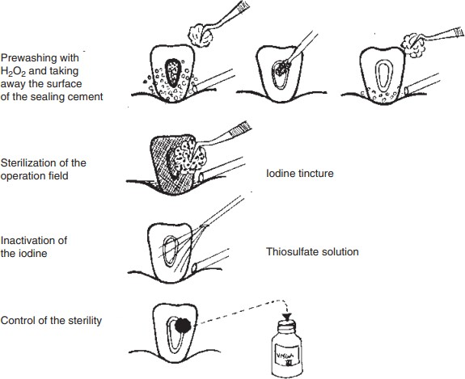
Endodontic samples are collected and transported to the laboratory in a viability-preserving, non-supportive, anaerobic medium. Followed by dispersing the sample using various techniques, diluting, and cultivating it in suitable culture media. Then the identification of microbes is made using various methods like gram-staining, gas-liquid chromatography, gel electrophoresis, fluorescence under ultraviolet light, microscopic techniques, etc. (Keijser et al., 2008).
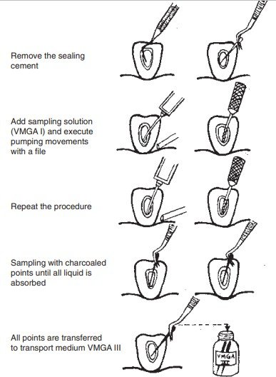

LABORATORY CONSIDERATIONS

The objectives are;

  - To identify the presence of viable bacteria in the sample

  - To determine the bacterial genus or species present in the sample

  - To obtain a semi-quantitative measure of the bacterial load

Liquid media are mostly preferred in laboratories. One of the advantages of using liquid media is that it allows the growth of fastidious and dormant microbe cells. There is no need for extra equipment for the anaerobic bacteria to grow, if tubes are filled with nitrogen gas during inoculation. If bacterial inoculation is done under anaerobic conditions and the bottom part of the tube is filled with bacteria, the tubes are capped tightly (rubber stopper), and the medium itself will ascertain anaerobic conditions even for the most oxygen-sensitive bacterial species.
Solid media (brucella agar plate, blood agar plate) to complement the liquid media, separate aerobic incubation, and anaerobic incubation jars are used to disclose the diverse microbial species and for the quantification of microbes grown in the liquid media. For the identification of microbial species and genera further biochemical tests, selective media, or gram staining should be carried out. (Fouad 2009).
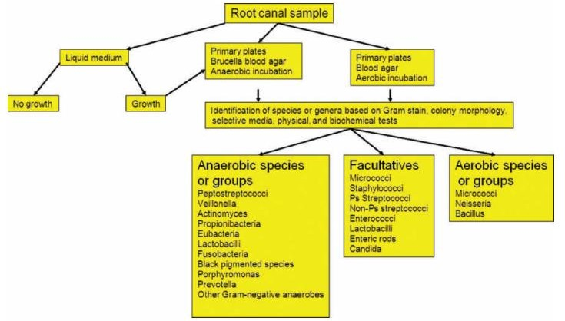

Culture media detect both cultivable and as-yet-uncultivated species and strains. High specificity and accurate identification of strains with ambiguous or aberrant phenotypic behaviour is an advantage of culture media. It has high sensitivity and detects species directly in clinical samples. Culture media is found rapid and most assays take no more than minutes to a few hours to identify a microbial species. There is no need for carefully controlled anaerobic conditions during sampling and transportation. Culture media can be used during antimicrobial treatment. The samples can be stored frozen for later analysis. The DNA can be transported easily between laboratories while using culture media. (Engelkirk PG et al, 1992)

LIMITATIONS
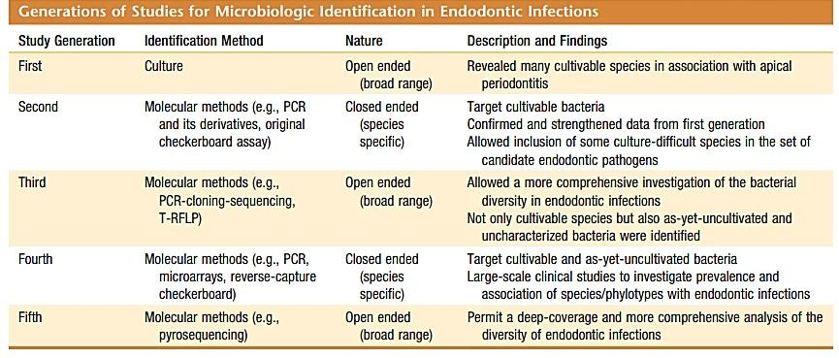
The limitations of culture media include the impossibility of culturing a large number of extant bacterial species, and the recovery of viable bacteria is also limited. It has a low sensitivity and specificity is dependent on the experience of the microbiologist. Extensive expertise and specialized equipment are needed to isolate anaerobes. Rather it takes several days to weeks to identify most anaerobes. The mode of sample transport is also of utmost importance. The sample requires immediate processing. It is costly, time-consuming

MOLECULAR METHODS

Molecular methods are based on the identification of certain genes that are unique to specific bacterial species (Woese; 2000; Wade; 2004). 16S and 23S rRNA genes are the genes mainly used for microbial identification in molecular biology techniques. The advantages of using the small subunit rRNA genes for microbial identification are that it is found in all organisms and it is long enough to be highly informative and short enough to be easily sequenced (particularly with the advent of automated DNA sequencers) and afford reliability for inferring phylogenetic relationships (Woese;1987).
Thus, the 16S rRNA gene (or 16S rDNA) of bacteria and archaea and the 18S rRNA gene (or 18S rDNA) of fungi and other eukaryotes have been extensively examined and used for identification. Some regions are virtually identical in all representative of a given domain (conserved regions) and other regions vary in sequence from one species to another (variable regions). Conserved and variable regions of genes are used in the case of broad-range and species-specific identification methods respectively. Variable regions contain the most information about the genus and species of the bacterium, with unique signatures that allow specific identification.
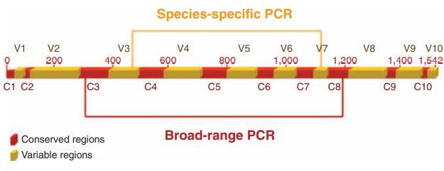
FIG 14: 16S rRNA gene (rDNA). Areas in yellow correspond to variable regions, which contain information about the genus and the species. Red areas correspond to conserved regions of the gene. Primers designed on these areas are used in broad-

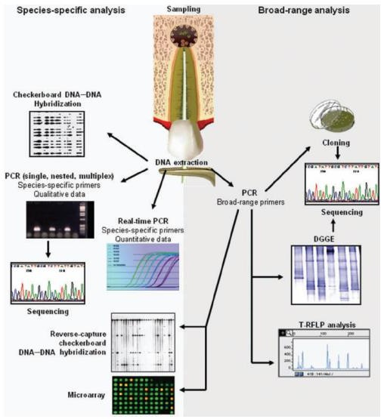
FIG15: Molecular biology methods used in the study of endodontic infections. The choice for a particular technique will depend on the type of analysis to be performed

PCR- Polymerase Chain Reaction

The invention of PCR (Kary Mullis, 1983) revolutionized the branch of molecular biology. In modern days, it is possible to isolate any gene from any organism and can be used for genome sequencing studies. It amplifies as few as one copy of a gene into millions to billions of copies. The basic steps involved in PCR include;
- The target DNA serving as the template is denatured (melted) at temperatures high enough to break the hydrogen bonds holding the strands together, thus liberating single strands of DNA.
- Two short oligonucleotides (primers) anneal to complementary sequences on opposite strands of the target DNA. Primers define the two ends of the amplified stretch of DNA.
- A complementary second strand of new DNA is synthesized through the extension of each annealed primer by a thermostable DNA polymerase in the presence of excess deoxyribonucleoside triphosphates.
- All previously synthesized products act as templates for new primer extension reactions in each ensuing cycle. The result is the exponential amplification of new products.
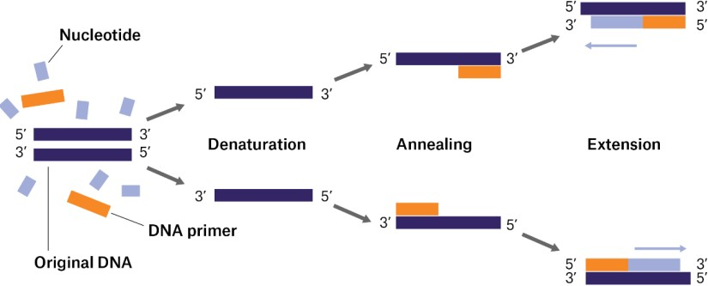

FIG 16.

There are several methods to check if the intended PCR product was generated. The most commonly used method for detecting PCR products is electrophoresis in an agarose gel.

Agarose Gel Electrophoresis

A small portion of the PCR reaction sample was taken into the gel and an electrical gradient was applied through the buffer solution. Based on the size of the products, they migrate through the gel and the larger products run a shorter distance in the gel, experiencing more resistance in the gel matrix. DNA ladder digests represent DNA fragments of known size and are run in the same gel to serve as molecular size standards, based on which the size of the PCR products will be estimated. The gel is usually visualized using ethidium bromide staining and ultraviolet transillumination. Designed primers are expected to generate a PCR product of a given size and observation of a band of the predicted size in the electrophoretic gel is consistent with a positive PCR result.
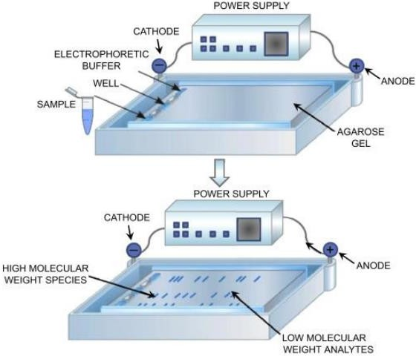

FIG 17.

The identity of PCR products should be confirmed by one of the following methods:

Sequencing of the PCR product

Hybridization of a specific oligonucleotide probe to a region of the PCR product that is internal to the priming sites
Amplification
Restriction enzyme cleavage of the PCR product using an enzyme that is known to cut a specific sequence within the product (restriction fragment length polymorphism—RFLP).

PCR and its derivatives

Species-specific

By this method, the variable regions of the 16S rRNA gene are most commonly used to detect and design primers specific to bacterial species. Using public databases that contain the 16S rRNA gene sequences from a vast number of oral bacteria, primers can be designed to specifically detect virtually every cultivable and as-yet-uncultivated oral species. Further with the help of agarose gel electrophoresis, the PCR product of the predicted size is determined and shows the occurrence of the target species in the sample. The best way to check the specificity of the assay is by sequencing the PCR product.
The specificity of the PCR assay can be increased by using a touchdown procedure. By this approach, the annealing temperature in the initial PCR cycle is set several degrees above the calculated melting temperature (Tm) of the primers. In succeeding cycles, the annealing temperature is decreased by 0.5– 2◦Cper cycle until a temperature is equal to, or 2–5◦C below, the Tm of the primers has reached. This technique has been considered useful in avoiding the

amplification of spurious DNA fragments (non-rRNA gene fragments and/or fragments with improper sizes)(Don et al., 1991).

Multiplex PCR

James et al. (2003) introduced multiplex PCR for the detection of GM soybeans. Multiplex PCR is a process where multiple primer pairs are used to simultaneously amplify several sequences in a single reaction (Chamberlain et al., 1988)(while common assays detect single species). Since more than one unique target sequence in a clinical specimen can be amplified at the same time, multiplex PCR assays permit the concomitant detection of different species. Multiplex PCR assays help to minimize the time and expenditure needed for detection approaches. Primers used in multiplex assays must be designed carefully to have similar annealing temperatures and avoid complementarity among them (Siqueirajr & Rocas, 2005).
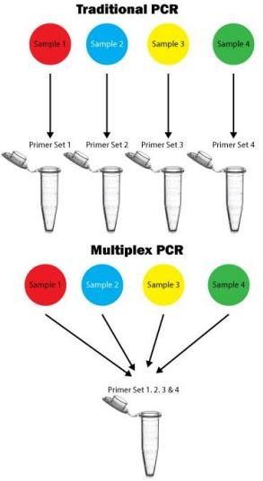

FIG. 17

Nested PCR

Nested PCR (nPCR) is a conventional PCR method that involves two separate reactions for amplifying the target region of DNA. In the first reaction, the outer primer pair is amplified and in the second reaction, the internal primer pair is amplified. The first PCR products are used as templates in the second round of amplification with a separate primer set, which anneals internally to the first products and generates a shorter amplified fragment (Haqqiet al. 1988).
It is a highly sensitive technique that detects target DNA several folds lower than conventional PCR. It involves a large number of cycles that add complexity to the procedure. It shows reduced background of eukaryotic DNA and other regions of the bacterial DNA making it difficult to distinguish with the target. The major drawback of the nested-PCR protocol is the high probability of contamination during the transfer of the first-round amplification products to a second reaction tube (Siqueirajr & Rocas, 2005).

Reverse transcriptase-PCR

Reverse transcriptase-PCR (RT-PCR) was developed to amplify RNA targets with the aid of the enzyme reverse transcriptase, which can produce a strand of complementary DNA (cDNA) from an RNA pattern. Most RT-PCR assays employ a two-step approach. In the first step, reverse transcriptase changes RNA into single-stranded cDNA. In the second step, PCR primers, DNA polymerase, and nucleotides are added to create another strand of cDNA. Once the double-stranded DNA is formed, it can be used as a template for amplification as in conventional PCR. This process can be modified into a one-step method by using it directly with RNA as the template. In this approach, an enzyme with both reverse transcriptase and DNA polymerase actions is used, (such as that from the bacteria Thermus thermophilus (Klara Abravaya, 2011; Siqueirajr & Rocas, 2005).

Quantitative PCR

Quantitative PCR (Q-PCR) can be performed using three distinct assays: most probable number (MPN)-PCR, competitive PCR, and real-time PCR. Of these, the real-time PCR method has been the most widely used approach, mostly because it is a high-throughput technique that is more accurate and precise than the other q-PCR assays, and requires no post-PCR manipulation steps, reducing the risks of contamination.
Recently, several commercially available systems have been developed that are capable of detecting the presence of a target within 30 to 120 minutes using PCR; this process is referred to as “real-time” PCR. Real-time PCR indirectly measures the production of DNA which is proportional to the fluorescence emitted and detected by closed tube format by a fluorimeter combined with the PCR thermocycler. This technology allows for high throughput of samples, multiplexing reactions, quantitation of target, and online monitoring. It is the most commonly employed method of PCR for the identification of microorganisms in which the PCR product is detected in real-time, by using a fluorescently labelled probe:
  - SYBR Green
  - Taq Man probe
  - Molecular beacon
Real-time PCR assays allow the quantification of individual target species as well as total bacteria in clinical samples (Klara Abravaya, 2011).

SYBR Green
It is the simplest and most affordable method of RT-PCR. It consists of a fluorescent dye that binds to double-stranded DNA. During extension, increasing amounts of dye bind to the increasing amount of newly formed double-stranded DNA. Dye that remains unbound exhibits little fluorescence in solution. The SYBR Green assay is very sensitive but has diminished specificity, as the dye binds to all double-stranded DNA present, and primer dimer may result in a false reading.

TaqMan method
This is another method of RT-PCR that uses a specific labelled oligonucleotide probe along with the primers. The TaqMan probe is a 20-to-30base-long oligonucleotide sequence that precisely anneals to a sequence lined by the two primers. The probe contains a reporter fluorescent dye at the 5’end and a quencher dye at the 3’end that quenches the emission spectrum of the reporter dye. As long as the probe remains bounded, it is intact and no signal is generated. During the extension step of real-time PCR, the Thermusaquaticus (Taq) DNA polymerase enzyme cleaves the TaqMan probe, resulting in the separation of the reporter dye from the quencher and increased fluorescence emission.
Maeda et al. (2003) reported no significant difference between the TaqMan and SYBR Green chemistry regarding specificity, quantitativity, and sensitivity for the detection of oral bacteria. The protocol used for the SYBR Green assay is usually simpler and less expensive than the TaqMan method.

Molecular beacons
Another real-time PCR assay uses molecular beacons, which are single-stranded oligonucleotides with a stem-and-loop structure. The loop sequence is complementary to a target sequence and is flanked by short complementary arms that form a stem. The oligonucleotide is labelled at one end with a fluorophore and at the other end with a quencher molecule. Free molecular beacons acquire a hairpin structure when in solution, and the stem keeps the arm nearby. This results in efficient quenching of the fluorescent dye In the stem-loop conformation, energy from the excited fluorophore is transferred to the quencher and released as heat instead of light, and after hybridization two ends will be separated and the energy from the excited fluorophore is emitted as light, generating a detectable signal (Klara Abravaya, 2011).
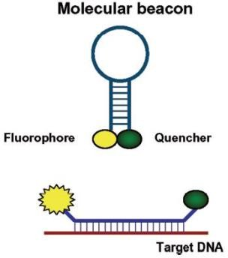

PCR-based microbial typing

PCR technology can also be used for clonal analysis of microorganisms. An example of the PCR techniques used for this purpose includes the arbitrarily primed PCR (AP-PCR), also referred to as random amplified polymorphic DNA.AP-PCR is a relatively rapid tool to determine whether two isolates of the same species are related. This method is based on the use of a single 10- to 20- 20-base-long random sequence primer that anneals to unspecified DNA target sites under conditions that allow for mismatched base pairing. The use of a random sequence primer at low stringency allows for priming at sites with imperfect matches.
Amplification will only occur when two primers anneal close enough to one another, in the proper forward and reverse directions necessary for the product to be formed. Genetic variations between two DNA templates result in discriminative DNA fingerprints because of the differences in the priming sites. The amplicons generated form a strain-specific pattern of about 5–15 bands per species in the electrophoretic gel (Spiegelman et al. 2005). The advantage of AP-PCR is its ability to furnish highly specific DNA profiles with no prerequisite for knowing the DNA sequences. Primers may also be designed to target known genetic elements, such as enterobacterial repetitive intergenic consensus sequences (ERIC-PCR) and repetitive extragenic palindromic sequences (REP- PCR. Clonal analysis may help elucidate whether certain strains of a given species are more associated with signs or symptoms of a given disease.
Clonal analysis may also help to track the origin of microorganisms infecting a given site. For instance, by comparing bacterial strains isolated from the root canal and the gingival sulcus or other oral sites, one can have information as to where bacteria present in the root canal system came from. Clonal analysis can also track the origin of the microorganisms present in a suspected focal disease by comparing the isolates found in this contrarily infected site with others present in the suspected original focus of infection (Siqueirajr & Rocas, 2005).

Broad range PCR

Broad-range PCR has identified various fastidious, as-yet-uncultivated bacterial pathogens from different human sites. In broad-range PCR, primers are designed that are complementary to conserved regions of a particular gene (mostly 16S rRNA gene) shared by a group of microorganisms. By using broad-range PCR and 16S rRNA gene clone library construction, one can identify virtually every bacterial species present in a sample (Conrads et al., 1997).
In this type of PCR, initially, bulk DNA is extracted directly from samples. Then 16S rRNA gene is isolated from the bulk DNA via PCR using specifically designed primers for conserved regions of the gene. Amplification with broad-range primers results in a mixture of the 16S rRNA gene amplified from nearly all bacteria in the sample. Hence there is a high risk for DNA from microbial contaminants to be amplified. For that, a wide range of precautions is necessary to avoid contamination, including separate rooms for pre- and post-PCR work, UV decontamination of surface areas, use of high-quality reagents, and adequate sampling techniques and vials for clinical specimens. Amplification with broad-range primers results in a mixture of the 16S rRNA gene amplified from nearly all bacteria in the sample. In mixed infections, direct sequencing of PCR products is not done because there are mixed products from the different species composing the consortium. Due to this, the products are cloned into a plasmid vector, which is used to transform Escherichia coli cells, establishing a library of 16S rRNA genes from the sample. The cloning procedure separates the sequences so that they can be characterized individually by sequencing. After the cloned genes are individually sequenced, the results are submitted for identification to databases.
A 98.5–99%identity in 16S rRNA gene sequence has been the most accepted criterion used to identify a bacterium to the species level. If a sequence exhibits low similarity scores (98.5–99%) to the other sequences from defined species in the databases, it potentially represents a new species. These new species are usually considered uncultivated and hitherto unknown bacterial taxa and an unofficial name is assigned (Drancourt et al., 2000; Woo et al., 2008).

Bulk nucleic acids are extracted directly from samples

↓

16S rDNA isolated via PCR with primers specific for conserved regions of the gene (universal or broad-range primers)

↓

Amplification of 16S rRNA gene

↓

In case of mixed infections, separate sequencing is done

↓

For that, PCR products are cloned into a plasmid vector

↓

Transforms Escherichia coli cells forming a cloning library of 16S rDNA

↓

Submitted for identification of bacterial species to the databases

↓

Sequenced individually

To improve the accuracy of the similarity method of broad range PCR phylogenetic method has also been developed. In this method, based on the dissimilarities in the variable regions of gene sequencing, computations are done to develop a phylogenetic tree (Leys et al. 2006). The relationships among various bacterial phylotypes (or taxa) are analyzed by special bioinformatic software and the results are shown in dendrograms or phylogenetic trees. The 16S rRNA gene can be used to establish phylogenetic relationships among bacteria even when sequences are derived from previously uncultivated and uncharacterized bacteria.
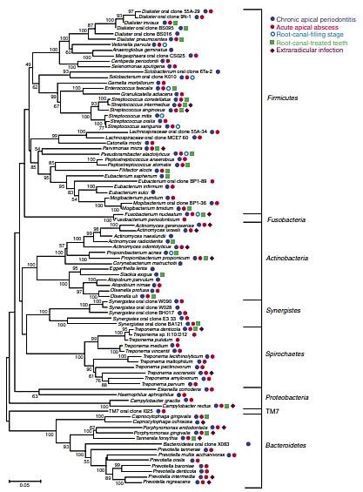

Bacterial flora in endodontic infections. Phylogenetic tree based on 16S rRNA gene comparisons showing several endodontic pathogens, their respective phyla, and the clinical conditions they have been associated with. Scale bar shows number of nucleotide substitutions per site

Denaturing gradient gel electrophoresis (DGGE)

It is one of the genetic fingerprinting techniques that determine the diversity of various microbial species living in diverse ecosystems and to understand microbial community behaviour over time. The DGGE technique is based on electrophoresis of PCR-amplified gene (usually 16S rRNA) fragments in polyacrylamide gels that contain an increasing gradient of DNA denaturants (mixture of urea and formamide). During the migration of PCR products in the gel, at certain points in the gel due to varying concentration gradients, it will become partially or fully denatured. Partial denaturation causes a significant decrease in the electrophoretic mobility of the DNA molecule. Different molecules with varying sequences may have a different melting behavior and will therefore stop migrating at different positions in the gel. The position in the gel at which the DNA melts will be determined by its nucleotide sequence and composition. DNA bands in DGGE can be visualized using ethidium bromide, SYBR Green, or silver staining (Chakraborty et al., 2014).

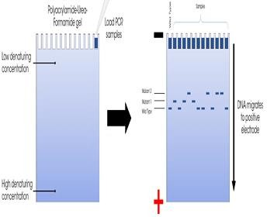

In DGGE, multiple samples can be analyzed concurrently, so that it helps to verify differences in microbial populations and the efficacy of various antimicrobials before and after their usage at various sites. Specific bands can also

be excised from the gels, re-amplified, and sequenced to allow microbial identification. Temperature Gradient Gel Electrophoresis (TGGE) also uses the same principle as DGGE, except for the fact that the gradient is temperature rather than chemical denaturants.
Terminal restriction fragment length polymorphism

Another method for the analysis of diverse microbial communities is Terminal restriction fragment length polymorphism(T-RFLP) which measures the size polymorphism of terminal restriction fragments from a PCR-amplified marker. In this technique, the initial step is PCR which causes the amplification of the 16S rRNA gene from different species in the sample. One of the PCR primers is labelled with a fluorescent dye. Then the PCR-amplified products are digested with restriction enzymes that produce fluorescently active terminal fragments of different lengths. These fragments are separated on high-resolution sequencing gel electrophoresis in an automated DNA sequencer to read both the size and the intensity of terminally labelled restriction fragments(T-RF), creating a typical profile (Cho & Tiedje, 2001).
The electrophoretogram represents the profile of a microbial community as a series of peaks varying in migration distance. In such a profile, size is represented on the horizontal axis, and intensity is represented on the vertical axis. In theory, each T-RF represents a single species. Extensive databases exist for 16S rRNA gene sequences and can be used to identify all T-RFs predicted from known sequences, considering a given set of primers and restriction enzymes. T-RF lengths are predicted by finding the restriction site closest to the site where the labelled primer will anneal and counting the number of nucleotides in between. Multiple restriction enzymes (four or five) are usually necessary to provide reliable identification since distinct species may generate the same T-RF when only one enzyme is used (Chakraborty et al., 2014; Fouad, 2009).
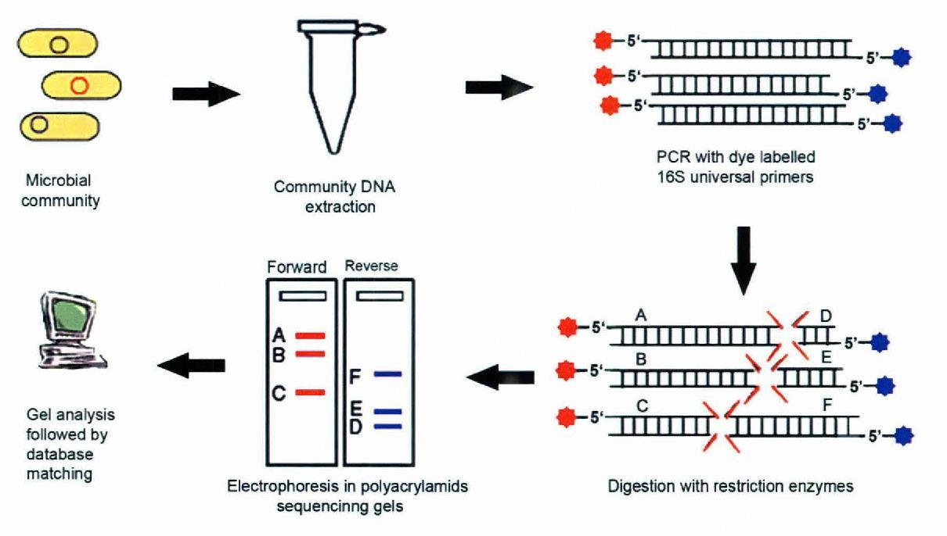

DNA-DNA Hybridization Assay

DNA–DNA hybridization methodology is the process of annealing the complementary bases of two single-stranded DNA molecules. These DNA probes are labeled with an enzyme, radioactive isotope, or a chemiluminescence reporter that can bind to their complementary nucleic acid sequences forming a new duplex molecule. The labelled duplex can then be detected.
Probes can be constructed from either whole genomic DNA or oligonucleotides. Whole genomic probes are more likely to cross-react with non-targeted microorganisms due to the presence of homologous sequences between different species. Oligonucleotide probes based on signature sequences of specific genes (such as the 16S rRNA gene) may display higher specificity since the known probe sequence allows calculation of stringent hybridization temperatures and mismatches are not tolerated due to the considerable reduction of bond strength between the short probe and the target.
Also, oligonucleotide probes can differentiate between closely related species or even subspecies and can be designed to detect as-yet-uncultivated bacteria (Cho & Tiedje, 2001).
Socransky et al. (1994) introduced a method for hybridizing large numbers of DNA samples against large numbers of digoxigenin-labeled whole genomic DNA or 16S rDNA-based oligonucleotide probes on a single support membrane—the checkerboard DNA-DNA hybridization method. It permits the simultaneous determination of the presence of a multitude of bacterial species in single or multiple clinical samples. It is particularly applicable in large-scale epidemiological research.

Checkerboard DNA–DNA hybridization-
Socransky et al. (1994) invented this technique for hybridizing large numbers of DNA samples against large numbers of digoxigenin-labelled whole genomic DNA on a single support membrane. The checkerboard method helps to determine the multitude of bacterial species in single or multiple clinical samples.
DNA collected from the samples is denatured and then fixed in a membrane and later placed on a Mini-blotter apparatus at an angle of 900. Digoxigenin-labelled whole genomic DNA probes are then loaded in individual lanes of the Mini-blotter so that the antibody to DNA probes conjugated with alkaline phosphatase and chemo-fluorescence or chemiluminescence is detected after hybridization. The presence of a spot on the membrane in the crossing lanes means that the hybridization of one probe to one sample occurred. The intensity of the spot is proportional to the amount of DNA from the target species in the sample. Another modification of the checkerboard method was proposed by Paster et al. (1998) which consists of a PCR-based, reverse-capture checkerboard hybridization methodology. The name reverse-capture’ because the probe is fixed first instead of the sample. This method is more specific than the original method, due to the presence of oligonucleotide probes. Moreover, oligonucleotide probes can be designed to detect both cultivable and as-yet-uncultivated bacteria, whereas, in the case of the original method which uses whole genomic probes, only cultivable species are identified.
The procedure circumvents the need for in vitro bacterial culture, necessary for the preparation of whole genomic probes in the original checkerboard approach. Up to 30 reverse-capture oligonucleotide probes that target regions of the 16S rRNA gene are deposited on a nylon membrane in separate horizontal lanes, using a Mini-blot apparatus. Probes are synthesized with a polythymidine tail, which is cross-linked to the membrane via ultraviolet irradiation or heat, leaving the probe available for hybridization. The 16S rRNA gene from clinical samples is PCR amplified using one of the primers labelled with digoxigenin. Hybridizations are performed in vertical channels in a Mini-blotter apparatus with digoxigenin-labeled PCR amplicons from up to 45 samples. Hybridization signals are detected using chemo-fluorescence or chemiluminescence procedures (Siqueirajr & Rocas, 2005).
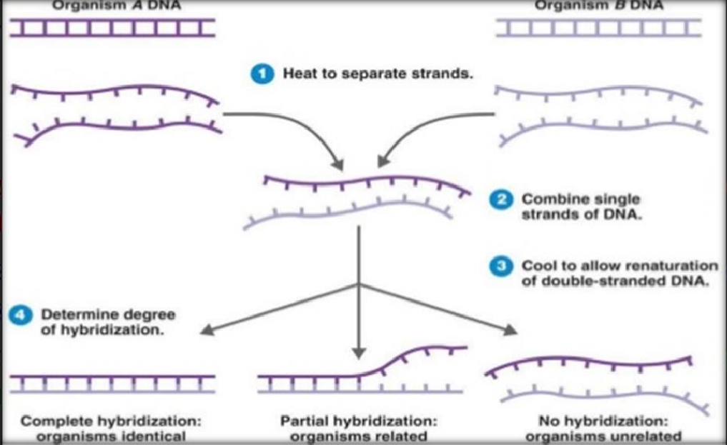

DNA microarrays

This method was introduced in 1995 by Schena et al. It is a simplified version of the checkerboard hybridization assay. It consists of a high-density matrix of DNA probes which are printed on a glass slide and are used to identify the target from the clinical sample. Targets will be incorporated with fluorescence and applied to an array, those that hybridize to complementary probes are detected using some type of reporter molecule. A high-resolution laser scanner is used for imaging and analysis by sophisticated computer software programs (Clarke & Zhu, 2006).
For detecting the oral microbial species, a DNA microarray technique is used, i.e. Human Oral Microbe Identification Microarray. This method can also be used for better detection and identification using PCR. When broad-range PCR is used to amplify DNA from samples of mixed infections, microarrays can then be used to identify the PCR products by hybridization to an array that is composed of hundreds to thousands of species-specific probes.
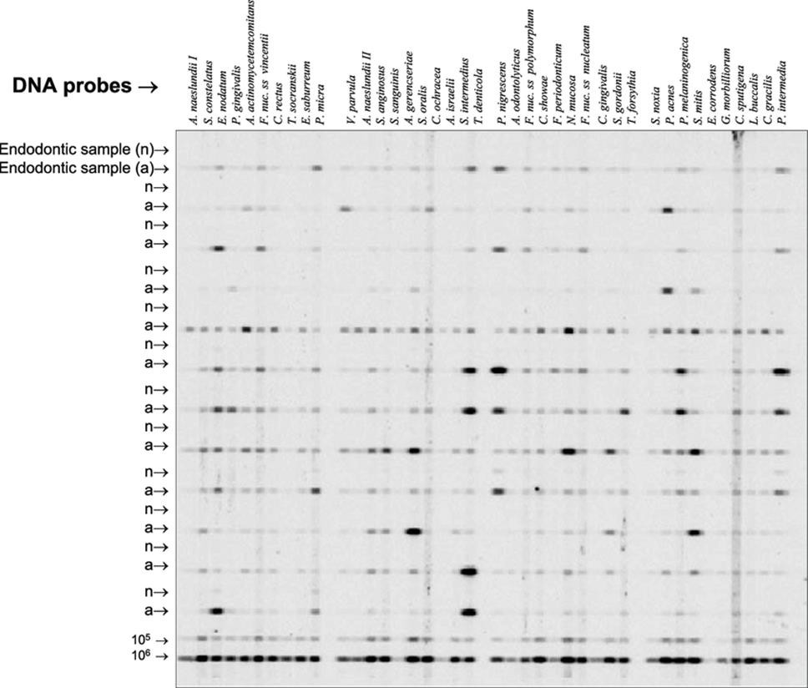
By using this method, a single hybridization approach can provide results as to the presence and levels of 200 target species/phylotypes at a time (Siqueira & Rocas, 2005; Smoot et al., 2005).

Fluorescence in situ hybridization
This method uses fluorescently labelled rRNA-directed probes and fluorescence microscopy to detect intact microbial cells directly in clinical specimens, in situ (Moter and Gobel; 2000). One of the greatest advantages of using fluorescence in situ hybridization (FISH) is that this technique allows identification while providing information about morphology, number, community architecture, and spatial relationships of microorganisms (Amann et al., 2001). Because oligonucleotide probes can be designed for use, FISH allows not only the detection of cultivable species but also the detection of as-yet-uncultivated phylotypes (Moter et al., 1998a, b). In FISH, microbial cells are fixed and then hybridized with rRNA-directed probes on a glass slide. Probes are short (15- to 25-base long) and labelled covalently at one end with a fluorescent dye. After stringent washing, cells are visualized by using a conventional epifluorescence microscope or a confocal laser scanning microscope. Multiple species-specific probes, each labelled with different.

Advantages of Molecular Genetic Methods
- Detection of not only cultivable species but also of uncultivable microbial species or strains.
- Higher specificity and accurate identification of microbial strains with ambiguous phenotypic behaviour, including divergent or convergent strains.
- Detection of microbial species directly in clinical samples, without the need for cultivation.
- Higher sensitivity.
- Faster and less time-consuming.
- They offer a rapid diagnosis, which is particularly advantageous in cases of life-threatening diseases or diseases caused by slow-growing micro-organisms.
- They do not require carefully controlled anaerobic conditions during sampling and transportation, which is advantageous since fastidious anaerobic bacteria and other fragile microorganisms can lose viability during transit.
- They can be used during antimicrobial treatment.
- When a large number of samples are to be surveyed in epidemiological studies, samples can be stored and analyzed all at once (Siqueira &Rocas, 2005).

- Limitations of PCR-derived technologies
- Most PCR assays used for identification purposes qualitatively detect the target microorganism but not its levels in the sample. Quantitative results can however be obtained in real-time PCR assays.
- Most PCR assays only detect one species or a few different species (multiplex PCR) at a time. However, broad-range PCR analysis can provide information about the identity of virtually all species in a community.
- Like DNA-DNA hybridization, most PCR assays only detect target species and consequently fail to detect unexpected species. This can be overcome by broad-range PCR assays.
- In addition to being laborious and costly, broad-range PCR analyses can be affected by some factors, such as biases in homogenization procedures, preferential DNA amplification, and differential DNA extraction.
- Microorganisms with thick cell walls, such as fungi, may be difficult to break open and may require additional steps for lysis and consequent DNA release to occur.
- False positive results have the potential to occur because of PCR amplification of contaminant DNA. The most important means of contamination is through carryover of amplification product and special precautions should be taken to avoid this.
- False negatives may occur because of enzyme inhibitors or nucleases present in clinical samples, which may abort the amplification reaction and degrade the DNA template, respectively. Analysis of small sample volumes may also lead to false negative results, particularly if the target species is present in low numbers (Siqueira & Rocas, 2005).

CONCLUSION
It is well established that bacteria are responsible for the development of pulpal and periradicular diseases and the presence of bacteria inside the root canal system or periapical tissue can alter the success rate of endodontic treatment. In primary endodontic cases root canal environment provides a better nutritional supply rich with peptides and amino acids for bacterial inhabitants of the root canal system. Whilst in the well-filled root canal most or all of the necrotic pulp tissue remnants are eliminated. Clinicians must understand the nature of polymicrobial endodontic infections and realize the importance of removing the reservoir of infection by endodontic treatment or tooth extraction. Endodontic biofilms are well-protected within the root canals of teeth and are difficult to access. Using the endogenous fluorescence of porphyrins and other bacterial metabolites for real-time detection and analysis of the presence and extent of these biofilms is a practical approach, with penetrating visible red light as the preferred excitation source. An optimal approach for biofilm removal will likely require the combination of several of the technologies discussed in this review, including improved methods for mechanical removal of biofilms using instrumentation combined with irrigation fluids, as well as enhanced chemical treatments and improved biocides that can inactivate microorganisms. As a result, there will be a need for decreased reliance on traditional antibiotics, and greater utilization of antimicrobial strategies for which the development of resistance is unlikely to occur. Recent advances in root canal disinfection using new technology and based on recent studies may improve the ability to disinfect the root canal system.
References
- Klara Abravaya. (2011). Molecular beacons as diagnostic tools. 2(3).
- Parsek MR, Greenberg EP. Sociomicrobiology: the connections between quorum sensing and biofilms. Trends Microbiol. (2005) 13:27–33. doi: 10.1016/j.tim.2004.11.007.
- Pickenpaugh L, Reader A, Beck M, Meyers WJ, Peterson LJ. Effect of prophylactic amoxicillin on endodontic flareup in asymptomatic, necrotic teeth. J Endod2001;27:53- 6.
- Peeters E, Nelis HJ, Coenye T. Comparison of multiple methods for quantification of microbial biofilms grown in microtiter plates. J Microbiol Methods. 2008;72:157–65.
- Pinheiro ET, Gomes BP, Ferraz CC, Teixeira FB, Zaia AA, Souza Filho FJ. Evaluation of root canal microorganisms isolated from teeth with endodontic failure and their antimicrobial susceptibility. Oral Microbiol Immunol 2003;18:100-3.
- Rôças IN, Jung IY, Lee CY, Siqueira JF, Jr. Polymerase chain reaction identification of microorganisms in previously root-filled teeth in a South Korean population. J Endod. 2004;30:504–508. 227.
- Ramirez T, Shrestha A, Kishen A. Inflammatory potential of monospecies biofilm matrix components. Int Endod J. (2019) 52:1020–7. doi: 10.1111/iej.13093.
- Siqueira JF, Rocas IN. Polymerase chain reaction-based analysis of microorganisms associated with failed endodontic treatment. Oral Surg Oral Med Oral Pathol Oral RadiolEndod. 2004;97(1):85-94.
- M. Sakamoto, I. N. Rôças,J. F. Siqueira Jr, Y. Benno, 2006, Molecular analysis of bacteria in asymptomatic and symptomatic endodontic infections, J. Molecular Oral Microbiology
- Siqueira, J. F., Rôças, I. N., & Lopes, H. P. (2002). Patterns of microbial colonization in primary root canal infections. Oral Surgery, Oral Medicine, Oral Pathology, Oral Radiology, and Endodontology, 93(2), 174–178. https://doi.org/10.1067/moe.2002.119910
- Siqueirajr, J., & Rocas, I. (2005). Exploiting Molecular Methods to Explore Endodontic Infections: Part 1—Current Molecular Technologies for Microbiological Diagnosis. Journal of Endodontics, 31(6), 411–423. https://doi.org/10.1097/01.don.0000157989.44949.26
- Slots, J. (1986). Rapid identification of important periodontal microorganisms by cultivation. Oral Microbiology and Immunology, 1(1), 48–57. https://doi.org/10.1111/j.1399-302x.1986.tb00318.x
- Smoot, L. M., Smoot, J. C., Smidt, H., Noble, P. A., Könneke, M., McMurry, Z. A., & Stahl, D. A. (2005). DNA Microarrays as Salivary Diagnostic Tools for Characterizing the Oral Cavity’s Microbial Community. Advances in Dental Research, 18(1), 6–11. https://doi.org/10.1177/154407370501800103
- Sanchez-Sanhueza G, Bello-Toledo H, Gonzalez-Rocha G, Goncalves AT, Valenzuela V, Gallardo-Escarate C. Metagenomic study of bacterial microbiota in persistent endodontic infections using Next-generation sequencing. Int Endod J. (2018) 51:1336–48. doi: 10.1111/iej.12953
- Saito D, Leonardo Rde T, Rodrigues JL, Tsai SM, Höfling JF, Gonçalves RB. Identification of bacteria in endodontic infections by sequence analysis of 16S rDNA clone libraries. J Med Microbiol. 2006;55:101–7.
- Siqueira JF, Rôças IN, Moraes SR, Santos KR. Direct amplification of rRNA gene sequences for identification of selected oral pathogens in root canal infections. Int Endod J. 2002;35:345–51.
- Siqueira JF, Jr, Rôças IN. Polymerase chain reaction-based analysis of microorganisms associated with failed endodontic treatment. Oral Surg Oral Med Oral Pathol Oral Radiol Endod. 2004;97:85–94. 228.
- Sundqvist G, Figdor D, Persson S, Sjogren U. Microbiologic analysis of teeth with failed endodontic treatment and the outcome of conservative re-treatment. Oral Surg Oral Med Oral Pathol Oral Radiol Endod. 1998;85:86–93.
- Sakamoto M, Siqueira JF, Jr, Rôças IN, Benno Y. Molecular analysis of the root canal microbiota associated with endodontic treatment failures. Oral Microbiol Immunol. 2008;23:275–281. 231.
- Waters, C. M., & Bassler, B. L. (2005). QUORUM SENSING: Cell-to-Cell Communication in Bacteria. Annual Review of Cell and Developmental Biology, 21(1), 319–346. https://doi.org/10.1146/annurev.cellbio. 21.012704.131001
- Woo, P. C. Y., Lau, S. K. P., Teng, J. L. L., Tse, H., & Yuen, K.-Y. (2008). Then and now: Use of 16S rDNA gene sequencing for bacterial identification and discovery of novel bacteria in clinical microbiology laboratories. Clinical Microbiology and Infection, 14(10), 908–934. https://doi.org/10.1111/j.1469-0691.2008.02070.x

