ROLE OF ARTIFICIAL INTELLIGENCE IN EMERGENCY MEDICINE

Mr. Jayasuriya M
Department of Trauma Care Management
School of Allied Health Sciences, Vinayaka Mission’s Research Foundation – DU,
AVMC & H Campus, Puducherry, India
E-mail: jaysuriya76@gmail.com

ABSTRACT
Artificial intelligence (AI) and machine learning algorithms are being used in emergency medicine for a variety of purposes, and this interest is growing. The field of artificial intelligence in medicine has benefitted greatly from the creation of ana effective informatics infrastructure. Artificial Intelligence (AI) and Machine Learning (ML) can process large volumes of healthcare data thanks to advances in computing and data storage. As a result, there’s plenty of room for growth in future emergency medicine research on the use of Artificial Intelligence and Machine Learning to solve clinical challenges. Emergency and Trauma Radiology is essential to provide patients visiting a hospital’s ED (Emergency Department) with high-quality care.

Keywords: Artificial Intelligence, Emergency medicine, machine learning.

- INTRODUCTION
With seemingly endless ways to improve patient care and optimize systems, artificial intelligence (AI) could be the next big technology to revolutionize healthcare delivery. Unlike other computer programs, machine learning (ML) and deep learning (DL) “learn” by constructing and testing inferences they make automatically from the analysis of large amounts of data. There’s a big difference between them and the rest of the computerized tools out there. Due to the unique nature of this particular clinical specialty, it’s no surprise that emergency medicine has been one of the first areas of discussion when it comes to applications for AI in healthcare. When it comes to emergency medicine, the promise of increased speed and accuracy offered by AI can’t be overstated. With increasing departmental flow issues and high-acuity patient demands for rapid and accurate decision-making, the potential for AI in emergency medicine has never been brighter.

ROLE OF ARTIFICIAL INTELLIGENCE IN EMERGENCY MEDICINE
- TRIAGE
Triage is the process by which patients are assessed as soon as they enter the ED and then prioritized based on the severity and urgency of their condition. The use of machine learning can improve the accuracy and effectiveness of triage while only requiring data that the triage staff collects on a regular basis [1]. Machine Learning can be used to develop screening tools to predict the risk of certain diseases as well as determining the severity of medical conditions.

- MEDICAL IMAGING
Emergency care providers don’t always have access to radiology interpretation. Accurately diagnosing a fracture on an x-ray image or a stroke on a magnetic resonance imaging scan typically requires immediate access to avoid false diagnostics and delays in treatment. With the help of advanced deep learning models, clinicians can identify life threatening pathologies faster with high sensitivity medical imaging. Recent reports suggest that AI interpretation is as good as a trained radiologist.

- MANAGEMENT AND OPERATIONS
Planning resources and managing crowds are essential in the emergency department (ED). Stochasticities in ED operations (e.g., patient arrival, type of medical treatment and diagnostic tests needed, duration of treatment and test, etc.) present unique challenges in anticipating future service demand [2]. In terms of ED operations, it would seem that the triage and radiology models would be adopted more quickly than in other areas. When input and output are provided from a system, a computer learns the relationship between the input and output. This is called machine learning.

- LANGUAGE PROCESSING
Another area in emergency medicine where AI is being used in natural language processing (NLP). Chatbots and voice assistants powered by AI can be useful. Patients are triaged and they receive basic medical care before they even get to emergency room advice. This may shorten wait times and enhance patient care.

- APPLICATIONS OF ARTIFICIAL INTELLIGENCE IN EMERGENCY MEDICINE

In the emergency room, AI supports doctors' diagnosis and treatment plans by using data analytics to support decision-making. Based on the data inputs, it can make recommendations about which diagnostics to run, saving time and money for both patients and hospitals. Based on the collected data, artificial intelligence can also assist in deciding whether a patient should be admitted or discharged [3]. AI can expedite the process of getting patients through the emergency room by automating tasks like scheduling follow-up appointments, prescribing medication, and planning out their course of treatment (Figure 1). AI can assist with the choices required to facilitate these transfers in rural areas where a transfer to a larger, regional medical facility is required.

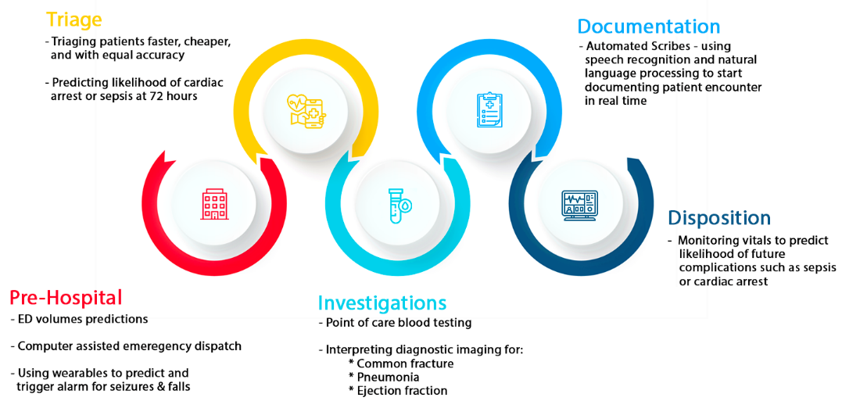

Figure 1 : Current applications of Artificial Intelligence in emergency medicine

- MACHINE LEARNING IN NEAR FUTURE
The AI system we’ll see in the next few years will be similar to what we’ve already seen. Systems that seem impossible or theoretical today will become feasible as training techniques evolve, computing systems improve, and training information becomes more readily available. Machine learning will read your medical history and pull relevant diagnoses and laboratory reports while a doctor administers a triage screen. [4]. Because it involves understanding the capabilities of technologies that haven’t even been invented yet, predicting the future of technology is at best challenging. At every stage of the patient journey, AI will have a positive impact on emergency & trauma radiology & clinical practice.
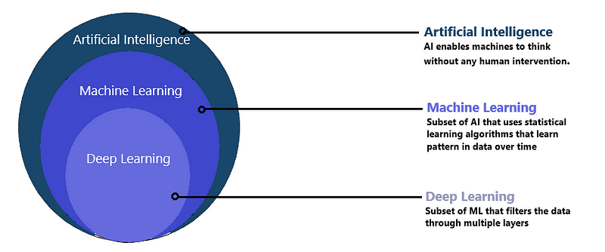
Figure 2 : Basic concept of Artificial Intelligence
- CONCLUSION
In the emergency room, AI holds out a lot of promise and has already made a difference in the effectiveness and caliber of some interventions. As with the adoption of any new technology, there are still obstacles to implementation, but as attitudes and laws surrounding it change, so too might those obstacles. Significant advancements are anticipated in the special environment of emergency departmental operations, emergency event prevention, and human performance due to a growing collaboration with AI.
REFERENCES
- Grant K, McParland A, Mehta S, Ackery AD. Artificial intelligence in emergency medicine: surmountable barriers with revolutionary potential. Annals of Emergency Medicine. 2020 Jun 1;75(6):721-6.
- Chenais G, Lagarde E, Gil-Jardiné C. Artificial Intelligence in Emergency Medicine: Viewpoint of Current Applications and Foreseeable Opportunities and Challenges. Journal of Medical Internet Research. 2023 May 23;25:e40031.
- Kirubarajan A, Taher A, Khan S, Masood S. Artificial intelligence in emergency medicine: a scoping review. Journal of the American College of Emergency Physicians Open. 2020 Dec;1(6):1691-702.
- AL O, EX F, RIMENTAL P, ICAL BM, IEN S. Artificial Intelligence in Emergency Medicine. Journal of Experimental and Basic Medical Sciences. 2023;4(1):33-6.
- Moulik SK, Kotter N, Fishman EK. Applications of artificial intelligence in the emergency department. Emergency Radiology. 2020 Aug;27(4):355-8.
- Liu N, Zhang Z, Ho AF, Ong ME. Artificial intelligence in emergency medicine. Journal of Emergency and Critical Care Medicine. 2018 Oct 26;2.

