A NOVEL PREDICTION MODEL FOR PSORIASIS SKIN DISEASE DETECTION USING COMPUTER VISION APPROACH.

Iyli Chiranjeevi  Department of Electronics and Communication Engineering ACED, Alliance University,  Bangalore, Karnataka, India.  Email: iylichiranjeevi03@gmail.com | K Sai Rishitha  Department of Information Technology ACED, Alliance University,  Bangalore, Karnataka, India.  Email: rishitha.kovur@gmail.com
Raksha S  Department of Electronics and Communication Engineering ACED, Alliance University,  Bangalore, Karnataka, India.  Email: Rakshasureshgowda2003@gmail.com | Neelapala Anil Kumar  Department of Electronics and Communication Engineering ACED, Alliance University, Bangalore, Karnataka, India.  Email: elegantanil2008@gmail.com

ABSTRACT:
According to the advanced overview, more than 125 million people are suffering from Psoriasis and skin cancer. The skin cancer rate has quickly increased over the last few decades, especially Melanoma is the foremost differentiating skin cancer. Dermatophytosis moreover incorporates a tall rate, particularly within the country zones.
If skin infections are not treated promptly, they can cause internal consequences, including the transfer of the disease from one person to the next. Skin diseases can be avoided by inspecting the polluted area as soon as possible. The qualities of the skin images have expanded, making it difficult task to design proficient and strong calculations for the planned identification of skin illness in its severity. Skin tone and colour are critical in detecting skin illnesses. Outwardly, skin colour and coarseness are unique. To differentiate various infections, programmed treatment of such images for skin investigation requires a quantitative discriminator. The proposed system is a combination demonstration for the detection and early detection of skin cancer, psoriasis, and Dermatophytosis [1]. Skin disease diagnosis is mostly based on several features such as shape, colour, surface, and so on. Skin infections have no medically recognised therapies. Different doctors will handle the same side effects in surprising ways. Early detection and treatment of skin diseases is a critical factor in their therapy. The proposed framework is used for the diagnosis of a variety of skin diseases using measurable parameter analysis. Measurable examination is at odds with irregular information examination. Irregular information is intended for skin diseases. [2]. A standard database is utilized for this information does not have any scientific expression; it has a few measurable properties. To examine irregular information, we must analyze factual properties of it.

Keywords-Artificial Neural Networks (ANN), Deep Learning, Image Processing, Median Filter, Over-the-counter (OTC), Supervised Learning

- INTRODUCTION
The objective of this venture is to execute a robotized discovery of skin malady utilizing computerized picture preparation. Utilizing MATLAB to extricate and distinguish the influenced region which can classify distinctive skin maladies like Psoriasis, Melanoma, and Dermatophytosis. An early avoidance of these illnesses makes a difference in empowering pharmaceutical to be performed to anticipate and indeed remedy these infections and the same is actualized by a miniaturized scale controller. The scope of this venture includes utilizing MATLAB and machine learning image procedures (e.g.: changing over picture to twofold arrange, re-sizing the picture, clamor evacuation, highlight extraction and factual investigation) and MATLAB capacities (e.g.: rgb2gray (RGB), imshow (I), medfilt2 (N) etc.) to get the crave last picture and influenced regions backed and spoken to investigation usage and planning of major skin infections.
- ANATOMY OF SKIN
Skin is the biggest organ within the body. It covers the body's whole outside surface, serving as a first-order obstruction against pathogens, UV light, and chemicals, and gives a mechanical boundary to harm. It moreover controls temperature and the sum of water discharged into the environment. The skin has seven layers of ectodermal tissues and watches the muscles, bones, tendons and inner organs of the body with the assistance of the since it interfaces with the environment, skin plays a major resistance part in ensuring the body against pathogens and over the top water misfortune. The human skin is composed of at slightest two major layers of tissues the epidermis and dermis. The epidermis is the furthest layer, giving the introductory obstruction to the outside environment. It is isolated from the dermis by the storm cellar layer. In people, skin pigmentation changes among populaces, and skin sort can extend from dry to sleek. Such skin assortment gives a wealthy and differing environment for microscopic organisms that number generally 1000 species from 19 phyla, displayed on the human skin.
- INTEGUMENTARY SYSTEM
The skin may be a portion of a critical organ framework called the integumentary framework. The integumentary framework comprises skin, nails, hair and exocrine organs It may serve as a water confirmation, secures the more profound tissues, excretes squander and controls body temperature [3], and is the connection location for tactile receptors to distinguish torment, sensation, weight and temperature.
• Ensure the body's inside living tissues and organs
• Secure against intrusion by diseases living beings
• Secure the body from parchedness
• Secure the body against unexpected changes in temperature
• Makes a difference to discharge of squandered materials through sweat
• Ensure the body against sunburns by emitting melanin
• Produce vitamin D through introduction to bright light
• Store water, fat, glucose, vitamin D
• Arrangement of modern cells from stratum germanium to repair minor wounds
• Secure from UV beams.
• Controls body temperature.

- ECTODERM
It is one of the three essential germ layers within the exceptionally early fetus. The other two layers are the mesoderm (center layer) and endoderm with the Ectoderm as the foremost outside (or distal) layer. It develops and begins from the external layer of germ cells. The Ectoderm is one of the essential layers of cells that exist in a fetus. The ectoderm cells separate into cells that shape several outside structures such as skin, sweat organs, skin sensor receptors, and hair follicles. In expansion, the ectoderm shapes the outside surfaces of the eyes (cornea and focal point), teeth (finish), mouth, and rectum, as well as the pineal and pituitary organs. In vertebrates, the Ectoderm has three parts: The outside ectoderm (also known as surface, ectoderm), the neural peak, and the neural tube. The last mentioned two are known as neuroectodermal Skin has three layers:

The epidermis, the peripheral layer of skin, gives a waterproof boundary and makes our skin tone.
The dermis, underneath the epidermis, contains extreme connective tissue, hair follicles, and sweat organs. The more profound subcutaneous tissue (hypodermis) is made of fat and connective tissue.
The skin's color is made by extraordinary cells called melanocytes, which deliver the shade melanin. Melanocytes are found within the epidermis. [4]
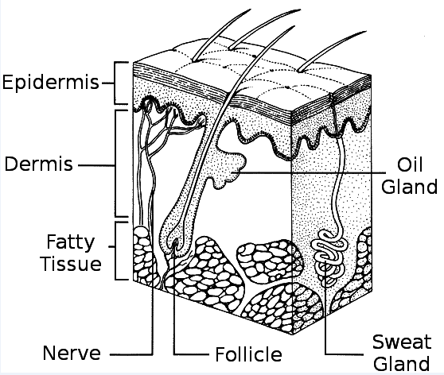
Fig 1: Layers of skin.

Epidermis:
The epidermis, the layer that covers the skin, is very thin on some parts of the body (the eyelids) and thicker on other parts (the soles of the feet). The epidermis is a layer of skin that has the following roles:
Making modern skin cells:
This occurs at the base of the epidermis. Skin cells migrate into the dermis layer and slough off after about a month of formation.
Giving skin its color:
The epidermis produces melanin, which gives the skin color and protects the body. The epidermis contains excellent cells that are part of a resilient framework and help keep the body strong.
Dermis:
Packaging takes place in the next layer, the dermis. The interests of the dermis include:
Making sweat:
The dermis has small pockets called sweat glands. Sweat flows through small tubes and exits through gaps called pores. Sweating keeps you cool and helps rid your body of unwanted and dreadful things. [5]
Helping you're feeling things:
Nerve endings in the dermis help us feel things. They can send signals to the brain to know how a thing feels when it's harmful (meaning you should stop touching it), annoying, or feels good after being touched.
Developing hair:
The dermis is the root of all the tiny hairs on the skin. Each root connects to a small muscle that anchors the muscle, giving you goosebumps when cold or frightened.
Making oil:
Another type of small body or organ within the skin produces oil. Oil keeps skin soft, smooth and waterproof. Occasionally, organs produce excess oil, which can lead to breakouts.
Bringing blood to your skin:
Blood strengthens the skin and carries harmful substances out through tiny tubes called blood vessels.

Subcutaneous fat:
The foot layer of skin is the subcutaneous fat layer. This layer plays an imperative part in your body by:
Connecting the dermis to your muscles and bones:
This layer contains an extraordinary interfacing tissue that joins the dermis to your muscles and bones.
Making a difference in the blood vessels and nerve cells:
Blood vessels and nerve cells that begin within the dermis get greater and go to the rest of your body from here.
Controlling your body temperature:
The subcutaneous fat is the layer that makes a difference and keep our body from getting as warm or as cold.
Putting away your fat:
This fat cushions your muscles and bones and protects them from bumps and falls.

- DISEASES CHARACTERISTICS CORRESPONDING TREATMENTS

Psoriatic Lesions:
Psoriatic lesions are a common, long-standing autoimmune disease that causes dry, red, scaly patches and lesions on the skin. Sometimes the rash subsides temporarily, but it often recurs due to factors such as stress. The disorder is thought to occur when the immune system inappropriately promotes the synthesis of skin cells. Psoriasis affects approximately 3% of the world's population, with 7.5 million cases reported in the United States alone. The condition affects men and women alike and can occur at any age, but most commonly occurs between those aged 15-35 and those aged 50-60. The average age of onset is 28 years, and approximately 15% of cases occur before the age of 10 years.

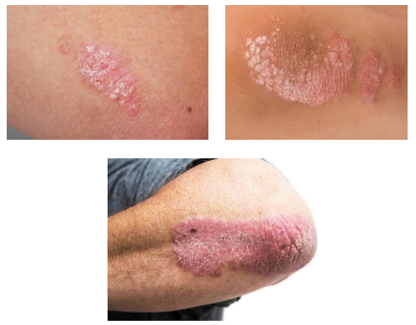
Fig 2: Psoriasis Clinical Images
Symptoms:
Psoriasis , due to the rapid cell turnover that is used dead and live cells accumulate on the surface of the skin. The disease is characterized by red, scaly, dry patches covered with silvery scales that quickly flake off and cause severe itching and burning. The severity of symptoms can range from minimum to maximum, based on the type of psoriasis. In Accordance with National Psoriasis Foundation, 3% affects claimed to be mild psoriasis of the body, 3% to 10% of the body claimed to be , moderate psoriasis and 10% or more as severe . Approximately 80% of population with psoriasis have mild psoriasis, while the remaining 20% ​​have severity ranging from moderate to severe psoriasis, but usually a small patches on the elbows, knees, hips, and scalp appears as small marks.
Several types of psoriasis are discussed as below:
• Psoriasis Lesions:
Plaque psoriasis is a prevalent form of psoriasis, affecting approximately 80 to 90 percent of individuals with the condition. It is characterized by raised, inflamed, red lesions covered by bright, white scales, typically appearing on the elbows, knees, scalp, and lower back.
• Converse psoriasis:
Inverse psoriasis is characterized by red lesions in areas such as the armpits, groin, under the breasts, and other skin folds, including around the genitals and buttocks. Unlike plaque psoriasis, these lesions do not have scales and may appear smooth and shiny. Located in delicate skin folds, friction and sweating can exacerbate the condition. It is common in overweight people and those with deeply wrinkled skin and can affect the genital area.

• Psoriatic Erythroderma:
Erythroderma psoriasis is severe psoriasis that causes marked redness on the surface of the body. When lesions are not well defined, erythema or redness is a typical symptom of people with unstable plaque psoriasis. Possible symptoms include peeling skin, itching, and pain. Erythroderma psoriasis is associated with disturbances in body homeostasis, causing protein and fluid loss, which can lead to severe disability. Edema, or swelling due to fluid accumulation, can also occur, especially in the lower legs. Chills can be caused by the body's inability to regulate body temperature. Infections, pneumonia, and heart failure can occur as a result of erythroderma psoriasis. People with symptoms of this disease should see a doctor. Seek medical attention immediately. In severe cases, hospitalization may be required.
• Guttate Dermatosis:
Guttate dermatosis Small, red, discrete skin lesions that are dry, not as thick as those seen in psoriasis vulgaris, commonly appear in childhood or early adulthood. This is caused by upper respiratory tract infections, tonsillitis, stress, skin damage, and the use of certain medications such as lithium and beta-blockers. Guttate psoriasis may heal on its own and not recur, or it may disappear temporarily and recur as patchy plaque psoriasis.
• Pustular Skin Disease:
Pustular Skin Disease primarily affects adults and accounts for a small percentage of psoriasis patients (less than 5%). This ailment appears as white pustules or blisters surrounded by red skin and containing non-infectious drainage. It can affect specific regions of the body, such as the hands and feet, or it can affect the entire body. Pustular psoriasis is not a contagious condition. It usually take the same path of the cycle in which skin redness is followed by pustules and scaling.
• Psoriatic joint pain:
Psoriatic joint pain, a condition characterized by joint pain and inflammation, affects up to 40 percent of individuals with psoriasis. This condition can cause significant damage to the joints and is most prevalent among individuals aged 30 to 50 years. In addition to physical discomfort, individuals with psoriatic joint pain may experience social exclusion and reduced self-esteem, which can negatively impact their quality of life. Furthermore, psoriasis has been linked to depression and an Increased cardiovascular disease and other health problems.

Causes:
• Psoriasis is a chronic autoimmune disorder that arises from dysregulation of the immune system. This condition occurs when the immune system malfunctions, leading to abnormal skin cell growth and inflammation.
• The secure framework comprises a type of cells referred to as T cells. Upon activation, these T cells respond to combat infections or facilitate wound healing. They produce chemical mediators that induce inflammation.
• Psoriasis is characterized by an excessive proliferation of skin cells and inflammation.
• Typically, the process of skin cell replacement occurs within a timeframe of 21 to 28 days. However, in individuals affected by psoriasis, this process is accelerated to a range of 2 to 6 days.
• The precise cause of this reaction remains unclear, however, individuals afflicted with psoriasis may observe that tension and discomfort, skin injuries, infections, and hormonal fluctuations can incite an exacerbation.
• Possible professional rewrite several pharmacological agents have been found to induce or exacerbate psoriasis, including lithium, antimalarials, quinidine, and indomethacin are examples of medications. Although some people link psoriasis to allergies, food, and stress, climate, there is limited evidence to support these claims. Psoriasis is not contagious.
Risk Promoters
There are several factors that all merger the likelihood of psoriasis, including cardiovascular disease, metabolic syndrome, skin injuries, and family history. If you have a close relative with psoriasis, your risk of developing psoriasis is 1 in 3 for him. If one parent has psoriasis, the chance is 10%, but if both parents have psoriasis, the chance increases to 50%. These statistics suggest a genetic component of the disease, but environmental factors may also play a role in triggering its development. It is estimated that at least 10% of the population carry the gene which causes psoriasis, but only 2-3% of people actually develop psoriasis. In young people, psoriasis may develop after an infection, especially a sore throat. 33% to 50% of adolescents with psoriasis experience ear pain and respiratory infections such as bronchitis, tonsillitis and strep throat, which may flare up within 2 to 6 weeks . [9]

- Dermatological Condition Recognition
People requiring medical attention should seek medical attention if the rash persists and does not respond to over-the-counter (OTC) treatment. Doctors thoroughly evaluate symptoms, it helps to know about the personal and family history, it also do a skin biopsy. A blood test for psoriasis is available. Not accessible. The choice of treatment after the diagnosis is confirmed depends on the nature and severity of the problem. The most common treatments are topical, systemic, and phototherapy. Topical treatments include applying drugs directly to the skin to limit skin cell proliferation and it also decreases the inflammation. These treatments are available both over-the-counter (OTC) and by prescription and include nonsteroidal and steroidal drugs. Keratolytic products containing salicylic acid, lactic acid, urea, or phenol can be used to reduce itching. Over-the-counter medications some of them are calamine, hydrocortisone, camphor, diphenhydramine hydrochloride (HCl), benzocaine, and menthol can also help but can cause skin dryness. Individuals should try several products to find out which one works best for them. Systemic therapy is used to treat patients with moderate to severe psoriasis and psoriatic arthritis. These drugs, such as acitretin, cyclosporine, and methotrexate, are given by mouth or by injection. Biologics are systemic treatments that target specific her T cells associated with psoriasis. Biologics are protein-based pharmaceuticals made from living cells grown in a laboratory.
Excimer Laser Therapy:
Phototherapy, also known as light therapy, involves the regular exposure of the skin to ultraviolet light, either in a medical facility or at home under the supervision of a healthcare professional. It is important to note that tanning beds are not a recommended substitute for this treatment. While there are no home remedies to completely avoid psoriasis, there are strategies that can help individuals cope with the condition. These include reducing stress through activities such as yoga, exercise, and meditation, maintaining a healthy weight and a balanced diet, identifying and avoiding eating triggers, finding help from a group or blog with similar experiences, and refraining from excessive smoking or alcohol consumption.[10] Additionally, to alleviate itching, it is recommended to keep the skin moisturized with a product recommended by a dermatologist and to take cold showers or use cold packs, as hot showers can dry out the skin.

- MACHINE LEARNING
It is an application of manufactured insights (AI) that gives frameworks the capacity to naturally learn and progress from encounters without being unequivocally modified [15]. Machine learning centres on the improvement of computer programs that can get to information and utilize it to learn for themselves. We utilized bolster forward back proliferation manufactured neural arrange (ANN) for this step. The ANN comprised of one input layer, two covered-up layers and one yield layer. Since we have utilized an administered machine learning calculation, the highlight table obtained after picture preparation was encouraged to the input layer and their comparing comes about to the yield layer for preparing [16]. A profound learning strategy utilizing the neural organize device in MATLAB which trains the demonstration utilizing a personality work was utilized to initialize the parameters of the show, the weight frameworks.

DEEP LEARNING:
Profound learning could be a portion of the broader family of machine learning wherein the learning can be directed, unsupervised or semi-directed. Profound learning is not at all like machine learning employments an expansive information set for the learning, and the number of classifiers utilized gets diminished substantially [17]. See the preparing time for the profound learning calculation increments since of the utilization of the exceptionally expansive information set. Profound learning calculation chooses its claim highlights not at all like the machine inclining making the prediction process simpler for the conclusion client because it does not utilize much pre-processing. We utilize directed machine learning calculations in this venture.
Some machine learning methods:
Machine learning calculations are regularly categorized as administered or unsupervised. Directed machine learning calculations can apply what has been learned in the past to modern information utilizing named illustrations to anticipate future occasions. Beginning from the investigation of a known preparing information set, the learning calculation produces a deduced work to form expectations almost the yield values.
In differentiate, unsupervised machine learning calculations are utilized when the data utilized to prepare is not one or the other classified nor named. Unsupervised learning thinks about how frameworks can gather work to portray a covered-up structure from unlabeled information. Semi-supervised machine learning calculations drop someplace in between directed and unsupervised learning since they utilize both named and unlabeled information [18], [19] for regularly preparing a little sum of named information and a huge sum of unlabeled information. The frameworks that utilize this strategy are able to significantly improve learning accuracy.
Fortification machine learning calculations could be a learning strategy that is interatomic with its environment by producing activities and finding blunders or rewards. Trial and blunder look and deferred compensation are the foremost pertinent characteristics of fortification learning. This strategy permits machines and program operators to consequently decide the perfect behavior inside a particular setting in arrange to maximize its execution.

- ALGORITHM DESIGN
Algorithm Design
The initial step in the calculation plan involves retrieving the database image tests of the diseases and converting them from color to grayscale. A parallel image is obtained from the dark color picture, and the converted image undergoes the process outlined in the flowchart. In the proposed framework, a standard database is utilized for the improvement and testing of the proposed framework. Initially, the system performs image preparation to denoise and enhance the image for statistical analysis. Following filtering, feature extraction is utilised to determine the range of parameters employed in the image by calculating entropy, standard deviation, and surface figure.[11] The table shows the range of picture measurable properties organised by category. To identify biological images, a two-level classifier is used, with the Ada Boost classifier choosing the range of relationships based on mean and standard deviation.

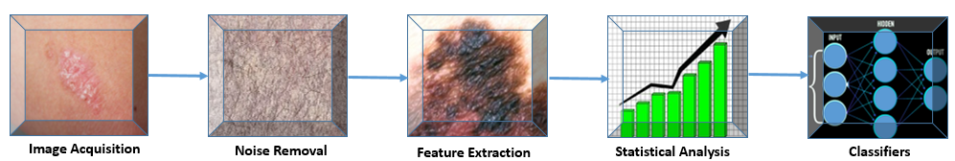
Fig 3: Algorithm Design

STEPS INVOLVED
1) Image Acquisition
2) Noise Removal
3) Feature Extraction
4) Statistical analysis
5) Classification

Image Acquisition:
Basic Component The image acquisition component of our mechanized image analysis system. This component is critical to the overall system functionality. Insufficient image storage can result in inaccessibility to the rest of the system components and inaccurate results. This component's image system requires a scaled image first for best results. The input image for the system is in RGB format. However, our proposed system requires grayscale photos. Therefore, use the RGB to Grayscale conversion in MATLAB to convert the RGB image to a grayscale image. The image is then resized to reduce processing time during the MATLAB encoding process.
Noise Mitigation:
Obtaining high-quality interference-free images is critical for accurate results. Noise in the image can lead to incorrect calculations. Therefore, image noise removal is an important image processing task. There are many ways to denoise an image. However, the key to a successful image denoising process is to remove the noise while leaving the edges intact. Linear models have been used in the past. used for this purpose. To denoise an image, a median filter is used to smooth the image. A median filter is an effective tool for removing noise in an image.
Feature Extractions:
High-quality biomedical images are critical to obtaining accurate results in biomedical imaging. However, this is not always an easy task as various factors result in low to medium quality photos. Therefore, it is very important to use image enhancement techniques to improve the quality. These algorithms enhance images by adjusting properties such as contrast and brightness. The image is analyzed, displayed in the form of a histogram, and the range of its coverage is estimated.

Statistical Analysis:
A quantifiable analysis of skin images is collected, providing various measures such as entropy, standard deviation and surface topography relationships. These parameters can be used to determine the extent of individual skin diseases. The parameters are also used to create a standard database of skin disease images. Averages are calculated for further analysis of the data.
$$m_{1}=\frac{ \sum_{i=l1}^{l2}{I_{i}}(i)}{l2-l1}$$First we calculate the variance with the benefit of sample mean
$${σ_{l}}^{2}= \frac{\sum_{l=l1}^{l2}{\begin{aligned}{\left(I_{1}(i)-m_{i}\right)}^{2}\end{aligned}}}{l_{2}-l_{1}}$$
Calculate the energy of image I using the variance by taking the mean square of the variance.
The brightness of the image is then calculated using the RGB components of the image.
$$R_{n }= \frac{R}{R+G+B} \\ G_{\begin{aligned}n \\ \end{aligned}}= \frac{G}{R+G+B}$$
$$B_{n }= \frac{B}{R+G+B}$$
$$L= \sqrt{(\left(0.3*r^{2}\right)+\left(0.587*g^{2}\right)+\left(0.114*b^{2}\right))}$$
Use scaled image (I2), texture (T2), window and brightness (L) to compare samples. Additionally, calculate the standard deviation of the images.
$$σ_{i}= \sqrt{{{(σ}_{i})}^{2}}$$
We are determining the image's entropy.
$$entropy= -sum(p*\log^{2}{(p))}$$
Classification:
This approach uses a two-level classifier framework. The first level classification distinguishes between normal and abnormal skin lesions, while the second level classifies abnormal lesions into specific categories such as melanoma, psoriasis, and dermis. The first stage of this framework involves image processing to detect and remove noise, followed by region-of-interest (ROI) segmentation of skin lesions. Image features are then created extracted from the segmented ROI, and these features are then inputted into the classifier for further analysis.. [12]
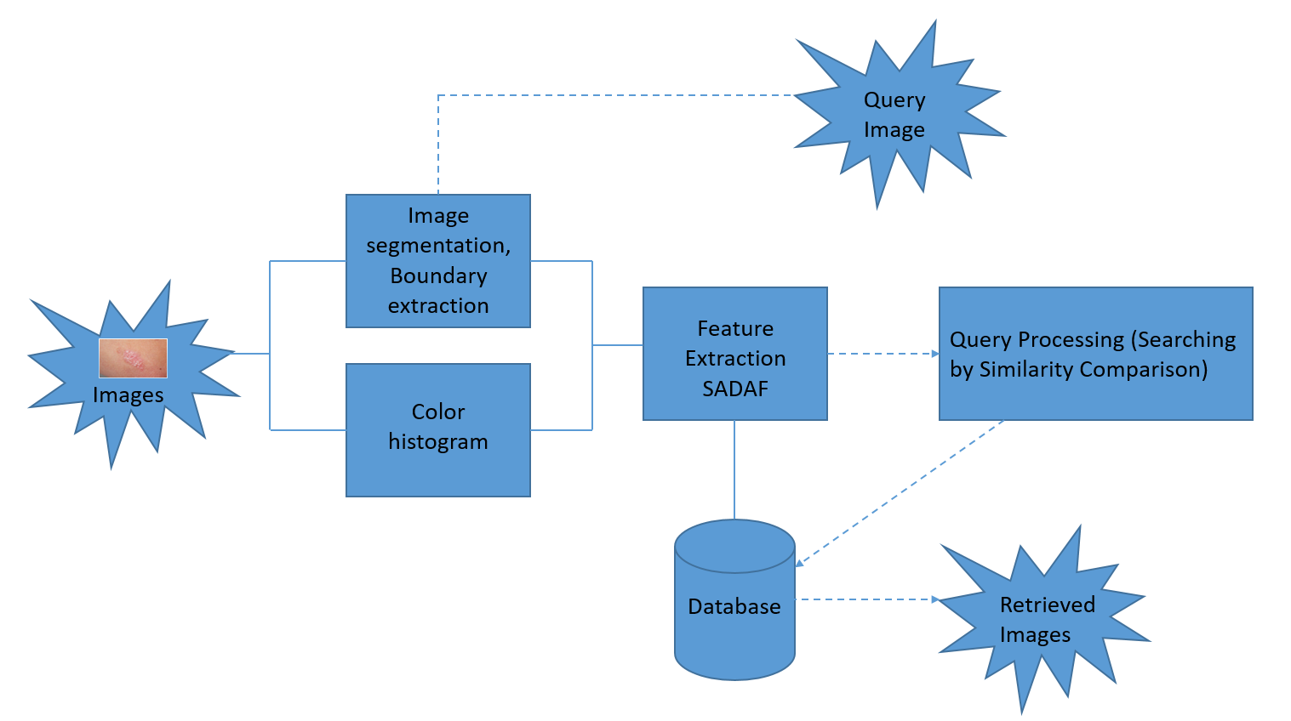
Fig 4: Framework Layout

RGB TO Gray Color diagrams Required:
The preparatory step within the calculation plan is to recover the information base picture tests of infections and change over them from colour to gray scale.
Unused outline = rgb2gray(map) returns a grayscale color outline identical to outline.
Note:
A grayscale picture is additionally called a gray-scale, gray scale, or gray-level picture.

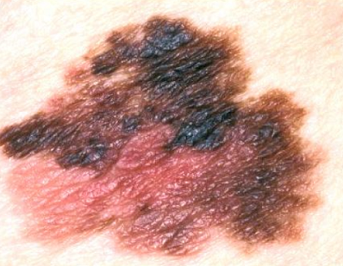

Fig 5: Original Image Fig 6: RGB to Gray color

Considering the picture to a gray one will disentangle the division address and lead to straightforward calumniation but lose a few picture data [13]. Considering the picture to a color one will be supportive to de-noise the picture but leads to more calculations. In this manner, in the event that we have a clean picture, which implies no commotion, at that point likely ready to treat it as a gray picture.
Re- sizing the image:
In this prepare we diminish the estimate of the picture since in the event that the picture measure is expansive it takes time to handle the whole program. So in the event that we decrease the measure of the picture at that point the it takes less utilization time and capacity space also will be less so within the picture securing we go for RGB to gray and re-sizing.

Fig 7: Median Filter
Middle sifting could be a common step in picture handling. In picture preparing it is ordinarily fundamental to perform tall degree of commotion diminishment in a picture some time recently performing higher-level handling steps, such as edge location. The middle channel could be a non-linear computerized sifting strategy, regularly utilized to evacuate clamor from pictures [14] or other signals. The thought is to look at a sample of the input and choose on the off chance that it is agent of the flag. Typically performed employing a window comprising of an odd number of tests. It is especially valuable to diminish dot clamor and salt and pepper commotion. Its edge-preserving nature makes it valuable in cases where edge obscuring is undesirable.B = medfilt2(z) performs middle sifting of the lattice A utilizing the default 3-by-3 neighborhood.
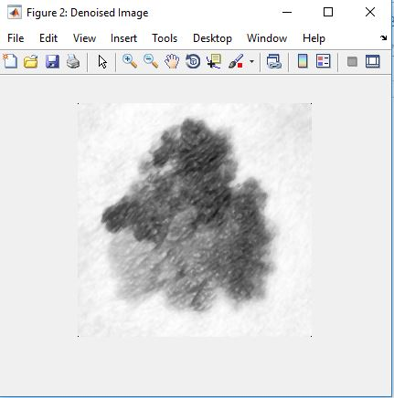
Fig 8: Median Filter
Extracting the Required Region:
For the sifted picture a filling administrator is connected to fill the locales which are unaffected region and calculated the range for the influenced portion of the locale.
After filling (vertically & evenly) the unaffected region as white locale .The number of pixels are calculated within the influenced locale. The region will be calculated for the influenced region (black portion) in micrometers.
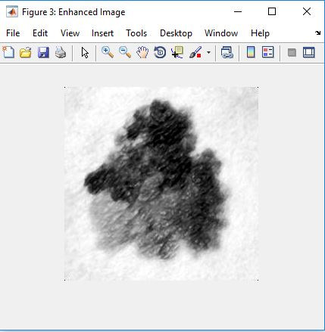
Fig 9: Extracting region

- SOFTWARE USED
We utilize the MATLAB program in our extent where MATLAB (lattice research facility) could be a numerical computing environment and fourth-generation programming dialect. Created by Math-works, MATLAB permits framework controls, plotting of capacities and information, usage of calculations, creation of client interfacing, and meddle with programs composed in other dialects, counting C, C++, Java, and Fortran. We utilize MATLAB 2016a adaptation in our venture. Although MATLAB is aiming basically for numerical computing, a discretionary tool stash employments the Mu Cushion typical motor, permitting get to typical computing capacities. An extra bundle, Simulink, includes graphical multi-domain reenactment and model-based plan for energetic and implanted framework.

FEATURES:
It could be a high-level dialect for numerical computation, visualization and application advancement.
MATLAB:
Unused different y-axis plots, polar plots, and condition visualization Delay, investigate, and continue MATLAB code execution
Neural organize tool kit:
Profound learning with convolutional neural systems (CNN’s) for picture classification assignments utilizing GPU speeding up in Parallel Computing Tool kit
Typical math tool kit:
Integration with the MATLAB Live Editor for altering typical code and visualizing comes about, and changing over Mu Cushion scratch pad to live scripts. Insights and machine learning tool stash:
Classification Learner app that trains numerous models naturally, visualizes comes about by lesson names, and performs calculated relapse classification
Control framework tool kit:
Unused and updated apps for planning SISO controllers, naturally tuning MIMO frameworks, and making reduced-order models Picture securing tool stash: Bolster for Kinect for Windows v2 and USB 3 Vision Computer vision framework tool stash Optical character acknowledgment (OCR) Coach app, person on foot location, and structure from movement and bundle alteration for 3-D vision
Exchanging tool kit:
Exchange fetched examination for trading, sensitivity, and post-trade execution.
GRAPHICAL USER INTERFACE:
GUI s (too known as GRAPHICAL Client INTERFACE) give point -and- press control of program applications, killing the got to learn a dialect or sort commands in arrange to run the application [20] .In our extend we are going to make a separate GUI for showing an each out independently. we make a record at that point we embed all the steps in this record , after that we embed the picture in this record we get the pictures step by step handle .This the most handle of GUI in our
X. MATLAB FUNCTION
 | COMMAND | DESCRIPTION
1 | imread | Imread which reads the grayscale or color image.
2 | imshow | imshow displays the grayscale or color image
3 | imresize | Imresize which resizes the image
4 | imadjust | Imadjust maps the intensity values in grayscale image
5 | imhist | Imhist (J) calculates the histogram for a grayscale image .

- SIMULATION RESULTS
The proposed framework uses a standard database for system improvement and testing. First, the system performs image processing to remove noise and enhance images for statistical analysis. After applying filtering and feature extraction, the system calculates entropy, standard deviation, and surface area coefficients to define the range of parameters used in the image. Table 1 shows the statistical properties of the photos based on their classification. A two-level classifier is used for better results. Using the classifier, photos are associated with a degree of relevance using their mean and standard deviation. Biomedical images are classified using an escalated classifier. . The classifier in the proposed system can classify normal, psoriasis, skin, and melanoma images with over 90% accuracy. Table II shows the standard deviation results. This automatic image analysis engine uses an image processing engine to classify images as psoriasis, melanoma, or dermatophytosis. 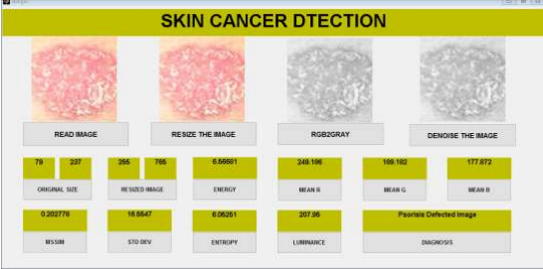
PSORIASIS

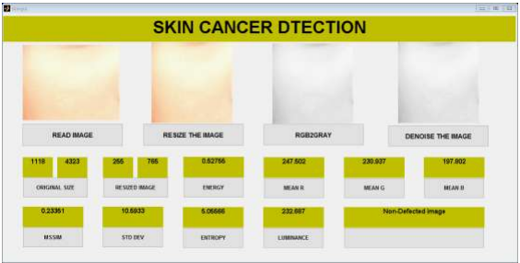
NORMAL SKIN

Statistical Data Summary:
 | Luminance | Standard deviation | Entropy
Normal skin | 226.8690 - 244.7091 | 4.0219 - 19.6765 | 3.6991 - 5.6361
Psoriasis | 200.1013 - 225.3665 | 9.5709 - 30.91 | 5.065 - 6.7293

- CONCLUSION
We provide a Picture Examination Framework for skin disease prevention and detection. We can diagnose psoriasis skin illnesses and classify other skin infections using statistical analysis with correlation calculation. Several quantitative measures, including brightness, standard deviation, and entropy, have been investigated to estimate the chance of infection. Advanced requirements may be implemented if necessary to broaden the measurable parameters. This framework's output is expected to analyse and classify diverse skin conditions, potentially reducing processing time and enhancing distribution speed. As a result, the framework will be faster and more efficient.

REFERENCE:
[1] Cheng, Yu-Wen, et al. "A desperate need for psoriasis health care in remote regions as revealed by a live interactive teledermatology program serving Penghu Islands in Taiwan Strait." Telemedicine and e-Health 28.8 (2022): 1109-1116.
[2] Pathania, Yashdeep Singh, et al. "Non‐invasive diagnostic techniques in pigmentary skin disorders and skin cancer." Journal of cosmetic dermatology 21.2 (2022): 444-450.
[3] Osterhout, Jessica A., et al. "A preoptic neuronal population controls fever and appetite during sickness." Nature 606.7916 (2022): 937-944.
[4] Frischhut, Nina, et al. "The spectrum of melanocytic nevi and their clinical implications." JDDG: Journal der Deutschen Dermatologischen Gesellschaft 20.4 (2022): 483-504.
[5] Snyder, Ashley M., et al. "Atopic Dermatitis: A Qualitative Study on the Burdens of Living with Itchiness." The Journal of Clinical and Aesthetic Dermatology 16.7 (2023): 22.
[6] Pouzesh, Mohsen, and Saleh Mobayen. "Event-triggered fractional-order sliding mode control technique for stabilization of disturbed quadrotor unmanned aerial vehicles." Aerospace Science and Technology 121 (2022): 107337.
[7] M. Shamsul Arifin, M. Golam Kibria, Adnan. F, M. Ashraful Amini, Hong Y, Dermatological disease diagnosis using color-skin images, Published in Proceedings of the 2012 International Conference on Machine Learning and Cybernetics, Xian, 15-17 July, 2021 .
[8] Florence T,Ernest M, Fred N. K, An image-based diagnosis of virus and bacterial skin infections, International Conference on Computing and ICT Research,2022.
[9] Damilola A. O, Olidayo O. O, Soloman A. O, Automating skin disease diagnosis using image classification, Published in Proceedings of the World Congress on Engineering and Computer Science 2013 Vol II WCECS 2018, 23-25 October, 2019, San Francisco, USA.
[10] Diepgen TL, Yihune G et al. Dermatology Online Atlas. Published online at: http://www.dermis.net/doia/.
[11] Teck T. T, Li Z, Ming J, , An intelligent decision support system for skin cancer detection from dermoscopic images in 12th International Conference on Natural Computation, Fuzzy Systems and Knowledge Discovery (ICNC-FSKD) .
[12] Er. Shrinidhi G, Ansari N, Ansari Z Shaikh R,An Innovative Approach for Skin Disease Detection Using Image Processing and Data Mining. In International Journal of Innovative Research in Computer and Communication Engineering.
[13] B.V.Dhandra, Shridevi Soma, Shweta Reddy, “Color Histogram Approach For Analysis Of Psoriasis Skin Disease”, IEEE system Journal, vol.99,pp. 25-29.
[14]. A. Karargyris, O. Karargyris, A. Pantelopoulos, “DERMA/ care: An Advanced Image- Processing Mobile Application for Monitoring Skin Cancer,”in IEEE 24th International Conference on Tools with Artificial intelligence(ICTAI), 2023, PP.1-7
[15]. R. Siegel, D. Naishadhama, A. Jemal, “Cancer Statistics, 2012,”CA: a cancer journal for clinicians, vol.62,2012, pp.10-29.
[16]. T. Wadhawan, N. Situ, K. Lancaster, X. Yuan, G. Zouridakis, “SkinScan: A Portable Library for Melanoma Detection On Handheld devicees,” in IEEE International Symposium On Biomedical Images: from nano to micro,2011,2011,pp.133-136.
[17]. Omar Abuzaghleh, Buket D. Barkana, Miad Faezipour, “SKIN cure: A Real Time Image Analysis System to Aid in the malignant melanoma Prevention and Early Detection.”Member IEEE SSIAI 2014, pp. 85-88.
[18]. Ho Tak Lau, Adel Al-Jumaily, “Automatically early detection of skin cancer,” International conference of soft computing and pattern recognition, IEEE 2009, pp.375-380.
[19]. Romero G, García M, Vera E, Martínez C, Cortina P, Sánchez P, Guerra A. “Preliminary results of DERMATEL: prospective randomized study comparing synchronous and asynchronous modalities of teledermatology.” Actas Dermosifiliogr. 2006 Dec; vol.97
[20]: pp 630-36. [8]. Scherr, D.; Zweiker, R.; Kollmann, A.; Kastner, P.; Schreier, G. & Fruhwald, F. “Mobile phone based surveillance of cardiac patients at home Journal of Telemedicine and Telecare,” 2006, vol 5, pp 255-261.

