WEB MONITORING AND SPEED CONTROL OF
BLDC MOTOR WITH IOT
Radhika S¹ , Vennila C² , Prabavathi V ³ , Monica G⁴ , R. Shoba ⁵ , Sharmila S ⁶
^{1,2,3,4} Department of Robotics and Automation, Karpaga Vinayaga College of Engineering and Tehnology, Tamil Nadu, India
⁵ Department of information technology, St. Joseph's College of Engineering, Chennai-600 119, Tamil Nadu, India.
⁶ Department of Artificial Intelligence &Data Science, Karpaga Vinayaga College of Engineering and Technology, Tamil Nadu

ABSTRACT:
In this project, we employ a closed-loop technique to regulate the speed of a Brushless Direct Current (BLDC) motor. The superiority of brushless DC motors over their conventional counterparts has established them as a burgeoning trend in various industrial applications. The control infrastructure is established through a Controller component. By utilizing an affordable Atmel 328p microprocessor, we gain the ability to govern the BLDC motor's frequency. The microcontroller, programmed with Embedded C, facilitates adjustments to the motor's duty cycle. Additionally, the communication module, which harnesses the power of the Internet of Things (IoT), is employed to monitor the operational state of the machinery. Notably, our proposed approach furnishes unique login credentials to industrial personnel, affording them the capability to oversee the motor's parameters through the IoT framework.
KEYWORDS: Speed Control, IOT, BLDC
INTRODUCTION:
IOT lets you do wireless ON/OFF control of the brushless DC motor. Using an android, you can toggle the BLDC motor on and off by linking both of their IP addresses to a certain web site. By using an internet-based domain, the user can turn the BLDC motor ON or OFF anywhere they are. Using the Ethernet shield, an Arduino controller can be utilised for downloading and broadcast signals from the internet. Configuring a function with a specific IP address for a web domain was done in the Arduino controller. The Ethernet shield is used to receive signals from the World Wide Web domain. Use the specified website address to ON/OFF the Brushless DC motor. The term "Internet of Things" (IoT) pertains to the connectivity of physical objects such as furniture, vehicles (also termed "interconnected devices" and "smart devices"), residences, and various items embedded with technological components like sensors, actuators, software, internet connectivity, and other elements that enable the gathering and sharing of data. As defined by the Internet of Things Global Standards Group (IOT-GSI), the IoT is described as "the framework of the information society." It allows for the remote monitoring and control of these objects through an established network infrastructure, offering the potential for swift interaction between the physical world and computer-driven systems. Additionally, this technology enhances efficiency, accuracy, and economic advantage while lowering the requirement for human involvement. The larger category of computerised systems with physical components, which also includes smart grid, smart home, intelligent public transportation, and smart city technologies, is expected to include IOT once it is further developed with sensors and actuators. Even while they are able to interact with one another using the present-day internet infrastructures each object has an embedded computing system that contributes to making it achievable for it to be identified by its unique features. As indicated by researchers, it is projected that the Internet of Things (IoT) could encompass around 50 billion devices by the year 2020. The IoT is envisaged to offer enhanced machine-to-machine (M2M) connectivity, encompassing devices, systems, and a wide array of products and services, along with various protocols, domains, and applications. The seamless assimilation of these embedded devices, constituting what are known as smart objects, is expected to facilitate the automation of nearly all industries and foster the emergence of innovative projects such as smart grids and intelligent neighbourhoods.
Things within the context of the Internet of Things encompasses a wide array of devices, ranging from cutting-edge implants for advanced monitoring to biochip transponders employed on farm animals, electric sensors deployed in coastal waters, integrated sensors integrated into automobiles, DNA analysis equipment for environmental/food/pathogen surveillance, and even outdoor electronic devices designed to aid firefighters in search and rescue missions. Legal experts suggest viewing "Things" as an intricate amalgamation of hardware, software, data, and services. These devices gather pertinent data and seamlessly transmit it to other devices using a variety of contemporary technologies. A current trend in the market involves home automation, often referred to as advancements in smart homes. This includes aspects like smart lighting, heating (via intelligent thermostats), ventilation, air conditioning, and household appliances such as dishwashers, washing machines, robotic vacuums, air purifiers, stoves, ovens, and refrigerators/freezers equipped with Wi-Fi for remote monitoring. The IoT is anticipated to generate substantial volumes of data from diverse sources, necessitating rapid data aggregation as well as a surge in requirements for indexing, storage, and more efficient management of such data. Moreover, the integration of the internet into automation has recently opened up numerous new application areas.
LITERATURE SURVEY:
The article titled "Efficient Control of BLDC Motors Using DSP-based Hall Effect Sensors" authored by Han-Chen Wu, Min-Yi Wen, and Ching-Chang Wong addresses the imperative need for enhanced efficiency and reduced carbon emissions in electrical systems. To address this, Brushless DC (BLDC) motors emerge as a solution due to their complete reliance on electricity and superior efficiency in comparison to traditional air-conditioning-powered induction motors. This research introduces an approach for regulating BLDC motor speed through the utilization of Hall effect sensors. These sensors, designed to detect the Hall effect, enable motor control by precisely tracking the rotor's position. The control strategy employed is based on a trapezoidal pulse width modulation (PWM) waveform, commonly known as trapezoidal control. To fine-tune the rotational speed, a Proportional-Integral (PI) controller is implemented. Several investigations have corroborated the effectiveness of PI control in producing motor speeds that are notably more accurate and consistent compared to control strategies lacking PI control.
Utilizing Hall Effect Sensors for Trapezoidal Control of BLDC Motors" authored by Bilal Akin, Manish Bhardwaj, and John Warriner presents a method for employing trapezoidal control in the management of Brushless DC (BLDC) motors. The approach outlined in this application note involves the utilization of TMS320F2803x microcontrollers to program the BLDC motors. These microcontrollers belong to the C2000 series, specifically the TMS320F280x devices, which enable the cost-effective and efficient development of advanced controllers tailored for three-phase motors. This technological progression facilitates the implementation of highly precise regulation algorithms. The paper offers a comprehensive solution that encompasses evaluations of energy conversion efficiency, organizational frameworks for management, configuration of power hardware, and management hardware.

Jose Carlose's work proposes the utilization of sensorless techniques for both position and speed control of brushless DC motors, while also offering guidance on the application of these methods. This project undertakes a meticulous technical examination of sensorless approaches for regulating brushless direct current (BLDC) motor operations. The study includes a comprehensive exploration of sensors, detailing their advantages and drawbacks. Notably, the advancement of sensorless technologies has resulted in improved performance and reliability of BLDC motor controllers in comparison to conventional control and sensing methodologies. The subsequent sections delve into recent advancements within this domain, elucidating their benefits and limitations. Furthermore, the analysis addresses practical challenges and real-world applications associated with these methodologies. The study particularly emphasizes an in-depth investigation of contemporary back electromotive force (EMF) detection techniques. These encompass PWM, terminal current detection, integration of third harmonic voltage, terminal voltage detection, and back EMF integration. In addition to these, the paper also briefly covers crucial estimation and model-based methods. This includes insights into techniques like the extended Kalman filter, adaptive model reference systems, adaptive observers (both full-order and pseudo-reduced-order), and artificial neural networks. The combined effect of these elements provides a comprehensive and well-rounded exploration of the cutting-edge landscape of sensorless control approaches for BLDC motors.
The BLDC motor's wide-range speed control system using Dong Hee Lee's suggested Hall Sensor Signal as a basis. For brushless DC motors with different low- and high-speed controllers, this study offers a hall sensor-based wide-range speed management strategy. Utilising the hall sensor data to determine the motor's velocity in the low-speed region is insufficient due to the low sensor resolution and time delay. The recommended technique describes a micro-stepping current management strategy based on the variation in torque angle. The reference speed, not the actual velocity supplied by the hallway sensor, controls the motor's frequency and rotation angle in this mode. a method for controlling motor wide-range speed that uses separate fast and low-speed controllers. A brushless DC (BLDC) motor wide-range speed management technique is presented in this study and is based on distinctive low- and fast speeds controllers. Due to the low sensor resolution and time delay, the usage of the hall sensor signal is insufficient to determine the motor's velocity in the low-speed area. The suggested method suggests using a torque angle-based micro-stepping current control methodology. Instead of using the actual velocity provided by the hallway sensor, in this mode the motor frequency and rotation angle are regulated by the speed utilised as a reference. In order to apply the vector control method based on discrete low- and rapid speeds controllers, the recorded speed and hall sensor direction are used to calculate the continuous rotor position. When the mode shifts between the low and standard speed ranges, calculations are done to identify the proper initial current command and reference location of the rotor. The calculated current instruction can be used to reduce the torque that causes ripple in transient mode. The suggested method is simple but effective in extending the acceleration range of a conventional BLDC motor with hall sensor without the use of a high-resolution encoder.
Based on Alex Simpkins' and Emanuel Todorov's analog linear Hall effect sensor design, this study addresses the control and position estimation of compact BLDC motors. In the realm of bio-inspired robotic systems, diverse engineering elements are required, including motors with attributes such as high torque, minimal torque-induced vibration, compact dimensions, and precise position control. Crafting an engine that fulfills all these criteria is often a challenging endeavor. Recent times have witnessed the introduction of meticulously crafted small-scale brushless DC motors by various manufacturers. However, achieving vibration-free and accurate control for asynchronous motors necessitates precise position sensing. Traditional installation of encoders on motor shafts can be complex, and relying solely on sensorless approaches might not be ideal for attaining meticulous position control. This study presents an innovative approach that employs analog Hall sensors to ascertain rotor position. These sensors gauge the magnetic field generated by rotor magnets, yielding an absolute measurement of the power cycle. This measurement serves as a foundation for the development of a computationally efficient motor control system. The Hall effect sensors, conveniently mounted on the motor, possess attributes of compactness, a wide bandwidth, affordability, and high accuracy. As a result, these sensors enable the tracking of position with minimal impact on motor dimensions.
PROPOSED SYSTEM:
We introduce an innovative technique utilizing analog Hall effect sensors to monitor the electromagnetic field generated by a rotor magnet, enabling precise determination of the exact location within an electrical circuit. This approach proves highly effective in constructing a streamlined motor control system that demands minimal computational complexity. Hall effect sensors, when directly affixed to the motor, exhibit impressive attributes such as high bandwidth, compact dimensions, affordability, and exceptional accuracy. These sensors facilitate unidirectional measurements, resulting in only marginal enlargement of the motor's size. In industrial domains like manipulators, robotics, and operations, DC drive systems find extensive utilization. This project's objective centers on leveraging the capabilities of the Internet of Things (IoT) to monitor and regulate the ON/OFF status of a brushless direct current (BLDC) motor. The IoT encompasses both the expanding network of physical objects equipped with an IP address for internet access and the communication linking these entities with other internet-connected systems and devices. Brushless DC motors (BLDCMs) are prevalent in industrial applications, boasting attributes such as heightened efficiency, reliability, and a favorable weight-to-torque ratio. Through this IoT-based controller, the motor's speed can be systematically adjusted to attain the desired outcomes for the end-user.
INTRODUCTION TO IOT:
The concept known as the Internet of Things, often abbreviated as IoT, establishes a network that interconnects computers, digital devices, mechanized systems, living beings like animals or people. These entities are each designated unique identifiers (UIDs) and possess the capability to exchange data across a network, all without necessitating direct human-computer interaction. In this context, the term "Thing" denotes any entity, whether naturally occurring or human-made, that can be allocated an IP or Internet Protocol (IP) address and possesses the capacity to transmit data through a network. Instances of such entities include individuals equipped with implanted heart rate monitors, pets furnished with biochip transmitters, vehicles integrated with tire pressure monitors, and a diverse range of other objects. Across various sectors, businesses are increasingly embracing IoT to streamline operations, enhance their comprehension of customer behavior, and engage in more informed decision-making processes that collectively contribute to elevating overall business value.
How IoT works
The Internet of Things (IoT) ecosystem is comprised of a network of interconnected intelligent devices. These devices incorporate embedded components like processors, cameras, sensors, and communication tools to gather, transmit, and utilize the data they acquire from their surroundings. To convey this data, IoT devices interface with an IoT gateway or other edge devices, which then either send the information to a cloud service for analysis or process it directly on the local level. Occasionally, these devices also establish communication with other similar counterparts, taking actions based on the shared information. The majority of tasks are carried out autonomously by electronic devices, minimizing the need for human intervention. However, people can engage with these devices to configure settings, issue commands, or obtain information. Implemented IoT applications exert a notable influence on the connectivity, social networks, and communication dynamics of these internet-enabled devices. Furthermore, IoT leverages the capabilities of machine learning and artificial intelligence (AI) to streamline data collection processes and foster adaptive behaviors.
Why IoT is important
The utilization of the Internet for diverse purposes empowers individuals to lead more informed lives, enabling them to make intelligent decisions and maintain comprehensive control over their activities. Beyond merely facilitating smart home automation gadgets, the Internet of Things (IoT) plays a pivotal role in the business landscape. Within this context, IoT empowers enterprises to gain real-time insights into their operations, offering a comprehensive overview encompassing aspects such as device performance, supply chain management, and logistics operations. This technological paradigm enables companies to automate various processes, leading to a reduction in labor costs. Furthermore, it contributes to cost efficiency in manufacturing and marketing, enhances service delivery, mitigates waste, and furnishes enhanced visibility into customer interactions. This is precisely why the Internet of Things has emerged as a prominent force in contemporary existence. As an increasing number of companies recognize the competitive advantages stemming from the integration of connected devices, the momentum behind the Internet of Things continues to surge. The technology's potential to enhance competitiveness is driving its widespread adoption across industries.

IOT
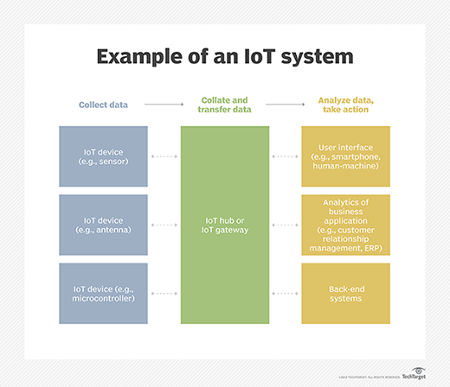
Fig 1 Internet Of Things
IoT benefits to organizations
The Internet of Things (IoT) presents an array of advantages for businesses, with certain benefits tailored to specific industries while others are applicable across various sectors. Several notable benefits that IoT offers to businesses include the following:
Comprehensive Business Tracking: IoT enables businesses to monitor their entire operations comprehensively.
Enhanced Customer Experience (CX): IoT facilitates improvements in customer experience by offering personalized services.
Efficiency Gains in Time and Cost: IoT drives time and cost savings for businesses.
Increased Labor Productivity: IoT contributes to heightened labor productivity.
Business Model Flexibility:Businesses can adapt and evolve their business models with the incorporation of IoT.
Holistic Business Insights:IoT provides businesses with improved insights into their operations.
Revenue Growth: IoT has the potential to boost business revenue.
Organizations have at their disposal IoT tools that can reshape their business strategies, prompting them to reconsider their operational approaches. Beyond its impact on businesses, IoT has also found relevance in diverse domains like infrastructure, home automation, and agriculture, propelling some entities towards digital transformation. The application of sensors and other IoT devices finds particular prominence in sectors like manufacturing, transportation, and urban development.
In the realm of agriculture, IoT's implementation assists farmers in simplifying tasks. Sensors gather data concerning soil composition, moisture levels, rainfall, temperature, and other factors that facilitate the automation of farming practices. Infrastructure activities can also benefit from IoT monitoring. Sensors are employed to track changes or advancements in structural components of constructions such as bridges and buildings, ushering in benefits like cost savings, time efficiency, improved quality of life, and streamlined paperless workflows.
Expanding its scope, IoT can be harnessed by home automation companies to manage and oversee a building's mechanical and electrical systems. On a broader scale, IoT contributes to the development of smart cities, enabling residents to conserve energy and reduce waste. The transformative impact of IoT spans across all sectors of the economy, including manufacturing, banking, retail, and healthcare.
Pros and cons of IoT
Several advantages of IoT encompass:
Universal Information Access: Information becomes accessible across devices, irrespective of location or time.
Enhanced Device Connectivity: Electronic devices that are interconnected experience improved connectivity.
Efficiency in Time and Cost: Data packets are efficiently transmitted through connected networks, leading to time and cost savings.
Task Automation: Automation of tasks reduces human involvement, elevating a company's service standards.
Some disadvantages of IoT include the following:
• With an increasing number of interconnected devices and the growing exchange of information among them, the risk of hackers compromising sensitive data becomes more pronounced.
• Enterprises may eventually encounter a substantial volume of IoT devices, potentially reaching millions, which could pose challenges in effectively gathering and overseeing data from this multitude of devices.
• The potential failure of any component within the interconnected device network could lead to a broader system malfunction.
• Due to the absence of a universal IoT compatibility standard, effective communication between devices from diverse manufacturers can prove to be intricate.
IoT standards and frameworks
Numerous emerging IoT standards are shaping the landscape, encompassing the following:
• LiteOS: Similar to Unix, LiteOS functions as an operating system (OS) tailored for wireless sensor networks. Its versatility spans a wide spectrum of devices, including mobile smartwatches, streamlined manufacturing applications, home automation, and the Internet of Vehicles (IoV). Smart device creation hinges on the foundation provided by this operating system.
• ZigBee: Serving predominantly in industrial environments, ZigBee constitutes a wireless network characterized by low data rates and minimal power consumption. At its core lies the IEEE 802.15.4 standard. The Dotdot global IoT language from the ZigBee Alliance empowers secure collaboration and communication among smart objects across diverse networks.
• OneM2M: Functioning as a service layer, OneM2M facilitates the connection of devices via machine-to-machine communication through hardware and software implementations. Its establishment as a global standardizing framework aims to offer reusable standards, enabling diverse IoT applications from various industries to interconnect seamlessly.
• **Data Distribution Service (DDS)**: Conceived by the Object Management Group (OMG), DDS emerges as an IoT standard designed for efficient real-time machine-to-machine communication.
• Advance Message Queuing Protocol (AMQP): AMQP, open source in nature, empowers asynchronous communication over various connections. This protocol ensures secure and interoperable application and enterprise distribution. It finds utility in client-server communication and the management of IoT devices.
• Constrained Application Protocol (CoAP): Devised by the Internet Engineering Task Force, CoAP addresses the needs of low-power, limited computing services within the realm of the Internet of Things.
• LoRaWAN: As a WAN protocol, LoRaWAN caters to expansive networks, particularly those seen in smart cities housing myriad low-power devices. Its design supports the connectivity requirements of large-scale IoT deployments.
IoT frameworks include the following:
• Amazon Web Services, known as AWS IoT, introduces a cloud-based IoT computing system unveiled by Amazon. This framework empowers secure connectivity and communication among intelligent devices, as well as between these devices and the AWS cloud.
• The Arms Mbed IoT platform offers a means to develop IoT applications using Arms microcontrollers. This platform seeks to establish a versatile, interconnected, and secure ecosystem for IoT devices by amalgamating Mbed tools and services.
• Microsoft's Azure IoT Suite encompasses an amalgamation of diverse services that furnish users with the capability to interact with data collected from connected devices. This suite enables a range of operations on this data, encompassing intricate evaluations, modifications, aggregations, and customization that align with distinct business needs.
• The Google Brillo/Weave platform expedites the creation of IoT applications. The platform's foundation rests on two pivotal pillars: Brillo, an Android-based operating system tailored for low-power embedded applications, and Weave, an IoT-oriented communication protocol functioning as the conduit between devices and the cloud.
• Ericsson's innovation, Calvin, constitutes a free and open source IoT platform that facilitates the construction and management of shared software applications, fostering device communication. Calvin encompasses both a runtime configuration for managing presently active applications and a prototype environment catering to experts crafting novel applications.
Consumer and enterprise IoT applications
• The Internet of Customers (IoT) presents a vast array of practical applications spanning consumer, enterprise, industrial, and industrial IoT (IIoT) domains. Numerous sectors, including automotive, social communication, and energy, integrate IoT applications into their operations.
• Within the consumer realm, smart homes can be managed remotely through workstations and smartphones. These smart homes encompass network-connected heating, cooling, electronic devices, and an array of intelligent devices.
• Wearable technologies encompass sensors and software that gather and assess user data, seamlessly integrating with other human-centric technologies to enhance convenience in daily life. Public safety also leverages wearable technology to expedite emergency response times for first responders. For instance, wearable devices offer optimal routes to destinations or monitor the well-being of firefighters and construction workers in potentially hazardous construction sites.
• The healthcare sector benefits significantly from IoT's implications, particularly evident in improved patient monitoring through data analysis. Hospitals harness IoT devices extensively for tasks like managing medical supplies and drug inventory.

• For instance, smart buildings optimize energy expenditure through sensor-driven occupancy assessments. This enables automated temperature control, such as activating air conditioning when sensors detect a fully occupied meeting room or deactivating heating once all employees exit the premises.
• In agriculture, IoT-based intelligent systems continuously monitor vital parameters like temperature, humidity, light, and soil moisture in agricultural zones via connected sensors. Furthermore, IoT facilitates the automation of irrigation systems.
• Smart cities utilize IoT sensors and applications like smart meters and lights to efficiently manage traffic, conserve energy, address environmental concerns, and enhance urban cleanliness.
IoT security and privacy issues
• The Internet of Things leverages millions of interconnected devices and billions of data points, necessitating robust protective measures. Given the expanded attack surface, the significance of IoT privacy and security has gained widespread recognition.
• Notably, one of the most prominent IoT attacks in recent years occurred in 2016 with the Mirai botnet. This attack temporarily crippled numerous websites in a massive distributed denial-of-service (DDoS) onslaught, documented as one of the largest of its kind by domain server provider Dyn. The attackers exploited network entry points via inadequately secured IoT devices.
• Owing to the interconnectivity of IoT devices, a single vulnerability can potentially be exploited by hackers to compromise and incapacitate an entire data network. Devices that remain inadequately updated or are not attended to by manufacturers become open avenues for unauthorized access.

• Users of interconnected devices often share personal information, encompassing details like titles, age ranges, phone numbers, addresses, and even social media profiles. Malicious hackers can exploit this sensitive data for their purposes.
• The realm of IoT not only faces threats from hackers, but consumers who engage with IoT devices also harbor serious privacy concerns. For instance, manufacturers and marketers of IoT devices targeting consumers might employ these tools to gather personal information for advertising purposes.
• Beyond the risks associated with the unauthorized exposure of personal data, the IoT poses potential threats to critical infrastructure, spanning sectors such as transportation, financial services, and governance. These sectors become vulnerable to potential disruptions stemming from IoT vulnerabilities.
APPLICATION
Electical, electronic, and robotics are essentially the main applications of the proposed system.
- Drone
- Social Robot
- Industrial Robotics
- Operate the connected device all over the world
MODULE EXPLANATION
This endeavor introduces a web-based approach for regulating speed and monitoring brushless direct current (BLDC) motors, specifically those powered by solar energy. The ascendancy of brushless DC motors over their counterparts has positioned them as a pioneering trend within industrial applications. The hardware configuration entails key components like the Controller board, an integral segment of the Inverter board, the MPPT algorithm, a MOSFET driver circuit, and a communication module. Leveraging a cost-effective Atmel 328p microcontroller, precise control of BLDC motor speed is achievable.
MODULE NAMES
- POTENTIOMETER
- ELECTRONIC SPEED CONTROLLER
- LITHIUM POLYMER BATTERY
- LCD DISPLAY
- ARDUINO UNO
- NODE MCU (ESP8266)
- BLDC MOTOR
MODULE DESCRIPTION
1.ARDUINO UNO
The Micro Controller open source initiative has crafted building blocks based on microcontrollers, enabling the creation of interactive and digital objects proficient in sensing and controlling tangible machinery. This architectural design is underpinned by diverse microcontroller board layouts, originating from multiple vendors and utilizing varying microcontrollers. The system encompasses both digital and analog input/output (I/O) connectors, facilitating versatile interfacing with a wide array of boards, expansion modules (referred to as shields), and additional circuitry. Included within the cards are serial ports that facilitate the execution of computer software, some of which offer USB connectivity. Notably, this microcontroller project furnishes a consolidated development framework (IDE) specialized for CPU programming, featuring support for microcontroller programming languages like C and C.

At the core of the Uno microcontroller board lies the ATmega328P chip. This board incorporates essential components, including a USB connection, a power input, an ICSP header, a reset button, a 16 MHz quartz crystal, six analog inputs, and 14 digital I/O pins, of which six are designated for PWM outputs. The Uno microcontroller is essentially a self-contained unit, requiring mere connection to a computer via a USB cable or power supply via an AC-DC adapter. Additionally, the Uno microcontroller is equipped with an assortment of functions enabling seamless interaction with other devices, alternative microprocessor boards, or additional microcontrollers.
ARDUINO UNO
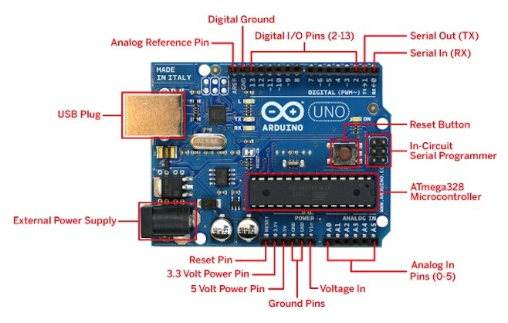
Fig 2 Arduino UNO
FEATURES
- Input voltage: 7-12V
- 32KB of flash memory
- EEPROM: 1KB
- Microcontroller: ATmega328P
- Operating voltage: 5V
APPLICATIONS
The Micro Chip Controller Uno, based on the Microchip ATmega328P microprocessor, is an open-source microcontroller board developed by Microcontroller.cc. This board offers both digital and analog input/output (I/O) connections that can be utilized for various purposes, including expansion (shields) and other circuitry. Out of the fourteen digital I/O pins on the board, six can also function as analog I/O pins for generating Pulse Width Modulation (PWM) signals. Programming for the board can be done using micro and medium driver Integrated Development Environment (IDE) via a USB Type B port. Power can be supplied to the board through a USB cable or an external 9-volt battery, with a voltage range of 7 to 20 volts. Similar to the Leonardo, Micro, and Nano consoles, the Uno follows a similar design pattern.
The official hardware reference design for the microcontroller is accessible on the microcontroller's website, provided under a Creative Commons Share Alike 2.5 license. Additional layouts and build files are also available for various hardware versions.
The initial software release for the Micro-controller was often referred to as "uno," which means "one" in Italian. The Uno board marked the beginning of a series of USB-based microcontroller boards, coinciding with the first release of the Micro IDE controller. Subsequent releases of the Micro-controller IDE version 1.0 replaced the board used in the Uno. The built-in ATmega328 on the Uno includes a bootloader that permits the addition of new code without requiring a third-party hardware programming tool. Notably, the Uno distinguishes itself from previous boards by retaining communication via the original STK500 protocol but foregoing the use of the FTDI-USB serial controller chip. Instead, it employs a USB-to-serial converter, typically featuring the Atmega16U2 (or Atmega8U2 version up to R2).
BACKGROUND
The microcontroller project originated at the Ivrea Institute (IDII), an interactive design school located in Ivrea, Italy. During that period, acquiring a microcontroller, often referred to as BASIC, posed a significant financial challenge for many students. Hernando Barragán initiated the development of the Wiring platform in collaboration with Massimo Banzi and Casey Reas in 2003, during his master's program at IDII. This initiative aimed to provide accessible and cost-effective tools that individuals without an engineering background could employ to create digital projects.
The Wiring platform encompassed an integrated development environment (IDE) centered around a processor, a printed circuit board (PCB) integrating an ATmega168 microcontroller, and a collection of library functions designed to facilitate rapid microcontroller programming. In 2003, Massimo Banzi, David Mellis, and another IDII student named David Cuartielles enhanced the Wiring platform by adding support for the more economical ATmega8 microprocessor. Rather than pursuing Wiring as a unified concept, they divided the project into distinct components and rebranded it as "microcontroller."
The initial microcontroller boards utilized the ATmega168 microprocessor and incorporated the FTDI-USB serial controller chip. Subsequently, the Uno board introduced a novel approach, combining the ATmega328P microprocessor and the ATmega16U2 microprocessor (up to the Atmega8U2 R2 version) as a USB serial converter. This distinctive configuration set the Uno apart from its predecessors.
Technical specifications
Microcontroller Overview:
The Microcontroller, based on the ATmega328P microchip, boasts the following specifications:
- Operating voltage: 5 volts
- Input voltage range: 7 to 20 volts
- Digital I/O pins: 14 (6 of which support PWM output)
- Analog input pins: 6
- Maximum DC current per pin: 20 mA
- Maximum DC current at 3.3 volts per pin: 50 mA
- Flash memory: 32 KB (including 0.5 KB used by the bootloader)
- SRAM: 2 KB
- EEPROM: 1 KB
- Clock frequency: 16 MHz
- Dimensions: Length - 68.6 mm, Width - 53.4 mm
- Weight: 25 g
Pin Functions:
1. LED: Driven by digital pin 13, the onboard LED is on when the pin is high and off when low.
2. VIN: This pin provides voltage from an external power supply (7-20V) to the microcontroller, not relying on USB or regulated power.
3. 5V: Produces a controlled 5V voltage for the board, sourced from USB (5V), DC power port (7-20V), or VIN connector (7-20V). Using 3.3V or 5V pins without SEC can damage the circuit.
4. 3V3: Provides a regulated 3.3V output, with a maximum current of 50 mA.
5. GND: Ground pins.
6. IOREF: Supplies the voltage reference needed by the microcontroller. Shields can adapt their power supply based on the voltage on this pin (5V or 3.3V).
7. Reset: Periodically triggers a reset, useful for shields that hinder the onboard reset button.
Special Pin Functions:
Software-controlled methods like pinMode(), digitalWrite(), and digitalRead() can be utilized to manage all 14 digital and 6 analog pins as inputs or outputs. Operating at 5 volts, each pin is designed for a recommended 20mA current and integrates a pull-up capacitor with a default resistance of 20-50K ohms. To protect the microcontroller, no I/O pin should exceed a 40 mA draw simultaneously. The six analog inputs (A0-A5) feature 10-bit resolution (1024 values) by default, measuring a range of 0 to 5 volts. However, the upper limit of this range can be altered using the analogReference() method and the AREF pin.
In addition, some pins have specialized functions:
Serial Communication and Pin Functions of Microcontroller Uno:
Serial/UART:
- TTL serial data is transmitted and received through pins 0 (RX) and 1 (TX).
- These pins connect to corresponding pins on the ATmega8U2 USB-TO-TTL serial chip.
External Interrupts:
- Pins 2 and 3 can be configured to trigger an interrupt based on low value, rising or falling edges, or value change.
PWM (Pulse Width Modulation):
- PWM output is available on pins 3, 5, 6, 9, 10, and 11.
- The AnalogWrite() function facilitates 8-bit PWM output control.

Communication:
- The Microcontroller/Genuino Uno supports various communication connections for interaction with computer systems, other Microcontroller/Genuino boards, or other microcontrollers.
- UART TTL (5V) serial interface employs digital pins 0 (RX) and 1 (TX).
- The built-in ATmega16U2 creates a virtual communication port for serial interaction via USB.
- ATmega16U2 integrates its own USB COM drivers, eliminating the need for standalone drivers. Windows requires a .inf file.
- The IDE's built-in serial monitor enables the microcontroller to send and receive plain text data for debugging.
- RX and TX LEDs blink during data transfer via the USB interface and the ATmega16U2 chip.
SoftwareSerial Library:
- The SoftwareSerial library allows serial communication on any digital pin of the Uno.
Automatic (Software) Reset:
- The Reset button on the Uno board doesn't need manual pressing before uploading code; connected computer software can reset it.
- The ATmega8U2/16U2 hardware's DTR line connects to the ATmega328 reset line via a capacitor.
- Asserting the DTR line triggers a reset on the chip.
- This setup results in the Uno rebooting upon connection to a computer running the latest version of macOS or Linux.
- The Uno loader runs within the next half second, even if the connected computer isn't sending new code.
- Despite being configured to skip invalid data, the first bytes sent after the connection establishment are captured.

Specifications
The Atmel 8-bit AVR-RISC-based microcontroller boasts an array of features, including:
1. USART Programming Kit: A Universal Synchronous/Asynchronous Receiver Transmitter (USART) for serial communication, including programming capabilities.
2. Byte 2-Wire Serial Interface: A two-wire serial communication interface for data exchange.
3. SPI Serial Port: A Serial Peripheral Interface (SPI) for synchronous serial communication.
4. 6-Channel 10-Bit A/D Converter: An analog-to-digital converter with six input channels and 10-bit resolution for analog signal conversion.
5. Programmable Wake-Up Time: The ability to set a customizable wake-up time, useful for power management.
6. 1 KB EEPROM: A 1 KB Electrically Erasable Programmable Read-Only Memory for non-volatile data storage.
7. 2 KB SRAM: A 2 KB Static Random-Access Memory for temporary data storage.
8. 23 General Purpose I/O Lines: 23 versatile digital input/output lines for interfacing with external devices.
9. 32 General-Purpose Cloud Work Registers: 32 registers used for temporary data storage and manipulation during computation.
10. Three Flexible Timer/Counters: Versatile timer/counters for various timing and counting functions.
The microcontroller operates within a voltage range of 1.8 to 5.5 volts and exhibits remarkable performance, achieving nearly 1 Million Instructions Per Second (MIPS) per Megahertz (MHz) clock frequency.
KEY PARAMETER
Parameter | Value
CPU type | 8-bit AVR
Performance | 20 MIPS at 20 MHz^{[2]}
Flash memory | 32 KB
SRAM | 2 KB
EEPROM | 1 KB
Pin count | 28 or 32 pin: PDIP-28, MLF-28, TQFP-32, MLF-32^{[2]}
Maximum operating frequency | 20 MHz
Number of touch channels | 16
Hardware QTouch Acquisition | No
Maximum I/O pins | 23
External interrupts | 2
USB Interface | No
USB Speed | –

Series Alternatives and Applications of the ATmega328 Microcontroller:
Series Alternatives:
- A notable competitor to the ATmega328 is the "picoPower" ATmega328P.
- The ATmega328P belongs to the ATmega328P super series and is closely related to the ATmega328PB.
- More details about other components within the megaAVR series can be found on the official Atmel website.
Variants in the ATmega328 Series:
- ATmega328P and ATmega328P-AUTOMOTIVE
- ATmega328PB and ATmega328PB-AUTOMOTIVE (ATmega328P super series)
- ATmega328
Applications:
- As of 2013, the ATmega328 microcontroller found wide application in various projects and independent vehicles that require a cost-effective and straightforward microcontroller solution.
- It's a popular choice in the Micro, Medium, Controller Uno, and Micro Controller Nano versions of the well-known Microcontroller development architecture.
- The microcontroller is well-regarded for its reliability. It has a rated containment failure rate of less than 1 Part Per Million (PPM) for 20 years at 85°C or 100 years at 25°C, meeting stringent reliability criteria.
PARALLEL PROGRAMMING

Programming signal | Pin Name | I/O | Function
RDY/BSY | PD1 | O | High means the MCU is ready for a new command, otherwise busy.
OE | PD2 | I | Output Enable (Active low)
WR | PD3 | I | Write Pulse (Active low)
BS1 | PD4 | I | Byte Select 1 (“0” = Low byte, “1” = High byte)
XA0 | PD5 | I | XTAL Action bit 0
XA1 | PD6 | I | XTAL Action bit 1
PAGEL | PD7 | I | Program memory and EEPROM Data Page Load
BS2 | PC2 | I | Byte Select 2 (“0” = Low byte, “1” = 2nd High byte)
DATA | PC[1:0]:PB[5:0] | I/O | Bi-directional data bus (Output when OE is low)

The ATmega328 microcontroller has emerged as a predominant choice for numerous projects, including applications in autonomous vehicles, from 2013 onward [citation needed]. Among the prevalent iterations of the widely recognized Microcontroller development architecture that employ this chip are the Micro, Medium, Controller Uno, and the Micro, Medium, Controller Nano.
2.3 SERIAL PROGRAMMING
Symbol | Pins | I/O | Description
MOSI | PB3 | I | Serial data in
MISO | PB4 | O | Serial Data out
SCK | PB5 | I | Serial Clock

Serial Data Transmission and Programming Steps:
Serial Data Transmission:
- Serial data is synchronized with the rising and falling edges, respectively, for data entering and leaving the microcontroller unit (MCU).
- Power is supplied to the VCC pin, while the RESET and SCK pins are set to 0.
- A software development instruction, "Enable serial instruction 0xAC, 0x53, 0x00, 0x00," is transmitted to the MOSI pin once at least 20 milliseconds have elapsed.
- The MCU will respond by sending back the second byte (0x53).
Programming in Microcontroller:
- Utilize the Microcontroller Desktop IDE along with your Semiconductor Uno.
- If you wish to program your Electronic Controller Uno offline, install the Microcontroller Desktop IDE.
- Ensure you have the Microcontroller Software (IDE) installed on your PC before proceeding. This IDE is used to program all boards, including the Uno.
- To connect your Uno board to a computer, you can use an A-B USB cable (commonly known as a USB printer cable).
NodeMCU (ESP8266):
- NodeMCU is a platform designed for developers and an open-source firmware based on Lua, specifically tailored for Internet of Things (IoT) applications.
- Its hardware is built around the ESP-12 module, and the software it employs is powered by Espressif Systems' ESP8266 Wi-Fi System-on-Chip (SoC).

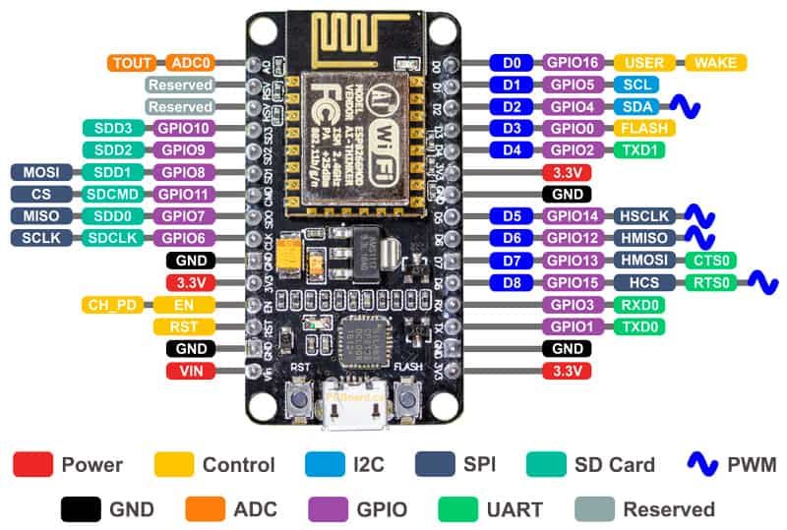
FIG 3 BLDC MOTOR
Brushless DC Electric Motors (BLDC Motors):
When a synchronous motor is powered by direct current (DC) electricity through an inverter or a switching power supply that generates alternating current (AC) in a closed loop controller, it's referred to as a brushless Washington, DC electric motor (BLDC motor or BL motor). It's also known as an electronically commutated motor (ECM or EC motor). The controller regulates torque and speed by applying small bursts of electrical charges to the motor windings.
Brushless vs. Brushed Motors:
Brushed DC motors, which date back to the 19th century, were commonly used. The advent of solid-state electronics in the 1960s made brushless DC motors feasible. In brushless motors, permanent magnets in the stator interact with revolving magnets on the rotor, generating torque by switching polarity. The stator, housing the rotor, often features an iron core and wire coil to create the magnetic field required by the motor's DC energy.

Variations in Construction:
- Conventional (Inrunner) Configuration: Permanent magnets are integral to the rotor, and three stator windings encircle the rotor.
- Outrunner (External-Rotor) Architecture: The stator coils act as the motor's core, and permanent magnetic fields inside an overhanging rotor produce torque by reversing the radial relationship between the magnets and coils.
- Conventional or Rectangular Axial Flux Type: Stator and rotor plates are arranged face-to-face, useful when space or shape constraints exist.
Potentiometer:
- A potentiometer is a three-terminal resistor featuring a sliding or rotating contact, creating a variable voltage divider.
- If the wiper and one terminal are used, it functions as a variable resistor or rheostat.
- The term "potentiometer" draws from the concept of a measuring tool that gauges electric potential (voltage) by acting as a voltage divider.
- Potentiometers frequently control electrical devices, like tuning knobs on musical instruments.
- When coupled with a joystick, potentiometers can serve as position transducers.
- Due to power dissipation concerns, potentiometers are rarely employed to directly control substantial amounts of electricity (more than one watt).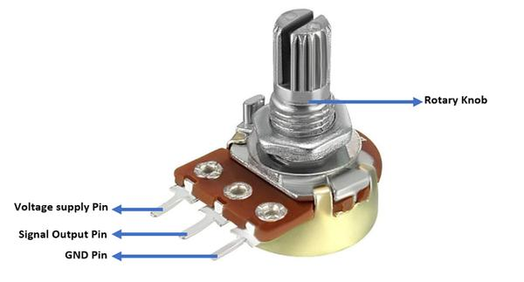
Fig 4 Potentiometer
ELECTRONIC SPEED CONTROLLER
The term "ESC," standing for "Electronic Speed Control," refers to an electronic circuit responsible for regulating the acceleration, braking, and direction of an electric motor. These components have become standard in electrically powered radio-controlled models. Particularly, brushless motors have become a popular upgrade, as they are provided with a low-voltage, three-phase energy source generated through advanced technology.
Usage and Integration:
- ESCs are now integral components in electrically powered radio-controlled models, enabling precise control over motor dynamics.
- Brushless motors are commonly used with ESCs due to their efficiency and the technological benefits they provide.
- ESCs are often incorporated into toy-grade R/C cars, but they can also be added as separate components, linked to the throttle function of the receiver control channel.
- Some R/C manufacturers equip their entry-level products with advanced electronics, consolidating hobbyist equipment onto a single circuit board for vehicles, vessels, or aircraft.
Components of an ESC:
1. Servo Signal or PWM Input: The input signal that governs the ESC's operation, often received from the radio receiver's throttle channel.
2. Positive (+) LIPO Connections: Connectors for the positive terminal of the Lithium Polymer (LiPo) battery.
3. Negative (-) LIPO Connections: Connectors for the negative terminal of the LiPo battery.
4. GND Reference for PWM Signal: Ground reference point for the PWM signal.
5. Solder Jumper for Rotation Direction (CW/CCW): Configurable solder jumper to adjust the rotation direction of the motor, either clockwise (CW) or counterclockwise (CCW).
6. Solder Jumper for PWM Input Signal Type: Configurable solder jumper to adjust the type of PWM input signal.
7. State LED: A light-emitting diode (LED) used to indicate the operational state of the ESC, providing visual feedback.
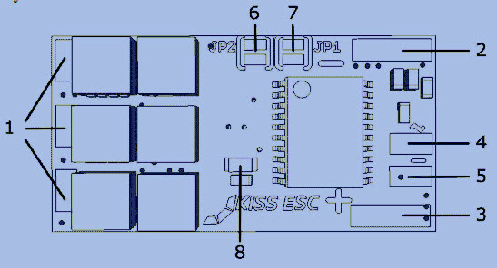

FIG 5 ESC

EXPERIMENTAL RESULT:
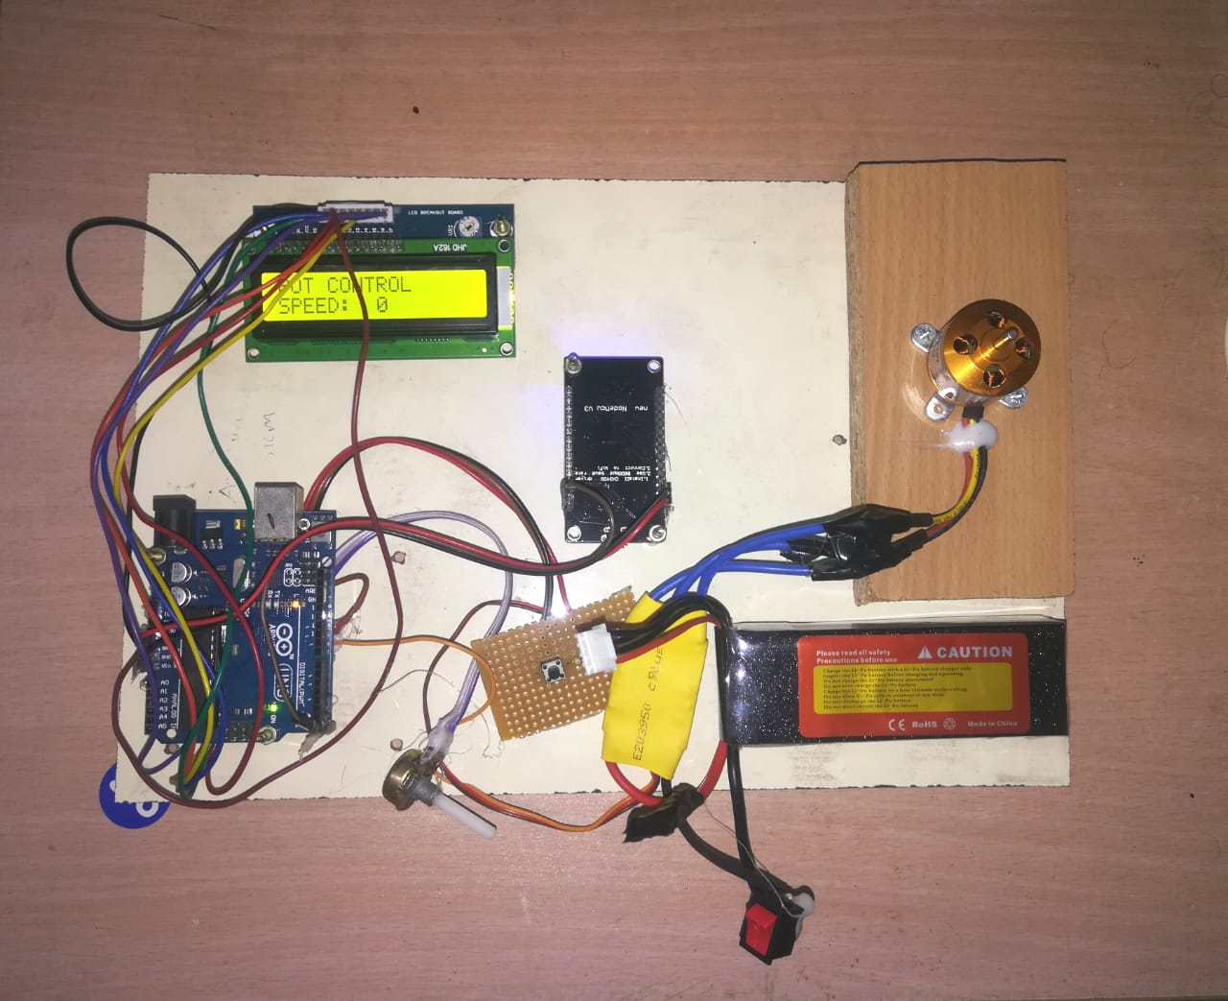
Fig 6 experimental result
CONCLUSION:
The proposed approach offers a streamlined solution that facilitates remote monitoring of the BLDC motor by industrial personnel. Through the utilization of Pulse Width Modulation (PWM) technology, the motor's speed can be precisely adjusted to meet specific operational requirements. This monitoring and control process is accomplished through the implementation of the Internet of Things (IoT).

The Internet of Things (IoT) plays a pivotal role in this system, serving as a fundamental communication tool. It enhances collaboration and connectivity across various components of the system. Leveraging IoT technology provides industries with significant benefits and promises a promising future. This recommended approach holds particular relevance for commercial applications, making it an ideal fit for business uses.
REFERENCE
[1] Sreeramk ,“Design of Fuzzy Logic Controller for Speed Control of Sensor less BLDC Motor Drive”, IEE International Conference On Control, Power , Communication and computing Technologies, pp 18- 24,2018.
[2] K.S. Krishna Veni; Dr.N.Senthil Kumar; J.Gnanavadivel, “Low Cost Fuzzy Logic Based Speed Control Of BLDC Motor”, IEEE International Conference On Advances In Electrical Technology For Green Energy, pp 1-5, 2017.
[3] K.Sowmiya;R.VishnuPriya, “Microcontroller Based Speed Control Scheme of BLDC Motor Using Proteus”, International Journal, Volume: 5, Issue: III,2017.
[4] Rodolfo L Valle ;Pedro M.de Almeida ;Andre A. Ferreira; Pedro G. Barbosa, “ Unipolar PWM Predictive Current–mode Control Of Variable-Speed Low inductance BLDC Motor drive”, Volume:11, Issue: 5,pp 688696,2017.
[5] Shaohua Chen; Gang Liu; Lianqing Zhu, “Sensor less control Strategy Of a 315K High –Speed BLDC Motor Based On a Speed Independent Flux Linkage Function”, IEEE Transactions On Industrial Electronics, Volume: 64, Issue: 11,pp 8607-8617,2017.
[6] WenzhuoLi ;Jiancheng Fang ; Haitao Li ; Jiqiang Tang, “Position Sensor less Control Without Phase Shifter For High Speed BLDC Motors With Low Inductance And Nonideal Back Emf”, IEEE Transactions On Power Electronics, Volume: 31 , Issue: 2,pp1354-1366,2016.

