A Review Study on the Improvised Epidemiological Approach to Cancer Diagnosis
Avra Pratim Chowdhury^{1a*}, Manigreeva Krishnatreya^{1b*} Alankrita Deka², Chidananda Bhuya³
1a. Post Graduate Trainee, DR. Bhubaneswar Borooah Cancer Institute, Assam, India.
1b. Cancer Epidemiologist, DR. Bhubaneswar Borooah Cancer Institute, Assam, India.
2. Clinical Pathologist, Agillus (SRL) Diagnostics, Assam, India.
3. Retired Professor of Medical Oncology, Dr B. Borooah Cancer Institute, Assam, India

*Corresponding authors: avranu132@gmail.com and manigreeva@gmail.com
Cell contact: +91 7575905963, +919954480692
Abstract
Background: Now a day’s cancer diagnosis is improvised on automated analysis at the background of consequences of malignant necrotic cell debris and fibrous materials in a scattered manner.
Purpose: Epidemiology that is oriented to malignancies, based on its etiology, risk factors, diagnosis, prevention, and control subjected to cancer epidemiology on invasive pathogens. Materials and Methods: This intense network of molecules, allowing communication among bacteria, viruses, and eukaryotic cells have evolved to guarantee optimal life in different ecological niches to each component of the ecosystem and is based upon effectors receptor for developing cancer.
Results: The key role of this advanced part is the prior augmentation for systematic diagnosis as for cancer registry among the population. The particular research on epidemiological studies based on cancer diagnosis can be categorized as endemic based in a particular area (example: Northeast India) and as sporadic based on its frequently spreading in the world scenario. The epidemiological study on laboratory diagnosis of topographical cancer is designed by Pathology, Histopathology, Immuno-chemistry, Radiology, and Molecular genesis.
Conclusion: So cancer is curable if preventive measures and controlling of risk factors can be done in the early stage of diagnosis at epidemiological reviewing on report analysis by an expert oncologist.
Keywords: Cancer epidemiology, Immune assay, Topographical cancer, Metastasis, Molecular genesis.

Introduction
Epidemiology is defined as cancer basis on its etiology, risk factors, diagnosis, prevention, and control is subjected to cancer epidemiology. Cancer is non-contagious and self-migrating cellular tissue mass in the host itself. A cancer registry is an information record designed for the collection and analysis of data on cancer patients with the diagnosis.
So it can be categorized as endemic based on a particular area (example: India) and as sporadic based on its frequently spreading (example: Retinoblastoma) (Bennett WP, et al. 1992). The first cancer registry was established in Mumbai by the Indian Cancer Society Bombay in 1963. The introductory norms were based on Hospital and ambulatory surgical treatment-based registry, Population-based registry, and Special registry (NCRP-ICMR, 2016). The highest cancer rate in India was reported in the state of Kerala. Mizoram accounted for the highest cancer death rate in the country followed by Kerala. So epidemiological data screening to a census in India is very updating and forwarded to prevalence against the risk factors.
The study on the diagnosis of cancer is designed by Pathology, Histopathology, Immunochemistry, and Radiology with Molecular genesis (Khatib O, and Aljurf M, 2008). Cancer is curable if preventive measures and controlling of risk factors can be done in an early stage of diagnosis (Toyota M, et al. 1999).
Microbiota-derived compounds can contribute to controlling host physiological and pathological states (Jia L, et al. 1999). Metabolomic profiling of gut bacteria can allow deciphering several molecules controlling cholesterol synthesis, obesity, cardiovascular diseases, and metabolic syndrome (Gertig DM, et al. 1998). Though volatile fatty acids, amino acids, and their derivatives usually contribute to flavor, taste, and color, there is no information available on these constituents. Inflammatory bowel disease (IBD) includes both ulcerative colitis (UC) and Crohn's disease (CD) (Bray F, and Parkin DM. 2009). Both of these disorders have an increased risk of colorectal cancer (CRC). Although colorectal cancer (CRC) in individuals with IBD only accounts for 1–2% of all cases of CRC in the general population, it is considered a serious complication of the disease and accounts for approximately 15% of all deaths in patients with IBD (Vineis, P. 1997). Pathognomic lesions of hematological cancer are non-contagious and self migrating indicates the cellular tissue mass in the host itself during migrations in erythrocytes from bone marrow (Wingo PA, et al. 2003). Different in-vitro implemented staining (example: MGG stain) shows epithelial cells in a group scattered with abundant cytoplasm and prominent nuclei at atypia in the early stage (Takiar R, and Shobana B. 2009).
The magnitude of the risk has been found to differ, however, in population-based studies. Recent figures suggest that the risk of colon cancer for people with IBD increases by 0.5–1.0% yearly, 8–10 years after diagnosis (Coffey DS. 2001). The magnitude of CRC risk also increases with early age at IBD diagnosis, longer duration of symptoms, and extent of disease, with pancolitis having more severe inflammation and a higher risk of dysplasia-carcinoma progression (Zeigler RG, et al 1993, Fabián G, et al. 2019). So cancer based registry is highly profiled to trace outpatients with their cancer history as a prognosis for medication and treatments.
Materials and Methods
The study is based on three modules of analysis. The first module is to study the cancer topographic region among the registered cancer patients. The second module deals with the population-based cancer registry (PBCR) leading the statistics in cancer registration, and their application to the patient. The third module is followed to study the hospital-based cancer registry (HBCR) for estimating the migration potency in a particular or non-particular region.
3.1 Research Data (ICMR, 2012-2016)
According to report of ICMR (2012-2016), In the North Eastern part the cancer cases were in Assam 24392, Manipur State 8202, Mizoram state 8059, Sikkim 20303, Meghalaya 7520, Tripura state 11473, Nagaland 20395, Arunachal Pradesh 3017.
3.2 Screening methods of patient history
Primary entry data from HBCR Data saved in computing format as patient history Registered patient supposed to visit respective doctors regarding the type of tumor or report Every history of treatment, diagnosis, hospital charge, documents and doctors prescription be recorded by HBCR HBCR sends all reports to PBCR PBCR verifies every parameter regarding cancer registry PBCR sends registered documents as computing file to Indian Council of Medical Research (ICMR, Bangalore). ICMR collected all the parameters of cancer profile from PBCR and publishes the annual report.
Methods of diagnostic profiling
Registry of cancer patients profiling of diagnostics reports screening the therapeutic doses Observations for treatment in hospital-based Indexing of therapeutic and medicinal doses along with recovery stages. Data entry and report analysis used during recovery or post-operative recovery or palliative care.
a. Biopsy
Specimen received Specimen into LIS (10% Formalin) Cassette of Specimen is made Place Specimen into Sakura processor Embedded Specimen in WAX block Slice it in microtome Place on slides Stain and cover slides Result out Transcribed analysis
b. Path Scan
The white marking dye is to use diagnose the metastatic origin of tumor cells. The fluorescent dye remarks for reflecting rays to diagnose malignancy of extraneous cells.
c. Fine Needle Aspirate Cytology (FNAC)
The diagnostic method is used to check for fresh bleeding from aspirated tissues. The used MGG stain of the particular smear shows epithelial cells in a scattered manner with necrotic fibrous materials of RBC as reported carcinoma.
d. PAP Test (Georgios Papanikolaou)
This is used to detect the sign of cervical cancer by observing the presence of cancerous cells by a smear. The negative result is screened for the patient each five to seven years interval.
e. Mammography
Pathological diagnosis for mammary gland, specified for breast cancer.
3.3 Epidemiological methods on improvised approach
Entry data on patient history Strata is used to follow on different sites of cancer records in PBCR and HBCR Assessments of records in studying cancer migration according to topographical view Review statements used to follow up the epidemiological behavior of cancer migration in a population-based study. Documents are registered as confidential files for a patient.

Figure 1 Three modules of improvised approaches are tabulated for updating the cancer registry in an epidemiological based study.
Results and Discussion
The study of epidemiological strata was noted at B. Boorah Cancer Research Institute during the summer training course on Cancer Epidemiology and Biostatistics in Guwahati, Assam. The modules were followed by reviewing studies for the trainee from cancer backgrounds along with palliative care.
The outcomes of this review based on three types of case studies-
The data were assembled and assimilated into editions of patient details in a Pro-forma copy of PBCR. The enlisted addresses, diagnostic reports, doctor's prescriptions, and therapeutic indexes of treatments were recorded on a basis of cancer epidemiology. The selective hospitalized patients were categorized from a population-based study to verify the migration of cancer on its topographic regions (Ziegler A, et al. 1994). The new entry of data from each individual had clarified by two categories of PBCR and HBCR classes. The continuously recorded data from Pro-forma leads to the computation analysis for bio-statistical calculation on cancer migration in a particular area. The demographic area signifies different analyses to point out to notify the region of the center of cancer migration.

Table 1 Analytical key factors of epidemiological approach between two types of cancer registry.
Population-based Cancer Registry | Hospital-based Cancer Registry
A figure of geographic region. | A figure of Hospital base treatment.
A figure of the population number. | A figure of the patient number.
Background of population. | Background of patient
Incident data collection. | Treatment base data collection.
Male and female ratio. | The ratio of the infected rate of cancer.
Cancer identifying details in population | Cancer identifying details in hospitals
Methods of diagnosis in a population | Methods of diagnosis in hospital
Follow up on the population. | . Follow up with the patient.

The case study is initiated with several prescribed patients suffering from long-term Hepatitis, Diabetes, and Humoral Immune deficiency syndrome. The diagnostic approach is first followed by traditional diagnosis methods. Topography and Morphology are determined by the Biopsy report. The removal of tissues or cells for analysis is called a Biopsy. A biopsy is only the sure way to diagnose most cancers.
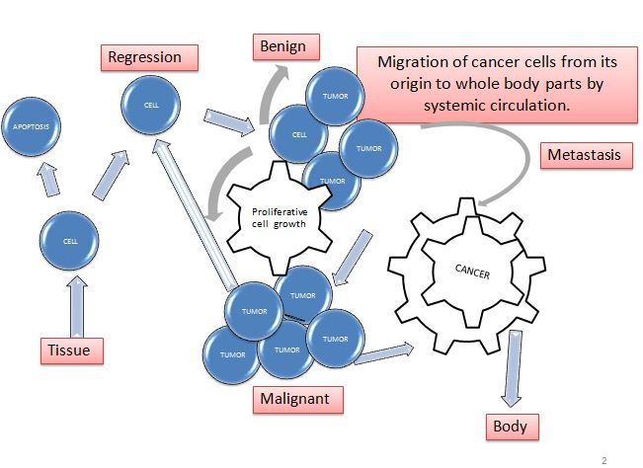
Figure 2 The metastatic transmission of tumor cells developing from Benign to Neo-plastic cancer.
Imaging tests like CT scans and X-Rays can help identify areas of cancers. Biopsies are typically associated to test either abnormalities' presence or absence in tissues. Two types of biopsy methods are reported Excision biopsy and Incision biopsy for approaching to diagnose identical malignancy. Several biopsies are also followed by oncologists and specialists viz. bone marrow biopsy, endoscopic biopsies, needle biopsies, and surgical biopsies.

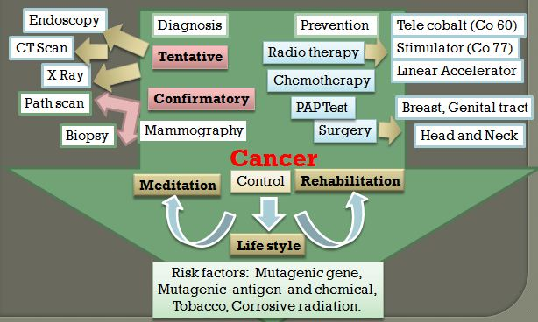
Figure 3 The cancer epidemiology of the data management system at Hospital-based Diagnosis

The two diagnosis system is to follow for the registry depending on tentative and confirmatory reports of patients. Surgical affection and hematological sort-out are designed to decorate the data for HBCR and PBCR. The diagnostic marker is used for viral interference for malignancy. A confirmed diagnosis is applied for hepatitis, diabetes, and HIV patient that suffered post malignancy of viral interference.
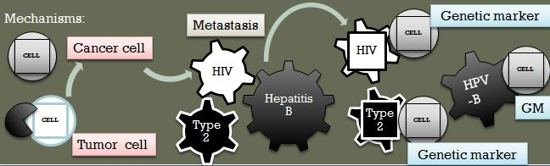

Figure 4 The figure showed the cancer-epidemiology of Viral and Insulin dependent-interference diagnosis systems at Hospital Based Cancer Registry
The case study is profiled on the data presented on the spot admission copy from the cancer patients. The submission form guides the interpretation of data for statistical analysis. The data is regulated from computational input to review malignancy parameters. The parameter is augmented for departmental treatment for following HBCR. The statistical calculation in manual diagrammed in software to follow the HBCR and PBCR for the assessment of patient history is data-based.
Table 2 The improvised epidemiological diagnostic tools to input data of cancer patients from the Hospital-based Registry.

Diagnostic type | Topography | Route | Confirmatory Diagnosis | Cancer types
CT- Scan | Metastatic origin of tumor cell | Radio-active transportation to the tentative organ from an external source | Biopsy | Benign and Metastatic
X-ray | Metastatic origin of tumor cell | Radio-active transportation to the tentative organ from an external source | Biopsy | Benign
Endoscopy | Carcinogenic origin of tumor cell | Optical fiber reflex through the elementary tract. | Biopsy, Cell cyto-pathy with genetic markers | Metastatic and Neoplastic
Path-Scan | Carcinogenic origin of tumor cell | Transportation of chemo-synthetic fluorescence from tentative organs to the whole body by computational scanning. | Biopsy, Cell cyto-pathy with genetic markers | Metastatic and Neoplastic
Mammography | Metastatic origin of tumor cell | Mammary gland | Biopsy | Benign
FNAC | Pathological inclusion bodies | Localized Benign tumor | Biopsy | Benign

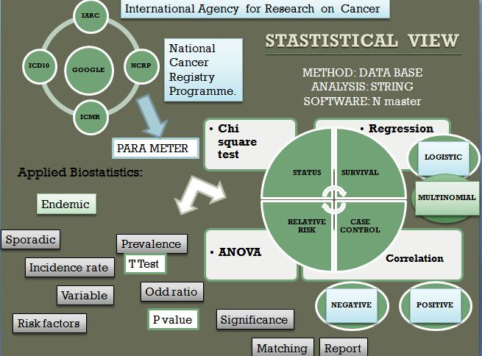
Figure 5 The outcomes of epidemiological bio-strata from cancer patients for their palliative care and management.
The data input is followed by the method to calculate on DATABASE Software (String software: N-master). The parameter collected from patient reports were assembled for analysis under the supervision of the Indian Council of Medical Research (ICMR), National Cancer Registry Programme (NCRP), and International Agency for Research on Cancer (IARC) continue with supervision for correctly verification. The data were reviewed by the implementation of software to analyze in Chi-square test, Regression, Correlation, and ANOVA. The integrated calculation determined the cofactor of malignancy to find out if it was positive or negatively correlated.
Conclusion
From this study course along with practical works, the mainstream conclusion stands for cancer detection in early-stage and treatment appropriately at the highest curable rate. The mainstay of the treatment is surgical and adjuvant radiotherapy required in the advanced stages of the diseases. The fundamentals of cancer research are subjected to cancer registry, assessment of data regarding recovery stages, and analysis of interpreted annual reports for each population and hospital-based.
Conflicts of interest
There are no conflicts among the authors during the summer training coursework and preparing the manuscript.
Acknowledgment
We acknowledge our review studies to Doctors, Oncologists, and all technicians at DR. Bhubaneswar Borooah Cancer Institute, Assam, India for their support during this training session.
References
- Bennett WP, Hollstein MC, Metcalf RA, et al. “p53 mutation and protein accumulation during multistage human esophageal carcinogenesis”. Cancer Research 1992; 52:6092–6097.
- Khatib O, Aljurf M. "Cancer Prevention and Control in the Eastern Mediterranean Region: The Need for a Public Health Approach". Hematol Oncol Stem Cell Ther 2008; 1: 44–52.
- Gertig DM, and Hunter DJ. “Genes and environment in the etiology of colorectal cancer”. Seminars in Cancer Biology 1998; 8:285–298.
- Fabián G, Vries D, Carolina W. "Importancia del acceso de los registros de cáncer de base poblacional a las estadísticas vitales: Barreras identificadas en Colombia". Revista Colombiana de Cancerología 2019; 23: 56–61.
- Toyota M, Herman JG, Baylin SB et al.“aCpG island methylator phenotype in colorectal cancer”. N Acad of Sci 1999; 96:8681– 8686.
- Bray F, Parkin DM. “Evaluation of data quality in the cancer registry: Principles and methods”. Eur J Cancer 2009, 45: 747 – 755.
- Jia L, Wang XW, Harris CC. “Hepatitis B virus X protein inhibits nucleotide excision repair”. Int J of Cancer 1999, 80:875–879.
- Takiar R, and Shobana B. “Cancer incidence rates and the problem of denominators - a new approach in Indian cancer registries”. Asian Pac J Cancer Prev 2009, 10: 123 – 126.
- Vineis, P. “Molecular epidemiology: Low-dose carcinogens and genetic susceptibility”. Int J of Cancer 1997, 71:1–3.
- Coffey DS. “Similarities of prostate and breast cancer: Evolution, diet, and estrogens". Urology 2001, 57:31–38.
- Wingo PA, Cardinez CJ, Landis SH, et al. “Long-term trends in cancer mortality in the United States, 1930-1998”. Cancer 2003, 97: 3133- 3275.
- Steliarova-Foucher E, Stiller C, Lacour B, Kaatsch P. “International Classification of Childhood Cancer, third edition”. Cancer 2005, 103: 1457- 1467.
- Zeigler RG, Hoover RN, Pike MC, et al. “Migration patterns and breast cancer risk in Asian-American women”. Journal of the National Cancer Institute 1993, 85:1819–1827.
- National Centre for Disease Informatics and Research: Consolidated Report of Population-Based Cancer Registries 2006-2008, 2009-2011, 2012-2016; Bengaluru, India, NCRP-ICMR.
- Thomas HV, Reeves GK, Key TJA. “Endogenous estrogen and postmenopausal breast cancer: A quantitative review”. Cancer Causes and Cont 1997, 8(6):922–928.
- Sherman, R., Firth, R., Charlton, M., et al. “Registry-Specific Cancer Mortality in the United States and Canada”. NAACCR, Can. in N. America 2020, 3: 2013-2017.

