SOME COMMON HEALTH PROBLEMS-DIATARYMANGANESE SUPPLEMENTSPRESENT IN SELECTED EDIBLE VEGETABLES, IMPHAL, MANIPUR, INDIA.

M. Aken Singh,

Department of Chemistry, G.P Women’s College, D.M University,Imphal -795001, Manipur.

* Corresponding author, E-mail: akenmaibam569@gmail.com , Phone: 09862125442.

ABTRACT: Energy Dispersive X-ray Fluorescence (EDXRF) technique was used for the determination of trace elements in some selected vegetables available in Manipur. Manganese and Zinc present in some selected vegetables as medicinal value,improves some common health problems.
Key words: EDXRF, Manganesesome selected edible vegetables, Tardive Dyskinesia, Goiter, Osteoporosis, Sprains-Strains and Diabetes Type 1, 2.
INTRODUCTION
Manipur referred to as the “Jewel of India” stretches from 23⁰83/ N - 25⁰86/N to 93⁰03/E - 94⁰78/E in the northeastern corner of the country. It is surrounded on the north by Nagaland on the east by upper Myanmar, on the south by Chin- hills of Myanmar and Lusai Hills ( Mizoram) and on the west by Cachar district of Assam.
The state has an area of 22.356 sq Km. with an oval shape fertile valley in the centre. The forest area is 15,154 sq. km. is reserved, 4171 Sq. Km is protected and 9.520 Sq. Km. is unclassed forest areas (Statistical Bulletin, Manipur Forest, 1990). The flora and fauna of the state is similar and related to those of the neighboring regions. However has its own endemic species too. Unexplored and hidden, Manipur holds the potential to become a remarkable tourist destination in the 21st century. This oval-shaped valley, encircled by lush green hills, is a treasure trove of art and traditions. It has often been likened to the "Switzerland of the East" due to its picturesque landscapes, including cascading rapids, meandering rivers, and vibrant carpets of exotic flowers. Throughout history, various cultures have harnessed the nutritional energy of plants as part of their diet. The human body requires a range of trace elements to function normally, typically sourced from the foods we consume. Imbalances in these trace elements, either in excess or deficiency, can lead to complications and metabolic disorders. Therefore, the analysis of trace elements in edible plants is of paramount importance. In this study, a selection of edible plants has been examined to determine their elemental concentrations.
Manganese Manganese (Mn) is a trace mineral and one of the most prevalent metals found in the tissues of mammals. It plays a crucial role in various essential biological processes, acting as a catalyst, an enzyme cofactor, and a gene modulator. Mn is indispensable for a wide range of bodily functions, including the metabolism of amino acids, cholesterol, glucose, and carbohydrates. Additionally, Mn is integral to other physiological processes, such as brain and skeletal development, blood clotting, reproduction, neuronal function, antioxidant defense, immune system maintenance, and innate antiviral immunity.
Manganese can be sourced from soil, water, and food legumes, and it exists in eleven different oxidation states, although it predominantly appears in biological tissues as Mn2+ and Mn3+ ions. A deficiency in Mn has been linked to an increased susceptibility to seizures, as well as birth and skeletal abnormalities. The normal concentration of Mn varies depending on the specific biological tissue being assessed. In general, estimated Mn levels in the body are around 4-12 micrograms per liter for the whole body, 1-8 micrograms per liter in urine, and 0.4-0.85 micrograms per liter in serum.^{9, 10}.
Manganese is a vital trace mineral required for the promotion of healthy skin, the formation of strong bones and cartilage, and the regulation of glucose tolerance. It also plays a crucial role in the activation of superoxide dismutase (SOD), a significant antioxidant.¹¹.
Tardive dyskinesia is a condition that arises as a result of the prolonged use of neuroleptic drugs, commonly prescribed for the treatment of psychiatric disorders. It is considered a side effect of antipsychotic medications. Notably, one medical practitioner has observed that the administration of the trace mineral manganese at a dosage of 15 mg per day can serve as a preventive measure, averting the onset of TD. Furthermore, higher doses of manganese, reaching up to 60 mg per day, have shown potential in reversing TD that has already manifested. Various other researchers have reported comparable positive outcomes associated with the use of manganese.¹².
An abnormal swelling of the thyroid gland is called a goiter. The butterfly-shaped gland that makes up our thyroid is situated under our Adam's apple at the base of our neck. Goiters typically don't hurt, but if they get big, they might make you cough and have trouble breathing or swallowing. Iodine deficiency is the leading cause of goiters in the world. In the United States, where iodized salt is widely used, goiters are more frequently caused by thyroid gland nodules or by an excess or shortage of thyroid hormones. Manganese insufficiency may be a contributing factor to goiter, a sign of iodine deficiency. Manganese supplements might be beneficial. Other nutrient levels become significant in the development of goiter when there is an iodine shortage. Zinc and manganese deficiencies can also be a factor in iodine insufficiency. iritis12. Goiter is caused by more reasons.
When our blood glucose (sugar, the body's primary energy source) levels fall, we have hypoglycemia. Diabetes sufferers experience it when their diet, exercise regimen, and/or medications aren't compatible. Because the body's mechanisms for regulating high and low blood sugar levels are similar, manganese may also aid with hypoglycemia. Manganese helps persons with diabetes control their blood sugar levels. Studies have demonstrated that either supplemental chromium (200 mcg daily) or manganese (340 mg daily) can stop hypoglycemia patients' blood sugar levels from dropping too low. People with hypoglycemia have also been reported to benefit from niacinamide, or vitamin B3. Vitamins C, E, Zinc, Cu, Mn, and B6 are among the other minerals that may assist diabetics control their blood sugar levels.¹⁴.
In developing teenagers, Osgood-Schlatter disease (also known as knee discomfort) is a prevalent cause of knee pain. It is an inflammation of the region directly below the knee where the patellar tendon, which joins to the shinbone, meets the tibia. A combination of zinc, manganese, and vitamin B6 has previously been shown by certain clinicians to have positive outcomes for patients with Osgood-Schlatter disease. For patients with Osgood-Schlatter disease, a different team of physicians has reported positive outcomes with a combination of zinc, manganese, and vitamin B6; the research did not specify the dosages of these supplements. The majority of doctors would recommend that teenagers consume 15 mg of zinc, 5 to 10 mg of manganese, and 25 mg of vitamin B6 every day. Higher dosages could be taken under physician guidance.^{15, 16}.
Fractures brought on by osteoporosis, or thinner bones, can hurt. Age, gender, low body weight, low sex hormones or menopause, smoking, and some drugs are risk factors for osteoporosis. Osteoporosis medicines, exercise, and calcium and vitamin D are among the preventive and therapeutic measures17. It has been observed that a mix of appropriate minerals, such as manganese, can stop bone loss. For those who are worried about maintaining bone mass, some doctors suggest taking manganese. When renowned basketball player Bill Walton's frequent fractures were prevented with manganese supplements, interest in the relationship between manganese and bone health sparked. A smaller proportion of osteoporotic women were shown to have manganese insufficiency in a later, undisclosed investigation. Since then, it has been claimed that a mix of minerals, including manganese, can stop bone loss. However, the impact of manganese supplementation alone on bone mass has not been studied in a human experiment. However, for those who are concerned about maintaining bone mass, some physicians advise taking 10 to 20 mg of manganese daily. For eight to nine months, a trial including postmenopausal women coupled hormone replacement treatment with magnesium (600 mg daily), calcium (500 mg daily), vitamin C, vitamin D, zinc, copper, magnesium, boron, and other minerals. Participants were also instructed to stay away from processed foods, consume less protein, prioritize plant-based protein over animal protein, and cut back on their intake of alcohol, salt, sugar, coffee, tea, chocolate, and tobacco. Bone density rose by an astounding 11%, while it only increased by 0.7% in women undergoing hormone replacement therapy alone.^{18, 19, 20}.
Type 1 diabetes, which is a chronic disease, occurs when the immune system targets and destroys insulin-producing beta cells in the pancreas. This condition is often diagnosed in children and young individuals, earning it the moniker "Juvenile diabetes." Individuals with type 1 diabetes cannot naturally produce insulin, a hormone crucial for enabling our body's cells to utilize glucose for energy. Glucose is sourced from the food we consume, and insulin facilitates its transfer from the bloodstream into the cells of our body. The addition of manganese as a supplement may enhance antioxidant defense mechanisms and lead to better blood sugar control in individuals with type 1 diabetes.
Manganese plays a crucial role in the functioning of a vital antioxidant enzyme system within the body. A genetic variant associated with reduced activity in this enzyme system has been suggested as a contributing factor in the onset of type-1 diabetes and its associated complications. Individuals with both type 1 and type 2 diabetes have been found to exhibit lower levels of manganese in their blood. Supplementation with manganese has demonstrated the capacity to enhance the effectiveness of this antioxidant enzyme system, elevate insulin secretion, and improve glucose metabolism. In fact, it has been reported that insulin-dependent diabetic patients who received oral manganese, typically at a dosage of 3 to 5 mg per day in the form of manganese chloride, experienced a significant reduction in blood glucose levels.
Type 2 diabetes is a lifelong condition that interferes with the body's ability to utilize insulin. Individuals with type 2 diabetes are characterized by having developed insulin resistance, where their response to insulin diminishes. Consequently, the body encounters difficulties in transferring glucose from the bloodstream into cells, which requires an adequate supply of this hormone. Remarkably, many individuals may remain unaware of their type 2 diabetes until they experience complications. While this condition is often associated with middle-aged and older individuals, it is also colloquially referred to as adult-onset diabetes. Type 2 diabetes can affect children and teenagers, primarily due to the prevalence of childhood obesity.
Manganese plays a significant role in enhancing antioxidant capacity and regulating metabolic processes. It serves as a critical nutrient for activating enzyme systems related to both antioxidants and metabolism. Notably, both excessively high and excessively low levels of manganese can contribute to elevated oxidative stress and the initiation and progression of type 2 diabetes. Research conducted in animal models and laboratories has suggested that manganese supplementation may enhance insulin sensitivity and shield blood vessels from damage resulting from elevated glucose levels in individuals with type 2 diabetes. While there is a lack of clinical trials to provide definitive evidence, taking a multivitamin/mineral supplement to ensure adequate manganese intake is considered a prudent precaution for individuals with type 2 diabetes. ²³.

Materials and methods:
Samples Preparation
The edible vegetable samples along with wild edible species were purchased from different vegetable venders at Imphal city and some wild plants from hilly areas of Manipur, India. A total of 8 samples were washed one by one with distilled water 2-3 times to remove contaminated particles, soil/sand and dried in the oven at 65⁰C for 24 hours. The analyzed samples were given in Table-1. One should take care that concentration of K can be changed if the drying temperature is higher than 70⁰C and subsequently ground by an agate mortar. The powdered samples were passed through sieve to have homogeneity in three dimensions. 150 mg of each sample were weighed and pelletized into thin pellets of uniform thickness having 13 mm diameters using a table-top K-Br press under a pressure of 150-200 kg/cm² for 5 minutes.
EDXRFAnalysis:
The pellets of the samples were analyzed in three replications by the Jordan Valley ED-3600 Energy Dispersive X-Ray fluorescence spectrometer, which works with liquid-nitrogen-cooled system. The NIST standard apple leaf (SRM-1515) was used as reference material for the analysis work. The data acquisition time was 10 minutes for each sample. Ti and Fe filters were used for 14 kV (e2) and 23 kV (e3) respectively. The spectra were analysed by using EXwin²⁵.

List of the samples analyzed.
Sl.No | Samples analysed | Code Names
1 | Local Name –Maroi napakpi(Leaves)  Bot Name- Allium hookerii Thw | MN
2 | Local Name-Laphu tharo  Bot Name- Musa paradisiacal L | LT
3 | Local Name- Thambou(white type)  Bot Name-Nelumbo nucifera Gaertn | TW
4 | Local Name- Thambou(Red type)  Bot Name-Nelumbo nucifera Gaertn | TR
5 | Local Name-Tokningkok(Rhizome)  Bot Name-Houttuynia cordat | TO
6 | Local Name-Heiba  Bot Name-Ficus palmate Forsk | HE
7 | Local Name- Karot akhabi  Bot Name- Momordica Charantia | KB
8 | Local Name- Kengoi  Bot Name- Lysimachia Obovata | KE
9 | Local Name-Loklei(Stem)  Bot Name-Hedycium coronarium | LS
10 | Local Name-Monsoubi  Bot Name-Chenopodium album | MO
11 | Local Name-Phakpai  Bot Name-Persicaria odorata | PH
12 | Local Name-Kolamani  Bot Name-Ipomoea aquatic | KL
13 | Local Name- Komprek  Bot Name-Oenanthe javanica | KO
14 | Local Name-Loklei(Rhizome)  Bot Name-Hedycium coronarium | LR
15 | Local Name- Kangouman  Bot Name-Elsholtzia blanda (Benth.) Benth | KG
Contd…
Sl.No | Samples analysed | Code Names
16 | Local Name-Yaipal  Bot Name-Cucurma angustifolia | YL
17 | Local Name-Peruk  Bot Name-Centella asiatica | PE
18 | Local Name-Awa phadigom  Bot Name-Eryngium foetidum L | AP
19 | Local Name- Tukuma(Seed)  Bot Name-Hyptis suaveolens | TU
20 | Local Name-Kuthab ukabi  Bot Name-Clerodendrum viscosum Vent | KU
21 | Local Name-Khumon  Bot Name- Nymphoides aquatica | KH

The photographs of Vegetables selected with their code names are shown below.
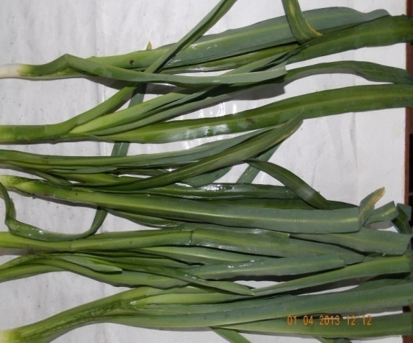  Plate-1. Local Name –Maroi napakpi(Leaves)  Bot Name-Allium hookerii Thw |  |  | 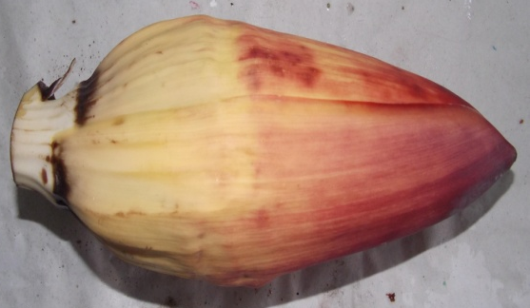  Plate-2-Local Name-Laphu tharo  Bot Name- Musa paradisiacal L
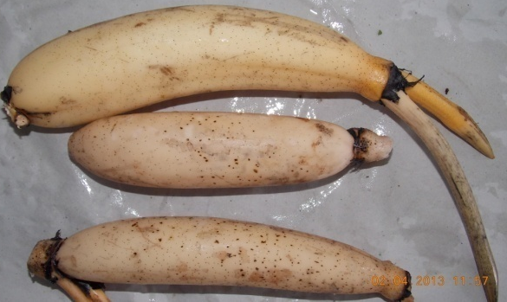  Plate-3.Local Name- Thambou(white type)  Bot.name- Nelumbo nucifera Gaertn |  |  | 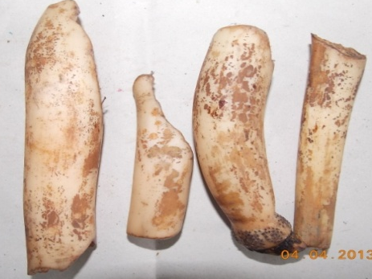  Plate-4.Local Name-Thambou(Red type)  Bot. name- Nelumbo nucifera Gaertn
 | 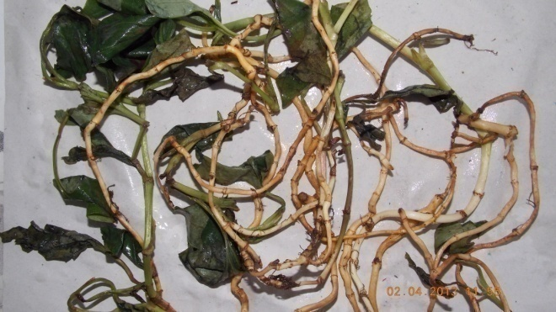  Plate-5.LocalName-Tokningkok(Rhizome)  Bot Name-Houttuynia cordat |  | 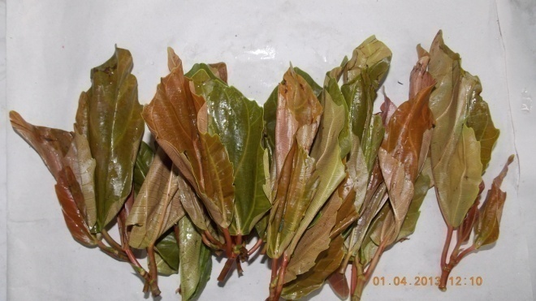  Plate-6. Local Name-Heiba  Bot Name-Ficus palmate Forsk
 | 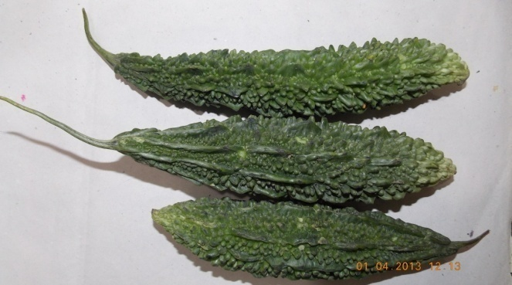  Plate-7. Local Name- Karot akhabi.  Bot Name-Momordica Charantia. |  | 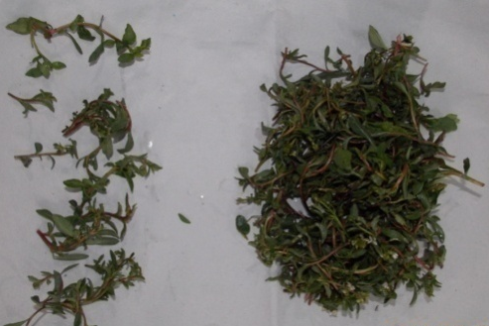  Plate-8.Local Name- Kengoi.  Bot Name-Lysimachia Obovata.
 | Plate-9.Local Name-Loklei(Stem)  Bot Name-Hedycium coronarium |  | 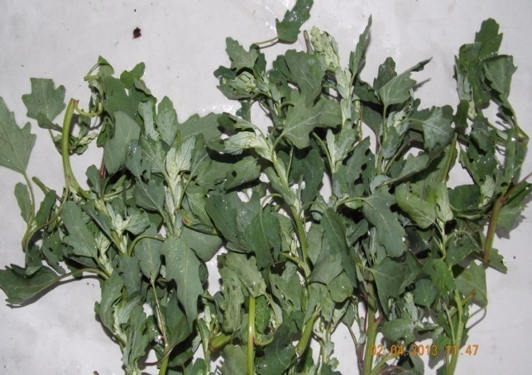  Plate-10.Local Name-Monsoubi  Bot Name-Chenopodium album
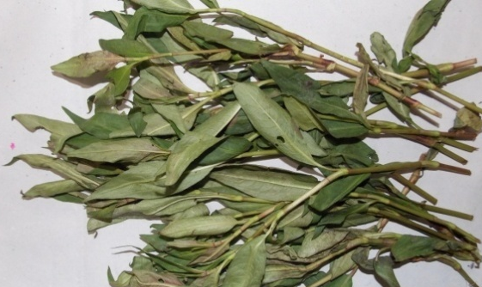  Plate-11.Local Name-Monsoubi  Bot Name-Chenopodium album |  | 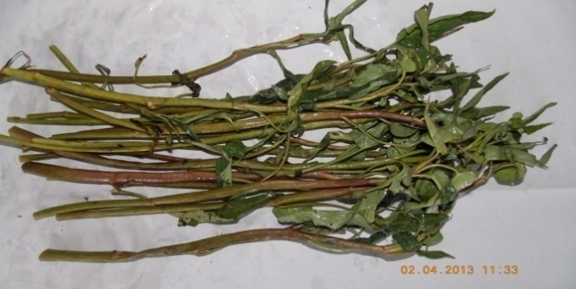  Local Name-Kolamani  Bot Name-Ipomoea aquatic
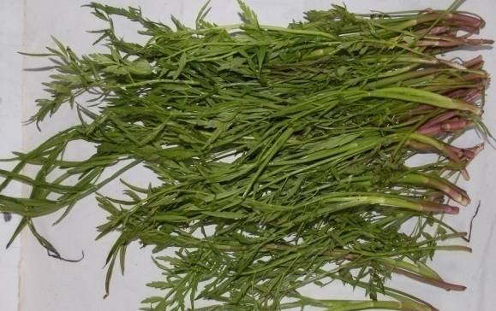Plate-13. Local Name- Komprek  Bot Name-Oenanthe javanica |  | Plate14.Local Name-Loklei(Rhizome)  Bot Name-Hedycium coronarium
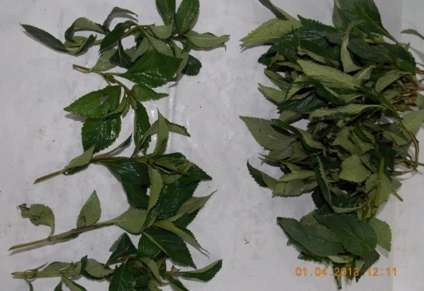  Plate-15. Local Name- Kangouman  Bot Name- Elsholtzia blanda (Benth.) Benth |  | 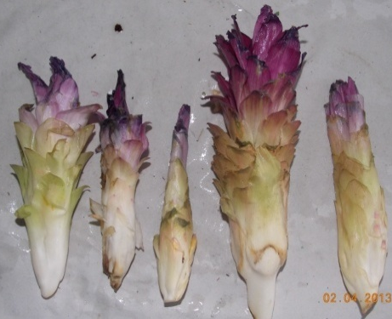  Plate-16.Local Name-Yaipal  Bot Name-Cucurma angustifolia
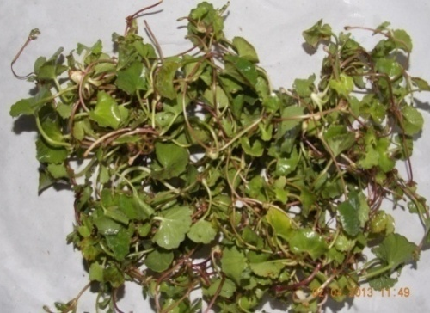  Plate-17. Local Name-Peruk  Bot Name-Centella asiatica |  | 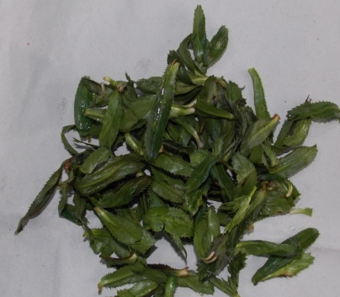  Plate-18. Local Name-Awa phadigom  Bot Name-Eryngium foetidum L
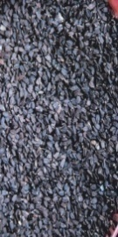
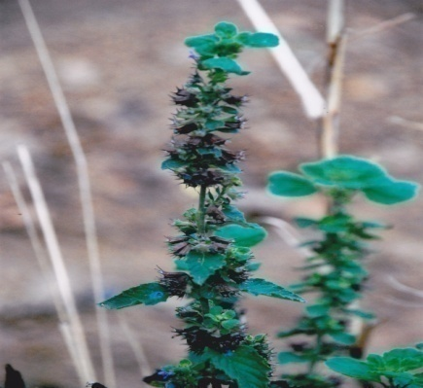
Plate-19.LocalName- Tukuma(Seed)
Bot Name-Hyptis suaveolens
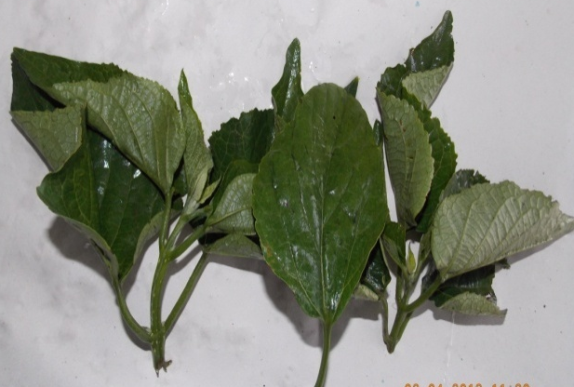  Plate-20. Local Name-Kuthab ukabi  Bot Name-Clerodendrum viscosum Vent |  | 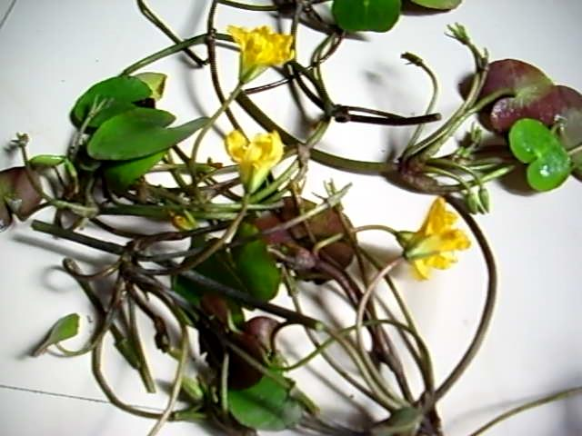  Plate-21. Local Name-Khumon  Bot Name-Nymphoides aquatica

ED-XRF Data
Procedure: biopellet_e2
Tables below showing Manganese present in ppm in 21 selected samples, concentration 50% above

Samples with codes
1-MN |  | Mean | 2-LT |  | Mean | 3-TW |  | Mean | 4-TR |  | Mean | 5-TO |  | Mean | 6-HE |  | Mean | 7-KB |  | Mean
R₁  R₂  R₃ | 47.69  52.84  50.57 | 50.36 | R₁  R₂  R₃ | 51.17  49.64  56.82 | 52.54 | R₁  R₂  R₃ | 62.65  68.91  52.23 | 61.26 | R₁  R₂  R₃ | 147.95  149.81  146.41 | 148.06 | R₁  R₂  R₃ | 170.83  189.19  181.19 | 180.41 | R₁  R₂  R₃ | 64.72  64.93  65.51 | 65.06 | R₁  R₂  R₃ | 52.18  52.83  48.49 | 51.17

Samples with codes
8-KE |  | Mean | 9-LS |  | Mean | 10-MO |  | Mean | 11-PH |  | Mean | 12-KL |  | Mean | 13-KO |  | Mean | 14-LR |  | Mean
R₁  R₂  R₃ | 57.87  58.75  59.43 | 58.69 | R₁  R₂  R₃ | 127.46  128.46  123.41 | 126.45 | R₁  R₂  R₃ | 233.95  220.10  219.92 | 224.66 | R₁  R₂  R₃ | 278.48  275.83  276.01 | 276.78 | R₁  R₂  R₃ | 229.39  220.31  224.76 | 224.82 | R₁  R₂  R₃ | 123.80  127.58  127.53 | 126.31 | R₁  R₂  R₃ | 343.08  324.83  340.20 | 336.04

Samples with codes
15-KG |  | Mean | 16-YL |  | Mean | 17-PE |  | Mean | 18-AP |  | Mean | 19-TU |  | Mean | 20-KU |  | Mean | 21-KH |  | Mean
R₁  R₂  R₃ | 53.54  52.26  54.59 | 53.47 | R₁  R₂  R₃ | 526.00  509.72  525.81 | 520.51 | R₁  R₂  R₃ | 382.33  389.54  387.04 | 386.31 | R₁  R₂  R₃ | 85.23  85.80  89.13 | 86.72 | R₁  R₂  R₃ | 112.45  114.85  115.11 | 114.14 | R₁  R₂  R₃ | 651.94  716.60  655.09 | 674.55 | R₁  R₂  R₃ | 1943.43  2011.80  1924.11 | 1959.78

Mean Values of 21 samples
Sl  No | Code  name | Mn in ppm
1 | MN | 50.36
2 | LT | 52.54
3 | TW | 61.26
4 | TR | 148.06
5 | TO | 180.41
6 | HE | 65.06
7 | KB | 51.17
8 | KE | 58.69
9 | LS | 126.45
10 | MO | 224.66
11 | PH | 276.78
12 | KL | 224.82
13 | KO | 126.31
14 | LR | 336.04
15 | KG | 53.47
16 | YL | 520.51
17 | PE | 386.31
18 | AP | 86.72
19 | TU | 114.14
20 | KU | 674.55
21 | KH | 1959.78

Results and Discussion
The human body lacks the capability to manufacture manganese, but it can accumulate this trace element in various organs, including the liver, pancreas, bones, kidneys, and brain. Typically, manganese is acquired through dietary intake.
The tables provided the mean values of three replicates, revealing the detection of manganese in 21 selected samples. This element plays a critical role in various physiological functions within our body, primarily by contributing to the production of Manganese superoxide dismutase (SOD). This antioxidant enzyme acts as a protective shield against free radicals, destructive molecules that can harm or damage cells in the body. SOD functions by breaking down one of the most hazardous free radicals known as superoxide (O2-), converting it into smaller, non-harmful components.
Manganese also contributes to the promotion of strong and dense bones, especially when combined with other essential nutrients like calcium and vitamin D. Furthermore, it has the capacity to reduce blood sugar levels, which is particularly beneficial for individuals with diabetes.
In addition to these functions, manganese plays a role in wound healing, and when in conjunction with Vitamin-K, it aids in the formation of blood clots. This initial stage of blood clotting occurs within damaged blood vessels and is an integral part of the body's natural healing process.²⁸.
Daily requirement of Manganese, Mn is 2.5-5.0 mg per day²⁹. The concentration of Mn found in the eight samples ranges from 50.36-1959.78 ppm and the intake capacity is within the permissible quantity. So these are not harmful to our health only improve the nutritive value.We consume 25-200gm per day these vegetables in different forms, deficiency of Mn will be neutralized.

Adequate Intakes (AIs) for Manganese³⁰
Age | Male | Female | Pregnancy | Lactation
Birth to 6 months* | 0.003 mg | 0.003 mg
7–12 months | 0.6 mg | 0.6 mg
1–3 years | 1.2 mg | 1.2 mg
4–8 years | 1.5 mg | 1.5 mg
9–13 years | 1.9 mg | 1.6 mg
14–18 years | 2.2 mg | 1.6 mg | 2.0 mg | 2.6 mg
19–50 years | 2.3 mg | 1.8 mg | 2.0 mg | 2.6 mg
51+ years | 2.3 mg | 1.8 mg

CONCLUSION
The trace elements in the twenty one different edible plants were detected by ED-XRF technique. The element plays definite and specific roles in the physiological function of our body. So it will be useful if we can find speciation of the elements present.
Excess of Mn give some help effects. The author need further study to impact more benefits to human society.

ACKNOWLEDGEMENT
The authors are thankful to UGC-DAE Consortium for Scientific Research, Kolkata Centre for extending the facility for the research work.

References;
- https://www.medicalnewstodays.com/articles/325636.
- Fitsanakis V.A., Au C., Erikson K.M., Aschner M. The effects of manganese on glutamate, dopamine and gamma-aminobutyric acid regulation. Neurochem. Int. 2006;48:426–433.doi:10.1016/j.neuint.2005.10.012. [PubMed] [CrossRef] [Google Scholar]
- Chen Y., Shen Y., Wang W., Wei D. Mn²⁺ modulates the expression of cellulase genes in Trichodermareesei Rut-C30 via calcium signaling. Biotechnol. Biofuels. 2018;11:54. doi: 10.1186/s13068-018-1055-6.[PMC free article] [PubMed] [CrossRef] [Google Scholar]
- Wang C., Guan Y., Lv M., Zhang R., Guo Z., Wei X., Du X., Yang J., Li T., Wan Y., et al. Manganese Increases the Sensitivity of the cGAS-STING Pathway for Double-Stranded DNA and Is Required for the Host Defense against DNA Viruses. Immunity. 2018;48:675–687. doi: 10.1016/j.immuni.2018.03.017. [PubMed] [CrossRef] [Google Scholar]
- Chen P., Chakraborty S., Mukhopadhyay S., Lee E., Paoliello M.M., Bowman A.B., Aschner M. Manganese homeostasis in the nervous system. J. Neurochem. 2015;134:601–610. doi: 10.1111/jnc.13170.[PMC free article] [PubMed] [CrossRef] [Google Scholar]
- Kwakye G.F., Paoliello M.M., Mukhopadhyay S., Bowman A.B., Aschner M. Manganese-Induced Parkinsonism and Parkinson’s Disease: Shared and Distinguishable Features. Int. J. Environ. Res. Public Health. 2015;12:7519–7540. doi: 10.3390/ijerph120707519. [PMC free article][PubMed] [CrossRef] [Google Scholar]
- Gonzalez-Reyes R.E., Gutierrez-Alvarez A.M., Moreno C.B. Manganese and epilepsy: A systematic review of the literature. Brain Res. Rev. 2007;53:332–336. doi: 10.1016/j.brainresrev.2006.10.002. [PubMed] [CrossRef] [Google Scholar]
- Zhaojun W., Lin W., Zhenyong W., Jian W., Ran L. Effects of manganese deficiency on serum hormones and biochemical markers of bone metabolism in chicks. J. Bone Miner Metab. 2013;31:285–292. doi: 10.1007/s00774-012-0417-6. [PubMed] [CrossRef] [Google Scholar]
- Da Silva A.L.C., Urbano M.R., Almeida Lopes A.C.B., Carvalho M.F.H., Buzzo M.L., Peixe T.S., Aschner M., Mesas A.E., Paoliello M.M.B. Blood manganese levels and associated factors in a population-based study in Southern Brazil. J. Toxicol. Environ.HealthA. 2017;80:1064–1077.doi: 10.1080/15287394.2017.1357354. [PubMed] [CrossRef] [Google Scholar]
- O’Neal S.L., Zheng W. Manganese Toxicity Upon Overexposure: A Decade in Review. Curr. Environ. Health Rep. 2015;2:315–328. doi: 10.1007/s40572-015-0056-x. [PMC free article] [PubMed] [CrossRef] [Google Scholar]
- https://www.peacehealth.org/medical-topics/id/hn-2881000
- https://www.peacehealth.org/medical-topics/id/hn-2881000
- chromium.
- antioxidant enzyme.
- zinc,
- vitamin B6.
- https://www.webmd.com/osteoporosis/default.htm.
- vitamin C.
- B vitamins.
- boron.
- https://medlineplus.gov/sprainsandstrains.html.
- https://www.webmd.com/diabetes/type-1-diabetes.
- https://www.webmd.com/diabetes/type-2-diabetes.
- https://www.ncbi.nlh.gov/pmc/articles/PMC 3185262/.
- https://www.medicalnewstodays.com/articles/248958 and 161618.
- https://www.medicalnewstodays.com/articles/248958.
- https://www.ncbi.nlh.gov/pmc/articles/PMC3973834.
- https://ods.od.nih.gov/factsheets/Manganese-HealthProfessional/#en5.
- A. K. Bhagi and G. R. Chatwal, Bioinorganic and Supra molecular Chemistry, Himalaya Publishing House, First Edn, 2003, 46(50), 55-56.
- https://ods.od.nih.gov/factsheets/Manganese-HealthProfessional/.
- Jordan Valley Next Series Operation Manual, Jordan Valley AR, Inc., Austin, 2000.
- M. Aken Singh, PhD, Studies of pesticides contamination and heavy metals in selected food items etc Manipur,India.
- E. Blaurock-Busch, PhD, The Clinical Effects of Manganese (Mn), 29-04-2013.

