Book chapter
Biosurfactants: A New Pharmaceutical Additive for Solubility Enhancement in Pharmaceutical and Cosmetic Industry

Mr. Sandeep Singh Bhadoriya1*, Dr. Sachin Kumar Jain², Dr. Prashant Wadagbalkar ³

- Malwanchal University,Indore Madhya Pradesh, India
- Oriental University, Indore, Madhya Pradesh, India
- Amaltas Medical College, Dewas, Madhya Pradesh, India

Introduction

Surfactants are amphiphillic molecules that accumulate at interfaces, decrease interfacial tensions and form aggregate structures such as micelles [1]. Numerous chemical surfactants that are synthetic and primarily petroleum-based currently exist to satisfy the market's current demand for surfactants. Only 32% of the global surfactant production is earmarked for industrial use, with around 54% going into household/laundry detergents [2]. Chemical surfactants come in a variety of shapes and are typically divided into four groups according to their charges: anionic, non-ionic, cationic, and amphoteric. The most toxic antimicrobials are cationic surfactants, which are also the most active against Gramme positive bacteria. Anionic and non-ionic surfactants are less toxic and more effective against Gramme negative bacteria, respectively. There are several significant surfactants, such as fatty alcohol ethoxylate (FAEO), linear alkyl benzene sulfonates (LAS), and lauryl ether sulfate (LES) [3]. The growing awareness towards the use of renewable-based products and “green products” has stimulated the development of alternatives to these chemical surfactants. Biosurfactants (BS) are an example of such environmental friendly options [4]. Biosurfactants can be produced biologically from renewable resources, through microbial fermentation, or through enzymatic synthesis [5]. The fact that biosurfactants have extremely low critical micelle concentrations (CMC) is a key characteristic. This indicates that biosurfactants are more potent at low concentrations than many surfactants manufactured chemically. Biosurfactants are good options for "green" detergents and surfactants since they are known to be biodegradable and because they only require minimal amounts to alleviate surface tension. Important Ingredients in Pharmaceutical Products: Surfactants Surfactants, chemical species that reduce the surface energy at liquid, solid, and/or gas phase interfaces, have a variety of functions in pharmaceutical goods [6,7]. In addition to having both hydrophilic and lipophilic domains in their chemical structure, surfactants are amphiphilic. Their primary role in pharmaceutical processing is to make drugs more soluble, especially those that are poorly soluble in water, which includes an increasing number of novel and developing bioactive agents (such as small molecular therapeutics, peptides, proteins, vitamins, vaccines, and oligonucleotides), in order to facilitate their in vivo delivery. Additionally, they increase the thermodynamic activity and diffusion rate as well as the stability of medications that have been encapsulated. They are especially crucial for allowing medications to pass through cell walls, membranes, the skin, and other biological interfaces. Surfactants are also important plasticizers, needed to improve the fluidity and in vivo dissolution of semisolid delivery vehicles and viscous excipients such as those employed for suppositories. For example, sucrose-fatty acid esters are important lubricants for tabletting [8]. They can also serve as wetting agents to enable drug incorporation into delivery vehicles and dispersants for powders, granules, and nanoparticles. The most common use of surfactants is for self-assembly systems as drug delivery vehicles. Common surfactant monolayer-based, self assembly structures are emulsions, dispersions of oil-in-water (O/W-) or vice versa (W/O-). Emulsions are relatively big, often on the scale of microns to millimetres, and are not thermodynamically stable, frequently needing agitation for their long-term stability. Aerosols and microencapsulation media are both prepared using emulsions. High-pressure homogenization can be employed to prepare nanoemulsions (also referred to as “mini-emulsions”), of average size 0.05-1.0 μm, which due to their smaller size can be sterilized by microfiltration and are more likely to avoid physiological clearance, and penetrate interfaces in vivo. Nanoemulsions are commonly used in parenteral delivery (Figure 1). Water-oil-surfactant mixtures often form thermodynamicallystable microemulsions, characterized by nanometer-sized architectures [9,10]. Hydrophilic and lipophilic surfactant systems form O-W- and W/O-microemulsions, respectively, typically consisting of spherical nanodroplets. Swollen lamellae or bicontinuous microemulsions, which are dynamically entwined networks of oil and water separated by surfactant monolayers, are formed by surfactant systems with balanced hydrophilicity and lipophilicity. Delivering a water-free mixture of the ingredients that self-microemulsify (emulsify) when in contact with water is a common way to create microemulsions (and emulsions) in vivo. Surfactants are used as therapeutic agents as well. Examples of substances with antimicrobial action include glycolipid biosurfactants, amino acid-based surfactants, and saccharide-fatty acid esters [11,12]. Glycolipid biosurfactants and polyunsaturated fatty acid monoacyl glycerol (MAGs) possess anticancer activity [12,13]. Sophorolipid biosurfactants are efficient immune response modulators [8]. A number of dermatological, cosmetic, and personal care products frequently contain surfactants. Figure 2 [10, 11] lists the chemical composition of typical surfactants used in medicinal formulations. The surfactants displayed are nonionic and very biocompatible. Oligonucleotide distribution requires the use of cationic surfactants. Recent research has indicated that biobased cationic arginine derivatives may function well as biocompatible delivery agents [12]. Phospholipids are a different class of common surfactant. They are the main ingredients of synthetic lung surfactant, which is used to treat acute and neonatal distress syndrome [14,15], as well as of the common delivery vehicle known as a liposome, which can be made up of one or more concentric phospholipid bilayers (either single or multi-lamellar) [16–18].

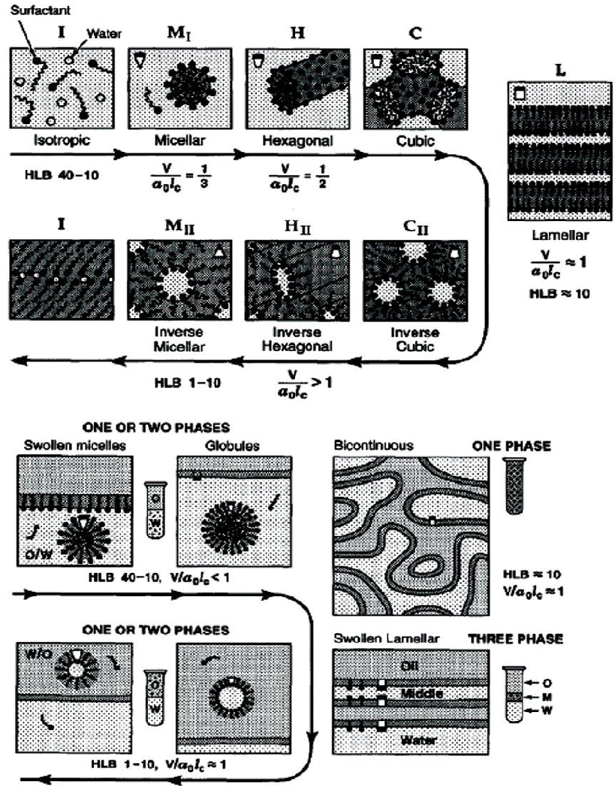

Figure 1: Surfactant self-assembly structures formed in: a) water surfactant and b) water-surfactant-oil systems as a function of the surfactant’s hydrophilic-lipophilic balance.

Advantages of Biosurfactants

Biosurfactants have many advantages when compared to their chemically synthesized counterparts, some of these are: Biodegradability- Microorganisms can quickly break down biosurfactants [6]. Small toxicity - Biosurfactants show less toxicity than surfactants made from chemicals. Additionally, it was shown that biosurfactants displayed greater EC 50 values than synthetic dispersants [7] (effective concentration to reduce 50% of test population). Existence of raw materials- Biosurfactants can be made from readily accessible, extremely affordable raw sources. The three sources of carbon mentioned earlier—hydrocarbons, carbohydrates, and/or lipids—can be employed singly or in combination [8]. Physical factors- Many biosurfactants are not affected by environmental factors such as temperature, pH and ionic strength tolerances. Lichenysin produced by Bacillus licheniformis strain was not affected by temperature ranges of up to 50°C, a pH range of 4.5- 9.0, and NaCl concentration of 50g/l and Ca concentration of 25g/l [9]. Surface and interface activity - Sagalowicz et al. [10] stated that a good surfactant can lower surface tension of water from 75 to 35 mN/m and the interfacial tension water/ hexadecane from 40 to 1 mN/m. Surfactin possess the ability to reduce the surface tension of water to 25 mN/m and the interfacial tension of water/hexadecane to he surface tension of water to 25 mN/m and the interfacial tension of water/hexadecane to <1mN/m [9].

Other advantages
Biocompatibility and digestibility - It allows their application in cosmetic, pharmaceuticals and as functional food additives [8].

Surfactants Employed in Pharmaceuticals are Primarily Biobased
The development of “biobased” surfactants is on the rise due mainly to the increased feedstock cost for petroleum compared to oleochemical starting materials (due to increased global demand and decreased production and availability), and the enhancement of sustainability for utilizing renewable feedstocks [19]. Apart from that, dependence on dwindling petroleum supplies—which is made worse by rising global demand—has been linked to environmental harm, including the 2010 Gulf of Mexico oil spill from the "Deepwater Horizon" offshore well, which was the worst environmental catastrophe in US history—as well as the production of greenhouse gases like CO2 and their effects on climate change. These components have boosted customer demand for more environmentally friendly products. In general, the cost of processing biobased surfactants is comparable to the cost of producing surfactants made from petroleum. Consequently, the market share of biobased surfactants has grown recently, and it is projected that this trend will continue. The majority of the surfactants mentioned in the previous section were produced using renewable resources to some extent [19,20]. Saccharide esters, polysorbates, MAG, and fatty acid ethoxylates all obtain their fatty acyl components from oleochemicals, with fatty acid methyl or ethyl esters—which make up the majority of biodiesel—serving as the main starting material. Since fuels, chemical intermediates, and biobased products are produced from oilseed crops, the development and expansion of oleochemical biorefineries complement each other effectively [19,20]. Feedstocks enriched in C10-C16 saturated fatty acyl groups include palm, palm kernel (particularly palm stearine, a palmitic acyl-rich byproduct from the fractionation of palm kernel oil), coconut, and cuphea oils. Inexpensive sources of 16:0, 18:0, 18:1 and 18:2 fatty acyl groups include tallow, used cooking oils, algal oils, jatropha oil, soapnut oil, and soapstock. Castor oil, which is produced in Brazil, India, and several other nations worldwide, is the source of ricinoleic acid. Through heterogeneous catalytic reactions, medium-chain fatty alcohols—the lipophilic group of APGs (Alkyl polyglycosides)—can be produced from either petroleum or fatty acid methyl ester. Gums, soapstock, and other oleochemical production byproducts can all be used to make phospholipids directly [21].

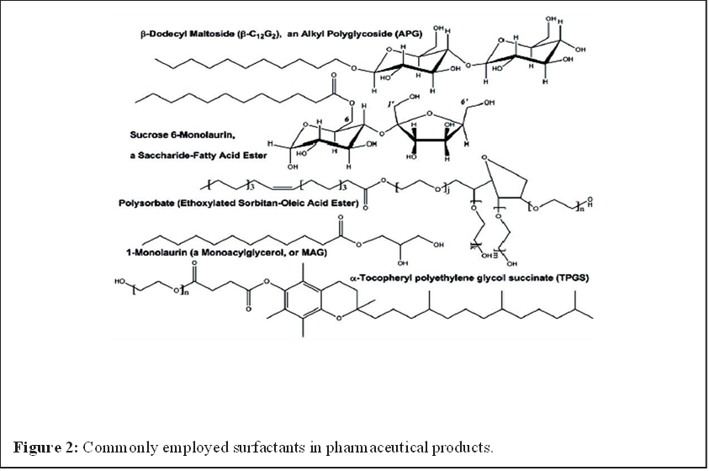
Advantages of Bioprocessing to Prepare Surfactants for Pharmaceuticals

Many biobased surfactants can potentially be produced with the aid of enzymes [19]. When compared to chemical processing, bioprocessing has numerous benefits, including increased sustainability, reduced energy consumption (due to lower temperatures), decreased waste and byproduct production, the absence of harmful metal catalysts or acids/bases, and safer working conditions. The main drawbacks of using enzymes over chemical catalysts are their exorbitant costs (although this issue is alleviated when enzymes are immobilised to allow for reuse) and the slower reaction rates that frequently accompany enzymatic reactions. In addition, due to the need to reduce any inhibitory agents, the starting materials must be prepurified; for instance, fatty acyl-containing material must not contain phospholipids, aldehydes/ketones, peroxides, and other contaminants. However, enzymatic bioprocessing is anticipated to become more cost-competitive and appealing as energy costs rise (as is expected), the value of sustainability rises (as a result of government regulation and/or consumer demand), and the capabilities of enzymes and their production systems rise (as a result of improved biotechnologies). enzymatic bioprocessing is anticipated to become more cost-competitive and attractive.
Application of Biosurfactant in Pharmaceutical and Cosmetic Industry
Biosurfactants have been suggested as a replacement for chemically produced surfactants in the cosmetics industry due to their effects on viscosity and product consistency through emulsification, foaming, water binding capacity, spreading, and wetting qualities (Table 1). These surfactants are used in insect repellents, antacids, bath products, acne pads, anti-dandruff products, contact lens solutions, baby products, mascara, lipsticks, toothpaste, dentine cleansers, and other items as emulsifiers, foaming agents, solubilizers, wetting agents, cleaners, antimicrobial agents, and mediators of enzyme action [22,23].

Table 1: Relevance of glycolipid biosurfactants to the pharmaceutical/cosmetic industry [23].

Glycolipid Type | Producing Organism | Activity | Pharmaceutical/Cosmetic Applications
Sophorolipids | Candida bombicola, Candida apicola | Antibacterial, Antioxidant, Moisturizing, Wetting, Foaming, Emulsifying, Stimulates dermal fibroblasts | Lotions, body washes, hair products, lip color, eye shadow, acne treatment, deodorants, skin smoothing, anti-wrinkle products
Rhamnolipids | Pseudomonas aeruginosa | Antimicrobial, Emulsifying agent | Anti-wrinkle and anti-aging products
Mannosylerythritol lipids | Candida antarctica | Antimicrobial, Emulsifying agent, Dispersant | Skin smoothing and anti-wrinkle products

Discussion
Biosurfactants can increase the bioavailability of high molecular weight hydrophobic substances, presumably by increasing their surface area, desorbing them from surfaces and increasing their apparent solubility. This property of biosurfactant can be used for the development of pharmaceuticals to enhance the bioavailability. Although the technology is still in its infancy, it has been shown that bioprocessing methods have a great potential utility for producing biobased surfactants for use in pharmaceutical goods. Due to its improvement of sustainability, improved selectivity towards desired products, and lesser creation of wastes, biocatalytic manufacturing is particularly appealing. Biotechnology will need to produce more robust enzymes at lower cost to enable this approach. Scientists and engineers will continue to improve enzymatic bioprocess design and perhaps develop new biobased surfactants for pharmaceutical application as the interest and availability of renewable feedstocks increases.

References

1. Van Hamme JD, Singh A, Ward OP (2006) Physiological aspects. Part 1 in a series of papers devoted to surfactants in microbiology and biotechnology. Biotechnol Adv 24: 604-620.
2. Banat IM, Makkar RS, Cameotra SS (2000) Potential commercial applications of microbial surfactants. Appl Microbiol Biotechnol 53: 495-508.
3. Develter DWG, Lauryssen LML (2010) Properties and industrial applications of sophorolipids. Eur J Lipid Sci Technol 112: 628-638.
4. Vaz DA, Gudiña EJ, Alameda EJ, Teixeira JA, Rodrigues LR (2012) Performance of a biosurfactant produced by a Bacillus subtilis strain isolated from crude oil samples as compared to commercial chemical surfactants. Colloids Surf B Biointerfaces 89: 167-174.
5. Syldatk C, Hausmann R (2010) Microbial Biosurfactants. Eur J Lipid Sci Technol 112: 615-616.
6. Chesko JR, Anderson C, Fox L, Kalvodova T, Dutil S, et al. (2009) Nonionic surfactants formulated into drug and vaccine delivery systems, in Non-Ionic Surfactants, edited by P.L. Wendt and D.S. Hoysted, Nova Science Publishers, Hauppauge NY USA 177-197.
7. Mishra M, Muthuprasanna P, Surya Prabha K, Sobhita Rani P, Satish Babu IA, et al. (2009) Basics and potential applications of surfactants-a review, Int J PharmTech Res 1:1354-1365.
8. Otomo N (2009) Biobased Surfactants and Detergents: Synthesis, Properties, and Applications, Hayes DG, Kitamoto D, Solaiman DKY, Ashby RD, (eds.). AOCS Press, Champaign, IL 275-298.
9. Garti N (2003) Microemulsions as microreactors for food applications. Curr Opin Colloid Interface Sci 8: 197-211.
10. Sagalowicz L, Leser ME, Watzke HJ, Michel M (2006) Monoglyceride SelfAssembly Structures as Delivery Vehicles. Trends in Food Science & Technology 17: 204-214.
11. Infante MR, Perez L, Moran C, Pons R, Pinazo A (2009) Synthesis, aggregation properties, and applications of biosurfactants derived from arginine. In: Biobased Surfactants and Detergents Synthesis, Properties, and Applications, Hayes DG, Kitamoto D, Solaiman DKY, Ashby RD, (eds.). AOCS Press, Champaign, IL USA 351-387.
12. Kitamoto D, Morita T, Fukuoka T, Imura T, Konishi M (2009) Self-assembling properties of glycolipid biosurfactants and their potential applications Curr Opin Colloid Interface Sci 14: 315-328.
13. Fortin S (2010) Polyunsaturated fatty acid monoglycerides, derivatives, and uses thereof. USA Patent 2009-535048, 20100160261.
14. Savić S, Tamburić S, Savić MM (2010) From conventional towards new-natural surfactants in drug delivery systems design: current status and perspectives. Expert Opin Drug Deliv 7: 353-369.
15. Müllertz A, Ogbonna A, Ren S, Rades T (2010) New perspectives on lipid and surfactant based drug delivery systems for oral delivery of poorly soluble drugs. J Pharm Pharmacol 62: 1622-1636.
16. Acosta EJ, Saad SMI, Kang N, Policova Z, Hair ML, et al. (2009) Lung surfactants: formulation, evaluation, and polymeric additives. In: Biobased Surfactants and Detergents: Synthesis, Properties, and Applications, Hayes DG, Kitamoto D, Solaiman DKY, Ashby RD, (eds.). American Oil Chemists’ Society Press, Champaign, IL USA 191-229.
17. Shailesh S, Neelam S, Sandeep K, Gupta GD (2009) Liposomes: a review. Journal of Pharmacy Research 2: 1163-1167.
18. Immordino ML, Dosio F, Cattel L (2006) Stealth liposomes: review of the basic science, rationale, and clinical applications, existing and potential. Int J Nanomedicine 1: 297-315.
19. Hayes DG (2009) Biobased Surfactants and Detergents: Synthesis, Properties, and Applications. D.G. Hayes DG, Kitamoto D, Solaiman DKY, Ashby RD. American Oil Chemists’ Society Press, Champaign, IL 3-25.
20. Giraldo L, Camargo G, Tirano J, Moreno-Pirajan JC (2010) Synthesis of fatty alcohols from oil palm using a catalyst of Ni-Cu supported onto zeolite. E-Journal of Chemistry 7: 1138-1147.
21. Gielen D, Newman J, Patel MK (2008) Reducing industrial energy use and CO2 emissions: the role of materials science. MRS Bulletin 33: 471-477.
22. Gharaei-Fathabad E (2011) Biosurfactants in pharmaceutical industry: A Mini Review. Am J Drug Discov Dev 1-11. 23. Williams K (2009) Biosurfactants for cosmetic application: Overcoming production challenges. MMG 445 Basic Biotechnology 5: 78.

