An Image-Based E-Tourism Web Application

Mitali Gupta Meenal Bagaddeo
Dept. of Computer Science Dept. of Computer Science
Medi-Caps University Indore, India Medi-Caps University Indore, India mitaligupta770@gmail.com meenalbagaddeo26@gmail,com

Manav Dewani Dr. Harsh Pratap Singh
Dept. of Computer Science Dept. of Computer Science
Medi-Caps University Indore, India Medi-Caps University Indore, India en19cs301189@medicaps.ac.in harshpratap.singh@medicaps.ac.in

Corresponding Author: Dr. Harsh Pratap Singh, harshpratap.singh@medicaps.ac.in

Abstract-Tourism is an important industry that contributes significantly to the global economy. The advent of digital technologies has transformed the way people plan and experience their travel. Today, many travelers use the internet to research destinations, book accommodations, and plan their itinerary. In this context, image-based e-tourism has emerged as a powerful tool for promoting travel destinations and attracting tourists. This paper presents an e-Tourism Web Application system that serves as a Virtual Guide, facilitating the travel planning process. The main function of this application is to recognize a monument or a famous spot from the picture uploaded by the user and to provide detailed information regarding it. What sets this system apart from other similar applications is its unique integration of information and functions necessary for travel planning. It offers features such as monument recognition, live weather conditions for travel, checking hotel availability, calculating optimal routes between user-specified locations at various travel destinations, and providing suggestions for other tourist spots. The system significantly reduces the time required to search for a place, leading to quicker decision-making, making trips easy and comfortable, and providing users with relevant information regarding the monuments.
Keywords- travel; web services; web applications; Image Recognition

I. INTRODUCTION
The recent trend towards globalization has given rise to an unprecedented surge in both local and international travel, leading to people’s consumption structure to improve steadily. There has been a large increase in the number of people out on tours, for the sake of recreation and entertainment. As a result, tourists often prefer to visit multiple destinations in a single trip.
Tourism industry is also responsible for generating an estimated 11% of the global gross domestic product(GDP)[4]. However, the abundance of information available makes it increasingly challenging to access relevant data, thereby complicating the decision-making process.
Planning a travel itinerary has become an increasingly daunting, intricate, and time-consuming task, involving multiple steps such as selecting the most suitable transportation options, identifying desirable destinations and lodging accommodations, researching tourist attractions at various locations, crafting daily schedules that account for breaks, and filtering through dining options. Furthermore, calculating the most efficient routes to optimize the limited time available only adds to the complexity of the process. Numerous travel-related websites and online services have emerged in recent years to aid travelers in planning their trips. However, these services are often numerous, disjointed, and limited in scope, providing only a narrow view of the planning process and offering limited customization options for querying and generating results. These factors have contributed to the exacerbation of the travel planning problem.

Although, there is greatly enriched travel information provided to the tourists on the Internet and through the apps. However, there is no app for a tourist to directly get the history or any other information related with any monument or place by just its picture. To know more about any place or monument the tourists visiting that place have to employ guides.

To address this issue, our system provides a comprehensive solution that integrates all existing services and technologies into a single platform[5]. Our proposed system leverages image processing to extract information about tourist spots and nearby amenities, including restaurants, hotels, and live weather conditions. With our system, tourists can easily explore a city's landmarks and receive only relevant information with a single click. In summary, we have developed a web-based intelligent system[10], which streamlines the travel planning process and is implemented with a focus on providing tourists with accurate, comprehensive, and customized information.
The rest of this paper is organized as follows: Section 2 provides an overview of currently available applications for assisting travelers in planning their trips. Section 3 describes the implementation and functionalities of the Smart Travel Planner system. In section 4 the data as compiled is presented and the findings are discussed. Section 5 concludes the paper and identifies several directions for future work.

II. LITERATURE SURVEY
B. Maulik et al. focused on developing flutter-based application which integrates different functionalities into a single app hence helping the tourists get important information and functionalities at the same place without the need to explore multiple applications. [1]
M. Wang, et al. elaborates the design idea of the smart tourism system platform can also plan travel routes based on different travel service indicators. [2]
L. Zhang, focused on the optimization design of virtual and real integration of the visual communication based scenic spot guidance system. [3]
Y. Zhang, et al. focused on next-generation art technology combined with the rendering effects of the Unreal 4 engine and the VR architecture. [4]
P. K. Katkuri, et al. focused on Virtual and Augmented Reality, which provides the necessary information about the destinations and their attractions.[5]
J. -L. Tseng, et al. focused on virtual reality technology to show the landscape information intelligently by detecting what the user sees.[6]
Ivaldir de Farias, et al. focused on creating an application that aims to help tourists to know better the cities they're visiting, by providing information of the area. [7]
Alexander Smirnov, et al. focused on creating a mobile application that proactively recommends the tourist attractions based on the tourist preferences and the current situation in the region. [8]
A. Smirnov, et al. developed an Android Mobile application which incorporates APIs of Google Maps to determine the location and also forecasts weather conditions. [9]
K. Al-Rayes, et al. highlighted functions of intelligent automatic system. With rapid development of electronic information technology and computer technology as the support, this thesis combines with the shortest path algorithm and related knowledge of graph theory to design algorithm and processing scheme. Moreover, this thesis also introduces research design of intelligent tourist system as well. [10]
Xiaoyu Shi, et al. provided the basic idea on some common conversation in the different places that the travelers need to go after coming to that place. The interaction between users is its main highlight.[11]
Jian Meng and Neng Xu created a hybrid recommendation system based on agent technology is designed by considering online communication with other sectors in the tourism industry, such as the tourism supply chain, agency etc. However, online communication between the sectors via agents is designed and developed based on the contract net protocol.[12]
S. Sharma and A. Agrawal focued on providing the tourists to know the all information about the particular tourist places and take full advantage of the visit without missing the main information and history.[13]

III. METHODS
To facilitate the process of organizing a journey, we have developed the web-based intelligent system that offers several functionalities. The application is implemented using Google Maps API technology, Python, and JavaScript as the programming language, and OpenCV for image recognition. The system makes use of the GoogleMapsActivity to incorporate Google Maps. OpenCV is utilized in the app for image recognition, where the uploaded image is compared with the images present in the database using OpenCV to identify the monument. The app uses histogram comparison along with feature detection using the ORB algorithm to compare two images.

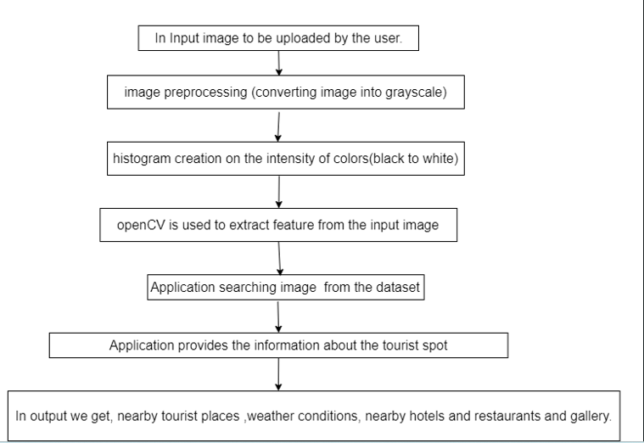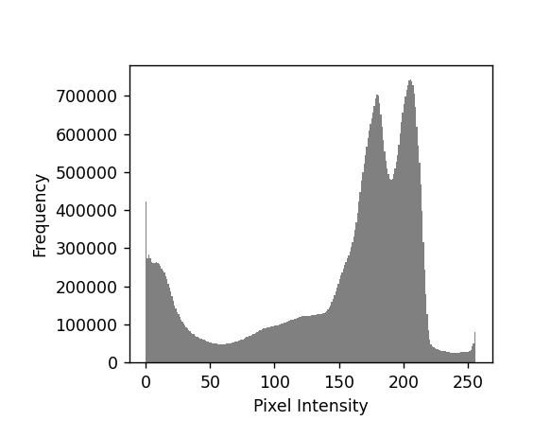

Fig. 1. Data Flow Diagram. Fig. 2. Histogram of the monument’s image.

The application provides several features and functionalities, which are displayed in the form of buttons as cards on the home screen.
A. The Splash Screen, (Fig.3) is the first screen displayed when the user opens the application, contains an image, video, or the current version of the software. The Go button is meant to upload an image by the user.
B. The main screen or Home Screen(Fig.4) allows users to view the relevant information about the monument. This screen gives the main feature and functionalities of the application. The main screen of our application contains buttons for each of the functionalities provided by the application. (Fig.4)
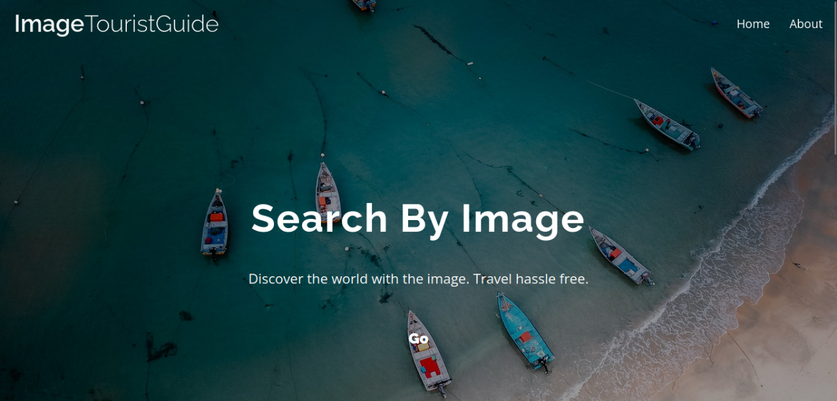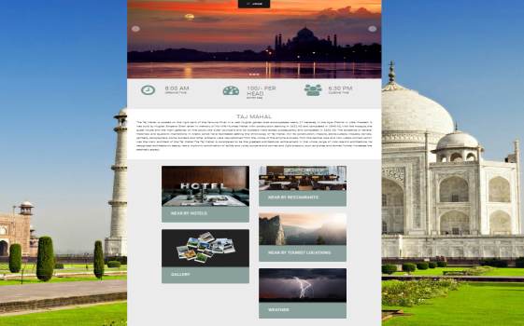
Fig. 3. Splash Screen. Fig. 4. Home Screen.

C. The Nearby Hotels and Nearby Restaurants buttons (Fig.5) display the location of the hotels and restaurants and their locations, respectively, using the Google Maps API.
D.The Nearby Tourist Locations button (Fig.6) displays a list of all the tourist spots surrounding the location of the uploaded image and also displays their location and route.

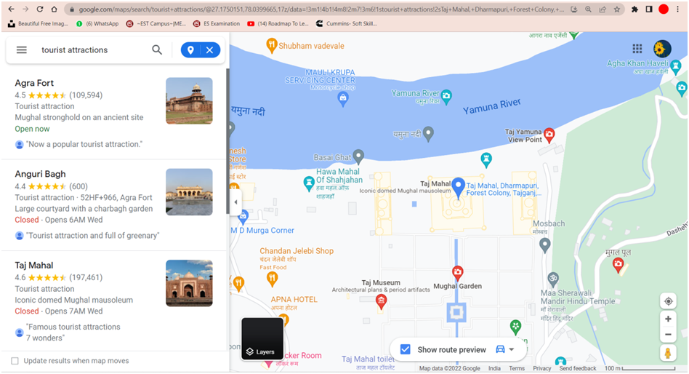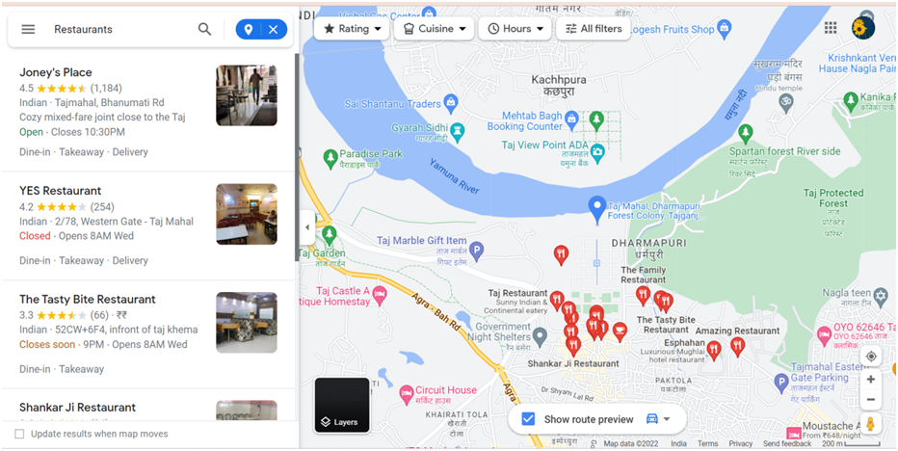
Fig. 5. Nearby Tourist Location. Fig. 6. Nearby Hotels and Restaurants.
E. The Gallery button(Fig.7) displays the pictures of the monument using Google Images. It displays lot of beautiful photos to showcase the travel destination and venues.
F. The Weather button (Fig.8), displays the current and future weather conditions of the location of the monument or tourist spot in a tabular and graphical manner which is implemented using the web application.
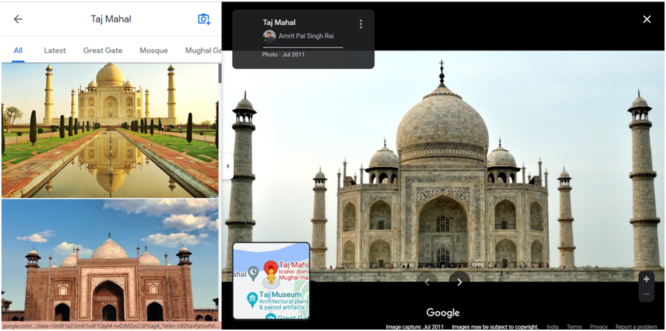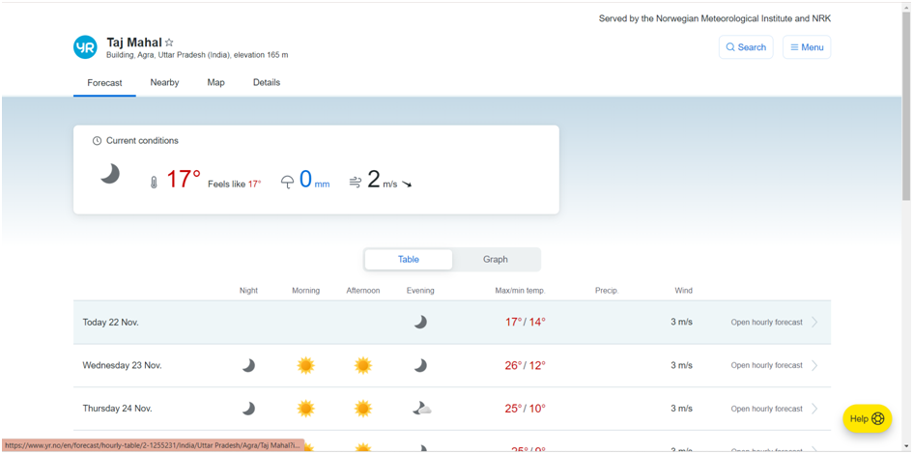
Fig. 7. Gallery. Fig. 8. Weather Conditions.

IV. RESULTS AND DISCUSSIONS
The application displays a menu with the main categories of attractions available, by uploading the image all the related information is displayed. The user will also have access to more detailed information about the spot and have a number of actions, e.g. gallery, weather conditions, navigate to it or know a little more of its history. When the nearby hotels and restaurant feature is selected, Maps. The user can also have the possibility of an exclusive list of nearby tourist destinations. All the images are matched from the dataset created. Thus, due to its prototyped nature, the dataset is small size.

Features | Proposed  Application | Locatify | Fluxguide | Tour Buddy
Touristic Sites | Y | Y | Y | Y
Access to maps | Y | Y | Y | Y
Bus Routes | Y | X | X | Y
Hotels | Y | Y | Y | Y
Tourist Attractions | Y | Y | X | Y
Bilingual | X | Y | X | Y
Image as input | Y | X | X | X
Table 1: Comparision between our application and existing
V. CONCLUSION AND FUTURE WORK
Some enhancements that can be carried out in the future in this app are:
- The database used in this app is not an open source database. It is just a prototype database containing images for testing the app. This database will have to be extended in the future to contain information about monuments for different cities around the country/ world.
- A feature for faster searching in the database can also be provided. This can be achieved by dividing the database according to country, state and city. The user can be asked to provide the country or state or city they are visiting to improve the speed and accuracy of results.
- A feature to allow the user to register, create a profile, update it and set his preferences.
- A feature for providing detailed information about the region the user is currently in, and not just any monument can also be provided.
- A feature for translating any text written by the user into local language and converting the translated text to voice can be introduced. Also, by taking a voice input in the native language it can be converted to text in the user's language. This feature will allow tourists to communicate easily and effectively with the local people.

VI. ACKNOWLEDGMENT
We would like to express our gratitude to our Organization “Medi-caps University, Pigdamber Rau” for providing support and guidance for this research paper. We thank our colleagues who provided insight and expertise that greatly assisted the research. At last, we would like to extend our heartfelt thanks to our guide (Mr. Harsh Pratap Singh) for helping and guiding us in this project.

VII. REFERENCES
[1] B. Maulik, A. P. Nayak, S. U, S. Alok and D. K. N, "Design and Implementation of Virtual Tour Guide App," IEEE (ICACTA),2022

[2] M. Wang, Z. Liu, H. Fang, F. Ding and J. Zhang, "Design and implementation of smart tourism platform supported by VR technology,"2021 IEEE(ICMLCA), 2021

[3] L. Zhang, "Intelligent Guide System of Scenic Spot Based on Visual Communication," IEEE (ICITBS), 2021
[4] Y. Zhang, X. Li and M. Dai, "Virtual Tourism Immersive Experience System," 2020 International Conference on Virtual Reality and Visualization IEEE(ICVRV),2020
[5] P. K. Katkuri, A. Mantri and S. Anireddy, "Innovations in Tourism Industry & Development Using Augmented Reality (AR), Virtual Reality (VR)," IEEE(TENCON),2019

[6] J. -L. Tseng, Y. -Y. Jiang, S. -J. Peng and H. -E. Wei, "Development of Intelligent Tourism Information System Based On Virtual Reality," 2018 IEEE (ICAM), 2018
[7] Ivaldir de Farias; Nelson Leitao Júnior; Marcelo M. Teixeira, ”Urbis: A touristic virtual guide”, In IEEE (CISTI) 2017
[8] Alexander Smirnov; Alexey Kashevnik; Andrew Ponomarev; Maksim Shchekotov; Kirill Kulakov,”Application for e-Tourism: Intelligent Mobile Tourist Guide
“In IEEE(IIAI 4th International Congress on Advanced Applied Informatics) 2015
[9] A. Smirnov, A. Kashevnik, A. Ponomarev, N. Shilov, M. Shchekotov and N. Teslya, "Smart space-based intelligent mobile tourist guide: Service-based implementation," In IEEE (Proceedings of 15th Conference of Open Innovations Association FRUCT), 2014
[10] K. Al-Rayes, A. Sevkli, H. Al-Moaiqel, H. Al-Ajlan, K. Al-Salem and N. Al-Fantoukh, "A Mobile Tourist Guide for Trip Planning", IEEE (Multidisciplinary Eng. Education Magazine), 2011
[11] Xiaoyu Shi; Ting Sun; Yanming Shen; Keqiu Li; Wenyu Qu”Tour-Guide: Providing Location-Based Tourist Information on Mobile Phones “In IEEE (International Conference on Computer and Information Technology) 2010
[12] Jian Meng,Neng Xu ,“A Mobile Tourist Guide System Based on Mashup Technology“ In IEEE( International Conference on Information Science and Engineering) 2010
[13] S. Sharma and A. Agrawal, "IMTS- an Interactive Multimodal Tourist-Guide System," In IEEE (International Conference on Signal and Image Processing) 2010

