Real-time Structural Health Monitoring System using IoT

Spandana A P¹, Sridevi Shetty², Shravya P³, Ashwini A⁴
¹ ² ³ Dept. of CSE, ⁴ Dept. of EEE
BNM Institute of Technology, Bengaluru, India
ap.spandana@gmail.com, shravyaganiga0608@gmail.com,
sridevishettykottakki@gmail.com, ashwinia@bnmit.in

ABSTRACT

Structural Health Monitoring (SHM) involves the ongoing surveillance of civil and industrial structures, aiming to enhance human safety and minimize maintenance expenses. Similarly, monitoring the machine and its parts is essential in industries. These can be achieved through IoT-based systems which are fast, compact, efficient, and reliable. Our objective revolves around developing an economical wireless device alongside data management software, designed for the purpose of monitoring the structural well-being of buildings, as well as machine health. This will be achieved through the utilization of remotely controlled sensors that are either embedded within or placed onto various components. These sensors will be responsible for measuring an array of critical parameters such as stresses, accelerations, and other relevant factors.

Keywords: SHM, machine health, monitoring, IoT.

- Introduction

SHM is the procedure of monitoring the conditional state of a structure over time to detect changes in its properties and behaviour that may indicate the development of damage or degradation. SHM systems typically use sensors and data analysis techniques to detect changes in parameters such as vibration, strain, temperature, and other factors that can indicate damage or degradation. The primary goal of SHM is to detect damage early on and prevent catastrophic failure of the structure, which can lead to significant safety risks and costly repairs. SHM systems can be used for a wide range of structures, including bridges, buildings, aircraft, wind turbines, pipelines, and more.
SHM systems can be either passive or active. Passive systems typically use sensors that are placed on the structure and measure its response to external stimuli, such as wind or traffic. On the other hand, active systems use sensors and actuators to actively control the structure's behaviour, which can help mitigate the effects of external stimuli and prevent damage. The data collected from SHM systems are typically analysed using advanced data analysis techniques in order to recognize recurrent motifs and tendencies that might suggest the evolution of damage over time. By detecting damage early on, SHM systems can help to reduce maintenance costs and extend the lifespan of structures.
The SHM system provides insights into changes occurring in either individual components or the entire structure due to factors like material aging, environmental influences, or unforeseen incidents. Typically, SHM systems are focused on overseeing variables like humidity, temperature, accelerations, tensile stress, compressive stress, and the degradation of building materials. These approaches are minimally intrusive and involve positioning sensors at predefined checkpoints, as determined by experts. The data collected from these sensors is then integrated with mathematical models to assess structural safety.
Advancements in sensing technologies, such as radio-frequency identification and various types of sensors, coupled with the merging of information technologies like wireless communication and the Internet, have led to the rise of the Internet of Things (IoT) as a significant technology for monitoring systems. This connectivity empowers devices to transmit and process data, opening up novel possibilities in the design of data acquisition systems across diverse scientific and engineering domains. From bridges and roads to buildings and airports, these structures are essential for the functioning of modern society, and their failure can have devastating consequences. SHM can help ensure the safety and longevity of these structures by detecting potential problems before they lead to failure. For example, consider a bridge that is subjected to heavy traffic and changing weather conditions. Over time, the stresses on the bridge can cause fatigue, corrosion, and other forms of damage that can compromise its structural integrity. These problems can go undetected without proper monitoring until they lead to catastrophic failure. SHM systems can continuously monitor the bridge for signs of damage, such as cracks, corrosion, or changes in vibration, and provide early warning of potential problems. This can allow for proactive maintenance and repairs, extending the bridge's life and preventing accidents. Similarly, buildings are subject to a wide range of environmental and human factors that can affect their structural integrity. By using SHM systems to monitor factors such as stress, temperature, and vibration, potential problems can be detected before they lead to damage or failure. This can be especially important in areas prone to earthquakes, where the ability to detect and respond to seismic activity can save lives and reduce property damage. Overall, the need for SHM in daily life is clear. By providing early warning of potential problems and optimizing maintenance and repair schedules, SHM systems can help ensure the safety and reliability of our built environment, saving lives and reducing costs in the process.
Structural health monitoring (SHM) systems help improve our lives by ensuring the safety, reliability, and longevity of critical infrastructure systems, like bridges, buildings, and airports. These systems use a variety of sensors and data analysis techniques to monitor the structural behaviour and condition of these structures, detecting potential problems before they lead to catastrophic failure. SHM systems typically consist of several components, including:
- Sensors: SHM systems use a variety of sensors to collect data on the behaviours and conditions of a structure. These sensors may measure factors such as stress, strain, temperature, vibration, and other environmental factors.
- Data acquisition devices: The data collected by the sensors is typically transmitted to a data acquisition device, which stores the data and prepares it for analysis.
- Analysis software: The data collected by the sensors is then analysed using statistical, mathematical, and machine-learning algorithms to detect patterns or trends that could indicate potential structural problems.
- User interface: The analysis is typically presented to the user through a user interface, which may include visualizations, alerts, and other tools to help interpret the data.
Considering the many advantages of the application of IoT in the field of SHM, this chapter provides the details of the design, development, and testing of a low-cost, real-time structural health monitoring system consisting the features for data monitoring and analysis with an inbuilt system to trigger an alert in case of emergency. The project has ensured the user experience and provides two layers of data security.
- Literature Survey

After thoroughly reviewing C. Scuro et al.'s article on 'IoT for structural health monitoring,' it has been established that Structural Health Monitoring (SHM) is centred around the ongoing surveillance of civil and industrial structures to enhance human well-being and curtail maintenance expenses. The SHM framework offers insights into modifications within individual components or the entirety of a structure, attributed to processes like material aging, environmental influences, or unforeseen incidents. Typically, SHM systems are specialized in overseeing variables such as humidity, temperature, accelerations, tensile stress, compressive stress, and the deterioration of building materials. The techniques employed are non-intrusive and necessitate the strategic placement of sensors at predefined checkpoints, as outlined by experts. The data gathered from these sensors is integrated with mathematical models to evaluate the structure's integrity. [1]
Upon delving into C. Arcadius Tokognon et al.'s article on the 'Structural Health Monitoring Framework Based on Internet of Things,' it has come to our attention that the Internet of Things (IoT) has garnered significant attention in recent times due to its inherent potential and adaptability within intricate systems. This attention is primarily due to its capability to seamlessly integrate into complex setups. Driven by the rapid advancements in sensing technologies, including radio-frequency identification and various sensors, and the convergence of information technologies encompassing wireless communication and the Internet, the IoT has emerged as a pivotal technology for monitoring systems. This article undertakes a comprehensive exploration and presentation of a framework for structural health monitoring (SHM) that harnesses IoT technologies for intelligent and dependable monitoring. The focus lies on the technologies constituting the IoT landscape and their integration into SHM systems, alongside the articulation of a data routing strategy tailored for IoT environments. Acknowledging the significant volume and velocity of data generated by sensing devices, the paper also introduces big data solutions to manage the intricate and substantial datasets derived from sensors affixed to structures. [2]
The paper “IoT sensors for modern structural health monitoring. A new frontier” by Donato Abruzzese, et al. discusses the use of Internet of Things sensors for structural health monitoring, which is a critical aspect of infrastructure management. The authors state that traditional monitoring methods are limited in their ability to detect potential structural failures, and therefore, IoT sensors provide a new frontier for enhancing structural health monitoring. The paper presents various types of IoT sensors, including strain, temperature, and vibration sensors, and explains their working principles. The authors also discuss the advantages of using IoT sensors, such as real-time monitoring and data analysis, which can provide early warnings of potential structural failures. They also present some case studies of successful implementations of IoT sensors for SHM. In conclusion, the paper highlights the potential of IoT sensors for modern structural health monitoring and suggests that further research is needed to explore the full potential of these sensors in infrastructure management.[3]
From the research article titled "Structural health monitoring: An IoT sensor system for structural damage indicator evaluation" by Muttillo, Mirco, et al. we learn about developing and applying a new IoT-based sensor system for structural health monitoring and damage assessment of structures. The authors describe the design, implementation, and testing of the sensor system, which uses various sensors to monitor different aspects of structural health, such as temperature, humidity, and vibration. The collected data is then processed and analysed to evaluate structural damage indicators and assess the overall health of the structure. The article also discusses the potential applications of the system in various fields, such as civil engineering, transportation, and aerospace. The authors suggest that the IoT-based sensor system can provide live monitoring of structural health and enable early detection of potential damage, which can help prevent catastrophic failures and reduce maintenance costs. Overall, the article provides valuable insights into the development of new technologies for SHM and the potential benefits of using IoT-based sensor systems for this purpose.[4]
In the paper “Towards integrating structural health monitoring with the Internet of Things (IoT)” the author Myers, et al. emphasize the importance of SHM in ensuring the safety and longevity of structures, such as bridges, buildings, and aircraft. They argue that the IoT can be a powerful tool for SHM, as it enables real-time monitoring, data analysis, and communication among different components of the system. The paper proposes a framework for integrating SHM with IoT, which includes using various sensors, wireless communication, and cloud-based data storage and analysis. Overall, the paper provides valuable insights into the potential benefits of integrating SHM with IoT and proposes a framework for achieving this integration. It highlights the importance of using new technologies to improve the safety and efficiency of critical structures and infrastructure.[5]
C. Scuro et al. have highlighted the IoT paradigm's main goal: extending connectivity for common SHM devices via the Internet. This connectivity empowers devices to transmit and process data, transforming data acquisition in various scientific and engineering fields. Current applications include individual structural monitoring to prevent collapses and detect material degradation. The authors present two IoT-based SHM systems for historical masonry structures, showcasing their earthquake protection benefits. These systems are detailed with cyber and physical components in the paper.[6]

- Methodology

The project design includes 5 major phases they are as follows:
- Data acquisition
- Data Processing
- Data transmission
- Received Data storage and processing on the cloud server
- End-user interface

- Data acquisition
Data acquisition is the primary step in the project. Here the sensors reading must be acquired for analysis of it. This is carried out with the help of the piezoelectric pzt-5 sensor and the inbuilt temperature sensor in the ESP-WROOM-32 processor. The primary purpose of SHM is to detect any changes or damage to the structure, assess its severity, and provide early warning to prevent catastrophic failure. The piezo sensors work on the principle of the inverted piezo effect. The piezoelectric sensors are sensitive to any strain or force applied to them and indicate these changes by producing different voltages. This voltage data is used for further analysis. The piezo sensors are deployed at the spots of the structure where the changes in the structure’s strength or increase in pressure that are applied to the structure can be easily monitored.
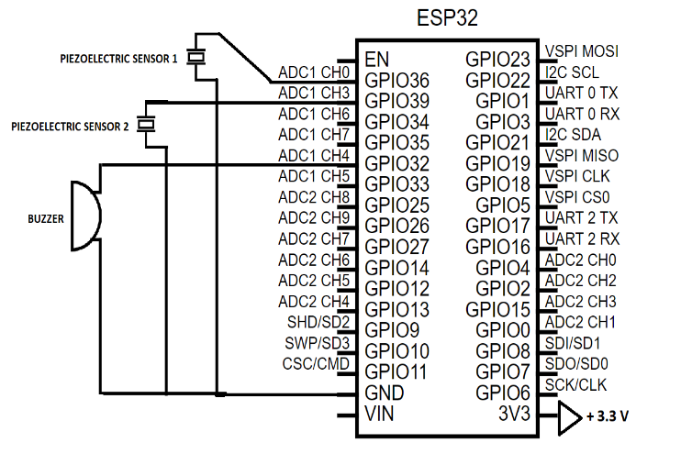
Figure 1: Circuit diagram
- Data processing and transmission
The data received from the sensors are processed by the ESP-WROOM-32 processor. The ESP-WROOM-32 is programmed using Arduino IDE to input the analogue voltage data and then converted it to digital form. Similarly, the processor reads the temperature data. This data is read and processed every 15 seconds and are sent to the cloud server through Wi-Fi. The data is processed to check for an increase in the value beyond the threshold value in order to alert the surrounding area for evacuation with the help of a buzzer.
- The Cloud
The cloud server is the storehouse for the real-time data sent from the processor. The cloud is also used to visualize real-time data on a time scale. Thingspeak open-source software is used to deploy the cloud model for this project. The cloud server provides a unique API key to read and write data onto their server and this data is accessible only by the authorized person which acts as a data security layer for the project. The cloud platform can be accessed from anywhere at any time and the data can be downloaded for further analysis also. The data is also processed on the cloud using the MATLAB analysis tool to check for changes in the sensor data and indicate immediately to the concerned person/authority by triggering an alert email.
- End-user interface
A user-friendly website has been developed for accessing the data and other services provided by us. This website also provides information and guidelines on how structural health data can be monitored in real-time. The user can also post their queries through the website, which can be addressed by us. Therefore, increasing the user experience.
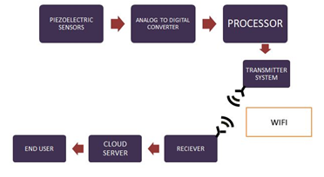
Figure 2: Workflow of the project
- Steps involved in the implementation of the project

- Sign in to Thingspeak
- Create a new channel with 3 fields
- Add a numeric display wedge on the channel
- Open a new sketch on Arduino IDE
- Install the Wi-Fi and Thingspeak Library & include them on Arduino IDE
- Define the pins 36, 39, 32 on Arduino IDE
- Connect to the ThingsSpeak server using ssid[], pass[]
- Set the channel number and API key of ThingSpeak
- Define a function reading temperature
- Read the temperature and store it in a variable temperature
- Return the temperature value
- Define a function reading_Piezo1_value() to read one of the piezo sensor data and return it
- Define a function reading_Piezo2_value() to read one of the piezo sensor data and return it
- Begin Serial Communication
- Set pin 32 to OUTPUT
- Initialize ThingSpeak
- Check if the Wi-Fi status is connected
- Set the field 1 of ThingSpeak with read_temperature()
- Set the field 2 of ThingSpeak with read_piezo1_value()
- Set the field 3 of ThingSpeak with reading_piezo2_value()
- Write the value to ThingSpeak Field
- If the mean of the 2 sensors' voltage exceeds the threshold value
Switch ON the buzzer
Else
Switch OFF the buzzer
- Open MATLAB Analysis on Thingspeak
- Input the sensor field values from the Thingspeak channel
- If the mean of the 2 sensors' voltage exceeds the threshold value
Trigger the ALERT email
- Run the analysis using REACT every time data is inserted into the channel

- Flowchart
False
True
END
Buzzer OFF
Buzzer ON
If
(val1+val2)/2 >= threshold

Write the values to the fields
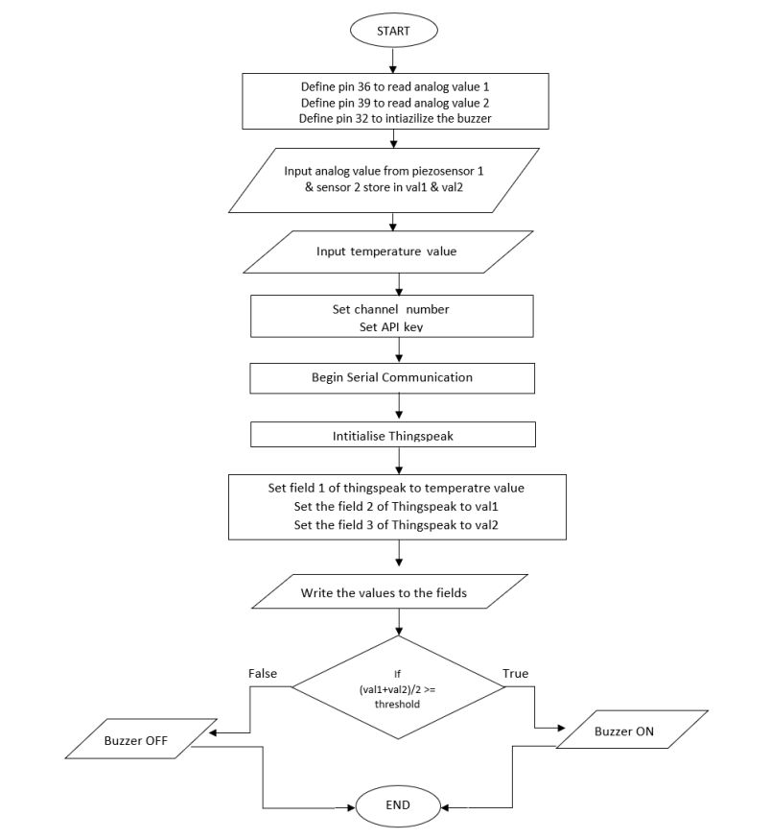
- Hardware Requirements

- ESP-WROOM-32
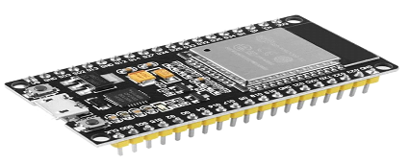
Figure 3: ESP-WROOM-32
The ESP-WROOM-32 is an economical, energy-efficient system on a chip microcontroller featuring built-in Wi-Fi and dual-mode Bluetooth capabilities.
- Piezoelectric Sensor
Figure 4: Piezoelectric Sensor
A piezoelectric sensor utilizes the piezoelectric effect to translate alterations in pressure, acceleration, temperature, strain, or force into electrical charges. These sensors serve as versatile instruments for measuring diverse processes.
- TMB12A12 Piezo Buzzer
Figure 1: Buzzer
TMB12A12 piezo buzzer is used for alarming. It is an active (driven circuit included) 85dB sound at 12V,10cm diameter, Magnetic 12V 2300Hz Plugin, D=12mm, Buzzers ROHS
- Software Requirements

- ThingSpeak

Figure 2:ThingSpeak website
ThingSpeak is an IoT analytics platform that enables the aggregation, visualization, and analysis of real-time data streams in the cloud. It facilitates immediate data visualization from devices uploaded to ThingSpeak. Additionally, it supports MATLAB code execution, allowing for online analysis and data processing. Commonly used for prototyping and proof-of-concept IoT systems with analytics requirements, ThingSpeak facilitates data transmission from internet-connected devices through REST API or MQTT. This platform streamlines cloud-based data storage and analysis without the need for web server configuration. Furthermore, it empowers the creation of advanced event-triggered email alerts based on incoming data from connected devices.
- wix.com
Figure 3: wix.com
Wix.com Ltd. is an Israeli software company that is publicly traded in the United States. The company specializes in offering cloud-based web development services. Its platform enables users to effortlessly build HTML5 websites and mobile sites using intuitive drag-and-drop tools available online.
- Arduino IDE

Figure 4: Arduino IDE
Arduino is a collaborative endeavor encompassing open-source hardware and software. It functions as a company, project, and user community engaged in designing and producing single-board microcontrollers and microcontroller kits to craft digital devices. The hardware products adhere to a CC BY-SA license, while the software is subject to licensing under the GNU Lesser General Public License (LGPL) or the GNU General Public License (GPL). This enables anyone to manufacture Arduino boards and distribute the software. These microcontrollers are programmable in C and C++, using a standardized API referred to as the Arduino Programming Language. This language is influenced by the Processing language and pairs with a customized version of the Processing IDE. Alongside conventional compiler toolchains, the Arduino initiative offers an integrated development environment (IDE) and a command line tool, both developed using Go.
- Results and Discussion

The website has been created successfully to coordinate the software aspects of the project and to provide an easy user experience. The website has a list of all the services provided and consists of a chatbot to pitch the user queries. The website also acts as an 2nd layer for data security as the user should log in in order to access the data. The website provides all the necessary guidelines on how to access and act upon the sensor's data.
Figure 9.a: Home page of our website
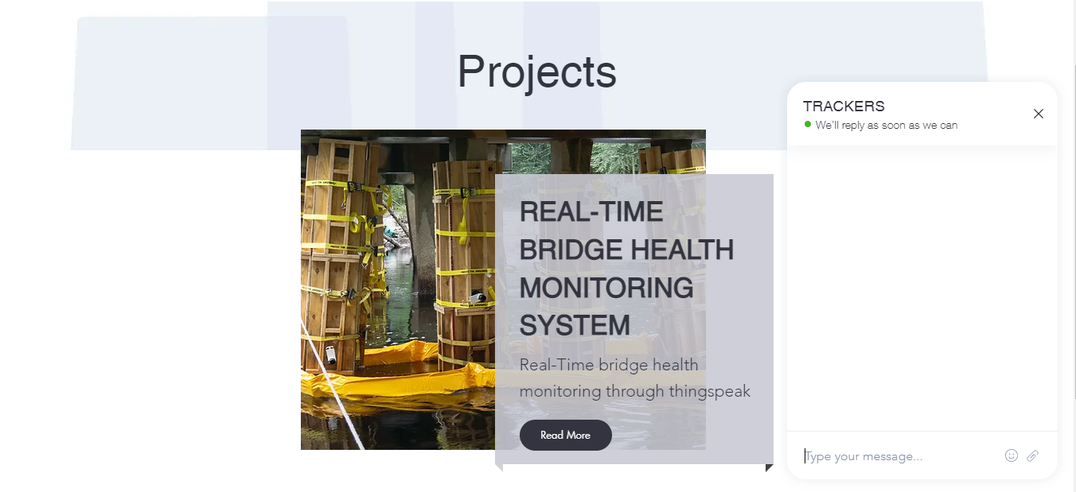
Figure 9.b: Few visualizes of our website
The temperature of the internal chips of the processor is recorded and analysed. This is to make sure that the processor is in good condition.
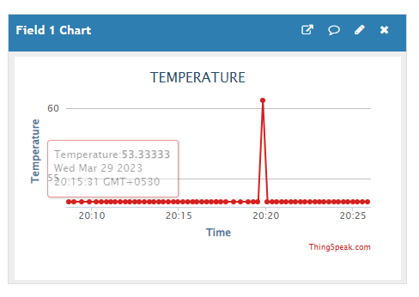
Figure 10: Plot of temperature v/s time on Thingspeak
The changes in the vibration and strain data of the bridge is acquired and sent to the Thingspeak cloud successfully. This real-time data is displayed on the channel dashboard through a plot of sensors value v/s the time of action and also the latest data is displayed on the screen. The plot can be of line, bar, column, spline, or step format. The plot can be changed for sum, mean, or median values of a number of days that helps in analysis.
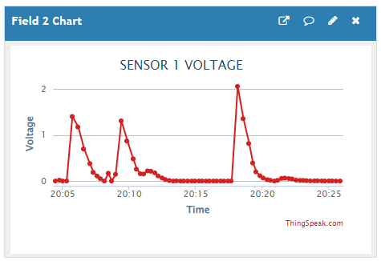
Figure 11: Plot of piezo sensor 1 value v/s time (in line format)
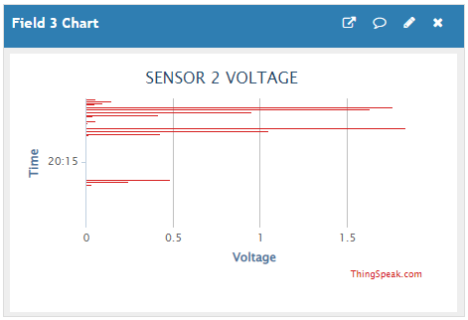
Figure 12: Plot of piezo sensor 2 value v/s time (in bar format)

Figure 13: Numerical display of the values of the piezo sensors
The sensors data are processed and analysed on the cloud and have been programmed to trigger alert emails to the concerned person or authority. This makes sure that immediate actions are taken at the place.
Figure 14: Alert email

The working prototype of the project is shown in Figure 15. The prototype is compact and easy to install on the structures.

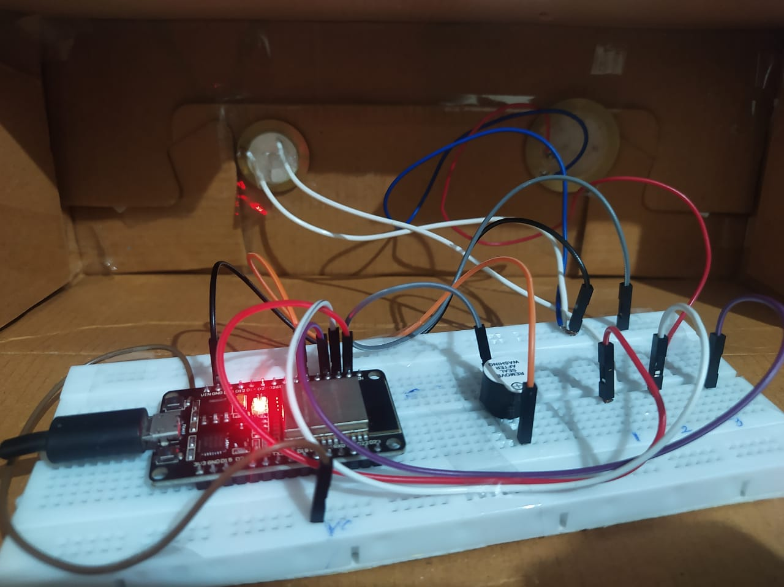

Figure 15: A working model

- Conclusion

A compact integrated smart IoT-based solution for monitoring the health of the structures in real time is realized. With this project, real-time monitoring of data is possible without delay or data loss. Easy maintenance of data transmission through Wi-Fi stands as an advantage over wired systems. The project has overcome the issues of data security while implementing SHM through IoT.

An IoT-SHM system yields immediate favourable outcomes, including significant cost reductions in monitoring and heightened human safety via continuous surveillance. It expedites the development and integration of monitoring systems, utilizing cable-free wireless technologies. This allows seamless integration into both new and pre-existing structures with minimal disruption. The incorporation of IoT-SHM into residential settings and smart cities facilitates comprehensive monitoring over broader regions. Notably, this project is constructed using diverse open-source platforms, resulting in zero software costs.

- Future scope
The widespread popularity of the Internet of Things (IoT) is leading to its integration in various domains, showcasing its potential benefits. Applying IoT principles to Structural Health Monitoring (SHM) stands as a notable example of this synergy, revealing its advantageous outcomes through projects like this. The project's implications extend beyond its current scope, opening avenues for diverse applications. Beyond its current focus, this project holds the potential to expand its utility to areas such as bridge and infrastructure monitoring, cold storage surveillance, machine vibration analysis, and temperature tracking. The adaptability of this smart system underscores its relevance across sectors, especially in instances demanding real-time monitoring of machinery and structural health. Organizations and industries requiring continuous machine and structural health monitoring systems stand to gain significantly from this endeavour. The project's success highlights the demand for sophisticated monitoring solutions that provide instant insights and contribute to operational efficiency.
Furthermore, the project's reach can be further extended by incorporating additional parameters that influence structural well-being. By measuring and analysing a broader range of factors, this system could offer comprehensive insights into the health of various structures, ensuring a more holistic approach to maintenance and safety. In essence, the project's impact reverberates beyond its immediate focus, indicating the transformative potential of IoT-driven SHM solutions. As IoT continues to proliferate across diverse sectors, such initiatives play a pivotal role in realizing enhanced efficiency, safety, and overall performance in a range of applications.

REFERENCES
[1] C. Scuro, P. F. Sciammarella, F. Lamonaca, R. S. Olivito, and D. L. Carni, "IoT for structural health monitoring," in IEEE Instrumentation & Measurement Magazine, vol. 21, no. 6, pp. 4-14, December 2018, Doi: 10.1109/MIM.2018.8573586.
[2] C. Arcadius Tokognon, B. Gao, G. Y. Tian, and Y. Yan, "Structural Health Monitoring Framework Based on Internet of Things: A Survey," in IEEE Internet of Things Journal, vol. 4, no. 3, pp. 619-635, June 2017, Doi: 10.1109/JIOT.2017.2664072.
[3] Donato Abruzzese, Andrea Micheletti, Alessandro Tiero, Manuel Cosentino, Damiano Forconi, Gianmarco Grizzi, Gianluca Scarano, Sreymom Vuth, Pierluigi Abiuso, IoT sensors for modern structural health monitoring. A new frontier, Procedia Structural Integrity, Volume 25,2020, Pages 378-385, ISSN 2452-3216, https://doi.org/10.1016/j.prostr.2020.04.043.
[4] Muttillo, Mirco, Vincenzo Stornelli, Rocco Alaggio, Romina Paolucci, Luca Di Battista, Tullio de Rubeis, and Giuseppe Ferri. "Structural health monitoring: An iot sensor system for structural damage indicator evaluation." Sensors 20, no. 17 (2020): 4908. https://doi.org/10.3390/s20174908
[5] Myers, Alex, Md Anam Mahmud, Ahmed Abdelgawad, and Kumar Yelamarthi. "Toward integrating structural health monitoring with Internet of Things (IoT)." In 2016 IEEE International Conference on Electro Information Technology (EIT), pp. 0438-0441. IEEE, 2016. doi: 10.1109/EIT.2016.7535280.
[6] C. Scuro, F. Lamonaca, S. Porzio, G. Milani, R.S. Olivito, Internet of Things (IoT) for masonry structural health monitoring (SHM): Overview and examples of innovative systems, Construction and Building Materials, Volume 290, 2021, 123092, ISSN 0950-0618, https://doi.org/10.1016/j.conbuildmat.2021.123092.
[7] Mayank Mishra, Paulo B. Lourenço, G.V. Ramana, Structural health monitoring of civil engineering structures by using the internet of things: A review, Journal of Building Engineering, Volume 48, 2022, 103954, ISSN 2352-7102, https://doi.org/10.1016/j.jobe.2021.103954.

