A Study on BFS and DFS Adaptive Algorithms with Application in Computer Science

Girija B
Independent Research Scholar,
Oscar College,Vellore, India
girijaranjith2017@gmail.com

ABSTRACT
Many real life problems exhibits a connectivity structure in nature. Before, data solving techniques for including, bioinformatics, communication network, image data, wireless networks etc., are more complicated because of high computational complexity. Hence, nowadays, there are lots of graph models and these can be solved using graph theory algorithms such as BFS, DFS, Diijkstras algorithm and so on. These algorithms are applied in data structures. This paper explains BFS and DFS algorithms with application.

Keywords—graph, directed graph, connectivity, trees, subgraph, spanning subgraph, spanning trees.

INTRODUCTION

Mathematics plays an immense role in many fields, especially Graph Theory occupies an important role in the field of computer science. Graph theory is a mathematical model of pair wise relations between objects. Graphs are the convenient to represent mathematical objects. There is a wide range of application of graph theory in computer science.

Here, we will see, the algorithms such as BFS ANS DFS, with applications.

The Breadth First Traversal Algorithm

This algorithm is used to search a graph data structure with vertices. It starts at the root of the graph and travels all the vertices at the current depth level. The BFS for a graph is similar to BFS of a tree. The only difference is graphs contain cycles but trees are not. To avoid repeated travel of same vertices, we divide into two categories:
- Visited
- Not visited.
For this, we consider that all the vertices are reachable with the starting vertex. BFS uses a queue data structure for traversal. Starting from the first vertex, all the vertices in a same level are visited first and then the vertices in the next level are visited. All the adjacent unvisited vertices are made into the queue, and the vertices of current level are marked visited, and eliminated from the queue.

Let us understand the working algorithm of BFS with the following simple example:
Step-1: Initially the queue and visited arrays are empty.

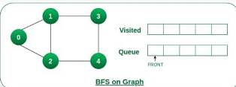

Step-2: Push node 0 into queue and mark visited.

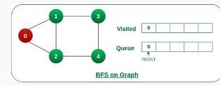

Step-3: Remove node 0 from the front of the queue and visit the unvisited neighbors and push them into queue.
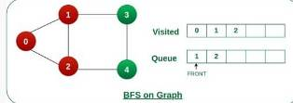

Step-4: Remove node 1 from the front of the queueand visit the unvisited neighbours and push them into queue.
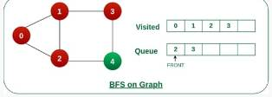

Step-5: Remove node 2 from the queue and visist the unvisited neighbors and push them into queue.
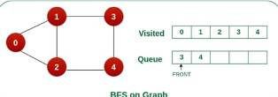
Step-6: Remove node 3 form the queue and visit the unvisited neighbors. As we can see that every neighbor of node 3 visited, so move to the next node that are in front of the queue.
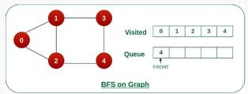

Step-7: Remove node 4 from the front of the queue and visit the unvisited neighbors. As we can see that neighbors of node 4 visited, so move to the next node that are in front of the queue.
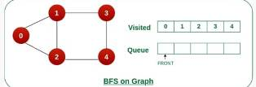

Now, queue become empty, so terminate the process of iteration.

Illustration C Program for BFS algorithm:

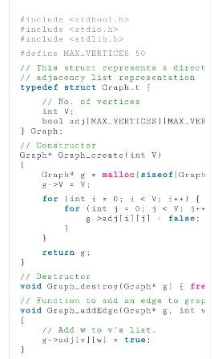
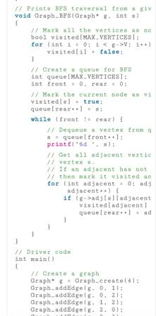
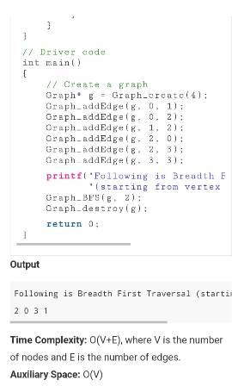

The Depth First Search Algorithm

DFS of a graph is similar to DFS traversal of a tree. A graph can have more than one DFS traversal. This algorithm is for traversing or searching a tree or a graph data structures. The algorithm starts with a root node and travels as far as possible along each branch before backtracking.
Let us understand the working of DFS with the following illustration.

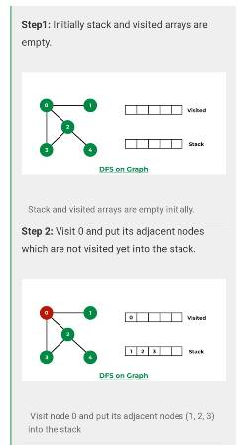
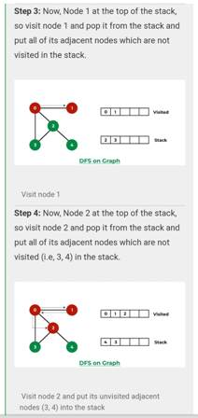

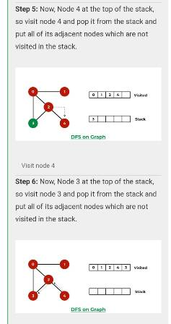
Now stack becomes empty, which means we have visited all the nodes and our DFS traversal ends.

Let us implement above process by C Program

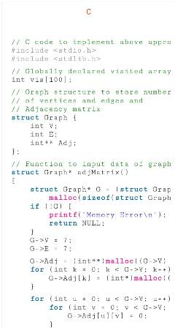

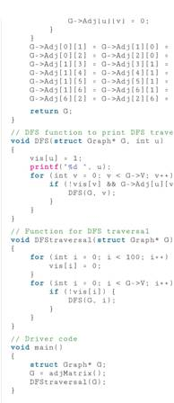

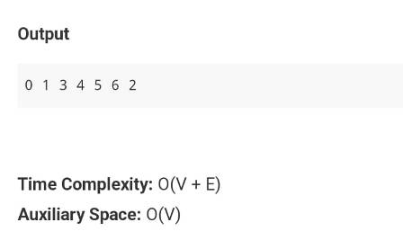

The difference between BFS and DFS Algorithms

BFS is a vertex based technique and it uses queue data structure whereas DFS is an edge based technique and uses stack data structure.

Conclusion

In this paper, we discuss about the algorithms of BFS and DFS with example and with implementation. Both the algorithms are very useful and easy to understand. We can use either BFS or DFS which suits for our program

AUTHOR PROFILE

Girija.B. completed her undergraduate, graduate, and master's degrees in philosophy in mathematics at Auxilium College in Vellore, Tamil Nadu, where she also won the university's gold medal. She is currently in research on mathematical algorithms used in computer science. Before beginning her research, she held a position as an assistant professor of mathematics at Sri Arcot Sri Mahalaksmi College of Arts and Science in Arcot, Ranipet.

REFERENCES

- https://www.geeksforgeeks.org/breadth-first-search-or-bfs-for-a-graph/
- https://www.geeksforgeeks.org/depth-first-search-or-dfs-for-a-graph/
- https://www.geeksforgeeks.org/difference-between-bfs-and-dfs/
- A. Elumalai, “Graph theory applications in computer science and engineerin”, Malaya Journal of Matematik, Vol. S, No : 4025-4027, 2000.
- Serafino Cicerone, Gabriele Di Stafano, “Graph algorithms and Applications” ISBN 978-3-0365-1542-7 (Hbk), ISBN 978-3-0365-1541-0 (PDF)

