Biobased and biodegradable materials Polymers and natural fibres: Emerging materials for an environmentally green planet.
*Raghavendra Subramanya
Department of Mechanical Engineering, Sai Vidya Institute of technology, Bangalore, Visvesvaraya Technological University.
Email: rvs.sdly@gmail.com
*Corresponding author: Raghavendra.S
Ravi Kumar .M
Department of Mechanical Engineering, BMS college of Engineering, Bangalore, Visvesvaraya Technological University.
Email: ravikumar.muk@gmail.com
Jatadhara.G S
Department of Mechanical Engineering, Siddaganga Institute of Technology, Bangalore, Visvesvaraya Technological University.
Email: jatadhara@sit.ac.in
Manjunatha KN
Department of Mechanical Engineering,SJCIT, Chikaballapura,
Visvesvaraya Technological University.
Email: bangaloreju@gmail.com
Chandra Shekar.A
Department of Mechanical Engineering,Bangalore Institute of Technology, Bangalore, Visvesvaraya Technological University
Email: acsmech@gmail.com

Abstract:
Plastics are widely recognised as one of the most valuable materials, due to their exceptional adaptability as well as affordable cost. Their uses include packing, structural, vehicles, aviation parts, electrical components, biomedical, and consumer goods like as toys, cutlery, cameras, and watches. However, the increasing usage of plastics has been a major cause of worry due to their detrimental environmental effect; notably, the sources from which plastics are created and their biodegradability. Almost all synthetic plastics are derived from petroleum and its byproducts. Furthermore, plastics manufactured from fossil fuels are typically non-biodegradable. Biobased polymers or bioplastics are environmentally friendly, biodegradable, and biocompatible. They lessen our reliance on diminishing fossil fuels while being carbon neutral. Despite fulfilling a critical and timely demand for environmental sustainability, bioplastics have failed to establish a prominent position in the plastics sector. This is due to bioplastics' inferior characteristics when compared to synthetic counterparts. As a result, scientists and engineers worldwide have been investigating ways to enhance the characteristics of bioplastics by blending/compounding them with other polymers and fibres. Green composites, which are made by combining bioplastics and natural fibres, give a sustainable alternative that is completely biodegradable. However, studies are being conducted to combine bioplastics with synthetic materials with natural fibres.

Contents:
- Introduction
- Different types of Bio polymers & Natural Fibers
2.1 Poly Lactic Acid (PLA)
2.2 Epoxidized soybean oil
2.3 Polyester bio-resin
2.4 Epoxidized linseed oil
2.5 Starch Based biopolymers
2.6 Natural fibers
- Processing of Bio composites
- Applications of Bio composites
- Conclusion
- References
1. Introduction:
Plastics have long been regarded as one of the most valuable materials, owing to their exceptional adaptability and low cost [1]. Polyolefins such as polypropylene, polycarbonate, polyvinyl chloride, polyethylene, polystyrene, and others are used to make the majority of plastics. All of these synthetic polymers are made from fossil fuels and its by-products. These natural resources form over thousands of years and are limited in number. Furthermore, plastics manufactured from fossil fuels are typically non-biodegradable. As a result, the depletion of oil reserves, as well as increased environmental consciousness and legislation, have prompted the development of next-generation materials that are environmentally benign and/or readily available to fulfil a growing need for polymers.
Biobased polymers, also known as bioplastics, are created from renewable materials and can be sustainably recycled by biological processes, preserving limited environmental assets (fossil fuels) and lowering greenhouse gas emissions [2-3]. Bioplastics are now sustainable, biodegradable, and biocompatible [4]. Bioplastics are being used in a wide range of industrial uses, including packaging for foods, the agricultural sector, decomposing bags, and healthcare [5].
Aside from those, it is expected that bioplastics are going to be employed in biomedical, structural, electrical, and various other everyday uses as the material's functionality improves.
Considering rising global plastic use, it is estimated that the need for biodegradable polymers would rise by 30% every year [6]. As a result, a great deal of effort is being directed to researching novel green polymeric materials in order to address the ever-growing demand for natural and biodegradable polymers. poly (trimethylene terephthalate), soy-based plastics, polyhydroxybutyrate (PHB), Polylactic acid (PLA), cellulose polyesters, starch-based bioplastics, plant oil-derived bioplastics, biopolyethylene, and other bioplastics are among the most well-known in today's world.
Though bioplastics pique the curiosity of many researchers and technologists worldwide, they have poorer qualities as compared with the manmade substitutes. As a result, their applicability is limited in places dominated by fossil fuel-based polymers.
Biocomposites are extremely important in the material field due to their give distinctive qualities that are not found in nature. Their characteristics can also be altered by selected design composition and manufacturing. This promotes the adoption of biocomposites in a variety of industries, including aerospace, automotive, building and construction, marine, consumer items, and electrical components.
- Different types of bio polymers
Bio-composites are made by combining bio-fibers such as Kenaf, Hemp, Rax, Jute, Henequen, Pineapple leaf fibre, and Sisal with resin matrices derived from both renewable and non-renewable resources.
Corn, lactic acid, soy-bean oil, linseed oil, pine oil, and vegetable oils are used to make biopolymers. As shown in Table 1, the majority of these resins are thermosets and so may be used in LCM techniques to create natural-fiber derived polymer composites.
Table1: list of commercially important biopolymers
Name | Type of Resin | Resin Base
Polylactic acid | Thermoplastic | Lactic acid
Epoxidized soybean oil | Thermoset | Soybean Oil
Polyester bio-resin | Thermoset | Soy
Epoxidized linseed oil | Thermoset | Linseed oil

Composites made from bio are created by reinforcing natural fibres with bio resins, causing the fibres to absorb liquid resin and expand. As a result, the porosity of the wetted fiber-preform, and hence its permeability, decreases over time. The presence of cellulose molecules is the primary cause of enlargement and absorption in natural fibres. Because of this pre-wetting of fibres, short fibres are preferred.
  - Poly Lactic Acid (PLA)
Through fermenting a source of carbohydrates, typically glucose produced by means of starch hydrolysis, lactic acid can be produced.Lactic acid has one asymmetric carbon in its molecule and so has two stereoisomers. L-lactic acid occurs naturally in many species, but D-lactic acid is extremely uncommon in nature.
PLA is a favoured product above other biodegradable polyesters due to its availability and inexpensive cost. Depending on the qualities evaluated, PLA exhibits mechanical and thermal properties similar to poly(ethyleneterephtalate) (PET) or polystyrene (PS). When compared to polystyrene (PS), PLA has modest barrier qualities (water vapour permeability and oxygen permeability). However, its usage is limited due to its high density, high polarity, low heat resistance, and brittleness.

2.2 Epoxidized soybean oil
Within the spectrum of resins derived from petroleum, epoxy resins stand out as thermoset polymers renowned for their exceptional attributes, such as impressive adhesive strength, tensile strength, stiffness, electrical resistance, and substantial heat and chemical tolerance. Epoxy resins find extensive utilization across various industrial sectors, including adhesives, electronics, coatings, and composite materials. However, a notable drawback of epoxy resins is their susceptibility to brittleness. To address this limitation and enhance the biobased content of the resulting composites, several readily available vegetable oils, such as epoxidized soybean oil, can be employed. These oils not only increase the toughness of epoxy resin but also contribute to its environmentally friendly composition [8-9].
Epoxidized soybean oil is the result of the conversion of soybean oil's double bonds into oxiran groups, which is a triglyceride comprising saturated and unsaturated fatty acids.
2.3 Polyester bio-resin
Unsaturated polyester (UP) resins find extensive application across a diverse range of industrial, household, and hobby-related uses. These applications encompass fiber-reinforced composites (commonly employed in the automotive, boat, and construction sectors), fillers, cabinet fixtures, buttons, and numerous other purposes. UP resins primarily exist as low-viscosity liquids, although certain variants can exhibit high viscosity. They primarily consist of two key constituents: an unsaturated polyester and, as a reactive diluent, monomeric styrene, which can make up to 60% of the composition, serving to reduce overall viscosity. To initiate curing, a hardener or initiator is introduced. This hardener kickstarts a chemical curing reaction between the polyester and styrene, resulting in the formation of a mechanically robust material.
2.4 Epoxidized linseed oil
Because of their outstanding dimensional and thermal stability, as well as a high level of processability, epoxy resins constitute an essential family of thermosets.The most prevalent vegetable oils are made up of fatty acids that include 14-22 carbon atoms and can have between 0 and 3 double bonds between carbon and carbon Linseed oil (LO) especially represents the group of the vegetable oils with the most carbon-carbon double bonds per triglyceride, with an average value of 6.6, which can be selectively functionalized due to their reactivity [10], making it one of the top choices for the synthesis of bio-based thermosetting resins. Linseed oil may be customised by epoxidation to generate oxirane rings as a result of double bond interaction with peracids.
The processes of linseed oil produces epoxidized linseed oil (ELO), which has qualities comparable to some petroleum-based epoxy resins. By utilising amines [11], anhydrides [12], and anhydrides [13], ELO may be crosslinked in the same way as any other standard epoxy resin.
2.5 Starch Based biopolymers
Starch-based polymers stand out due to their unique ability to be manufactured primarily from a readily recyclable resource: natural starch. This sets them apart from most other bio-based polymers, which typically involve costly synthesis processes. Additionally, the utilization of starch as a polymeric material presents a promising opportunity for starch-related industries to diversify into non-food applications. Starch, derived from sources such as corn, wheat, potato, cassava, tapioca, and rice, is a polysaccharide composed of two distinct macromolecules based on glucose units known as amylose and amylopectin. This polymeric material is commonly referred to as thermoplastic starch (TPS) or plasticized starch. TPS, being a thermoplastic polymer, shares similarities with oil-based thermoplastics and finds valuable applications, particularly in the field of packaging and various industrial sectors.
Natural fibers
A wide range of natural fibers derived from leaves, stalks (bast), and seeds can be effectively employed to reinforce or fill thermoplastic materials. Generally, the higher the aspect ratio (the ratio of length to diameter) of the fiber, the greater the enhancement observed in properties when compared to pure thermoplastics. In particular, bast fibers tend to yield substantial improvements in tensile and bending strength as well as modulus. When seeking increased toughness, coarser fibers like sisal and coir fiber are preferable. In addition to these fibers, fines resulting from the processing of materials such as wood, coir, agave, hemp, and jute, as well as rice and nut hulls, cereal straws, and corn cobs, can be utilized to enhance the dimensional stability and stiffness of thermoplastics.
Some examples of natural fibers and their category are listed below.Table 3.2, the cellulose content and the percentage of several natural fibres is listed. Because cellulose makes up a major portion of natural fibres, swelling is to be considered if bio-resins, which are organic liquids, come into proximity to natural fibres.

Table 2 The cellulose percentages of some natural fibers.
Fiber | Cellulose Percentage (wt%)
Sisal | 66-77.2
Banana | 61.5
Bowstring Hemp | 69.7
Pineapple | 71.6
Ramie | 91
Jute | 75.3
Hemp | 77.07
Kenaf | 65.7
Coir | 43
sugarcane | 50

Sisal, scientifically known as Agave sisalana, belongs to the agave plant family. The fibers of sisal are extracted from the leaves of this plant. Typically, the fiber extraction process involves mechanical decortication, where the leaves are compressed between rollers. The resulting pulp is then removed from the fiber, which is subsequently washed and dried using either mechanical or natural methods. Sisal fiber is characterized by its coarse and rigid nature. It is renowned for its attributes such as strength, durability, stretchiness, its ability to readily absorb specific dyes, and resistance to damage from saltwater. Sisal ropes, known for these advantageous qualities, find extensive use in maritime, agricultural, and various industrial applications.
Fibres made of jute. It is a bast fibre and one of the most affordable natural fibres. It has weak moisture resistance, brittles when exposed to light, and readily absorbs paint. Jute is made up of extremely small elementary fibres (0.7-6 mm in length) that are joined together by lignin to produce long brittle fibres (300-400 mm in length).
Coir husk fibres are found inside the husk and the coconut's outer shell. Coir processing is mostly influenced by demand because it is a byproduct of the manufacture of other coconut goods. Given the availability of manpower and other inputs, large amounts of coconut husk mean that coir manufacturers can respond to market circumstances and prices very quickly.
Ramie is a member of the Urticaceae (Boehmeria) family, which has over 100 species. Ramie's appeal as a textile fibre has been hampered mostly by producing locations and a chemical makeup that need more intensive pre-treatment processes than other commercially relevant bast fibres.
Kenaf is a member of the Hibiscus genus, which has over 300 varieties. Kenaf is a novel species in the United States with high potential for use as an ingredient in composite goods. Recent advancements in decortication machinery that separates the core from the bast fibre, along with fibre scarcity, have reignited interest in kenaf as a fibre source.
Natural fibre qualities varied across the papers given because various fibres were utilised, varied moisture levels was present, and various test methodologies were used. The performance of polymer composites reinforced with natural fibers is contingent on several parameters. These factors encompass the chemical composition of the fibers, cell size, microfibrillar angle, structural defects, overall structure, physical attributes, and mechanical properties. Additionally, the interaction between the fiber and the polymer plays a significant role. Gaining a comprehensive understanding of these fiber properties is crucial for expanding the application of natural fibers in composite materials and enhancing their overall performance. The variety of distinctive values, and they constitutes one of the downsides of all natural goods, is noticeably greater than that of glass fibres, which may be explained by variances in fibre structure related to overall environmental circumstances during growth. Natural fibres can be treated in a variety of ways to provide strengthening components with varying mechanical qualities. Many factors can alter the mechanical characteristics of natural fibres. If cellulose-fibers are utilised as reinforcement in plastics, their hydrophilic nature is a big issue. The moisture content of fibres is determined by the non-crystalline component content and the quantity of voids of the fibres.
The primary drawbacks of natural fibres in composite reinforcement were their lack of interaction with the matrix and their excessive moisture absorption. As a result, natural fibre modifications are taken into account when changing the surface characteristics of fibres to optimise their adherence with various matrices. A firm contact that is particularly brittle in nature with easy fracture propagation across the matrix and fibre might attain an outstanding strength and stiffness. A weaker contact might impair the effectiveness of stress transmission from the matrix to the fibre.

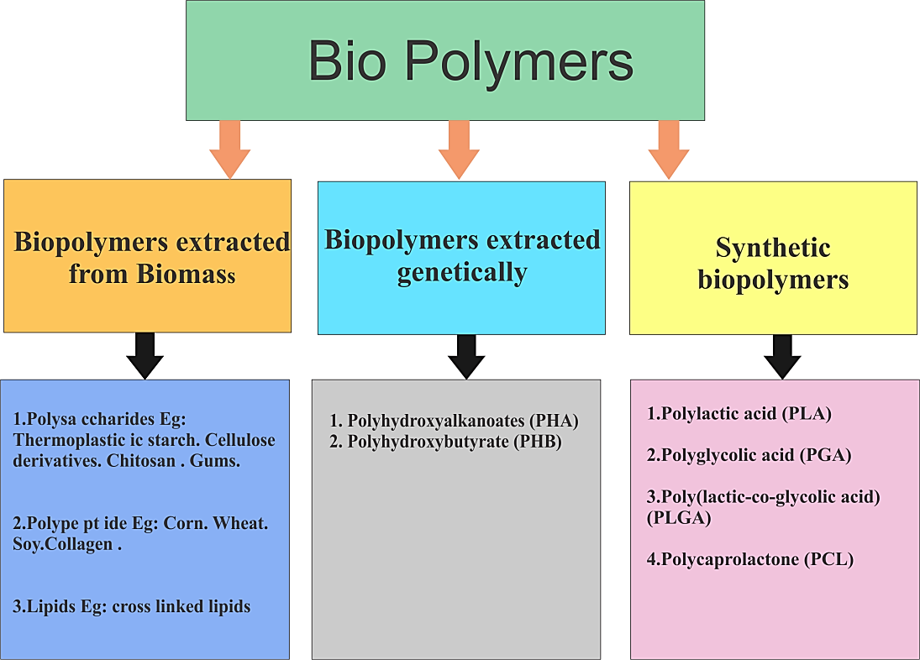
Figure1: classification of Bio Polymers
- Processing of Bio composites
There are many approaches to develop the bio composites, few important methods are discussed below.
Hand Lay-Up Method: The fiber-matrix mixture is manually poured into an open mould, and light pressure is applied by roller to remove entrapped air and improve thermoset compatibility. The limitations are low cost, no size constraints, suitability for research and research and development work, slight surface polish, air pockets, and long curing time.
Filament Winding Process:
Resin-impregnated continuous fibre is wound on a revolving mandrel in a manual, computer-controlled, and regulated fibre orientation. The restrictions are hollow tube-like shapes, continuous fibre, and thermoplastic resin, as well as a high fibre volume fraction.
Pultrusion Process:
Resin-soaked fibres are then pulled through a die of the required shape; the shape of the result is determined by the die cross section. Overall cost is minimal, appropriate for thermosets and thermoplastics, and continues cross section is limited.
Compression Moulding:
The heated closed mould is filled with the fiber-resin combination, and a compressive load is delivered via the upper part of the mould. High production rate, excellent surface polish, multiple component development, can be used for thermoset polymer for the development of vehicle parts.
Liquid Transfer Moulding Process:
Resin is introduced into the enclosed moulded fibre, and the mould chamber is sucked or at atmospheric pressure. The key restrictions include a product with complicated geometry, a high fibre volume percentage, an excellent surface polish, resin injection, curing, and heat transmission.
Autoclave Processing:
Prepregs are laid in the mould mechanically, and the complete assembly is vacuumed packaged and placed into the autoclave for curing. Larger fibre volume percentage, appropriate amalgamation of composite ingredients, no air pockets, high surface adhesion, aeroplane parts, and both types of polymers.
Injection Moulding:
Extruder is utilised for pushing the necessary volume of fibre resin mixture into the cavity of the mould. Combination with both types of resin, high production rate, shorter curing time, and various car parts.
Diaphragm forming:
Thermoplastic prepregs strips are sandwiched between elastic diaphragms, which are then inserted into the mould for curing. Only for parts with a consistent size and an irregular fibre dispersion.
5.Conclusions:
The solid waste treatment issue, a lack of resources, and imbalance between environment, technology, and the economics connected to traditional polymer composites prompted the creation of nonconventional, namely natural and biodegradable composites (bio-composites). The study discusses several production strategies for the future growth of bio-composites. It discusses the primary characterisation characteristics and application possibilities of bio-composites in various engineering components. There is always room for developing and testing novel biodegradable fibres and polymers that compete against non-biodegradable fibres and polymers.
References
1. Frech, Cheryl. (2002). Green Plastics: An Introduction to the New Science of Biodegradable Plastics (Stevens, E. S.). Journal of Chemical Education. 79. 1072-. 10.1021/ed079p1072.1.
2. Ray, S.S. and Bousmina, M. (2005) Biodegradable Polymers and Their Layered Silicate Nanocomposites: In Greening the 21st Century Materials World. Progress in Materials Science, 50, 962-1079.
3. Fomin VA, Guzeev VV. Biodegradable Polymers, Their Present State and Future Prospects. Progress in Rubber and Plastics Technology. 2001;17(3):186-204. doi:10.1177/147776060101700303.
4.Richard A. Gross Bhanu Kalra ,Biodegradable Polymers for the Environment.Science297,803-807(2002).DOI:10.1126/science.297.5582.803.
5. Bastioli, C. (2001), Global Status of the Production of Biobased Packaging Materials. Starch/Stärke, 53: 351-355.
6. Leaversuch, R. (2002). Biodegradable polyesters: packaging goes green. Plastics technology, 48(9), 66-79.
7. R.A. Gross, and B. Kalra, Green Chemistry, Vol. 297, p. 803,2002.
8.Miyagawa, H.; Misra, M.; Drzal, L. T.; Mohanty, A. K. Fracture toughness and impact strength of anhydride-cured biobased epoxy. Polym. Eng. Sci. 2005, 45, 487−495
9.Wang, R.; Schuman, T.; Vuppalapati, R. R.; Chandrashekhara, K. Fabrication of bio-based epoxy−clay nanocomposites. Green Chem. 2014, 16, 1871.
10.Khot, S.N., et al., Development and application of triglyceride-based polymers and composites. Journal of Applied Polymer Science, 2001. 82(3): p. 703-723.
11. Miyagawa, H., et al., Thermo-physical and impact properties of epoxy containing epoxidized linseed oil, 2(a) - Amine-cured epoxy. Macromolecular Materials and Engineering, 2004. 289(7): p. 636-641.
12. Miyagawa, H., et al., Thermo-physical and impact properties of epoxy containing epoxidized linseed oil, 1 - Anhydride-cured epoxy. Macromolecular Materials and Engineering, 2004. 289(7): p. 629-635.
13. Samper, M.D., et al., Thermal and Mechanical Characterization of Epoxy Resins (ELO and ESO) Cured with Anhydrides. Journal of the American Oil Chemists Society, 2012. 89(8): p. 1521-1528.]

