SATELLITE AND SPACE COMMUNICATION

Dr.Shalini S Sheela S
Dept. Computer Science and Engineering Dept.Computer Science and Engineering
Global Academy of Technology Global Academy of Technology
Bangalore, India Bangalore, India
shalini.siddamallappa@gmail.com Sheela.s@gat.ac.in
Prathyusha S Syed Mezan Naimuddin
Dept. Aeronautical Engineering Dept. Aeronautical Engineering
Global Academy of Technology Global Academy of Technology
Bangalore, India Bangalore, India
prathyushas354@gmail.com mezan990@gmail.com

Akshay D Vivek N
Dept. Computer Science and Engineering Dept. Aeronautical Engineering
Global Academy of Technology Global Academy of Technology Bangalore, India Bangalore, India
akshay70224@gmail.com viveknanjundaiah2003@gmail.com

ABSTRACT
Satellite and space communication plays a vital role in revolutionizing how we connect and communicate globally. This paper presents an overview of satellite technology and its profound impact on modern society. With an ever-increasing demand for faster and more reliable communication. It explores the essential components of a satellite system, such as the satellite itself, ground stations, and user terminals. The paper highlights the various orbits utilized by satellites, including geostationary, medium Earth orbit (MEO), and low Earth orbit (LEO). The differences in advantages and limitations emphasize their application in different communication scenarios. Satellites act as essential relays, facilitating long-distance communication between remote regions and providing internet access to underserved or hard-to-reach areas. This has led to incredible advancements in education, healthcare, disaster management, etc... Furthermore, the abstract outlines satellite technology, including high-throughput satellites (HTS), software-defined radios (SDR), and improved signal-processing techniques. The abstract concludes by addressing the emerging trends in space communication, such as the integration of satellite constellations and the rise of private space companies. The introduction of mega-constellations of small satellites in LEO can revolutionize global connectivity and further drive innovation in space technology. Satellite and space communication represents a transformative force in the modern world, enhancing connectivity all over the world and catalysing socioeconomic progress. As technological advancements continue to soar, satellite-based communication is poised to play an even more critical role in shaping the future of our interconnected world.
keywords: - satellite, space, communication

INTRODUCTION
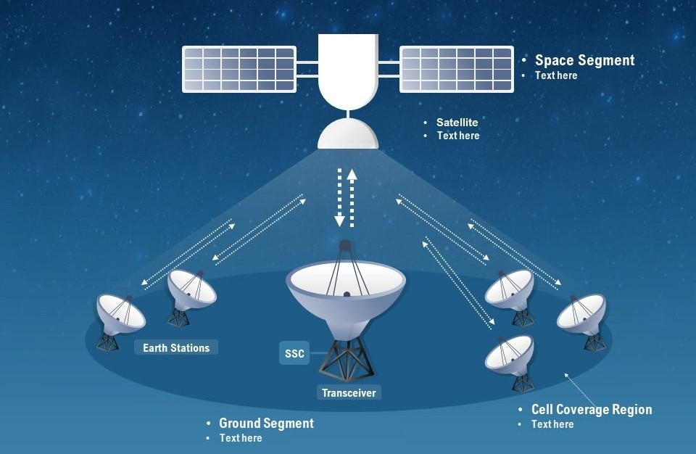
A communication satellite acts as a microwave repeater station in space, assisting in different communication industries such as telecommunications, radio broadcasting, television transmission, and internet connectivity. Satellites are advanced transponders, as opposed to typical repeaters, which merely amplify and retransmit signals. They receive signals from Earth-based ground stations, strengthen them, and then retransmit them to precise areas around the world. Satellites are not planets or moons; rather, they are artificial machines built to orbit a planet or star, including our own. The ground segment and the space segment are critical components of a space communication system. The ground segment includes the Earth-based stations that send and receive signals to and from the satellite.

SATELLITE
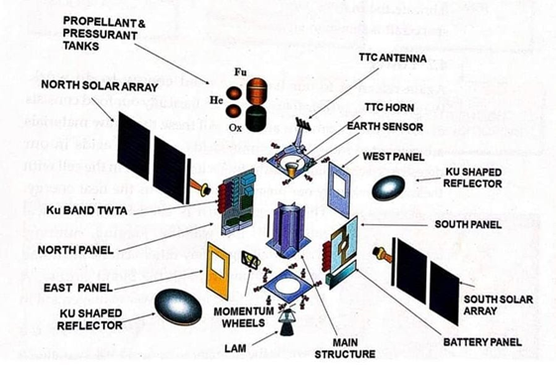
A satellite is a celestial object that circles a larger celestial entity. In the context of our planet, Earth is considered a satellite, and those that occur naturally are referred to as "natural satellites." However, when people talk about satellites, they usually mean "man-made" or "artificial" satellites. Humans have created and launched these robots into space to orbit Earth or other celestial planets. Many man-made satellites serve various purposes. Some are designed for Earth observation and capture photographs to aid scientists in their research of our planet, the solar system, and beyond. Others have specialized jobs, such as photographing other planets, the sun, and faraway objects, which contributes essential information to space research. Aside from scientific research, man-made satellites play an important role in worldwide communication.
SATELLITE
COMMUNICATION
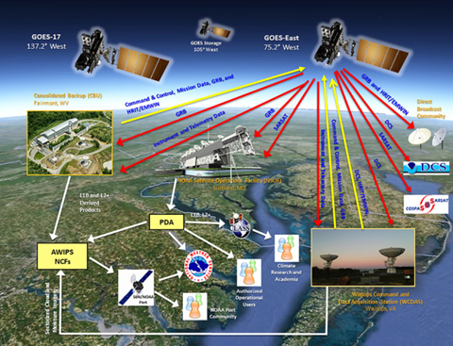
A communication satellite is a man-made device that receives radio communications signals from a source transmitter on Earth, amplifies those signals using a transponder, and then relays them to receivers in various locations across the world. These satellites are used for a variety of functions, including television, telephone, radio, internet, and military communication. The majority of communications satellites are in geostationary orbit, which is approximately 22,300 miles (35,900 km) above the equator. This strategic location allows the satellite to remain stationary relative to the Earth's surface, allowing ground station antennas to be locked in place and pointed towards the satellite rather than constantly adjusting to track its movement. Other communication satellites, on the other hand, create constellations in low Earth orbit, necessitating the use of ground antennas to track the satellites' positions.
.
SPACE
COMMUNICATIONS
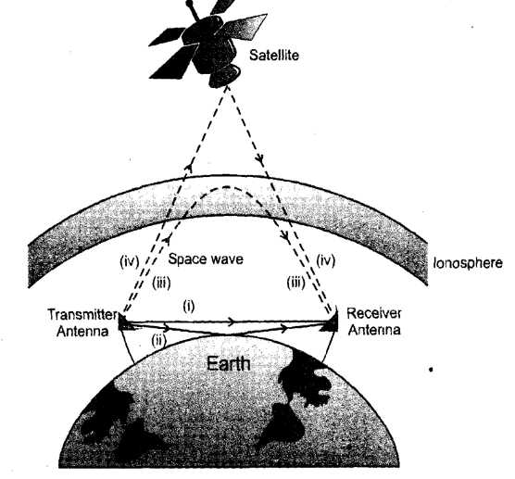
Data is transferred between Earth and Space, or between two distant places in Space, using space communication. Because of the long distances involved, this mode of communication involves the employment of cutting-edge technology. A full space communication system consists of two critical components: the ground segment (at least one base station on Earth) and the space segment (at least one spacecraft). The ground segment is in charge of duties like as relaying commands or data from Earth to the spacecraft, known as "uplink." It also receives data from spacecraft and satellites, known as "downlink," and may act as a mediator for data exchange between satellites. The space segment, on the other hand, consists of spacecraft or satellites orbiting the Earth.

Challenges of Space Communication
Space communication relies on a transmitter to encode messages onto electromagnetic waves through modulation, and a receiver to collect and decode those messages. The waves carrying the information travel through space from the transmitter to the receiver.
- NASA has a global network of antennas located on all seven continents to communicate with spacecraft. These ground stations are strategically positioned to ensure smooth communication as spacecraft passes overhead.
- Some NASA missions use relay satellites to transmit data to the ground. For example, the space station communicates through Tracking and Data Relay Satellites (TDRS), which forward data to ground stations in New Mexico and Guam. Similarly, the Mars 2020 Perseverance rover sends data through orbiters around Mars before it reaches Earth.
- NASA encodes data on different electromagnetic frequency bands, each with varying capabilities. Higher bandwidths can transmit more data per second, enabling faster data transfer. The agency is also exploring optical communications using infrared lasers.
- The data rates of missions depend on the bandwidth used. For instance, Apollo missions sent low-quality video from the Moon, while upcoming missions like Artemis II will transmit 4K ultra-high-definition video from lunar orbit.
- Latency poses a challenge in space communication. At Mars' closest approach, the delay in receiving messages is about four minutes, increasing to around 24 minutes at the greatest distance. Astronauts may need to wait several minutes for messages to reach mission control and receive responses.
- Interference can affect communication quality over long distances or through the atmosphere. Radiation from other missions, the Sun, or celestial bodies can also disrupt transmissions, potentially garbling the transmitted data.

PROPAGATION OF WAVES IN THE EARTH'S ATMOSPHERE
The Earth's atmosphere has a considerable impact on how electromagnetic waves propagate from one spot on the planet's surface to another. To better appreciate its impact on communication, consider the properties of the Earth's atmosphere, which can be thought of as a series of layers based on variations in temperature, air density, and electrical conductivity with height. The troposphere is the lowest layer of the Earth's atmosphere. The temperature in this layer drops with increasing altitude at a rate of around 6 degrees Celsius each kilometre. This results in a temperature range, with values at the equator around 290K and dropping to roughly 220K at higher altitudes near the tropopause. Variations in air density can also be found in the troposphere.
SPACE WAVE PROPAGATION
The VHF (Very High Frequency) radio wave band spanning from 30 MHz to 300 MHz is referred to as the space wave in space communication. There are two sorts of waves in the space wave category: direct waves and ground reflected waves, as shown in Figure. The direct wave mode is the most often utilized mode for antenna communication. The radio wave is propagated directly from the transmitting antenna to the receiving antenna without passing through the Earth's surface. As a result, the direct wave is neither attenuated or weakened as it travels, making it extremely effective at maintaining signal intensity over great distances. The ground-reflected wave, on the other hand, involves the radio wave bouncing off the ground.
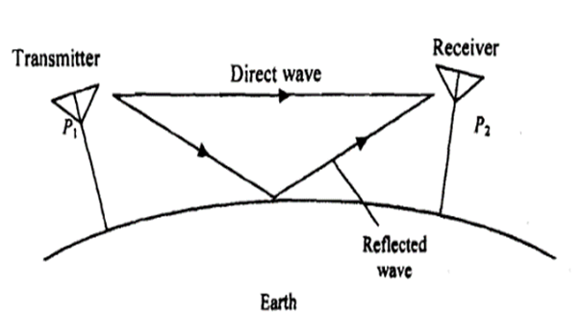
Abbreviations
EOS – EARTH OBSERVING SYSTEM
NEO – NEAR-EARTH OBJECT
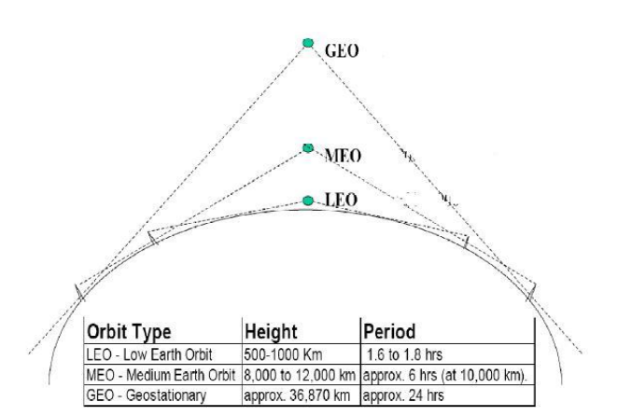
SATELLITE SYSTEM

1.LEO:
Because of its ability to escape attenuation produced by the Earth's surface, direct waves are the favored choice for many space communication applications. Communication signals can move effectively and consistently between sending and receiving antennas when using the direct wave. This efficiency provides smooth communication over long distances, making it important for a variety of space-related jobs and enabling seamless communication across large distances. Space missions, satellite communication, and other space-related operations can be successfully supported thanks to the direct wave's dependable transmission, boosting our ability to explore and communicate in space.
2.MEO:
Satellites in Medium Earth Orbit (MEO) orbit the Earth at altitudes ranging from 3,000 to 30,000 kilometres above the surface. These satellites are most commonly used in navigation systems, with GPS (Global Positioning System) being one of the most used. MEO satellites' strategic positioning enables them to efficiently send precise location information and navigation data to GPS receivers on Earth. MEO satellites find a balance between coverage area and signal precision by operating in this orbital range, making them critical components of modern navigation technology and enabling numerous location-based services and applications worldwide.
3.GEO:
Satellites in Medium Earth Orbit (MEO) orbit the Earth at altitudes ranging from 3,000 to 30,000 kilometers above the surface. These satellites are most commonly used in navigation systems, with GPS (Global Positioning System) being one of the most used. MEO satellites' strategic positioning enables them to efficiently send precise location information and navigation data to GPS receivers on Earth. MEO satellites find a balance between coverage area and signal precision by operating in this orbital range, making them critical components of modern navigation technology and enabling numerous location-based services and applications worldwide.
Medium Earth Orbit (MEO) satellites are a type of satellite that circles the Earth at altitudes of 3,000 to 30,000 kilometers. These satellites are crucial in navigation systems.

Satellite uplink and downlink Analysis and Design

Equivalent Isotropic Radiated Power (EIRP) is an important statistic in calculating link budgets for communication systems. It denotes the amount of power required by an isotropic radiator (a hypothetical antenna that radiates equally in all directions) to achieve the same power flux density as the actual transmitting antenna at a given distance. EIRP is commonly stated in decibels relative to one watt (dBW). It is calculated as the product of the transmitting antenna's input power and its gain in decibels (dB). As a result, EIRP (dBW) = Input Power (dBW) + Antenna Gain (dB). Losses occur along the path of any transmission link, some of which are constant. These losses must be taken into account when estimating the power received at the other end of the link.

Authors
Dr.Shalini.S
Sheela. S
Prathyusha. S
Syed Mezan Naimuddin
Akshay. D
Vivek. N
Affiliations
Dr. Shalini. S | Dept. Computer Science and Engineering
Sheela. | Dept. Computer Science and Engineering
Prathyusha. S | Dept. Aeronautical Engineering
Syed Mezan Nazimuddin | Dept. Aeronautical Engineering
Akshay. D | Dept. Computer Science and Engineering
Vivek. N | Dept. Aeronautical Engineering

Conclusion
In conclusion, satellite and space communication have revolutionized the way we interact with the world and understand the universe. These technologies have ushered in an era of global connectivity, enabling seamless communication and data exchange across vast distances. From telecommunications to disaster management, navigation to scientific research, and national security to environmental monitoring, satellites play a pivotal role in shaping various aspects of our modern lives. Satellite communication has connected people, businesses, and nations, transcended geographical barriers, and fostered global collaboration. It has empowered remote and underserved regions with access to essential services, driving economic growth and improving livelihoods. Additionally, satellites have become indispensable in disaster management, providing timely information and aiding humanitarian efforts during natural calamities.

REFERENCES

[1]. Wilbur L. Pritchard, Hendri G. Suyderhoud, Robert A. Nelson, “Satellite Communication Systems Engineering”, Prentice Hall/Pearson, 2007.
[2]. N. Agarwal, “Design of Geosynchronous Space Craft”, Prentice Hall, 1986.
[3]. Bruce R. Elbert, “Satellite Communication Applications”, Hand Book, Artech House Boston London,1997
[4]. Tri T. Ha, “Digital Satellite Communication”, II nd edition, 1990
[5]. Robert G. Winch, “Telecommunication Transmission Systems”, Mc Graw-Hill Book Co., 1983
[6]. Brian Ackroyd, “World Satellite Communication and earth station Design”, BSP Professional Books, 1990.
[7]. G.B.Bleazard, “Introducing Satellite communications“, NCC Publication, 1985.
[8]. M.Richharia, “Satellite Communication Systems-Design Principles”, Macmillan 2003.
[9]. Emanuel Fthenakis, “Manual of Satellite Communications”, Mc Graw Hill Book Co., 1984

