MSME: A NEW DIMENSION FOR EMPLOYBILITY IN 21st CENTURY

Dr.Samir Kumar Panigrahi

Post Doctorate Fellow MATS University, Raipur

Prof.(Dr.) K.P Yadav

Vice chancellor MATS university, Raipur

Abstract

India is known as a land of rural and semi urban area. More than 80% of total population lives in rural and semi urban area. Though India put her step in development path since 1991 (after introduction of LPG) but till now India is unable to put her foot print in path of developed nation. Since last decade, its economic development is a remarkable position within the world but till now India is facing a crucial problem like unemployment, and this problem create obstacle for India to become a developed country. In present situation the Micro, Small and Medium (MSMEs) plays an important role to solve the problem like unemployment. Here the researchers try to focus on the role of MSME towards generating employability in present scenario and also try to focus on two aspects like generating new entrepreneur as well as creating employment scope for semiskilled and non skilled people.
Keywords: MSME, Employment, Problems, Prospects

Introduction

In present situation MSME sector plays a vital role in Indian economy not only to create the industrialization process but also it create a positive atmosphere for generating vibrant , innovative entrepreneur as well as construct a developed path for job creation mechanism within the nation. If we see in a general sense The MSME producing a wide variety of goods and services to meet the consumer demand with the scope of 8 million peoples employment. MSME contribute near about 30% over all GDP to the whole economy. In present scenario MSME provide different scope to unemployed youth in different angle to become not only an entrepreneur but also job provider

for others. The different scopes are Financial support , up gradation of technology ,up to date quality assurance facility etc. it also create different skill based training scope for unemployed youth like product development , product designing, packing, market fore casting through different expert agency.

MSME Schemes in Present scenario:

Atamnirbhar Bharat is attractive scheme lunched by MSME to motivate educated young dynamic people to continue their creative business plans. Apart from this scheme Govt of India also lunch different plans like Market Promotion and Development Scheme (MPDA) Coir Vikas Yojana (CVY), Trade and Industry Related Fundamental Support Service (TRIFSS), Expert Market Promotion (EMP), Domestic Market Promotion (DMP) Credit Guarantee scheme (CGS) etc.

Review of Literatures:

C.B. Bhave (2010): Here the researcher clearly opined that MSMEs plays a vital role in most of the economies and consist of a lion part of the industrial process. Generally MSMEs are facing crucial problems financial deficit. As per the findings of researcher SME stock exchange will appear as a boon for MSME as it facilitate the scope of pool capital and improvement of credibility status.
SME.Chamber of India (2011): SMEs are now creating the atmosphere of much more opportunities than ever expansion and diversification across the sectors. In present scenario Indian markets are expand rapidly and entrepreneurs of India are making a remarkable improvement in different industries.
Vijay Kumar (2011): Here the researcher focused on issues relating to MSME sector like Lack of awareness, lack of opportunities for investment and recourse, lack of waste management capacity, lack of improvement in product design.
Willam.Stoever (2002): Here the researcher focused that india has always strategized foreign investment policies with the motive of being self reliant. India has always targeted to import only those items and products that not available in domestic market.

Objectives:

  - To show the actual existence status of MSME in India
  - Explore the role of MSME towards employability mechanism.
  - To explore the actual reason behind unsuccessful entrepreneurs in MSME units.

Research methodology:

This study is purely based on secondary data and that are collected from government report, newspaper, magazine, MSME department report, and other related published report. Here the data are put into the tabular form for clarity in interpretation.

Classification of MSME in India:

Table-1

S.L NO | Type of Enterprise | Investment | Turnover
1 | Micro Enterprise | Not more than Rs 1  crore | Not more than Rs 5  crore
2 | Small Enterprises | Not more than Rs .10  Crore | Not more than Rs 50  crore
3 | Medium Enterprise | Not more than Rs. 50  crore | Not more than Rs 250  crore

Estimated number of MSMEs state Wise Distribution:

Table-2 (In lakhs)

S.L No | State/UT | Micro | Small | Medium | Total MSME
1 | Andhra  Pradesh | 33.74 | 0.13 | 0.00 | 33.87
2 | Arunachal  Pradesh | 0.22 | 0.00 | 0.00 | 0.23
3 | Assam | 12.10 | 0.04 | 0.00 | 12.14
4 | Bihar | 34.41 | 0.04 | 0.00 | 34.46
5 | Chhattisgarh | 8.45 | 0.03 | 0.00 | 8.48

6 | Delhi | 9.25 | 0.11 | 0.00 | 9.36
7 | Goa | 0.70 | 0.00 | 0.00 | 0.70
8 | Gujarat | 32.67 | 0.50 | 0.00 | 33.16
9 | Haryana | 9.53 | 0.17 | 0.00 | 9.70
10 | Himachal  Pradesh | 3.86 | 0.06 | 0.00 | 3.92
11 | Jammu  Kashmir | 7.06 | 0.03 | 0.00 | 7.09
12 | Jharkhand | 15.78 | 0.10 | 0.00 | 15.88
13 | Karnataka | 38.25 | 0.09 | 0.00 | 38.34
14 | Kerala | 23.58 | 0.21 | 0.00 | 23.79
15 | Madhya  Pradesh | 26.42 | 0.31 | 0.01 | 26.74
16 | Maharashtra | 47.60 | 0.17 | 0.00 | 47.78
17 | Manipur | 1.80 | 0.00 | 0.00 | 1.80
18 | Meghalaya | 1.12 | 0.00 | 0.00 | 1.12
19 | Mizoram | 0.35 | 0.00 | 0.00 | 0.35
20 | Nagaland | 0.91 | 0.00 | 0.00 | 0.91
21 | Odisha | 19.80 | 0.04 | 0.00 | 19.84
22 | Punjab | 14.56 | 0.09 | 0.00 | 14.65
23 | Rajasthan | 26.66 | 0.20 | 0.01 | 26.87
24 | Sikkim | 0.26 | 0.00 | 0.00 | 0.26
25 | Tamilnadu | 49.27 | 0.21 | 0.00 | 49.48
26 | Telangana | 25.94 | 0.10 | 0.01 | 26.05
27 | Tripura | 2.10 | 0.01 | 0.00 | 2.11
28 | Uttar Pradesh | 89.64 | 0.36 | 0.00 | 89.99
29 | Uttarakhand | 4.14 | 0.02 | 0.00 | 4.17
30 | West Bengal | 88.41 | 0.26 | 0.01 | 88.67
31 | A & N Island | 0.19 | 0.00 | 0.00 | 0.19
32 | Chandigarh | 0.56 | 0.00 | 0.00 | 0.56

33 | Dadra Nagar  Haveli | 0.15 | 0.01 | 0.00 | 0.16
34 | Daman & Diu | 0.08 | 0.00 | 0.00 | 0.00
35 | Lakshadweep | 0.02 | 0.00 | 0.00 | 0.02
36 | Pondicherry | 0.96 | 0.00 | 0.00 | 0.96
All |  | 630.52 | 3.31 | 0.05 | 633.88
Source: All India MSME annual report 2022-2023

Interpretation:

This table gives the clear picture of MSME unit in different states of India with categorically on its size basis. Here it is clear that India is based on micro scale MSME unit. But small scale is very less as well as existence of medium scale MSME unit is very negligible even if 75 years of independence.

Number of MSMEs (Activity Wise)

Table-3 (in Lakhs)

Activity  Category | Rural | Urban | Total
Manufacturing | 114.14 | 82.50 | 196.65
Electricity | 0.03 | 0.01 | 0.04
Trade | 108.71 | 121.64 | 230.35
Other Services | 102.00 | 104.85 | 206.85
All | 324.88 | 309.00 | 633.88
Source: All India MSME annual report 2022-2023

Distribution of MSME Sector wise:

Table-4

Sector | Micro | Small | Medium | Total | Share (%)
Rural | 324.09 | 0.78 | 0.01 | 324.88 | 51
Urban | 306.43 | 2.53 | 0.04 | 309.00 | 49
All | 630.52 | 3.31 | 0.05 | 633.88 | 100
Source: All India MSME annual report 2022-2023

Distribution of MSMEs ownership Wise

Table-5

Sector | Male | Female | All
Rural | 77.76 | 22.24 | 100
Urban | 81.58 | 18.42 | 100
All | 79.63 | 20.37 | 100
Source: All India MSME annual report 2022-2023 Distribution of MSMEs ownership wise (Gender Basic) Table-6
Category | Male | Female | All
Micro | 79.56 | 20.44 | 100
Small | 94.74 | 5.26 | 100
Medium | 97.33 | 2.67 | 100
All | 79.63 | 20.37 | 100
Source: All India MSME annual report 2022-2023

Distribution of MSMEs social category wise

Table-7

Sector | SC | ST | OBC | Others | Not  Specify | Total
Micro | 12.48 | 4.11 | 49.83 | 32.79 | 0.79 | 100
Small | 5.50 | 1.65 | 29.64 | 62.82 | 0.39 | 100
Medium | 0.00 | 1.09 | 23.85 | 70.80 | 4.27 | 100
All | 12.45 | 4.10 | 49.72 | 32.95 | 0.79 | 100
Source: All India MSME annual report 2022-2023

Distribution of Employment by type of Enterprise in Rural and Urban area.

Table-8 (Numbers in lakhs)

Sector | Micro | Small | Medium | Total | Share (%)
Rural | 489.30 | 7.88 | 0.60 | 497.78 | 45
Urban | 586.88 | 24.06 | 1.16 | 612.10 | 55
All | 1076.19 | 31.95 | 1.75 | 1109.89 | 100
Source: All India MSME annual report 2022-2023

Distribution of workers by gender in rural & urban areas

Table-9 (Numbers in lakhs)

Sector | Female | Male | Total | Share (%)
Rural | 137.50 | 360.15 | 497.78 | 45
Urban | 127.42 | 484.54 | 612.10 | 55
Total | 264.92 | 844.68 | 1109.89 | 100
Share (%) | 24 | 76 | 100
Source: All India MSME annual report 2022-2023

Problems of MSME sector in India:

Lack of Finance Facility: In reality for starting a MSME unit, every entrepreneur depends on nationalized banks for funds. But in present situation, though every bank provides various schemes for entrepreneurs but that banks charge high interest rate and more documentation. That interest rate creates a burden over entrepreneur to sustain in competitive market.
Compete with Global brand: In present situation LPG fully effected in Indian market. So local product produced by MSME units always face difficulties to compete with global brand with a sensitive pricing practice.
Inadequate infrastructure: Though now MSME unit owners are improving rapidly in different angles but till now they are facing the problem like lack of infrastructure in comparison to other entrepreneur.

Less scope for acquiring Raw materials:

Though, the availability of raw material for MSME unit is organized by different government sectors but till now most of the MSME unit owner facing the problems like acquiring of raw materials in proper time in a basic price.

Non availability of modernized technology:

Though our nation now able to produce new technology based industrial tools and techniques but MSME unit holders till today unable to use modern technology based machines for their business unit due to financial and skilled workers deficiencies.

Unable to implement modern distribution system:

MSME unit owners are unable to use proper distribution system for their business unit due to less financial capability and very low market coverage.

Less awareness about recent business trend:

Till now more than 80% of MSME unit owners are less educated and they concern only in their business unit. They have very less knowledge on recent business trend and government practices etc.

Overall GDP contribution by MSME sector towards Indian Economy:

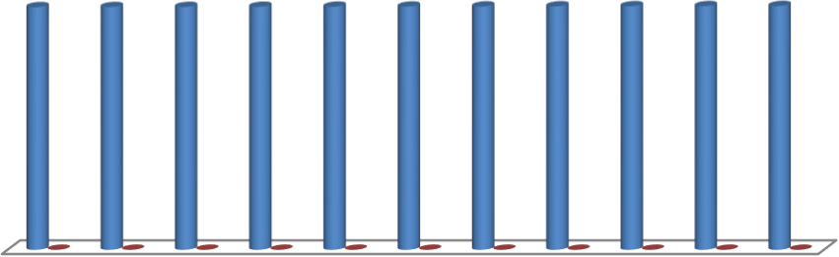
Chart Title
Financial Year GDP (%)
2012 2013 2014 2015 2016 2017 2018 2019 2020 2021 2022
30% 30.40%30.20%29.30%29.48%29.25%29.69%30.50% 30% 26.83%30.60%
1
2
3
4
5
6
7
8
9
10 11

Global Scenario on MSME:

The International Finance Corporation (IFC) estimates that 65 million firms, or 40% of formal micro, small and medium enterprises (MSMEs) in developing countries, have an unmet financing need of $5.2 trillion every year, which is equivalent to 1.4 times the current level of the global MSME lending. East Asia and Pacific accounts for the largest share (46%) of the total global finance gap and is followed by Latin America and the Caribbean (23%) and Europe and Central Asia (15%). The gap volume varies considerably region to region. Latin America and the Caribbean and the Middle East and North Africa regions, in particular, have the highest proportion of the finance gap compared to potential demand, measured at 87% and 88%, respectively. About half

Of formal SMEs don’t have access to formal credit. The financing gap is even larger when micro
and informal enterprises are taken into account.

Global Scenario on MSME:
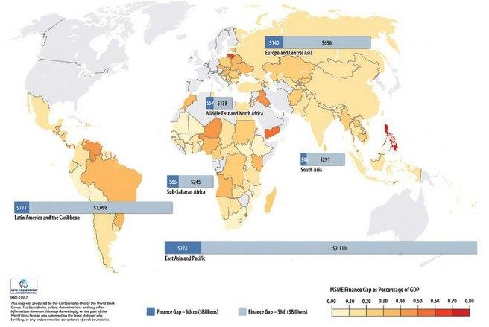

Findings:

In the above data analysis we found that though MSME sector improve significantly since last decade but till now it is unable to expand his full potentiality in terms of employability. Here we can clearly observe that MSMEs in India put their step in micro industry where as small and medium scales are very negligible existence in each and every state. Though it provide near about 30% GDP to the whole economy of our nation since last 10 years but it is not quite sufficient for our nation to become a developed nation. This is best time for MSME sector not only to put their effort for innovating new entrepreneurs to set up small and medium scale industries but also help and appreciate them in other kinds like financial, documentation, distribution system as well as provide suggestion regarding government rules and regulation.

Suggestions:

- MSME sector should focus on small and medium scale industrial set up.
- Central government as well as each state government should prepare plan and policies to encourage educated dynamic young youths to set up small and medium scale MSME units instead of searching jobs.
- Training facility must be touching to both rural urban area people those who are interested for MSME.
- Central government should impose policy through RBI for Banks towards simple documentation for MSME financial assistance.
- MSME sector should focus on development of distribution channel for MSME products.

Conclusion:
In present scenario MSME plays a vital role in Indian economy not only in terms of providing mass employment to both skilled and unskilled people but also provide near about 30% GDP to our whole nations economy since last 10 years. So here we can say the existence of MSME sector in India is in a stable position. For the development of this sector not only central government but also each every state government put their best effort through implementing new entrepreneurial schemes, imposing entrepreneurial based syllabus in higher education.

Reference:
- Annual Report 2022-2023, Govt of India, Ministry of Micro Small and Medium Enterprises.
- RBI report 2022
- Ministry of statistics and program implementation, Govt of India
- Dr. Sp. Mathiraj (2018) “Performance of MSME units in India” . National Conference on Prospects of Micro, Small & Medium enterprises (MSMEs) in Indian scenario , The American College , Madurai, February 2018.

