Batteries: The Renewable Energy Storage Bottleneck

Muskan Sharma

Indian Institute of Technology Mandi, Chemistry Department
Himachal Pradesh
muskansharma6685@gmail.com
Abstract
Carbon emissions are rising as a result of urbanization and a rapid increase of population rise, which causes climate change and global warming. The power sector is switching to alternative energy sources including solar power, wind power, and battery power-storage systems (BPSS), among others, due to an increase in the use of fossil fuels and their shortage. BESS is viewed as a potential solution to the global warming issue since it has some benefits over conventional energy sources, such as quick and consistent reaction, flexibility, friendly to the environment. An in-depth analysis of the battery energy-storage system is provided in this chapter. Theoretically having a substantially higher energy density than lithium-ion batteries, metal-air batteries are commonly promoted as a next-generation electrochemical energy storage option for grid energy storage or electric car applications.
Introduction
Rapid worldwide rises in population and greater urbanization are driving up energy demand, particularly in developing countries. Energy is a basic requirement for human social and economic progress, as well as improving human health and wellbeing. The ongoing use of nonrenewable fuel sources, such as natural gas, petroleum, and coal, is the direct result of rising energy demand. These have proven to be the world's major source of energy production accountable for human development over the years. They have significant downsides due to massive emissions of damaging air pollutants and also carbon dioxide, the most significant man-made climate-changing greenhouse gas. To enable the preservation and release of energy during off- and on-peak hours, energy storage devices must be linked with the renewable energy installations. Different battery types, including lead-acid, metal-air, and lithium-ion cells, have been employed for energy storage across time. These batteries have excellent power and energy density, which contribute to their comparatively strong performance traits.
Renewable energy and energy storage:
With a growing population and a shortage of fossil fuels, there is a critical need for a shift to renewable energy resources [1]. Due to this, many issues have arisen like environmental pollution, global warming etc. We have to convert to a cleaner, more sustainable, and ecologically friendly energy source in order to reduce our dependence on fossil fuels and greenhouse gas emissions. Renewable energy is derived from natural sources that replenish them self-faster than they are depleted. Sunlight and wind are two examples of such consistently replenished sources. Batteries, fuel cells, and super capacitors are examples of electrochemically based energy storage technologies that have received a lot of attention due to their long-life period, low environmental impact, and less costly than conventional storage systems [3]. A fuel cell is a device which generates electricity on electrochemical reaction. In fuel cell Hydrogen and oxygen are formed which together combines to produce electricity. When fuel cell combines with electrolyzer which convert an electrical energy into storable fuel. It provides clean energy and no carbon emission with high efficiency. It is similar with battery in functions, it does not require recharging. As long as fuel and oxygen are available it produces power. Battery is a device which contain two electrode one is cathode and another is anode. At anode loss of electrons take place and at cathode accepting of electrons by reduction take place. Supercapacitor are also energy storage devices where charge is stored in EDLC where electron transfer take place.
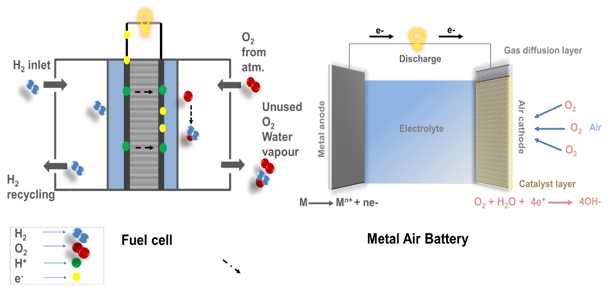
Fig 1.1 Energy storage devices Fuel cell and Metal air battery
Source: ACS Appl. Mater. Interfaces 2022, 18, 20418–20429
In Fig 1.2 Ragone Plot Energy storage devices are essentially defined by their energy density (the amount of energy stored per unit volume or mass) and power (the rate at which the energy may be provided) [4]. Capacitors have tremendous power but only hold modest quantities of energy. At the other end of the spectrum, there are fuel cells, which have a very high energy supply but quickly become ineffective under enormous power demands. Batteries can store a large amount of energy and maintain an energy density that is high for an extended period of time. On the Ragone plot, supercapacitors are located between capacitors and batteries. They providing a unique mix of high power and high energy.
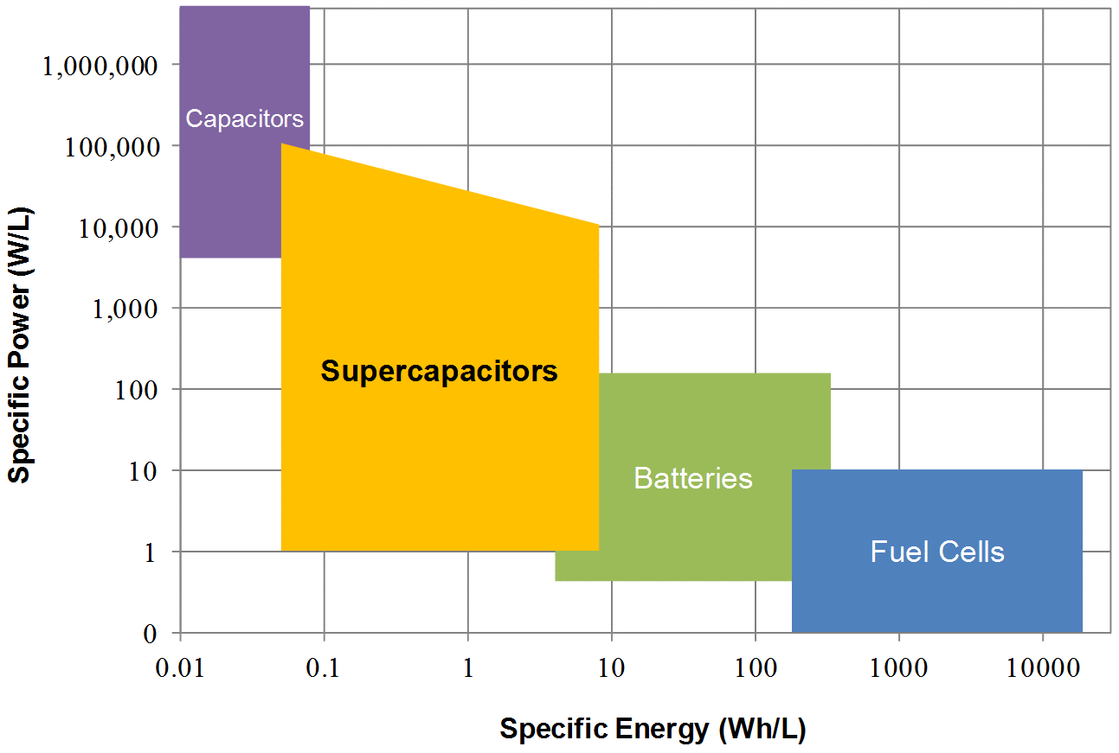

Fig 1.2: Ragone Plot
Source: CAP-X Supercapacitors Powering next generation products
Types of Storage
Depending on the storage technology utilized, energy storage devices can be classified as mechanical, electrochemical, chemical, electrical, or thermal [5]. Hydropower and wnidpower are under mechanical technology devices. Capacitor is an example of electrical technology and Electrochemical Technology exist in Batteries and Fuel cell work on the principle of electrical technology.
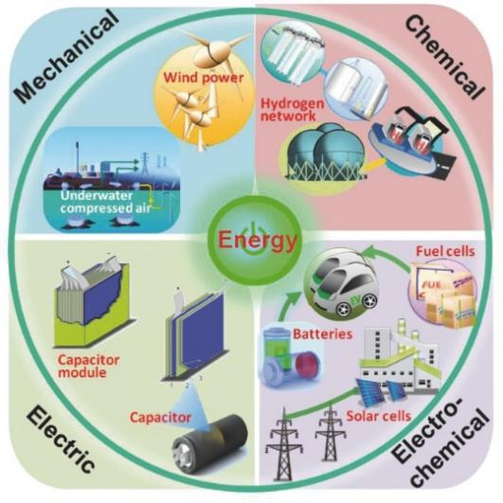

Figure 1.3: Different types of Storage Technologies
Source: Advanced Energy Storage Devices: Basic Principles, Analytical Methods and Rational Materials Design Copyright 2017, Advance Science
History of Batteries
Batteries have been used for a very long time because of their capacity to effectively convert and conserve electrical energy [10]. Alexandra Volta invents the first real battery system. He stacked both copper and zinc discs as electrode that were separated by salty water-soaked cloths. This one provided 0.76 V. When no. of cells is stacked together a high voltage is produced.
Then Lead acid batteries came, it is the rechargeable battery. This contain leas oxide as cathode and lead as anode and sulphuric acid as electrolyte. Lead anode releases an electron during discharge, which moves from lead anode to cathode through external circuit to generate current in the battery and change lead oxide into lead sulphate at the same time. Reverse current travels from cathode to anode during recharging.
There was an enormous increase in the production of batteries for energy storage after lead acid batteries, including alkaline batteries (Nickel-Hydrogen, Nickel-Metal Hydride), dry cell batteries etc. Then, the most economically viable battery has turned out to be Lithium ion batteries [11]. Since lithium has the lowest density of any metal, the highest electrochemical potential, and the highest energy-to-weight ratio. Its diffusion is accelerated by its tiny ions and low atomic weight, which suggests that it would be an excellent material for batteries. Professor M.S Whittingham created LIB by employing titanium disulfide as an anode and lithium-aluminum as a cathode along with an organic electrolyte [12]. He demonstrated that energy may be stored and released at the cathode of a rechargeable battery utilizing electrochemical intercalation and de-intercalation. Later, Prof. John B. Goodenough changed this cathode and created a new lithium-ion battery with a rock salt-type structure (ccp) [13]. Prof. Yoshino afterwards built a marketable LIB based on Prof. Goodenough's design. Later that in year 2019, all three were received the Nobel Prize in Chemistry for LIB.
Beyond Lithium -ion Batteries
LIB attains attention due to its high charge density and high-power capacity. They are maintenance-free; long cycle and has increased shelf life [15]. They posse’s low reduction potential and small in size so they are used in laptop, camera, calculators etc. There are some disadvantages of LIB: They are degraded at high temperature, some safety concern for lithium and its high cost. Then, metal air batteries are very effective and environmentally friendly, we switched to using them [16]. In contrast to LIB (which uses monovalent Li+ as the anode), MAB uses various metals, such as Al+3 and Zn+2, as an anodic material increasing the anode's ability to absorb electrons. Metal air batteries have properties which are intermediate of Lithium ion battery and fuel cell.
Metal Air Batteries
They have high theoretical energy density than lithium-ion battery. Metal-air batteries merge the design properties of traditional and hydrogen fuel cell batteries [17]. Common types of metal-air batteries consist of sodium air battery, magnesium-air battery, lithium air battery, aluminum air battery, and zinc air battery, among others. MABs contain a metallic anode and porous cathode. Cathodic material is generally porous in nature through which continuous supply of air take place. The metal of an anodic material can be of group 2, group 1 and transition metal [17]. Electrolyte may be aqueous and non-aqueous. Those metal which are degrade in presence of atmosphere, require non-aqueous elec
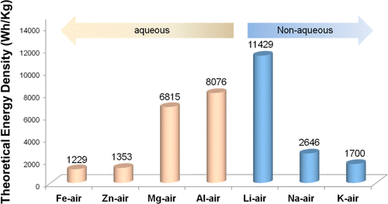
Figure 1.4: Comparison of Theoretical energy density of MAB’s in aqueous and non-aqueous electrolyte. Reprinted from reference Copyright 2017, American Chemical Society.

References

1. X. Zhang, X.-G. Wang, Z. Xie and Z. Zhou, Recent progress in rechargeable alkali metal-air batteries, Green Energy Environ., vol.1, no. 1, pp. 4-17,2016

2. Ahuja D, Kalpna V and Varshney P K, Metal air battery: A sustainable and low-cost material for energy storage, J. Phys.: Conf. Ser. 1913 012065

3. D. Linden and T. B Reddy, Eds., Handbook of Batteries, Third.McGraw-Hill,2010

4. https://www.cap-xx.com/resource/power-vs-energy/

5. HANDBOOK ON BATTERY ENERGY STORAGE SYSTEM, ASIAN DEVELOPMENT BANK,2018

6. https://phys.org/news/2015-04-history-batteries.html

7. Juqu T, Willenberg SC, Pokpas K, Ross N, Advances in paper-based battery research for biodegradable energy storage

8. M.A. Hannan et al., Battery energy-storage system: A review of technologies, optimization objectives, constraints, approaches, and outstanding issues, Journal of Energy Storage 42 (2021) 103023

9. ACS Appl. Mater. Interfaces 2022, 18, 20418–20429

10. Y. Li and H. Dai, “Recent advances in Zinc -air batteries,” Chem.Soc.Rev., vol.43, no.15, pp. 5257-5257,2014

11.M.R. Palacin, “Recent advances in rechargeable battery materials: A chemist’s perspective,” Chem.Soc.Rev., vol.38, no.9, pp. 2565-2575,2009

12. M.S. Whittingham, “The Role of Ternary Phases in Cathode Reactions,” J Electrochem. Soc., vol.123, no.3, pp.315-320,1976

13. A. Chakraborty et al, Layered Cathode Materials for Lithium -Ion Batteries. Review of Computational Studies on LiNi1-x-yCoxMnyO2 and LiNi1-x-yCoxAlyO2,” Chem.Mater., vol. 32, no. 3, pp.915-952,2020

14.Liu J, Wang J, Xu C, Jiang H, Li C, Zhang L, Lin J, Shen ZX, Advanced Energy Storage Devices: Basic Principles, Analytical Methods, and Rational Materials Design, Adv. Sci. 2017, 1700322

15. M. Liu, H. Gao, G. Hu, K. Zhu and H. Huang, Facile preparation of core shell Si@Li4Ti5O12 nanocomposite as large capacity lithium ion battery anode, J Energy Chem, vol.32, no,3, pp.915-952,2020

16. X.F. Lu, Y Chen, S. Gao, and X.W. Lou, Interfacing Manganese Oxide and Cobalt in porous Graphitic Carbon Polyhedrons Boosts Oxygen electrocatalyst for Zn-Air Batteries, Adv.Mater. vol31, no.39, pp.1-8,2019

17. Li Y, Lu J, Metal–Air Batteries: Will They Be the Future Electrochemical Energy Storage Device of Choice? ACS Energy Lett. 2017, 2, 6, 1370–1377

