Agriculture Equipment and Smart Technologies
Chelpuri Ramulu¹, Subhashisa Prharaj¹, M.L Meena¹, MS Kundu², Anupama Kumari² and Anshu Gnagwar³
1* KVK Madhopur, West Champaran, , DR.RPCAU Bihar
2* Director Extension Education, DR.RPCAU Bihar
3* KVK Parsauni, East Champaran, , DR.RPCAU Bihar

- Introduction
The objective of farm mechanization is to increase the yield, save cost of operation, reduce the drudgery for farming operation and timeliness of operations. However, when you engage in intensive or large-scale farming, At the same cost of an activity, you realize this farm machinery may accomplish more. You can greatly minimize the cost of production with the help of farm mechanization and also help in carrying out farming operations more rapidly and easier. This means you can do more work within a specified space of time. We aware that all crops are should sown in specific period, otherwise yield may affects negatively, honestly speaks most of the farmers could not sown timely because lack of labour. This issue can easily avoid by use farm mechanization by that farmer can get more yield. The inputs such as seeds, fertilizer and spray solution, etc, used in farming operations can reduce with the help of sowing machinery, fertilizer spreader and sprayers. The farm mechanization reduces drudgery as well as cost of operation by means of saving inputs and labour cost. Farm mechanization can also lead to lesser numbers of labour for farming opeartion. So the surplus manpower may be available for other economic activities. There are so many things to discus about benefits of farm mechanization for various agricultural crops.
We already aware about that rice and wheat are the major crops grown in Indian is about 76.5 Million hectares. So due to this scenario in this chapter we are going to discuss about some important agricultural equipment and latest technologies which gives benefit to major crops grown farmers of India in terms of saving in cost of operation and time.
2.1. Latest Mechanization options for paddy and wheat
The farming operations involved in both paddy and wheat crops are land preparation, levelling, sowing, transplanting in case of paddy crop, intercultural operations, fertilizer and spraying, harvesting, threshing, straw management and loading etc. The most important, drudgery and costliest among all the operations rice cultivation are transplanting and harvesting. The latest machinery used for paddy crop and wheat crop are laser land leveller, paddy wheat seeder, inclined plate planter, happy seeder, brush cutter operated paddy weeder, self propelled spraying machinery, combine harvester, straw baler, fertilizer spreader, etc. The below mentioned important and cost saving machinery will be explained in this chapter.
2.2. Laser land levelling
Laser land levelling equipment can make the contour the land for different irrigation practices. Laser leveling may boost crop yields by 10% to 20% while lowering water use by 20–30%. A topographic study and field preparation should be done prior to beginning the laser land leveling process. Zero-grade leveling for crop production is one method to increase irrigation efficiency. Fields with zero slope can be drained or flushed more quickly. A greater uniformity of flood depth is possible on level fields, using less water and reducing expenditures on pumping. While there may occasionally need to be some little land smoothing owing to field operations and weather conditions, the advantages of precision leveling of land last for many years.
Laser-controlled precision field leveling enhances cultivable area by roughly 3 to 5%, enhances crop establishment, maintains uniformity of crop maturity, and can boost water application efficiency by up to 50%. Rice yields rose by 61%, and wheat yields rose by 15%. Weed problems decreased, and weed management effectiveness increased.
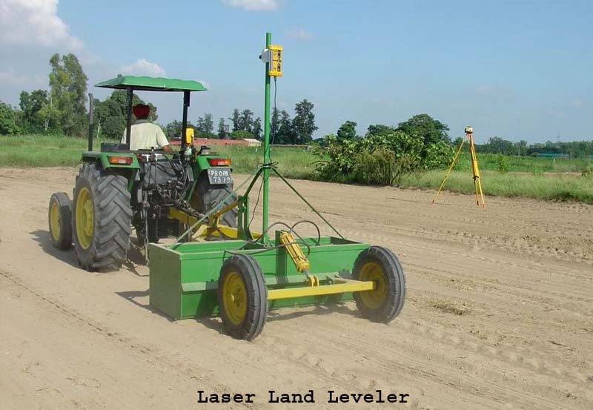
2.2.1 Components of laser land levelling system
The laser leveller works by using a laser (transmitter) to create a rapidly rotating beam parallel to the desired field plane. A sensor (receiving unit) mounted to a tractor picks up this beam and directs it toward the scraper unit. A hydraulic control system automatically adjusts the cut and fill levels based on the received signal and changes the scraper level accordingly. The scraper guiding is entirely automatic, eliminating any potential for operator error and enabling constantly precise ground leveling. There are two units in the setup, the platform-mounted laser transmitter, which is elevated. When it quickly rotates, the laser light is sent in a circle similar to a lighthouse, but because it is a laser, it stays in a circle. A laser-controlled land leveling system consists of the following five major components: (i) Drag bucket (ii) Laser transmitter (iii) Laser receiver (iv) Control box (v) Hydraulic system.
2.3. DSR Machinery
In India, the technique of direct sowing rice is quite old. Farmers completely do away with seedling nursery preparation and transplanting in rain-fed regions. Direct Seeded Rice (DSR) production is gaining momentum with the creation of some enhanced cultivars and the advancement of efficient weedicides. Farmers are currently disseminating dry paddy seeds in finely ground soil as they gradually embrace the DSR (Direct Seeded Rice) technology. When seeds are spread into the soil by tillage machinery, they are mixed with the soil and dispersed at varying depths in a haphazard pattern, leading to poor seed germination and subsequent poor crop establishment. The DSR makes several recommendations, such as the leveling of the field and the proper application of pre-emergence and post-emergence herbicides. If farmers heed the aforementioned advice before going DSR, they will benefit from DSR.
2.3.1 Rice-Wheat Seeder
The Rice-Wheat Seeder machinery is able to regulate the seed rate and plant the seeds at the required depth while maintaining an appropriate plant-to-plant spacing of 8 to 15 cm within the row. This feature of the machine enables users to sow paddy in clearly defined rows that are 20 cm apart, giving farmers the possibility to weed between two adjacent rows using mechanical weeding tools. This machine can cover 1 acre/day of land with help of two farm labour. The cost of machine is ranging from Rs. 8000-9000. This type technology well suited for very small farmers who cannot afford high price of machine. By using this technology in paddy crop farmer can save around Rs. 6500-8000 for 1 acre DSR compared to conventional practice till the time of transplanting.
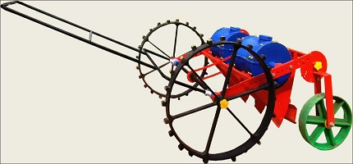

2.3.2 Inclined plate planter

A multicrop planter is planter is used for growing bold and small seeds that traditional drill cannot successfully sow.Drilling rice seeds into a fine seedbed at a depth of 24 cm can be used for dry seeding.Due to reduced puddling and longer irrigation intervals, the direct seeded paddy conserves roughly 25% of irrigation water.When compared to conventional puddled transplanted rice, direct sown paddy resulted in a net saving of Rs. 15,000/ha in crop establishment.A frame with a tool bar, modular seed boxes, furrow openers, and a ground drive wheel system make up the Planter.For sowing under dry soil conditions, shoe design furrow openers ensure deeper placement of seeds in the moist zone. Through a chain and sprocket system, the ground driving wheel transmits power to the seed metering mechanism. The first compartment of the seed box is loaded with seeds. To maintain a consistent seed rate, the flow of seeds into the seed metering compartment is controlled by altering the angle of the seed box. The most appropriate seeding rates for hybrids are 8–10 kg/ha and 20–25 kg/ha for coarse grains when using an inclined plate planter. This machine has provisions for lowering seed rate as well as the ability to maintain proper spacing (20 cm). A larger seed rate (25–30 kg/ha) is necessary for broadcasting. For effective germination, seeding depth is crucial. If you want your crop to stand at the desired level, keep the depth under 3 cm. Because the soil moisture in the upper layer dries out quickly, placing seeds below 3 cm has a negative impact on the dynamics of seed emergence. By seeding rice at the right point, this method lowers the amount of labor required, the amount of input needed, the amount of money needed, and saves time. Transplanted rice takes 7–10 extra days to mature. The cost of machine starts from Rs.80000 and cost of operation is about 1200 Rs/acre.
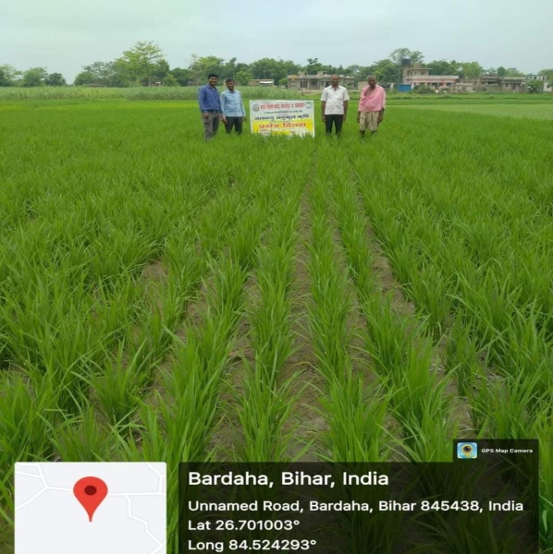
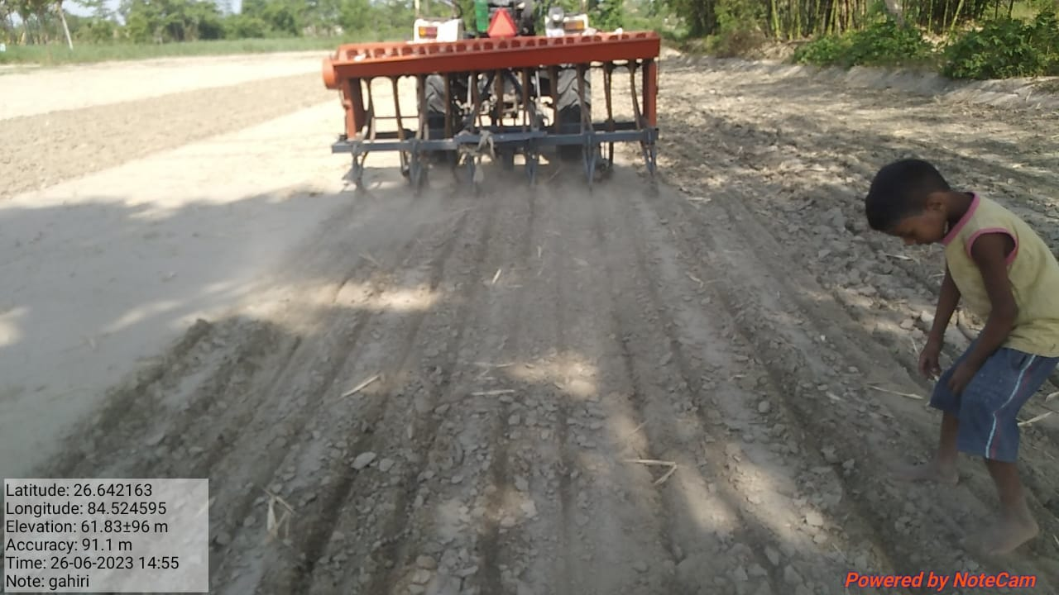
Inclined Plate Planter DSR technology Paddy crop
2.4 Happy seeder
A Happy Seeder is a no-till planter that is pulled by a tractor and sows the seeds directly into a rice field that has just been harvested by a combine. It has a three-point linkage connection and is driven by the tractor's PTO. It has a flail baldes and a zero-till drill that enable new crops to be sown in the leftovers of previous crops. The straw management rotor is equipped with straight blades of the flail type that are used to chop the stubbles that come into touch with the sowing tine. It spreads the crop's leftovers as mulch across the field that has been sown. In North India, it is primarily used to sow wheat after the paddy harvest. After several investigation it is said observed that costs for sowing of wheat about 50-60% lower with happy seeder than with conventional sowing. The initial cost of machine is about 1.5 Lakh. The cost of opeartion of sowing of wheat by using happy seeder around 1200-1400 Rs/acre if a farmer hire happy seeder from nearby krishi vigyan kendras of north western states of India.
2.5 Self propelled sprayer
The sprayer consists of a light weight power unit and a spraying unit. The power unit has 3.75 kW diesel engine. It has two narrow rubber wheels which are powered from the engine through gears and chains. The ground clearance of the machine is 500 mm. A third wheel is also provided at the rear which acts as a support. The spray unit consists of a tank of 100 l capacity, roller type spray pump and a boom with 12 nozzles. The spraying boom has been mounted on the power unit through a canopy frame in such a way that spraying is done at the rear of the operator so that spray solution does not come on the operator. Provision has also been made in the mounting frame to adjust boom height from 600 mm to 1300 mm to suit different crops. The nozzle spacing is kept at 500 mm which can be adjusted to suit different types of nozzles and applications. A provision has also been made to adjust the track width from 900 mm to 1050 mm. Evolution of the machine The light weight boom sprayer on self propelled power unit was a felt need of wheat and vegetable growing farmers to complete the operation timely. The initial trials of sprayer upto 20 kg/cm2 pressure was carried out at Research farm which gave uniform and effective spraying. The sprayer covered a width of 7 m in a single pass. The fuel consumption varied from 0.5 - 0.6 l/h. For spraying in wheat crop at farmer’s fields, boom was adjusted at a height of about 600 mm from the ground. In order to make use of the same power source for spraying on paddy, a spray boom attachment was developed. The spray boom is attached to the sprayer through a long flexible pipe. The boom has 14 nozzles at a spacing of 500 mm. The boom was carried on the shoulders by two operators. The field capacity varied from 0.6 - 0.8 ha/h for spraying in paddy crop.
2.6 Straw chopper cum incorporator
The adjustable frame, the incorporator, and the straw chopper were all merged in the straw chopper cum incorporator machine. The processed paddy residues will be included using an incorporator with L-type blades, and the straw chopper has inverted gamma-type blades. In a single pass, this machine cuts, chops, and incorporates straw. By speeding up the decomposition of paddy waste and adding it to the soil, soil health would be enhanced. The machine gathers the remaining combing stubbles, cuts them into bits, and spreads them on the ground all at once. The chopped and scattered stubbles were simply buried in the soil and decomposed following watering using a single rotavator or disc harrow operation. The rice straw chopper-cum-spreader performs admirably in both conditions of loose and stand stubble. This device's main function was to reduce the size of the straw and chaff came from the combine's straw walker and filter before redistributing them throughout the harvested field.
3.0 Conclusions and recommendations
The conclusions drawn from this chapter is above mentioned machinery are cost saving, environment friendly and most useful machinery for farmers. We can recommended that farmers to use above cost saving machinery and also recommend to agriculture allied sectors to promote above discussed machinery for paddy and wheat cultivation.
References
- Bhatt R, Sharma M (2009) Laser leveller for precision land levelling for judicious use of water in Punjab,Extension Bulletin, Krishi Vigyan Kendra, Kapurthala, Punjab Agricultural University, Ludhiana.
- https://icar.org.in/content/profitable-paddy-cultivation-through-direct-seeding-technology-rice-wheat-seeder-0
- Ramulu, C., Pateriya, R.N., Naik, M.A. et al. A residue management machine for chopping paddy residues in combine harvested paddy field. Sci Rep 13, 5077 (2023). https://doi.org/10.1038/s41598-023-32148-9
- Raushan Kumar1 , Sachin Chaudhary2 and Rajat Arya (2022). Laser Land Leveler: A Technology for Resource Conservation in India. Just Agriculture.Vol.2 Issue-8, APRIL 2022 (e-ISSN: 2582-8223)
- Self propelled light weight boom sprayer a success story. All India Coordinated Research Project on FARM IMPLEMENTS AND MACHINERY Central Institute of Agricultural Engineering Nabi Bagh, Berasia Road, Bhopal - 462 038 (M.P.) India
- Sidhu HS, Singh M, Singh Y, Blackwell J, Singh V, Gupta N. Machinery development for crop residue management under direct drilling, 2015.

