Wearable Safety device for Special Children
Dr.A.Sivasangari
Associate Professor, Department of ECE, GMR Institute of Technology, Andhra Pradesh, India
*sivasangari.a@gmrit.edu.in

ABSTRACT
In these days with the advancement of technology, it is proposed to design a wearable safety device for special children that works on our finger tips by using IOT Technology. The major advantage of this device is that it wearable and it is low cost. The main aim of this device is that it can alerts the parents when a quick conversation is needed for the special children during crisis. This device also helps parents to locate their special children by requesting a message from their mobile. This device is constructed by using Arduino NANO, GSM module and GPS module. GPS module helps in locating the precise position of the special children and the GSM module helps in sending the locality of the children to the parent’s mobile.
Keywords: Arduino NANO, GSM module, GPS module, Internet of Things
INTRODUCTION
The term "Internet of Things System" (IOT) describes a collection of hardware and software that is permanently connected to the Internet using real-world sensors and actuators. IOT comprises a wide range of gadgets, including automated homes, wearable technology, and even human implants. Smartphones are also included, which are increasingly utilized to measure their surroundings. Wireless sensor networks that monitor the weather, flood protection, tides, and others are similar. The demand for child safety is growing, especially in light of the possibility of a youngster becoming lost in densely populated regions, which is what spurred the development of this wearable. This initiative focuses on the crucial idea that those close to a lost kid may assist them and play a role in their recovery.

Today's wearables are primarily designed to give parents Wi-Fi and Bluetooth access to the child's whereabouts. However, it appears that Wi-Fi and Bluetooth are relatively poor sources for information transfer. Because SMS has a lower failure rate than Wi-Fi and Bluetooth, it is intended to be used as the means of communication between the wearable devices of the parent and kid. The Arduino Nano microcontroller board, based on the ATmega328P, will serve as the work's operating system, and the Arduino GSM shield will handle the GSM network-based SMS, call, and internet connectivity functionalities. Additionally, extra modules are used to reveal the child's position right now.
METHODOLOGY
This work describes the safe and secure electronic device for special children which comprises of an Arduino Nano, GSM module, GPS module and a push button shown in fig 1. A push button is placed on the device. If special children presses the button then the location of the kid is sent to the parent’s mobile via GSM. It indicates that the kid is in danger and the parent can take an appropriate measure in order to save the kid.
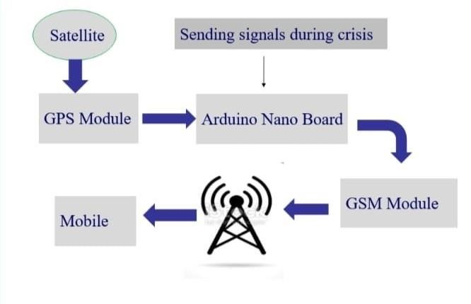
Fig.1 Block diagram of working of device
The Arduino Nano receives a message whenever the user sends a signal (pressing push button) during the crisis. Then GPS and GSM modules will be activated, GPS module will track the location from corresponding satellites and sends the location in the form of message through GSM to the respected mobile. In the same way, whenever the guardian or parent think that their child was in crisis, they can send a message request to the device, then the device reacts to the request and send the location of the current device to the requested mobile number. The working model of this device majorly consists of GSM, GPS and Arduino Nano. SIM800L is a tiny cellular module that supports voice and data conversations, SMS services and GPRS transfer. It offers long range communication and is inexpensive. When the power is connected, the module starts up, looks for a cellular network, and logs in automatically. A SIM800L GSM cellular chip from SimCom powers the module's core functionality. The chip is a perfect choice for direct LiPo battery supply because its operational voltage ranges from 3.4V to 4.4V. All of the SIM800L GSM chip's required data pins are separated out into 0.1 pitch headers. This comprises the pins necessary for using UART to communicate with a microcontroller. The module enables Auto-Baud detection and baud rates between 1200bps and 115200bps. For any audio or data transmission, as well as some SIM instructions, the module must be used with an antenna. So choosing an antenna might be quite important. SIM800L module can have an antenna added in one of two methods. The first one, a Helical GSM antenna, often attaches directly to the PCB's NET connector and is included with modules. A 3dB GSM antenna and a U.FL to SMA converter make up the second. On the top-left corner of the module, there is a little UFL connection that this antenna may snap into. This kind of antenna performs better and enables you to house your module within a metal casing so long as the antenna is outdoors the condition of your cellular network. A satellite-based navigation system with at least 24 satellites is called the Global Positioning System (GPS). A u-blox NEO-6M GPS chip serves as the module's brain. It has a maximum tracking sensitivity of -161 dB and can monitor up to 22 satellites on 50 channels while using just 45 mA of supply current. Additionally, the u-blox 6 positioning engine offers a Time-To-First-Fix (TTFF) of less than one second. The chip's Power Save Mode is among its greatest features (PSM). By selectively turning ON and OFF specific receiver components, it enables a decrease in system power usage. This significantly lowers the module's power consumption to just 11mA, making it appropriate for power-sensitive applications like GPS wristwatches. The NEO-6M GPS chip is divided into "0.1" pitch headers for the appropriate data pins. This comprises the pins necessary for using UART to communicate with a microcontroller. Without a battery, the GPS always starts cold, which prolongs the time it takes to establish a GPS lock. The battery maintains data for up to two weeks without power and is automatically charged when electricity is introduced. Any type of communication using the module needs an antenna, which is the patch antenna module, which has a -161 dBm sensitivity. GPS is made up of four pins: Vcc, Tx, Rx, and Gnd. Vcc is linked to Arduino's 5v, TX pin is attached to its fourth pin, Rx is connected to its fifth pin, and Gnd is connected to its ground via a resistor shown in fig 2.
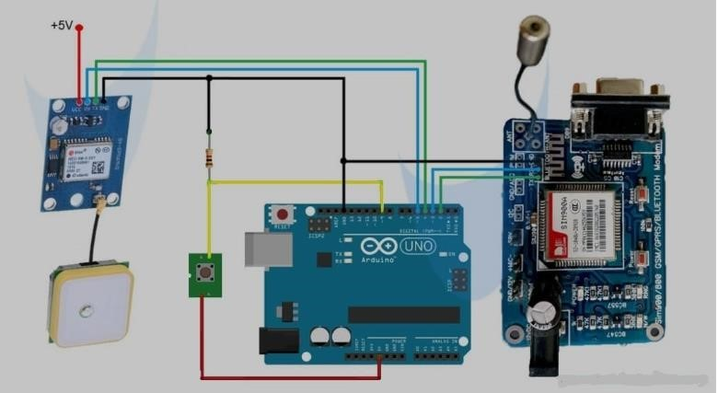
Fig.2: Connection diagram

RESULTS AND DISCUSSIONS
The experimentation with the suggested hardware design and the Android application is presented in this part along with the findings. The GSM module is initially checked to make sure it is correctly connected and set up. After the working of device, the results are shown in below fig 3 and the responses are shown in fig 4.
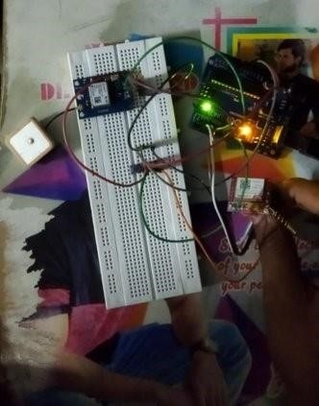
Fig.3: Interfacing components

Fig.4: Response of the device
When the latitude and longitude are searched in location app like google maps, the location is shown in below fig 5.
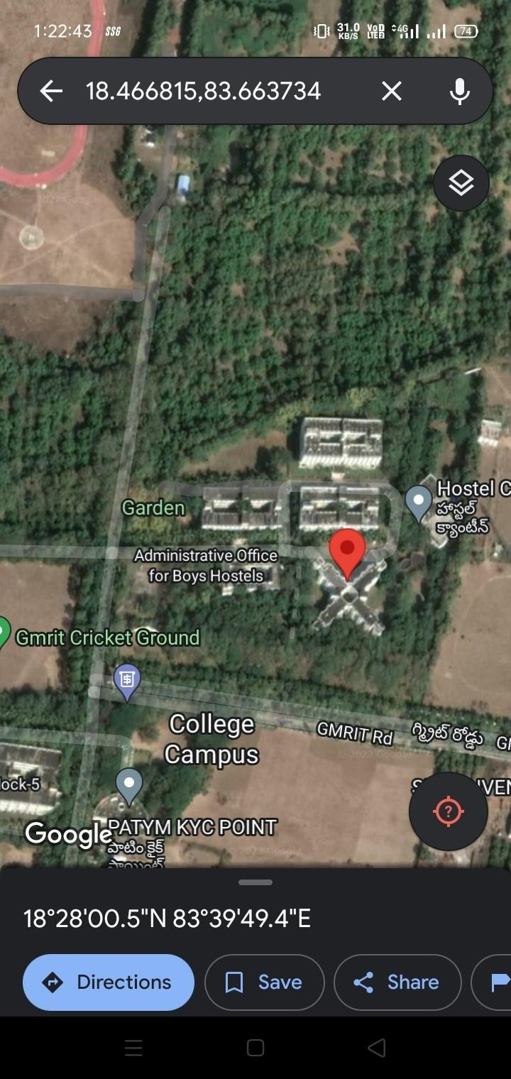
Fig.5: Obtained Location
CONCLUSION & FUTURE SCOPE
The proposed child safety gadget intends to give exceptional children total protection in contemporary situations. In order for the user to submit their location during a critical situation, the Location is employed as a unique identifier for the user. SMS mode is incorporated into the architecture for full security, preventing information from being sent from unreliable sources and preventing mishaps. Text messaging makes sure that the victim's immediate family and the police are informed of their current whereabouts. In this work, a smart gadget prototype for children's safety is shown; performance indicators must be taken into account for future analysis to demonstrate its effectiveness.

REFERENCES
1. B. Ranjeeth, B. S. Reddy, Y. M. K. Reddy, S. Suchitra and B. Pavithra, "Smart Child Safety Wearable Device," 2020 International Conference on Electronics and Sustainable Communication Systems (ICESC), 2020, pp. 116-120, doi:
10.1109/ICESC48915.2020.9156001.
2. International Journal of Innovative Technology and Exploring Engineering (IJITEE) ISSN: 2278-3075, Volume-8 Issue-8 June, 2019 1791 Published By: Blue Eyes Intelligence Engineering Retrieval Number H6836058719/19©BEIESP & Sciences Publication Smart IOT Device for Child Safety and Tracking M Nandini Priyanka, S Murugan, K N H Srinivas, T D S Sarveswararao, E Kusuma Kumari.
3. U. Chowdhury et al., "Multi-sensor Wearable for Child Safety," 2019 IEEE 10th Annual Ubiquitous Computing, Electronics & Mobile Communication Conference (UEMCON), 2019, pp. 0968-0972, doi: 10.1109/UEMCON47517.2019.8992950.
4. Z. Gao, H. Guo, Y. Xie, Y. Luo, H. Lu and K. Yan, "ChildGuard: A Child-Safety Monitoring System," in IEEE MultiMedia, vol. 24, no. 4, pp. 48-57, October-December 2017, doi: 10.1109/MMUL.2017.4031309.
5.F. Haider and G. Shaker, "Wearable-free wireless fall detection system," 2017 IEEE International Symposium on Antennas and Propagation & USNC/URSI National Radio Science Meeting, 2017, pp. 2457-2458.
6.T. Elakkiya, "Wearable safety wristband device for elderly health monitoring with fall detect and heart attack alarm," 2017 Third International Conference on Science Technology Engineering & Management (ICONSTEM), 2017, pp. 1018-1022, doi:
10.1109/ICONSTEM.2017.8261318.
7. B. Dorsemaine, 1. P. Gaulier, 1. P. Wary, N. Kheir and P. Urien, "Internet of Things: A Definition and Taxonomy," Next Generation Mobile Applications, Services and Technologies, 2015 9th International Conference on, Cambridge, 2015, pp. 72- 77.
8. H. Moustafa, H. Kenn, K. Sayrafian, W. Scanlon and Y. Zhang, "Mobile wearable communications [Guest Editorial]," in IEEE Wireless Communications, vol. 22, no. 1, pp. lO-l1, February 2015.
9. S. Nasrin and P. 1. Radcliffe, "Novel protocol enables DIY home automation," Telecommunication Networks and Applications Conference (ATNAC), 2014 Australasian, Southbank, VIC, 2014, pp. 212-216.
10.F. A. Silva, "Industrial Wireless Sensor Networks: Applications, Protocols, and Standards" in IEEE Industrial Electronics Magazine, vol. 8, no. 4, pp. 67-68, Dec. 2014.
11.Jun Zheng; Simplot-Ryl, D.; Bisdikian, c.; Mouftah, H.T., "The internet of things [Guest Editorial]," in Communications Magazine, IEEE , vo1.49, no.ll, pp.30-31, November 2011 doi: 10.1109/MCOM.2011.6069706
12.K. Braam, Tsung-Ching Huang, Chin-Hui Chen, E. Montgomery, S. Vo and R. Beausoleil, "Wristband Vital: A wearable multi-sensor microsystem for real-time assistance via low-power Bluetooth link," Internet of Things (WF-IoT), 2015 IEEE 2nd World Forwn on, Milan, 2015, pp. 87-9l. doi: 10.l109/WF-IoT.2015.7389032
13."Digital parenting: The best wearables and new smart baby monitors. The latest smart baby monitors and connected tech for your peace of mind,'Tech. Rep., 2015. [Online]. Available: http://www.wareable.com/parenting/the-best -wearable lesbabies-smart-babymonitors.
14."WiFi and WiMAX - break through in wireless access technologies," Wireless, Mobile and Multimedia Networks, 2008. lET International Conference on, Beijing, 2008, pp. 141- 145.
15.A. Badamasi, "The working principle of an Arduino," Electronics, Computer and Computation (ICECCO), 2014 11th International Conference on, Abuja, 2014, pp. 1-4.
16.N. N. Prince, "Design and implementation of microcontroller based short message service control system," Internet Technology and Secured Transactions (ICITST), 2013 8th International Conference for, London, 2013, pp. 494-499.
16.A. Anastasiou, C. Tsirmpas, A. Rompas, K. Giokas and D. Koutsouris, "3D printing: Basic concepts mathematics and technologies," Bioinformatics and Bioengineering (BIBE), 2013 IEEE 13th International Conference on, Chania, 2013, pp. 1-4.

