The Evolution of Corporate Social Responsibility in India
CH.VIJAYALAKSHMI, Assistant professor
TJPS COLLEGE, Guntur.
E mail :- vijayalakshmich2434@gmail.com
Ph no:- 8186006584
Abstract
Corporate social responsibility (CSR) is the idea that businesses voluntarily choose to make improvements to society and the environment. It is the idea that businesses voluntarily incorporate social and other positive issues into their operations for the benefit of their stakeholders and society at large. By raising the likelihood of being seen by customers, CSR encourages initiatives to make the world a better place and enhances society's perception of itself. CSR may assist your business in setting itself apart from rivals if it participates in communities of all types. The CSR Policy outlines the tasks that businesses must do and the funds that they must allocate by Annex VII of the law. A lot of businesses, like TATA and Birla, donate to his CSR. The law creates that Indian businesses are required to adopt a corporate social responsibility (CSR) culture that compels them to create CSR policies and invest money in initiatives that promote social good. The current study focuses on how businesses support society and act responsibly toward the nation despite numerous difficulties.
keywords:-
Corporate Social Responsibility, Stakeholders, Communities, Business, CSR Policy, Consumers, Competition.

INTRODUCTION:-

With the 2013 revisions to the Companies Act, India became the first nation in the world to make Corporate Social Responsibility (CSR) mandatory in April 2014. Companies with net assets of 5 billion rupees (US$70 million) or more, annual sales of 10 billion rupees (US$140 million), and net profits of 50 million rupees (US$699,125) or more are required to spend 2 percent of their average net profit over three years on CSR under the proposed amendments to the Companies Act of 2013. Before the Companies Act 2013 was passed, her CSR in India was seen as a charitable endeavor. According to Indian tradition, regardless of the corporation's financial health, all firms were seen to have a moral obligation to actively participate in upholding their social commitments. India is the first nation to have passed legislation requiring the implementation of CSR initiatives under the new Companies Act of 2013 and reporting on CSR initiatives. A new age of CSR in India is now underway. Previously, if a business did not use the whole CSR budget in a given year, it may carry over that money and use it in addition to the funds from that year in the next fiscal year.
The legislation's CSR amendments mandated that the corporation transfer any unused CSR contributions throughout the fiscal year to the fund specified in Annex VII of the law. Three years must pass after the transfer date before using this money. If not, it must be transferred to one of the approved funds.
Companies have utilized corporate social responsibility, or CSR, as a management concept for decades to give back to society. CSR emerged in the early 1950s and is mostly a twentieth-century phenomenon. Although CSR has grown in popularity recently, it has its roots in the Industrial Revolution and was used by ethical businesses more than a century ago. 'Corporate social responsibility' Howard Bowen, an American economist, coined the term "responsibility" in his 1953 book, "The Businessman's Social Responsibilities." He is recognized by many as the "father" of CSR.

CSR trends in India:-
Since the mandated CSR laws went into effect in 2014, Indian businesses have dramatically boosted their CSR investment. According to the research, businesses contributed $1 billion to CSR projects in 2018 and spent 47% more than they did in 2014–2015.
In addition, CSR donations to the Prime Minister's Relief Fund surged by 139% last year. Listed Indian firms have invested 100 billion rupees (US$1.4 billion) in a variety of initiatives, including education programs, skill development, social welfare, health care, and environmental preservation.
According to the CSR Act, businesses having net assets exceeding Rs. 50 crore are required to invest 2% of their average net profit over the previous three years in CSR initiatives. India Co. spent Rs 14.558 billion on CSR initiatives in 2021–22, a small amount less than the Rs 14.615 billion spent the previous year. However, a study of CSR expenditure by NSE-listed businesses indicated that there are now 1,278 companies in the industry, up from 1,251 the year before.
Figure:- 1 CSR expenditures per year
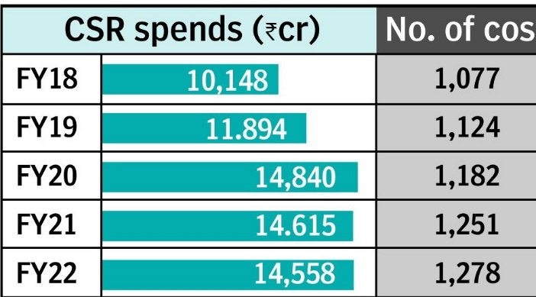

Examples of CSR in India:-
Group Tata
The Indian conglomerate Tata Group oversees several CSR initiatives, the majority of which focus on eradicating poverty and enhancing communities. The business focuses on women's empowerment, income generation, rural community development, and other community service program activities through self-help organizations. The Tata Group supports several institutions through grants and gifts in the area of education. The creation of infrastructure including hospitals, research facilities, educational institutions, sports academies, and cultural centers promotes economic empowerment in addition to agricultural programs, environmental protection, the provision of sports scholarships, and other initiatives.
Ultra Tech Cement
The largest cement business in India, Ultra Tech Cement, is involved in social programs in 407 villages all across the nation to foster sustainability and independence. His CSR initiatives are mostly focused on infrastructure, education, health, and family welfare programs and eco-friendly lifestyles.
The business coordinates medical clinics, immunization campaigns, sanitation campaigns, registration campaigns, plantation efforts, water conservation campaigns, industrial training programs, and organic agricultural initiatives.

Mahindra and Company
K.C. was created by Indian carmaker Mahindra & Mahindra (M&M). The Mahindra Educational Trust was founded in 1954, and the Mahindra Foundation for the Promotion of Education was created in 1969. The company's primary area of concentration is on educational initiatives that support communities that are economically and socially underprivileged
His company's CSR program funds projects for disaster assistance, rural healthcare, livelihood training, and water conservation. M&M runs initiatives including Nanhi Kali, which prioritizes females' education, Mahindra Pride School, which offers industrial training, and Lifeline Express, which provides healthcare in rural regions.

Group ITC
The ITC Group, a conglomerate with interests in fast-moving consumer products, agribusiness, information technology, and packaging, has concentrated on developing environmentally friendly initiatives and sustainable living. The corporation has been able to create sustainable lives for 6 million individuals as a result of its CSR initiatives.
With participation from 40,000 communities and more than 4 million farmers, their e-choupal initiative attempts to link rural farmers to online markets where they may source their goods. Its projects for agricultural and social forestry aid farmers in converting fallow land into pulp plantations. For more than 40,000 women in rural regions, social empowerment initiatives using microenterprises and loans generate sustainable livelihoods.
Figure :- List of Permitted Activities To Be Included under Schedule VII of the Companies Act, 2013

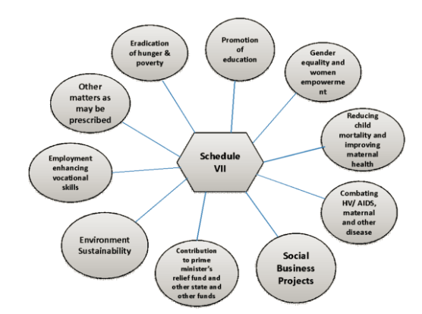

CSR activities:-
Contribute to Swach Bharat Kosh, a program started by the government to end poverty, starvation, and malnutrition as well as to advance preventative health care, sanitation, and access to clean water.

Projects aimed at improving livelihoods as well as improvements to special education, employment, and women's, children's, senior citizens, and people with disabilities' vocational skills.

3. Implement policies to advance gender equality, create shelters and hostels for women and orphans, nursing homes, daycare facilities, and other comparable facilities for the elderly, and lessen disparities between socially and economically disadvantaged groups.

4. Maintaining environmental sustainability, ecological balance, animal welfare, agroforestry, resource conservation, soil, air, and water quality preservation, including a contribution to the Ganges River's rehabilitation.
5. Preservation of the nation's artistic and cultural history, including the repair of historically significant structures, locations, and artwork. construction of a public library the development and promotion of traditional crafts.
6. Measures to Aid Veterans of the National Armed Forces, War Widows and Their Families, Veterans of the Central Armed Police Force (CAPF), and Veterans of the Central Paramilitary Forces (CPMF), including Widows.

7. Promotional training for regional sports, recognized national sports, Paralympic sports, and Olympic sports.

8. Contributions to the Prime Minister's State Aid Fund, Prime Minister's State Aid Fund (PM-CARES), or other socioeconomic development funds set up by the Central Government to support and give welfare to the nominated castes, nominated and underclasses, minorities, and women.
9. Donations to incubators or R&D initiatives in the disciplines of science, technology, engineering, or medicine supported by federal or state agencies, public-sector businesses, or federal or state governments.

10. Contributions to publicly supported universities established under the DAE, DBT, DST, Pharmacy, AYUSH Department, Department of Electronics and Information Technology, IIT, national laboratories, self-governing institutions, and organizations like DRDO, ICAR, ICMR, and CSIR that conduct research in science, technology, engineering, and medicine ahead of the Sustainable Development Goals (SDGs).

11 initiatives for rural development.

12 Construction in a slum neighborhood.

13 Disaster management, comprising assistance, recovery, and building projects.
THE CSR ACTIVITIES SHALL BE UNDERTAKEN BY THE COMPANY, AS PER ITS STATED CSR POLICY :
a) a business created under Section 8 of the Act, or a registered trust or society created by the company, either alone or in conjunction with another company, or

(b) A corporation created under Section 8 of the Act, a registered trust, a registered society, or any other organization created under a law passed by the Parliament or a state legislature.
c) A company may also work in conjunction with other businesses to carry out projects, programs, or CSR initiatives as long as the CSR Committees of the participating businesses can provide separate reports on these actions in line with the regulations.

(d) Businesses may develop the CSR skills of their employees as well as those of their implementation partners by working with institutions that have a minimum of three financial years of track record.
THE FOLLOWING ACTIVITIES SHALL NOT BE CONSIDERED CSR ACTIVITIES:

a) Direct or indirect financial contributions of any kind to political parties are not acceptable as CSR activities.

b) In line with section 135 of the Act, CSR projects, programs, or activities that primarily benefit the company's workers and their families are not to be regarded as CSR activities.

Conclusion:-
CSR refers to a business's social responsibility. To advise management and the board of directors, company secretaries are expected to comprehend the legal and technical requirements associated with CSR. Finally, the 1990s economic reforms and globalization dramatically altered India's perception of CSR. Companies based in India no longer simply tackle CSR in occasional ways through charity. In addition to giving funds, they are now more actively engaged in creating a stakeholder-oriented strategy and utilizing their core capabilities to further their CSR objectives. They understand that a company's long-term success depends on the community's numerous stakeholders being satisfied.
References:-
https://scholar.smu.edu/cgi/viewcontent.cgi?article=1317&context=til#:~:text=After%20a%20detailed%20analysis%2C%20the,sustainability%20in%20the%20world%20economy.
https://www.businessnewsdaily.com/4679-corporate-social-responsibility.html
https://www.managementstudyguide.com/corporate-social-responsibility.html
https://hbr.org/2015/01/the-truth-about-csr
https://www.bdc.ca/en/articles-tools/entrepreneur-toolkit/templates-business-guides/glossary/corporate-social-responsibility
https://www.frontiersin.org/articles/10.3389/fpsyg.2022.893193/full

