IMPACT of Micro and Nano Plastics on Ocean Environment
Subhodeep Sengupta
Department of Electronics and Communication
Guru Nanak Institute of Technology
Sodepur, India

Shubhajit Mridha
Department of Electronics and Communication
Guru Nanak Institute of Technology
Sodepur, India

Soumyajit Moulik
Department of Electronics and Communication
Guru Nanak Institute of Technology
Sodepur, India
Supriyo Mondal
Department of Electronics and Communication
Guru Nanak Institute of Technology
Sodepur, India

Dr. Soumik Podder
Guru Nanak Institute of Technology
Sodepur, India

ABSTRACT
These polymers are both purposefully produced for use in numerous sectors and are derived from the deterioration of bigger plastic objects. They have an impact on marine species at the bottom of the food chain because of how easy they can enter marine ecosystems due to their small size. These particles are consumed by phytoplankton and zooplankton, which are vital for marine life and the creation of oxygen, and this causes bioaccumulation as they rise up the food chain. This bioaccumulation has negative impacts on fish, marine mammals, and seabirds, and it may have consequences for human health if people consume seafood. Furthermore, toxic contaminants are carried by microplastics and nanoplastics, which concentrate dangerous compounds on their surfaces. These poisons have the ability to harm marine organisms' immune systems, reproductive processes, and endocrine systems. Additionally, the particles change the ocean water's physicochemical composition, influencing its temperature, transparency, and nutrient cycle. The difficulty of cleanup and mitigation is made more difficult by the dispersion of these plastics throughout broad maritime stretches. Interdisciplinary research and international partnerships are essential to addressing this issue because they will help create practical plans for reducing plastic manufacturing, improving waste management, and creating cutting-edge technology to remove existing micro- and nanoplastics from the oceans. Micro and nanoplastics have a significant, encompassing ecological, biological, and chemical impact on the ocean ecosystem. For the protection of marine ecosystems and the sustainability of our world, this issue must be addressed.

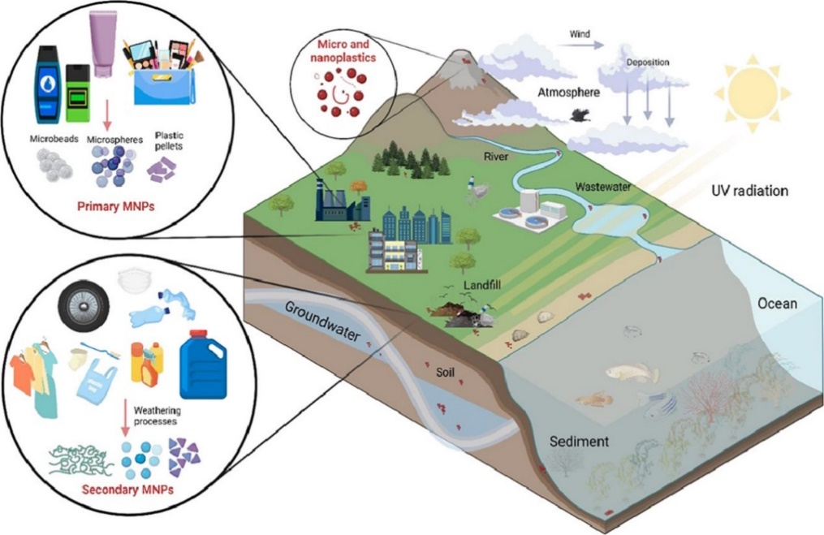
Keywords---Microplastics, Bioaccumulation, Marine ecosystems, Pollution, Sustainability.
Figure 1: Graphical Abstract

INTRODUCTION
The sum of plastic created around the world for different mechanical items has expanded quickly; the result is a cosmic increment in squander created from this polymer. It is assessed that plastic generation has expanded from many tons within the early 1950s to about 400 million tons in 2018. Since at that point, plastic squander has gotten to be omnipresent, non-biodegradable, and broadly dispersed all through the planet's different biological systems. Hence, it has ended up a source of expanded consideration and discourse among scholars, traditionalists, scientists, and the common open. It has too been famous that over time, plastic squander loses its mechanical judgment through different natural variables such as absorption, photo-oxidation and different biotic debasement pathways. Over time, this squander plastic breaks down into little particles. microplastics and nanoplastics (MNPs), which posture an boundless risk to the environment. These "minor" plastic particles have pulled in the consideration of researchers since they were distinguished as a major component of sea flotsam and jetsam within the 1970s, when the term "microplastic" was coined. Thompson et al. (2004), who to begin with portrayed the aggregation of infinitesimal plastic particles in marine dregs and the water column of European waters, have since been included in both MNPs, which are little plastic particles shaped by the fracture of bigger particles.
It has been watched that the current writing isn't reliable with the categorization of MNPs molecule estimate, since the molecule measure has been characterized in an unexpected way by diverse authors and educate. However, it was watched that most thinks about set the upper restrain for microplastics at 5 mm and the upper restrain for nanoplastics at 100 nm. In expansion, the Universal Organization for Standardization has characterized nanoparticles as objects with outside measurements on the nanoscale (the measure is around 1 to 100 nm. Hence, in this consider, microplastics are characterized as plastic particles within the measure run of 100 nm to 5 mm, whereas nanoplastics are those plastic particles littler than 100 nm. Two MNPs were found to dominate the number of plastic particles completely different situations. In this case, they have been detailed to be show throughout the planet, from the polar ice caps to the open water around the equator, as well as from the coast to the profound sea.
Microplastics and nanoplastics are isolated into essential and auxiliary microplastics/nanoplastics based on their source. Essential MNPs are items of particulate outflows from different mechanical forms and enter the environment in their unique little estimate related with particular applications and customer items. These items primarily incorporate cleaning items such as cosmetics and toothpaste, crude materials utilized to create plastic items, and material strands that are evacuated amid washing or drying. On the other hand, auxiliary MNPs are shaped as a result of the debasement of plastic particles due to physical, creature and microbial operators.
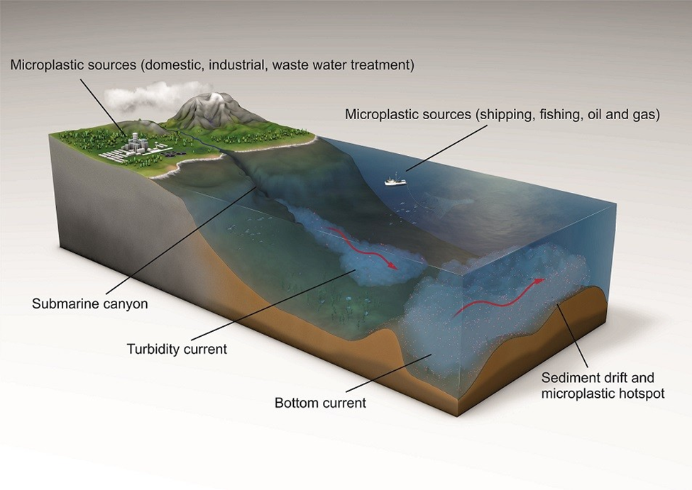
Figure 2: Microplastic Sources

Classification and Sources of MNPS

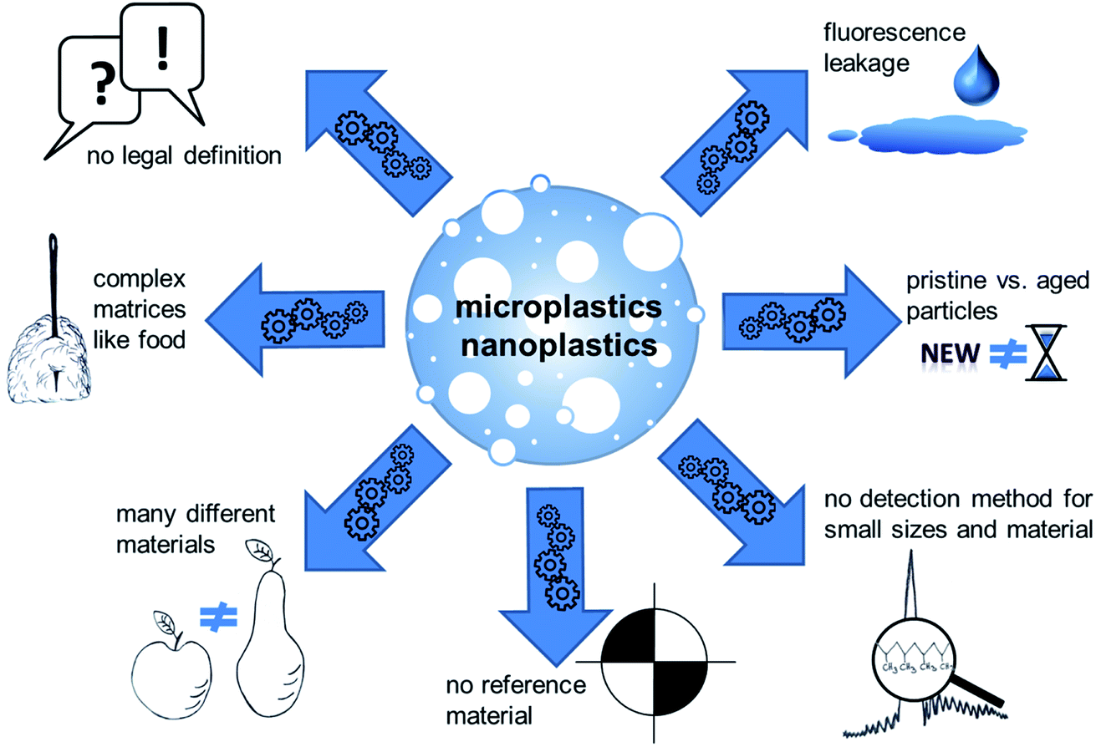
MNPs are either delivered straightforwardly or determined from the breakdown of huge plastics over time; subsequently, on this premise, it is partitioned into essential and auxiliary MNPs, as appeared in Figure 1. Essential MNPs come from plastic particles and individual care items that contain microspheres. Other imperative sources of major PMNs incorporate manufactured gum, paint, materials washed with wastewater, sewage slime, plastic streets in schools, elastic streets and vehicle tires. Organisms are extraordinary microplastics made from polyethylene, polypropylene, and polystyrene that are intentioned included to makeup and other individual care items. In specific, they ended up absorbents and cleansers in individual care items, as well as in biomedical investigate and wellbeing sciences. MNP microspheres are too utilized as film-forming operators, utilitarian polymers, hydrophilic operators, and silicones in individual care and restorative items. Properties such as sphericity and molecule measure consistency make a ball-bearing impact, coming about in a plush surface and scattering, alluring properties in makeup. These MNPs can be non-spherical, circular, unpredictable, and stringy, and can be utilized rather than common materials such as pumice and actuated carbon. Colorful germs make a visual affect on individual care items. It has been recognized as a tricky source of microplastics when they pass through sewage treatment plants unhindered into canals, waterways, streams and other water bodies after being discharged from sewage. It is estimated that 11% (~2300 t/yr) of plastic waste dumped in the North Sea is MNP microbes. Pre-production chewing gum particles (granules), mainly used in plastic production, are recognized as a major source of MNE waste. These plastic particles are particularly subject to plastic processing for cleaning, crushing, softening, sorting and preparing for finishing.
Figure 3: Classification of MNPs

- Goods of MNPs on Pollution in Terrain

Due to their potential to cause pollution in terrestrial habitats, microplastics and nanoplastics, tiny plastic particles with dimensions ranging from a few micrometers to nanometers, have been a major concern in recent years. These microscopic plastic pieces also represent significant ecological and environmental dangers, even though larger plastic objects are more obviously associated with pollution. Terrain pollution now has a new dimension thanks to the development of microplastics and nanoplastics. These particles are largely produced by numerous industrial processes, as well as by the breakdown of bigger plastic goods including bottles, bags, and packaging. Due to their small size, they are easily dispersed throughout numerous landscapes by the wind, water, and even living things. The persistence of micro and nanoplastics in the environment is one of the major problems they cause. They can last for decades in the environment and are too tiny to be handled by traditional waste management methods. Due to their tenacity, it is more likely that they will gather in soil and silt, which can be harmful to plant growth and soil health. These plastics can build up in soils, changing their physical characteristics and reducing aeration, nutrient availability, and water retention. In consequence, this may reduce agricultural output and have an effect on food security. Additionally, microplastics and nanoplastics have the potential to harm species and disturb ecosystems. Various creatures, from insects to mammals, can consume these particles either directly from the environment or indirectly through the food chain. Plastic consumption can result in internal harm, inflammation, and altered feeding habits, all of which have an impact on an organism's ability to survive and reproduce. Plastics contain hazardous compounds that can leak into the soil and perhaps enter the food chain, endangering human health. These microscopic plastic particles spread more widely across various terrains due to wind and water transmission. These particles can be transported by wind for long distances, which enables them to settle in remote locations far from their initial sources. Microplastics and nanoplastics are transported by water bodies such as rivers and oceans, where they are then deposited by deposition in terrestrial settings. As it becomes more difficult to identify and address the origins, the pollution issue is further exacerbated by this infiltration into other terrains.

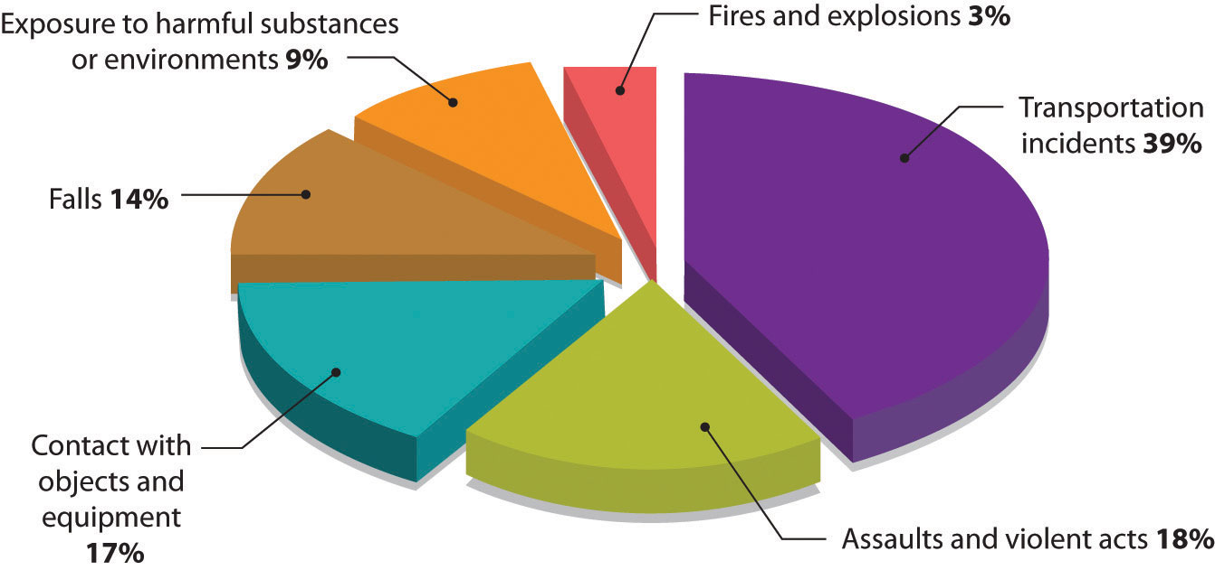
A comprehensive strategy is needed to address the problem of micro- and nanoplastic contamination in terrains. These tiny particles require new waste management strategies that not only focus on their cleanup from the environment but also on their prevention. Innovative technologies are crucial for the identification, eradication, and degradation of nano- and microplastics. Additionally, encouraging responsible plastic product usage and disposal as well as switching to sustainable alternatives can greatly minimize the amount of these contaminants entering the environment. Both microplastics and nanoplastics are imperceptible but significant polluters of terrestrial habitats. They present a serious challenge because of their tenacity, potential for ecological damage, and capacity to invade isolated environments. To address this issue, industries, policymakers, researchers, and citizens must work together to reduce their production, consumption, and improper disposal. We can only hope to lessen the negative impacts of micro and nanoplastics on terrains and protect the health of our world by a concerted global campaign.
Figure 4: Pi Charts of the Percentage of Pollution

- Occurrence and Effects of MNPS in Aquatic Habitats

Due to their ubiquitous prevalence and potential negative impacts on aquatic environments, microplastics and nanoplastics have become an urgent environmental concern. These tiny plastic fragments, which are frequently less than 5 millimeters, are largely produced through the breakdown of bigger plastic objects or are purposefully created for different industrial applications. Due to their small size, which makes them challenging to identify and remove, they tend to accumulate in aquatic settings like lakes, rivers, oceans, and even groundwater sources. Both direct pollution and the breakdown of bigger plastic objects contribute to the presence of microplastics and nanoplastics in aquatic habitats. Stormwater runoff, inappropriate wastewater treatment, and improper disposal can all lead to the entry of plastic waste into water bodies, whether it is from single-use plastics, packaging materials, or synthetic textiles. These plastics degrade physically and through photodegradation over time, becoming smaller fragments. The issue is further exacerbated by the purposeful release of nanoscale plastic particles into the environment from several industrial and personal care items. Due to their potential to disturb ecosystems and destroy marine life, the effects of microplastics and nanoplastics on aquatic habitats are a reason for concern. A vast variety of aquatic species, from zooplankton and small fish to larger marine mammals, can consume these particles. Plastics can obstruct the digestive system, cause bodily injury, and limit an animal's ability to feed. In addition, hazardous compounds from the environment, such as heavy metals and persistent organic pollutants, can be absorbed by microplastics. These harmful compounds can leak into the tissues of species when these plastic particles are swallowed, thereby infiltrating the food chain and causing hazards to human health. Beyond particular creatures, the effects of microplastics and nanoplastics are widespread. By impacting nutrient cycling, changing the properties of sediment, and interfering with the behavior of aquatic species, they can have an impact on entire ecosystems. For instance, a buildup of plastics on water's surface can make it harder for light to penetrate, impairing aquatic plants' ability to photosynthesise and upsetting the delicate balance of the underwater ecology. Additionally, adding plastic particles to sediments can alter their composition and affect the habitats of species that live at the sediment's bottom. A multifaceted strategy including research, policy, and public education is needed to address this issue. To determine the degree of microplastic and nanoplastic pollution in various aquatic environments, monitoring programs are crucial. Controlling the emission of plastic particles from industrial sources and limiting the manufacture of plastic through regulatory measures are essential first steps. The development of technologies for the removal of plastic trash from water bodies as well as improved wastewater treatment facilities are essential parts of the answer. A major factor in lowering the amount of microplastics and nanoplastics entering aquatic environments is public education. One way to reduce plastic pollution at its source is to increase knowledge of the negative environmental effects of single-use plastics, promote responsible consumer behavior, and encourage recycling and upcycling. The presence and consequences of microplastics and nanoplastics in aquatic environments pose significant risks to the wellbeing of aquatic ecosystems and creatures. To lessen their effects, quick and thorough action is required. Governments, businesses, academics, and the general public must all work together. It is possible to address this problem and safeguard the precarious balance of aquatic habitats for current and future generations by combining efficient regulations, technological advancements, and behavioral changes.
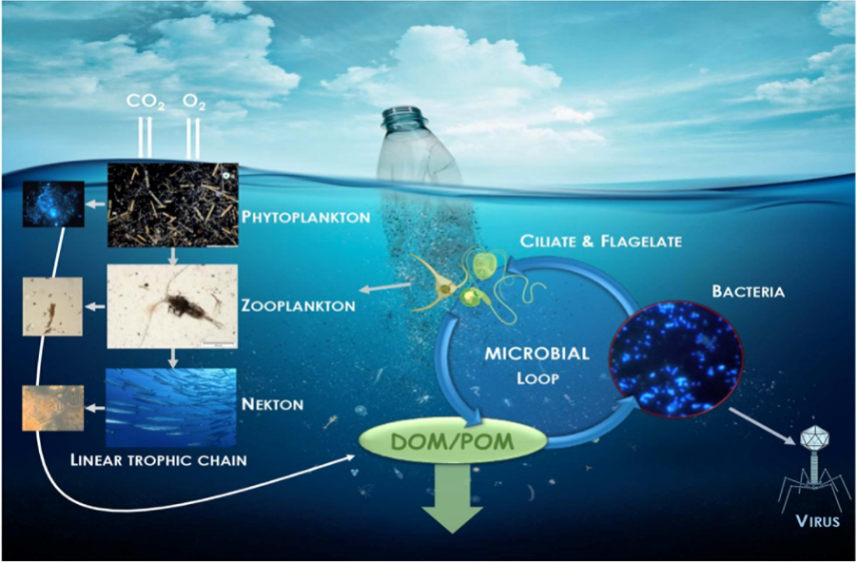
Figure 5: Effects of MNPs in Aquatic Habitats

- Occurrence and Effects of MNPS in Terrestrial Habitats

Due to their ubiquitous presence and potential biological effects in terrestrial environments, microplastics and nanoplastics—two types of tiny plastic particles measuring less than 5 millimeters and 1 micrometer, respectively—have drawn increased attention. Recent studies have shed light on the existence and impact of these microscopic plastic particles in terrestrial ecosystems as well, despite the fact that the majority of study to date has been on marine habitats. These particles, if released into terrestrial ecosystems, can be carried by wind, water, and even by animals' digestive tracts. As a result, they are found in a variety of habitats, from crowded cities to isolated wilderness locations. Microplastics and nanoplastics are widely distributed; studies have found them in soils, sediments, and even the air. Due to their endurance and the pervasive usage of plastic items, microplastics and nanoplastics can be found in terrestrial environments. These particles can come from a variety of places, such as the deterioration of bulkier plastic products like bottles and bags or the breakdown of synthetic textiles during washing. Additionally, toothpaste and other personal care items like exfoliating scrubs frequently include microplastics that can enter the environment through wastewater systems. The foundation of terrestrial ecosystems, the soil, is equally susceptible to plastic pollution. Water retention, nitrogen cycling, and soil structure can all be affected by micro- and nanoplastics. This can then affect the development of plants and soil-dwelling creatures. A growing topic of concern is how microplastics and nanoplastics affect terrestrial environments. On living things and ecosystems, these minute particles may have both direct and indirect effects. Direct impacts include physical harm from ingesting them, which can result in internal damage and potential obstructions when small animals mistake them for food. The capacity of tiny particles to concentrate and absorb hazardous chemicals from the environment causes indirect effects. These substances can move up the food chain after being consumed by animals, putting higher trophic levels—including humans—at risk. The complete impact of microplastics and nanoplastics on terrestrial environments is still being understood, though. Due to the large range of habitats, plastic kinds, and particle sizes involved, research in this subject is complicated. Additionally, standardized techniques are required to precisely quantify and describe these particles in various contexts. The effects of microplastics and nanoplastics must be mitigated using a variety of strategies. The goal should be to stop the production of plastic garbage at the source by enhancing waste management and utilizing more biodegradable substitutes. In addition, stronger limits on the usage of microplastics in consumer goods can aid in limiting their environmental release. Campaigns to raise public awareness can be extremely effective in lowering plastic usage and fostering responsible plastic disposal. Growing worry has been expressed about the presence and consequences of microplastics and nanoplastics in terrestrial environments. The fact that they are present in soil, air, and water suggests that in-depth study is required to comprehend their ecological effects. It is essential that proactive steps be made to reduce the discharge of these particles and mitigate their potential effects on terrestrial ecosystems as we better grasp the scope of the problem.

- Occurrence and Impacts of MNPS within the Air

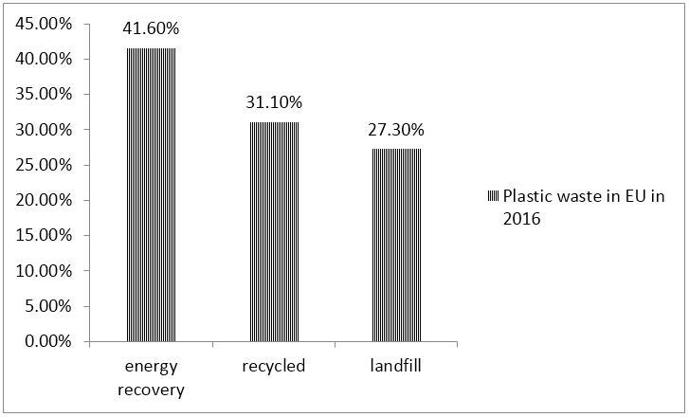
Due to their pervasiveness and potential consequences, microplastics and nanoplastics are environmental contaminants that are receiving more attention. Even while they have received a lot of attention for their existence in aquatic ecosystems, current study has showed they are also present in the air, which has led to worries about their impact on both human health and the environment. Nanoplastics are even smaller than microplastics, with dimensions measured in nanometers, and are often less than 5 millimeters in size. These particles can come from a number of places, including the disintegration of bigger plastic waste, the breakage of synthetic fibers, and even the direct emission from goods like paints and personal care products. Once released into the environment, they have the ability to float in the air and cover large areas. Air sampling investigations carried out in urban, suburban, and isolated regions have verified the presence of microplastics and nanoplastics in the air. Aerosolized dust, microfiber fragments, and airborne dust are all examples of these particles. Urban regions that use a lot of plastic and have poor waste management practices are especially vulnerable to high quantities of airborne plastics. Additionally, through wearing down plastic materials, activities like traffic and industrial processes can contribute to the creation of plastic particles. There is ongoing research into how micro- and nanoplastics affect ecosystems,
Figure 6: Plastic waste in percentage

human health, and air quality. For airborne microplastics, inhalation is thought to be the main exposure route, which may cause respiratory and cardiovascular consequences in people. Concerns about ecosystem consequences are also warranted. Deposition of airborne microplastics on soil and water bodies may disrupt nutrient cycles and have an adverse effect on the health of the soil, which may have an influence on agricultural production. Additionally, these particles have the potential to act as carriers of additional contaminants, so aggravating the pollution of the environment. Multidisciplinary approaches are needed to address the occurrence and effects of micro and nanoplastics in the atmosphere. The emission of these particles can be reduced through better waste management techniques, a decrease in plastic consumption, and the creation of sustainable substitutes. Advanced air filtration systems in commercial and residential locations may also aid in lowering the amount of plastic particles released into the atmosphere. Micro and nanoplastics in the air are a troubling environmental problem that could have an impact on ecosystems and human health. As this field of study advances, it is critical to develop efficient removal methods for these particles from the air and to take proactive steps to prevent their release into the environment. We can only hope to lessen the effects of micro and nano plastics and maintain the standard of our air and environment for future generations via concerted efforts.
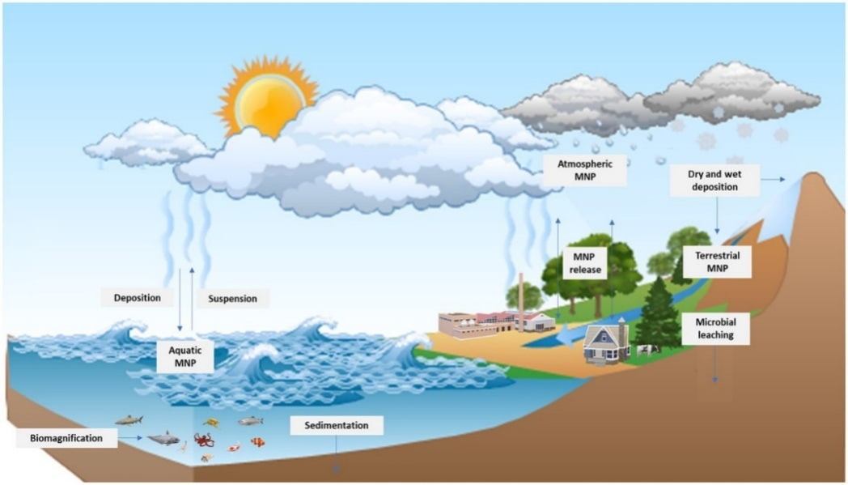
Figure 7: Impacts of MNPs in atmosphere

- Toxicological Impacts of MNPS on Human Wellbeing

Nanotechnology has created incredible opportunities in a wide range of sectors, including medical, electronics, and materials research. Magnetic nanoparticles (MNPs) are a well-known subset of nanomaterial with unique magnetic properties that make them useful for applications such as targeted medication administration, imaging, and environmental remediation. However, in addition to their potential benefits, MNPs' deleterious consequences on human health have received significant attention as their use has increased. This article investigates the potential negative effects of MNPs on human health.
MNPs' compact size and expanded surface area make it easier for them to interact with biological systems. MNPs can accumulate in a variety of tissues, including the liver, spleen, and lungs, raising concerns about potential long-term damage. Their accumulation could lead to altered cellular functioning, oxidative stress, and inflammation, all of which could contribute to the development of chronic illnesses.

- Oxidative Stress and Inflammation:
The unique surface characteristics of MNPs can trigger the formation of reactive oxygen species (ROS), resulting in oxidative stress. Prolonged oxidative stress can cause cellular damage, disruption of signaling cascades, and, eventually, inflammation. Chronic inflammation has been linked to a variety of diseases such as cardiovascular disease, neurological disorders, and cancer. Understanding MNPs' ability to cause oxidative stress and inflammation is thus critical in determining their toxicological effects.
The ability of MNPs to cross cellular barriers raises concerns regarding their genotoxic potential. Certain MNPs have been shown in studies to cause DNA damage, chromosomal abnormalities, and mutations. Furthermore, long-term exposure to genotoxic chemicals raises the risk of carcinogenesis. While research in this field is ongoing, it is critical to assess MNPs' ability to cause genetic harm as well as their implications for long-term human health.
The permeability of the blood-brain barrier to MNPs has prompted concerns regarding their potential neurological effects. The accumulation of MNPs in the brain may interfere with normal neuronal processes and contribute to neurodegenerative disorders. Preliminary study suggests that MNPs may impact neurotransmitter levels, synaptic communication, and neuronal survival, emphasizing the importance of additional investigation into their neurotoxicity.

- Bioaccumulation Risk:
Because of their unique magnetic properties, MNPs are appealing for environmental applications such as water filtration. However, there is concern that MNPs employed in such procedures could infiltrate the food chain and potentially harm human health via bioaccumulation in aquatic creatures ingested by humans. Monitoring and monitoring the potential dangers associated with the release of MNPs into the environment is critical in order to avoid unforeseen health repercussions.
- Mitigation and Regulation:
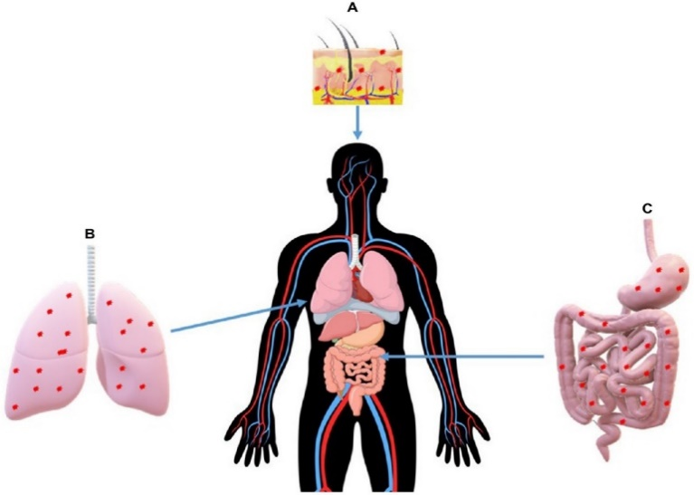
To address the potential toxicological effects of MNPs on human wellbeing, thorough rules and guidelines for their manufacturing, use, and disposal are required. Surface changes that lower toxicity while retaining functioning should be prioritized by researchers and producers in the development of safer MNPs. To appropriately assess the safety profiles of MNPs before their broad use in consumer products and medicinal therapies, rigorous toxicological studies are required.
Figure 8: Impacts of MNPs on Human Health

- Biodegradation of MNPS

Micro &Nanoparticles (MNPs) have sparked considerable attention due to their numerous uses in a variety of disciplines. Concerns about their possible environmental impact, on the other hand, have encouraged research into their fate, particularly biodegradation. The natural breakdown of materials by biological organisms is referred to as biodegradation, and it is an important process in assessing the long-term behaviour and safety of MNPs within ecosystems.

The biodegradability of MNPs is affected by a number of parameters, including their size, surface coating, and chemical composition. Smaller MNPs have a higher surface area compared to their volume, which may improve biodegradation rates. Furthermore, the presence of biodegradable surface coatings, such as organic compounds, can promote microbial adhesion and enzymatic breakdown.
Microorganisms, notably bacteria and fungus, play an important role in the biodegradation of MNPs. These bacteria have enzymes that can degrade a wide range of organic and inorganic substances. Due to the metal presence of MNPs, certain microbes can recognize them as potential nutrition sources when exposed to them. This identification can activate enzymatic activity targeted at removing important components from MNPs, resulting in their progressive breakdown.
MNP biodegradation frequently comprises two essential steps. Bio adsorption and enzymatic degradation. Microorganisms cling to the surface of the MNP during the bio-adsorption phase, generating a biofilm. This biofilm produces a milieu in which enzymes are secreted, so commencing the enzymatic destruction of the MNPs. Environmental variables such as temperature, pH, and nutrient availability all have an impact on the rate of biodegradation.
MNP biodegradation investigations have yielded disparate outcomes depending on the type of nanoparticle, microbial community, and environmental circumstances. MNPs have been reported to suffer partial deterioration in some situations, with changes in size, shape, and magnetic characteristics. The degradation products formed during this process may have different toxicity profiles than the initial MNPs, stressing the need of understanding the possible consequences of the transition products. It is crucial to highlight that, while biodegradation has the potential to reduce MNP persistence in the environment, total degradation may not always occur. Some MNPs, particularly those with stable and inert structures, may degrade at a slower rate. MNPs may accumulate in environmental compartments in such instances, potentially entering food chains and posing ecological consequences.
As research into MNP biodegradation proceeds, there is a rising realization of the necessity to design MNPs with a low environmental impact. Surface changes that improve biodegradability while maintaining functionality may pave the path for safer applications. Furthermore, understanding the destiny of degradation products and their possible effects on ecosystems is critical for estimating the overall environmental risk of MNPs.
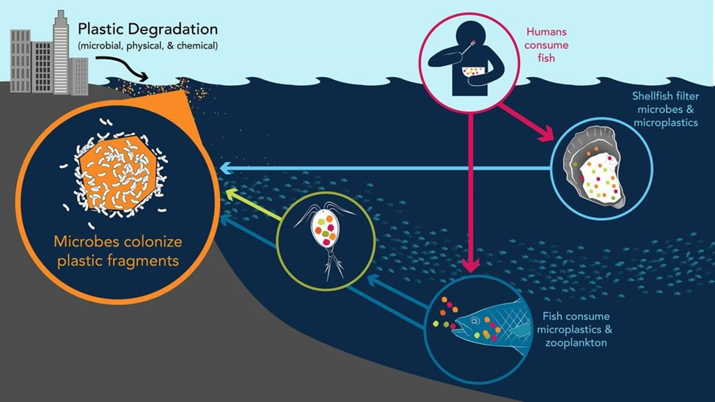
Furthermore, MNP biodegradation is a complex process that is regulated by parameters such as size, surface coating, microbial activity, and environmental conditions. Microorganisms have an important role in the bio-adsorption and enzymatic breakdown of MNPs. While biodegradation is a potential method for reducing MNP persistence in the environment, there are still issues in assuring complete degradation and understanding the ramifications of degradation products.
Figure 9: Biodegradation of MNPS

- Alleviating the Impacts of MNPs

- Strategies for a Safer Future
Magnetic nanoparticles (MNPs) have transformed a variety of industries, from medical to electronics, by providing a diverse range of creative uses. However, as the usage of MNPs grows, worries regarding their possible effects on human health and the environment have emerged. To address these concerns, a multidimensional approach that focuses on limiting negative effects while enhancing the benefits of MNPs is required.

- Surface Modifications and Coatings for Improved Biocompatibility and Stability
Surface alterations are critical in adapting MNP characteristics for specific applications while limiting their possible negative affects. MNPs can be coated with biocompatible materials to increase their interaction with biological systems and reduce toxicity. These coatings operate as a barrier between the MNP core and the surrounding environment, reducing harmful emissions.

- Controlling Size and Toxicity
The size of MNPs has a substantial impact on their behaviour and possible toxicity. Smaller MNPs have a bigger surface area per volume, which increases their reactivity and potential toxicity. It is feasible to limit the negative impacts of MNPs while keeping their desired qualities by properly managing their size. Size optimization can also help to lower the risk of bioaccumulation in species and ecosystems, making MNPs safer to employ.

- Regulation and Risk Assessment
A thorough grasp of the potential dangers associated with MNPs is required for prudent use. To analyse the toxicity and environmental impact of MNPs before they are included into goods or processes, robust risk assessment methodologies should be devised. Governments and regulatory bodies play a critical role in establishing rules and norms that safeguard the safety of the public.

- Eco-Design and Lifecycle Analysis
It is critical to consider the complete lifecycle of MNP-containing products in order to minimize their consequences. Eco-design principles encourage producers to assess their products' environmental footprint, from raw material extraction to end-of-life disposal. This method has the potential to result in the development of more sustainable MNP-containing products, lowering their total impact on human health and the environment.

- Ethical Considerations and Public Awareness
It is critical to educate the public on the potential benefits and risks of MNPs in order to make informed decisions. Transparent communication encourages responsible behaviour and increases consumer demand for safer products. Furthermore, ethical concerns about the use of MNPs, such as equal access to benefits and potential environmental justice issues, should be thoroughly investigated and addressed.

- Interdisciplinary Research and Collaboration
To address the effects of MNPs, scientists, engineers, environmentalists, legislators, and industry must work together. Interdisciplinary research can provide thorough insights into MNP behaviour, allowing effective mitigation techniques to be developed. An open communication among stakeholders is required to guarantee that advances in MNPs benefit society while not jeopardizing safety.

Furthermore, the multidimensional character of MNPs' impacts on human health and the environment necessitates a proactive and comprehensive strategy to mitigation. Surface changes, size control, oxidative stress management, biodegradable design, risk assessment, eco-design, public awareness, and interdisciplinary collaboration can be used to mitigate the potential negative effects of MNPs while maximizing their inventive potential. By applying these methods, we can pave the road for a more secure and long-term future for MNPs.
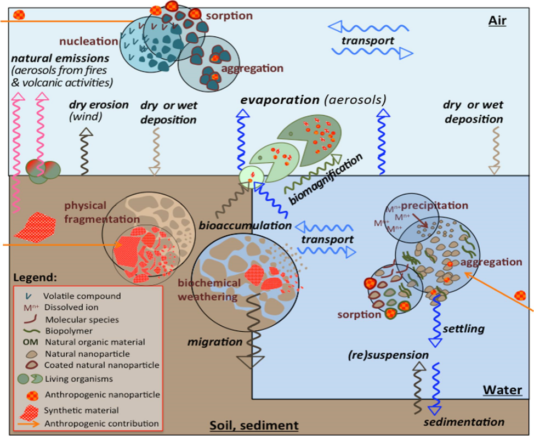
Figure 10: Alleviating the Effects of Mnps

Conclusion:

Microplastics and nanoplastics, miniature products made from plastic materials, travel long distances across the planet due to their unique properties such as flexibility, strength, lightness and shape. However, terrestrial ecosystems have been identified as important sources and transport pathways of MNPs into water and the atmosphere. The proliferation of MNPs in this environment, enhanced by their unique properties, allows them to penetrate and eventually move up the food chain of microbes at the bottom of the food chain and other organisms, especially marine life such as phytoplankton. Once inside these organisms, they accumulate in various organelles and organs and cause various toxic effects mainly through oxidative stress. However, various scientific efforts to reduce the adverse effects of MNPs on living species are not as effective as expected due to the complexity of the environment and the diversity of organisms in the food chain. The time scale required to demonstrate MNP biodegradation was also considered a significant obstacle. Due to the lack of understanding of the ecotoxicological effects and fate of MNP in the environment, regardless of whether they originate from primary or secondary sources, there is a need to develop appropriate and more effective scientific methods to assess the environmental risks and toxicological effects on different trophies. floor The study should also effectively determine the rate of degradation of large plastic particles to MNP and the mechanism of that degradation process. In addition, there is a need to develop and implement laws and regulations that deal with MNP and plastic materials in general. Standardization of inspection methods, identification of technical deficiencies and waste management and promotion of recycling will reduce the harmful effects of MNP. This review is expected to contribute to an understanding of the enormous challenges facing MNEs and provide important insights into the management of MNEs in developing and developed countries around the world.Magnetic nanoparticles hold enormous promise for a variety of uses, but their potential toxicological effects on human health must not be overlooked. Accumulation in key organs, oxidative stress, inflammation, genotoxicity, neurotoxicity, and the risk of bioaccumulation are all causes for worry that should be thoroughly investigated. To address these problems, academics, regulatory organizations, and industry must work together to assure the safe development and implementation of MNPs. Balancing the benefits of MNPs with their possible hazards is critical for maximizing their potential while protecting human health.

References:

- Rochman, C. M., Browne, M. A.: "The Ecological Impacts of Marine Debris: Unraveling the Demonstrated Evidence from What Is Perceived" Ecology, 2013, Volume: 97, Issue: 2, Pages: 302-312

- Wright, S. L., Thompson, R. C."Investigating the Threat of Microplastics to Marine Organisms: A Review" Marine Pollution Bulletin, 2013, Volume: 69, Issue: 1-2, Pages: 7-17

- Andrady, A. L."Microplastics in the Marine Environment", Source: Marine Pollution Bulletin, 2011, Volume: 62, Issue: 8, Pages: 1596-1605

- Galloway, T. S. Title: "Micro- and Nano-plastics and Human Health", Reference Module in Earth Systems and Environmental Sciences, 2019, Pages: 1-6

