**Comparative Analysis of Mathematical Models for Non-Newtonian Stress Relaxation Flow of Blood through an Artery with Multiple Stenosis**

Goutam Dasa, Bhawna Agrawalb and Sanjeet Kumarc

*a ,b Department of Mathematics,* *Rabindranath Tagore University, Bhopal (M.P), India*

[*mailmeatgoutam@gmail.com*](mailto:mailmeatgoutam@gmail.com)*,* [*bhawnakhushiagrawal@gmail.com*](mailto:bhawnakhushiagrawal@gmail.com)

*c Department of Mathematics Lakshmi Narain College of Technology & Science, Bhopal (M.P), India*

[*sanjeetkumarmath@gmail.com*](mailto:sanjeetkumarmath@gmail.com)

**Abstract:** In this analytical study a mathematical model is developed for studying stress relaxation flow of blood through a tapered artery with multiple stenoses. The analytical expressions for flux and velocity are derived using appropriate boundary conditions. The derived quantitative analysis is performed for the flux, flow velocity, resistive impedances, and the variation wall shear stress with time discussed. The axial velocity as a function for different values of the Jeffrey parameter is presented graphically in the stenotic region.

**Keywords:** Stress relaxation, tapered artery, multiple stenoses, flux, wall shear stress, axial velocity, Jeffrey parameter, stenotic region.

**Introduction:**

Stenosis means abnormal and unnatural growth in the lumen of an artery. This abnormality in arteries is embarrassing the flow field. The stenosed arteries have blocked 50%-90% area. Mathematical modeling and analysis of an artery with multiple stenoses are of wide use for Bio-mathematicians and medical Scientists because it involves the investigation of various characteristics of blood. The main objective of this theoretical study is to investigate the flow mechanics of non-Newtonian blood flow through a tapered artery with multiple stenoses which will be needful in the field of medical sciences as medical Scientists do not have precise information about various flow parameters of the blood.

There is strong evidence that some hydrodynamic factors such as resistance to flow, wall shear stress, and apparent viscosity may play an important role in the development and progression of arterial stenosis. In the recent past, quite a good number of theoretical and analytical studies related to blood flow through tapered arteries in the presence of stenosis have been carried out. Most of the studies have concentrated on non-Newtonian blood flow. Mathur and Jain (2013) studied mathematical modeling of non-Newtonian blood flow through an artery in the presence of stenosis. They have treated the effects of stenosis in an artery and consider the blood as power-law fluid. It has been concluded that the pressure drop and shear stress increase as the size of the stenosis increases for a given non-Newtonian model of the blood. Ramesh Babu and Savita (2019) investigated the flow of Jeffrey fluid through an artery with multiple stenoses to experiment with the variation of velocity profiles and volumetric flow rate in different regions of flow with various boundary conditions. Halder et. al. (2017) studied Newtonian and non-Newtonian pulsatile flows through an artery with stenosis and presented three-dimensional modeling and analysis of blood flow through artery stenosis under several variants of pulsatile flow to mimic the atherosclerosis artery disease. Sriyab (2020) analyzed the effect of stenotic geometry and non-Newtonian property of blood flow through arterial stenosis. He considered a mathematical model of non-Newtonian blood flow through several stenosis, like bell shape and cosine shape. It is also concluded that the stenosed artery geometry, the stenosis length, stenosis thickness, and the power law index (in non-Newtonian behavior) are key factors affecting the blood flow through the stenosed artery. Shit et. al. (2012) studied mathematical modeling of blood flow through a tapered overlapping stenosed artery with variable viscosity. They observed that the impact of hematocrit, magnetic field, and the shape of the artery significantly influence the velocity profile, pressure gradient, and wall shear stress. The variable viscosity of blood depends on hematocrit and the blood has been treated as the porous medium in this investigation. They solved this problem analytically by using the Frobenius method. Nanda and Bose (2012) investigated a mathematical model for blood flow through a narrow artery with multiple stenoses. In their investigation, they investigated the rheological parameters, stenosis height, and yield stress of the fluid strongly impression the flow characteristics qualitatively and quantitatively. Nanda and Mallik (2012) analyzed a non-Newtonian two-phase fluid model for blood flow through arteries under stenotic conditions. Their analysis was carried out by performing large-scale numerical of the measurable flow variables having more physiological significance by developing computer codes. Mandal et al. (2007) have developed a mathematical model by treating blood as a non-Newtonian fluid characterized by the generalized power-law model blending both the shear-thickening and shear-thinning characters of the flowing blood. The arterial wall has been behaved as an elastic cylindrical tube having a stenosis of its lumen. The mechanism of unsteady flow in the stenosed artery subject to a pulsatile pressure gradient arising from the normal functioning of the heart has been accounted for.

The present study is motivated towards a theoretical investigation of mathematical modeling of non-Newtonian stress relaxation flow of blood through an artery with multiple stenosis. The analytical results for flow velocity and flux are derived in this study. The derived analytical expressions are predicted to examine the variation of velocity profiles and volumetric flow rate in various flow regions.

**Mathematical model:**

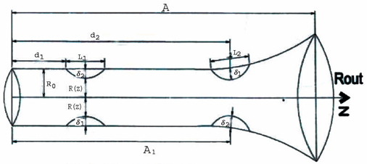

**Figure 1: Physical model of multiple stenosis**

Consider the steady flow of a Jeffrey fluid through a non-uniform and cross-section tube with two stenoses. We consider a cylindrical polar coordinate system (r, z) so that z is measured along the tube axis and r is normal to the axis of the tube. The stenoses are mild and axially symmetric.

The radius of the tube is taken as:

and where 

 where 

 where 

 where 

 where 

 where  (1)

Here, lengths of the two stenoses are (where i =1,2) and the maximum thickness of two stenoses are  (where i =1,2) and the restrictions for the mild stenosis are satisfied.





Where 

The basic equation managing the flow is

 (2)

Where is Jeffrey parameter, is the pressure, is the viscosity of the fluid,  is the radius of the tube

The boundary conditions are

 where  (3)

 where  (4)

Introducing following non-dimensional variables:

 (5)

Non-dimensionalising the governing equations after dropping bars:

 (6)

The non-dimensional boundary conditions are:

 where  (7)

 where  (8)

**Solution of the problem:**

**Velocity Distribution:**

Integrating equation (1) by applying boundary conditions (7) and (8) the axial velocity can be obtained as:

 (9)

The volumetric rate of flow is obtained as:

 (10)

**Pressure Difference:**

The pressure difference $∆p$ along the total length of the tube as follows:

 (11)

**Result and Discussion:** We have calculated the axial velocity as a function of for different values of Jeffrey parameter from equation (9) in the stenotic regions  and  and shown in the figures (2) and (3). It is observed that the velocity decreases with the increase in the Jeffery parameter $μ_{1}$ in both the stenotic regoins.

The volumetric flux is calculated from equation (10) for different Jeffery parameter in the stenotic region and is shown in the figure (4). The curve resembles an inverted parabola. It is noticed that minimum flux rate is attained at , that is the midpoint of the stenosis.

Corresponding to the stenotic region, the volumetric flux is calculated for different Jeffery parameter and is shown in the figure (5). It is observed that the flux rate decreases with increase in Jeffery parameterin the stenotic region.

The volumetric flux is calculated for different values of k and is shown in figure (6). It is assuming in the third stenotic region for numerical computation that:

 where 

and .

Here we have seen that flux increases in the value of. The variation of the flow rate for different values of Jeffery parameter in the third stenotic region is shown in the figure (7). Here it is seen that flux decreases as Jeffery parameter increases.

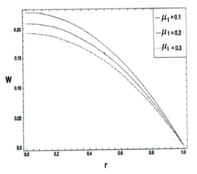

**Figure 2:** Velocity Profiles for different values of Jeffery parameter  in first stenotic region 

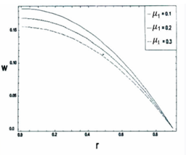

**Figure 3:** Velocity Profiles for different values of Jeffery parameter  in second stenotic region 

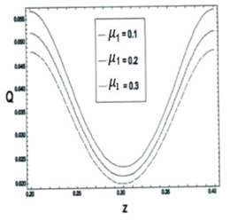

**Figure 4:** Volumetric Flux for different values of Jeffery parameter  in first stenotic region 

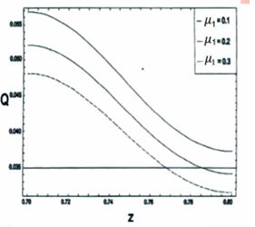

**Figure 5:** Volumetric Flux for different values of Jeffery parameter  in second stenotic region 

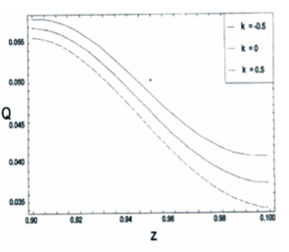

**Figure 6:** Volumetric Flux for different values of  in the third stenotic region 

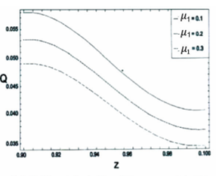

**Figure 7:** Volumetric Flux for different values of Jeffery parameter  in the third stenotic region 

**References:**

1. Chakravarty, S. and Mandal, P.K. (2000), Two-dimensional blood flow through tapered arteries under stenotic conditions, International Journal of Non-Linear Mechanics, vol. 35(5), pp. 779-793.
2. Dash, R.K., Jayaraman, G. and Mehta, K. N.(1999), Flow in a catheterized curved artery with stenosis, Journal of Biomechanics, vol. 32(1), pp. 49–61.
3. Diwakar, C. and Kumar, S. (2016), Effects of axially symmetric stenosis on the blood flow in an artery having mild stenosis, International Journal of Mathematics Trends and Technology, vol. 35(3), pp. 163-167.
4. Halder, P., Husain, A., Zunaid, M. and Samad, A. (2017), Newtonian and non-Newtonian pulsatile flows through an artery with stenosis, The Journal of Engineering Research, vol. 14(2), pp. 191-205.
5. Hye, M.A. and Paul, M.C. (2015), A computational study on spiral blood flow in stenosed arteries with and without an upstream curved section, Applied Mathematical Modelling, vol. 39(16), pp. 4746–4766.
6. Joshi, P., Pathak, A. and Joshi, B. K. (2009), Two-layered model of blood flow through composite stenosed artery, Applications and Applied Mathematics, vol. 4(2), pp. 343-354.
7. Kumar, A. and Awasthi, U. (2010), A mathematical model for blood flow in a multiple stenosis artery, International Journal of Math. Analysis, vol. 4 (50), pp. 2465 – 2472.
8. Kumar, S., Kumar, S. and Kumar, D. (2021), Comparative study of non-Newtonian physiological blood flow through elastic stenotic artery with rigid body stenotic artery, Series on Biomechanics, vol. 34 (4), pp.26-41.
9. Liu,Y. and Liu, W. (2019), Blood ﬂow analysis in tapered stenosed arteries with the inﬂuence of heat and mass transfer, Journal of Applied Mathematics and Computing, vol. 63, pp. 523-541.
10. Mathur, P. and Jain, S. (2013), Mathematical modeling of non-Newtonian blood flow through artery in the presence of stenosis, Advances in Applied Mathematical Biosciences, vol. 4(1), pp. 1-12.
11. Mekheimer, K.S., Haroun, M.H. and Elkot, M.A. (2011), Effects of magnetic ﬁeld, porosity, and wall properties for anisotropically elastic multi-stenosis arteries on blood ﬂow characteristics, Applied Mathematics and Mechanics, vol. 32(3), pp. 1047-1064.
12. Mishra, S., Siddiqui, S.U. and Madhavi, A. (2011), Blood flow through a composite stenosis in an artery with permeable wall, Applications and Applied Mathematics, vol. 6(11), pp. 1798 – 1813.
13. Misra, J.C. and Shit, G.C. (2006), Blood flow through arteries in a pathological state: A theoretical study, International Journal of Engineering Science, vol. 44(10), pp. 662-671.
14. Nanda, S.P. and Bose, R.K. (2012), A mathematical model for blood flow through a narrow artery with multiple stenoses, Journal of Applied Mathematics and Fluid Mechanics, vol. 4(2), pp. 233-242.
15. Nanda, S.P. and Mallik, B.B. (2012), A non-Newtonian two phase fluid model for blood flow through arteries under stenotic condition, International Journal of Pharmacy and Biological Sciences, vol. 2(1), pp. 237-247.
16. Ponalagusamy, R. (2007), Blood Flow through an Artery with Mild Stenosis: A two – layered model, different shapes of stenoses and slip velocity at the wall, Journal of Applied Sciences, vol. 7, pp. 1071-1077.
17. Pralhad, R.N. and Schultz, D.H. (2004), Modeling of arterial stenosis and its applications to blood diseases, Mathematical Biosciences, vol. 190(2), pp. 203-220.
18. Ramesh Babu, V. and Savita, T. (2019), Flow of Jeffrey fluid through an artery with multiple stenosis, International Journal of Engineering Development and Research, vol. 7(2), pp. 473-477.
19. Shah, S.R., Siddiqui, S.U. and Singh, A. (2016), Mathematical modeling and numerical simulation of blood Flow through tapered artery, International Journal of Innovative Science, Engineering & Technology, vol. 3 (2), pp. 710-717.
20. Shit, G. C., Roy, M. and Sinha A. (2012), Mathematical modeling of blood flow through a tapered overlapping stenosed artery with variable viscosity, Applied Bionics and Biomechanics, vol. 11 pp. 185-195.
21. Singh, B., Joshi, P. and Joshi, B.K. (2010), Blood flow through an artery having radially non-symmetric mild stenosis, Applied Mathematical Sciences, vol. 4(22), pp. 1065-1072.
22. Srivastava, V. P. (2003), Flow of a Couple Stress Fluid Representing Blood through Stenotic Vessels with a Peripheral Layer, Indian Journal of Pure and Applied Mathematics, vol. 34, pp. 1727-1740.
23. Srivastava, V. P. and Rastogi, R. (2009), Effects of hematocrit on impedance and shear stress during stenosed artery catheterization, Applications and Applied Mathematics, vol. 4(1), pp. 98-113.
24. Sriyab, S, (2020), The effect of stenotic geometry and non-Newtonian property of blood flow through arterial stenosis, Cardiovascular & Hematological Disorders-Drug Targets, vol. 20(1), pp.16-30.