**Charged Stellar Model with generalized Chaplygin equation of state compatible with observational data**

Manuel Malaver1 and Rajan Iyer2

1Maritime University of the Caribbean, Department of Basic Sciences, Catia la Mar, Venezuela.

Email: [mmf.umc@gmail.com](mailto:mmf.umc@gmail.com)

2Environmental Materials Theoretical Physicist, Department of Physical Mathematics Sciences Engineering Project Technologies, Engineeringinc International Operational Teknet Earth Global, Tempe, Arizona, United States of America

Email: [engginc@msn.com](mailto:engginc@msn.com)

**Abstract:** In this paper, we found a new model for compact star with charged anisotropic matter distribution considering the generalized Chaplygin equation of state. The Einstein-Maxwell field equations have been solved with a particular form of metric potential and electric field intensity. The plots generated show that physical variables such as radial pressure, energy density, charge density, anisotropy, radial speed sound and the mass are fully well defined and are regular in the interior of star. We obtained some models consistent with stellar objects as GJ 832, LHS 43, SAO 81292, GJ 380, GJ 412 and SAO 62377. The new models of this research are physically relevant in the analysis of compact structures.

**Keywords:** Einstein-Maxwell field equations; Chaplygin equation of state; Electric field

intensity; Metric potential; Radial pressure; Anisotropy.

1. **Introduction**

Research on compact objects and strange stars within the framework of the general theory of relativity is a central issue of great importance in theoretical astrophysics in the last decades [1,2]. The obtained models in general relativity have been used to describe fluid spheres with strong gravitational fields as is the case in strange stars and neutron stars. The physics of ultrahigh densities is not well understood and many of the strange stars studies have been performed within the framework of the MIT bag model where the matter equation of state has the following linear form  . In this equation *ρ* is the energy density, *P* is the isotropic pressure and *B* is the bag constant. In the first detailed models of strange stars based on a strange quark matter equation of state were considered specific features of accretion on strange stars [3]. Other authors [4-10] analyzed strange stars with the normal crust and proposed scenarios for the formation of these compact objects.

Researches as Komathiraj and Maharaj [11], Ivanov [12], Malaver and Kasmaei [13], Bowers and Liang [14],Gokhroo and Mehra [15], Esculpi et al. [16], Malaver [17,18], Chan et al.[19], Malaver [20] and Cosenza et al. [21] have used numerous mathematical strategies to try to obtain exact solutions which indicates that the Einstein-Maxwell field equations is of great importance to describe compact objects.

In order to propose physical models of interest that behave well it is important to consider an adequate equation of state. Many researchers have developed exact analytical models of strange stars within the framework of linear equation of state based on MIT bag model together with a particular choice of metric potentials or mass function [22-32]. Thirukkanesh and Ragel [33] obtained new exact solutions to the Einstein-Maxwell system of equations with a polytropic equation of state. Feroze and Siddiqui [34,35], Sunzu et al. [36], Pant et al. [37] and Malaver [38-41] consider a quadratic equation of state for the matter distribution and specify particular forms for the gravitational potential and electric field intensity. Sunzu and Danford [42] and Komathiraj and Maharaj [43] obtained new relativistic stellar models with a particular type of metric function. Tello-Ortiz et al. [44] also found an anisotropic fluid sphere solution of the Einstein-Maxwell field equations with a modified version of the Chaplygin equation. More recently Malaver and Iyer [45] generated new models of compact stars considering the new version of Chaplygin equation of state proposed for Errehymy and Daoud [46].

The presence of an electric field within a fluid sphere has been a subject of great interest because it has allowed studying the effect of electromagnetic fields on astrophysical stellar objects [47-51]. According Bhar and Murad [52] the existence of charge affects the values of redshifts, luminosities and mass for stars. Malaver and Iyer [53,54] have developed some stellar models with a well-defined electric field.

In recent decades, the theoretical research [54-64] in realistic stellar models show that the nuclear matter may be locally anisotropic in certain very high density ranges (ρ˃1015 gcm-3), where the relativistic treatment of nuclear interactions in the stellar matter becomes important. From the pioneering work of Bowers and Liang [54] that generalized the equation of hydrostatic equilibrium for the case local anisotropy, there has been an extensive literature devoted to study the effect of local anisotropy on the bulk properties of spherically symmetric static general relativistic compact objects [55-70]. Therefore it is always interesting to explore the consequences produced by the appearance of local anisotropy under variety of circumstances.

Presently there are efforts underway to understand the underlying quantum aspects with astrophysical charged stellar models [52-57]. How the energy matter quantum wavefunction creates situations with equation of state potential, expansions with quintessence field cosmologies with interior having dark energy matter generation compact stellar anisotropic gravitational potential and structure of many objects, especially strange quark stars as well have been key in Quantum Astrophysical projects ongoing [54-60]. There is also study of the symmetry group theory with authors advancing that will help to classify general field-particle metrics linking towards Standard Model Particle Physics String Theories with Hubble and James Webb Telescope observations of the expanding universe models that is supposed to manifest from natural astrophysical Big Bang Theory [56-67] .

In this paper, we generated a new model of charged anisotropic compact object with the modified Chaplygin equation of state proposed for Pourhassan [68] and studied by Bernardini and Bertolami [69]. The modified Chaplygin equation of state is described by  where *A*, *B*, *α* are constants and 0 ≤ *α* ≤ 1. If we take *α*=1 then it gives generalized Chaplygin equation of state [52]. Using a particular form of gravitational potential *Z(x)* that is nonsingular, continuous and well behaved in the interior of the star, we can obtain a new class of static spherically symmetrical model for a charged anisotropic matter distribution. It is expected that the solution obtained in this work can be applied in the description and the study of internal structure of strange quark stars. The article is organized as follows: In section 2 we present Einstein-Maxwell field equations. In section 3 we make a particular choice for gravitational potential  and the electric field intensity and generated new models for charged anisotropic matter. In Section 4, physical acceptability conditions are discussed. The physical properties and physical validity of these new solutions are analyzed in section 5. The conclusions of the results obtained are shown in the section 6.

**2. Einstein-Maxwell system of equations**

We consider a spherically symmetric, static and homogeneous space-time. In Schwarzschild coordinates, the metric is given by:

 (1)

where  and are two arbitrary functions.

The Einstein field equations for the charged anisotropic matter are given by [30]:

 (2)

 (3)

 (4)

 (5)

where is the energy density, is the radial pressure,  is electric field intensity,is the tangential pressure and primes denote differentiations with respect to .Using the transformations,and with arbitrary constants and *C*>0 suggested by Durgapal and Bannerji [70], the Einstein field equations can be written as:

 (6)

 (7)

 (8)

 (9)

 (10)

 (11)

 is the charge density,  is the anisotropy factor and dots denote differentiations with respect to .With the transformations of [70], the mass within a radius  of the sphere takes the form:

 (12)

Where



In this paper, we assume the following equation of state where the radial pressure and the density *ρ* are related to the following form:

 (13)

with *A* and *B* as constant parameters, and *α*=1 .

with *A* and *B* as constant parameters and  .

**3.** **Charged Anisotropic Model**

In this work, we take the form of the gravitational potential *Z(x)* as *Z(x)=1-ax*proposed for Thirukanesh and Ragel [33] and Malaver [38] where a is a real constant. This potential is regular at the origin and well behaved in the interior of the sphere. Following Liguda et al. [71] for the electric field ,we make the particular choice:

 (14)

This electric field is finite at the center of the star and remains continuous in the interior. Using  and eq.(14) in eq.(6), we obtain

 (15)

Substituting eq. (15) in eq. (13), the radial pressure can be written in the form:

 (16)

Using eq. (15) in eq. (12), the expression of the mass function is

 (17)

With eq. (14) and *Z(x)* in eq. (11), the charge density is

 (18)

With equations (13), (14), (15) and ,eq.(7) becomes:

 (19)

Integrating eq. (19) we obtain:

 (20)

where for the convenience we have let

 (21)



(22)

 (23)

and  is the constant of integration.

The metric functions and can be written as:

 (25)

 (26)

and the anisotropy Δ is given by:



(27)

1. **Elementary Criteria for Physical Acceptability**

A physically acceptable interior solution of the gravitational field equations must comply with the certain (not necessarily mutually independent) physical conditions [3, 48,72] :

1. The solution should be free from physical and geometric singularities, i.e., ˃ 0, ˃ 0 and , , *ρ* are finite in the range 0 ≤ r ≤ R.
2. The radial and tangential pressures and density are non-negative , , *ρ ≥ 0*
3. Radial pressure  should be zero at the boundary *r= R* , i.e., , the energy density and tangential pressure may follow and .
4. The condition  be the condition that the speed of sound not exceeds that of light.
5. Pressure and density should be maximum at the center and monotonically decreasing towards the pressure free interface (i.e., boundary of the fluid sphere). Mathematically

 ≤ 0 and  ≤ 0 for 0 ≤ r ≤ R.

1. Electric field intensity *E* , such that *E(0) = 0* , is taken to be monotonically increasing, i.e., ˃ 0 for *0* *≤ r ≤ R*.
2. Pressure anisotropy vanishes at the centre, i.e., *Δ(0)=0* [3].

(viii) The charged interior solution should be matched with the [Reissner–Nordström](https://en.wikipedia.org/wiki/Reissner%E2%80%93Nordstr%C3%B6m_black_hole)  exterior solution, for which the metric is given by:

 (28)

through the boundary *r=R* where *M* and *Q* are the total mass and the total charge of the star,

respectively.

1. **Physical Analysis**

We now present the analysis of the physical characteristics for the new model. The metric functions and should remain positive throughout the stellar interior and in the origin , .We note in *r=0* that .This demonstrates that the gravitational potentials are regular at the centre *r=0* . The energy density and radial pressure are positive and well behaved inside the stellar interior. Also, we have the central density and pressure , . According to the expression of radial pressure, *pr(0)* will be non-negative at the centre as it is satisfied by the condition 3*AaC* ˃  .

In the surface of the star *r=R ,* we have  and

 (29)

For a realistic star, it is expected that the gradient of energy density and radial pressure should be decreasing functions of the radial coordinate 𝑟. In this model, for all *0 < r < R,*  we obtain respectively:

 ˂ 0 (30)

 ˂ 0

(31)

and according to the equations (29) and (30), the energy density and radial pressure decrease from the centre to the surface of the star.

From eq. (17), we have for the total mass of the star :

 (32)

The causality condition demands that the radial sound speed defined as should not exceed the speed of light and it must be within the limit in the interior of the star [3]. With the transformations of Durgapal and Bannerji [70] in this model we have:

 (33)

On the boundary *r=R*, the solution must match the Reissner–Nordström exterior space–time as:

 (34)

and therefore, the continuity of  and across the boundary *r=R* is

 (35)

Then for the matching conditions, we obtain:

 (36)

In Table 1 presents the values of the parameters chosen *K*, *A*, *B* and *a*. The masses of stellar objects are also shown

**Table 1**. Parameters *a*, *A*, *B* and stellar masses for different values of *k*

|  |  |  |  |  |
| --- | --- | --- | --- | --- |
| *k* | *A* | *B(x10-5)* | *a* | *M(Mʘ)* |
| 0.0011 | 0.2 | 1.5 | 0.011 | 0.60*Mʘ* |
| 0.0012 | 0.2 | 1.5 | 0.011 | 0.55*Mʘ* |
| 0.0013 | 0.2 | 1.5 | 0.011 | 0.48*Mʘ* |

Where *Mʘ* is the mass of the sun

The figures 1, 2, 3, 4, 5, 6, 7, 8 and 9 represent the graphs of *ρ* , *pr* , *M(x)* , *σ2* , *E2*, Δ ,

, and  with the radial coordinate, respectively. In all the cases we have considered *C*=1.

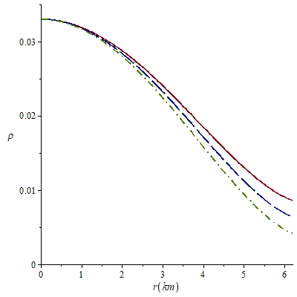

**Figure 1**. Variation of energy density with the radial coordinate for *k*=0.0011 (solid line), *k*=0.0012 (long-dash line) and *k*=0.0013 (dash-dot line).

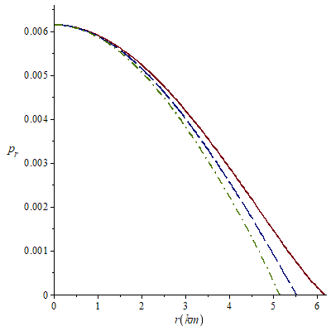

**Figure 2**. Variation of radial pressure with the radial coordinate for *k*=0.0011 (solid line), *k*=0.0012 (long-dash line) and *k*=0.0013 (dash-dot line).

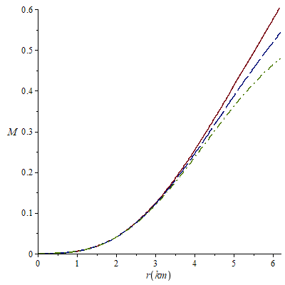

**Figure 3**. Variation of Mass function *M* with the radial parameter for *k*=0.0011 (solid line), *k*=0.0012 (long-dash line) and *k*=0.0013 (dash-dot line).

.

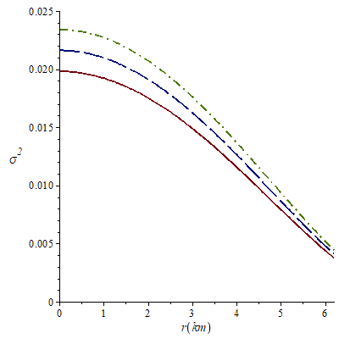

**Figure 4**. Variation of charge density with the radial parameter for *k*=0.0011 (solid line), *k*=0.0012 (long-dash line) and *k*=0.0013 (dash-dot line).

.

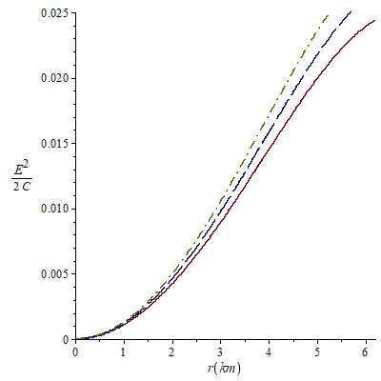

**Figure 5**. Variation of electric field intensity with the radial parameter for *k*=0.0011 (solid line), *k*=0.0012 (long-dash line) and *k*=0.0013 (dash-dot line).

.

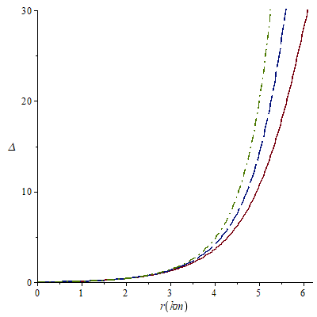

**Figure 6**. Variation of anisotropy with the radial parameter for *k*=0.0011 (solid line), *k*=0.0012 (long-dash line) and *k*=0.0013 (dash-dot line).

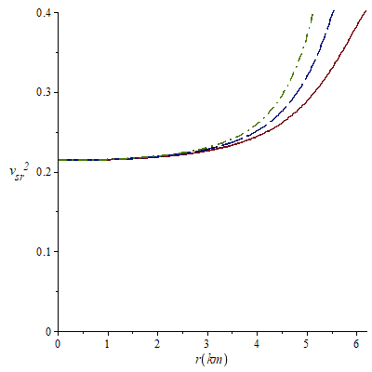

**Figure 7.** Variation ofradial speed sound with radial coordinate for *k*=0.0011 (solid line), *k*=0.0012 (long-dash line) and *k*=0.0013 (dash-dot line).

. 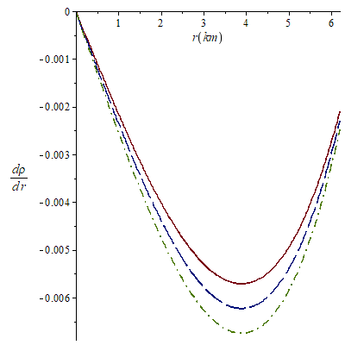

**Figure 8.** Variation ofgradient of density with radial coordinate for *k*=0.0011 (solid line), *k*=0.0012 (long-dash line) and *k*=0.0013 (dash-dot line).

.

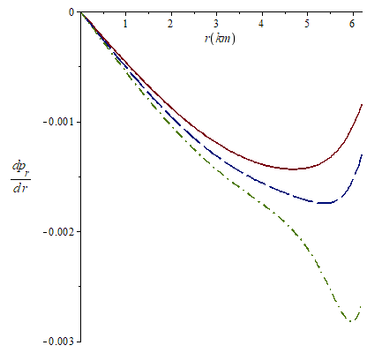

**Figure 9.** Variation ofgradient of radial pressure with radial coordinate for *k*=0.0011 (solid line), *k*=0.0012 (long-dash line) and *k*=0.0013 (dash-dot line).

.

The Fig. 1 shows that the energy density is continuous, finite, decreases radially outward and vanishes at the boundary. In Fig. 2, we note that the radial pressure *ρ* also is finite, continuous and monotonically decreasing function. In Fig. 3, it is observed that the mass function is regular, strictly increasing and well behaved. Fig. 4 shows that the charge density is regular at the centre, non-negative and decreases with the radial parameter for the chosen k values. In Fig. 5, the electric field intensity *E2* is positive and monotonically increasing throughout the interior of the star in all the considered cases. In Fig. 6, the anisotropy factor Δ vanishes at *r=0*, it monotonically increases and is continuous in the stellar interior. In Fig. 7, we note that the  is within the desired range  for the different values of *k*, which is a physical requirement for the construction of a realistic star [3]. The Figures 8 and 9 respectively show that the gradients of radial pressure  and energy density  are decreasing throughout the star.

We can compare the values calculated for the mass function with observational data. For *k*=0.0011 the values of *A*, *B* and *a* allow to obtain a mass of 0.6*Mʘ* which can correspond to astronomic object GJ 440 also known as LHS 43 [73] or could be associated with the orange dwarf GJ 380 [74]. For the case *k*=0.0012 we obtained comparable masses with the red dwarf Lacaille 8760 with a mass between (0.56-0.60)*Mʘ* [75]. With *k*=0.0013, the resulting mass is very similar to the red dwarf Lalande 21185 whose mass is 0.46*Mʘ* [76]. The values of the masses for these compact stars are tabulated is Table 2

|  |  |
| --- | --- |
| Compact Star | Masses *M*(*Mʘ*) |
| LHS 43 | 0.62*Mʘ* |
| GJ 380 | 0.64*Mʘ* |
| Lacaille 8760 | (0.56-0.60)*Mʘ* |
| Lalande 21185 | 0.46*Mʘ* |

**Table 2**. The reported values of the masses for the compact stars

There is also quantum contribution to these masses, since the state of the clock affects environment vacuum oscillations, like neutrino oscillations that change flavor of the quark-gluon-plasma as well as switching quaternion operation of gauge fields of light as well as sound outputs quantum activities [8, 52, 54, 61,62]. The underlying mass effects on dwarf compact stars perhaps will explain their variability with energy density, pressure, mass function, charge density, anisotropy, electric intensity of field, especially in the interior of these stellar objects, and radial sound aspects correlating results demonstrated successfully above [52, 55, 56, 57, 58, 59, 60, 62, 63, 64].

1. **Conclusion**

In this work, we have developed some simple relativistic charged stellar models obtained by solving Einstein-Maxwell field equations for a static spherically symmetric locally anisotropic fluid distribution with a particular form of gravitational potential and the generalized Chaplygin equation of state and presented a new class of solution that satisfies the physical requirements of a anisotropic charged stellar model.

How the energy matter wavefunction creates situations with equation of state potential, expansion with quintessence field cosmologies with interior having dark energy matter generation compact stellar anisotropic gravitational potential and structure of many objects, especially strange quark stars as well have been key in Quantum Astrophysical projects ongoing. The underlying mass effects on dwarf compact stars perhaps will explain their variability with energy density, pressure, mass function, charge density, anisotropy, electric intensity of field, especially in the interior of these stellar objects, and radial sound aspects correlating results demonstrated successfully above. quantum contribution to these masses, since the state_of_the_clock affects environment vacuum oscillations, like neutrino oscillations that change flavor of the quark-gluon-plasma as well as switching quaternion operation of gauge fields of light as well as sound outputs quantum activities.

**References**

[1] Kuhfitting, P.K.(2011). Some remarks on exact wormhole solutions, *Adv. Stud. Theor. Phys*., 5, 365-367.

[2] Bicak, J.(2006). Einstein equations: exact solutions, Encyclopaedia of Mathematical Physics, 2, 165-173.

[3] Delgaty, M.S.R and Lake, K. (1998). Physical Acceptability of Isolated, Static, Spherically Symmetric, Perfect Fluid Solutions of Einstein's Equations, *Comput. Phys. Commun.* 115, 395-415.

[4] Joshi, P.S. (1993). Global Aspects in Gravitation and Cosmology. Clarendon Press, Oxford.

[5] Schwarzschild, K. (1916). Uber das Gravitationsfeld einer Kugel aus inkompressibler Flussigkeit nach der Einsteinschen Theorie. *Math.Phys.Tech*, 424-434.

[6] Tolman, R.C.(1939). Static Solutions of Einstein's Field Equations for Spheres of Fluid. *Phys. Rev*., 55(4), 364-373 .

[7] Oppenheimer, J.R. and Volkoff, G. (1939). On Massive Neutron Cores. *Phys. Rev*., 55(4), 374-381.

[8] Chandrasekahr, S. (1931). The Maximum mass of ideal white dwarfs. *Astrophys. J*, 74, 81-82.

[9] Baade, W. and Zwicky, F. (1934). On Super-novae. *Proc.Nat.Acad.Sci.U.S* 20(5), 254-259.

### [10] Beckenstein, J.D. (1971). Hydrostatic equilibrium and gravitational collapse of relativistic charged fluid balls*. Phys.RevD 4*, 2185.

[11] Komathiraj, K., and Maharaj, S.D. (2007). Analytical models for quark stars. *Int. J. Mod. Phys.* D16, 1803-1811.

[12] Ivanov, B.V. (2002). [Static charged perfect fluid spheres in general relativity](javascript:void(0)). *Phys. Rev.D65*, 104011.

[13] Malaver, M. and Kasmaei, H.D. (2020). Relativistic stellar models with quadratic equation of state. *International Journal of Mathematical Modelling & Computations*., 10(2), 111-124.

[14] Bowers, R.L. and Liang, E.P.T. (1974). Anisotropic Spheres in General Relativity. *Astrophys. J*, 188, 657-665.

[15] Gokhroo, M. K. and Mehra, A. L. (1994). Anisotropic Spheres with Variable Energy Density in General Relativity. *Gen. Relat.Grav,* 26(1), 75 -84.

[16] Esculpi, M., Malaver, M. and Aloma, E. (2007). A Comparative Analysis of the Adiabatic Stability of Anisotropic Spherically Symmetric solutions in General Relativity. *Gen. Relat.Grav*, 39(5), 633-652.

[17] Malaver, M. (2018). Generalized Nonsingular Model for Compact Stars Electrically Charged. *World Scientific News*, 92(2), 327-339.

[18] Malaver, M. (2018). Some new models of anisotropic compact stars with quadratic equation of state. *World Scientific News*, 109, 180-194.

[19] Chan R., Herrera L. and Santos N. O.(1992). Dynamical instability in the collapse of anisotropic matter. *Class. Quantum Grav*, 9(10), L133.

[20] Malaver, M. (2017). New Mathematical Models of Compact Stars with Charge Distributions. *International Journal of Systems Science and Applied Mathematics*, 2(5), 93-98.

[21] Cosenza M., Herrera L., Esculpi M. and Witten L.(1982). Evolution of radiating anisotropic spheres in general relativity. *Phys.Rev. D*, 25(10), 2527-2535.

[22] Herrera L.(1992). Cracking of self-gravitating compact objects. *Phys. Lett. A*, 165,

206-210.

[23] Herrera L. and Ponce de Leon J.(1985).Perfect fluid spheres admitting a one‐parameter group of conformal motions. *J.Math.Phys*, 26, 778.

[24] Herrera L. and Nuñez L.(1989). Modeling 'hydrodynamic phase transitions' in a radiating spherically symmetric distribution of matter. *The Astrophysical Journal*, 339(1), 339-353.

[25] Herrera L., Ruggeri G. J. and Witten L.(1979). Adiabatic Contraction of Anisotropic Spheres in General Relativity. *The Astrophysical Journal*, 234, 1094-1099.

[26] Herrera L., Jimenez L., Leal L., Ponce de Leon J., Esculpi M and Galina V.(1984). Anisotropic fluids and conformal motions in general relativity. *J. Math. Phys*, 25, 3274.

[27] Sokolov. A. I. (1980). Phase transitions in a superfluid neutron liquid. *Sov. Phys. JETP*, 52(4), 575-576.

[28] Usov, V. V. (2004). Electric fields at the quark surface of strange stars in the color- flavor locked phase. *Phys. Rev. D*, 70(6), 067301.

[29] Bhar, P., Murad, M.H. and Pant, N. (2015). Relativistic anisotropic stellar models with Tolman VII spacetime. *Astrophys. Space Sci*., 359, 13 (2015).

[30] Thirukkanesh, S. and Maharaj, S.D.(2008). Charged anisotropic matter with a linear equation of state. *Class. Quantum Gravity*,25(23), 235001.

[31] Maharaj, S.D., Sunzu, J.M. and Ray, S. (2014). Some simple models for quark stars. *Eur. Phys. J.Plus,* 129, 3.

[32] Thirukkanesh, S. and Ragel, F.C.(2013). A class of exact strange quark star model. *PRAMANA-Journal of physics*, 81(2), 275-286.

[33] Thirukkanesh, S. and Ragel, F.C. (2012). Exact anisotropic sphere with polytropic equation of state, *PRAMANA-Journal of Physics*, 78(5), 687-696.

[34] Feroze, T. and Siddiqui, A.(2011). Charged anisotropic matter with quadratic equation of state. *Gen. Rel. Grav*, 43, 1025-1035.

[35] Feroze, T. and Siddiqui, A. (2014). Some Exact Solutions of the Einstein-Maxwell Equations with a Quadratic Equation of State*. Journal of the Korean Physical Society*, 65(6), 944-947.

[36] Sunzu, J.M, Maharaj, S.D. and Ray, S.(2014). Quark star model with charged anisotropic matter. *Astrophysics. Space.Sci*, 354, 517-524.

[37] Pant, N., Pradhan, N. and Malaver, M.(2015). Anisotropic fluid star model in isotropic coordinates. *International Journal of Astrophysics and Space Science*. Special Issue: Compact Objects in General Relativity. 3(1), 1-5.

[38] Malaver, M.(2014**).** Strange Quark Star Model with Quadratic Equation of State.*Frontiers of Mathematics and Its Applications*,1(1), 9-15.

[39] Malaver, M. (2018).Charged anisotropic models in a modified Tolman IV space time. *World Scientific News*, 101, 31-43.

[40] Malaver, M. (2018). Charged stellar model with a prescribed form of metric function y(x) in a Tolman VII spacetime. *World Scientific News*, 108, 41-52.

[41] Malaver, M. (2016). Classes of relativistic stars with quadratic equation of state*. World Scientific News*, 57, 70 -80.

[42] Sunzu, J. and Danford, P. (2017). New exact models for anisotropic matter with electric field. *Pramana – J. Phys.*, 89, 44.

[43]Komathiraj, K. and Maharaj,S.D. (2008). Classes of exact Einstein-Maxwell solutions,*Gen. Rel.Grav.* 39(12), 2079-2093.

[44] Tello-Ortiz, F., Malaver, M., Rincón, A. and Gomez-Leyton, Y. (2020). Relativistic Anisotropic Fluid Spheres Satisfying a Non-Linear Equation of State. *Eur. Phys. J. C* 80, 371.

[45] Malaver, M., Iyer, R.(2022). Analytical model of compact star with a new version of modified chaplygin equation of state, *Applied Physics*, Volume 5, Issue 1, pp. 18-36. <https://arxiv.org/abs/2204.13108>

[46] Errehymy, A.; Daoud, M. A new well-behaved class of compact strange astrophysical model consistent with observational data. Eur. Phys. J. C. 2021, 81, 556, DOI: <https://doi.org/10.1140/epjc/s10052-021-09330-2>.

[47] Malaver, M. (2009). Análisis comparativo de algunos modelos analíticos para estrellas de quarks, *Revista Integración*, 27(2), 125-133.

[48] Bombaci, I. (1997). Observational evidence for strange matter in compact objects from the x- ray burster 4U 1820-30, *Phys. Rev*, C55, 1587- 1590.

[49] Dey, M., Bombaci, I, Dey, J, Ray, S and. Samanta, B.C.(1998). Strange stars with realistic quark vector interaction and phenomenological density-dependent scalar potential, *Phys. Lett*, B438, 123-128.

[50] Takisa, P.M. and Maharaj, S.D.(2013). Some charged polytropic models. *Gen.Rel.Grav*, 45, 1951-1969.

[51] Malaver, M. (2013). Analytical model for charged polytropic stars with Van der Waals Modified Equation of State, *American Journal of Astronomy and Astrophysics*, 1(4), 37-42.

[52] Bhar, P. and Murad,M.H. (2016). Relativistic compact anisotropic charged stellar models with Chaplygin equation of state. *Astrophys. Space. Sci*, 361(10), 334.

[53] Malaver, M., Iyer, R.(2023) Some new models of anisotropic relativistic stars in linear and quadratic regime, *International Astronomy and Astrophysics Research Journal* Volume 5, Issue 1, pp. 1-19, <https://doi.org/10.48550/arXiv.2303.12161>.

[54] Malaver, M., Iyer, R. (2022). Charged Dark Energy Stars in a Finch-Skea Spacetime, arXiv:2206.13943 [gr-qc], <https://doi.org/10.48550/arXiv.2206.13943>

[55] Iyer, R., O’Neill, C., Malaver, M., Hodge, J., Zhang, W., Taylor, E. (2022). Modeling of Gage Discontinuity Dissipative Physics, *Canadian Journal of Pure and Applied Sciences*, 16(1), 5367-5377, Online @ www.cjpas.net.

[56] Markoulakis, E., Konstantaras, A., Chatzakis, J., Iyer, R., Antonidakis, E. (2019). Real time observation of a stationary magneton, *Results in Physics*. 15:102793.

[57] Iyer, R., Malaver, M., Taylor, E. (2023). Theoretical to Experimental Design Observables General Conjectural Modeling Transforms Measurement Instrumented PHYSICS Compendium. *Research Journal of Modern Physics*, 2(1):1-14.

[58] Malaver, M., Kasmaei, H., Iyer, R. Magnetars and Stellar Objects: Applications in Astrophysics, Eliva Press Global Ltd., Moldova, Europe, 2022, pp. 274, ISBN:978-99949-8-246-2.

[59] Malaver, M., Iyer, R., Kar, A., Sadhukhan, S. Upadhyay, S., Gudekli, E. (2022). Buchdahl Spacetime with Compact Body Solution of Charged Fluid and Scalar Field Theory, https://arxiv.org/pdf/2204.00981, 2022, ui.adsabs.harvard.edu.

[60] Malaver, M., Kasmaei, H., Iyer, R., Sadhukhan, S., Kar, A. (2021). Theoretical model of Dark Energy Stars in Einstein-Gauss Bonnet Gravity, *Applied Physics*, Volume 4, Issue 3, pp 1-21, https://doi.org/10.31058/j.ap.2021.43001/ arXiv:2106.09520.

[61] Malaver, M., Iyer, R.(2022). Analytical model of compact star with a new version of modified chaplygin equation of state, *Applied Physics*, Volume 5, Issue 1, pp. 18-36. <https://arxiv.org/abs/2204.13108>

[62] Iyer,R. (2022). Quantum Physical Observables with Conjectural Modeling: Paradigm shifting Formalisms II: A Review. *Oriental Journal of Physical Sciences*, 7(2).

[63] Iyer, R. (2023). Algorithm of time preliminary theoretical results pointing to space geometry physics transforms, *Canadian Journal of Pure and Applied Sciences*, 17(2): 5673-5685.

[64] Iyer, R. (2023). Strong gravity versus weak gravity: fiber transforms gravity- bundle - strings: preliminary results, *Canadian Journal of Pure and Applied Sciences*, 17(2): 5697-5703, Publishing Online ISSN: 1920-3853, Print ISSN: 1715-9997, Online @ www.cjpas.net.

[65] Malaver, M., Iyer, R., Khan, I. (2022). Study of Compact Stars with Buchdahl Potential in 5-D Einstein-Gauss-Bonnet Gravity, *Physical Science International Journal*, Volume 26, Issue 9-10, Page 1-18; Article no. PSIJ.96077ISSN: 2348-0130, arXiv preprint arXiv:2301.08860, 2023, arxiv.org.

### [66] Caldwell, R.R., Dave, R. and Steinhardt, P.J . (1998). Cosmological Imprint of an Energy Component with General Equation of State. *Phys. Rev. Lett.* 80, 1582

### [67] Xu, L., Lu, J. and Wang, Y. (2012). Revisiting generalized Chaplygin gas as a unified dark matter and dark energy model. *Eur. Phys. J*. C 72, 1883.

### [68] Pourhassan, B. (2013). Viscous modified cosmic chaplygin gas cosmology. *Int. J. Modern Phys. D*, 22(9), 1350061.

##### [69] Bernardini, A.E. and Bertolami, O. (2005). Stability of mass varying particle lumps. *Phys. Rev. D.* 80, 123011.

[70] Durgapal, M.C. and Bannerji, R.(1983). New analytical stellar model in general relativity. *Phys.Rev. D27*, 328-331.

[71] Lighuda AS, Sunzu JM, Maharaj SD, Mureithi EW. Charged stellar model with three layers. *Res Astron Astrophys*. 2021;21(12):310. DOI: 10.1088/1674-4527/21/12/310

[72] Bibi, R., Feroze, T. and Siddiqui, A. (2016). Solution of the Einstein-Maxwell Equations with Anisotropic Negative Pressure as a Potential Model of a Dark Energy Star. *Canadian Journal of Physics*, 94(8), 758-762.

[73] Burleigh, M. R.; Clarke, F. J.; Hodgkin, S. T. (2002). [Imaging planets around nearby white dwarfs](http://adsabs.harvard.edu/abs/2002MNRAS.331L..41B). [*Monthly Notices of the Royal Astronomical Society*](https://es.wikipedia.org/wiki/Monthly_Notices_of_the_Royal_Astronomical_Society) **331** (4): L41-L45. DOI:[10.1046/j.1365-8711.2002.05417.x](https://dx.doi.org/10.1046%2Fj.1365-8711.2002.05417.x).

[74] Ségransan, D., Kervella, P., Forveille, T., Queloz, D. (2003). First radius easurements of very low mass stars with the VLTI. *Astronomy and Astrophysics*. 397 (3): L5–L8. [arXiv](https://en.wikipedia.org/wiki/ArXiv_(identifier)" \o "ArXiv (identifier)):[astro-ph/0211647](https://arxiv.org/abs/astro-ph/0211647).  [doi](https://en.wikipedia.org/wiki/Doi_(identifier)):[10.1051/0004-6361:20021714](https://doi.org/10.1051%2F0004-6361%3A20021714). [S2CID](https://en.wikipedia.org/wiki/S2CID_(identifier)) [10748478](https://api.semanticscholar.org/CorpusID:10748478).

[75]  Allen, C.; Herrera, M. A. ( 1998).The Galactic Orbits of Nearby UV Ceti Stars. Revista Mexicana de Astronomía y Astrofísica, 34: 37–46

[76] Holmberg, J., Nordström, B., Andersen, J. (2009). The Geneva-Copenhagen survey of the solar neighbourhood. III. Improved distances, ages, and kinematics. *Astronomy and Astrophysics*, 501 (3): 941–947, [arXiv](https://en.wikipedia.org/wiki/ArXiv_(identifier)):[0811.3982](https://arxiv.org/abs/0811.3982)