GREEN SYNTHESIS AND CHARACTERIZATION OF TRIMETALLIC ALLOY NANOPARTICLES
^{*1}Dr.R.SIVAKUMAR
Assistant Professor, PG and Research Department of Chemistry
J.J College of Arts and Science (Autonomous)
Pudukkottai, Tamilnadu, India-622422
Corresponding author Email: sivachemjj86@gmail.com

²Dr.A.ASRAR AHAMED
Assistant Professor, PG and Research Department of Chemistry
Jamal Mohamed College (Autonomous)
Trichy, Tamilandu, India

³Dr.V.MARIMUTHU
Guest Lecturer, Department of Chemistry
Government Arts College
Karambakudi, Pudukkottai, Tamilnadu, India

ABSTRACT
Crystallized Manganese (Mn), Nickel (Ni), Zinc (Zn) tri-metallic nanometal alloy have been prepared and stabilized using plant extracts of Caparis Zylanica leaves in an aqueous system. Aqueous solutions of Mn⁺², Ni⁺², Zn⁺² ions are in 1: 1: 1 ratio of Mn-Ni-Zn alloy was treated with a filtered solution of Caparis Zylanica leaves extract for the formation of Mn-Ni-Zn tri-metallic alloy nano particles (Mn-Ni-ZnNP). Analysis of the feasibility of the biologically synthesized bio-functional nanometal alloy from plant leaves extract is particularly noteworthy. The colloidal suspensions obtained were in stable condition for 2-3 weeks. The composition, morphology, size and structure of the nanoparticles were determined by UV-Visible spectroscopy (UV-Vis), Fourier transform infrared spectroscopy (FTIR) and Scanning electron microscopy (SEM).
Key words: Trimetallic alloy nanoparticles, Capparis zeylanica, FTIR, SEM

I. INTRODUCTION
Nanotechnology is a science that can stand encompasses the empathetic of the central physics, chemistry, biology and knowledge of nanometer-scale matters [1]. Nanoparticles are mainly divided into two sorts known as organic and inorganic nanoparticles. Organic nanoparticles are nanoparticles which comprises carbon nanoparticles such by way of fullerenes, carbon nanotubes, etc. Though inorganic nanoparticles encompasses compelling nanoparticles, noble iron nanoparticles such as Silver, Gold [2] semi-channel [3] and Zinc oxide [4]. Metallic NPs like silver [5], gold [6], Copper [7] are viewing a good practical belongings so it is used as an indispensable tool for the researchers to their biomedical requests. Green chemistry is biosynthesis of nanoparticles using plant extract [8]. Due to wide delivery of the plant and safety fashionable handling this biosynthesis can remain regarded as a monetary way [9]. Processes active for production nanoparticles using plant extracts are readily ascendable and for the maximum part, fewer expensive [10]. In judgment to the fairly expensive methods based on bacteriological processes [11], nanoparticles produced from plant extract, because of their curative properties, could be used in drugs, targeted drug transfer and cosmetic claims [12].
Furthermore, in judgement with chemical besides corporeal methods, green synthesis has many beneﬁts such by way of environmentally friendly, cost effective, and simply scaled up for large gauge synthesis. The increasing need of conservational friendly nanoparticles takes attracted countless researchers to use green fusion methods of many metal nanoparticles [13] due to their interesting and amazing properties with a variety of applications over their bulk material[14].Considering the photochemical reduction, chemical reduction methods, electrochemical reduction, warmness evaporation etc., the life method is extra advantageous [15]. In this life method, the plant extract has been used as reducing agent and topping agent for the synthesis of nanoparticles [16] due to their dipping properties [17]. About properties such as size, distribution, and morphology of the particles are clearly gotten from the nanoparticles [18].
In this present investigation, Capparis zeylanica Linn own to the family of capparidaceae commonly known as Indian caper, is a climbing scandant shrub found throughout India and been used as a ‘Rasayana’ drug in the traditional medicine. This plant extract was used as reducing agent for the synthesis of MN-Ni-Zn nanoparticles [19]. The plant extract mainly consists of fatty acids, alkaloids and flavonoids. Capparis zeylanica Linn was reported to hold antioxidant, antimicrobial, anti inflammatory and immune stimulant activity [20].
II. MATERIALS AND METHODS
A. MATERIALS
Plant
Capparis zeylanica leaf was collected from Thirumayam, Pudukkottai, Tamilnadu, India.
Chemicals
The metal salt solutions used were 0.1M Manganese sulphate-MnSO_{4,} 0.1M Nickel chloride-NiCl₂, 0.1M Zinc sulphate-ZnSO₄
General Information of Plant
Capparis zeylanica is an evergreen climbing shrub producing stems 2-5 meters long, occasionally to 10 meters. The plant is harvested from the wild for local use as a medicine and occasionally as a food. Beautiful flowers, which are essentiality a spreading spray of pink-white stamens, are 4-5sm across, and appear solitary in leaf axils. The flowers turn dark pink while fading.

B. METHODS
The bottom up bio synthesis method is used. The leaves were cleaned and then mashed by using mortar and pestle then the squashed leaves were boiled in distilled water. Then the leaves remains were filtered out and the extract solution was stored in refrigerator. The tri metal alloy of Mn-Ni-Zn was prepared by mixing 1:1:1 ratio of their 0.1M salt solutions which is of Manganes sulphate, Nickel chloride and Zinc sulphate. 25ml of each of these salts were mixed together. Then 25ml of extract was added and a colour change was observed from pale yellow to reddish and then turned darker and kept at room temperature. Then the sample was sent for characterization tests which are UV- visible spectroscopy, SEM, FTIR.
Preparation of Extract
The extract was prepared by modifying the method reported by [21]. The Capparis zeylanica collected were washed several times with water and rinsed with deionized water for the removal of impurities. 10g of sliced Capparis zeylanica leaves was weighed then water for 10 minutes and was filtered using Whatman’sno.1 filter paper. The filtrate was collected in clean, dry conical flask and kept for further use.
Table.1. General Information of plant
Caparis zylanica leaf | Leaf Powder | Scientific Classification
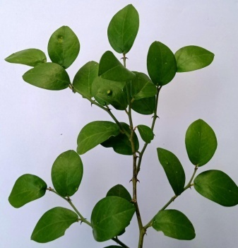 | 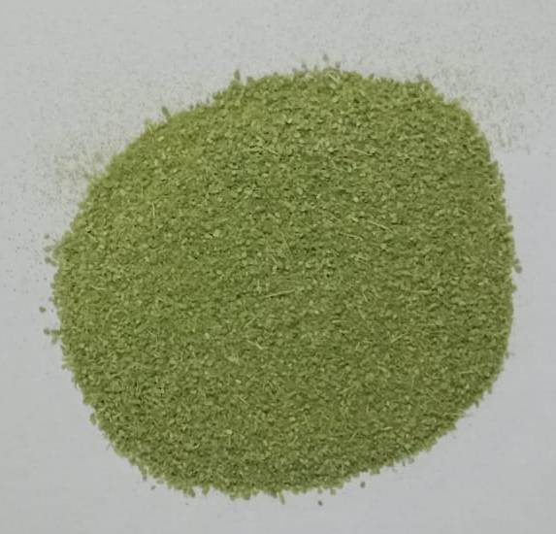 | Kingdom | Plantae
 |  | Phylum | Tracheophyta
 |  | Class | Magnoliopsida
 |  | Order | Capparales
 |  | Family | Capparaceae(caper family)
 |  | Genus | Capparis
 |  | Species | Capparis zeylanica.L
 |  | Common name | Ceylon coper,Indian caper
 |  | Tamil name | Adondai, Karrottai

Synthesis of Mn-Ni-Zn Nanoparticles
25ml stock solution of leaf extract was slowly added into 10ml of solution of Mn-Ni-Zn under continuous stirring for20 minutes. After the complete addition of leaf extract, the colourless solution changed into pale yellow colour, after 20min colour changed from pale yellow to reddish brown which indicates formation of Mn-Ni-Zn. Then the solution was centrifuged at 6000 rpm for 15min.

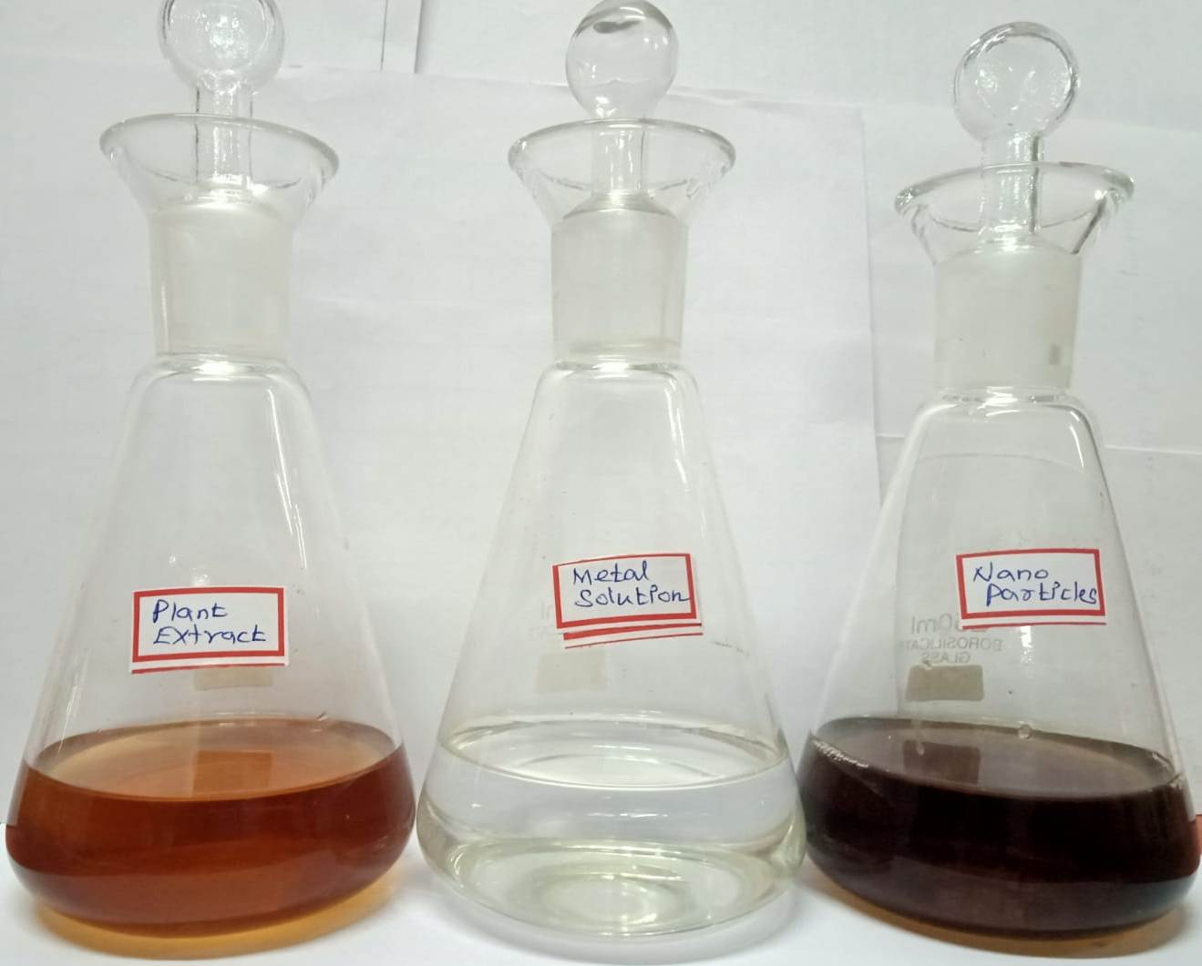

Fig.4.Synthesis of Nanoparticles

Characterization
The UV-Visible spectral measurements were used to confirm the formation of Mn-Ni-Zn by using PERKIN ELMER-UV-WIN spectrophotometer instrument in the range between 200-800nm [22]. FTIR experiment to were carried out to determine the biomolecules present in the leaf extract responsible for the reduction of Mn-Ni-Zn ions with 400- 4000 cm⁻¹ of spectra range. The sample was centrifuged at 9000 rpm for 15min, then dried and ground with KBr to for a pellet and analyzed on PERKINELMER-FTIR model. The sample were prepared on a carbon coated grid by just dipping a very small amount of the prepared Mn-Ni- ZnNPs on the grid, by using blotting paper the extra solution was isolated, then the sample were allowed to dry for SEM analysis using Suprazeis with resolution of 1nm at 30kV with 20mm Oxford EDS detector.

Phyto Chemical Screening
Qualitative phytochemical of [23] the following tests were performed on extracts to detect various phytochemicals present in them.
Table.2. Phyto chemical Screening analysis of plant material
Test | Specific Test | Reagent Composition | Observed Color | Inference
Detection of Flavonoids | Ferric chloride Test | Solution when treated with a drop of Ferric chloride | Blackish red color | Presence of Flavonoids
Detection of Alkaloids | Mayer’s Test | Extract mixed with ammonia and then with chloroform solution. Dil HCl was added. Acid layer with a few drops of Mayer’s reagent. | Creamy white precipitate | Presence of Alkaloids
Detection of Tannins | - | 5ml of extract, FeCl₃ was added. | Deep blue (or) greenish black color | Presence of Tannins
Detection of Glycosides | Keller killani’s Test | Dissolved the extract in water with glacial acetic acid, FeCl_{3,}Con.H₂SO₄ | Brown ring | Presence of Glycosides
Detection of Steroids | Salkowski’s of Steroids | 2ml of extract, 2ml of chloroform was added, followed by 3ml of H₂SO_{4.} | Reddish brown color | Presence of Steroids
Detection of Phenols | - | Extract was dissolved in 5ml of distilled water. Few drops of neutral 5% FeCl₃ solution was added. | Dark green color | Presence of Phenolic Compound.
Detection of Saponis | - | A pinch of dried powdered plant was added to 2-3 ml of distilled water. The mixture was shaken vigorously | - | Presence of saponis
Detection of Carbohydrates | Molish Test | Powdered plant extracts 1ml of napthol solution.con. H₂SO₄ was added to the sides of test tube | Purple (or) reddish Violet color | Presence of Carbohydrates
Detection of Proteins | Xanthoprotein Test | Few mg of powder 1ml of Con.HNO₃ was added. It was then boiled and cooled | White precipitate | Presence of Proteins
Detection of Amino acid | - | 3ml of test solution and 3 drops of 5% Ninhydrin solution were added in test tube and heated in water bath for 10 minutes. | Purple (or) bluish Color | Presence of Amino acid

III.RESULT AND DISCUSSION
A. UV-Vis Spectroscopy Analysis
The change in colour of the mixture from brown to sea green within few minutes indicates the formation of metal nanoparticles. On allowing the solution for a day, it becomes darker solution than previous colour. UV-Visible spectroscopy analysis of plant extract and Mn-Ni-Zn nanoparticles was confirmed and shown in Figure 2.a and Figure 2.b.When the plant35 extract was added into the Mn-Ni-Zn solution the pale yellow color was obtained. After 20 minutes, the colour changes from pale yellow to dark reddish brown. The absorption spectra of Mn-Ni-Zn nanoparticles formed in the reaction mixture was obtained by the UV-Vis analysis at the range between 200-800nm, the Mn-Ni-ZnNPs has sharp absorbance with highest peak at 438nm and progressively decreased while increased [24]
B. FTIR Analysis
FTIR measurement was done to identify the reducing ,capping and stabilizing capacity of Capparis zeylanica leaf extract. The FTIR analysis was done for both plant extract and Mn-Ni-Zn NPs. In Figure 3a, aqueous plant extract shown the peaks at 1636cm⁻¹ , 2119.75cm⁻¹ , 3331.76cm¹, 592cm⁻¹ the peak at 2119.75cm⁻¹ shows the bonds due corresponds to in alkynes[25] and 3331.76cm⁻¹corresponds to O-H stretching of carboxylic acid C≡C stretching like gallic acid, acetic acid and gibberellic acids;1636 C=O cm⁻¹ Stretching [26], 592cm⁻¹ C-Cl Stretching s Peak at 1636cm⁻¹ was a strong absorption peak which indicates the characteristics IR absorption of polysaccharides shows the bonds due to C=O stretching, amines[27]. Whereas the Mn-Ni-Zn nanoparticles present in the solution shows the peaks at around 1637,2123.39, 3331.73, 592.51 Figure 3b. The peak at 1637cm⁻¹corresponds to C=O stretching,(amides). Peak at 2123.39cm⁻¹corresponds to C≡C stretching of phenolic compound. 3331.73 cm⁻¹ Where as the other peaks obtained in Mn-Ni-Zn nanoparticle sample due to O=H stretching of hydroxyl groups[28,29].Particularly the plant leaves contained the chemical constituents of phenolic compounds, Alkaloids, flavonoids ,and fatty acids, such as thioglycoside, β-carotene, glycocapparin, α-amyrin are acting as a capping and reducing agents[30].
C. Scanning Electron Microscopy (SEM) analysis
The surface morphology of Mn-Ni-ZnNPs was analyzed by scanning electron microscope it was performed by EVO-18 CAREL ZEISS model an operating on the voltage of 10 kV and for operation need a very small amount of dry powder sample put on a grid and removed excess sample with the help of blotting paper. Shape and morphology of the synthesized nanoparticles were identified by scanning electron microscope analysis. Then nanoparticles were examined under various magnifications of X10,000, X25,000, X35,000 and X45,000 SEM images of the synthesized Mn-Ni-Zn nanoparticles are shown in Fig.4 It shows relatively spherical shaped nanoparticles. It was shown that spherical and relatively uniform shape of the Mn-Ni-Zn nanoparticles in the range 253-350 nm.
Fig.4. SEM images of Synthesized Mn-Ni-Zn nanoparticles

IV.CONCLUSION
In the ﬁeld of nanotechnology, improvement of reliable and ecopleasant techniques for the synthesis of steel nanoparticles is top need. The gift look at fulfills the objective of ‘Green’ synthesis of Mn-Ni-Zn nanoparticles with the aid of a simple method. The Mn-Ni-Zn alloy nanoparticles have been efficaciously synthesized with the aid of using novel Capparis zeylanica plant leaves as first time, which offers price effective, easy and proficient manner for synthesis of Mn-Ni-ZnNPs. The useful institution gift inside the leaf extract changed into showed via FTIR analysis. The traits of the received Mn-Ni-Zn alloy nanoparticles have been studied using UV-Vis, FTIR, SEM evaluation techniques. The experimental effects showed that the synthesized Mn-Ni-Zn nanoparticles are strong with a median length of approximately 253-350 nm.

V. REFERENCE
- Ghorbani,H . R.,A.A.Safekordi,H. AttarandS. Sorkhaba- di, 2011. “Biological and non-biological methods for silver nanoparticles synthesis”. Chemical and Biochemical Engineering quarterly, 25 (3): 317-326.
- Veerasamy,R., T.Z. Xin,S. Gunasagaran, T.F.W. Xiang, E.F.C. YangandN. Jeyakumar,2011.”Biosynthesisofsilver nanoparticles using mangosteen leaf extract and evaluation of their antimicrobial activities”. Journal of Saudi Chemical Society, 15 (2):113-120.
- Mittal, A.K., Y.Chisti and U.C.Banerjee, 2013. “Synthesis of metallic nanoparticles using plant extracts”. Biotechnology Advances, 31 (2): 346 56.
- Iravani, S., 2011. “Green synthesis of metal nanoparticles using plants”. Green Chemistry, 13 (10): 2638-2650.
- Mittal,J., A.Batra, A.SinghandM.M.Sharma,2014. “Phytofabrication of nanoparticles through plant as nanofactories”. Advances in Natural Sciences: Nanoscience and Nanotechnology, 5 (4): 043002.
- Saranyaadevi, K., V.Subha,R.E. Ravindran and S.Renganathan, 2014. Synthesis and characterization of copper nanoparticle using Capparis zeylanica leaf extract. International Journal of Chemistry, Technology and Research, 6(10) : 4533-4541 .
- Christopher L, Kitchens, Douglas E,Hirt,Scott M, Husson, Alexey A, Vertegel. Synthesis, Stabilization, and Characterization of Metal Nanoparticles. The Graduate School of Clemson Universit y 2 010;
- Hasna Abdul Salam, Rajiv P , KamarajM, Jagadeeswaran P, Sangeetha Gunalan and Rajeshwari Sivaraj. Plants: Green Route for Nanoparticle Synthesis. Inter. Res .J . Bio.Sci.2012;1(5):85-90.
- Geoprincy G, VidhyasrrBN, Poonguzhali U, NagendraGandhiN, Renganathan S. A review on green synthesis of silver rnanoparticles. Asian.J . Pharma.Clini.res.2013; 6(1):8–12.
- Akl MAwwad1, Nidà M. Green Synthesis of Silver Nanoparticles by Mulberry Leaves Extract Nanoscience and Nanotechnology.2012;2(4):125-128.
- Umesh B. Jagtap, VishwasA. Bapat.Green synthesis of silver nanoparticles using Artocarpus heterophyllus Lam. Seed extract and its anti bacterial activity. Industrial Crops and Products.2013; 46:132–137.
- Nethra Devi C, Sivakumar P, Renganathan S ,Green synthesis of silver nanoparticles using Datura metel flower extract and evaluation of their anti imicrobial activity .Inter.J. Nanomat.Biostruct.2012;2(2):16 –21.
- Choi , Hyungsoo, and Sung-HoPark."Seedless growth offree-standing copper nanowires by chemical vapor deposition."Journal of the American Chemical Society126, 20 (2004):6248-6249.
- Huang, Lena, HeqingJi ang, Jisheng Zhang, Zhijun Zhang, and Pingyu Zhang."Synthesis of copper nanoparticles containing diam ond-like carbon films bye lectrochemical method." Electrochemistry Communications8, no. 2 (2006): 262-266.
- Joshi,S. S., S. F. Patil, V. Iyer, and S.Mahumuni. "Radiation induced synthesis and characterization of copper nanoparticles." Nanostructured materials 10, no. 7 (1998):1135-1144.
- Dhas,N. Arul,C. Paul Raj,and A.Gedanken. "Synthesis, characterization, and properties of metallic copper nanoparticles."Chemistry of materials 10,no. 5 (1998):1446-1452.
- Hashemipour, Hassan, Maryam Ehtesham Zadeh, Rabee Pourakbari,and Payman Rahimi. "Investigation on synthesis and size control of copper nanoparticle via electro chemical and chemical reduction method."International Journal of PhysicalSciences6, 18 (2011):4331-4336.
- Saranyaadevi, K., V. Subha, RS ErnestR avindran, and S. A.H. A.D.E.V.A.N. Renganathan. "Green synthesis and characterization of silver nanoparticles using leaf extract of Capparis zeylanica."Asian J. Pharm.Clin. Res 7 (2014):44-48
- Lather Amit, Chudhary AmrendraKumar, GuptaVikas, Bansar Parveen, BansarRenu. Phytochemistry and Pharma cological Activities of Capparis zeylanica: anover view.Inter.J.Pharma.Anal.Res2010;1(2):384-389.
- DhabalePN, ShrikhandeVN SakharkarDM. Physicochemicals and Phytochemicals Evaluation of Capparis Zeylanica Linn Inter.J.Pharma.Sci.Res.2012;3(1):198-200
- K Saranyadevi, Vsubha, ErnestR and S Renganathan 2014. Chennai, India IJ.Chem Tech Research, 64533-4541
- Muthu Karuppiah, Rangasamy Rajmohan. Green synthesis of silver nanoparticles using Ixora coccinea leaves extract.MaterialsLetters2013;97:141–143.
- Kokate CK, purohit AP, Gokhale SB (1995) Pharmacognosy, 3rd edition, Nlrall prakashan, pune, india.
- Suman TY, Radhika Rajasree SR, Kanchanab A, Beena Elizabethc SS. Biosynthesis, characterization and cytotoxic effect of plant mediated silver nanoparticle susing Morinda citrifoliaroot extract. Colloids SurfB: Biointer faces 2013;106:74–78.
- Mehrdad Forough1, Khalil Farhadi. Biological and green synthesis of silver nanoparticle TurkishJ. Eng.Env.Sci. 2010;34:281-287.
- Rajathi1K, Sridhar S. Green Synthesized Silver Nanoparticles from the Medicinal Plant Wrightia Tinctoria and Its Antimicrobial Potential. Inter.J. ChemTech Res: 2013; 5 (4):1707-1713.
- .Jannathul Firdhouse M, Lalitha P. Green Synthesis of Silver Nanoparticle susing the aqueous extract of Portulaca Oleracea (L.). Asian.J.Pharma.Clinic.Res2013;6(1).
- Rastogi L, Arunachalam J. Sun light based irradiation strategy for rapid green synthesis of highly stable silver nanoparticles using aqueous garlic (Allium sativum) extract and their antibacterial potential. Mat. Chem. Physics. 2011; 129: 558 –563.
- Prakash P, Gnanaprakasam P, Emmanuel R, ArokiyarajS, Saravanan M. Green synthesis of silver nanoparticles from leaf extract of Mimusops elengi, Linn. For enhanced antibacterial activity again stmulti drugresis tantclinical isolates. Colloids and Surf B: Biointerfaces. 2013; 108:255–259.
- Baker C, Pradhan A, PakstisL, Pochan DJ, Shah SI. Synthesis and Antibacterial Properties of Silver Nanoparticles. Nanosci. Nanotechnol. 2005; 5:224-249.

