A STUDY ON THE BIOCHEMICAL & MORPHOLOGICAL CHANGES ON GROUNDNUT (Arachis hypogaea) SEEDS EXPOSED TO PULSED MAGNETIC FIELD
D. Saravanan* and KR. Velunachiyar Department of Biochemistry Department of Biochemistry, Dwaraka Doss Goverdhan Doss Vaishnav College,Arumbakkam,Chennai-600106

*Corresponding author:
Dr. D.Saravanan
Assistant Professor,
Department of Biochemistry,
Dwaraka Doss Goverdhan Doss Vaishnav College,
Arumbakkam,Chennai-600106.
saravanan@dgvaishnavcollege.edu.in
ABSTRACT:
Arachis hypogeae seeds were exposed to a pulsed magnetic field of sine wave form with varying frequencies as 100, 500, 1000 Hz and constant intensity of about 1500 nT. The seeds were exposed to frequency of 100 Hz is taken as Test-1, 500 Hz as Test – 2, 1000 Hz as Test10– 3. Seeds are subjected to the high pulsed magnetic field for a time interval of 5 hours per day for 15 days. After the exposure time over, on the 16 th day, the estimations are carried out for carbohydrates, proteins, amino acids, nucleic acids (DNA &amp; RNA), enzymes (Amylase &amp;Protease).It is seen from the experiment that the magnetic field has enhanced the morphological and biochemical parameters of the seeds.From our investigation, it was studied that, Test 3 has maximum stimulating effect on the enzyme activity, Test 1 has shown increase in the biochemical parameters and Test 2 shows an increase in some biochemical parameters, but it is not steady as above two.Thus, this frequency might provide a feasible non – chemical solution for seeds germination. Therefore, it is evident that the use of varying magnetic field frequency will definitely proves to be a pretreatment catalyst in agriculture promoting vigor growth and good yield of crops. This is a best alternative way in place of pesticides will definitely help in protecting environment.

KEYWORD: Magnetic field,frequency,parameters,growth,crops

INTRODUCTION
The Earth behaves like a very large bar magnet with a north pole and a south pole. It is now believed that the Earth's magnetism is due to the magnetic effect of current which is flowing in the liquid core at the center of the Earth. Thus, the Earth is a huge electromagnet.
The origin of our knowledge of Magnetism has been lost in antiquity, only vague reference being available during years of the Christian era. It is claimed that Chinese scholars were aware of the mysterious property of Magnetism as early as 2600. The possibility that magnetic field might have an influence on the biological process has been long discussed. It has been well established that magnetic field has an influence on the germination of seeds, activation of protein formation and root growth. A survey of the plant life near high voltage transmission lines suggested that electric field caused a slight enhancement of growth.

The first studies were conducted by P.W.Savostin in 1930 who observed increase in the rate of elongation of wheat seedling under magnetic condition. Later, Murphy in 1942 reported changes in seed germination due to a magnetic field. Until the 19th century electricity and magnetism was treated as two different branches of physics. It was Ampere who theorized the influence of electricity and Magnetism on each other.

MAGNETIC FIELD
The force they apply to other magnetic materials and moving electric charges, magnetic fields that surround magnetic objects and electric currents can be identified.Both the direction and the magnitude (or strength) of the magnetic field at any one site are known. A zone of space around a magnetized body or current is known as a magnetized region of space. carrying circuit where the magnetic force produced may be measured. a problem identified in the area surrounding a magnet or electric current that is identified by the presence of a magnetic force that can be measured at every location in the area and by the presence of magnetic poles.

DEFINITION
The "magnetic field"—a force of magnetism emanating from the magnet—is depicted by lines. When the lines of force are close together (turned) and when they are far apart (blue), the magnetic field is at its strongest.

MAGNETIC FORCE
A magnetic field exerts a magnetic force, also called Lorentz-force, Fm on a charged particle moving with velocity v
Fm=qvB

where the arrows are multiplied to produce a new arrow that is perpendicular to the magnetic field and velocity directions. This equation gives the definition of the magnetic field (the force acting on a unit charge travelling at a unit speed) and gives rise to the SI unit known as 1 Tesla (T).
The magnetic field is stationary and is referred to as a magnetostatic field when it surrounds a permanent magnet or a wire carrying a constant electric current in one direction. Its magnitude and direction are constant at any given site. The magnetic field is constantly changing in strength and direction around an alternating current or a fluctuating direct current. Continuous lines of force or magnetic flux that leave north-seeking magnetic poles and enter south-seeking magnetic poles can be used to illustrate magnetic fields. The lines' density reveals how strong the magnetic field is. The field lines are congested or more dense, for example, at the poles of a magnet where the magnetic field is high.Where the magnetic field is weaker and further away, they fan out and lose density. Parallel straight lines that are evenly spaced apart represent a homogenous magnetic field.

SOURCES OF MAGNETIC FIELD

- The magnetic fields are produced by the poles (north and south).
- If electrostatic charges move, they produce magnetic fields.
- Any charged particle that travels along a path will produce a magnetic field. It can also be impacted by an external magnetic field, on the other hand.
- A magnetic dipole, similar to one seen in an atom, might be produced by the separation of charges. (Positive nucleus surrounded by a cloud of negatively charged electrons).
- The mobility of electrons within a conductor is one possibility. Electrical current flowing via a wire.
- The electromagnetic force is one of the universe's four fundamental forces. The electromagnetic force, not the magnetic one. There won't be a magnetic field if there isn't any moving charge. Both phenomena are inextricably linked.
ELECTROMAGNETIC FIELD
A property of space that results from the movement of an electric charge. Only an electric field will be created by a stationary charge in the surrounding area. There is also the creation of a magnetic field when the charge is traveling. A shifting magnetic field can likewise create an electric field. An electromagnetic field is created when the electric and magnetic fields interact. This field is thought to exist independently of any charges or currents (a stream of moving charges) to which it may be associated. When particular conditions are met, this electromagnetic field can be thought of as a wave that carries electromagnetic energy. Depending on the frequency, electromagnetic fields, waves, and impulses have distinct regions.

- ELF- occupy frequency band between 3 Hz and 3kHz (extremely low frequency region)
- VLF-occupy region between 3Hz to 30kHz(very low frequency region)
- ULF-occupy region of < 3Hz(ultra low frequency region)
poles. Two magnets will be attracted by their opposite poles, and each will repel the like pole of the other magnet. Magnetism has many uses in modern life.

Generation of Magnetic Fields

- Static Magnetic Field: A simple bar magnet has got the magnetic lines of force travelling from its north (N) pole to its south (S) pole.
- DC Magnetic Field: If in the place of a magnet, we have a coil of wire carrying a Direct Current (DC) from a battery.
- Pulsed Magnetic Field: With an Alternating Current (AC) generator in the place of a battery, we have a current surging forward and backward in the coil windings generating a magnetic field surging back and forth in the coil along its axis.

Parameters
There are 4 important parameters for PMF. They are,
- Amplitude

- Frequency

- Wave Shape

- Duration of Exposure

Four different wave forms are

- Sine wave
- Square wave
- Ramp wave
- Pulse group

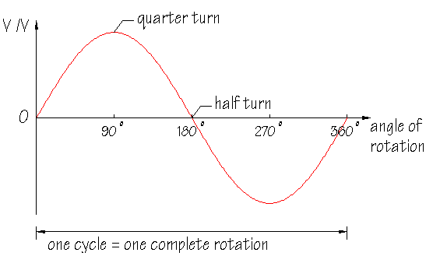

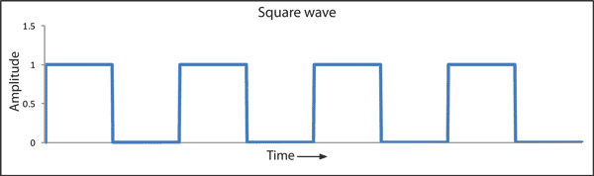

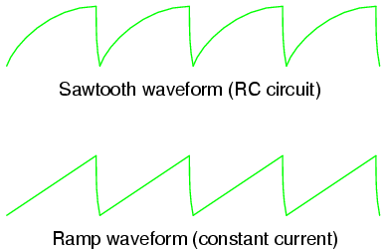

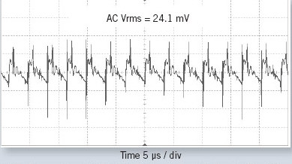

APPLICATION OF PULSED MAGNETIC FIELD
The pulsed magnetic field has been used in various fields like medicine, biotechnology, biomass, agriculture, genetics etc.
healing, colitis/Irritable Bowel Syndrome, osteoarthritis, migraine headaches and more, PEMF uses electrical energy to direct a series of magnetic pulses through injured tissues whereby each magnetic pulse induce a tiny electrical signal that stimulate cellular repair.

BIOLOGICAL SAMPLE
Arachis hypogaea (GROUND NUT)

This is just one use for a pulsed magnetic field. The field germination rates of seeds can be increased by treating them with PMF since it speeds up seed germination, encourages further plant growth, and boosts grain and vegetable output.

We will use groundnut in this instance as our sample for the pulsed magnetic field. Because they are legumes, peanuts work in symbiosis with particular Rhizobium bacteria to fix, or manufacture, their own nitrogen. Arachis hypogaea L. is the official scientific name of the self-pollinating plant species that produces peanuts.

BINOMIAL CLASSIFICATION

- Domain : Eukarya
- Kingdom : Plantae
- Phylum : Magnoliphyta
- Class : Magnoliopsida
- Order : Fabales
- Family : Leguminosae
- Sub-family : Papilionaceae
- Genus : Arachis
- Species : hypogaea

The two subspecies of peanuts are hypogaea and fastigiata. The hypogaea subspecies, in general, mature later, have a high water requirement, have alternate branching patterns, and generate huge seed because they do not blossom on the main stem. The fastigiata subspecies has sequential branching, produces blooms on the main stem, matures quicker than the other subspecies, requires less water, and has less seedf production.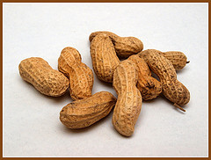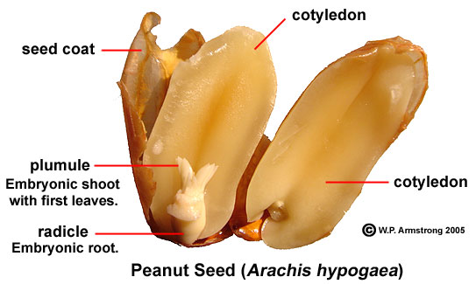
FIG: 1 PEANUT SEEDS
NUTRIENTS IN GROUNDNUT
Nutrient-dense peanuts include more than 30 phytonutrients and vital minerals. Niacin, folate, fiber, magnesium, vitamin E, magnesium, and phosphorus are all nutrients that are abundant in peanuts. Additionally, they naturally lack salt and trans fats and have a protein content of roughly 25%, which is higher than that of any genuine nut.
Nutritional value per 100g

Energy 2,385 KJ (570Kcal)
Carbohydrate 21g
Sugar 0.0g
Dietary fiber 9g
Fat 48g
Fatty acid
Saturated 3g
Monounsaturated 24g
Polyunsaturated 16g
Protein 25g
Water 4.26g
Vitamins
Thiamine (vit.B1) 0.6 mg(52%)
Niacin(vit.B3) 12.9mg(86%)
Pantothenicacid 1.8mg(36%)
Vit. B6 0.3mg(23%)
Folate(vit.B9) 246μg(62%)
Vit.C 0.0g
Calcium 62mg(6%)
Iron 2mg(15%)
Magnesium 184mg(52%)
Phosphorus 336mg(48%)
Potassium 332mg(7%)
Zinc 3.3mg(35%)

AIM AND OBJECTIVE
AIM
To determine the biochemical and morphological changes on groundnut seeds exposed to pulsed magnetic field.

OBJECTIVE
To evaluate if there is any changes in seeds after exposed to pulsed magnetic field of beneficial parameters such as carbohydrate, protein, amino acid, nucleic acid, and enzyme activities
MATERIALS
Pulsed Magnetic Field Exposure
A specifically constructed Controlled Magnetic Field (CMF) enclosure was used to produce the pulsed magnetic field (PMF) that was employed in the studies. The three-member coil system of the CMF enclosure, which was created using Fansleau and Braunbeck's fundamental equations, consists of two sets of circular coils, the inner two of which have a larger diameter than the outer two, and all four of which are positioned coplanarly and coaxially. The four coils are each wound with the same number of turns of enameled copper wire, and they are all electrically linked together in a configuration known as "series-aiding." The two sets of coils' diameter ratios and the distance (or spacing) between them are calibrated in such a way that the entire disc-shaped volume between the inner (bigger) coils provides the most homogenous (i.e., homogenous) magnetic field. A part in 5000 is about how homogeneous this arrangement .This Fansleau and Braunbeck coil system is an improved version of the traditional Helmholtz 2-coil system that offers a vast volume of extremely uniform magnetic field that is 20 to 30 times larger than that provided by a Helmholtz coil with identical physical dimensions.A function generator (PLATE: 3) that allows for precise control of the output current's intensity, frequency, and waveform powers the coil system with pulsed electric current. Consequently, the coil system is giving a highly homogeneous or uniform pulsating magnetic field along its axis.An UPS system is integrated into the supply circuit, which provides uninterrupted power regardless of any power failures, to ensure that the alternating current power supply to the function generator (domestic electric power) is not stopped during the PMF exposure. Regarding the PMF presentation geometry, all of the CMF coil assemblies were maintained with their axes vertical, allowing the PMF axis to pass through the test objects vertically.
The Madras Institute of Magnetobiology's magnetic standardization lab uses high-precision magnetometers and current measuring equipment to properly calibrate the coil assemblies that were designed and made there. Using a magnetometer to make these measurements .

The PMF for exposure of dry seeds is obtained from a standard function generator, wherein a “carrier wave” of frequency 100 Hz is “frequency - modulated” by another wave of 0.3 Hz. In principle with the above system the input pulsating magnetic field will be a constant intensity where whose frequency pulses at 0.3 sec frequency.
Exposure Details
50g of Ground nut seeds are taken in 3 packets. The seeds are exposed to pulsed magnetic field of frequency [T₁- 100 Hz, T₂ – 500 Hz, T₃ – 1000 Hz] with intensity ±1500 nT, current of 30mA using sine wave for 5hrs duration per day for a period of 15 days. Seeds without exposure to pulsed magnetic field served as control. The seeds exposed to PMF are in dry condition.

- Control - Seeds not exposed to magnetic field
- Test 1(T₁) - Seeds exposed to 100 Hz
- Test 2(T₂) - Seeds exposed to 500 Hz
- Test 3(T₃) - Seeds exposed to 1000 Hz

PLATE 1
Arachis hypogeae (GROUND NUT) Seeds Exposed to Pulsed Magnetic Field 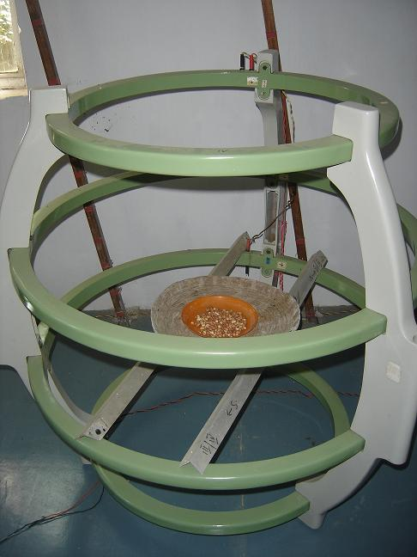

RESULTS & DISCUSSIONS
MORPHOLOGICAL ANALYSIS
25 seeds from each exposed samples were counted and soaked separately for overnight. After the seeds were soaked overnight the seeds were sown in three different pots. The unexposed control seeds were also sown in separate pot. The seeds were allowed to germinate and the studies of their growth parameters like there root and shoot length, fresh and dry weights were studied on the 15th day of germination. The seeds started emerging on the 4 th day of germination. On the 7th day, under control - 2 plants, in T1 – 4 plants, T2 – 5 plants and in T3 - 3 plants were grown.
S.NO | PARAMETER | CONTROL | TEST - 1 | TEST - 2 | TEST - 3
1 | Percentage of Germination | 60 | 28 | 84 | 32
2 | Shoot Length | 9.00 | 14.00 | 23.50 | 19.00
3 | Root Length | 2.00 | 4.00 | 5.50 | 5.00
4 | Fresh Weight | 3.34 | 3.10 | 4.81 | 4.17
5 | Dry Weight | 1.68 | 1.26 | 2.36 | 1.91
6 | Moisture content | 49.64 | 59.28 | 50.94 | 54.16

MOISTURE CONTENT
By obtaining the fresh and dry weight of the samples, the moisture content of the samples, control, T1, T2, T3 were calculated using formula:

$$Moisture Content=\frac{\left(Fresh Weight\right)− (Dry Weight)}{Fresh Weight}∗100$$

PLATE: 3
GERMINATION OF PEANUTS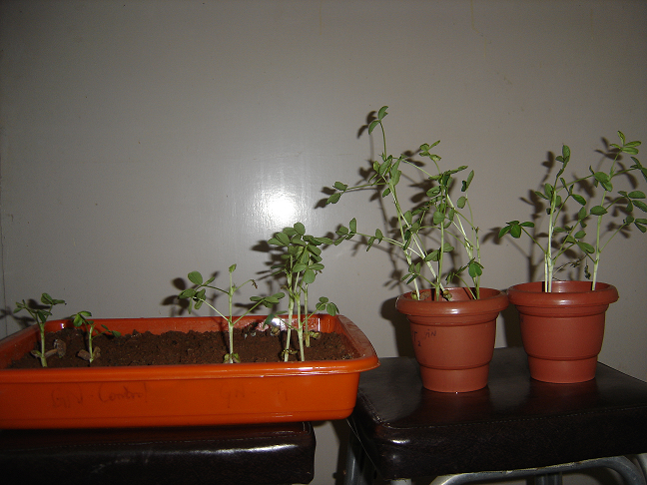

PLATE: 4
ANALYSIS OF SEEDLINGS
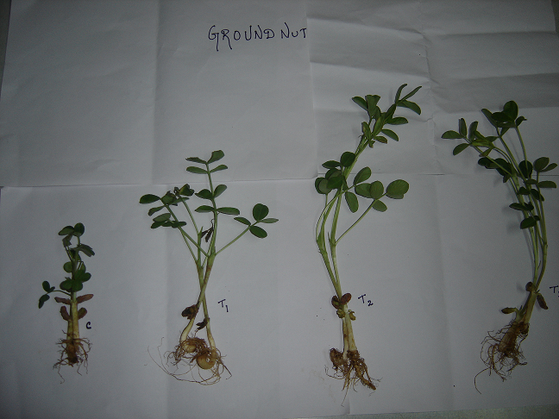
In order to pre-treat seeds, a pulsed magnetic field must be applied to them. It encourages more plant development, speeds up seed germination, and increases grain and vegetable crop yields. Magnetic fields fluctuate throughout time, which affects the bio-electric field within or surrounding the cell and alters how permeable the cell membrane is. Depending on the type of magnetic therapy employed, such as the magnetic field's strength, frequency, or exposure time, the beneficial benefits on seedlings have been observed in a number of circumstances. During development, plants convert various growth responses into physical and chemical signals (such as light, gravity, phytohormones, etc.). These environmental or physiological studies open the door for cellular, biochemical, and molecular development projects in the future.In order to pre-treat seeds, a pulsed magnetic field must be applied to them. It encourages more plant development, speeds up seed germination, and increases grain and vegetable crop yields. Magnetic fields fluctuate throughout time, which affects the bio-electric field within or surrounding the cell and alters how permeable the cell membrane is. Depending on the type of magnetic therapy employed, such as the magnetic field's strength, frequency, or exposure time, the beneficial benefits on seedlings have been observed in a number of circumstances. During development, plants convert various growth responses into physical and chemical signals (such as light, gravity, phytohormones, etc.). These environmental or physiological studies open the door for cellular, biochemical, and molecular development projects in the future.

ANALYSIS OF BIOCHEMICAL PARAMETERS

S.NO | PARAMETER | CONTROL | TEST - 1 | TEST - 2 | TEST - 3
1 | CARBOHYDRATES | 22 | 46 | 40 | 28
2 | PROTEIN | 80 | 88 | 14 | 100
3 | AMINO ACIDS | 3.9 | 3 | 4 | 3.4
4 | PROTEASE | 3.5 | 0.7 | 2.6 | 0.5
5 | DNA | 80 | 224 | 168 | 136
6 | RNA | 360 | 368 | 376 | 160
7 | α - Amylase | 40 | 32 | 56 | 88
8 | β - Amylase | 0.04 | 0.08 | 0.11 | 0.04

The present study has been framed with the objective to study the effect of pulsed magnetic fields on various biochemical parameters of Arachis hypogaea seeds.

FIGURE: 1 ESTIMATION OF CARBOHYDRATES

In experiments conducted to estimate the amount of carbohydrate showed a gradual increase in Test-1, Test-2 and Test-3 when compared to control. Analysis of the total content of carbohydrates present in the given samples shows that there is only a slight variance in the level of carbohydrates compared to that of the control. The total amount of carbs remained relatively unchanged when PMF was raised. (Yu. I. Novitsky et al., November 2001).

FIGURE: 2 ESTIMATION OF PROTEINS

The amount of protein present in the given sample was estimated by the Lowry’s method. There is an increase in the Test 2, Test 1 and Test 3 values as compared to the control. The increase in the protein content is supported by the works of SemaAlikamanoglu and Ayse Sen, “stimulation of growth and some biochemical parameters by magnetic field in wheat tissue cultures”.Sema Alikamanoglu ⁽³⁷⁾ (2011) studied the effects of magnetic field (2.9 to 4.8 mT by 1ms⁻¹) applied to mature embryos of wheat variety.They determined the various physiological and biochemical parameters(protein ,enzyme activities) .Protein content in mature embryo culture exposed to magnetic field showed increase by compared to control respectively.

FIGURE:3 ESTIMATION OF AMINOACIDS

The amino acid content of our samples has been determined. There is only slight variations with control and Test-2 .Test-1 and Test-3 are less compared to control (unexposed seeds). These results are supported in the paper ELF magnetic fields boost the uptake of amino acids by Vicia faba L. roots and modify ion transport across the plasma membrane. B.C. Stange and others (38). (2002) demonstrated a substantial increase in amino acid uptake into undamaged roots in Vicia faba seedlings exposed to a 10 T 50 Hz square wave magnetic field for 40 min together with a radioactive pulse. A square wave of 100 T and 50 Hz resulted in a more subdued growth.

FIGURE:4 ESTIMATION OF PROTEASE

According to the current study, exposed seeds had less protease activity than the control seeds, which were not treated. An enzyme called protease is responsible for the process of proteolysis, which involves breaking down long protein chains into smaller pieces by severing the peptide bonds that connect amino acid residue. P. Rajendra (39) examined the "effects of power frequency electromagnetic field on growth of germinating Vicia faba L., the broad bean" in his research. A model system, the growing Vicia faba seedling, was used in the experimental investigations to determine the effects of continuous and delayed exposure to power frequency electromagnetic field at 5, 50, and 100 T. On the second and fourth days of their investigation, they examine physiological variables, biochemical components, and enzyme activities.

FIGURE:5 ESTIMATION OF DNA

FIGURE: 6 ESTIMATION OF RNA

In the experiments conducted to estimate the Nucleic acid content it is seen that there is an increase in all the test values in the amount of DNA as compared to the control. Similarly there is an increase in Test-2 as compared to control in the amount of RNA .Test-1 showed equal value of control were Test-3 is less than control preliminary studies by M.Racuciu et.al,⁽⁴⁰⁾ 2006, applied five different static magnetic field induction values, ranging from 50mT to 250mT, for 14 days (Zea mays).They looked into how chlorophyll, cartenoid, and nucleic acid underwent biochemical changes. In contrast to the control sample, the average nucleic acid level is increased in low magnetic field energy density, however an inhibitory effect on the average nucleic acid level was seen with increasing magnetic field energy density.
FIGURE: 7 ESTIMATION OF α – AMYLASE

FIGURE: 8 ESTIMATION OF β – AMYLASE

In experiments conducted to estimate the enzyme activity,α-Amylase showed a marked gradual increase in Test 1, Test 2 as compared to the control. Test 3 decreased drastically compared to that of control, Test 1 and Test 2. In the case of β-Amylase, the enzyme activity is seen increased in Test-1 and Test-2 compared to control. Jyotsna Bhardwaj et.al ⁽⁴¹⁾, Biochemical and biophysical changes associated with magneto priming in germinating cucumber seeds. The activity of hydrolytic enzymes were greater than untreated control (2012).

REFERENCE
- Abdelrahim A, et.al, “effects of pulsed magnetic field on healing of Mandibular fracture”, Joural of oral ad maxillofacial surgery, Vol – 69, issue 6, page – 1708 – 17.

- Mert.T, et-al, “Neurobiological effects of pulsed magnetic field on diabetes – induced neuropathy”, Bioelectromagetics, Vol – 31, issue – 1, page – 39 – 47, 2010.

- Pan.W, et.al, “Effects of pulsed magnetic field on the formation of magnetosomes in the Magnetospirillum Sp.strain AMB 1”, Bioelectromagnetics, Vol – 31, issue – 3, page – 246 – 51, 2010.

- Ch. Dahmani, et.al, “Rotational Magnetic pulses enhance the magnetofection efficiency in vitro in adherent and suspension cells”, Journal of Magnetism and Magnetic Materials., Volume 332, page 1 – 204, 2012.

- Sarah. W, et.al, “Enhancement of the efficiency of non-viral gene delivery by application of pulsed magnetic field,” Oxford Joural, nucleic acid research, Vol 34, Issue – 5, 2006.

- L.Zhang, et.al, “Effects of pulsed magnetic field microstructures and morphology of the primary phase in semisolid A 356 A1 Slurry,” Materials letters, vol 66, issue -1, page 190 – 192, 2012.

- Hunt RW, “Electromagetic biostimulation of living cultures for biotechnology, bio fuel and bio energy applications,” It. Journal Molecular Science, vol.10, issue 10, page 4515 -58, 2009.

- I.I. Nagy, et.al, “effects of pulsed variable magnetic fields over plant seeds”, Romanian, Journal of Biophysics, vol.15, page 133 – 139, 2005.

- Alegre RM, et.al, “Growth of Escherichia Coli, under extremely low frequency electromagnetic field”, Appl. Biochem Biotechnol, vol.134, issue 2 , page 155 – 163, 2006.

- Pilla A.A, et.al, “Pulsed magnetic fields accelerate Cutaneous waind healing in rats”, Plast Reconstr. Surg, vol.120, issue 2, page 425 430, 2007.

- Vashisth. A, et.al, “Exposure of seeds to static magnetic field enhances germination and early growth characteristics in chickpea”, Bioelectromagnetics, Vol.29, issue 7, page 571 – 578.

- Hunt. R.W., et.al, “Electromagnetic biostimulation of living cultures for biotech- nology, biofuel and bioenergy applications”, Internatioal journal of Molecular science, vol.10, issue 10, page 4515 – 58, 2009.

- Ananta Vashisth, et.al, “Effect of germination and early growth characteristics in sunflower (Helianthus annuces) seeds exposed to static magnetic field”, Journal of plantPhysiology, vol.167, issue 2, page 149 – 156, 2009.

- V.Nimmi, et.al, “Effect of pre-sowing treatment with permanent magnetic field on germination and growth of chilli”, International Agrophysics, vol.23, page 195 – 198, 2009.

- J.A. Odhiambo, et.al, “Effect of Static electromagnetic fields art 24 hours incubation on the germination of rose coco beans”, Romanian journal of Biophysics, vol.19, No.2, page 135 -147, 2009.

- Hanna Dorna, et.al, “Effects of permanent magnetic field together with the shielding of an alternating electric field on carrot seed vigour and germination”, Ecological chemistry and engineering , vol.17, No:1 ,2010.

- Radhakrishnan. R, et.al, “Pulsed magnetic field, a contemporary approach offers to enhance plant growth and yield of soybean”, Plant Physiol Biochem, vol.51, page 139 – 44, 2011.

- Hyun Sook Lee , “Effect of pulsed magnetic field stimulus o electroencephalogram Alpha activity”, Magnetics, vol.47, issue 10, page 3060 – 62, 2011.

- Shine M.B. , et.al, “Enhancement of germination, growth, and photosynthesis in soybean by pre-treatment of seeds with magnetic field”, Bioelectromagnetics, vol.32, issue 6, page 474 – 84, 2011.

- Iqbal, et.al, “Effect of pre-sowing magnetic treatment on properties of Pea”, International Agrophysics, vol.26, page 25 31, 2011.

- Anjali Anand, et.al, “Pre-treatment of seeds with static magnetic field ameliorates soil water stress in seedling of maize”, Indian Journal of Biochemistry and Biophysics , vol.49, page 63 – 70, 2011.

- Leelapriya. T, et.al, “Effect of pulsed magnetic field treatment of soybean seeds on Calli growth, Cell damage and biochemical changes under salt stress”, Bioelectromagnetics, vol.33, issue 8, page 670 81.

- Naz.A, et.al, “Enhancement in the germination, growth and yield of Okra using pre-sowing magnetic treatment of seeds, “Indian Journal of Biochem, Biophysics, vol.49, issue 3, page 211 – 14 , 2012.

- Mihaela Racuciu, “Influence of extremely lowfrequenmcy magnetic field on assimilatory pigments and nucleic acid in Zea mays, and curcubita pepo seedlings”, Romanian Biotechnological Letters, vol.17., No.5, 2012.

- K.Venkateswar Reddy, et.al, “Exposure of green gram seeds, to static magnetic field, effects on germination and α amylase activity”, Research Journal of seed science, vol.5, issue 3, page 106 – 114, 2012.

- Maroua Akacha Touat, et.al, “Effects of moderate SMF presowing treatment on seedling growth and oxidative status in two Raphanus sativus L varieties”, African journal of biotechnology , vol.12, issue.3, page 275 to 283 , 2012.

- Santosh kumar Tripathi, “Protein level changes under magnetic exposure of Larvae in Bombyx mori : A multivoltine mulberry silkworm, Academic journal of entomology, vol.5, issue.2 , page 73 to 80, 2012

- Dimitroios. J, et.al, “Magnetic field pre-sowing treatment as an organic friendly technique to promote plant growth and chemical elements accumulation in early stage of cotton” , Australian Journal of Crop Science, vol.7, issue 1, page 46-50,2013.

- Lowry O.H., Rose Borough N.J Farr A.L Randell R.J. (1951), Journal of biological chemistry, Volume 196, Pg. no:- 265.
- Carrol. N.V, Longley.N, and Reo.J.A (1956), Journal of Biological chemistry, Volume. 250, Pg.No. 283
- Lee X.P. and Thakaski T (1966), Estimation of Amino acids, Analytical Biochemistry. Volume 4: 152
- Burton.K (1956), Journal of Bio-chemistry, Volume 24, Pg.no:- 315.
- Ashwell.G (1957), Methods in Enzymology, Volume 3, Academic press, Newyork, Pg.no:-87
- Mc.Clearly.B.V., Gibson.J.S., Solah.V., and Mugford.D.C. (1994), Cereal chemistry, Volume 71, Pg.no:- 501 - 508.
- Nihon Naika Gakkai zasshi (1986), The Journal of the Japanese Society of Internal Medicine. Nippon Jinzo Gakkai shi. 28(4): 447- 454
- u.I. Novitsky, et.al, “Growth of green onions in a weak permanent magnetic field” Russian journal of plant physiology, vol.48, issue 6, page 709-716,2001.

- Alikamanoglu and Ayse sen, “stimulation of growth some biochemical parameters by magnetic field in wheat tissue culture”, African journal of biotechnology, vol.10, issue 53, page 10957210963, 2011.

- C.Stange,et.al, “ELF magnetic field increase amino acid uptake into vicia faba L. Roots and alter ion movement across the plasma membrane,” Bioelectro magnetics, vol.23, issue 5, page 347 to 354, 2002.

- Rajendra, et.al, “effects of power frequency electromagnetic fields on growth of germinating Vicia faba L., the broad bean”. Electro magnetic biology and medicine, vol.24, No.1, page 39 to 54, 2005.

- Racuciu, et.al, “Plant growth under static magnetic field influence”, Rom.Journal of physics, vol.53, page 353 to 359, 2006.

- yotsna Bardwaj. et.al. “Biochemical and Biophysical cxhanges associated with magneto priming in germinating cucumber seeds.” Plant physiological Biochemistry, vol.57, page 67 to 73, 2012.

