Protein Nanoparticles: Integrating the Strength of Proteins with Approaches from Engineering Design
T. Naga Aparna,
Assistant Professor,
Department of Pharmaceutics,
Sri Indu Institute of Pharmacy,
Sheriguda, Ibrahimpatnam,
INDIA
nagaaparna4@gmail.com
naga_aparna@yahoo.co.in

ABSTRACT
The nanomedicine era has lately undergone a transformation owing to the crucial function of protein-based nanostructures. Due to their size and larger surface area, which causes them to be more reactive to other molecules, protein nanoparticles have proven to be the main catalyst for changing the properties of many conventional materials. Better biocompatibility, biodegradability, and surface modification options are all features of protein nanoparticles. Proteins like albumin, gelatin, whey protein, gliadin, legumin, elastin, zein, soy protein, and milk protein can be used to create these nanostructures. They can be made by emulsification, desolvation, complicated coacervation, and electrospray, among other methods. Particle size, particle shape, surface charge, drug loading, determining drug entrapment, particle structure, and in vitro drug release are the characterization criteria of protein nanoparticles. This review describes the proteins and techniques utilised to create protein nanoparticles and contrasts their related benefits and drawbacks. Eminent scholars have investigated and reported on a wide range of protein nanoparticle applications through various methods of administration, which are discussed in the current study.

1. Introduction
In modern medicine, drug delivery systems are an important tool for the treatment and prevention of disease. Drug distribution relied on archaic methods like applying poultices or ingesting herbal substances until the development of drug particle microencapsulation in the 1950s [1]. While somewhat beneficial at the time, these techniques are ineffective and present unneeded health hazards. However, advances in our understanding of pharmacokinetics have resulted in the creation of cutting-edge and ground-breaking techniques for delivering a range of treatments throughout the body. Nowadays, drug delivery techniques enable controlled drug release and targeting to enhance the safety and effectiveness of therapy. Nanotechnology is now being used in the field to improve medicine delivery even more. A successful method for delivering drugs to precisely targeted areas of the body is the use of nanoparticles as carriers [2,3].
Research, technical advancement, and controlled manipulation and investigation of structural ranges from 1 to 100 nm have increased dramatically in recent years. Nanoparticles are colloidal drug delivery systems that function as a unit. Drug carriers promote cellular uptake and body distribution. Due to their higher surface area per weight than microparticles, nanoparticles are more active drug carriers have changed the characteristics of many conventional materials. Polymeric nanoparticles, polymeric micelles, solid nanoparticles, lipid-based nanoparticles (SLN, NLC, LDC), liposomes, inorganic nanoparticles, dendrimers, magnetic nanoparticles, nanocrystals, and nanotubes are all nanoparticulate systems. Polymers, lipids, carbohydrates, and proteins make nanoparticles. Size, desired drug release profile, drug qualities like solubility and stability, and material features like biodegradability and toxicity are used to choose matrix material for nanoparticles. Due to their low toxicity and biodegradability, biopolymer-based nanoparticles, particularly protein nanoparticles, are increasingly employed in medicines and nutraceuticals [4,5].
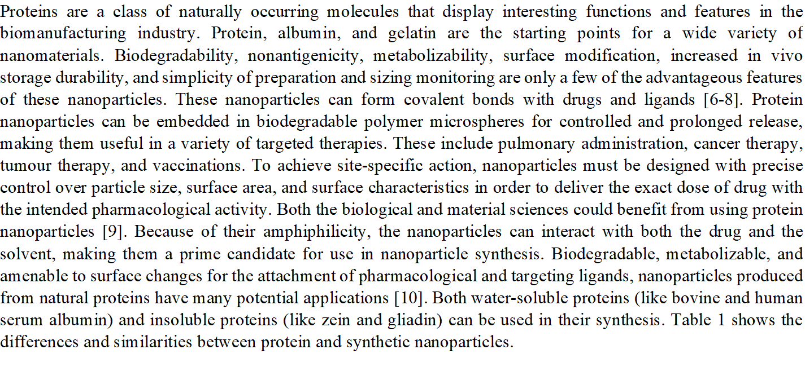

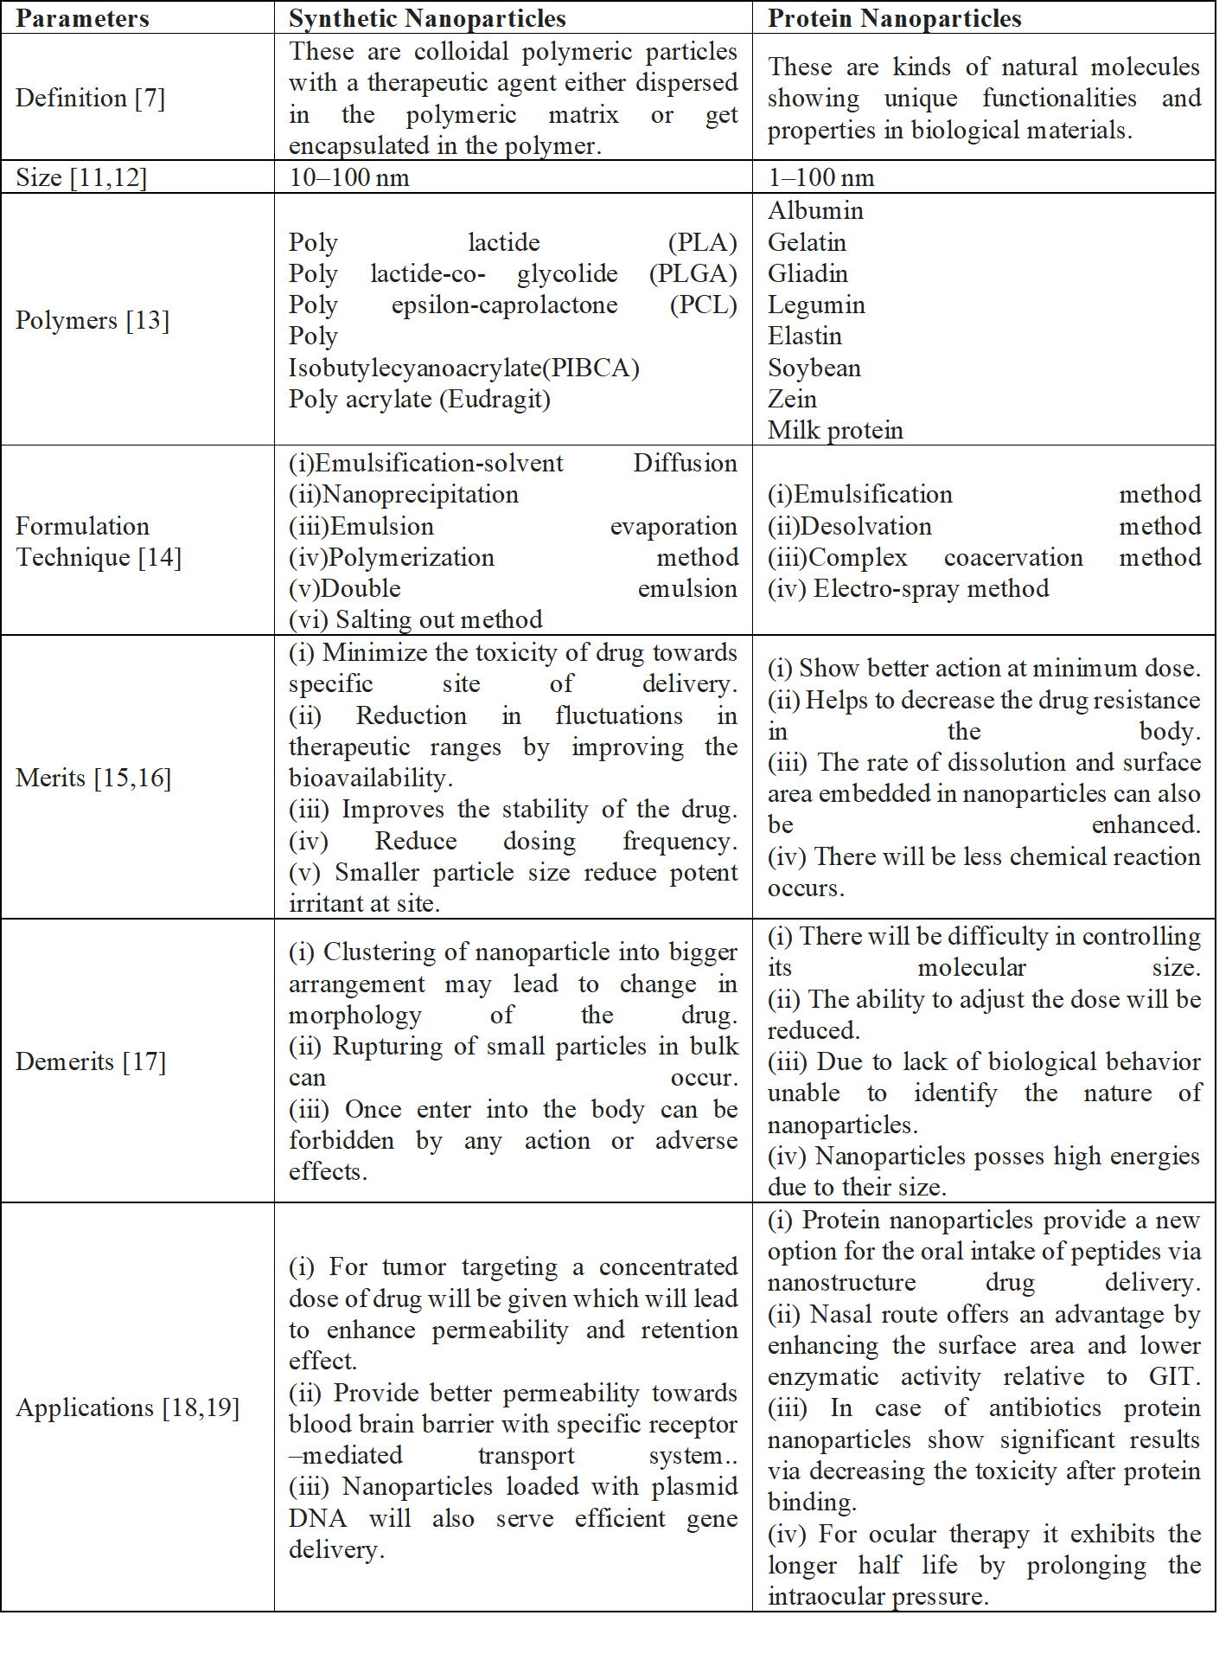

Advantages of Protein Nanoparticles [20]
- Help in reducing toxicity
- Enhance the release of drug
- Improve bioavailability
- Provide better formulation opportunities
- Show better action at minimum dose
- Decrease the drug resistance in body
- Biocompatible
- Biodegradable
- Non immunogenic
- High number of functional groups can be modified for targeting
Limitations of protein nanoparticles [21]
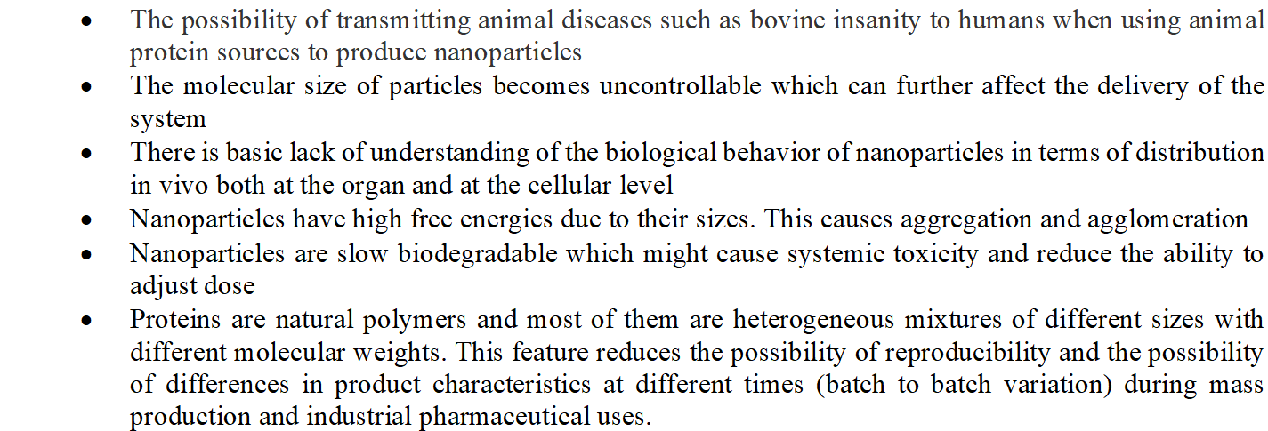

Protein nanoparticle production uses many proteins. Drug delivery is possible with several natural extracts.

2.1 ALBUMIN
Albumin has become a strong macromolecular carrier in medical therapeutic and diagnostic applications in recent decades. This protein with a circulatory half-life of 19 days can target medicines and improve pharmacokinetics. Water-soluble protein maintains osmotic pressure, binds nutrients, and transports them to cells. At pH 7.4, it is 40% w/v soluble in diluted salt solution. It is denaturation-free at 60°C for 10 hours. Nanospheres and nanocapsules are often made with albumin. These albumin nanocarriers are nontoxic, biodegradable, easy to manufacture, nonimmunogenic, well-defined, and include reactive groups (thiol, amines, and carboxyl). They can bind ligands or modify surfaces. Ligand-binding albumin can be covalently linked. Protease digests the albumin nanoparticle-entrapped medication.[22]

Albumin is produced from a variety of sources for commercial purposes, including ovalbumin, a type of egg white, bovine serum albumin (BSA), and human serum albumin (HSA). Other sources of albumin include milk, soy, and legumes.

Ovalbumin is a popular dietary protein. This 47-kDa glycoprotein has 385 amino acid origins and one disulfide bond. This protein is used as a medication carrier due to its low cost and convenient availability. It also gels, suspends, and foams. Ovalbumin could limit drug release due to its pH- and temperature-sensitivity [23].
Drug delivery is common with this 69-kDa protein. This protein is popular due to its availability, low cost, facile separation and purification from bovine serum, high ligand binding capability, and extensive pharmaceutical industry acceptability [24].

Human serum albumin is a 66.5 kDa spherical soluble protein with 585 amino acids in a single polypeptide strand. These alpha-helix chains produce three second structures (Fig. 1). 35 cysteine roots produce 17 disulfide connections, helping albumin establish its structure. The inclusion of several charged amino acids including lysine, arginine, glutamic acid, and aspartic acid in its structure helps albumin produce nanoparticles and bind numerous components. X-ray crystallography shows that human albumin has an 80 by 30 angstrom heart-like structure [25]. In solution, all three are elliptical.
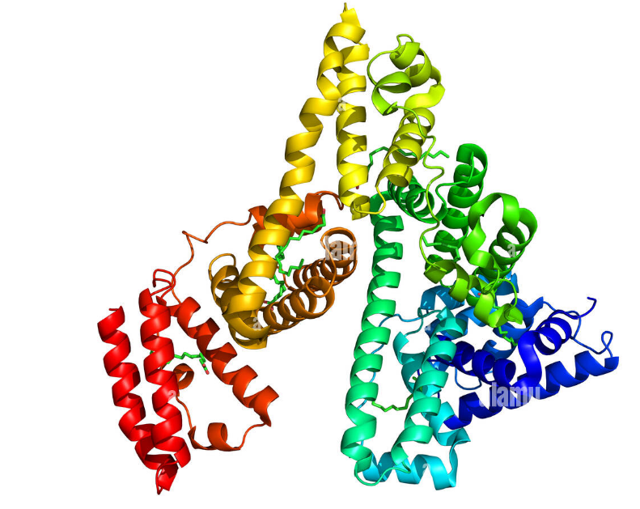
Albumin is a vital plasma protein with several functions. This protein comprises over 60% of plasma proteins and is 35–50 g per litre of blood serum. Albumin buffers blood pH and accounts for 80% of plasma osmolality pressure. Like many plasma proteins, this protein is generated in the liver and has a half-life of 19 days in human blood serum. Its daily synthesis is 10–15 g. Albumin transports fatty acids, eicosanoids, bile acids, steroid hormones, vitamins C, D, folate, copper, zinc, calcium, magnesium, and numerous blood medicines like penicillin, sulfonamides, and benzodiazepines. Endolytic chemicals are involved. Albumin protects by transporting bilirubin to the liver for elimination. Albumin protects against exogenous toxins like benzene and Afflation by binding to them. It treats human serum. albumin for shock, burns, albumin deficiency, trauma, cardiac surgery, acute respiratory difficulties, and blood dialysis. As a medication carrier, it preferentially absorbs inflamed and tumour tissues [26].
Noorani et al. (2015) created an albumin nanoparticle that increased albendazole's anticancer activity in ovarian cancer xenografts. In this work, albendazole-loaded bovine serum albumin nanoparticles were 7–10 nm. The least toxic ovarian cancer cell killer has the highest killing effectiveness in vitro.

2.2 GELATIN
Nanoparticle formulation uses gelatin, the oldest proteinaceous substance. Controlled hydrolysis of fibrous, insoluble protein and collagen from skin, bones, and connective tissues produces it. Nanoparticulate compositions use biodegradable gelatin. Biodegradable, harmless gelatin crosslinks easily. Ionizable groups such amino, phenol, guanidine, and imidazole made it a possible colloidal drug delivery method. It is affordable, sterilizable, nontoxic, pyrogen-free, and low-antigenic. The negative aspect of gelatin formulations is that the outer layer might crosslink intermolecular and intramolecular with time, temperature, and humidity. The formulation was stabilised and shaped with chemical crosslinkers such glutaraldehyde to improve in vivo circulation time. A and B gelatin exist. Both gelatin can be generated by acid or base hydrolysis, which changes their molecular weight, pH, viscosity, amino acid makeup, and isoelectric points. Gelatin type A has pH 7–9, whereas type B has pH 4-5. USFDA-approved pharmaceutical excipient gelatin is GRAS. Solanki et al. make protein-delivering gelatin nanoparticles [27]. Protein, BSA, and HSA were precipitated to create biodegradable hydrophilic gelatin nanoparticles. BSA and HSA encapsulated 90% and 80%, respectively. BSA and HSA released protein linearly and controllably after 6 days.

2.3 GLIADIN
70% ethanol extracts wheat gluten's major protein, gliadin. Gliadin is made of 25–100 kDa single-chain polypeptides connected by intramolecular disulfide bonds. Except at high pH, gliadin is insoluble in water. Hydrophobic interactions and disulfide links that fold the protein cause limited water solubility. Gliadin nanoparticles can release hydrophobic and amphiphilic medicines in a regulated manner. Water-insoluble proteins don't need curing to keep water-based goods intact. As a drug delivery method, gliadin offers good biocompatibility, biodegradability, non-toxicity, and stability. It can also be a polymer for oral and local drug delivery systems that attach to the mucosa. Gliadin nanoparticles are polymers that target the upper gastrointestinal tract but not the rest. Umamaheshwari et al. created amoxicillin-containing mucoadhesive gliadin nanoparticles to kill Helicobacter pylori. Desolvation produced gliadin nanoparticles with a zeta potential of 26.6 ± 0.8 mV. Their sizes ranged from 392 ± 20 nm to 285 ± 44 nm. Gliadin nanoparticles carried 60% payload. Gliadin concentration determined nanoparticle size. Due to mucosal adherence and prolonged residence duration, nanoparticles eliminated Helicobacter pylori better than free amoxicillin in the gastrointestinal system. Gliadin's hydrophobicity and limited solubility can create nanoparticles that protect and release drug-loaded nanoparticles. Gulfam et al. killed breast cancer cells with gliadin nanoparticles. To modulate cyclophosphamide (CP) release, they electrosprayed gliadin and gliadin-gelatin complex nanoparticles. CP-containing gliadin nanoparticles released within 48 h, while gliadin-gelatin nanoparticles released quickly. The drug loading efficiency was 72%, and the gliadin nanoparticles were 218.66 ± 5.1 and 398.56 ± 4.2, respectively. Neutral and lipophilic amino acids dominate gliadin. Neutral amino acids hydrogen bind with mucosa, while lipophilic amino acids interact with biological tissues hydrophobically. Ezpeleta et al. created a gliadin-based nanocarrier system for trans-retinoic acid (RA). Desolvation produced 500-nm RA-containing gliadin nanoparticles. This approach yields 90% protein-based gliadin nanoparticles. PBS at pH 7.4 stabilised these nanoparticles for 4 days. Gliadin nanoparticles aggregate and become unstable due to pH, heating, and salt. Protein-polysaccharide interactions can improve protein nanoparticle durability against environmental stress, according to recent research [28].

2.4 LEGUMIN
Legumin, an 11S globulin protein, is a significant soybean seed (Pisum sativum L.) storage protein. Legumin comprises six subunits and a 300–400 kDa molecular mass. Bioadhesive and large-surfaced legumin nanoparticles have great contact potential with biological surfaces. Legumin nanoparticles are most often synthesised via coacervation. Phase separation forms nanoparticles as legumin solubility falls during coacervation. Mirshahi et al. attempted to create micro- and nanoparticle-formed legumin colloidal delivery systems for sustained release and tailored drug administration. GA crosslinked nanoparticles after aggregation. Chemical crosslinking of pH-coacervation and GA has been tried to improve yield, size, and surface charge without organic solvents. PBS (pH 7.4) stabilised nanoparticles, however this approach generated only 27% of the original materials. GA crosslinking reduced legumin's immunogenicity by decreasing its antigenic determinants [29]. Near neutral pH produces submicron coacervates. Particles are 250–300 nm at pH 4.5–7. Neutral pH storage stabilised the particles. Legumin-based nanoparticles have tiny size, high stability, and minimal antigenicity, but more optimisation is needed to boost yield and verify their medicinal utility.

2.5. ELASTIN
Elastin keeps connective tissue firm and strong. Desmosine and isodesmosine crosslink elastin. Oxidative deamination of three of four lysine side chains produces them. Elastin was produced by lysine-mediated crosslinking of tropoelastin. Two types of elastin-derived polypeptides have been used for drug delivery: (a) α–o elastin undergoes aggregation under selective conditions of concentrations and temperature called cloud point, and when the temperature rises above cloud point, elastin starts forming complexes, and (b) elastin-like polypeptides are repetitive peptide polymers sequences derived from tropoelastin and undergo an inverse phase transi. Elastin-like polypeptides dissolve easily. Mc Daniel et al. (2009) electrosprayed drug-delivering elastin-like polypeptide nanoparticles [30]. Electrospray is used to create bioresponsive ELP nanoparticles. In organic solvent, ELPs and drug demonstrate substantial particle diameter, polydispersity, and surface charge outcomes. Electrospray appears to be a versatile method for producing stimuli-responsive drug particles

2.6. ZEIN
Zein comprises hydrophobic amino acids, proline, and glutamine in rich prolamine protein. Zein films and coatings are popular. FDA declared zein a GRAS polymer for human use. Zein protein nanoparticles encapsulate medications like coumarin and 5-fluorouracil. Zein released coumarin over 9 days in vitro. Zargar et al. (2016) use zein bionanoparticles as a novel green nanopolymer dispersive solid-phase extraction adsorbent to separate and measure azorubine in foods. DSPE formed zein nanoparticles. This study analyses soft drink, pastel candy, ice cream, and smarties for azorubine (AZ) levels ranging from 94.6% to 103.2%. The approach calculates food sample AZ values quickly and easily. Dhanya and Haridas (2012) create drug-carrying zein-pectin nanoparticles [31]. Ultrasonication is used to create biodegradable and nontoxic zein-pectin nanoparticles. Nanoparticles have hydrophobic zein cores and hydrophilic pectin shells.

2.7. SOY PROTEIN
Most plant protein comes from soybeans (glycine max). Soy protein isolates are nutritionally dense and useful. Soy protein isolate needs glycinin and β conglycinin. Soy protein isolate aggregates and produces microspheres, hydrogels, and polymer mixes when crosslinked. Desolvation agents or glycinin fraction of defatted soy flour extraction can be used to simple coacervation to make soy protein nanoparticles. Teng et al. (2012) created soy protein nanoparticles for nutraceutical encapsulation. Dispersion, desolvation, drug incorporation, crosslinking, and evaporation were used to create soy protein nanoparticles. The nanoparticles included curcumin. Nanoparticles averaged 220.1–286.7 nm and had the maximum encapsulation efficiency of 97.2%. Liu and Tang (2013) create oil-in-water emulsion pickering stabilisers from soy protein nanoparticle aggregates [32]. The study examines soy protein nanoparticles as pickering stabilisers for oil-in-water emulsions. Heated soy protein isolate outperforms unheated. Droplet size decreases, but resilience against coalescence and creaming increases, forming a gel-like network that can entrap oil droplets. Thus, nutraceutical soy protein emulsion stabilises pickering.

2.8 MILK PROTEINS
Milk proteins transport bioactive compounds. They fall into two structural types :
1. The linear and flexible caseins and spherical whey proteins
2. Whey's key proteins used to produce drug nanocarriers are beta- and alpha-lactoglobin.
Casein
Milk is mostly casein. Its drug-carrying nanoparticles are inexpensive, stable, and easy to source. Caseins can transport drugs due to their structural and physicochemical features. These features include water-binding and gel-forming, stability, surface activity, self-assembly, and emulsification. Whey globular proteins denaturate and alter structurally above 70 °C, although caseins are not . Casein films are desirable tablet coatings because to their great tensile strength. Caseins also protect delicate shipments. Casein that absorbs intense light, especially in the wavelength range of 200–300 nm, can protect its cargo from radiation, especially UV light. Casein may be appropriate for creating nano-camels and other drug delivery devices due to its properties. Caseins have immunosuppression and allergic risks. After disintegration in the gastrointestinal tract, milk casein is absorbed as amino acids, but direct intravenous injection of these proteins may cause an immunological response [33].
Casein structure
Milk casein is 94% protein and 6% colloidal calcium phosphate. These phosphoproteins are 19–25 kDa and 4.6–4.8 isoelectric. Caseins are dual-protein proteins that produce block copolymers that self-regulate micelles in the 50–500 nm range (average 250 nm). These spherical micelles have a hydrophobic inner component and a hydrophilic casein kappa () layer that stabilises them by repulsion. Casein micelles in milk carry amino acids and calcium phosphate from mother to child. While processing milk to make dairy products, these micelles remain stable. Recently, casein or copolymer micelles have been used with other polymers to transport hydrophobic cargoes, protecting vitamin D, omega-3 unsaturated fatty acids, and beta-carotene from degradation and oxidation by ultraviolet light (Fig. 2). Curcumin, mitoxantrone, vinbelastin, docetaxel, and paclitaxel are carried by casein nanomicels. Due to stomach degradation, beta casein may target gastric tumours. Paclitaxel is liberated from stomach beta-casein nanoparticles by pepsin, reducing gastric cancer cell proliferation. Nano mysel prevents the medicine from being released before the stomach and from causing harm to the mouth and oesophagus. Intelligent drug delivery systems can leverage this protein's pH-sensitive gels. Casein nanoparticles can be lyophilized without cryo-protectants for therapeutic formulations [34].

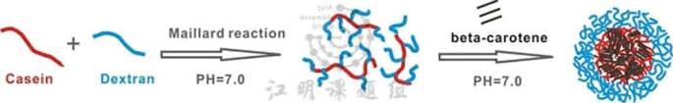

- Whey Proteins
Various globular proteins make up whey proteins. Whey protein concentrates and isolates are industrially manufactured dietary protein components. Major whey protein BLG controls these products' functions. Drug delivery vehicles include whey protein and BLG. The trapping of these molecules in whey protein hydrogels is what makes BLG a drug delivery carrier. Hydrogels are polymer networks that contain a lot of water. Because it binds hydrophobic components, BLG is excellent for lipophilic compound medication delivery systems. Native BLG is acid-resistant and gastric protease-resistant [35].

- β-Lactoglobulin
10% of cow milk proteins are β-Lactoglobulin (βLG), the main whey protein. Small (18.3 kDa, 162 amino acids) globular protein βLG has two disulfide bridges and a free thiol group. Due to electrostatic repulsion between subunits, the protein dissociates into monomers between pH 2 and 3 at room temperature and neutral to slightly acidic pH. Amphiphilic βLG is edible, solubilized, and emulsifies. Its affordability, abundance, and acceptability make it a promising drug carrier protein. βLG's tiny molecular weight, fast unfolding, and low hydrophobicity make it an excellent NP precursor. βLG's main anticancer drug carrier uses are:
- Solubilizing hydrophobic anticancer medicines
- Targeting colon carcinoma
- Protecting unstable anticancer nutraceuticals
2.9 Collagen
Protein polymers are easily obtained from animals and plants and are biodegradable and biocompatible. They are renewable resources for biocompatible NPs [88]. Collagen is the body's most abundant biopolymer. Long triple-helical sections make collagen flexible and strong. Glycine-X-Y represents these helical components. X and Y may be lysine, leucine, proline, or hydroxyproline. Tropocollagens create fibrils through binding. (Fig 3) Crosslinking fibril structures creates cell scaffolds for tissue engineering [36].

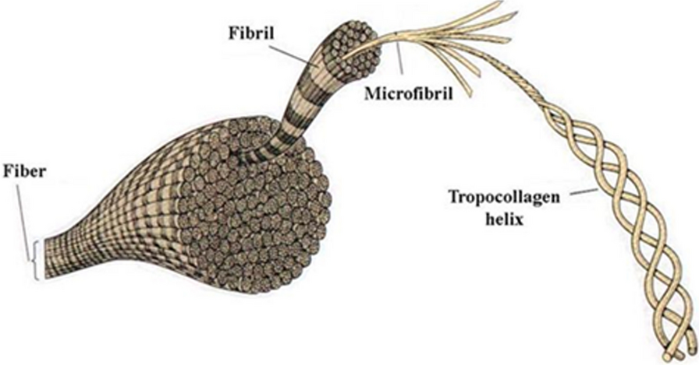
Collagen differentiates bone marrow stromal cells to regenerate and remodel bone. Because it acts as osteoid in mineralization, it is mostly used in biomedicine. Fig. 4 shows its use in skin grafting, cartilage and bone repair, and wound healing for diabetic foot ulcers. Due to its availability, low antigenicity, biocompatibility, and biodegradability, collagen is widely employed clinically. Collagen forms high-tensile fibrils. Thus, coating material, sponges, sheets, membranes, hydrogels, beads, nanofibers, and NPs are created. Electrospinning, nanoemulsion, electrospray deposition, and milling produce collagen [37].
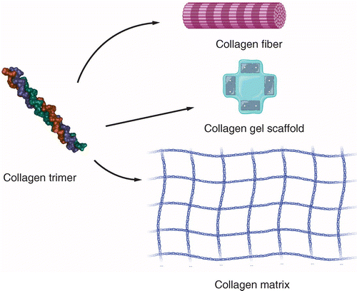
Collagen-based NPs can enter tumour cell microenvironments and release anticancer agents. Collagen-based NPs can be easily tailored for controlled-release systems due to their size, surface area, and absorption capacity. In a recent study, collagen-poly (3-acrylamidophenylboronic acid) NPs encapsulating doxorubicin were tested for ovarian cancer treatment. Transmission electron microscopy showed spherical NPs with consistent 75 nm diameters. High encapsulation efficiency and prolonged drug release were observed in vitro. A2780 cells were MTT-tested for cytotoxicity. In addition, BALB/c mice were used to test the anticancer impact in vivo. A2780 cells were unaffected by blank collagen NPs. Compared to free doxorubicin, collagen-based NPs reduced tumour development [38].
Collagen has limited mechanical strength and considerable degradability. In a recent study, bioactive glasses were added to collagen as a second phase. Collagen-associated bioglass nanofibers prevent infection and regenerate skin. Thus, collagen and bioactive glasses create a bone-like biomedical device [38].

2.10. SILK PROTEIN FIBROIN
Silk fibres have 65–85% fibroin. Thermochemical degumming with Na2CO3 removes the exterior sericin from Bombyx mori silkworm silk to obtain fibroin. LiBr or CaCl2 is used to make regenerative fibroin from insoluble separated fibroin.
Semi-crystalline fibroin has heavy and light chains. The heavy chain (45% Gly, 30% Ala, 12% Ser) has 12 large hydrophobic domains joined by 11 hydrophobic hydrophilic portions. Each hydrophobic domain has many repetitions of Gly-Ala-Gly-Ala-Gly-Ser and numerous repetitions of Gly-X (X = Ala, Ser, Thr, Tyr, or Val), while the hydrophilic section can be any amino acid sequence. Intermolecular hydrogen bonds (primarily between Gly and Ala) and van der Waals forces stabilise antiparallel crystalline β-sheets in the heavy chain. This structure gives silk fibroin solid mechanical characteristics and strong tensile strength. The light chain contains 15% Asp, 14% Ala, 11% Gly, 11% Ser, and trace cysteine. The light chain's hydrophilicity helps fibroin flexibility. Silk fibroin has an isoelectric point (IEP) of pH 7 or lower and a molecular weight (MW) of 83 kDa, but its size might vary depending on extraction and treatment. Due to its flexibility, mechanical strength, high stability, low immunogenicity, biodegradability, biocompatibility, vast volume, and low cost, fibroin is often used to make nanoparticles. Fibroin nanoparticles have negative zeta potentials. A positively charged polymer like PEI, chitosan, or EDC can crosslink the surface to give it a positive charge [39]. Fibroin MW, crystallinity, encapsulated drug characteristics, and production conditions might affect FNP attributes such average size, size distribution, surface zeta potential, drug encapsulation, release profile, and particle stability.
The organic solvent aids formation. Polar protic solvents including acetone, methanol, and ethanol can create spherical fibroin nanoparticles in aqueous fibroin solutions, while acetonitrile does not [40]. Nanoparticles made from fibroins have a restricted size distribution (less than 0.5 multivariance index) and are substantially larger than their MW. greater ratios between initial fibroin concentration, fibroin solution, and ethanol create greater multivariance indices. Fibroin crystallinity affects medication encapsulation and release. Salt, organic solvent, and temperature affect fibroin crystallinity. At low salt concentrations, the hydrogen bonding of the crystalline β-sheets loosens, forming an irregular structure. As salt concentration increases, fibronectin precipitates. Organic solvents dehydrate fibroin surface charges, enhancing crystalline moieties through intramolecular and intermolecular interactions. They promote crystallinity by altering secondary structure non-covalent interactions. High temperature increases water entropy, which reduces solvation of the hydrophobic region, allowing more non-covalent bonds to form. The captured drug's pKa and solubility determine the drug-loading dose. Electrostatic, hydrogen bonding, and hydrophobic interactions link drug compounds to fibroin. Even freeze-dried powder nanoparticles' physicochemical stability depends on storage temperature. Due to reduced intermolecular and intermolecular interactions, fibroin nanoparticles are durable for almost six months at 4 °C. At 25 °C, particles agglomerate. Particle surface characteristics affect stability . In a comparable desolvation procedure, particles with a surface charge of less than ±30 mV agglomerate more than those with larger charges.
Many research have used fibroin nanoparticles to deliver low-molecular-weight medications because they can overcome some of their drawbacks. All fibroin nanoparticles loaded with small molecule pharmaceuticals improve drug treatment effectiveness, capture efficiency, adjustable sustained release profile, drug solubility and stability, degradation inhibition, and toxicity reduction. Supercritical fluid technique created indocyanine green fibroin nanoparticles [41]. Photothermal stability and pH interactions freed the dye from the tumour acidic environment. Light-induced hyperthermia killed tumour cells in vivo and in vitro with these particles. Natural substances treat cardiovascular disease [42]. Their limited solubility and probable systemic metabolic effects make them less therapeutic.
Thus, fibroin nanoparticles are valued as medication delivery systems that can include several natural chemicals. Pham et al. made nanoparticles using alpha mangosteen, an anticancer chemotherapeutic drug isolated from mangosteen pericarp by crosslinking processes. The crosslinking agent, N-ethyl-N-(3-dimethylaminopropyl)-carbodiimide (EDC) or polyethyleneimine (PEI), produced 300-nm-sized spherical particles. Crosslinker type and quantity influenced particle surface charge from −15 to +30 mV. This work showed that crosslinking agents can modulate surface charge in fibroin nanoparticles. Compared to uncrosslinked nanoparticles, crosslinked nanoparticles entrapped 70% and loaded 7% more drugs. These particles also increased alpha mangosteen solubility, sustained release for 72 h, reduced medication hematopoietic toxicity by 90%, and maintained drug therapeutic effect. Lozano-Pérez et al. desolvated quercetin and encapsulated it in fibroin nanoparticles [43]. Encapsulation efficiency reached 70% depending on quercetin-fibroin ratio. Controlled release sustained quercetin activity. A rat colitis model received resveratrol via fibroin nanoparticles [44]. Fibroin nanoparticles inhibited lipopolysaccharide-stimulated RAW 264.7 macrophage nitrite production, making them non-cytotoxic and immunomodulatory. In the rat colitis model, resveratrol-loaded fibroin nanoparticles had a greater anti-inflammatory impact than pure resveratrol, suggesting a synergistic effect. These findings show that natural compound-containing fibroin nanoparticles enhance medication action. Through chemical interactions between fibroin tyrosine amino acid residues and enzyme structures, fibroin nanoparticles can immobilise enzymes, increasing enzyme stability and activity. Kim et al. created a cationic lipid-encapsulated fibroin nanoparticle that binds to the Pin1 isomerase (phosphorine-proline or phosphothreonine-proline motifs of various proteins) [46]. Rollyl cis-trans isomerase was cytoplasmically administered. These fibroin nanoparticle-lipid complexes efficiently and safely supplied enzymes, increasing Runx2 and Smad signalling and restoring bone formation marker gene expression and mineral deposition in Pin1-deficient cells. Recently, fibroin nanoparticles have been praised for their versatility, non-toxicity, high transfection efficiency, and DNase resistance. Song et al. created a c-myc anti-sense oligo deoxyneucleotide-containing fibroin-PEI NP with or without magnetic NP to target MDA-MB-231 breast cancer cells [45]. Varying fibrin regulated particle size and zeta potential. Fibroin-PEI NP was less cytotoxic than PEI NP, allowing MDA-MB-231 cells to receive encapsulated genetic material. Fibroin-PEI and magnetic NP magnetofection increased DNA transport after 20 min compared to non-magnetofection [46]. Shahbazi et al. made siRNA-delivering oligo-chitosan-fibroin nanoparticles. Polyplex particles were 250–450 nm. Fibroin concentration increased siRNA loading efficiency [118]. Compared to fibroin-free polyplex, foetal bovine serum and heparin increased stability. Due to poorer loading efficiency, fibroin nanoparticles had lower siRNA gene silencing efficiency and cytotoxicity.
Fibroin is a drug delivery method with pros and cons. Sericin can induce immunological function, hence silk fibres must be adequately cleaned [47]. In applications that demand fast and thorough nanoparticle carrier removal, the delayed degradation of the fibroin crystalline antiparallel β-sheet domain can be a drawback. As a protein, fibrin can be attacked by immune systems including macrophages and giant cells, which can encapsulate and form granulomas inside them, releasing drugs outside the target. Finally, while fibroin can be isolated from many sources, like other natural products, each batch may vary due to post-conversion process variations in species and individuals.

2.11. LEGUMIN
Legumin, an 11S globulin protein, is a significant soybean seed (Pisum sativum L.) storage protein. Legumin comprises six subunits and a 300–400 kDa molecular mass. Bioadhesive and large-surfaced legumin nanoparticles have great contact potential with biological surfaces. Legumin nanoparticles are most often synthesised via coacervation. Phase separation forms nanoparticles as legumin solubility falls during coacervation. Mirshahi et al. attempted to create micro- and nanoparticle-formed legumin colloidal delivery systems for sustained release and tailored drug administration. GA crosslinked nanoparticles after aggregation. Chemical crosslinking of pH-coacervation and GA has been tried to improve yield, size, and surface charge without organic solvents. PBS (pH 7.4) stabilised nanoparticles, however this approach generated only 27% of the original materials. GA crosslinking reduced legumin's immunogenicity by decreasing its antigenic determinants [48]. Near neutral pH produces submicron coacervates. Particles are 250–300 nm at pH 4.5–7. Neutral pH storage stabilised the particles. Legumin-based nanoparticles have tiny size, high stability, and minimal antigenicity, but more optimisation is needed to boost yield and verify their medicinal utility.

2.12. 30KC19 PROTEIN DERIVED FROM SILKWORM HEMOLYMPH
Silkworm hemolymph proteins (30Kc6, 30Kc12, 30Kc19, 30Kc21, 30Kc23) have comparable architectures. 30K proteins, with a MW of 30 kDa, stabilise enzymes and promote cell growth and survival. 30Kc19, the most abundant 30K protein, penetrates cells [84]. 30Kc19 has six N-terminal alpha-helixes and 12 C-terminal beta-strands. α-helix domain CPP Pep-c19 [127-129]. Lee et al. used 30Kc19 protein nanoparticles to deliver β-galactosidase into cells [84]. GA crosslinked desolvated nanoparticles. Nanoparticles made with 30Kc19 were poorly shaped and overly big. However, 50 wt% 30Kc19-HSA nanoparticles were tiny and had high pharmacological activity. pH correlated with particle size and 30Kc19 concentration. The loading capacity yielded 80–90% protein. 30Kc19 protein nanoparticles released 30–50% of β-gal within 24 h and up to 60% continuously. Using 30Kc19 and HSA, they created nanoparticles with α-galactosidase (α-gal) and transported them to cells. Nanoparticles rose from 230 to 310 nm when 30Kc19 protein wt% increased from 0 to 70%. 30Kc19 nanoparticles loaded 80–95% α-gal. 30Kc19 stabilises enzymes by increasing α-gal specific activity in nanoparticles. 30Kc19 nanoparticles were spherical. Human fibroblasts ingest 30Kc19-HSA nanoparticles better than HSA nanoparticles.
The enzyme-stabilizing impact of the 30Kc193 protein on the cargo protein is linked to the 30Kc19α domain, which has a stronger cell-penetrating ability than the total protein. 30Kc19α intracellular cargo protein delivery efficiency was comparable to Pep-c19 CPP. Unlike the β-sheet domain (30Kc19β), the α-helix domain (30Kc19α) is soluble. Park et al. recently created 30Kc19α nanoparticles that transport β-gal into cells without HSA [49]. Desolvation created protein nanoparticles. High pH and low 30Kc19α concentration reduced nanoparticle size. Loading capacity was 60–65%, lower than 30Kc19-HSA nanoparticles. Within 10 h, β-gal released 30% and sustained 60%.
Producing tiny nanoparticles with the 30Kc19 protein has been difficult. Compared to HSA nanoparticles, 50% 30Kc19-HSA nanoparticles had better protein activity and intracellular transport efficiency. These data imply that HSA combined with 30Kc19 is better for drug delivery nanoparticles than regular HSA. The efficiency of intracellular cargo protein delivery was similar to that of Pep-c19 cell-penetrating peptides, suggesting that 30Kc19α, a 30Kc19 α-helix domain, can be used to make protein nanoparticles.

2.13. LECTIN
Glycoproteins that bind carbohydrates called lectins. WGA is one of the most studied plant lectins. This protein has high stability, low toxicity and immunogenicity, resistance to proteolytic degradation, and specific identification and binding site to glycosylated intestinal mucosa, which improves oral medication absorption [50]. Pharmaceutical companies have considered lectins in two primary areas for the past two decades. The first is to improve the absorption of low-bioavailability medications, and the second is to create cancer-targeted drug formulations [51]. WGA and other lectins induce cancer cell death, which has anticancer effects. Cell membranes contain many proteins and phospholipids that can bind to diverse oligosaccharide roots [52]. Drug delivery via lectins targets sugar roots at the cell surface. Cancer cells generally have different oligosaccharide chains on their surfaces than normal cells of the same type, so distinct lectins can be utilised as markers. Carriers transport drugs to tissues and cells. Many research have covered various nanoparticles with lectins and produced targeted drug delivery systems. Lectins, the second generation of bioadhesive enhancers, increase cell uptake of drug formulations and release nanoparticles from the mucosal layer via clathrin-dependent and Caveola-mediated endocytosis [53]. Lectins that bind to Helicobacter pylori carbohydrate surfaces can also improve treatment [54]. Oral vaccinations use lectins. Nanoparticles with pathogenic antigens and lectins targeting Peyer's patches in the intestine boost oral vaccination immune response. Aged plaque cells show gut immune system antigens. Besides the gastrointestinal mucosa, lectin binding improves drug delivery through non-oral routes like the nasal mucosa, vagina, lungs, eyes, and blood–brain barrier. Odorranalectin, the smallest lectin, can detect and bind L-fucose and is less immunogenic. This sugar coats nasal mucosa cells. This lectin-containing nanoparticles improve nose-to-brain transport [55].

2.14 LIPOPROTEINS
Lipoproteins carry fats. Lipoproteins are diverse delivery vehicles with many advantages. All lipoprotein nanoparticles comprise a core of triglycerides and cholesterol esters coated by phospholipids and amphipathic apolipoproteins. High-density lipoprotein (HDL; 7 to 13 nm), low-density lipoprotein (LDL; 22 to 27 nm), intermediate-density lipoprotein (IDL; 27 to 30 nm), very low-density lipoprotein (VLDL; 35 to 80 nm), and chylomicrons (80 to 1200 nm). Size, density, lipid composition, main apolipoproteins, and function define these lipoproteins. Density-based ultracentrifugation separates plasma from lipoprotein nanoparticles [56].

Lipoprotein nanoparticles, which are biocompatible, non-immunogenic, biodegradable, and naturally targeted, are intriguing alternatives to synthetic nanocarriers for drug delivery. Lipoproteins had 48–72 h circulation half-lives, compared to non-lipoprotein nanoparticles. Lipoprotein nanoparticles can carry medicines, nucleic acids, and ligands for targeting. Lipoprotein nanoparticles treat Alzheimer’s [57].
Cardiovascular disorders involve lipoproteins. LDL-cholesterol plasma levels are linked to coronary artery disease. Statins reduce the risk of coronary artery disease by lowering LDL-cholesterol. The anti-CSK9 antibody against Phave also reduces LDL levels. Some cancer cells overexpress the LDL receptor and take up LDL at up to fifty times the normal tissue rate, making LDL an appealing drug delivery mechanism. HDL-cholesterol levels are inversely connected to cardiovascular disease. Liver, adrenal, and macrophages express high-affinity HDL receptor SR-BI. It also targets cancer in HDL-based drug delivery systems. HDL-based nanoparticles have been clinically tested. The risk of cardiovascular disease decreased with apoA-I Milano expression. ApoA-I Milano/phospholipids weekly for 5 weeks reduced coronary atherosclerosis [58].

2.15 FERRITIN
Ferritin, discovered by Laufberger in 1937, is found in microbes, plants, and animals. A spherical polypeptide shell (Apoferritin) surrounds a 6-nm inorganic core of hydrated iron oxide ferrihydrite in this hollow globular protein of 474 kDa and 24 subunits. In mammalian cells, ferritin H and L work together to absorb iron. Twenty-four ferritin subunits self-assemble into nanoparticles. The H subunit's four-helix dinuclear ferroxidase site oxidises iron by O2. The L subunit does not have this dinuclear ferroxidase site, but it has additional glutamate residues on the inner surface of the protein shell, which facilitate mineralization and iron (III) turnover at the H subunit site. Iron penetrates ferritin nanoparticles via eight hydrophilic routes across the protein shell. Targeting and drug loading are possible because ferritin nanoparticles have exterior and interior surfaces. Ferritin nanoparticles can be chemically manipulated and loaded with high-affinity small molecules and metals. Ferritin can endure 75 °C for 10 min. It also resists denaturants. From pH 2.5 to pH 7.5, ferritin nanoparticles can restore protein structure.
Liang et al. developed a natural H-ferritin (HFn) nanocarrier that delivered doxorubicin (Dox) to tumour cells at high concentrations and significantly inhibited tumour growth with a single dose. HFn nanocages can bind to tumour cells that overexpress TfR1 [59]. HFn-Dox bound and internalised tumour cells via overexpressed TfR1 and released Dox in the lysosomes. HFn-Dox reduced tumour growth with ten times higher intratumoral medication concentration than the Dox-free group. In all tumour models, HFn-Dox had higher median survival periods and lower toxicity than the clinically licenced liposomal Dox (Doxil) at the same dose.

2.16 KERATIN
Over the past 40 years, keratin has become a popular biomaterial due to its abundance, low cost, biocompatibility, and safe biodegradation [179]. Keratin is a fibrous structural protein generated from the epidermis and epidermal appendages, such as hair, scales, feathers, and quills in mammals, reptiles, and birds. Epithelial cells usually include keratin. Cell-cell adhesion forms a protective layer using this structural protein. Keratin proteins form a polymerized complex by coiling left-handed alpha-helixes. α-, β-, and -keratins exist. Intermediate filaments, which are part of the cytoskeleton, are found in α-keratins in soft tissues. Intermediate filaments are present in scales, nails, and β-keratins. The cytoskeleton does not involve -keratin. Keratin-based nanoparticles can target tumours and deliver drugs, according to recent research. Keratin nanoparticles can deliver high-molecular-weight medicines due to cysteine residue disulfide bonds and amine group hydrogen bonds. Keratin's negative charge helps positively charged molecules stick to the nanoparticle for improved transport. pH sensitivity helps keratin-based nanoparticles target. Keratin-based nanoparticles release drugs in response to pH changes. Keratin is a good support polymer for synthetic nanoparticle composites because of its water stability. Keratin-coated silver nanoparticles improve aqueous stability. Keratin aids cell attachment and proliferation. Keratin-coated gold nanoparticles are biocompatible and antimicrobial [60]. Keratin may be a promising medication carrier.

2.17 LACTOFERRIN
Lactoferrin, a naturally occurring cationic glycoprotein, binds iron. This protein solubilizes ferric ions (Fe3+) to control free irons in biological fluids [61]. This distinguishes its anticancer, antibacterial, antioxidant, anti-inflammatory, and immune-stimulating activities. Lactoferrin has many hydrophobic therapy benefits due to its tailored delivery on cell surfaces [62]. Lactoferrin mainly in circulation may be a predictive sign for inflammatory responses like severe acute respiratory syndrome or septicemia. Structural investigations show lactoferrin has two lobes. Multiple domains separated by a cleft can bind Fe3+ and CO32- in each lobe. Opening and closure are closely linked to substrate attachment or release. Lactoferrin retained its iron-binding properties at 65° to 90°C with ionic strength of 0.01 or less. Lactoferrin precipitated and lost iron-binding activity at high temperatures. Lactoferrin could resist heating at an ionic strength of up to 0.37 at pH 3.5, but it aggregated at more than 0.47, demonstrating that both ionic strength and pH affected its thermostability [63]. Lactoferrin is one of few proteins with a positive net charge at physiological conidiation and an isoelectric point of 8.0–8.5 [64].
Studies show that lactoferrin is persistent in the gastrointestinal tract and has many receptors that promote NP oral absorption and bioavailability. Overexpression of lactoferrin receptors increases nutrient absorption and demand for fast growing malignant cells [65]. Lactoferrin-based nanocarriers also have a pH-dependent release profile. Acidic pH accelerates drug release, which may improve the therapeutic efficacy of hydrophobic active chemicals entrapped in tumour tissue microenvironments [66]. The sol–oil method is used to generate doxorubicin-loaded lactoferrin NPs. During three months, doxorubicin-loaded lactoferrin loses 2.5–5% drug and does not harm erythrocyte membranes. Oral administration of doxorubicin-loaded lactoferrin NPs caused no weight loss, liver, or kidney toxicity, proving their safety and biocompatibility. Another study encapsulated zidovudine with lactoferrin. The 50–60 nm particles have a 67% drug encapsulation effectiveness and are stable at room temperature and 4°C without changing size. Lactoferrin NPs are stable under demanding conditions since drug release was low in simulated stomach and intestinal fluids. Oral zidovudine-loaded lactoferrin NPs had the same anti-HIV-1 effect as free medicine. Drug-loaded NPs had a superior pharmacokinetic profile than free medicines and lower organ toxicity, showing that this nanoformulation is a safe nanoplatform for enhancing drug delivery.
2.18 VIRAL PROTEIN CAGES
Viruses create protein cages. These particles are usually a few nanometers to a few tens. Virus cages are capsids lacking nucleic acids. Viruses determine virus cage design, size, and stability. A few porous nano spheres produce these cages. The cage's inner, outer, and subunit distances are important in this structure. For medical diagnosis and therapy, all three regions can be manipulated chemically or genetically (by modifying subunit nucleotide sequences) without changing cage structure. Protein cages can withstand chemical changes. Thus, a protein cage can simultaneously load drugs, image, and target a cell or tissue. Genetic engineering can bind pharmaceuticals, imaging agents, and fluorophores to the cage by adding cysteine and lysine (Fig. 5). Protein cages are consistent in size. These nanoparticles may load relatively exact amounts of medication, which is significant for pharmacokinetics. The protein cage shields medicines and therapeutic agents from chemical and enzymatic breakdown in numerous physiological settings. Protein cages may be used in cancer treatment. Nanometer cages are smaller than the pores of tumour tissue vessels (Fenestrate) and can enter and adhere to cells and tumour tissue, injecting significant amounts of chemotherapy drug into tumour tissue. These particles bypass liver tissue macrophage cells because the cages are tiny [67,68].

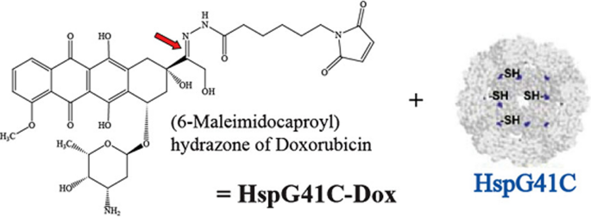

- Fabrication methods of Protein Nanoparticles
Protein nanoparticles can be made by chemical, physical, or self-assembly methods. Emulsification, Complex coacervation and Salting out are employed chemically. Electrospray and Nanospray drying are physical processes. Self-assembly includes Desolvation. Each strategy has pros and cons.

3.1 CHEMICAL METHODS
3.1.1 Emulsification Method
In 1995, Gao and his colleagues rediscovered Scheffel's 1972 method for making albumin spheres. Aqueous albumin was made using distilled water and organic phase plant oil such cotton seed oil [69]. The oil and water phase were mixed in the container under mechanical homogenizer to create an oil-water (o/w) emulsion. The aforesaid emulsion will be dropped into the preheat oil over 120°C. Water evaporation and irreversible albumin degradation will generate nanoparticles. Particles were suspended in ice. Emulsification was diagrammed in Fig. 6.
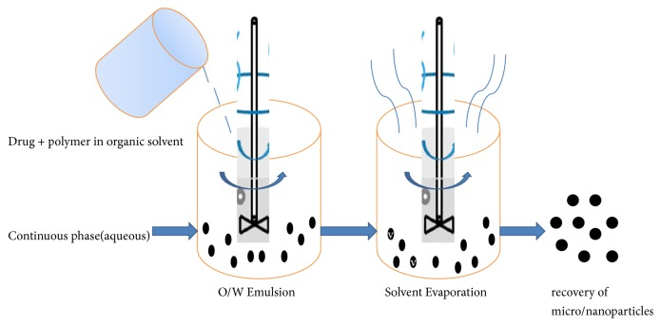
3.1.2 Complex Coacervation Method
This approach traps DNA well. Proteins are amphoteric, therefore pH can make them cationic or anionic. Proteins in aqueous solution were taken and pH changed because positive-charged particles rose. Then, the protein solution was mixed with a DNA-salt solution. DNA-protein complex coacervation occurs. To make crosslinked DNA-loaded protein nanoparticles, 1-ethyl-3-(3-dimethyl amino propyl) carbodiimide (EDC) was added. Last, DNA is physically incarcerated in the protein matrix. Alternatively, DNA was complexed with cationized protein [70]. Cationized gelatin was covalently bonded to cholamine. Coacervation with acetone and glutaraldehyde produced gelatin nanoparticles. Cholamine coupled with gelatin nanoparticles absorbed DNA. Fig. 7 shows complicated coacervation protein nanoparticle production.
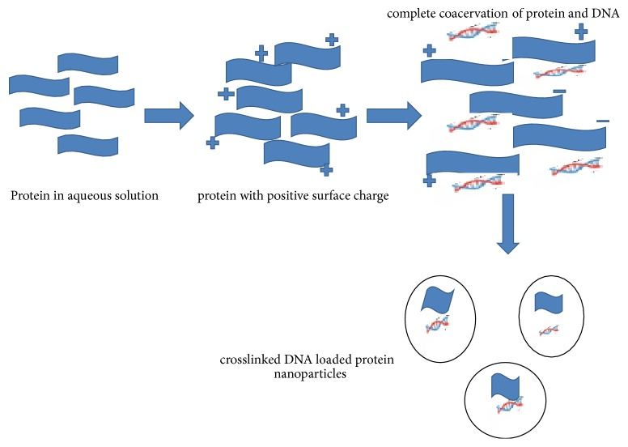

3.1.3 Salting out
Salting-out protein-based nanoparticles is simple but effective. Desolvation-like without organic solvents. High-concentration salt ions generate protein coacervates. Salt ions are more hydrophilic than protein micelles, thus they mix with water and remove protein hydration layers. Protein solubility decreases. Salting-out salts also dissociate strongly. Salt dissociation inhibits weak protein electrolytes, lowering the protein's charge and making it simpler to combine and precipitate. Salting-out preserves protein shape. Thus, nanoparticles preserve protein bioactivity and function. The salting-out technique created drug-delivering silk fibroin nanoparticles [71]]. pH and ionic strength of potassium phosphate solutions determined morphology and salting-out efficiency. The salting-out method's large protein nanoparticle size distribution is a downside.

3.2. PHYSICAL METHODS
3.2.1. Electrospray Technique
Electrospraying liquids. It manipulates submicron materials. The protein solution needs high voltage to spray the liquid jet stream through the nozzle to generate the aerosolized droplet. Aerosolized droplets include colloidal protein nanoparticles (Fig 8a). This approach efficiently integrates medicines and nucleic acids into nanoparticles. Solvent evaporation creates solids. Drug delivery systems vary in needle gauge diameter, applied voltage, flow rate, and operational distance. Electrospraying uses high voltage to create nanoparticles from polymer solutions. Electrospraying is comparable to nanostructure-producing electrical radiation. A coaxial spray head guides both solutions to the electric field in the innovative electrospraying approach. Yang et al. electrosprayed meletin-containing gliadin nanoparticles. 570 ± 80 nm particles released 28.8% of the medication within 1 h and 93.7% within 16 h [72].

3.2.2. Nano Spray Drying
Nano spray drying processes liquid nanoparticles. Liquid samples are sprayed into heated nitrogen and carbon dioxide chambers. The chamber's bottom electrode collects nanoparticles. These electrodes charge the sprayed droplets electrostatically when they fall to the chamber floor. This step-by-step method produces tiny protein particles quickly and cheaply. Spray-dried nanoparticles can contain hydrophilic medicines (Fig 8b). The approach can be used on heat-sensitive specimens since solvent evaporation maintains nanoparticle droplet temperature. This nanoparticle manufacturing approach is helpful since the particle size can be adjusted by adjusting parameters like the nozzle size and spray rate. Protein nanoparticles need surfactants to stabilise polymer particles. Lee et al. employed Nano Spray Dryer B-90 with Tween 80 as a surfactant to make BSA nanoparticles [73]. Surfactants stabilise nanoparticles by making them spherical. A high concentration of the BSA was used to establish consistency in morphology. The size of the spray mesh and the BSA concentration were the key determinants of particle size.
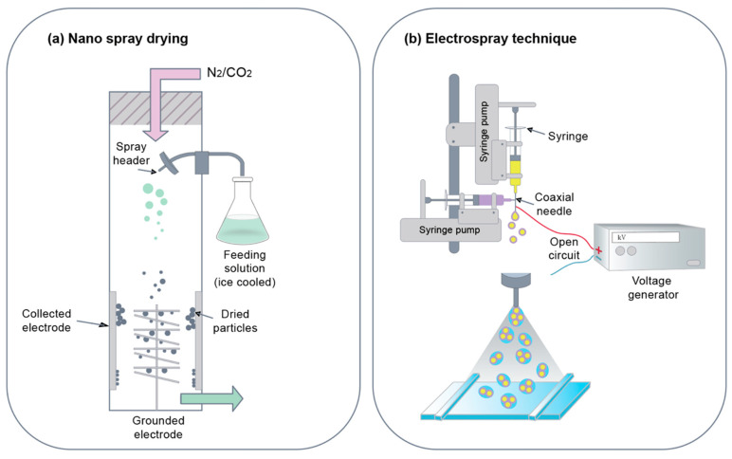
Fig 8: (a) Nano spray drying (b) The electrospray technique

3.3. SELF-ASSEMBLY METHODS
3.3.1. Self-Assembly
When individual protein chains are dissolved in a solution that is greater than the critical micelle concentration (CMC) and at the critical solution temperature (CMT) to form nanosized aggregates, protein micelles can spontaneously form (Fig. 9a). Micelles can be stabilised during the solidification process by creating a bridge between the chains. Through the hydrophobic modification process, albumin, a hydrophilic protein, can acquire amphiphilic properties. When added to aqueous solutions, hydrophobically modified proteins can self-assemble into micelle nanoparticles. Furthermore, active molecules can go through hydrophobic centres.

3.3.2. Desolvation
The most popular technique for creating protein-based nanoparticles is desolvation. The desolvation approach makes it easy to create nanoparticles by adding desolvating chemicals, including ethanol and acetone, to protein solutions that include medications. Desolvating chemicals alter the protein's structure and make it less soluble, which causes protein nanoparticles to precipitate out as precipitation (Fig. 9b). The process of particle creation in which the number of particles of the same size gradually grows and the particle size increases up to a specific level. When nanoparticles are created, bridging agents like GA are used to connect them. The desolvation process can be used to produce protein nanoparticles with variable particle sizes [74]. Particle size is primarily influenced by protein concentration, desolating agent addition rate, pH, and temperature. Smaller nanoparticles can be produced, especially at high pH and low protein content. The protein is concentrated by decreasing the solubility of the protein using the desolvating agent, making the desolvation process a self-assembly method even if it is not directly engaged in the creation of nanoparticles. The technique is frequently used to create nanoparticles from albumin.
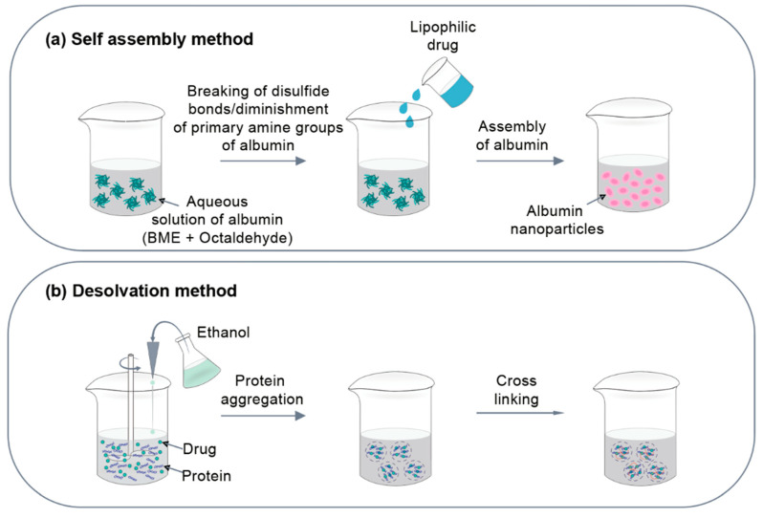
Fig 9: (a) Self assembly method (b) Desolvation method

Table 2: Pros and Cons of protein nanoparticle manufacturing methods.
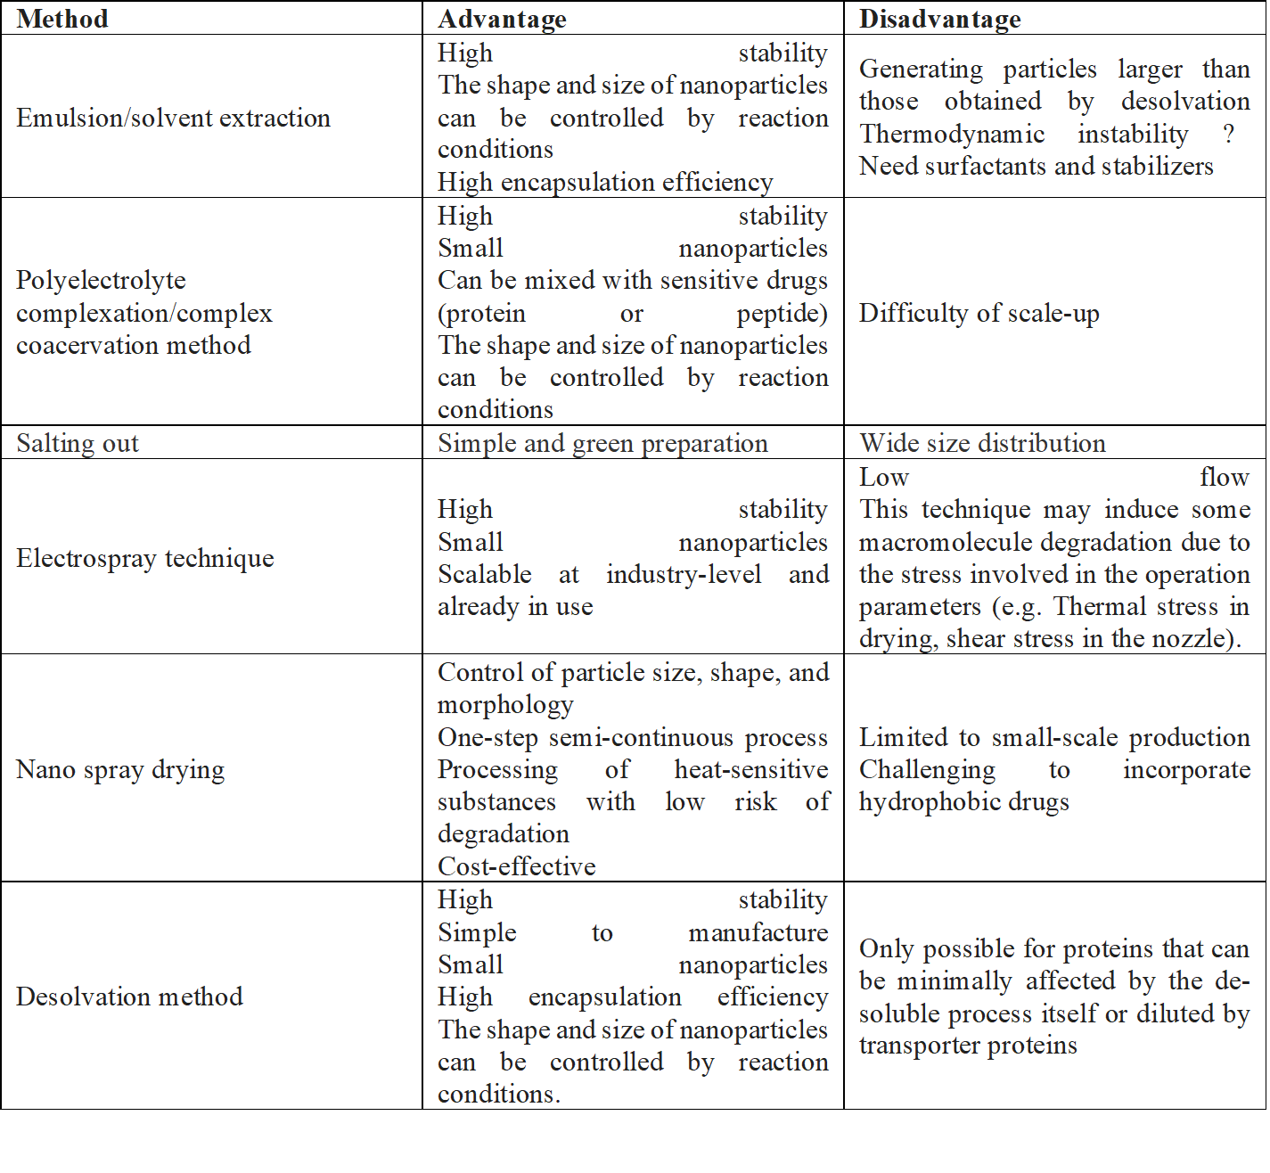
- Characterization of Protein Nanoparticles

4.1. Particle Size and Polydispersity
The most crucial properties of nanoparticle systems are particle size and size distribution. Numerous studies have demonstrated that when used as medication delivery methods, nanoparticles have significant advantages over microparticles. Because they exhibit much better intracellular absorption due to their smaller sizes as compared to microparticles and because they are relatively mobile, nanoparticles are often relevant to a wide range of biological targets. For instance, a study of body distribution revealed that the spleen accumulates nanoparticles larger than 230 nm due to capillary size. Other in vitro investigations provided evidence that nanoparticle particle size also influences cell uptake. Additionally, it was discovered that Tween 80-coated nanoparticles could cross the blood-brain barrier after the hyper osmotic molecule softened a hard junction, suggesting that Tween 80 may have therapeutic potential in the treatment of neurological disorders like brain tumours. The majority of medications that are on or near a particle's surface release quickly because smaller particles have a bigger surface area. Larger particles, on the other hand, can encapsulate more medications and disperse them more gradually. Additionally, during the storage and transportation of nanoparticle dispersion, smaller particles are more likely to aggregate. The creation of nanoparticles with the greatest stability while maintaining the lowest possible size is never easy. Particle size may also have an impact on polymer breakdown. For instance, it was discovered in vitro that the rate of poly(lactic-co-glycolic acid) polymer breakdown increased as the particle size rose. Using Photon Correlation Spectroscopy (PCS) or Dynamic Light Scanning (DLS) is now the quickest and most popular way to detect particle size. The method of choice for commercial submicron mouth analysis is PCS. Particles that are evenly scattered in liquid mediums make up the samples examined by PCS equipment. The PCS laser travels through the Brownian motion, which particles continue to have under these circumstances, and measures the speed of this motion. The PCS calculates sample PI and average particle size. Particle size measurements are accurate to a maximum of 0.7 (70%) [75]. A tried-and-true method for determining particle sizes, from nanometer to micrometre, is the DLS theory. The assumption that tiny particles in suspension move in random patterns is used by this theory. At the same temperature, larger particles travel more slowly than smaller ones.
  - Particle Morphology
Electronic, diagnostic, and therapeutic applications can be revolutionised by manipulating the physical and chemical properties of a material at the nanoscale. If nanoscale materials exhibit unwanted effects, such as toxicity, it is crucial to know about them in advance of any future large-scale application. Nanomaterials should be thoroughly characterised with regard to the correlation between reported hazardous effects vis-à-vis the physical and chemical properties of the material in order to evaluate the results of cell culture and animal models. Atomic force microscopy (AFM) and scanning electron microscopy (SEM) are two methods that can be used to analyse the structure of nanoparticles. An extremely high resolution scanning probe microscope known as an AFM or scan force microscope (SFM) has a resolution of nanometer fractions, which is around 1000 times greater than the optical diffraction limit. SEM is a particular kind of electronic microscope that takes photographs of a specimen's surface by scanning it with a high-energy electron beam in a raster injection pattern. SEM possesses the necessary submicron resolution at the nanometer scale, which is essential for determining particle form. As a result of the electron's interactions with the sample's atoms, a signal is created that comprises details about the sample, including its composition, electrical conductivity, and surface topography.[76]

4.3. Surface Charge
When nanoparticles are administered intravenously, the immune system quickly detects the foreign substances during the circulation process, and they are then eliminated via the phagocytosis process. Surface charge, hydrophobicity, and nanoparticle size are just a few of the variables that play a role in the removal process. As a result, several people have looked into how to mimic the nanoparticles' surfaces. The effectiveness of surface modification can be estimated through measurements of surface charge, density, and hydrophilicity. Nanoparticles in aqueous solutions can have their zeta potential measured, which is a typical method of determining the surface charge. The distribution of the nanoparticles can also be determined using the polydispersity index. Particle interaction is crucial for the stability of colloidal systems. This interaction is quantified by using the zeta potential measurement to forecast stability. Zeta potential is a metric for particle rebound. Additionally, as electrostatic repulsion stabilises the majority of water-soluble colloid systems, the more repulsion between the particles, the less probable it is that they will approach one another and form cohesion [77]. It has been found that nanoparticles with jet potentials greater than 30 mV (+/) are stable in the deposit because the surface charge keeps the particles from clotting. Zeta potential can also be utilised to determine if the loaded active substance is contained within the nanoparticle's centre or has been adsorbed to its surface.
5. Routes of Administration of Protein Nanoparticles
The use of protein nanoparticles as carriers for the administration of proteins, drugs, and peptides via various routes of administration has been studied in more detail.
5.1. Oral Route
For all pharmacological applications, oral administration is the most popular route because it offers a number of benefits, including patient comfort and compliance and the prevention of contaminations and infections. However, due to decreased intestinal epithelial penetration, aggregation, and denaturation, protein and peptides have limited oral bioavailability. Physical, chemical, and enzymatic barriers can all prevent the oral delivery of proteins and peptides [78]. The continuous monolayer of intestinal epithelial cells, which strongly express intercellular tight junctions, is primarily responsible for the physical barrier. Polymeric NPs' physical-chemical characteristics can be tailored to promote transport through intestinal epithelial cells.
5.2. Nasal Route
For noninvasive protein and peptide delivery, the nasal route is frequently employed. Research interest in protein and peptide administration via this route has significantly increased as a result of recent developments in biotechnology, inhalation devices, and targeting motifs. Large surface area, highly vascularized mucosa, porous endothelium membrane, decreased enzymatic activity compared to GIT, and the avoidance of first-pass metabolism are some of its benefits. Protein delivery, however, may face considerable difficulties due to the pattern of deposition and size distribution caused by delivery devices and nasal clearance systems. Proteins can be absorbed directly into the central nervous system (CNS), across the gastrointestinal tract (GIT), or into the systemic circulation after intranasal delivery. A few of the commercially available proteins and peptides for nasal delivery include Miacalcin®, DDAVP®, Synarel®, Fortical®, and Syntocinon® [78].
5.3. Pulmonary Route
One of the most often researched noninvasive strategies to increase protein and peptide absorption is the pulmonary route. Even though this route has several benefits, such as a large absorptive surface area (100 m2), high levels of vascularization, a thin alveolar epithelial membrane (0.1–0.2 m), and low levels of enzymatic activity, a number of variables may affect pulmonary protein and peptide absorption. The therapy of respiratory illnesses has been projected to benefit from the use of alpha 1-antitrypsin-loaded PLGA NPs.
5.4. Blood Brain Barrier Route
Protein nanoparticles can pass the blood-brain barrier, unlike IV drugs. Loperamide, tubocurarine, and doxorubicin are protein nanoparticle-bound.
5.5. Ocular Therapy
In comparison to eyedrops, protein nanoparticles have a significantly longer half-life in the eye. In comparison to a pilocarpine eye-drop solution, pilocarpine attached to gelatin nanoparticles significantly delayed the meiosis time and intraocular pressure reduction in rabbits with experimental glaucoma.

6. Biomedical Applications of Protein Nanoparticles
6.1 Nonviral Gene Delivery
Nonviral gene delivery using cationized gelatin nanoparticles is promising. Gelatin nanoparticles' minimal cell toxicity, facile synthesis, and inexpensive cost are their main advantages [79].

6.2 Immunological Adjuvant
Immunological adjuvant gelatin nanoparticles boost humoral and cellular antigen responses. Sundar et al. (2010) delivered CFTR-gene into human tracheal epithelial cells using gelatin-DNA nanosphere coacervate [80].

6.3. Antibiotics
Protein nanoparticles also work in antibiotics. Protein nanoparticles improve antibiotic effectiveness or toxicity. Amoxicillin and gliadin nanoparticles with amoxicillin (AGNP) both killed Helicobacter pylori, but AGNP required a lower dose [80].

6.4. Diseases
Below are protein nanoparticle uses for various disorders.
6.4.1. Tuberculosis (TB)
Mycobacterium tuberculosis causes TB, which can kill if untreated. Nanotechnology is an emerging technology in Tb treatment because it allows controlled release to infected cells for a long time through an effective delivery method. Rifampicin-loaded gelatin nanoparticles reduce cytotoxicity and promote drug targetability by lowering dosage. RIF gelatin nanoparticles accumulated in more organs than ordinary RIF. RIF nanoparticles will improve medication pharmacokinetics and sustain plasma levels by increasing mean residence time and area under the curve. Isoniazid-loaded mannosylated gelatin nanoparticles intravenously reduce bacterial counts in the lungs and spleen of tuberculosis-infected mice and reduce hepatotoxicity [81].

6.4.2. Leishmaniasis
Leishmania donovani causes leishmaniasis. AmB, a polyene antibiotic, treats visceral leishmaniasis. AmB-loaded gelatin nanoparticles minimise cytotoxicity and increase macrophage absorption. In vitro and in vivo, 1,2-diacyl-sn-glycero-3-phospho-1-serine coated gelatin nanoparticles loaded with AmB accumulate AmB in liver and spleen, increasing antileishmanial activity [82].

6.4.3. Cancer Therapy
Chemotherapy and radiotherapy treat cancer. Nanoparticles are being investigated for targeted drug delivery, however standard therapy has severe negative effects, including drug toxicity and drug resistance. Paclitaxel-loaded gelatin nanoparticles exhibit rate-limiting drug solubility in aqueous media in vitro and in vivo. Intravesical paclitaxel gelatin nanoparticles reduced systemic absorption and targeted bladder tumours. Pacitaxel-loaded gelatin nanoparticles release medication continuously, eliminating drug dilution and reducing treatment frequency. Breast cancer treatment with DOX-PEI-loaded HSA nanoparticles proved successful. DOX-PEI-loaded HSA improved biocompatibility and cytotoxicity. HSA nanoparticles containing tetramethylrhodamine-conjugated bovine serum albumin barely transfected 80% of cells [83].

6.4.4. Parkinson's Disease
The loss of dopaminergic cells in the substantia nigra region causes resting tremor, muscle rigidity, bradykinesia, and postural instability in Parkinson's disease (PD). Neuropeptide substance P (SP) loaded gelatin nanoparticles (SP-GNP) have better cell viability and lower apoptosis than normal SP solution, which mediates neuroimmunomodulatory activities and neurogenic inflammation in the central and peripheral nervous system [84].

6.4.5. Rheumatoid Arthritis
RA is an autoimmune illness that damages joints and reduces quality of life. Methotrexate (MTX) is often used to treat RA because it reduces tissue specificity and increases half-life. MTX-HSA reduced synovial fibroblast and cartilage degeneration [85].

7. Conclusion
Protein nanoparticles show promise in nasal, pulmonary, oral, and ocular delivery, nonviral gene delivery, blood brain barrier route, and immunological adjuvant. Nanoparticle drug delivery systems can treat many life-threatening diseases safely, effectively, and stablely. Albumin and gelatin nanoparticles are also commercially advanced. Plant proteins and milk can be employed in nanotechnologies to develop novel medications with promising results. Advancement in nanoparticle fields can improve the use of protein nanoparticles to treat diseases, which have already shown promising results.

REFERENCES
- Rosen, H. The rise and rise of drug delivery. Nat. Rev. Drug Discov. 2005, 4, 381–385.
- Ischakov, R.; Adler-Abramovich, L.; Buzhansky, L.; Shekhter, T.; Gazit, E. Peptide-based hydrogel nanoparticles as effective drug delivery agents. Bioorg. Med. Chem. 2013, 21, 3517–3522.
- Vogelson, C.T. Advances in drug delivery systems. Mod. Drug Discov. 2001, 4, 49–50
- Coester C., Nayyar P., Samuel J. In vitro uptake of gelatin nanoparticles by murine dendritic cells and their intracellular localisation. 2006;62(3):306–314.
- Verma R. K., Garg S. Current status of drug delivery technologies and future directions. 2001;25:1–14.
- Lohcharoenkal W., Wang L., Chen Y. C., Rojanasakul Y. Protein nanoparticles as drug delivery carriers for cancer therapy. 2014;2014:12. doi: 10.1155/2014/180549.180549
- Pathak Y., Thassu D. Vol. 191. New York, NY, USA: Informa Healthcare; 2009. (Desgin nad formulation of protein based NPDDS).
- Jahanshahi M., Zhang Z., Lyddiatt A. Subtractive chromatography for purification and recovery of nano-bioproducts. 2005;152(3):121–126.
- Moghimi S. M. Recent developments in polymeric nanoparticle engineering and their applications in experimental and clinical oncology. 2006;6(6):553–561.
- Langer R. Drug delivery and targeting. 1998;392(6679):5–10.
- Mallakpour S., Behranvand V. Polymeric nanoparticles: Recent development in synthesis and application. 2016;10(11):895–913.
- Piella J., Bastús N. G., Puntes V. Size-dependent protein-nanoparticle interactions in citrate-stabilized gold nanoparticles: The emergence of the protein corona. 2017;28(1):88–97.
- Samuli H. Preparation and characterization of poly (lactic acid) nanoparticles for pharmaceutical use. 2008;15:1–30.
- Sanyogitta P. University of Nottingham; 2007.
- Mandal B., Alexander K. S., Riga A. T. Preparation and physicochemical characterization of eudragitⓇ RL100 Nanosuspension with potential for ocular delivery of Sulfacetamide. 2010;13(4):510–523.
- Mohanraj V. J., Chen Y. Nanoparticles—a review. 2006;5(1):561–573.
- Dastagiri Reddy Y., Dhachinamoorthi D., Chandra Sekhar K. B. A brief review on polymeric nanoparticles for drug delivery and targeting. 2015;2(7):19–32.
- Shering M. A., Kannan C., Kumar K. S., Kumar V. S., Suganeshwari M. Formulation of 5-Fluorouracil loaded chitosan nanoparticles by emulsion droplet coalescence method for cancer therapy. 2011;2(3):926–931.
- Salata O. V. Applications of nanoparticles in biology and medicine. 2004;2(1, article 3):1–6.
- Kianfar, E. Protein nanoparticles in drug delivery: animal protein, plant proteins and protein cages, albumin nanoparticles. J Nanobiotechnol 19, 159 (2021).
- Lohcharoenkal W, Wang L, Chen YC, Rojanasakul Y. Protein nanoparticles as drug delivery carriers for cancer therapy. BioMed Res Int. 2014;2014:1–12.
- Kreuter J. Nanoparticles. In: Kreuter J., editor. New York, NY, USA: Marcel Dekker; 1994. pp. 219–342.
- MaHam A, Tang Z, Hong W, Wang J, Lin Y. Protein-based nanomedicine platforms for drug delivery. Small. 2009;5:1706–21.
- Sripriyalakshmi S, Jose P, Ravindran A, et al. Recent trends in drug delivery system using protein nanoparticles. Cell Biochem Biophys. 2014;70:17–26.
- Elzoghby AO, Samy WM, Elgindy NA. Protein-based nanocarriers as promising drug and gene delivery systems. J Control Rel. 2012;161:38–49.
- Lohcharoenkal W, Wang L, Chen YC, Rojanasakul Y. Protein nanoparticles as drug delivery carriers for cancer therapy. BioMed Res Int. 2014;2014:1–12.
- Kaintura R., Sharma P., Singh S., Rawat K., Solanki P. R. Gelatin nanoparticles as a delivery system for proteins. 2015;2(1):1–3.
- Liang H., Huang Q., Zhou B., He L., Lin L., An Y., Li Y., Liu S., Chen Y., Li B. Self-assembled zein–sodium carboxymethyl cellulose nanoparticles as an effective drug carrier and transporter. J. Mater. Chem. B. 2015;3:3242–3253.
- Mirshahi T., Irache J., Gueguen J., Orecchioni A. Development of drug delivery systems from vegetal proteins: Legumin nanoparticles. Drug Dev. Ind. Pharm. 1996;22:841–846.
- Wu Y., Mackay J. A., Mcdaniel J. R., Chilkoti A., Clark R. L. Fabrication of elastin-like polypeptide nanoparticles for drug delivery by electrospraying. 2009;10(1):19–24.
- Dhanya A. T., Haridas K. R. Development of zein-pectin nanoparticle as drug carrier. 2012;(4):147–152.
- Liu F., Tang C.-H. Soy protein nanoparticle aggregates as pickering stabilizers for oil-in-water emulsions. 2013;61(37):8888–8898.
- Chong Y, Ge C, Yang Z, et al. Reduced cytotoxicity of graphene nanosheets mediated by blood-protein coating. ACS Nano. 2015;9(6):5713–24.
- Su H, Liu C, Hu S, et al. Progress in application of microbeam x-ray fluorescence spectroscopy in forensic science. Fa Yi Xue Za Zhi. 2013;29(1):43–8.
- Q. Wang, J. C. Allen, and H. E. Swaisgood, “Binding of retinol to beta-lactoglobulin isolated by bioselective adsorption,” Journal of Dairy Science, vol. 80, no. 6, pp. 1047–1053, 1997.
- Xu S, Xu H, Wang W et al. The role of collagen in cancer: from bench to bedside. J. Transl. Med. 17(1), 309 (2019).
- Lo S, Fauzi MB. Current update of collagen nanomaterials – fabrication, characterisation and its applications: a review. Pharmaceutics 13(3), 316 (2021).
- Jiang H, Liang G, Dai M et al. Preparation of doxorubicin-loaded collagen-PAPBA nanoparticles and their anticancer efficacy in ovarian cancer. ATM 8(14), 880 (2020).
- Wang S., Xu T., Yang Y., Shao Z. Colloidal stability of silk fibroin nanoparticles coated with cationic polymer for effective drug delivery. ACS Appl. Mater. Interfaces. 2015;7:21254–21262.
- Zhang Y.-Q., Shen W.-D., Xiang R.-L., Zhuge L.-J., Gao W.-J., Wang W.-B. Formation of silk fibroin nanoparticles in water-miscible organic solvent and their characterization. J. Nanopart. Res. 2007;9:885–900.
- Chen B.-Q., Kankala R.K., He G.-Y., Yang D.-Y., Li G.-P., Wang P., Wang S.-B., Zhang Y.S., Chen A.-Z. Supercritical fluid-assisted fabrication of indocyanine green-encapsulated silk fibroin nanoparticles for dual-triggered cancer therapy. ACS Biomater. Sci. Eng. 2018;4:3487–3497.
- Nazari H., Heirani-Tabasi A., Hajiabbas M., Salimi Bani M., Nazari M., Pirhajati Mahabadi V., Rad I., Kehtari M., Ahmadi Tafti S.H., Soleimani M. Incorporation of SPION-casein core-shells into silk-fibroin nanofibers for cardiac tissue engineering. J. Cell. Biochem. 2020;121:2981–2993.
- Lozano-Pérez A.A., Rivero H.C., Hernández M.d.C.P., Pagán A., Montalbán M.G., Víllora G., Cénis J.L. Silk fibroin nanoparticles: Efficient vehicles for the natural antioxidant quercetin. Int. J. Pharm. 2017;518:11–19.
- Lozano-Pérez A.A., Rodriguez-Nogales A., Ortiz-Cullera V., Algieri F., Garrido-Mesa J., Zorrilla P., Rodriguez-Cabezas M.E., Garrido-Mesa N., Utrilla M.P., De Matteis L. Silk fibroin nanoparticles constitute a vector for controlled release of resveratrol in an experimental model of inflammatory bowel disease in rats. Int. J. Nanomed. 2014;9:4507.
- Song W., Gregory D.A., Al-janabi H., Muthana M., Cai Z., Zhao X. Magnetic-silk/polyethyleneimine core-shell nanoparticles for targeted gene delivery into human breast cancer cells. Int. J. Pharm. 2019;555:322–336.
- Kim W.J., Islam R., Kim B.S., Cho Y.D., Yoon W.J., Baek J.H., Woo K.M., Ryoo H.M. Direct Delivery of Recombinant Pin1 Protein Rescued Osteoblast Differentiation of Pin1-Deficient Cells. J. Cell. Physiol. 2017;232:2798–2805.
- Pham D.T., Tiyaboonchai W. Fibroin nanoparticles: A promising drug delivery system. Drug Deliv. 2020;27:431–448.
- Mirshahi T., Irache J., Gueguen J., Orecchioni A. Development of drug delivery systems from vegetal proteins: Legumin nanoparticles. Drug Dev. Ind. Pharm. 1996;22:841–846.
- Park H.H., Woo Y.H., Ryu J., Lee H.J., Park J.H., Park T.H. Enzyme delivery using protein-stabilizing and cell-penetrating 30Kc19α protein nanoparticles. Process. Biochem. 2017;63:76–83.
- Mukherjee S, Dasari M, Priyamvada S, Kotcherlakota R, Bollu VS, Patra CR. A green chemistry approach for the synthesis of gold nanoconjugates that induce the inhibition of cancer cell proliferation through induction of oxidative stress and their in vivo toxicity study. J Mater Chem B. 2015;3(18):3820–30.
- Kianfar M, Kianfar F, Kianfar E. The effect of nano-composites on the mechanic and morphological characteristics of NBR/PA6 blends. Am J Oil Chem Technol. 2016;4(1):29–44.
- Neunzehn J, Draude F, Golla-Schindler U, Arlinghaus HF, Wiesmann HP. Detection of protein coatings on nanoparticles surfaces by ToF-SIMS and advanced electron microscopy. Surf Interf Anal. 2013;45(9):1340–6.
- Pelaz B, Del Pino P, Maffre P, et al. Surface functionalization of nanoparticles with polyethylene glycol: effects on protein adsorption and cellular uptake. ACS Nano. 2015;9(7):6996–7008.
- Kianfar E. The effect of nano-composites on the mechanic and morphological characteristics of NBR/PA6 blends. Am J Oil Chem Technol. 2016;4(1):27–42.
- Brewer SH, Glomm WR, Johnson MC, Knag MK, Franzen S. Probing BSA binding to citrate-coated gold nanoparticles and surfaces. Langmuir. 2005;21(20):9303–7.
- Havel R.J., Eder H.A., Bragdon J.H. The distribution and chemical composition of ultracentrifugally separated lipoproteins in human serum. J. Clin. Investig. 1955;34:1345–1353.
- Song Q., Huang M., Yao L., Wang X., Gu X., Chen J., Chen J., Huang J., Hu Q., Kang T. Lipoprotein-based nanoparticles rescue the memory loss of mice with Alzheimer’s disease by accelerating the clearance of amyloid-beta. ACS Nano. 2014;8:2345–2359.
- Nissen S.E., Tsunoda T., Tuzcu E.M., Schoenhagen P., Cooper C.J., Yasin M., Eaton G.M., Lauer M.A., Sheldon W.S., Grines C.L. Effect of recombinant ApoA-I Milano on coronary atherosclerosis in patients with acute coronary syndromes: A randomized controlled trial. JAMA. 2003;290:2292–2300.
- Fan K., Cao C., Pan Y., Lu D., Yang D., Feng J., Song L., Liang M., Yan X. Magnetoferritin nanoparticles for targeting and visualizing tumour tissues. Nat. Nanotechnol. 2012;7:459–464.
- Tran, C.D.; Prosenc, F.; Franko, M. Facile synthesis, structure, biocompatibility and antimicrobial property of gold nanoparticle composites from cellulose and keratin. J. Colloid Interface Sci. 2018, 510, 237–245.
- Lönnerdal B, Iyer S. Lactoferrin: molecular structure and biological function. Annu. Rev. Nutr. 15, 93–110 (1995).
- Sabra S, Agwa MM. Lactoferrin, a unique molecule with diverse therapeutical and nanotechnological applications. Int. J. Biol. Macromol. 164, 1046–1060 (2020).
- Kawakami H, Tanaka M, Tatsumi K, Dosako SI. Effects of ionic strength and pH on the thermostability of lactoferrin. Int. Dairy J. 2(5), 287–298 (1992).
- Wahlgren MC, Arnebrant T, Paulsson MA. The adsorption from solutions of β-lactoglobulin mixed with lactoferrin or lysozyme onto silica and methylated silica surfaces. J. Colloid Interface Sci. 158(1), 46–53 (1993).
- Golla K, Cherukuvada Bhaskar FA, Kondapi AK. A target-specific oral formulation of doxorubicin-protein nanoparticles: efficacy and safety in hepatocellular cancer. J. Cancer 4(8), 644 (2013).
- Jing H, Huang X, Du X, Mo L, Ma C, Wang H. Facile synthesis of pH-responsive sodium alginate/carboxymethyl chitosan hydrogel beads promoted by hydrogen bond. Carbohydr. Polym. 278, 118993 (2022).
- Tavanti F, Pedone A, Menziani MC. Multiscale molecular dynamics simulation of multiple protein adsorption on gold nanoparticles. Int J Mol Sci. 2019;20(14):3539
- Zanganeh S, Spitler R, Erfanzadeh M, Alkilany AM, Mahmoudi M. Protein corona: opportunities and challenges. Int J Biochem Cell Biol. 2016;75:143–7
- Jahanshahi M., Babaei Z. Protein nanoparticle: a unique system as drug delivery vehicles. 2008;7(25):4926–4934.
- Jahanshahi M., Sanati M. H., Babaei Z. Optimization of parameters for the fabrication of gelatin nanoparticles by the Taguchi robust design method. 2008;35(11-12):1345–1353.
- A.S. Lammel, X. Hu, S.-H. Park, D.L. Kaplan, T.R. Scheibel, Controlling silk fibroin particle features for drug delivery. Biomaterials 31, 4583–4591 (2010)
- Yang Y.-Y., Zhang M., Liu Z.-P., Wang K., Yu D.-G. Meletin sustained-release gliadin nanoparticles prepared via solvent surface modification on blending electrospraying. Appl. Surf. Sci. 2018;434:1040–1047.
- Lee S.H., Heng D., Ng W.K., Chan H.-K., Tan R.B. Nano spray drying: A novel method for preparing protein nanoparticles for protein therapy. Int. J. Pharm. 2011;403:192–200.
- Langer K., Anhorn M., Steinhauser I., Dreis S., Celebi D., Schrickel N., Faust S., Vogel V. Human serum albumin (HSA) nanoparticles: Reproducibility of preparation process and kinetics of enzymatic degradation. Int. J. Pharm. 2008;347:109–117.
- Dunne M., Corrigan O., Ramtoola Z. Influence of particle size and dissolution conditions on the degradation properties of polylactide-co-glycolide particles. Biomaterials. 2000;21:1659–1668.
- Jalili N., Laxminarayana K. A review of atomic force microscopy imaging systems: Application to molecular metrology and biological sciences. Mechatronics. 2004;14:907–945.
- Mirshahi T., Irache J. M., Nicolas C., et al. Adaptive immune responses of legumin nanoparticles. 2002;10(8):625–631.
- Huang J., Shu Q., Wang L., Wu H., Wang A. Y., Mao H. Layer-by-layer assembled milk protein coated magnetic nanoparticle enabled oral drug delivery with high stability in stomach and enzyme-responsive release in small intestine. 2015;39:105–113.
- Sundar S., Kundu J., Kundu S. C. Biopolymeric nanoparticles. 2010;11014104
- Khatik R., Dwivedi P., Khare P., et al. Development of targeted 1,2-diacyl-sn-glycero-3-phospho-l-serine-coated gelatin nanoparticles loaded with amphotericin B for improved in vitro and in vivo effect in leishmaniasis. 2014;11(5):633–646.
- Abbasi S., Paul A., Shao W., Prakash S. Cationic albumin nanoparticles for enhanced drug delivery to treat breast cancer: preparation and. 2012;2012:8.
- Shukla A. K., Pragya P., Chaouhan H. S., Patel D. K., Abdin M. Z., Kar Chowdhuri D. A mutation in Drosophila methuselah resists paraquat induced Parkinson-like phenotypes. 2014;35(10):2419.e1–2419.e16.
- Oh M., Kim J. S., Kim J. Y., et al. Subregional patterns of preferential striatal dopamine transporter loss differ in Parkinson disease, progressive supranuclear palsy, and multiple-system atrophy. 2012;53(3):399–406.
- Zhao Y., Jin R., Yang W., et al. Using gelatin nanoparticle mediated intranasal delivery of neuropeptide substance P to enhance neuro-recovery in hemiparkinsonian rats. 2016;11(2):1–18.
- Ren K., Dusad A., Dong R., Quan L. Albumin as a delivery carrier for rheumatoid arthritis. 2013;4(4, article 176):1–4.

