Consumer Behavioral Trends Towards Sustainable Fashion Products: A Systematic Review (2012-2023)
Ms. Mona Sharma, Research Scholar
School of Management and Commerce
Manav Rachna University
Faridabad
monanps9@gmail.com

Dr. Priyanka Chadha, Assistant Professor
Amity Business School
Amity University
Noida
priyanka03chadha@gmail.com

Abstract
Consumer nowadays are becoming more and more concerned about environmental degradation, yet there has not been a corresponding increase in the demand of sustainable goods. This study tries to investigate factors behind sustainable consumption to systematise earlier research findings and identifying the most important factors for accelerating the shift to a greener economy. This article's goal is to define and categorise all the primary factors influencing sustainable fashion consumer behavior in order to systematise past research findings and determine the key factors propelling the shift to a more sustainable economy. We also focused on the most used theoretical frameworks, frequent paper published year and motives for buying sustainable fashion products. Findings revealed that TPB is the most used theory in the recent years in relation to sustainable marketing. Year 2020 got maximum number of publications. Factors like environmental knowledge, environmental concern are found to be the most significant factors behind the adoption of sustainable fashion products.
Keywords: TPB, Sustainable Fashion Products, Consumer Behavior, Sustainable Consumption.

I. INTRODUCTION
The primary causes of environmental deterioration, according to different sustainability reports, are the overcrowding of the past three decades and the waste generated as a result of excessive consumption of food, manufactured goods, and services. To achieve sustainable growth, businesses and consumers must take steps to reduce their negative environmental effects [3]. As a result, a substantial market of customers who care about the environment has developed recently. These consumers are keen to buy environmentally friendly products and value businesses that use sustainable business practises [4-6]. Due to this shift in consumer behaviour, businesses are making efforts to develop, promote, sell, and distribute goods that have less detrimental environmental effects [7]. They were compelled to alter their goods, production processes, and packaging materials as a result, among other things, demonstrating a stronger dedication to environmental protection [8].
These programs, which the authors label "Green Marketing" (GM) [9,10], are meant to satisfy the demands of clients who favour eco-friendly products and services. The consumer becomes increasingly demanding and continuously assesses company status as a result avoiding businesses who merely use "greenwashing" to improve their public image [11]. This unethical behaviour entails a deceptive ecological orientation that aims to sway consumers' opinions of an organization's goods, services, and policies in order to boost its profitability [12,13]. In this aspect, it's critical to distinguish between legitimate GM practises and unethical ones.
The manufacture of textiles has a negative influence on the environment because it consumes more water and energy, emits greenhouse gases that contaminate the air and water, and utilises a lot of pesticides [14]. The textile industry ranks second globally in terms of environmental pollution, and it is solely responsible for 10% of all CO2 emissions [15]. The global environmental quality is impacted by the hazardous waste and air pollutants from the textile production process [16]. Due to the rapid growth in global textile demand, this problem has gotten worse in recent years [18]. This is a result of the "fast fashion" trend, which has grown in popularity among younger generations [17].
With a focus on green purchasing behaviour, the aim of this systematic review is to increase knowledge of sustainable practises that have been linked in the scientific literature to important aspects of consumer purchasing behaviour. This study encourages sustainable development by raising awareness of the shared obligation between companies and customers to protect the environment. This awareness can be raised by understanding these practises and how they relate to consumer behaviour. As a result, managers and marketing specialists will benefit from this study's guidance as they embrace business policies and plans for sustainable development while also enhancing their organisations' reputation, consumer acceptance, profitability, and competitiveness. This study will also assist academics in visualising the many components linked to consumer spending and sustainable marketing, which will ultimately help in studies related to review as well as empirical papers.
Our main area of interest was products for sustainable fashion. We highlight fashion products in our publication, including clothing, activewear, and cosmetics. The majority of the study's papers dealt with clothing from a sustainability angle. For this study's backdrop, a thorough analysis of the literature on sustainable marketing was carried out in order to identify the themes, sub-themes, and gaps in consumers' views of and purchasing tendencies for eco-friendly goods. An environmental product selection method that is divided into three categories—personal variables impacting green purchasing, sustainable purchasing, and sustainable marketing mix—was also included [15].

By addressing three primary research questions, the current study seeks to give a thorough grasp of green purchase behavior studies.
RQ1. What are the determinants of sustainable fashion purchase intention in the selected studies?
RQ2. What are the main theories employed as the theoretical framework?
RQ3. What are the motives to purchase sustainable fashion products?

A. Sustainability
The ability of the present and future generations to meet their needs without compromising the ability of the latter to do the same is known as sustainability. Striking a balance between social progress, economic growth, and environmental protection is essential. Sustainability has gained importance as the world battles more serious environmental problems like pollution, resource depletion, and climate change. One of the most well-known definitions of sustainability may be found in the Brundtland Report, which was published in 1987 by the World Commision on Environment and Development. According to the study, sustainability is defined as development that meets present requirements without endangering the capacity of future generations to meet their own needs [16].
B. Sustainable Marketing:
Green marketing, eco-marketing, and sustainable marketing are other terms for the activity of promoting goods and services with negligible to no negative consequences on society or the environment. It involves incorporating sustainability principles and ideas into a variety of marketing strategies, such as product design, packaging, distribution, and communication. The basic objective of sustainable marketing is to satisfy client needs today without compromising the capacity of future generations to satisfy their own needs.
C. Sustainable Fashion:
Sustainable fashion refers to methods for creating, using, and discarding clothing and accessories that have as little detrimental influence on the environment , society, and economy. It involves making choices that consider the environmental and social consequences throughout the entire lifecycle of a fashion product, including design, sourcing, manufacturing, distribution, use, and disposal. Sustainable fashion aims to address issues such as excessive waste, pollution, exploitation of workers, and depletion of resources commonly associated with the fashion industry.

II. LITERATURE REVIEW
Various studies have been done in the area of sustainability with relation to fashion products. But we have analysed good 35 papers based on systematic review as well as empirical study not only in the area of clothing but cosmetics and other fashion areas also. Table 1. Shows the review of 20 most cited papers out of the 35 papers based on the title name, authors name, publishing year, finding related to the article etc.

Table 1. Relevant Papers for Review
Title of the paper | Year of publication | Authors | Model/  theory used | Review/  Empirical | Findings
Factors Affecting Sustainable Apparel Consumption  in Emerging Countries: A Systematic Literature  Review | 2019 | Nornajihah Nadia Hasbullah  , Zuraidah Sulaiman and Adaviah Mas’od | TPB and TRA | Review | According to the review's findings, the majority of consumers in emerging markets have already shown an increasing interest in sustainable clothing due to their strong growth in knowledge, intense concern, values, and social networks.
Interdisciplinary Literaure Analysis between Cosmetic Container Design  and Customer Purchasing Intention | 2021 | Ikkyung Sung |  | Review | Different consumers' purchasing habits are affected differently by various container design elements. Shape, colour, material and textual, and artistic aspects are the most important elements of container design. These elements have varying levels of market appeal and are employed by designers for various projects.
Green Marketing Practices Related to Key Variables of  Consumer Purchasing Behavior | 2022 | Elizabeth Emperatriz García-Salirrosas , and Rafael Fernando Rondon-Eusebio | TPB theory | Review | Green purchasing preference, word of mouth,green attitude, green purchasing intention, perceived value, green experiential value, responsible consumption, environmental awareness, green satisfaction, green engagement, green trust, green loyalty, and green purchasing decision were the main factors of purchasing behaviour that were identified.
Green purchase: A systematic review and future research agenda | 2022 | Setyo Ferry Wibowo, Mukhamad Najib, Ujang Sumarwan, Yudha Heryawan Asnawi | theory of planned behaviour | Review | Three major theoretical frameworks for the study of consumer green buying behaviour across goods and nations emerged: namely, the theories of planned behaviour, perceived value, and self-worth.
Exploring Consumer Behavior towards  Sustainability of Green Cosmetics | 2021 | Surabhi Acharya, Santosh Bali and B. S. Bhatia | Not mentioned | Empirical | 250 residents of the tri-city (Chandigarh, Panchkula, and Mohali) took part in this study. Teenagers and seniors were surveyed. According to research, the majority of consumers place a higher priority on product quality when making a purchasing decision than any other consideration.
Investigating the determinants of  behavioral intentions of generation Z  for recycled clothing: an evidence  from a developing economy | 2020 | Pallavi Chaturvedi, Kushagra Kulshreshtha and Vikas Tripathi | Theory of planned behavior | Empirical | The findings suggested that generation Z's propensity to purchase recycled apparel is influenced by elements including desire to pay, environmental awareness, perceived value, and personal conventions. The main predictors of intention to purchase recycled apparel were likelihood of making a purchase, financial capability, and environmental concern.
Green Marketing and Customers’ Purchasing Behavior:  A Systematic Literature Review for Future Research Agenda | 2023 | Ilona Skackauskiene and Neringa Vilkaite-Vaitone | Theory of planned behavior | Review Paper | According to the review, the theory of planned behaviour and its predecessor idea of reasoned action appear to be prominent. The literature places a strong emphasis on green marketing's tactical influence on customer behaviour metrics during and after the purchase stage.
Success factors for environmentally sustainable product innovation: a  systematic literature review | 2014 | Janine Fleith de Medeiros, Jose Luis Duarte Ribeiro, Marcelo Nogueira Cortimiglia | Not mentioned | Review paper | According to the findings, market, legislative, and regulatory information, cross-functional cooperation, learning that is focused on innovation, and R&D expenditure are the four main success factors for the development of environmentally friendly products.
Environmentally Sustainable Clothing  Consumption: Knowledge, Attitudes,  and Behavior | 2014 | Kim Y. Hiller Connell and Joy M. Kozar | Not mentioned | Review paper | Numerous academics have observed that consumers' ability to act in an environmentally responsible manner may be constrained by a lack of knowledge and information. Additionally, customers need greater information on the variety of accessible options for adopting ecologically friendly clothing practises, such as reducing overall consumption and buying better-quality, historically-inspired clothing.
The sustainable clothing market:  an evaluation of potential  strategies for UK retailers | 2012 | Helen Goworek, Tom Fisher, Tim Cooper | Not mentioned | Empirical | Because of this, there is a lot of opportunity for more stores of all sizes to provide sustainable clothing lines, which might result in benefits including lower operating costs, more brand recognition, and new marketing opportunities.
Sustainable clothing: challenges, barriers and interventions  for encouraging more sustainable consumer behaviour | 2015 | Fiona Harris, Helen Roby and Sally Dibb | TPB | Empirical | Internal barriers, or those relating to consumers themselves, included lack of environmental awareness on their part, ignorance of the environmental effects of clothing consumption, negative attitudes towards sustainable clothing, and demographic factors like age and education.
Sustainable Fashion Consumption: Advocating Philanthropic  and Economic Motives in Clothing Disposal Behaviour | 2022 | Siti Hasnah Hassan , Jasmine A. L. Yeap and Nabil Hasan Al-Kumaim | Theory of inter-personal behavior which is based on TRA and TPB | Empirical | The data indicate that personal norms, social norms, and environmental knowledge were the primary factors influencing the use of sustainable fashion. As a result, charitable and financial motivations for garment disposal behaviours showed a positive and significant link with sustainable fashion consumption.
Antecedents of green purchase  behavior of cosmetics products  An empirical investigation among  Malaysian consumers | 2019 | Azila Jaini, Farzana Quoquab, Jihad Mohammad, Nazimah Hussin |  |  | The results demonstrated that pro-environmental belief is considerably and favourably influenced by hedonic value. Additionally, it has been found that positive pro-environmental thinking influences personal norms favourably, which in turn affects consumers' propensity to make green purchases.
Antecedents to green apparel purchase behavior  of Indian consumers | 2020 | Arpita Khare, Pradeep Kautish | TRA/TPB | Empirical | According to the findings, green clothing knowledge (GAK), perceived effectiveness (GAPE), and green clothes purchasing behaviour (GAPB) among Indian consumers are positively correlated. Consumer independent judgement making (CIJM) and novelty-seeking behaviour (CNS), two concepts of consumer innovativeness, showed no beneficial influence on the general acquisition pattern of eco-friendly clothing (GAPB).
The values and motivations behind sustainable fashion consumption | 2016 | Louise Lundblad, Iain A. Davies | Means End theory approach | Empirical | One of the most important elements in making a purchase is one's own benefits, such as a sense of accomplishment, better health, self-esteem, and value for money.

A. Theoretical Framework:
In our study we reviewed 35 papers and found that Theory of planned behavior (TPB) and TRA(Theory of Reasoned Action) is one of the most used theoretical framwrok in the field of sustainability.
- The Theory of Reasoned Action: According to (Ajzen and Fishbein), Theory of reasoned action explains that there are two main elements of performing a particular type of behavior. Theory of reasoned action talks about the important element Attitude towards any product or service which later on decides how the consumers deals with it. Attitude of a particular product or service directly explains the behavior intention of the consumer. Another element found was perception, it means how others let the consumer choose the particular product or service. Ajzen revised his Theory of Planned Behaviour as a result, and in 1988 he included a new variable called perceived behavioural control, which is described as "the person's belief as to how easy or difficult performance of the behaviour is likely to be" (Ajzen and Madden, 1986).
- Theory of Planned Behavior: The TPB of Ajzen (1991) is recognised as a valuable social psychology model in research of consumer purchasing behaviour. According to the TPB, a person's perception of behavioural control, subjective norms, and attitude towards behaviour are all highly predicative of their intentions and subsequent actions (Ajzen, 1991). The first factor, attitude towards behaviour, is defined by Ajzen (1991) as "the extent to which a person has a favourable or unfavourable evaluation or appraisal of the behaviour." According to Ajzen (1991), Fishbein and Ajzen (1975), and other authors, attitude is defined as a person's beliefs and assessment of the outcomes that can be obtained by activity. It may also be referred to as a person's level of approval or disapproval of a particular behaviour. The second factor, subjective norms, is the degree to which a person feels pressured by friends, family, or coworkers to follow a specific conduct (or not) (Ajzen, 1991).

III. RESEARCH METHODOLOGY
The following terms were used to develop this research and were defined in relation to the study's objective: quantitative empirical research articles referring to sustainable marketing practises and containing, at the same time, a relationship with the key variables influencing consumer behaviour, without making any distinctions based on the age of the publications, the nation, or the economic sector of the organisations where they have been used. On a survey of the literature, this study is built. Additionally, we used the PRISMA approach to extract the publications. The scientific papers were located using the Scopus and Web of Science (WoS) databases. These links provide a comprehensive list of reputable journals that provide in-depth, peer-reviewed assessments of scientific research papers. As a result, the scientific community acknowledges their level of reliability when presenting information. Given that the systematic reviews that serve as the foundation for this study only used Scopus as a search source [17,18] and used Google Scholar as a search engine to discover the Scopus and WoS databases [15], the use of these databases is justified. Following completion of the analysis, the discussion will concentrate on the findings and recommendations. review articles, conference proceedings, and research papers that have been published in respectable journals and have a high assessment citation index are acceptable. The study excluded master's theses and works of opinion research. Each paper was also examined individually to determine whether it adhered to the study's approach. To boost the review's credibility, only papers from conferences and peer-reviewed publications were considered; dissertations, books, and volumes were excluded. When abstracting papers from databases, the keywords "sustainable behaviour," "sustainable fashion," "green," "consumer purchase intention," "intention behind sustainability," "undergraduate," or this and a broad range of other boolean variations produced the most hits. Only citations from articles that matched the following requirements were used: The following conditions require that higher education be the main focus with regard to entrepreneurship education (or a component thereof) and its empirical impact on entrepreneurial results (broadly defined to encompass both attitudinal and behavioural outcomes): Working papers, conference papers, or unpublished material are not acceptable substitutes for peer-reviewed journal articles, and (A) empirical data is preferred over purely conceptual data.

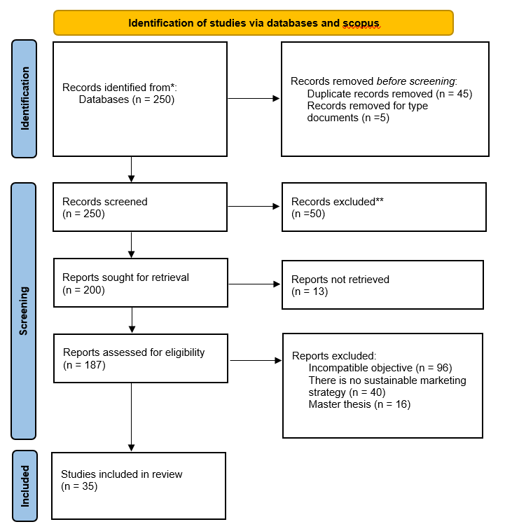
(Figure 1. PRISMA Flow Chart (35), n= no. of documents)

IV. RESULTS AND DISCUSSION
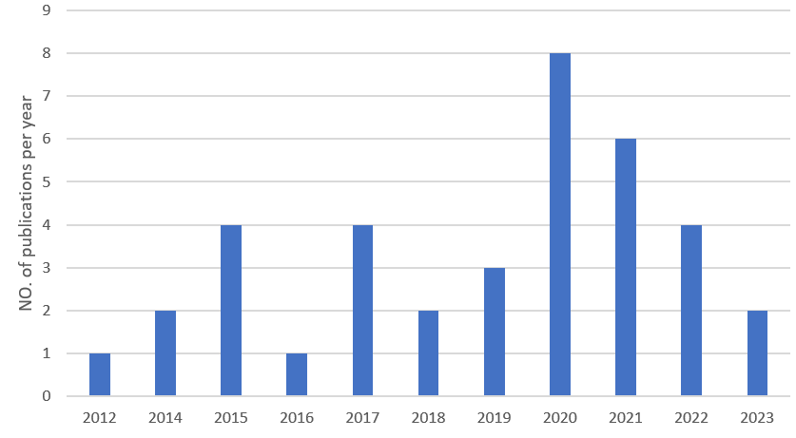
“Figure 2. Number of Publication Per Year”

“THEORY USED” | “NO. OF PAPERS”
Theory of planned Behavior | 25
Theory of reasoned action | 15
Means-end theory | 2
Theory of Interpersonal Bhevaior | 1

Figure 3. Theory Used in Number of Papers

Figure 2. depicts that the year which has the maximum number of publications out of the 35 papers is year 2023 followed by 2022 and 2017. This result shows that after the pandemic 2020, consumers drastically has shifted to sustainable products from the traditional products. They now are more aware about the environmental concern after using any product or service. This section provides an overview and discussion of the findings from the related papers we have incorporated into this study.
Figure 3. depicts the theories used in number of papers. Following results can be analysed by this reviewed paper:
- One of the primary research focuses of this study was the evaluation of the research methodologies, approaches, and theoretical frameworks widely used in sustainability papers. The study's main objective was to pinpoint the various factors that support the effective creation of sustainable fashion products and their impact on consumer behaviour.

- Our research focused on figuring out the various elements that affect consumers' adoption of sustainable fashion products. The 35 papers that were reviewed for the study and that diverse authors used to help develop these criteria are relevant to this investigation.

- The behavioural theories that have been used the most frequently in previous research to evaluate consumers' propensity to embrace new technologies and innovations are the Theory of Reasoned Action (TRA) and Theory of Planned Behaviour (TPB) (Gupta et al., 2021).

- One of the main deciding elements in purchasing has been recognised as benefits for oneself, environmental concern, environmental awareness, sense of success, increased health, self-esteem, and value for money. Internal constraints include consumer apathy towards the environment, ignorance of how clothing use affects the environment, negative attitudes towards sustainable clothes, and demographic characteristics like age and education.

V. RESEARCH IMPLICATIONS
Today, every organisation and manufacturing business has switched from using conventional techniques to creating products in a way that is more sustainable or favourable to the environment. Our government has also created a number of sustainability-related policies that can be adopted by any organisation to protect the environment. In our essay, we sought to identify the driving forces behind consumer adoption of sustainable goods while also concentrating on the obstacles that prevented them from doing so. The results provide helpful information for educators, legislators, and fresh graduates who want to launch their own firms. This study might aid stakeholders in choosing more sensible sustainable products for upcoming marketing campaigns.
VI. LIMITATIONS
There are a few limitations to this study that should be emphasised. Due to the growing complexity and resource constraints, the paper only focused on a few factors. It is possible to identify additional obstacles, factors and motives and rank them according to importance. For various consumer groups, different segments might be used. Future academics can examine the barriers behind the non-adoption of sustainable fashion products . We recently added 35 papers to our study for review, and based on those papers, we identified a few characteristics that influenced customers' intentions to use sustainable products. After reading more articles, future researchers will be able to identify more factors.

VII. FUTURE DIRECTIONS
Future studies should examine the most effective media platforms and marketing techniques for teaching customers about environmental concerns connected to the apparel and textile supply chain as well as the variations in operations and practises of green versus conventional businesses. For apparel and textile businesses operating with a stronger commitment to environmental sustainability, this has significant implications, including the need to better educate customers about their brands and increase their awareness through focused media campaigns.

REFERENCES
- Severo, E.A.; de Guimarães, J.C.F.; Henri Dorion, E.C. Cleaner Production, Social Responsibility and Eco-Innovation: Generations’ Perception for a Sustainable Future. J. Clean. Prod. 2018, 186, 91–103.
- Chekima, B.C.; Syed Khalid Wafa, S.A.W.; Igau, O.A.; Chekima, S.; Sondoh, S.L. Examining Green Consumerism Motivational Drivers: Does Premium Price and Demographics Matter to Green Purchasing? J. Clean. Prod. 2016, 112, 3436–3450.
- Severo, E.A.; Guimarães, J.C.F. de Dorion, E.C.H. Cleaner Production and Environmental Management as Sustainable Product Innovation Antecedents: A Survey in Brazilian Industries. J. Clean. Prod. 2017, 142, 87–97.
- Chung, K.C. Green Marketing Orientation: Achieving Sustainable Development in Green Hotel Management. J. Hosp. Mark. Manag. 2019, 29, 722–738.
- Do Paço, A.M.F.; Reis, R. Factors Affecting Skepticism toward Green Advertising. J. Advert. 2012, 41, 147–155.
- Yazdanifard, R.; Mercy, I.E. The Impact of Green Marketing on Customer Satisfaction and Envi- Ronmental Safety. Int. Conf. Comput. Commun. Manag. 2011, 5, 637–641.
- Peattie, K.; Crane, A. Green Marketing: Legend, Myth, Farce or Prophesy? Qual. Mark. Res. Int. J. 2005, 8, 357–370.
- Ahuja, K. A Study on Green Advertisement and Its Impact on Consumer Purchase Intention. J. Creat. Commun. 2015, 6, 259–276.
- Lee, Y.K. The Relationship between Green Country Image, Green Trust, and Purchase Intention of Korean Products: Focusing on Vietnamese Gen Z Consumers. Sustainability 2020, 12, 5098.
- Lakatos, E.S.; Nan, L.M.; Bacali, L.; Ciobanu, G.; Ciobanu, A.M.; Cioca, L.I. Consumer Satisfaction toward Green Products: Empirical Insights from Romania. Sustainability 2021, 13, 10982.
- FAO-ICAC (2015), “Measuring sustainability in cotton farming systems: towards a guidance framework”,
- Rome, available at: www.fao.org/3/a-i4170e.pdf (accessed 5 July 2019).
- Allwood, J.M., Laursen, S.E., de Rodriguez, C.M. and Bocken, N.M. (2006), “Well dressed? The present and future sustainability of clothing and textiles in the United Kingdom”, Journal of the Home Economics Institute of Australia, Vol. 22, p. 42.
- Khan, S. and Malik, A. (2014), “Environmental and health effects of textile industry wastewater”, in Malik A., Grohmann E. and Akhtar R. (Eds), Environmental Deterioration and Human Health, Springer, Dordrecht, pp. 55-71.
- Bhardwaj, V. and Fairhurst, A. (2010), “Fast fashion: response to changes in the fashion industry”, The International Review of Retail, Distribution and Consumer Research, Vol. 20 No. 1, pp. 165-173.
- The Fiber Year Consulting (2015), “The fiber year 2015, world survey on textiles and nonwovens”, Issue 15, available at: www.textilemedia.com/assets/Uploads/TFY15-sample-pages.pdf
- Sharma, A.P. Consumers’ Purchase Behaviour and Green Marketing: A Synthesis, Review and Agenda. Int. J. Consum. Stud. 2021,45, 1217–1238.
- World Commission on Environment and Development. (1987). Our common future. Oxford: Oxford University Press.
- Zhang,X.;Dong,F.WhyDoConsumersMakeGreenPurchaseDecisions?InsightsfromaSystematicReview. Int.J.Environ.Res.PublicHealth 2020 , 17 ,6607.

