Role of Artificial Intelligence in Remote Area Medical Services

1. Ajay Ganesh J, MBBS
Junior Resident
Department of Physiology
Lala Lajpat Rai Memorial Medical College, Meerut
2. Snehlata Verma, MD, FIACM, FUPDA
Associate Professor
Department of Medicine
Lala Lajpat Rai Memorial Medical College, Meerut

Introduction
India as an aspiring nation has made big strides in the healthcare sector in recent years showing its strength to the world in pharma, telemedicine, and traditional medicine. Although India achieved them, the services are yet to reach everyone within the nation as shown by the Economic Survey. According to the Global Burden of Disease Study in 2016, India is ranked 145th out of 180 nations in terms of the accessibility and quality of healthcare(1). With advancements in new futuristic technologies, India can leverage the latest developments to make healthcare services feasible and accessible to millions of citizens.
Medical Manpower in India
India is on the right foot for making highly trained manpower in the ever-expanding healthcare sector with 4.7 million workers as of 2021(2). That is a jump from 0.83 million in 2010 to 1.3 million in November 2021[the number of allopathic doctors with recognised medical qualifications (under the I.M.C Act) registered with state medical councils/national medical council]. India has an abundance of highly trained medical professionals to its competitive advantage. With over 4.7 million workers as of 2021, the Indian healthcare industry is becoming one of the country’s largest employer. Based on Aspire Circle, the Indian healthcare sector is expected to reach $744 billion by 2030, driven by greater access to insurance, health awareness, lifestyle diseases, and rising income(3). Due to its relatively low cost of clinical research, India has become a centre for research and development activities for foreign businesses. India is one of the world’s most sought out medical tourism destinations, and this industry has significant role to play in the coming years. The low cost of healthcare has led to an increase in medical tourism in the nation, drawing people from all over the world. India possesses all the essential components for this industry to grow rapidly, including a massive population, a strong pharmaceutical and medical supply chain, more than 750 million smartphone users, the third-largest global start-up pool with simple access to Venture Capital funding, and innovative tech entrepreneurs looking to address global healthcare issues.
Drawbacks
Although India’s healthcare sector has made significant progress in terms of health indicators, it still has some serious drawbacks in service delivery due to inadequate health infrastructure. Insufficient access to basic healthcare services to all, due to a shortage of medical professionals, a lack of quality assurance, and insufficient health spending. The administration's lack of financial resources and insufficient financing for research and development are major causes for concern. India’s government will only spend 2.1% of its GDP on healthcare in 2021–22, compared to 10% for Japan, Canada, and France(4). Preventive treatment is underestimated in India despite having been proven to be quite helpful in easing a range of challenges for patients in terms of dissatisfaction and monetary loss. Doctors, nurses, and other healthcare professionals are less comparing to the population in need. According to a minister’s study presented in Parliament, India is short 600,000 doctors(5). Private hospitals are expensive, whereas public hospitals are either inadequate or lacking the basic facilities for the Indian population. The concept of health insurance is still underdeveloped in India, and the market is yet to mature. These weaknesses can be easily patched up with the upcoming futuristic technologies.
National Initiatives
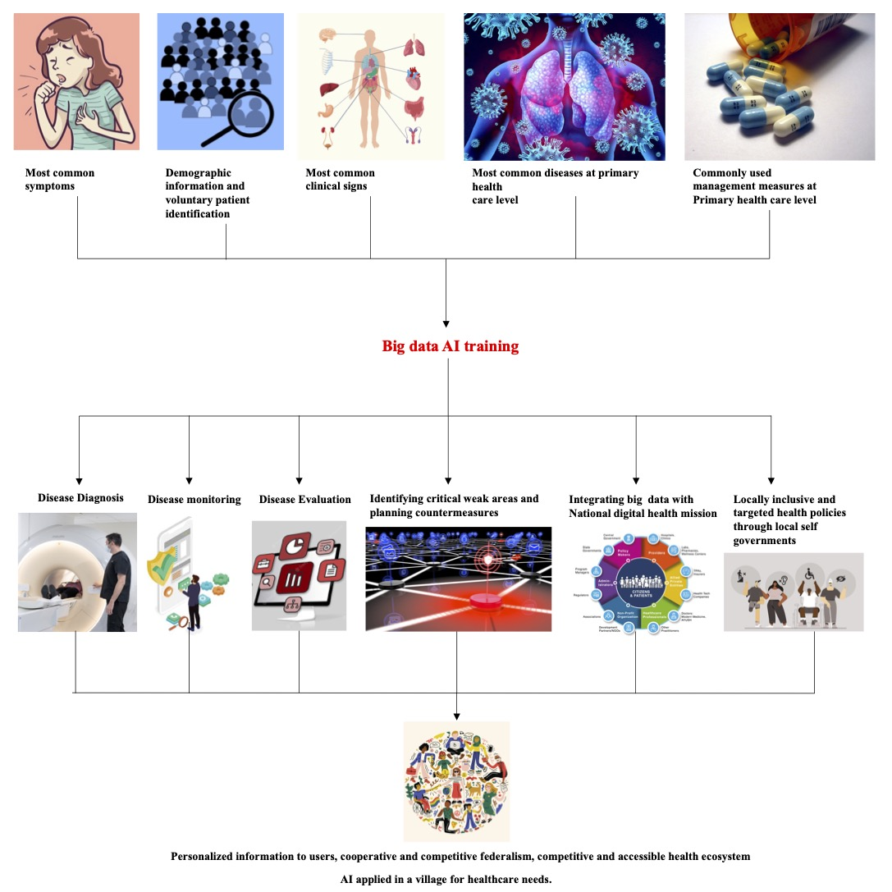
India has taken the foremost and essential steps to apply futuristic technology in healthcare by launching a national digital health mission through which a digital Health ID will be introduced, which will save patient data. It aids effective policymaking and benefits private firms for a competitive advantage in the market introduction of innovative technology. With the advent of information technology and big data, it would be easy for private players to spend strategically. The flagship program opens the door for multiple innovative solutions for healthcare such as the Internet of Medical Things, immersive technologies like augmented and virtual realities, digitized healthcare, implementing artificial intelligence for autonomous monitoring of patient data, cloud computing and electronic management of big data(6).

The Internet of Things
The Internet of Things can be used to produce products that require less or no human involvement to offer health care services, as India might still fall short of the WHO-recommended doctor-population ratio of 1:1,000 by 2030. With networked medical devices, equipment, and infrastructure, numerous applications will be feasible, including automatic disinfection, intelligent diagnosis, and remote patient care. For real-time disease diagnosis, monitoring, tracking, and control, it combines sensory data, automatic processing, and network connection(7).
AR and VR
There is a rising trend among Indians for mental health disorders and lifestyle diseases. Families have been devastated by the disease’s effects. India still lacks the infrastructure necessary for these people to receive proper treatment and rehabilitation. Applications for VR range from helping with physical and cognitive rehabilitation to exposure treatment for anxiety disorders(8). It is also worth noting that augmented and virtual reality will be effective in training doctors and other healthcare professionals, especially in the field of surgical procedures.
Telemedicine
Telemedicine and remote diagnostic developments have given rise to the treatment of patients using online tools, platforms, and communications(9). Due to the growing number of highly skilled doctors, India has enormous potential in this sector. In India, the telemedicine market was estimated to be worth close to 830 million dollars in 2019. The market was worth $647 million the previous year. Since 2010, the country's telemedicine market has been steadily expanding, and from 2020 to 2025, it is projected to increase at a CAGR of 31%. Telemedicine, teleradiology, telepathology, and teleconsultation are examples of implementations. As time goes on, it is anticipated that telemedicine will become more prevalent as a way to close the public health gaps and help the government achieve its goal of creating a "Digital India." By reducing the load on the current healthcare systems, doctors will be able to consult with patients easily and issue prescriptions remotely using digital platforms. This also establishes a distinct line between critical and non-critical illnesses: whereas patients with critical conditions must visit hospitals, those with non-critical illnesses can receive expert advice from the comfort of their homes, relieving pressure on hospital staff and cutting down on travel time.
Artificial intelligence (AI) is already influencing how we live our daily lives, thus it can no longer be regarded as science fiction. AI is becoming more adept at performing human tasks, but it does so more quickly, efficiently, and affordably. The use of AI in healthcare has immense promise, and its use is improving patient care and outcomes all across the world. Digital health innovations during the Covid-19 pandemic revolutionised how millions of people received medical care, accelerating the adoption of digital tools including telehealth platforms, mobile symptom monitors, and autonomous remote monitoring. According to CB Insights, India saw funding for the AI industry to increase by 108% in 2021, with healthcare accounting for nearly a fifth of the total funding(10). AI algorithms are now being used in healthcare for early disease identification, drug development trials, accurate patient monitoring, and self-care. According to statistics, India would invest US$11.78 billion in its primary sector AI by 2025, increasing its GDP by US$1 trillion by 2035. This is already becoming a reality thanks to new firms like HealthifyMe, DocTalk, Tricog and others(11).
Cloud Computing and Data Digitisation
To bridge the gap in the disparity of accessibility of healthcare services in rural areas compared to urban areas, cloud computing enables medical practitioners to set up technical health services. Access and identity management are integrated with network, security, billing, monitoring, and warnings. The reports are accessible to patients at any time and from any location in their mobile devices. With the new services, patients can receive the proper care more quickly and efficiently while also being monitored by doctors in real-time. Additionally, it performs clinical data analysis, offers insightful clinical information and offers interactive dashboards for remote and digital healthcare services in India. Medical institutions will inevitably need data scientists in the future as massive data will be produced by the digitization of medical records. Big data enables healthcare providers to save and keep more patient data. Many corporate hospitals are already enjoying the fundamental advantages of medical records, which motivates the improvement of electronic data administration. More patient information could be saved because to electronic data management. Such easily accessible data could be the raw material for rapid increase in clinical researches. Electronic management also makes it possible to organise information more effectively and to repurpose narratives for diagnoses and treatment strategies.
Conclusion
The healthcare sector is always evolving thanks to the creation of new ideas, technology, and methods for giving people better treatment. We can anticipate numerous changes in the healthcare sector as technology advances. To benefit the most from the industry's advancements, whether you're a patient or a doctor, you need to stay up to date on these changes. A number of ideas have been successful and are still being developed. We are fortunate to be able to see all of these since they make the future tremendously fascinating.

References
1. Global, regional, and national incidence, prevalence, and years lived with disability for 328 diseases and injuries for 195 countries, 1990–2016: a systematic analysis for the Global Burden of Disease Study 2016. Lancet Lond Engl. 2017 Sep 16;390(10100):1211–59.
2. EconomicSurvey2023Q44O.pdf [Internet]. [cited 2023 Jul 17]. Available from: https://static.pib.gov.in/WriteReadData/userfiles/file/EconomicSurvey2023Q44O.pdf
3. Inc42_Edtech_Report_updated.pdf [Internet]. [cited 2023 Jul 17]. Available from: https://aspirecircle.org/wp-content/uploads/2021/04/Inc42_Edtech_Report_updated.pdf
4. dgsum.pdf [Internet]. [cited 2023 Jul 17]. Available from: https://www.indiabudget.gov.in/doc/eb/dgsum.pdf
5. Hitting the road to alleviate India’s rural doctor shortage - PMC [Internet]. [cited 2023 Jul 17]. Available from: https://www.ncbi.nlm.nih.gov/pmc/articles/PMC2679820/
6. National Digital Health Mission | Make In India [Internet]. [cited 2023 Jul 17]. Available from: https://www.makeinindia.com/national-digital-health-mission
7. Javaid M, Khan IH. Internet of Things (IoT) enabled healthcare helps to take the challenges of COVID-19 Pandemic. J Oral Biol Craniofacial Res. 2021;11(2):209–14.
8. Donnelly MR, Reinberg R, Ito KL, Saldana D, Neureither M, Schmiesing A, et al. Virtual Reality for the Treatment of Anxiety Disorders: A Scoping Review. Am J Occup Ther. 2021;75(6):7506205040.
9. Chellaiyan VG, Nirupama AY, Taneja N. Telemedicine in India: Where do we stand? J Fam Med Prim Care. 2019 Jun;8(6):1872–6.
10. CB Insights Research [Internet]. [cited 2023 Jul 17]. Understanding Generative AI’s Potential in Healthcare. Available from: https://www.cbinsights.com/research/briefing/generative-ai-in-healthcare/
11. Leading AI Healthcare Startups in India - Analytics Drift [Internet]. [cited 2023 Jul 17]. Available from: https://analyticsdrift.com/leading-ai-healthcare-startups-in-india/

