SMART AND NATURAL POLYMERS USED FOR CONTROLLED DRUG DELIVERY
Parmar Komal*, Butani Ajay, Patel Srushti, Sorathia Kishorkumar, Patel Mehul, Soni Tejal
Faculty of Pharmacy, Dharmsinh Desai University, Nadiad-387001, Gujarat, India

1. Introduction
1.1 Merits and Demerits of Controlled Drug Delivery System
1.2 Role of Polymers for Controlled Drug Delivery System
2. Classification of polymers
2.1 Smart Polymers
2.1.1 pH-sensitive smart polymers
2.1.2 Temperature-sensitive smart polymers
2.1.3 Polymers with dual stimuli-responsiveness
2.1.4 Phase-sensitive smart polymers
2.1.5 Light-sensitive smart polymers
2.2 Natural Polymers
2.2.1 Plant Origin
2.2.2 Animal Origin
3. Conclusion
4. References

1. INTRODUCTION
Smart polymers are made up of polymers that react to relatively minor changes in their surroundings. They are also known as stimuli-responsive polymers' or 'environmental-sensitive polymers.[1] Smart polymers are a class of dynamically evolving macromolecules that have applications in the pharmaceutical and life science industries. They respond to environmental conditions by emulating the behavior of biological organisms' structures and functions in order to adapt to changes in nature.[2] For the usage of oral matrix systems, smart polymers with a combination of temperature and pH responsiveness have also been produced utilising acrylic acid and N-isopropyl acrylamide. The fundamental benefit of such a system is that, while maintaining a constant temperature, a tiny change in pH causes significant volume differences. Polyesters, polyanhydrides, and polylactic acid are a few examples of these polymers.[3] Stimuli-responsive polymers provide a drug delivery method that can be used to modulate rate in a stable and biologically active manner.[4] Natural polymers are materials with high molecular weights derived from natural sources such as plants, microorganisms, and animals. Natural polymers have a wide range of applications in the pharmaceutical, culinary, and cosmetic industries. Natural polymers are biogenic, and because of their biological characteristics, including cell recognition and interaction, enzymatic degradability, similarity to the extracellular matrix, and chemical flexibility, they are preferred as drug delivery materials.[5] Plant-derived substances provide various potential challenges, such as being synthesized in small quantities and being structurally complex mixes that may differ depending on the location of the plants and other variables such as the season. Plant-derived polymers are used in pharmaceutical formulations to make implants, beads, solid monolithic matrix systems, nanoparticles, and viscous liquid formulation, among other things [6].
Controlled drug delivery technology is an innovative scientific field that requires a diverse scientific approach and contributes to human health care. Biomedical experts face a difficult task in developing acceptable medication delivery vehicles. Genes, oligonucleotides, peptides, and proteins are all brittle substances that need to be protected against deterioration in a biological system. In the development of these carriers, a number of research have been reported, and the creation of biodegradable nanoparticles has attracted a great deal of attention. [7]
1.1 Merits and Demerits of Controlled Drug Delivery System

Merits:
Systems with controlled releases offer various advantages over those with continuous releases. They minimise the frequency of delivery to maintain medication levels within the intended range, reduce side effects and toxicity, and improve efficacy, patient compliance, and comfort.[5] Many researchers studying cancer therapy have become interested in DDSs that minimise the negative effects of anticancer medications.

Demerits:
The drawbacks of using these systems include potential material toxicity, dose dumping, elevated risk of hepatic first-pass metabolism, requirement for surgical procedures to insert or remove the system, potential delay in onset of action, potential low system availability, and expensive manufacturing.[8]

1.2 Role of Polymers for Controlled Drug Delivery System

Polymers are an important component of the sustained dose form. In 1960, the first polymeric device for systems of controlled drug release was invented. Reservoir Membrane Devices and Matrix Monolithic Devices are two general categories for the polymer-based controlled drug delivery systems. The polymeric membrane that covers the drug moiety in each of them regulates the drug release. These polymeric membranes can be divided into nonporous, microporous, hydrophilic, and hydrophobic materials, including hydrogels and polymers that swell when exposed to water. Polyacrylate, vinyl polymers, polyurethane, and cellulose derivatives are frequently utilised in transdermal medication therapy. Film-forming agents are employed in cellulosic and acrylic polymers to create durable protective coatings.[9]

Chitosan can be used widely in the development of the film dosage form since it is readily available as a film-forming agent. Chitosan can be dissolved in organic acids like lactic acid and acetic acid before being cast into films. Starch acetate (SA) polymer has been identified as a novel and versatile excipient for the direct compression, tableting method. Collagen, fibrin, and fibrinogen are among the substances that have been looked into as potential carriers for cutting-edge drug delivery systems. Collagen possesses effective structural, physical, chemical, and immunological qualities that are adaptable and non-toxic to the majority of tissues. Diffusion over the membrane and tablet coating affect the pace of drug release so that the polymer doesn't experience degradation and breakdown over the course of its lifetime. [9] The ammonium methacrylate copolymers (Eudragit RS and RL), cellulose derivatives ethyl cellulose and cellulose acetate, and polyvinyl derivative polyvinyl acetate are the most often utilised water-insoluble polymers for extended-release applications.[10]

2. CLASSIFICATION OF POLYMERS

NATURAL POLYMERS
SMART POLYMERS
POLYMERS

- pH sensitive smart polymers
- Temperature sensitive smart polymers
- Polymers with dual stimuli-responsiveness
- Phase sensitive smart polymers
- Light sensitive smart polymers

Plant origin
Animal origin

Chitin and Chitosan Alginates, Carageenans, Xanthum gum.
Cellulose, Agar, Rosin, Guar gum, Gum Acacia, Karaya gum, Gum Tragacanth,

2.1 Smart Polymers

2.1.1 pH-sensitive smart polymers

The protonation and deprotonation cycle of a weak polybase and/or weak polyacid in the block copolymers at different pH levels or by pH-induced conformation changes copolymers are typically used to determine a polymer's pH responsiveness.[8] Smart polymers that are sensitive to pH changes are polyelectrolytes with weak basic or acidic groups that release or receive protons in response to changes in the pH environment. When a polymer contains weakly acidic (anionic) groups known as polyacids, swelling of the polymer likewise increases as the external pH rises; however, swelling of the polymer reduces if the polymer also contains weakly basic (cationic) groups known as polybases. [1]
Ionizable polymers with pKa values ranging from 3 to 10 are acceptable for use in pH-responsive systems. When the pH changes, bases and weak acids such as phosphoric acid, carboxylic acids, and amines change their ionisation states. This causes hydrogels and soluble polymers to swell in a different conformation when these ionizable groups are attached to the polymer structure.[8] Poor solvents collapse into globules and precipitate from solutions when polyelectrolyte chains are ionised in hydrophobic form. The interaction between hydrophobic surface energy charges and electrostatic repulsion controls how the polyelectrolytes behave. The electrostatic repulsion raises the hydrodynamic volume of the polymer by producing the charge along the polymer backbone.
Table 1: Applications of pH-responsive polymeric drug delivery systems.
Drug | Polymer | Application | Outcome | Ref.
Ketoprofen | Poly(acrylamide)-g-carrageenan and sodium alginate | For colon targeted  delivery | Ketoprofen release was significantly increased when the pH of the medium was increased from acidic to alkaline | [1]
Fibroblast  growth factor | Poly (n-isopropyl acrylamide co propyl acrylic acid-co-butyl acrylate) | To improve angiogenesis infracted myocardium | It provides the advantage of acidic Microenvironment of ischemic  Myocardium | [12]
Paclitaxel and  doxorubicin | Poly (ethylene glycol)-block-poly (propylene glycol)-poly (ethylene glycol) | Prolongation of survival Time in comparison with single-drug therapy | The release rate can be accelerated by  Decreasing the environmental pH from  acidic to alkaline | [13]

2.1.2 Temperature-sensitive smart polymers

One of the most widely used stimuli for stimuli-sensitive polymers is temperature since it is easily controlled and has practical in vitro and in vivo advantages.[8]
"Smart polymers with temperature sensitivity display distinct phases depending on the surrounding temperature. Above a specific temperature, they exhibit one phase and undergo phase separation below it, known as the upper critical solution temperature (USCT). On the other hand, certain polymer solutions exhibit a monophasic state below a certain temperature and transition to a biphasic state above it, referred to as the lower critical solution temperature (LCST)[1].

The significance of these temperature-sensitive properties lies in their potential application for drug delivery in response to changes in body or body-site temperature caused by fever, local infections, or diseases. If the LCST of the material aligns with the body temperature, it can trigger the release of the drug. There are several methods to incorporate therapeutic agents into these systems. One approach involves swelling the dry material in a drug-containing solution until it reaches equilibrium. Another method entails synthesizing the gel by mixing the monomer (along with the initiator and cross-linker) or the polymer (along with the cross-linker) together with the drug[1].

Table 2: Applications of temperature-responsive polymeric drug delivery systems.
Drug | Polymer | Application | Outcome | Ref.
Exenatide | PLGA–PEG–PLGA | Treatment of type II Diabetes | To produce a long-acting injectable Formulation | [14]
Docetaxel | Conjugated linoleic acid  coupled with Pluronic F-127 | Peritoneal  dissemination of gastric cancer | Hydrogel produced controlled release and excellent antitumor activity | [15]
Ethosuximide | Chitosan with  glycerophosphate  disodium salt and glycerol | Injectable gels for depot therapy | To produce a sustained-release injectable Formulation | [16]
Leuprolide | Poly-benzo fulvene | For treatment of Tumors | To protect the oligopeptide drug and regulate the release rate by external temperature | [17]

2.1.3 Polymers with dual stimuli-responsiveness

In recent times, responsive polymers that can react to multiple stimuli have been employed in dual and multi-responsive delivery systems. The aim of these efforts is to create delivery systems that are more effective and consistent in responding to specific stimuli. Among these, pH-responsive polymers have been extensively utilized (as shown in Table 3). Notably, Wang et al. introduced an innovative pH and redox dual-sensitive hepatoma-targeted MPEG-b-PMAGP-SS-DOX multifunctional polymeric micelle system. This particular amphiphilic block conjugate demonstrated significant antitumor activity in vitro and also exhibited sustained and controlled drug-release kinetics[18].

Table 3: Overview of dual-responsive carriers for stimuli-modulated drug delivery
Stimuli | Carrier | Drugs | Ref.
pH/redox | - CS-SH and DS based LbL nanocapsules  - PDS-g-PEG/cRGD nanoparticles  - Poly (b-amino ester) s-PEG micelles  - PEG-PAsp(MEA)-PAsp(DIP) micelles  - PEG-SS-PTMBPEC micelles  - DOX-conjugated PEO-b-PMAA micelles  - Polythioether ketal nanoparticles | Bovine Serum -Albumin  Doxorubicin  Adriamycin  Ovalbumin | [19]
pH/magnetic | - Fe3O4 nanocarriers coated with peptide mimic Polymers  - DOX-tethered Fe3O4 conjugates nanoparticles  - Fe3O4 @SiO2 nanoparticles coated with PEGpoly(imidazole l-aspartame)  - MCM-TAA- Fe3O4-capped MSNs mPEG-b-PMAA-b-PGMA-Fe3O4 nanoparticles | Doxorubicin HCl  Doxorubicin  Adriamycin | [19]
Temperature/redox | PEO-PPA-PNIPAAm polymersomes | Proteins | [19]
Temperature/magnetic | Pluronic with Fe3O4 nanoparticles | Doxorubicin | [19]
Temperature/enzyme | DNA-capped MSNs | Camptothecin, floxuridine | [19]

2.1.4 Phase-sensitive smart polymers

Phase-sensitive smart polymers are utilized to create biocompatible formulations that can effectively control proteins in a stable and biologically active state. Compared to other systems, this approach offers several advantages, including ease of manufacturing, less stress on sensitive drug molecules during the manufacturing process, and high drug loading capacity[1].

The technique involves using a water-insoluble biodegradable polymer, such as poly(D, L-lactide-e-caprolactone), poly(D, L-lactide-co-glycolide), or poly(D, L-lactide), which is dissolved in a pharmaceutically suitable solvent. The drug is then added to this solution or suspension. Once the formulation is administered into the body, the water-miscible organic solvent dissipates, and water permeates the organic phase. This leads to a phase separation phenomenon and results in the precipitation of the polymer, forming a depot at the site of injection. The organic solvents used in this process can be hydrophobic, such as N-methyl-2-pyrrolidone (NMP), or hydrophilic, such as tetraglycol and benzyl benzoate[20].

Table 4: Phase-sensitive smart polymers in drug delivery
Smart polymer system | Solvent | Drug | Ref.
PLGA | N-methyl-2-pyrrolidone (NMP),  Glycofurol, Triacetin, Dimethyl sulfoxide | Leuprolide acetate, Bovine serum albumin (BSA), Leuprolide acetate, BSA | [21]
PLA | Benzyl benzoate (BB) | Levonorgestrel, Lysozyme,  Testosterone | [22]
PLC | Dimethyl sulfoxide | Cisplatin | [20]

2.1.5 Light sensitive smart polymers

Light responsiveness is gaining significant attention as it offers the possibility of creating materials sensitive to harmless electromagnetic radiation, particularly in the UV, visible, and near-infrared range. This property opens up exciting applications where these materials can be used at specific sites in the body as needed. In the domain of drug delivery systems (DDSs), light-responsive approaches are being explored, and there are two main types of such systems.

Firstly, some light-responsive DDSs are designed for single-use, where exposure to light triggers an irreversible change leading to the release of the entire drug dose. On the other hand, there are also light-responsive DDSs that can undergo reversible structural changes when subjected to cycles of light and dark. These systems act as multi-switchable carriers, releasing the drug in a pulsatile manner[8].

The macromers used in these light-responsive DDSs typically comprise three regions: one water-soluble region that is biodegradable and two regions that can be polymerized via free radical initiators upon exposure to visible or ultraviolet light. The water-soluble core region may consist of various materials such as PEG, PEO-PPO, poly(vinyl alcohol), proteins like albumin, or polysaccharides like hyaluronic acid. The biodegradable regions are composed of substances like polylactones, polylactic acid, or poly(amino acids). The polymerizable regions most commonly used include acrylates, diacrylates, and methacrylates. To initiate the generation of free radicals for polymerization, initiators like ethyl eosin, camphorquinone, or acetophenone derivatives can be employed[23]
Table 5: Types of response for light-sensitive smart polymers
Chains of physical form | Types of response | Examples | Ref.
Uncross-linked-free linear chains (conjugates) | Solubilization/ precipitation | Use of polymers active compound conjugates | [24]
Amphiphilic (uncross-linked) block and surface-grafted copolymers | Micellization | Pluronics or poloxamers (PEO-PPO-PEO) | [25]
Cross-linked hydrogels | Swelling -deswelling response | Pulsed drug delivery | [26]
Modified surfaces | Responsive interfaces | New substrates for cell culture | [27]

2.2 Natural Polymers

2.2.1 Plant Origin

Cellulose

In 1838, the French chemist Anselme Payen made the discovery of cellulose, which is derived from plant material, and he identified its chemical formula. Cellulose is an organic polysaccharide with the chemical formula (C6H10O5) n. It is composed of a linear chain of numerous β (1→4) linked D-glucose units, ranging from several hundred to over ten thousand in number[6].
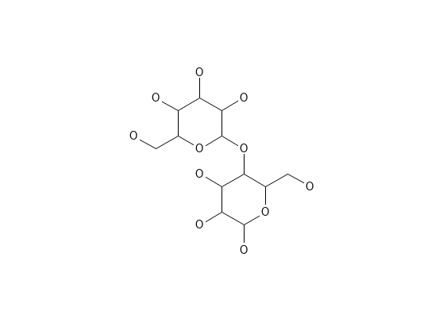
Figure 1: Structure of cellulose

Source

Cellulose derivatives can be obtained from various sources through synthetic and non-synthetic methods. They are available in multiple forms, each serving different purposes. Some of the applications of cellulose derivatives in food products include acting as a processing aid for juice filtration, an anti-caking agent for shredded cheese, and a processing aid in the form of peelable hot dog casings [28].

Application

Cellulose derivatives have a wide range of applications, including the formulation of membrane-controlled drug release systems or monolithic matrix systems. Film coating techniques utilizing cellulose derivatives are employed for enteric-coated dosage forms and semipermeable membranes in osmotic pump delivery systems.
Microcrystalline cellulose is widely used in the pharmaceutical industry as a binder and diluent in tablets for both direct compression and granulation processes. Carboxylated methylcellulose is utilized in various drug formulations, serving as a binder for drugs, a film-coating agent, and an ointment base. Additionally, cellulose acetate fibers find application in wound dressings.

Agar

Agar is composed of a combination of agaropectin and agarose. The main constituent, agarose, is a linear polymer consisting of repeating units of agarobiose. Agarobiose is a disaccharide composed of D-galactose and 3,6-anhydro-L-galactopyranose. On the other hand, agaropectin is a mixture of smaller acidic molecules that have poor gelling properties[5].

The unique property of agar is that it can form gels without imparting any flavor of its own. Unlike other gelling agents that require the addition of cations with strong flavors (such as potassium or calcium), agar can be used without any issues to gel food products with delicate or subtle flavors[6].
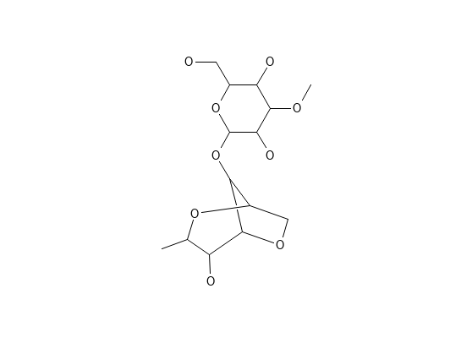
Figure 2: Structure of Agar
Source

Agar, also known as agar-agar, is a dried gelatinous substance derived from Gelidium amansii (belonging to the Gelidaceae family) as well as various other species of red algae such as Gracilaria (belonging to the Gracilariaceae family) and Pterocladia (also from the Gelidaceae family)[5].

Applications

Agar has several other applications in various industries and fields:
- Food Industry: Agar is widely used in the food industry as a gelling agent in desserts, jellies, puddings, and confectionery. It is also used to stabilize emulsions and thicken sauces and soups.
- Microbiology: Agar is a common medium for culturing bacteria, fungi, and other microorganisms in laboratories. Petri dishes and agar plates are used for this purpose.
- Biotechnology: Agar is utilized in biotechnology for techniques like gel electrophoresis, a method to separate and analyze DNA, RNA, and proteins based on their size and charge.
- Cosmetics: Agar is employed in the cosmetic industry to stabilize emulsions and create gels in various products such as creams, lotions, and shampoos.
- Medical and Pharmaceutical Applications: Agar is used in the formulation of various pharmaceutical products like capsules, suppositories, and ointments. It can also be found in medical lubricants used during surgical procedures.
- Textile Industry: Agar can be used as a sizing agent in textiles to improve their properties and handling during weaving and finishing processes.
- Plant Tissue Culture: Agar is used as a solidifying agent in plant tissue culture media, providing a supportive matrix for the growth of plant cells and tissues.
- Water Treatment: Agar is employed in water treatment processes to aid in the removal of impurities and particulates.
Overall, agar's unique properties make it a versatile and valuable substance with a wide range of applications across different industries and scientific fields.

Rosin

Rosin is composed of around 90% rosin acids, which are monocarboxylic acids with a molecular formula of C20H30O2. Among the rosin acids, the main ones are abietic acid, which contains conjugated double bonds, and pimaric acid, which has non-conjugated double bonds. These rosin acid molecules have two chemically reactive centers: the double bonds and the carboxyl group. Despite this reactivity, rosin continues to be a valuable and renewable source of chemicals that find applications in polymer synthesis and the pharmaceutical industry [29].
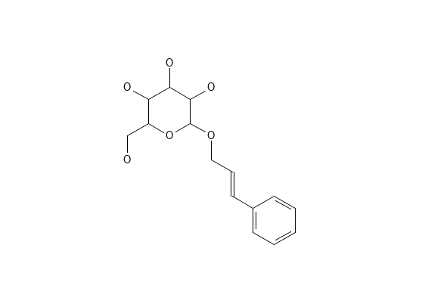
Figure 3: Structure of Rosin
Source

Rosin, also known as colophony, is a solid and resinous substance derived from various sources. It is obtained from the oleoresin, or tree sap, of live pine trees, which is referred to as gum rosin. Additionally, rosin can be obtained from the stump wood of dead pine trees through solvent extraction, known as wood rosin. It is also obtained as a byproduct in the pulp paper recovery process, which is then termed tall oil rosin[30].

Application

The traditional uses of rosin and its derivatives, such as paper sizing agents, adhesives, printing inks, and chewing gum, have experienced a decline primarily due to the rising production labor costs associated with rosin. However, to adapt to changing demands and requirements, modified resins derived from rosin have been developed. These modified resins offer more specialized properties that enhance or alter factors like stability, aging, color, and tackiness of the rosin-based products[31].

Guar gum

Guar gum is classified as a galactomannan and stands out from many other plant gums due to the absence of uronic acid. It possesses one of the highest molecular weights among naturally occurring water-soluble polysaccharides. The viscosity of a guar gum solution can be more accurately referred to as apparent viscosity, and like most hydrocolloids, it is strongly influenced by shear rate. As guar gum is anionic in nature, it remains stable and maintains consistent viscosity over a wide pH range. The highest viscosity is achieved within the pH range of 6–9, while the lowest viscosity is observed at pH 3.5[31].
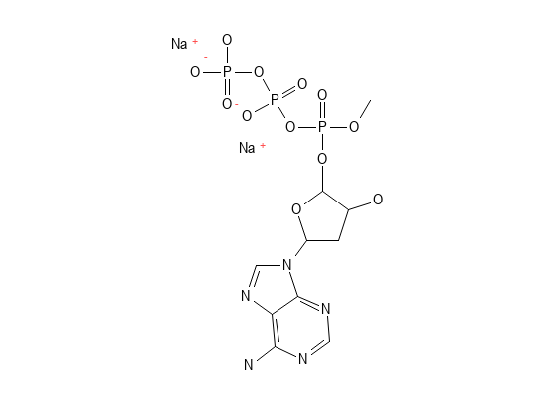
Figure 4: Structure of Guar gum
Source

Guar gum is derived from the endosperm of the seeds of Cyamopsis tetragonolobus Linn. (Leguminosae) and is found in the form of a powder. It goes by various names, including guaran, Calcutta lucern, cluster bean, Cyamopsis gum, Gum Cyamopsis, Glucotard, Guarina, and Guyarem[6].
Applications

Carboxymethyl guar film finds application in the development of a transdermal therapeutic system. Guar gum is particularly beneficial for colon delivery because it can be broken down by specific enzymes present in the gastrointestinal tract's colon region. This property allows the gum to shield the drug while passing through the stomach and small intestine, facilitating drug delivery to the colon. In the colon, the drug is either absorbed by specific microorganisms or broken down by enzymes produced by these microorganisms[5].
Additionally, guar gum is widely used in various industries such as food, paper, cosmetics, textiles, explosives, and mining. Its versatile properties make it a valuable component in a wide range of products and applications across different sectors.

Karaya Gum

Gum karaya is known for its low solubility among exudate gums. Its high viscosity, acid stability, and suspension properties make it an excellent choice for stabilizing low pH emulsions, such as sauces and dressings. When dispersed in water, gum karaya particles do not dissolve but instead, they absorb water and undergo extensive swelling, increasing their volume by over 60 times and forming a viscous colloidal sol. This swelling behavior is a result of the presence of acetyl groups in the gum's structure[1].

Gum karaya is derived from Sterculia urens (Sterculiaceae) and is a partially acetylated polymer composed of rhamnose, galactose, and glucuronic acid. Swellable hydrophilic natural gums, including karaya gum and xanthan gum, have been utilized as release-controlling agents in the production of directly compressed matrices[6].

Applications

Gum Karaya finds extensive use in various industries, despite their lack of apparent relation, owing to its unique properties such as water and moisture absorption, gel-forming abilities, and film-forming capabilities. Additionally, it exhibits strong adhesive properties. One of its notable features is its high resistance to hydrolysis by mild acids and degradation by most microorganisms.
The primary application of Gum Karaya is as a bulk laxative due to its capacity to form a mucilaginous gel when in contact with water. This property makes it effective in aiding bowel movement. Gum Karaya is also utilized in the treatment of diverticular disease and as a laxative in other medical contexts. Furthermore, it plays a significant role in the cosmetics and food industries, where it is employed for various purposes. Additionally, Gum Karaya is used in the development of controlled-release dosage forms and systems[6].

Gum Tragacanth

Source

This gum is derived from the branches of Astragalus gummifer (Leguminosae). Tragacanth consists of two main fractions: a water-soluble fraction known as tragacanthin, which makes up 20% to 30% of the gum and is composed of tragacanthic acid and arabinogalactan. The other fraction is water-insoluble and accounts for 60% to 70% of the gum, called bassorin.
Tragacanthic acid is composed of various sugars, including D-xylose, D-galacturonic acid, D-galactose, L-fructose, and others. Tragacanthin, on the other hand, is made up of arabinose and uronic acid, and it dissolves in water to form a thick colloidal solution with high viscosity. In contrast, bassorin swells in the presence of water to form a dense gel-like substance[6].

Applications

GT (Glycyrrhiza glabra extract), a plant-derived molecule, has proven to be highly valuable in various healthcare-related applications. It is commonly used in lotions for external applications, such as hair and hand creams. One of its notable features is its exceptional stability across a wide range of pH levels and temperatures, making it a preferred emulsifier in food, drug, and related industries with an extended shelf life. In the pharmaceutical sector, GT finds application as an emulsifying and suspending agent. Historically, GT has been utilized as an analgesic and a traditional remedy for treating cough and lip fissures[32].

2.2.2 Animal origin:

Chitin and chitosan

Chitin is a polysaccharide derivative that contains both amino and acetyl groups. It is the most abundant organic component found in the skeletal material of invertebrates. This biopolymer is present in various organisms such as annelids, molluscs, and arthropods. Additionally, chitin is also found in the mycelia and spores of many fungi[6].
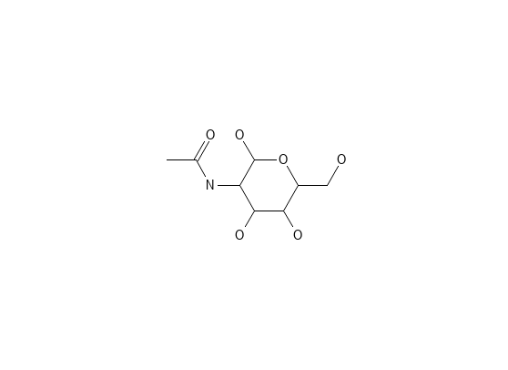
Figure 5: Structure of Chitin

New polyelectrolyte complex gel beads were developed using phosphorylated chitosan (PCS) as a base for the controlled release of ibuprofen in oral administration. These gel beads were easily prepared by employing tripolyphosphate (TPP) as a counter polyanion for ionotropic gelation with soluble phosphorylated chitosan at a pH of 4.0. The release of ibuprofen from the PCS gel beads increased as the pH of the dissolution medium was raised[6].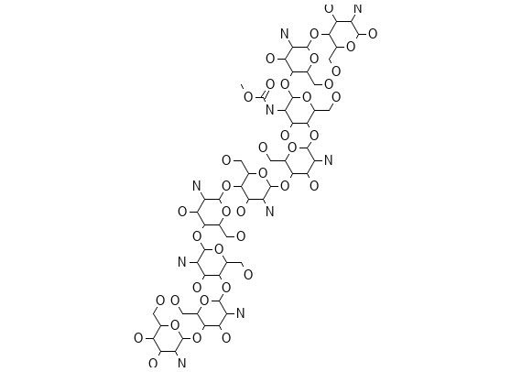
Figure 6: Structure of Chitosan

Applications

Chitosan, a biopolymer derived from chitin, has several applications in the pharmaceutical industry due to its unique properties and biocompatibility. Some of the pharmaceutical applications of chitosan include:
- Drug Delivery Systems: Chitosan is used to create drug delivery systems, such as nanoparticles, microparticles, and hydrogels. These systems can enhance the stability, bioavailability, and controlled release of drugs, improving their therapeutic efficacy.
- Wound Healing: Chitosan has wound healing properties and is used in the formulation of dressings and bandages for promoting tissue regeneration and wound closure.
- Mucoadhesive Films and Tablets: Chitosan's mucoadhesive properties make it suitable for developing films and tablets that adhere to mucosal surfaces, such as oral or nasal mucosa, allowing for extended drug release and localized drug delivery.
- Antibacterial and Antimicrobial Applications: Chitosan exhibits antimicrobial activity against various microorganisms, making it valuable in the development of antimicrobial coatings, wound dressings, and topical formulations for infections.
- Dental Applications: Chitosan is used in dental materials like mouthwashes, gels, and dental restorative materials due to its antibacterial properties and biocompatibility.
- Gene Delivery: Chitosan is investigated for its potential as a gene delivery vector in gene therapy, allowing targeted and controlled delivery of therapeutic genes to specific tissues.
- Imaging Agents: Chitosan-based nanoparticles can be used to carry imaging agents for diagnostic purposes, enabling better visualization of tissues or organs.
- Vaccine Adjuvants: Chitosan is explored as a vaccine adjuvant, enhancing the immune response and efficacy of vaccines.
These are just a few examples of the diverse applications of chitosan in the pharmaceutical industry. Its biodegradability, biocompatibility, and versatile properties make it a promising material for various drug delivery and therapeutic applications.

Alginate

Alginate, a natural biopolymer, has been successfully employed for the removal of various heavy metals and colorants from aqueous solutions. This effectiveness is attributed to the presence of negatively charged carboxyl groups in alginate. Alginate is characterized by its biocompatibility, non-toxicity, hydrophilicity, and the presence of l-guluronic acid. It is a linear copolymer consisting of b-(1-4) linked d-mannuronic subunits, which are obtained from the cell walls of brown algae[33].
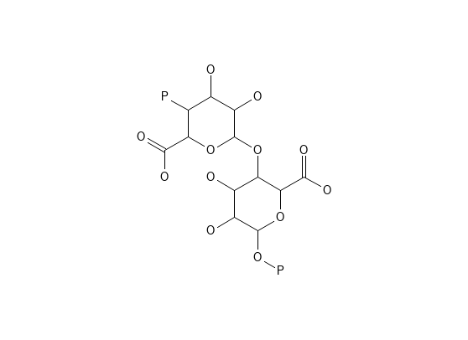
Figure 7: Structure of Alginate

Source

Alginates, also known as alginic acids, are anionic polysaccharides that exist in a linear, unbranched form. They are naturally present in brown seaweed and marine algae like Laminaria Hyperborea, Ascophyllum nodosum, and Macrocystis pyrifera.

Applications

Alginate beads find extensive use in decontamination processes, effectively removing a range of aquatic pollutants, including heavy metals, colored contaminants (dyes), and various organic/inorganic pollutants. This elimination occurs through various mechanisms, such as meta-biologically mediated or physico-chemical pathways like adsorption, precipitation, ion exchange, reverse osmosis, evaporation, floatation, oxidation, and biosorption processes (alginate).
Moreover, alginates serve as stabilizers in emulsions, suspending agents, and perform roles as tablet binders and tablet disintegrants[5].

Carrageenan’s

Carrageenan (CG) refers to a group of high molecular weight sulphated polysaccharides obtained from red seaweeds. These polysaccharides are composed of alternating units of D-galactose and 3,6-anhydro-galactose (3,6-AG), connected by α-1,3 and β-1,4-glycosidic linkages. CG is classified as a sulphated polyglactin with an ester-sulphate content ranging from 15% to 40%, making it an anionic polysaccharide[34].
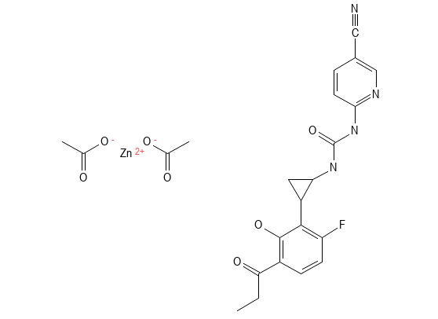
Figure 8: Structure of Carrageenan
Source

Carrageenan is derived from red seaweeds belonging to the Rhodophyceae family, particularly from genera like Eucheuma, Solieria, Cripus, Agardhiella, Chondrus, Hypnea, Sarconema, Iridaea, Gigartina stellate, and Agardhiella. Among these, Eucheuma and Kappaphycus seaweeds are the most widely cultivated species in Malaysia and Southeast Asia [34].

Applications

Carrageenans are utilized to induce experimental inflammation and inflammatory pain. They find numerous applications in both non-food and food production. In the food industry, carrageenans are highly valued for their outstanding physical and functional properties, including their ability to stabilize, gel, emulsify, and thicken. Consequently, they are commonly employed to enhance the quality of dairy products, sweets, puddings, and cheese. Moreover, carrageenans serve as stabilizers and binders in the meat manufacturing industry, contributing to the production of low-calorie sandwiches.

Xanthan Gum

Xanthan gum is a high molecular weight extracellular polysaccharide that is produced through the fermentation of the gram-negative bacterium Xanthomonas campestris. Its primary structure is similar to a cellulose derivative, consisting of a cellulosic backbone with β-D-glucose residues. Additionally, it has a trisaccharide side chain composed of β-D-mannose-β-D-glucuronic acid-α-D-mannose, attached to alternate glucose residues of the main chain. Xanthan gum exhibits a higher ability to slow down drug release compared to synthetic hydroxypropyl methylcellulose[6].
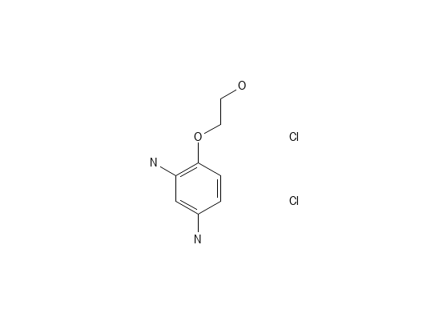
Figure 9: Structure of Xanthan gum

Applications

Xanthan gum is used in pharmaceutics for controlled release formulations due to its excellent thickening, gelling, and mucoadhesive properties. Some of the applications of xanthan gum in controlled release formulations include:
- Matrix Tablets: Xanthan gum is used as a matrix material in the formulation of sustained-release tablets. It helps control the release rate of the drug by forming a gel-like matrix that retards the dissolution and release of the active ingredient.
- Gel Beads and Microspheres: Xanthan gum is employed in the preparation of gel beads and microspheres to encapsulate drugs for controlled release. The beads and microspheres can be administered orally or through injection to achieve sustained drug delivery.
- Transdermal Patches: Xanthan gum is incorporated into transdermal patches to provide a controlled release of drugs through the skin. It helps maintain drug concentration within the therapeutic range over an extended period.
- Topical Gels and Creams: Xanthan gum is used in topical gels and creams to prolong drug release at the site of application. It enhances drug retention and bioavailability on the skin surface.
- Mucoadhesive Formulations: Xanthan gum's mucoadhesive properties allow it to adhere to mucosal surfaces, such as oral or nasal mucosa, ensuring sustained drug release and targeted delivery.
- Oral Liquids and Suspensions: Xanthan gum can be used in oral liquids and suspensions to enhance the stability of the formulation and control the release of the drug after ingestion.

CONCLUSION

Smart polymers and natural polymers play an important role in drug delivery. Here we can say that smart polymers have a very wide range of applications and have an exciting future. The smart polymer also provides a link between therapeutic needs and drug delivery. While natural polymers it is very advantageous for controlled drug delivery. It shows fewer side effects comparatively than synthetic polymers. Natural polymers are also used for nano formulation for targeting and sustained delivery with fewer side effects.

REFERENCES
1. Mahajan A, Aggarwal G. Smart polymers: innovations in novel drug delivery. Int J Drug Dev Res. 2011;3(3):16–30.
2. Subramani M, Vekatashwaramurthy DN, Sambathkumar DR. A Novel Approach on Role of Polymers Used In Sustained Release Drug Delivery System-A Review. Saudi J Med Pharm Sci. 2021;7(4):170–8.
3. Zaborniak I, Macior A, Chmielarz P. Smart, naturally-derived macromolecules for controlled drug release. Molecules. 2021;26(7):1918.
4. Priya James H, John R, Alex A, Anoop KR. Smart polymers for the controlled delivery of drugs – a concise overview. Acta Pharm Sin B. 2014 Apr 1;4(2):120–7.
5. Rajeswari S, Prasanthi T, Sudha N, Swain RP, Panda S, Goka V. Natural polymers: a recent review. World J Pharm Pharm Sci. 2017;6:472–94.
6. Kulkarni Vishakha S, Butte Kishor D, Rathod Sudha S. Natural polymers–A comprehensive review. Int J Res Pharm Biomed Sci. 2012;3(4):1597–613.
7. Prabaharan M, Mano JF. Chitosan-based particles as controlled drug delivery systems. Drug Deliv. 2004;12(1):41–57.
8. Aghabegi Moghanjoughi A, Khoshnevis D, Zarrabi A. A concise review on smart polymers for controlled drug release. Drug Deliv Transl Res. 2016;6(3):333–40.
9. Sharma D, Dev D, Prasad DN, Hans M. Sustained release drug delivery system with the role of natural polymers: A review. J Drug Deliv Ther. 2019;9(3-s):913–23.
10. Kaur R, Kaur S. Role of polymers in drug delivery. J Drug Deliv Ther. 2014;4(3):32–6.
11. Kulkarni RV, Boppana R, Mohan GK, Mutalik S, Kalyane NV. pH-responsive interpenetrating network hydrogel beads of poly (acrylamide)-g-carrageenan and sodium alginate for intestinal targeted drug delivery: Synthesis, in vitro and in vivo evaluation. J Colloid Interface Sci. 2012;367(1):509–17.
12. Garbern JC, Minami E, Stayton PS, Murry CE. Delivery of basic fibroblast growth factor with a pH-responsive, injectable hydrogel to improve angiogenesis in infarcted myocardium. Biomaterials. 2011;32(9):2407–16.
13. Zhao L, Zhu L, Liu F, Liu C, Wang Q, Zhang C, et al. pH triggered injectable amphiphilic hydrogel containing doxorubicin and paclitaxel. Int J Pharm. 2011;410(1–2):83–91.
14. Li K, Yu L, Liu X, Chen C, Chen Q, Ding J. A long-acting formulation of a polypeptide drug exenatide in treatment of diabetes using an injectable block copolymer hydrogel. Biomaterials. 2013;34(11):2834–42.
15. Bae WK, Park MS, Lee JH, Hwang JE, Shim HJ, Cho SH, et al. Docetaxel-loaded thermoresponsive conjugated linoleic acid-incorporated poloxamer hydrogel for the suppression of peritoneal metastasis of gastric cancer. Biomaterials. 2013;34(4):1433–41.
16. Hsiao M-H, Larsson M, Larsson A, Evenbratt H, Chen Y-Y, Chen Y-Y, et al. Design and characterization of a novel amphiphilic chitosan nanocapsule-based thermo-gelling biogel with sustained in vivo release of the hydrophilic anti-epilepsy drug ethosuximide. J Controlled Release. 2012;161(3):942–8.
17. Licciardi M, Amato G, Cappelli A, Paolino M, Giuliani G, Belmonte B, et al. Evaluation of thermoresponsive properties and biocompatibility of polybenzofulvene aggregates for leuprolide delivery. Int J Pharm. 2012;438(1–2):279–86.
18. Indermun S, Govender M, Kumar P, Choonara YE, Pillay V. Stimuli-responsive polymers as smart drug delivery systems: classifications based on carrier type and triggered-release mechanism. In: Stimuli Responsive Polymeric Nanocarriers for Drug Delivery Applications, Volume 1. Elsevier; 2018. p. 43–58.
19. Cheng R, Meng F, Deng C, Klok H-A, Zhong Z. Dual and multi-stimuli responsive polymeric nanoparticles for programmed site-specific drug delivery. Biomaterials. 2013;34(14):3647–57.
20. Higuchi T. Mechanism of sustained-action medication. Theoretical analysis of rate of release of solid drugs dispersed in solid matrices. J Pharm Sci. 1963;52(12):1145–9.
21. Kranz H, Bodmeier R. A novel in situ forming drug delivery system for controlled parenteral drug delivery. Int J Pharm. 2007;332(1–2):107–14.
22. Chen S, Singh J. In vitro release of levonorgestrel from phase sensitive and thermosensitive smart polymer delivery systems. Pharm Dev Technol. 2005;10(2):319–25.
23. Gan LH, Gan YY, Deen GR. Poly (N-acryloyl-N ‘-propylpiperazine): A new stimuli-responsive polymer. Macromolecules. 2000;33(21):7893–7.
24. Lupitskyy R, Roiter Y, Tsitsilianis C, Minko S. From smart polymer molecules to responsive nanostructured surfaces. Langmuir. 2005;21(19):8591–3.
25. Brown W, Schillen K, Hvidt S. Triblock copolymers in aqueous solution studied by static and dynamic light scattering and oscillatory shear measurements: influence of relative block sizes. J Phys Chem. 1992;96(14):6038–44.
26. Galaev IY, Mattiasson B. ‘Smart’polymers and what they could do in biotechnology and medicine. Trends Biotechnol. 1999;17(8):335–40.
27. da Silva RM, López-Pérez PM, Elvira C, Mano JF, Román JS, Reis RL. Poly (N-isopropylacrylamide) surface-grafted chitosan membranes as a new substrate for cell sheet engineering and manipulation. Biotechnol Bioeng. 2008;101(6):1321–31.
28. Lavanya D, Kulkarni PK, Dixit M, Raavi PK, Krishna LNV. Sources of cellulose and their applications—A review. Int J Drug Formul Res. 2011;2(6):19–38.
29. Pal OP, Malviya R, Bansal V, Sharma PK. Rosin an important polymer for drug delivery: a short review. Int J Pharm Sci Rev Res. 2010;3(1):35–7.
30. Chavda VP, Soniwala MM, Chavda JR. Role of rosin in controlled and targeted drug delivery. Crit Rev Pharm Sci. 2012;1(2):15–20.
31. George A, Shah PA, Shrivastav PS. Guar gum: Versatile natural polymer for drug delivery applications. Eur Polym J. 2019;112:722–35.
32. Taghavizadeh Yazdi ME, Nazarnezhad S, Mousavi SH, Sadegh Amiri M, Darroudi M, Baino F, et al. Gum Tragacanth (GT): A versatile biocompatible material beyond borders. Molecules. 2021;26(6):1510.
33. Thakur S. An overview on alginate based bio-composite materials for wastewater remedial. Mater Today Proc. 2021;37:3305–9.
34. Zia KM, Tabasum S, Nasif M, Sultan N, Aslam N, Noreen A, et al. A review on synthesis, properties and applications of natural polymer based carrageenan blends and composites. Int J Biol Macromol. 2017;96:282–301.

