Synthesis and Characterization of MoO₃ Nanorods
Neha Desai, Rajesh Kavade
Department of Chemistry, K.B.P. Mahavidyalaya Pandharpur
Email id of corresponding author :- nehadesai323@gmail.com
Abstract:-
In this research, we synthesized MoO3 nanoparticles by chemical bath deposition. The synthesized MoO3 nanoparticles are well indexed to the hexagonal crystal structure. A morphological study reveals the presence of nanorods with a hexagonal crystal structure. An optical study shows a direct allowed band gap with absorption in the ultraviolet region. Compositional analysis shows the presence of molybdenum and oxygen in the synthesized nanoparticles.
Keywords :- MoO₃, CBD, nanorods
Introduction:-
Recently, transition metal oxides (TMOs) have attracted much attention in the field of materials science due to their variety of crystalline phases and properties. Nanocrystalline transition metal oxides such as TiO2, MoO3 and ZnO are the most studied by various researchers worldwide. Among transition metal oxides, molybdenum oxide (MoO3) exhibits superior intercalation chemistry with unique chemical, electrochemical, electronic, and catalytic properties.
MoO₃ is the most produced product of molybdenum worldwide than any other molybdenum compound due to the comparative instability of molybdenum oxides of lower oxidation states.
MoO₃ exhibits different crystal phases such as orthorhombic (α-MoO3) and hexagonal (h-MoO3). Of the two hexagonal forms, MoO3 is metastable, with the orthorhombic form of MoO3 being more thermodynamically stable than any other form.
Molybdenum oxide (MoO₃) exhibits excellent structural, chemical, electrical, catalytic and optical properties. They have a perovskite-like structure, which makes them a suitable candidate for optoelectronic applications. Several studies have been carried out to learn more about the optical, structural and morphological properties of MoO₃. Potential applications of MoO₃ include sensors, catalysts, fuel cells, solar cells, supercapacitors, memory devices, etc.
Experimental:-
Chemical bath deposition method is used for the synthesis of MoO3 nanomaterials. In a typical synthesis ammonium heptamolybdate tetrahydrate (AHM) and conc. Nitric acid (HNO₃) is used as a precursor for the reaction.
In the experimental setup, 15 mL of 0.05 M AHM solution was placed in the reaction bath. The temperature of the solution was slowly increased up to 500 C using a heating jacket. To this, 5 mL of concentrated HNO 3 was added dropwise with constant stirring to give a clear solution. This clear solution was then stirred for 15 min and the temperature of the reaction bath was maintained at 700 C for 30 min to obtain a yellowish-white precipitate of h –MoO₃. The reaction mixture is then cooled to room temperature. Finally, the precipitate of h-MoO ₃ was filtered off with a Buchner funnel using Whatman No. 42 filter paper. Then, the precipitate was washed with hot distilled water and the product was dried in a muffle furnace at 500 °C for 2 hours.
Growth and reaction mechanism: -
The growth of nanoparticles by CBD follows Ostwald ripening law. According to the Ostwald ripening law, the number of smaller crystallites sacrifices themselves to form larger crystallites. As a result of this initially the seed nuclei is formed by using the Ostwald ripening. After this these seed nuclei combine to form a multi-nucleation centres. The uniform growth of the nanoparticles is possible due to ripening of multi-nucleation centres. Hence to obtain a desired morphology control over the process of nucleation or growth is the most important aspect. Hence by controlling the parameters of CBD we have obtained the growth of nano rods for the MoO₃. The nano rods are 1D in nature with hexagonal cross section. The 1D nanomaterial is having a higher surface area. Hence they show a better catalytic activity. The reactions which are taking place are as follows,
Optical study:
In order to study optical properties of MoO₃, optical absorption of h-MoO₃ and α-MoO₃ is recorded on UV spectrophotometer in range 190 to 700nm, the absorption spectra clearly indicates that MoO₃ is active in UV region. The band gap for MoO₃ samples are calculated by the classical absorption equation. It is found that the λ_{max} value for h-MoO₃ is 280nm and for α-MoO₃ λ_{max} is 300nm. From λ_{max} values of both the samples it is clear that the band gap for MoO₃ is near about 3eV. From this we can conclude that MoO₃ is wide band gap semiconductor material.
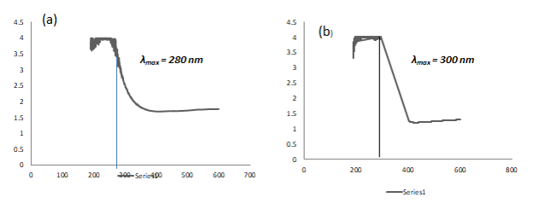

Fig 1: (a) Graph of h- MoO₃ ( Wavelength vs Absorbance) (b) Graph of α MoO₃ ( Wavelength vs Absorbance).
Structural study:
The structural study aspects of MoO₃ nanoparticles was determined by using X-Ray diffraction. XRD pattern of the samples h-MoO₃ is shown in figure 2,
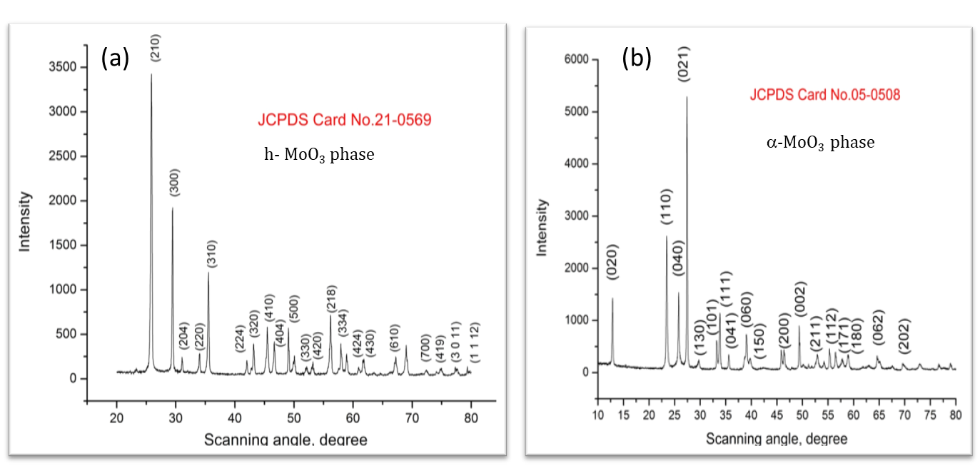
Fig 2. XRD pattern of h-MoO₃

The crystal structure and phase identification of MoO₃ sample was carried out by using X-ray diffraction analysis. Here we have synthesized h-MoO₃ nanoparticles. All the peaks in the XRD are well indexed to the JCPDS card no. 21-0569. No extra peaks due to impurity are seen.
The crystallite size is calculated by using equation,
D= 0.9λ/βCosƟ
The crystallite size is calculated by using most intense (210) peak. The crystallite size of h-MoO₃ is 35nm.
Morphological study:-
The morphology of nanomaterials plays a fundamental role in the physical and chemical properties of nanomaterials. To study the morphological aspects of MoO3 nanoparticles. The surface morphology of both h-MoO3 was characterized by SEM analysis. The image below clearly shows the presence of 1D hexagonal rods. All the nanorods are assembled together to form a nanoflower-like structure. The size of each nanoflower is about 1 micron.

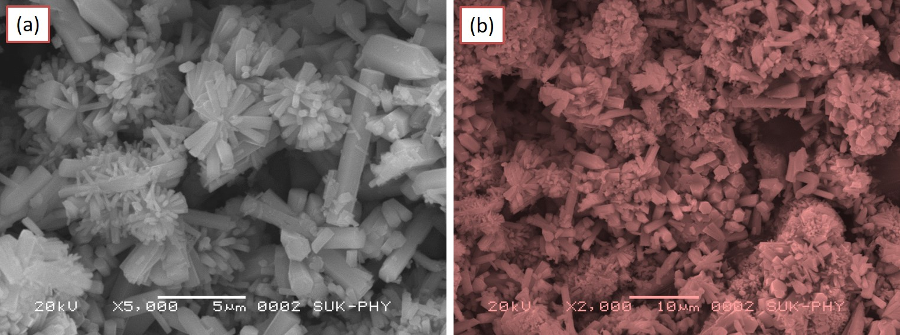
Fig.3 SEM micrographs of MoO3 nanorods
Compositional analysis:-
In order to confirm the composition of a nanomaterial EDS analysis is carried out. The presence of Mo and O in synthesised nanopowder is shown in the EDS spectra.
The observed and actual atomic percentage is in good agreement.
EDS spectrum of MoO₃ thin film

Conclusions:-
The MoO₃ nanopowder is synthesized by chemical bath deposition. The structural study shows hexagonal crystal structure. The SEM micrographs reveals nanorod like structure. The EDS spectra confirms presence of molybdenum and oxygen. The optical study reveals the absorption in the Ultra violet region. All these properties reveals that MoO3 is a better candidate for gas sensing.
References:-
- Trans. Nonferrous Met. Soc. China 33(2023) 2155−2167.
- Results in OpticsVolume 11, May 2023, 100374
- Int. J. Electrochem. Sci., 15 (2020) 9824 – 9837.
- Materials Science in Semiconductor ProcessingVolume 150, 1 November 2022, 106974
- International Journal of Hydrogen Energy Volume 47, Issue 47, 1 June 2022, Pages 20475-20493
- Arabian Journal of Chemistry Volume 15, Issue 9, September 2022, 104083
Reference id - IIPER1655365759

