BIOMECHANICS IN IMPLANTS: - A CRITICAL OPINION
Sangram Kumar Panda¹, Mirna Garnayak², Sitansu Sekhar Das³, Abhijita Mohapatra⁴, Abhilash Mohapatra⁵
¹ Associate Professor, ² Professor, Institute of Dental Sciences, Siksha O Anusandhan (Deemed to be University), Bhubaneswar, Odisha, India.
Corresponding author: Dr. Sangram Panda; Email: sangrampanda@soa.ac.in

ABSTRACT
Dental implants are regarded as the finest treatment option for replacing missing teeth due to their high survival rates and wide range of applications. However, only a small percentage of dental implant therapies are effective, and some fail for biological and mechanical reasons. This study aimed to comprehensively review literature that concentrates on the biomechanical characteristics of dental implants and highlight all the variables that affect the implant's survival rates.
KEYWORDS: Biomechanics, Oral implants, Oral prosthesis, loading.

INTRODUCTION
The research fields of biomechanics heavily rely on applied mechanics, particularly thermodynamics and mechanical engineering specialities like fluid mechanics and solid mechanics. The study of living organisms' mechanics, application of engineering principles to and from biological systems, and bio-engineering are all included in biomechanics. ⁽¹⁾. There are two different types of aspects to biomechanics. There are Reactive biomechanics and Therapeutic biomechanics. Therapeutic biomechanics remediates each biomechanical factor to diminish implant overloading ⁽²⁾.
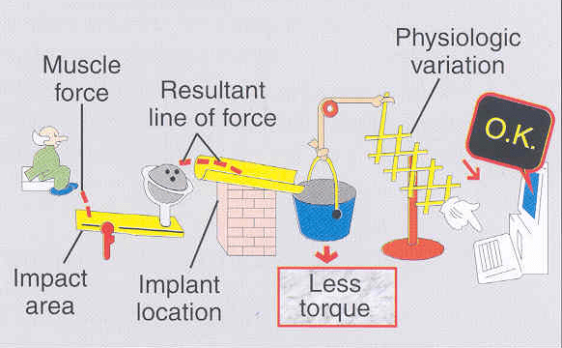
Figure 1. Schematic depiction of Therapeutic biomechanics^{. (3)}
Reactive biomechanics includes any implant prosthesis that increases the implant stress loading ability, which translates into more stress on the implant, resulting in better remodelling of bone around the implant and better Osseointegration ⁽⁴⁾.
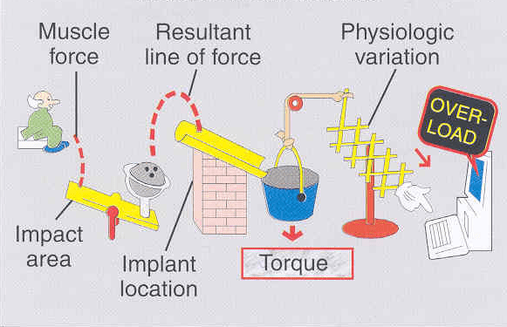
Figure 2. Schematic depiction of overload in biomechanics. ⁽⁴⁾

INTERRELATED FACTORS
Many interrelated factors contribute to the success of Implants, which should be duly analysed, and accordingly, diagnosis and treatment planning should be developed to maintain a state of equilibrium. The factors that determine the proper functional ability of the prosthesis are biomechanics, occlusal forces and esthetics ⁽⁵⁾.
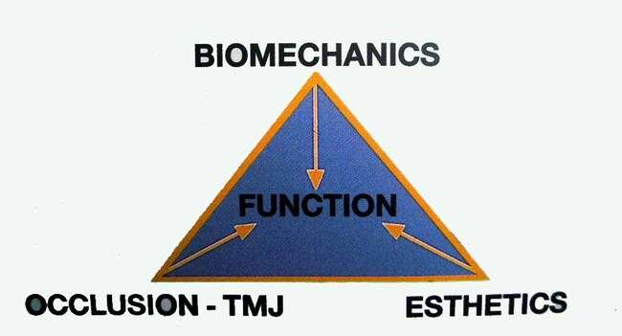
Figure 3. Correlation between different factors and functions. ⁽⁶⁾
Force is any application of energy, either internal or external to a structure, that initiates, changes or arrests motion. Many related force factors include magnitude, duration, type, direction and magnification ⁽⁷⁾. Magnitude varies from location to location inside the patient’s mouth, depending on the prosthesis type. Duration of the force also impacts mastication force of about 9 minutes per day, producing a force of 20 to 30 psi while swallowing about 20 minutes per day 3 to 5 psi⁽⁸⁾. There are also many forces magnifying factor that increases the torque on implant prosthesis like extreme angulation, cantilevers, crown height, Parafunction and bone density. A 1 mm increase in the implant crown height will cause a 20 per cent increase in torque ⁽⁹⁾. Torque is a multiple of force and distance where, in the case of a natural tooth, the distance is measured from the height of the contour of the tooth to the apical one-third of the natural tooth. In the case of implants, the distance is measured from the height of the contour to the first third screw level ⁽¹⁰⁾.

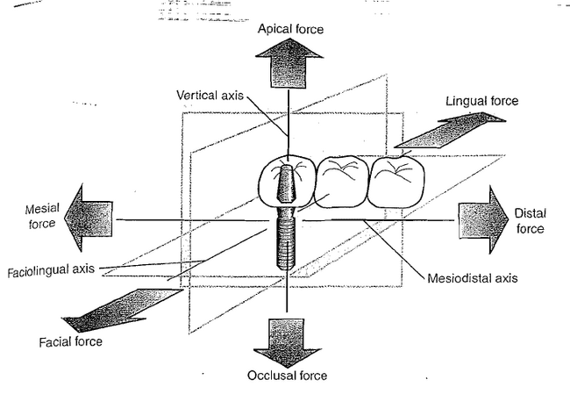
Figure 4. Three-dimensional forces have parts that are directed along one or more clinical coordinate axes: Occlusal, Faciolingual and Mesiodistal.¹¹
Compressive forces tend to maintain the integrity of the bone-implant interface and are also best accommodated by a complete implant prosthesis system. Tensile forces pull the object apart and tend to distract and disrupt such an interface ⁽¹²⁾. Shear forces are most destructive to implants and can cause sliding of the implants. Shear forces also tend to distract or disrupt bone to the implant surface. Forces falling on natural teeth are transmitted to the periodontal ligament, which causes flexion in the crestal bone, resulting in an even distribution of the force. However, in the case of a rigid, fixed and stiff structure, the forces concentrate the first three thread levels of the implant screw, resulting in crestal bone loss and even periimplantitis ⁽¹³⁾. Osseo-integrated implants have the potential as a firm osseous anchorage and resist continuous horizontal forces of at least 5 Newton (about 510 gms) for several months. Successful dental Implants also show an average of 0.1 mm of bone loss after the first year. There is also a mean loss of 0.1 mm to 0.13 mm per year after the first year of implant prosthesis functions ⁽¹⁴⁾.
Differential Mobility
There is a qualitative difference between the flexure of the periodontal ligament of the natural tooth and the stiffness of the Osseointegrated dental implant. The amount of micro-movement significantly differs between natural tooth and Dental implants. A natural tooth with good bone will move laterally approximately 0.5 mm measured occlusally. A Dental Implant can move laterally 0.1 mm or less laterally measured occlusally. The table below depicts the differences between the natural tooth and Dental Implant ⁽¹⁵⁾.
Forces acting on the Implants
Various forces are falling on the implants, like normal occlusal loading of implants and parafunctional habits. Passive implant loading is caused by mandibular flexure, contact with the first-stage cover screw and second-stage permucosal extension ⁽¹⁶⁾. There are also peri-oral forces and non-passive prostheses. Out of which, the traumatic forces or the forces that cause implant overloading are non-passive forces, parafunctional habits, initial contact during maximum intercuspation and labial stresses generated during eccentric movement. Therefore, it is essential to eliminate posterior contact during protrusion and lateral excursion. Implant prostheses should only come in contact during maximum intercuspation to avoid lateral destructive forces on the implant, which may eventually cause prosthesis failure ⁽¹⁷⁾.
Force distribution in the multiple Implant prosthesis
Natural teeth have periodontal ligaments, which are elastic fibers attached to teeth in different angulations and help dissipate forces; thus, they act as shock absorbers. Implants are stiff when Osseo is integrated, there is no force distribution, and force only concentrates at the crestal bone ⁽¹⁸⁾.
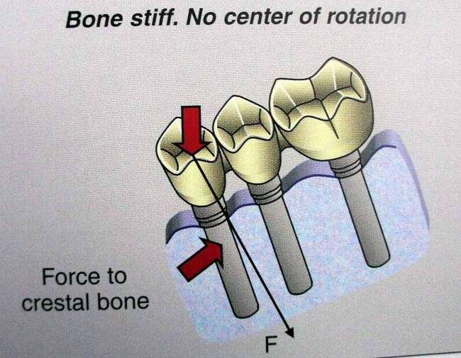
Figure 5. Effect of Occlusal forces on crestal bone. ⁽¹⁹⁾
Another school of thought is force distribution in the combined prosthesis, supported by natural teeth and implants. In these types of prostheses, the mode of attachment is stiff and flexible ⁽²⁰⁾. Flexible attachment is mainly preferred in internal attachment embedded inside the crowns of the abutment tooth and implant abutment. A stiff prosthesis is preferred when implants are the terminal abutment with only centric contacts and no eccentric contacts. Flexible attachment is in the form of female attachment in the tooth-supported prosthesis and as a stiff attachment (screw retained) implant prosthesis, which results in flexion but has no deleterious effect on the integrity of the prosthesis.

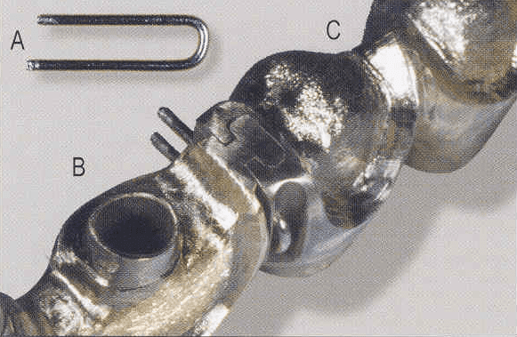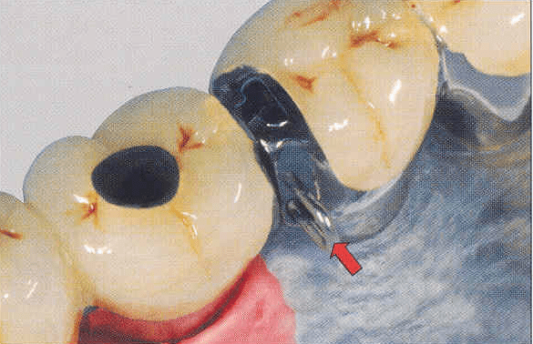
Figures 6 & 7. Flexible connector attachment to reduce occlusal forces. ⁽²¹⁾
If the stiff attachment is preferred, the crown is cemented onto the tooth with a permanent cement. In contrast, the implant-supported retainer is cemented with temporary cement, which tends to loosen if and when occlusal load, both centric and eccentric, falls on it, making retrievability easier and further corrections and cementation more practical.
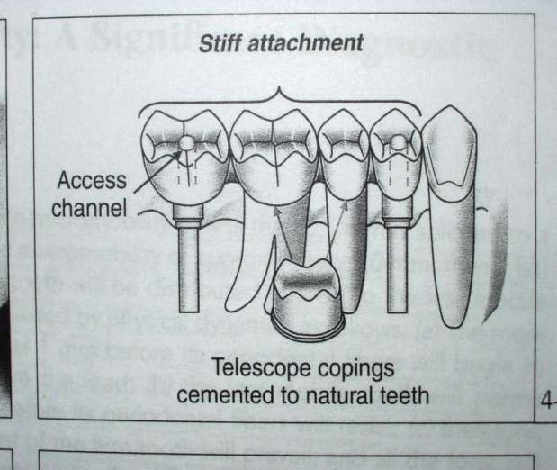
Figure 8. Telescoping coping cemented to a natural tooth. ⁽²²⁾
Diagnostic Factors in Combined Prosthesis
Standard prosthesis design for combined prosthesis provides an internal attachment placed in the distal part of the natural tooth. This will compensate for the differential mobility between an apically flexible tooth and a rigid implant prosthesis. Attaching a rigid implant with an apically flexible natural tooth may cause loss of the designed prosthesis. Even increasing the lever arm increases the torque on the prosthesis, which increases the chances of destruction of the prosthesis. Recommended prosthesis design dictates that there should be one cantilever pontic in each segment, which prevents drifting apart of the segment and decreases the torque, thereby preventing the prosthesis's failure ⁽²³⁾.
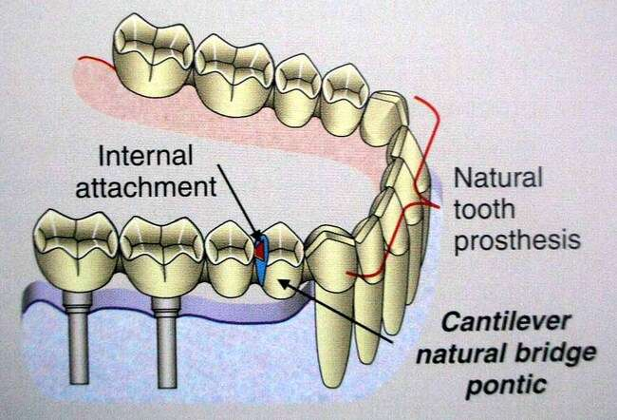
Figure 9. Internal attachment in case of implant-supported restoration. ⁽²⁴⁾
Four clinical variants with Implant loading
The four clinical variants in implants can be classified into Cuspal inclination, Impact inclination, Horizontal implant offset and vertical/apical implant offset.
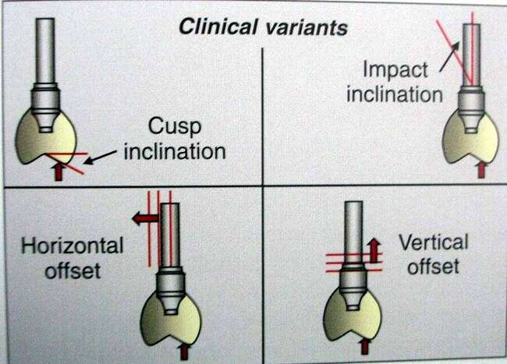
Figure 10. A visual depiction of different forces falling on a supported crown. ⁽²⁵⁾
Cuspal inclination: In contrast to cortical bone stress, which reduced as cusp inclination rose, stresses on the implant and the implant/abutment contact increased. An increase in 10 degrees of Cuspal inclination results in a 30 per cent increase in torque forces.
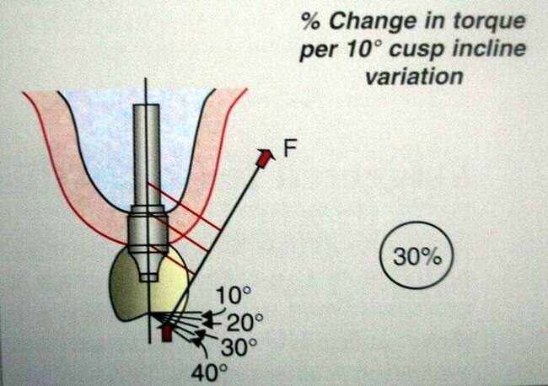
Figure 11. Change in forces on Implant depending upon different angulations. ⁽²⁶⁾

Impact inclination: An increase in 10 degrees causes an increase in 5 per cent torque.
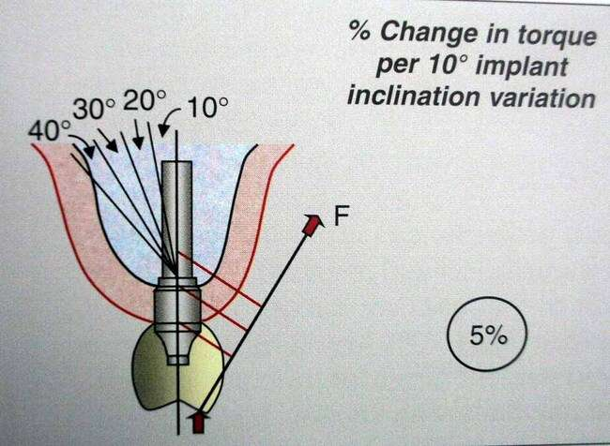
Figure 12. Change in torque per 10-degree implant inclination variation. ⁽²⁷⁾
Horizontal Implant offset: There are several anatomical constraints that prevent the insertion of implants in their typical configuration. A possible treatment option would be to offset-place implants in the prosthetic unit. It is safe to say that the in-line implant arrangement offers biomechanical advantages in terms of minimizing stress concentration over the offset placement of a single dental implant. The amount of offset should be as minimal as possible. An increase in 1 mm of horizontal implant offset increases the torque to around 15 per cent ⁽²⁸⁾.
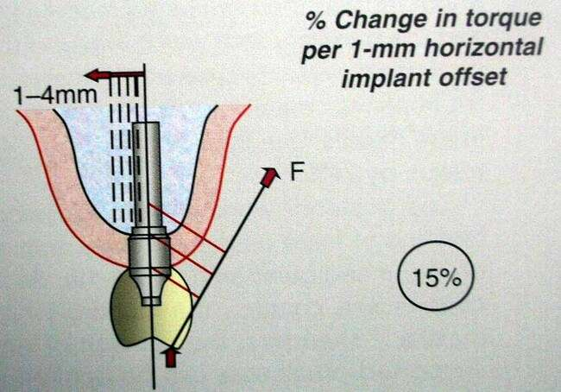
Figure 13. Change in torque per 1 mm horizontal implant offset. ⁽²⁸⁾
Apical Implant offset: - It is similar to the horizontal implant offset. Still, it is in a vertical direction where an increase of 1 mm causes an increase in 5 per cent of the torque.
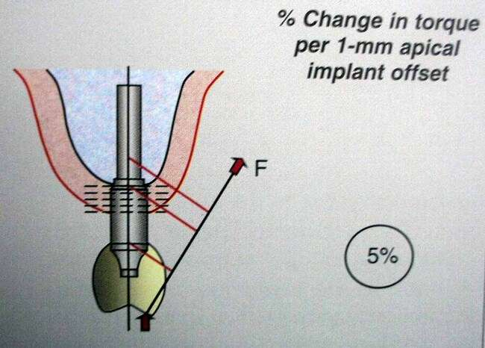
Figure 14. Change in torque per 1 mm apical implant offset. ⁽²⁹⁾
A concept of staggered implant offset was introduced where there is staggered buccal and lingual offset placement of implants, which creates a tripod effect and helps compensate for the torque forces falling on the prosthesis ⁽³⁰⁾. To achieve this, Implants are placed 1.5 mm buccal and lingual from the centre line to achieve tripods ⁽³¹⁾.
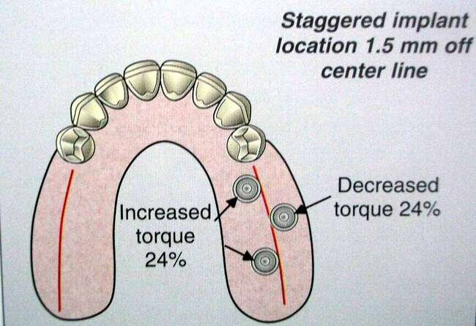
Figure 15. Implants placed with tripodism concept. ⁽³²⁾
It was found that a palatal offset increases the torque by 24 per cent while a buccal offset, in the maxilla, decreases the torque by 24 per cent. Therefore, keeping the buccal offset in the maxilla is preferred to reduce the torque ⁽³³⁾. Placement of the implant in the posterior region is critical as posteriors are the active zone for the occlusal loading onto implants ⁽³⁴⁾. Accordingly, the occlusal forces should fall as parallel to the long axis of the implants as much as possible.
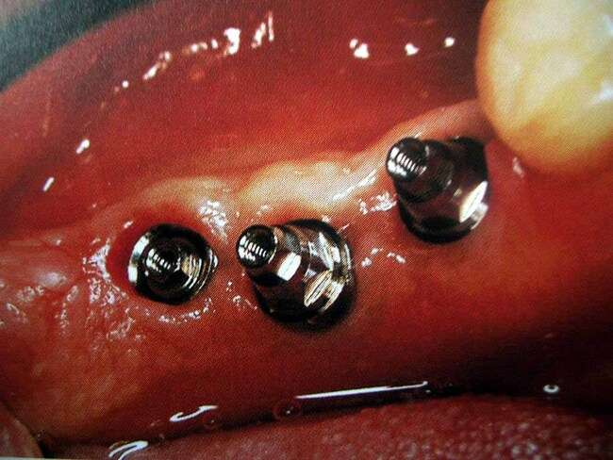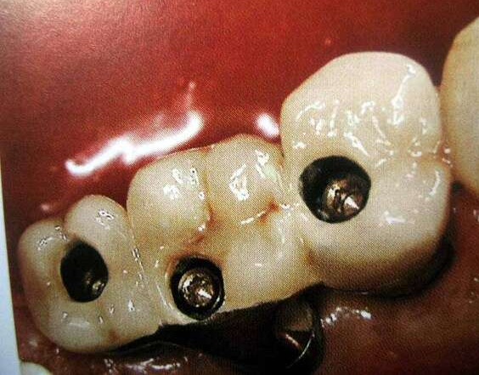
Figure 16, 17. Tripodal implant placement and restoration. ⁽³⁵⁾
Therapeutic Biomechanics
Five potential remedial methods that can be combined in the therapeutic biomechanics’ method are employed to lessen implant loading. This method entails (i) Cross occlusion (ii) placing the implant head as close to the midline of the restorations as possible (iii) using an angled or custom-regulated abutment (iv) using shallow cusp inclines, (v) using modified centric occlusal architecture ⁽³⁶⁾.
Cross Occlusion. Changing the bucco-lingual relation of the implant vis-a-vis opposing teeth helps reduce the horizontal implant offset and thereby significantly helps reduce torque.

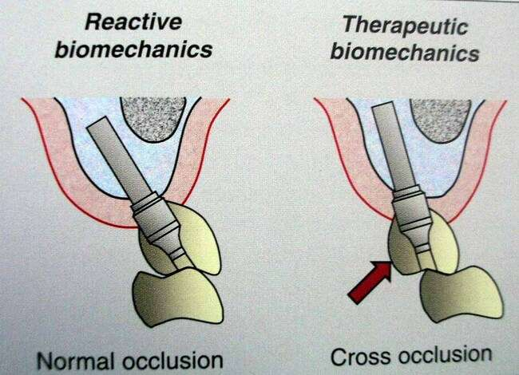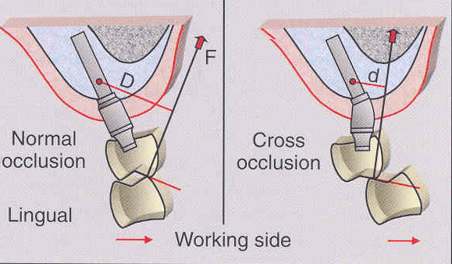
Figure 18, 19. Normal occlusion and cross occlusion in Implant prosthesis. ⁽³⁷⁾
Decrease in Cuspal Inclination: Decreasing the Cuspal inclination reduces the distance between the implant and the resultant line of force.
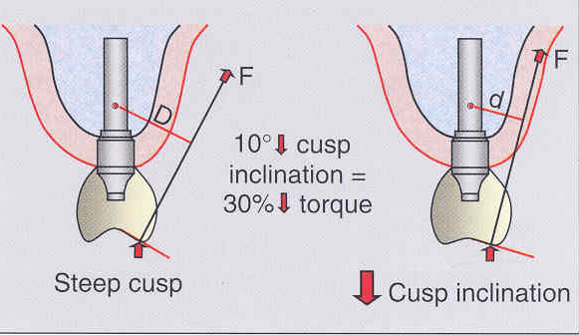
Figure 20. A 10-degree decrease in cusp inclination results in a 30 per cent reduction in torque forces. (Courtesy; Atlas of Tooth and Implant supported prosthodontics medicine: Lawrence A.Weinberg ⁽³⁸⁾)
Implant position Keeping the head of the implant as close to the Centre line of restoration as possible helps reduce the horizontal offset and, thereby, helps in a 5% reduction in the torque.
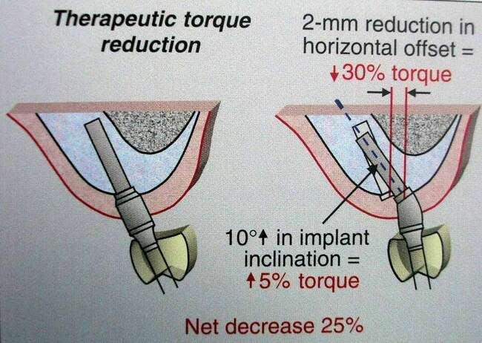
Figure 21. A 10-degree increase in implant inclination results in an increase in torque forces to about 5 per cent. ⁽³⁹⁾
Modified centric occlusal anatomy: The standard occlusal anatomy where the cusp inclines meet in a central groove, and the cusps cause buccal and lingual axis line of forces. There is a physiologic variation in centric relation of 0.4 mm as per records, and a lateral shift in the centric occlusion will result in a buccally and lingually inclined resultant line of forces. Modifying the occlusal anatomy by shallowing the fossa helps bring the vertical line of forces within the expected range of physiological variation.
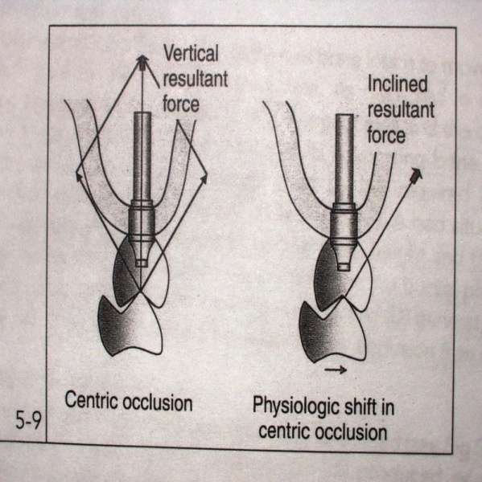
Figure 21. Difference between Vertical resultant forces and inclined resultant forces ⁽⁴⁰⁾
Anterior vertical overlap: Steep vertical overlap in the anterior region causes extreme torque and, thereby, failure of the prosthesis; however, reducing the steep vertical overlap reduces the torque.
Figures 23, 24. Depiction of increased vertical overlap results in increased torque forces. ⁽⁴¹⁾

Biomechanics and resorption pattern
Posterior mandible bone resorbs along the root inclination. Therefore, bone resorbs lingually, so if there is the lingual position of the restoration and buccal implant placement, then there is increased torque, which may cause failure of the implant and the restoration⁽⁴²⁾.
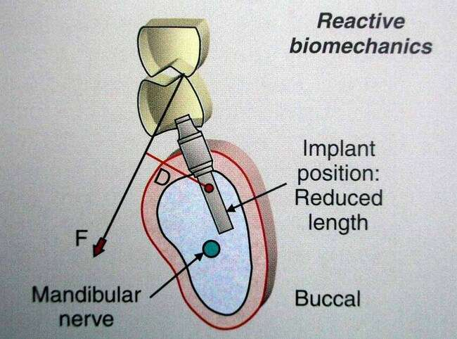
Figure 25. Schematic representation of Reactive biomechanics ⁽⁴³⁾
Therapeutic biomechanics can be done by reducing cusp inclination and putting the implant head close to the centre line of restoration, and the angulated abutment should be parallel.
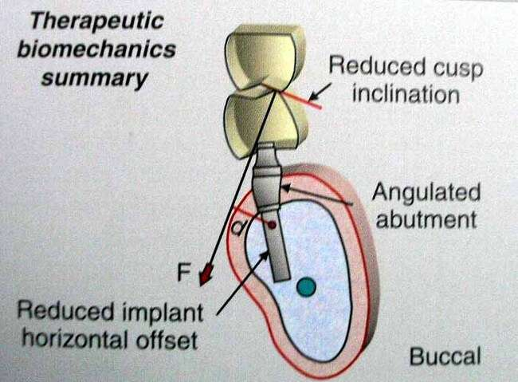
Figure 26. Schematic representation of Therapeutic biomechanics. ⁽⁴⁴⁾

In the posterior maxilla, there are many problems associated with the restricted maxilla, location of sinus, buccal cortical plate fracture and unfavourable mechanics.
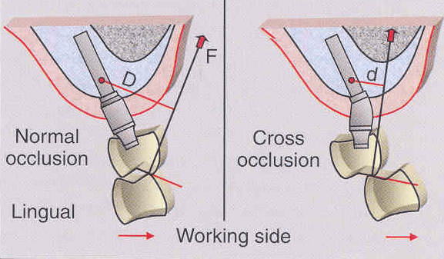
Figure 27. Difference between Normal occlusion and Cross occlusion on the working side. ⁽⁴⁵⁾
According to Therapeutic biomechanics, you can reduce Cuspal inclination and the head of the implant should be close to the centre of a restoration, using an angulated abutment or a customised abutment or cross occlusion to reduce torque forces ⁽⁴⁶⁾. In the case of the anterior maxilla, esthetics is paramount, along with a labial proclamation of the maxilla, resulting in steep vertical overlap of the anterior teeth, which causes increased torque. Therefore, a lingual horizontal stop can be given to redirect the forces vertically as possible, along with angulated abutment and implant head movement closer to the centre of rotation to reduce the horizontal offset ⁽⁴⁷⁾.
.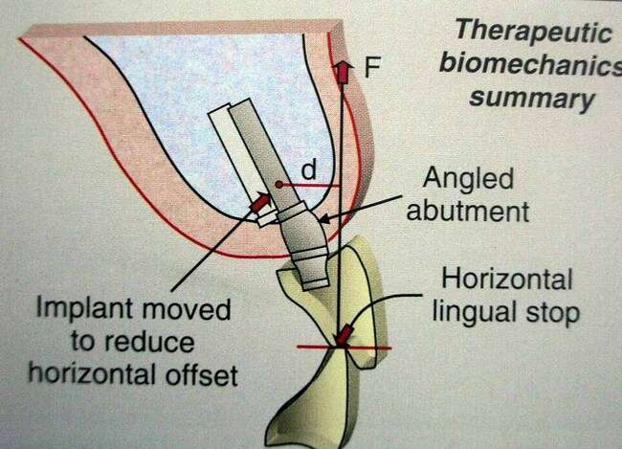
Figure 28. Schematic representation of therapeutic biomechanics. ⁽⁴⁸⁾
Complete Edentulism and Biomechanics
Screw loosening can be avoided in a patient who is being restored by using implants by placing the Implant across and around the arch. Cross splinting, which occurs by the placement of the Implant across and around the arch, reduces the lateral and vertical forces and adds to tripodism, providing excellent resistance to bending ⁽⁴⁹⁾.
Wider Implants
Dr. Burton Langer developed these implants, which have advantages in terms of increased surface area and placement in cases with limited bone height. More comprehensive implant also plays an important role when standard-size implant fails ⁽⁵⁰⁾. Also, when a more comprehensive implant is placed, it can cause tighter joints and increase the prosthesis's overall strength.
Bone Density and Biomechanics
Bone density increases the strength of the implant, and as a result, the overall integrity of the prosthesis increases. Bone density also increases the amount of bone contact with the implant and helps in better distribution and dissipation of force. A FEM study about the different stress contours of the bone gave the classification for different bone densities as below⁽⁵¹⁾
D 1 Crestal stress and lesser magnitude
D 2 Greater crestal stress along the implant body
D 3 Greater stress transmitted apically.
D 4 Greatest stress transmitted farthest apically.

Bone Density and treatment plan modifier
Several factors affect and augment bone density and help in modifying the treatment plan, as mentioned below ⁽⁵²⁾
- Prosthetic factors As the density of the bone decreases, the biomechanical load should also decrease significantly. We can reduce the load by shortening the cantilever length and narrowing down the occlusal table. It is also advised to reduce the offset load to the minimum, and if the patient is wearing a removable prosthesis, then removing it at night can reduce the unnecessary forces on the basal tissues. Using an RP-5 prosthesis is advisable as soft tissues share forces. Allowing the forces to be transmitted along the implant's long axis also helps reduce the biomechanical load and stress.
- Implant number Increasing the number of implants helps reduce the load as it helps distribute the load over a wide area(snowshoe effect) and helps increase the functional load capacity.
- Implant macro geometry In a D-1 bone, an increase in length by 10mm; in a D-2 bone by 12mm and in a D -3 bone, 14mm length with a V-shaped thread screw is preferred. Generally, it is believed that as the bone density quality increases, the implant length should increase if not impeded by any important anatomical site of pathology.
- Increase in the width of the implant: An increase in the width helps increase the surface area of the implant bone integration. A 1 mm increase can increase about a 30% increase in the surface area of the implant-bone contact. Therefore, in D 3 & D 4 bone, the placement of the more comprehensive implant is preferred.
- Implant design: A smooth cylindrical implant shows a lot of shear forces at the interface, whereas a threaded titanium implant exhibits the best biomechanical ability, biocompatibility, and corrosion resistance.
- Surface coating of the Implant Various types of coating, like hydroxyapatite coating along with sandblasting, help in increasing the surface area of the implant and also help in increasing the bone-implant Osseo-integration.
- Progressive loading The concept advocated a gradual increase in the occlusal load separated by an adequate time interval to allow the bone to accommodate. Softer bone requires an increase in the progressive loading period. This protocol includes time, diet, occlusal contacts and prosthesis design.
- Time: - Two surgical appointments between initial implant placement and stage 2 recovery may vary on density. For a D-1 bone, about four months is required, while for D-2, around five months is required; for a D-3 bone, around six months is given for osseointegration, while for a D-4 bone, around eight months is required.
- Diet The loading after implant placement is restricted using diet. Initially, the pressure is to be limited to a soft diet of around 10 pounds, while after early delivery of the prosthesis, the diet is to be restricted to around 21 pounds only.
- Prosthesis Design: - Prosthesis design is a means of reducing the forces and helping in increasing the osseointegration of the implant. No occlusal contact and no cantilever should be given during the first transitional phase. Occlusal contact can be given during the second transitional phase, but no cantilever is allowed. In final restoration, however, a fine occlusal table and slight cantilevering are permissible.
Cantilever prosthesis and Biomechanics: Cantilever prosthesis results in greater torque with the distal abutment as the fulcrum, which can be compared to the Class I lever arm. A cantilever prosthesis extended anteriorly results in a reduced amount of force compared to a posterior cantilever, which exerts excessive force ⁽⁵³⁾. Cantilevering an implant prosthetics depends upon stress factors like Parafunction, crown height, Impact width and Implant number.
Cantilever in fixed partial denture: When a cantilever is given in an implant-supported fixed partial denture, a sufficient bone height should exist to place the longer implant. Contact should be avoided on central incisors during protrusion, labial excursions and maximum intercuspation. A group function occlusal scheme should be provided in such prostheses to avoid eccentric forces falling on them during lateral movement. Loading on the canine is to be avoided, and lateral guidance should be central and lateral incisor. If two implants support a first molar and second premolar, with the first premolar being a cantilever, the active cusp can be eliminated.
Mandibular Flexure: The Mandible moves towards the midline on opening because of the external pterygoid muscle's action on the mandible's ramus. Medial movement of the mandible occurs distal to the mental foramen and increases as it approaches the ramus. It was also found that movement of the mandible is about 0.8mm in the 1st molar region and increases to about 1.5 mm in the ramus area. When flexion of the mandible happens, an implant placed in the arch flexes to about 0.1 mm, while natural teeth flexes around 0.5 mm. This loss of flexion of the implant results in bone loss around the implant and manifests in loss of implant fixation and material fracture.
Fatigue failure: An implant in the mouth is almost always under dynamic cyclic loading, which can fail the implant in a way of cyclic loading. The ability of the implant to resist fatigue failure depends on Biomaterial, geometry, force magnitude and number of cycles.
- Biomaterial: The stress level below which an implanted biomaterial can be loaded indefinitely is called endurance limit. Titanium alloy exhibits a high endurance limit.
- Implant geometry: It helps resist the bending and torsional load related to metal thickness. Increasing the metal thickness two times makes the prosthesis sixteen times stronger.
- Force magnitude: Arch position in the mouth determines the force magnitude. The force magnitude is higher in the posteriors and lower in the anterior. Force magnitude can also be eliminated by reducing torque and increasing the surface area of the prosthetic design.

- Number of loading cycles: Loading cycles should be reduced, and an effort should be made to eliminate parafunctional habit. Also, cyclic loading can be reduced by decreasing the occlusal contacts of the implant prosthesis.

Implant design and biomechanics
Titanium alloys present the greatest strength of all the designated implant materials. Smooth-sided cylindrical implants are subjected to shear forces. Smooth-sided tapered implants place extreme compressive load at the interface ⁽⁵⁴⁾. If the taper is increased, it increases the compressive load delivery; therefore, the taper cannot be increased for more than 30 degrees. An increase in the implant width increases the functional area of the implant. An increase in 1mm width helps increase the functional surface area by about 33 %⁽ ⁵⁵⁾.
Implant length is another factor because the increase in length helps in bicortical stabilisation. Maximum stress generated by the lateral loading on the implant can be dissipated by the implants in the range of 10-15mm ⁽⁵⁶⁾. If the patient has softer bone, greater length and width of the implants may be required to increase the likelihood of Osseointegration. To facilitate implant placement with increased length and width, sometimes procedures like sinus grafting and nerve repositioning may be required. However, longer implants are necessarily not always better, and their use has to be judicially restricted depending upon variation in different cases ⁽⁵⁷⁾.
Implants with crestal module design prevent bacterial ingress, provide initial stability and also help in increasing the surface area of the implant. An implant with crestal module angled at less than 20 degrees helps increase the implant bone contact area and provides for a beneficial compressive load ⁽⁵⁸⁾. The apical design of the implant provides an anti-rotational feature and helps resist torsional load. Anti-rotational feature can be added by adding a hole or vent in the implant's apical design, allowing bone to grow. A flat-sided groove placed on the implant's side helps the implant resist compression load ⁽⁵⁹⁾.
Surface coating of the implant with Titanium plasma spray or hydroxyapatite coating has also been advocated to provide increased surface area, roughness for initial stability and a more robust implant-bone interface ⁽⁶⁰⁾. The Disadvantages of surface coatings include flaking or scaling upon insertion, plaque retention, increased chances of bacterial infections and increased cost.

Implant protected Occlusal scheme
Implant-protected occlusion scheme was given by Misch in 1993, which advocates the transfer of occlusal load within the physiologic limit ⁽⁶¹⁾. Implant-protected occlusion should have no premature contacts or interferences by providing the timing of occlusal contact.
Timing of the occlusal contact: The implant has no periodontal ligament, so concerns arise about the potential of a mobile implant to bear total prosthesis load when joined to the mobile natural teeth. When exposed to sudden initial movement, the tooth moves around 8-28µm vertically under 3 to 5 pounds of force. Secondary tooth movement depends upon the property of the surrounding bone. Implant, however no sudden initial movement and may move 3 to 5 µm after bone causes it to move.
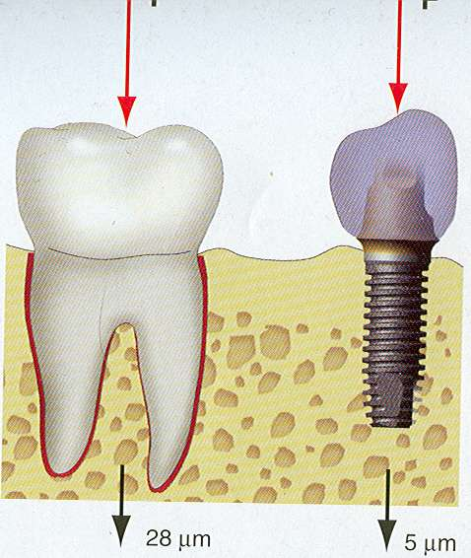
Figure 29. Schematic representation of the difference in sudden initial movement of Implant and Natural tooth. ⁽⁶²⁾
Influence of Surface Area: An essential parameter in Implant-protected occlusion is adequate surface area to sustain the load transmitted to implant prosthesis. Following are the methods suggested to influence the surface area of the implants.
- When implants of decreased surface area are subjected to angled or increased loads, additional implants can be placed to decrease magnified stress and strain.
- The load can be further distributed by increasing the number of implants.
- Splinting the implant crowns can further increase the surface area and help distribute the load.
- When forces of higher magnitude and duration are anticipated, ridge augmentation is advised.
- The Prosthesis type can be modified from a fixed prosthesis to a removable prosthesis to reduce the load.
- Wider root-form Implants could be chosen over narrower implants to allow load dissipation.
Mutually protected articulation: - Anterior guidance of the implant prosthesis with anterior implants should be as narrow as possible. The steeper the incisal guidance, the greater the force on the anterior implants. It has been shown that with every 10-degree change in the angle of disclusion, there is a 30% difference in the load.
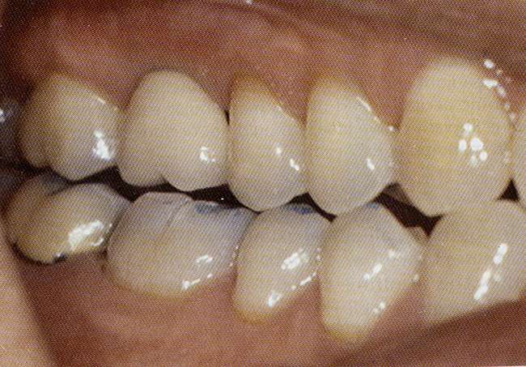
Figure 30. Visual depiction of mutually protected articulation. ⁽⁶³⁾
Implant body orientation and Influence of load distribution
When the direction of force changes to a more angled load stress, the magnitude of force increases three times or more. In addition, rather than compressive force, which can be more easily sustained by an implant, the tensile and shear forces are increased in angled load ⁽⁶⁴⁾.
Bone mechanics and force direction
The cortical bone of human beings is reported to be strongest in compression, about 30% weaker in tension and about 65% weaker in shear—implant protected occlusion attempts to eliminate or reduce all shear loads to implant-bone interface ⁽⁶⁵⁾. As shear forces are increased with an angled load, an attempt should be made to reduce the adverse effects of an angled load ⁽⁶⁶⁾.

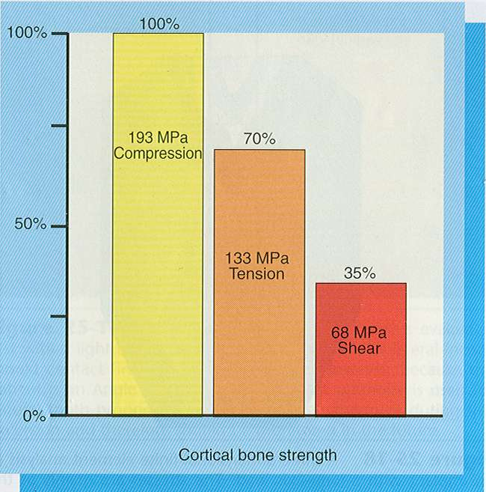
Figure 31. Graph showing the loading on cortical bone when forces fall on it in compression, tension and shear, respectively. ⁽⁶⁷⁾
Crown cusp angle: Natural teeth have about 30 degrees of cusp angulation, and the cusp angles modify the direction of forces to the implant, resulting in an angled load to the crestal bone. Occlusal contact on the implant crown is ideally a flat surface created by increasing the width of the central groove to about 2-3 mm and recontouring the opposing cusp⁽⁶⁸⁾.
Crown height and Implant protected occlusion: Crown height with the lateral load may act as a vertical cantilever and magnifier of stress at the implant-bone interface ⁽⁶⁹⁾. Whatever load is applied to the occlusal table it gets magnified by crown height. For example, a 12-degree angled load of 100 N on the implant crown results in 21 N lateral loads, and if the crown height is 15 mm and the final load to crestal bone is 315 N moment of force⁽⁷⁰⁾.
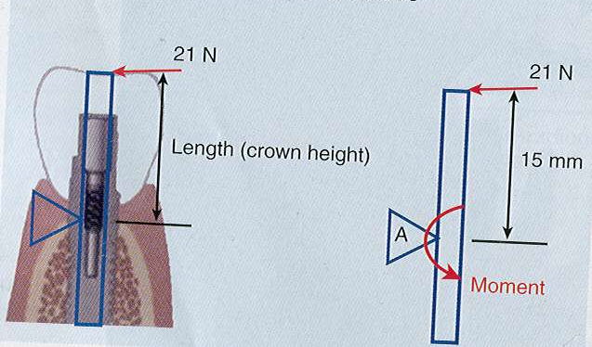
Figure 32. Moment of force. ⁽⁷¹⁾

Occlusal contact positons
Although the number of occlusal contacts in an occlusal scheme varies, according to the occlusion theory, there should be a tripod contact on each stamp cusp in each marginal ridge and the central fossa⁽⁷²⁾. The posterior implant must always be placed under the central fossa of the opposing crown because a buccal cusp contact is an offset and produces a cantilever load, which can cause failure of the prosthesis. Ideal occlusal contact is that which transmits occlusal load along the axial length of the implant.

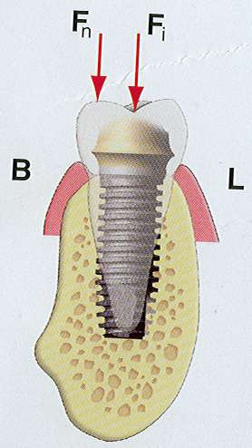
Figure 33. The axial load is transferred along the length of the implant. ⁽⁷³⁾
Implant crown contour.
Once teeth are lost, the maxillary ridge resorbs in a medial direction as it evolves slowly to become narrower in width. The posterior mandible also resorbs lingually, and as a result, the endosteal implants are more lingual than their natural tooth predecessors. As the ridge shifts lingually with the resorption of the implant, the body is not under the buccal cusp tips but near the central fossa or even more lingual under the lingual cusp of the natural tooth. The occlusal width of a posterior mandibular implant crown is related to the position of the implant body. The lingual contour should mimic the natural tooth, while the central fossa should be widened by about 2-3 mm to receive primary occlusal contact. The buccal cusp is reduced in width to decrease the offset load on the crown.

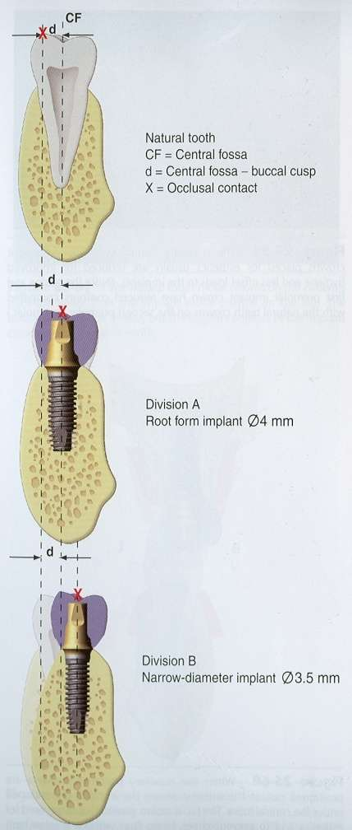
Figure 34. A schematic representation of centric forces falls on Natural tooth vis a vis Implants in different bone conditions. ⁽⁷⁴⁾
Implants in the esthetic zone replacing the canine and premolar are placed more frequently so that the crown emergence may appear more natural. Palatal contours of maxillary implant crowns are reduced for improved hygiene and less offset load to the implants.
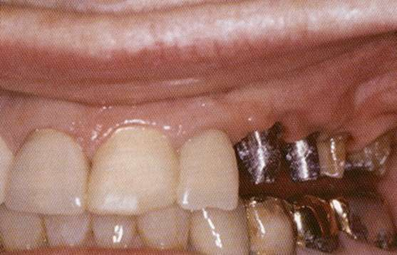
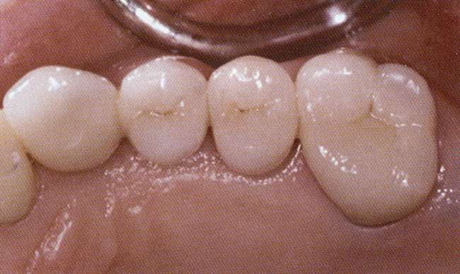
Figures 35, 36. Facially emerging implants emergence profile. ⁽⁷⁵ ⁾

OCCLUSAL MATERIALS
Occlusal surface materials affect the transmission of forces and maintenance of occlusal contacts. Occlusal material fracture is one of the most common complications in implants. Various materials like porcelain, acrylic resin, metal and composite are used as occlusal materials for implants. The following protocol will be followed while loading the occlusal material over the implant. In the initial step, no occlusal material should be placed over the implant with no occlusal contact. In the intermediate step, provisional restoration in the form of acrylic material with low-impact force should be placed out of occlusal contact. A final restoration can be given in occlusion with the opposing teeth made of metal or porcelain.
OCCLUSAL RISK FACTORS
Factors like Bruxism or Parafunction are the greatest threat to implant-supported restorations. Lateral occlusal contact on the implant-supported prosthesis and any other occlusal prematurity can cause prosthesis failure. Whenever a complete implant-supported rehabilitation is done in a patient with a known case of bruxism, the patient should use a night guard. It is also of absolute necessity that metal, including guidance, be built into the implant-supported prosthesis in case of a bruxism patient.
CONCLUSION
One of the key factors influencing the framework design for implant bone prostheses is biomechanics. When planning a diagnosis and course of treatment, it must be examined. It might affect decisions, eventually affecting how long an implant-supported prosthesis would last.
REFERENCES
- Jemt T, Linden B, Lekholm U. Failures and complications in 127 consecutively placed fixed partial prostheses supported by Branemark implants: From prosthetic treatment to first annual checkup. Implant Dent1992; 1:303.10. 1097/00008505-199200140-00014.
- Jung RE, Pjetursson BE, Glauser R, Zembic A, Zwahlen M, Lang NP. A systematic review of the 5-year survival and complication rates of implant-supported single crown. Clin Oral Implants Res 2008;19: 119-30.
- Atlas of tooth and Implant supported prosthesis-Lawrence A. Weinberg 2003; ISBN-13:978-0867154276 page no 69.
- Atlas of tooth and Implant supported prosthesis-Lawrence A. Weinberg 2003; ISBN-13:978-0867154276 page 69.
- Berglundh T, Persson L, Klinge B. A systematic review of the incidence of biological and technical complications in implant dentistry reported in prospective longitudinal studies of at least five years. J Clin Periodontol. 2002;29 (Suppl 3): 197-212; discussion 232-3.
- Risk factor in implant dentistry: Frank Renouard, Bo Rangert 1st edition 1999,ISBN-13:978-0867153552 page no 45.
- Goodacre CJ, Bernal G, Rungcharassaeng K, Kan JY. Clinical complications with implants and implant prostheses. J Prosthet Dent. 2003; 90:121–32.
- Salvi GE, Brägger U. Mechanical and technical risks in implant therapy. [January 18, 2020]; Int J Oral Maxillofac Implants. 2009 24(Suppl):69–85.
- Pjetursson BE, Tan K, Lang NP, Brägger U, Egger M, Zwahlen M. A systematic review of the survival and complication rates of fixed partial dentures (fpds) after an observation period of at least 5 years. Clin Oral Implants Res. 2004; 15:625–42.
- Nedir R, Bischof M, Szmukler-Moncler S, Belser UC, Samson J. Prosthetic complications with dental implants: From an up-to-8-year experience in private practice. Int J Oral Maxillofac Implants. 2006; 21:919–28.
- Textbook of Dental Implant prosthetics: Carl. E. Misch 2nd Edition page no17.
- Moher D, Shamseer L, Clarke M, Ghersi D, Liberati A, Petticrew M, et al. Preferred reporting items for systematic review and meta-analysis protocols (PRISMA-P) 2015 statement. Syst Rev. 2015; 4:1. 10.1186/2046-4053-4-1.
- Hooijmans CR, Rovers MM, de Vries RB, Leenaars M, Ritskes-Hoitinga M, Langendam MW. SYRCLE’S risk of bias tool for animal studies. BMC Med Res Methodol. 2014; 14:43.
- Shea B, Robertson J, Peterson J, Welch V, Losos M. The Newcastle-Ottawa Scale (NOS) for assessing the quality of nonrandomized studies in meta- analysis bias and confounding Newcastle-Ottawa scale. 2012. [Accessed January 21, 2020].
- Byrne D, Jacobs S, O’Connell B, Houston F, Claffey N. Preloads generated with repeated tightening in three types of screws used in dental implant assemblies. J Prosthodont. 2006; 15:164–71.
- Stüker RA, Teixeira ER, Beck JC, da Costa NP. Preload and torque removal evaluation of three different abutment screws for single standing implant restorations. J Appl Oral Sci. 2008; 16:55–8.
- Haack JE, Sakaguchi RL, Sun T, Coffey JP. Elongation and preload stress in dental implant abutment screws. Int J Oral Maxillofac Implants. 1995;10:529–36.
- Martin WC, Woody RD, Miller BH, Miller AW. Implant abutment screw rotations and p15. Cantwell A, Hobkirk JA. Preload loss in gold prosthesis-retaining screws as a function of time.
- Atlas of tooth and Implant supported prosthesis-Lawrence A. Weinberg 2003; ISBN-13:978-0867154276 page no 55.
- Al Jabbari YS, Fournelle R, Ziebert G, Toth J, Iacopino AM. Mechanical behavior and failure analysis of prosthetic retaining screws after long-term use in vivo. Part 3: Preload and tensile fracture load testing. J Prosthodont. 2008;17:192–200.
- Atlas of Tooth and Implant supported prosthodontics medicine : Lawrence A.Weinberg page no 81.
- Text book of Osseo integration and occlusal rehabilitation; Sumiya Hobo 1989 ISBN-13:978-4874172742 page no 85.
- Nithyapriya S, Ramesh AS, Kirubakaran A, Mani J, Raghunathan J. Systematic analysis of factors that cause loss of preload in dental implants. J Indian Prosthodont Soc. 2018; 18:189–95.
- Atlas of tooth and Implant supported prosthesis-Lawrence A. Weinberg 2003; ISBN-13:978-0867154276 page no 61.
- Atlas of tooth and Implant supported prosthesis-Lawrence A. Weinberg 2003; ISBN-13:978-0867154276 page no 63.
- Atlas of tooth and Implant supported prosthesis-Lawrence A. Weinberg 2003; ISBN-13:978-0867154276 page no 63.
- Atlas of tooth and Implant supported prosthesis-Lawrence A. Weinberg 2003; ISBN-13:978-0867154276 page no 63.
- Atlas of tooth and Implant supported prosthesis-Lawrence A. Weinberg 2003; ISBN-13:978-0867154276 page no 63.
- 29.) Atlas of tooth and Implant supported prosthesis-Lawrence A. Weinberg 2003;ISBN-13:978-0867154276 page no 63.
- Cibirka RM, Nelson SK, Lang BR, Rueggeberg FA. Examination of the implant-abutment interface after fatigue testing. J Prosthet Dent. 2001;85:268–75.
- Kanawati A, Richards MW, Becker JJ, Monaco NE. Measurement of clinicians’ ability to hand torque dental implant components. J Oral Implantol. 2009;35:185–8.
- Atlas of tooth and Implant supported prosthesis-Lawrence A. Weinberg 2003;ISBN-13:978-0867154276 page no 64.
- Goheen KL, Vermilyea SG, Vossoughi J, Agar JR. Torque generated by handheld screwdrivers and mechanical torquing devices for osseointegrated implants. Int J Oral Maxillofac Implants. 1994;9:149–55.
- Maeda Y, Miura J, Taki I, Sogo M. Biomechanical analysis on platform switching: Is there any biomechanical rationale? Clin Oral Implants Res. 2007;18:581–4.
- 35.) Atlas of tooth and Implant supported prosthesis-Lawrence A. Weinberg 2003;ISBN-13:978-0867154276 page no 70.
- Hansson S. Implant-abutment interface: Biomechanical study of flat top versus conical. Clin Implant Dent Relat Res. 2000;2:33–41.
- Atlas of tooth and Implant supported prosthesis-Lawrence A. Weinberg 2003;ISBN-13:978-0867154276 page no 71.
- Atlas of Tooth and Implant supported prosthodontics medicine : Lawrence A.Weinberg page no 77.
- Atlas of Tooth and Implant supported prosthodontics medicine : Lawrence A.Weinberg page no. 71.
- Text book of Osseo integration and occlusal rehabilitation; Sumiya Hobo 1989 ISBN-13:978-4874172742 page no 145.
- Atlas of Tooth and Implant supported prosthodontics medicine : Lawrence A.Weinberg page no. 75.
- Hälg GA, Schmid J, Hämmerle CH. Bone level changes at implants supporting crowns or fixed partial dentures with or without cantilevers. Clin Oral Implants Res. 2008;19:983–90.
- Atlas of Tooth and Implant supported prosthodontics medicine: Lawrence A.Weinberg page no 75.
- Atlas of Tooth and Implant supported prosthodontics medicine : Lawrence A.Weinberg page no. 103.
- Atlas of Tooth and Implant supported prosthodontics medicine : Lawrence A.Weinberg page no 104.
- Romeo E, Lops D, Margutti E, Ghisolfi M, Chiapasco M, Vogel G. Implant-supported fixed cantilever prostheses in partially edentulous arches. A seven-year prospective study. Clin Oral Implants Res. 2003;14:303–11.
- Text book of Osseo integration and occlusal rehabilitation; Sumiya Hobo 1989 ISBN-13:978-4874172742 page no 147.
- 48.) Atlas of Tooth and Implant supported prosthodontics medicine : Lawrence A.Weinberg page no. 103.
- 49.) Brosky ME, Korioth TW, Hodges J. The anterior cantilever in the implant-supported screw-retained mandibular prosthesis. J Prosthet Dent. 2003;89:244–9.
- Koutouzis T, Wennström JL. Bone level changes at axial- and non-axial-positioned implants supporting fixed partial dentures. A 5-year retrospective longitudinal study. Clin Oral Implants Res. 2007;18:585–90.
- Krekmanov L, Kahn M, Rangert B, Lindström H. Tilting of posterior mandibular and maxillary implants for improved prosthesis support. [January 16, 2020];Int J Oral Maxillofac Implants. 15:405–14.
- Sugiura T, Yamamoto K, Horita S, Murakami K, Tsutsumi S, Kirita T. Effects of implant tilting and the loading direction on the displacement and micromotion of immediately loaded implants: an in vitro experiment and finite element analysis. J Periodontal Implant Sci. 2017;47:251–262.
- Barbier L, Schepers E. Adaptive bone remodeling around oral implants under axial and nonaxial loading conditions in the dog mandible. Int J Oral Maxillofac Implants. 1997;12:215–23.
- Shemtov-Yona K, Rittel D. An Overview of the Mechanical Integrity of Dental Implants. Biomed Res Int. 2015;2015 547384.
- Celletti R, Pameijer CH, Bracchetti G, Donath K, Persichetti G, Visani I. Histologic evaluation of osseointegrated implants restored in nonaxial functional occlusion with preangled abutments. Int J Periodontics Restorative Dent. 1995;15:562–73.
- Al-Turki LEE, Chai J, Lautenschlager EP, Hutten MC. Changes in prosthetic screw stability because of misfit of implant-supported prostheses. [January 17, 2020];Int J Prosthodont. 15:38–42.
- Baggi L, Di Girolamo M, Vairo G, Sannino G. Comparative evaluation of osseointegrated dental implants based on platform-switching concept: influence of diameter, length, thread shape, and in-bone positioning depth on stress-based performance. Comput Math Methods Med. 2013;2013 250929.
- Jemt T, Book K. Prosthesis misfit and marginal bone loss in edentulous implant patients. Int J Oral Maxillofac Implants. 1996;11:620–5.
- Jemt T, Lekholm U, Johansson CB. Bone response to implant-supported frameworks with differing degrees of misfit preload: In vivo study in rabbits. Clin Implant Dent Relat Res. 2000;2:129–37.
- Farina AP, Spazzin AO, Consani RL, Mesquita MF. Screw joint stability after the application of retorque in implant-supported dentures under simulated masticatory conditions. J Prosthet Dent. 2014;111:499–504.
- Boggan RS, Strong JT, Misch CE, Bidez MW. Influence of hex geometry and prosthetic table width on static and fatigue strength of dental implants. J Prosthet Dent. 1999;82:436–40.
- Atlas of Oral Implantology by A.Norman Cranin 3rd Edition 1993 ISBN -13:978-0323045100 page no. 134.
- Atlas of Oral Implantology by A.Norman Cranin 3rd Edition 1993 ISBN -13:978-0323045100 page no 137.
- Yeo IS, Lee JH, Kang TJ, Kim SK, Heo SJ, Koak JY, et al. The effect of abutment screw length on screw loosening in dental implants with external abutment connections after thermocycling. Int J Oral Maxillofac Implants. 2014;29:59–62.
- Xia D, Lin H, Yuan S, Bai W, Zheng G. Dynamic fatigue performance of implant-abutment assembles with different tightening torque values. Biomed Mater Eng. 2014;24(6):2143–9.
- Lee FK, Tan KB, Nicholls JI. Critical bending moment of four implant-abutment interface designs. Int J Oral Maxillofac Implants. 2010;25:744–51.
- Atlas of Oral Implantology by A.Norman Cranin 3rd Edition 1993 ISBN -13:978-0323045100 page no. 172 .
- Lang LA, Kang B, Wang RF, Lang BR. Finite element analysis to determine implant preload. J Prosthet Dent. 2003;90:539–46.
- Torrecillas-Martínez L, Monje A, Lin GH, Suarez F, Ortega-Oller I, Galindo-Moreno P, et al. Effect of cantilevers for implant-supported prostheses on marginal bone loss and prosthetic complications: Systematic review and meta-analysis. Int J Oral Maxillofac Implants. 2014;29:1315–21.
- Sotto-Major BS, Senna PM, da Silva-Neto JP,de Arruda Nobilo MA,Del Bel Cury AA.Influence of crown-to implant ratio on stress around single short-wide implants:a photo elastic stress analysis. J Prosthodont.2015;24:52-56
- Atlas of tooth & Implant supported Prosthesis-Lawrence A.Weinberg page no.167.
- Verri FR, Batista VE, Santiago JF,Jr,Almeida DA, Pellizzer EP. Effect of crown-to-Implant ratio on peri-implant stress: A finte element analysis. Mater Sci Eng C Mater Biol Appl. 2014; 45:234-240.
- Atlas of Oral Implantology by A. Norman Cranin 3rd Edition 1993 ISBN -13:978-0323045100-page no. 178.
- Atlas of Oral Implantology by A. Norman Cranin 3rd Edition 1993 ISBN -13:978-0323045100-page no. 184.
- Atlas of Oral Implantology by A. Norman Cranin 3rd Edition 1993 ISBN -13:978-0323045100 page no. 190.

