Design & Implementation of a Mind Controlled Home Automation System

Dr. Vishal Shrivastava ¹, Er. Sangeeta Sharma ², Professor ¹, Assistant Professor ²
Dept of Computer Science & Information Technology
Arya College of Engineering & I .T. , Jaipur , Rajasthan ,India
vishalshrivastava.cs@aryacollege.in, sangeetayuwansh1@gmail.com,

*Sangeeta Sharma , Assistant Professor, Arya college of engineering & I.T.

Abstract—The design & implementation of a study describes a brain-computer interface based mind control home automation (BCI) system. The long-term effects of stroke and traumatic brain injury leave many people physically incapacitated today. A system known as BCI eschews more traditional lines of communication by providing direct communication and control between the human brain and physical objects. The proposed technology works by instantly translating different patterns of brain activity into commands. The EEG sensor detects brain signals and converts them into Bluetooth packets for export .The relay circuit receives control commands. Once this procedure is complete, the system can control any home appliance using brain signals connected to the relay circuit.

Keywords—Brain-computer interfaces (BCI),Bluetooth, Traumatic, Brain signal.
- INTRODUCTION

Neurons, glial cells and blood arteries make up our brain. There are about 100 billion neurons [1]. There are trillions of synapses connecting these many neurons together. Neurotransmitters, chemical messengers that stimulate or decrease the activity of responsive neurons, are used by neurons for communication [2]. Electroencephalography, a monitoring technique, can be used to record these electrical impulses (EEGs).

Thanks to advances in computer technology and neuroscience, it is now possible to establish a connection between the human brain and a computer. Brain-computer interface is the name of this method. People have long been fascinated by the prospect of connecting their minds to computers, and modern advances in engineering and neuroscience are making that dream a reality. : Created a system that uses a Brain-Computer Interface (BCI) to control various devices and ensure safety in case of disconnection.

- METHODOLOGY
Our brains have biochemical signals. Differential electrical potentials carried by ions on the membrane of each neuron are what cause messages to be transmitted. These weak signals have a quiet intensity measured in microvolt (V). EEG signals are divided into four groups according to human brain wave frequencies. Their names are Alpha, Beta, Gamma and Delta .Several types of EEG signals are shown in Figure 1.[ 13].

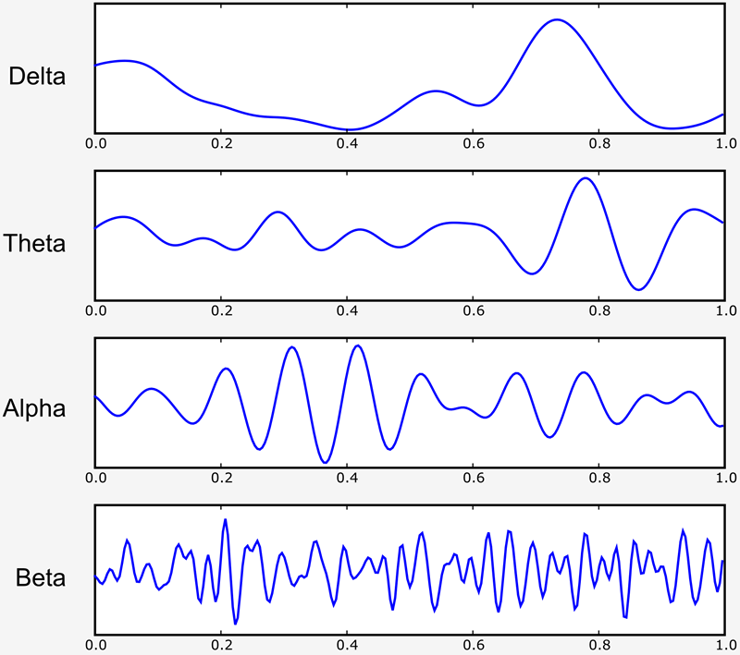

Fig 1: Different types of EEG Signals

A tool called Neurosky Mind Wave mobile is used to analyze the EEG signal. Two dry sensors help identify and eliminate EEG signals .One sensor – FP 1 in the picture. 2 - Located on the forehead. The sensor detects the background noise generated by the-human-muscles.
Electronics such as computers, light bulbs and electrical outlets. The second sensor, the ear clip, is used as a reference and ground. Thinker chips can filter out electrical noise thanks to their sensors. This is a recording of the brain's electrical activity transmitted via Bluetooth. The measures signal purity, power spectrum (alpha, beta, gamma, theta), head detection, attention level, coordination level, and blink detection [5]. This study focused on head detection and attention levels. The degree of mental "focus" or "attention" is determined by the level of attention. Values ​​range from 0 to 100. Attention levels increase when users focus on one idea or external object. When distracted, they collapse [6].
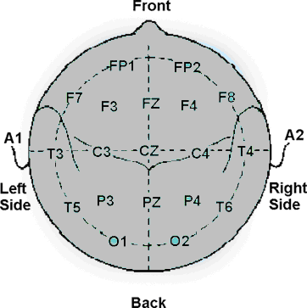

Fig-2 : FP 1 position of scalp

The direct connection between the brain and an external device is known as a brain-computer interface (BCI). Also known as brain-machine interface (BMI), direct neural interface (DNI), or MMI (BMI). A communication system that uses human intent to control devices such as computers, wheelchairs, or neural prostheses, and does not rely on typical brain output pathways from peripheral nerves and muscles, but rather on detectable signals to produce a response. or intentional brain activity [8]. on figs. 3 shows the brain-computer interaction process in this case.

BCIs have the potential to revolutionize the way we interact with technology and can have numerous applications in healthcare, rehabilitation, and assistive technology. However, there are still many technical and ethical challenges that need to be overcome before BCIs can become widely adopted. For example, the accuracy and reliability of BCI systems can be affected by factors such as noise, movement artifacts, and individual differences in brain activity. Additionally, there are concerns about privacy, security, and the potential for unintended consequences of brain-computer interaction.

Despite these challenges, ongoing research and development in the field of BCI hold promise for improving the lives of people with disabilities and advancing our understanding of the human brain.

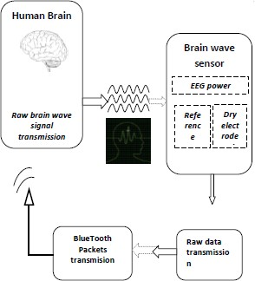

Fig-3: BCI (Brain Computer Interface)

The BCI interface and its control is explained by “J. Williamson in „Interaction design for brain computer interfaces [7].

- PROPOSED SYSTEM

- Working Procedure

The Neurosky Mind Wave LED blinks instantly when turned on. Establishes a connection with a pre-configured Bluetooth receiver in a fraction of the time. Scheme of the transport block On fig. 4 shows part of the proposed system.
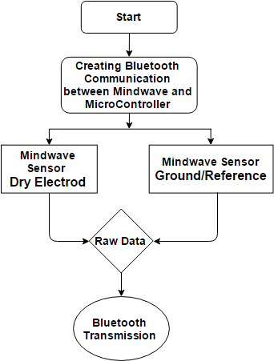
Fig-4: Transmission Section of proposed system

The data is simultaneously sent to the microcontroller by Neurosky mental waves. on figs. Figure 5 shows how the microcontroller analyzes the raw data to set the user's attention level and head detection. The relay circuit receives signals from the microcontroller according to the user's attention level. The microcontroller sends a signal to the relay circuit, and the relay circuit uses the signal to control the connected equipment.

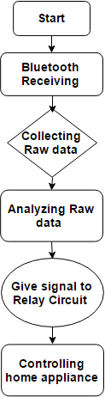

Fig-5: Receiver Section of proposed system

- Neurosky Mind Wave Headset

The tool used to detect electrical signals generated by brain activity is called the Neurosky Mind Wave. [9] This equipment is worn on the head to measure brain wave signals and consists of a headband, an ear clip, and a sensor arm with EEG electrodes placed on the forehead above the eyes. Neurosky Mind Wave has a Bluetooth connectivity mechanism. This allows the transmission of raw data to other controlled devices via Bluetooth. raw signals, EEG power spectrum, attention and meditation meters, blink detection, and head detection are used to quantify thought waves.

These EEG power spectra provide information about the user's brainwaves, such as delta, theta, alpha, beta, and gamma, as well as the attention and meditation meters, which indicate how successfully the user is using attention or meditation. This value can be deciphered from the electrical signal and using an algorithm to obtain readings from 0 to 100. The values ​​of these brain signals are listed in Table 1.
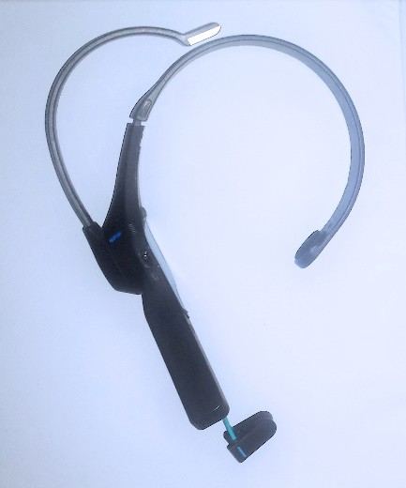

Fig 6.Neuro sky Mind Wave Headset

Table 1- Descriptions of meter values

Value | Description
1-20 | ‘Strongly lowered’ levels
20-40 | ‘Reduced’ levels
40-60 | ‘Neutral’/‘Baseline’ levels
60-80 | ‘Slightly elevated’ / higher than normal
80-100 | ‘Elevated’ / heightened levels

The meditation meter, which measures the user's mental "calmness" or "relaxation" level, and the attention meter both indicate the intensity of the user's mental "focus" or "attention" level to determine the level of concentration. Concentration or worry, on the other hand, can lower your attention meter. On the other hand, anxiety, excitement, and sensory stimuli can lower the level on your meditation meter. This project uses an attention meter and detection on the head.

- HC Serial Bluetooth

Available Bluetooth Serial Port Protocol (SPP), HC-05 module is for establishing a transparent wireless serial connection. A complete 3 Mbps Bluetooth V2.0 + EDR (Enhanced Data Rate) modulator with complete 2.4GHz baseband radio transmitter is available as a Bluetooth serial port module. Uses the CSR Bluecore 04-External single-chip Bluetooth system with CMOS and AFH (Adaptive Frequency Hopping Function) support. It measures only 12.7 mm x 27mm in area. We hope this simplifies the entire design and development cycle [10].
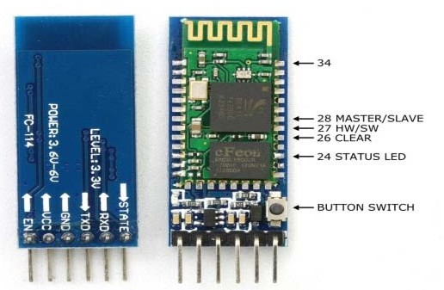
Fig 7: HC Serial Bluetooth

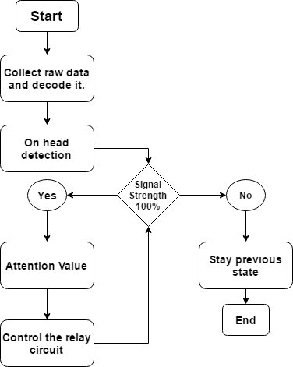
- Arduino UNO R3

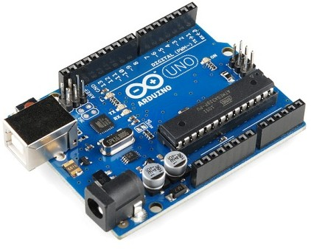
The ATmega328p based Arduino Uno R3 microcontroller board can coordinate the work of each module and process the necessary data [11]. It includes a 16MHz ceramic resonator, 6 analog inputs, 14 digital input/output pins (6 of which can be used as PWM outputs), a USB port, a power connector, an ICSP header, and a reset button. Includes 32KB of ATmega328 flash (of which 0.5KB is used for bootloader). It also has 1 KB EEPROM and 2 KB SRAM (which can be read and written using the EEPROM library). The FTDI USB-to-serial driver chip isn't used on the Uno, so it's different from all other boards before it. Instead I have an Atmega 16U2 configured to act as a USB to serial converter. The ATmega328 also provides a UART TTL serial connection that can be used via digital pins 0 (RXD) and 1 (TXD).

Fig 8. Ardiuno Uno

- Relay Circuits

An electromagnetic switch is a relay. A relatively small current that can turn on or off a much larger current supplies power. Relay circuits are used to control high voltage circuits. This circuit allows safe exchange of data between Arduino and high-voltage equipment. The signal generated by the Arduino UNO r3 is around 5 volts.

Fig-9: Algorithm of controlling section.

The raw data is acquired and decoded by the microcontroller as shown in Figure 9. This data is used by the microcontroller to determine if the Neuro Sky Mind Wave Mobile headset is worn on the head. Signal strength is 100% when the Neuro Sky Mind Wave Mobile headset is worn correctly on the head. The microcontroller then determines the alarm level and signals the relay circuit.
Devices are controlled in table 2 below, along with changes in attention value. Here, several operational conditions are employed.

Table 2. Commands to Control Device

COMMANDS | EEG SIGNALS
Operate Devices | On-head detection
Operate first device | Attention above 80%
Operate Second device | Attention above 50%
Stop devices | Attention below 20%

- ALGORITHM

Our entire system consists of two parts. Two sections: one for the controller and one for the user. A special program code was used to decode the raw signal and control the machine smoothly. Raw EEG data are sent to a level analysis unit (LAU). This increases the responsiveness and speed of the system so that users can easily control it with their thought waves.

- RESULT
The proposed system has been applied in practice, and controlling physical devices using brain signals can achieve expected results. So, when interest reaches 80%, the first light turns on and the second light turns off. pay close
When the level reaches 50%, the first light turns off and the second light turns on. Plot the attention level and detection on the head of the figure using MAT LAB software. Fig 10 Help you better understand how the device works. We observe different data in different responses. When the caution value drops to 0%, there is no caution value or head detection.

Fig 10: Attention Curve

- FINAL DESIGN

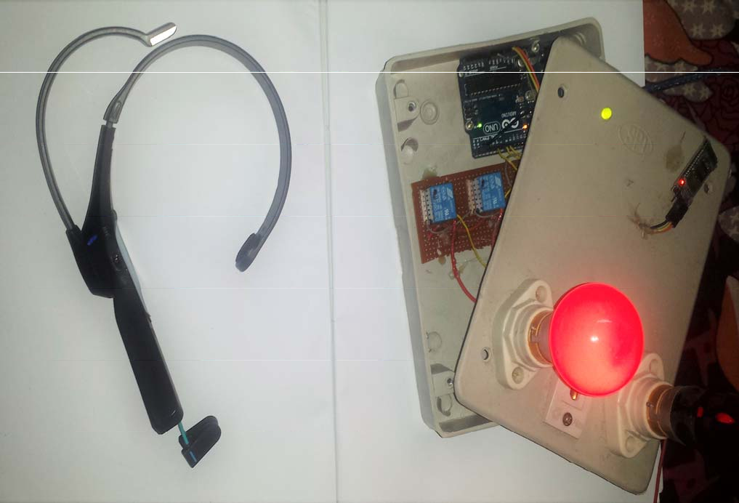
Fig 11: Mind controlled home automation system

- CONCLUSION
In this article, we develop and implement a non-invasive type of brain-computer interface. EEG-based brain signal interfaces can be used to control home appliances. This design is inexpensive and easy to manufacture. This study examines how the brain controls physical devices and password protection systems. As a result, it is a security-enhanced design that allows people who are paralyzed or have reduced mobility to independently perform tasks such as turning lights and fans on and off. Most modern systems required a computer, but this model uses a microcontroller. This approach allows multiple workloads to be processed on the same number of processors. Future applications include remote controls, industrial applications, monitoring device applications and automotive applications.

- REFERENCE

- https://en.wikipedia.org/wiki/Human_brain

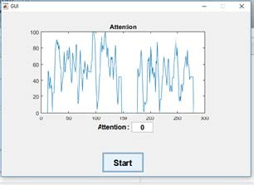
- ]https://science.education.nih.gov/supplements/nih2/addiction/guid e/lesson2-1.html\
- http://econtact.ca/14_2/ortiz_biofeedback.httm
- http://pepsic.bvsalud.org/scielo.php?script=sci_arttext&pid=S1806
-58212010000300004
- R. Robbins and M. Stonehill, “Investigating the NeuroSky MindWave™ EEG Headset”
- http://neurosky.com/biosensors/eeg-sensor/algorithms/
- J. Williamson, R. Murray-Smith, B. Blankertz, M. Krauledat, and K.-R.M¨uller, “Designing for uncertain, asymmetric control: Interaction design for brain–computer interfaces,” Int. J. Human- Comput. Stud., vol. 67, no. 10, pp. 827–841, Oct. 2009.
- Wolpow JR, Birbaumer N, McFarland DJ, et al. Brain-computer interface for communication and control, Clinical Neurophysiology, 2002, 113:767-791.
- R. Robbins and M. Stonehill, “Investigating the NeuroSky MindWave™ EEG Headset”
- HC Serial Bluetooth Products https://www.rcscomponents.kiev.ua/datasheets/hc_hc-05-user- instructions-bluetooth.pdf
- https://www.arduino.cc/en/Main/ArduinoBoardUno

