SMART TRAFFIC MANAGEMENT

SYSTEM USING IOT

by

Prof. Arjun K Guide
Students:
Swaroop K
Varun S
Bhavish Samani

Under the guidance of
Mr. Arjun K

Assistant Professor
Department of Computer Science & Engineering
SDM INSTITUTE OF TECHNOLOGY

SDM INSTITUTE OF TECHNOLOGY
(Affiliated to Visvesvaraya Technological University, Belagavi)

UJIRE–574240

Department of Computer Science and Engineering

Abstract
India's biggest issues with traffic congestion are primarily related to one or more of the following, such as poor traffic management practices, insufficient law enforcement, and signal failures. There shouldn't be any traffic jams because it greatly slows the speed of freight vehicles, lengthens lines at checkpoints and toll booths, costs untold numbers of productive man-hours in lost travel time, and causes physical and emotional exhaustion in people. Aside from that, the vehicles stuck traffic problems results roughly 40% higher pollution than individuals who regularly travel on roadways by way of additional fuel is consumed and therefore causing far too much carbon dioxide emissions, which would necessitate periodic maintenance. Our trials based on current data show that the suggested strategy can shorten the consumer's travel and waiting times. To address the sub risks to humanity, we devised a technical work around employing IoT.

Table of Contents
 | Page No.
Abstract | i
Table of Contents | ii
List of Figures | iv
List of Tables | v
Chapter 1 Introduction | 1
1.1 Project Introduction | 1
1.2 Problem Description | 2
Chapter 2 Literature Review | 3
2.1 Literature Survey | 3
2.2 Comparative Analysis of the Related Work | 4
2.3 Summary | 5
Chapter 3 Problem Formulation | 6
3.1 Problem Statement | 6
3.2 Objectives of the Present Study | 7
3.3 Summary | 7
Chapter 4 Requirements and Methodology | 8
4.1 Hardware Requirements | 8
4.2 Software Requirements | 8
4.3 Methodology Used | 9
Chapter 5 System Design | 10
5.1 Architecture of the Proposed System | 10
5.2 System Flowchart | 11
Chapter 6 Implementation  6.1 Pseudocode | 12
Chapter 7 System Testing, Results and Discussion | 15
7.1 System Testing | 15
7.2 Result Analysis | 16
7.3 Summary | 20
Chapter 8 Conclusion and Scope for Future Work | 21

  - Conclusion 21
  - Scope for Future work 21
References Publication Details Personal Profile

List of Figures

 |  | Page No.
Figure 5.1 | Architecture of the Proposed System | 10
Figure 5.2 | Flowchart of the Proposed System | 11
Figure 7.1 | Architecture of the project | 15
Figure 7.2 | Arduino Connectivity to LED | 15
Figure 7.3 | Connection to Stabiliser | 16
Figure 7.4 | Four Way Traffic Control | 17
Figure 7.5 | Working of Green Light | 18
Figure 7.6 | Working of White Light | 18
Figure 7.7 | Working of Red Light | 19

List of Tables

 |  | Page No.
Table2.1 | Comparative Analysis | 4
Table4.1 | Hardware requirements | 8
Table4.2 | Software requirements | 8
Table7.1 | Unit test cases | 15

Chapter 1

Introduction

Project Introduction
Most of the time, there is uneven traffic coming from all directions to a junction. Most countries regulate traffic using fixed-time signals, however some developed countries largest cities use centralized management systems to manage traffic. Events that are unpredictable but frequently occur, such as accidents, vehicle problems, improperly timed signalized intersections, special occasions like massive social gatherings and political rallies, bad weather, etc. are all variables that contribute to numerous types of traffic capacity problems. On the other hand, macro level factors, such as trends in property use, profiles of employment, trends of income, trends of vehicle ownership, designs of infrastructure investment, trends of regional economic factors, etc., may indeed lead to congestion. Traffic management systems have used the Internet of Things (IoT) concept. In this framework, we are putting forth a potent method by which radio wave flagging tactic can be used to identify these cars. The crisis cars will be identified and incorporated in a system that emits a Sensor Observation Service (SOS) signal. A sign detection unit can detect this signal, and it will then send a crisis trigger to the traffic executive's system. The criticism and the methodology presented could be handy for analogous developing nations.

Problem Description

In Bangalore city, traffic lights operate in a systematic way which causes a lot of delay for drivers in some cases. It gives every direction a specific time without reading the current traffic jam for each lane. Connecting traffic light with a smart system to control the timing is the aim. Bangalore Municipality doesn’t have records about how much is the jam inroad junction. So, it will be difficult to recognize which junction needs to be replaced with a bridge. Quality of road can be improved by using smart systems.

Literature Review

Chapter 2

  - Literature Survey
In [1] the Authors Gustav Nilsson, GiacomoComo presented a system in which the use of Advanced Traffic Management System (ATMS) can minimize traffic congestion, with the issues on the research route being identified after data collection and the execution of a road side discussion, a spot speed analysis, and a vehicular traffic study. The volume/capacity ratio can be calculated using traffic volume studies at intersections, and road side interviews throughout the study route provided information on the actual traffic- related issues. By implementing an Advanced Traffic Management System, an intersection's Quality of service and ability (LOS) can be improved (ATMS). Mudassar Khaliland Abida Sharif outlines a low-cost future STS that would use traffic rapid updates to deliver better service. The Internet of Things (IOT) is used to instantly collect and distribute public traffic data for data processing. Predictive analytics can be used to monitor traffic density and offer remedies utilizing a variety of analytical texts.
In [2] The authors M.N.V.M. SaiTeja, N.LasyaSree, LasyaHarshitha, and P.Venkata Bhargav have suggested a system in which the green signal is typically triggered for a comparable time span on two lines without taking traffic load into consideration, stretching the wait for vehicles in other lanes. In order to solve many of these issues caused by traffic congestion, we developed an algorithm that can shorten wait times by anticipating the amount of vehicles and adjusting the signal accordingly.
In [3] Authors P Indhiradevi, P Saravanakumar, R Varsha, S Sahithya have suggested a system where the area's traffic flow is governed by sensors and centrally controlled traffic signals. CCTV cameras have been installed for surveillance purposes to record the movement of vehicles on the road. CCTV cameras can help with image processing, making it successful. This enables prompt and accurate vehicle monitoring. Using a sensor, a modified image is sent to VMS (variable message sign) displays. Transportation users will be able to discover the path that is void of traffic and change their direction accordingly.
In [4] Rizwan and Suresh proposes a network that makes use of the Internet of Things (IoT) to deliver and directly collect traffic information for analysis. To do Real-time streaming data is provided, along with big data analyses. There are many analytical
methods which could be used to examine the vehicle density and propose solutions. A mobile application is developed as a user interface which offers an innovative technique of traffic management and permits consumers to gain insight in to the traffic density at multiple places.
In [5] The Author Septia Redisa Sriratnasari suggested the use of ITS in the form of Bus Rapid Transit (BRT),the Bus Information Management System (BIMS),which is disseminating authentic bus arrival statistics Agency (BPTJ), the Advanced Traffic Signal Control Systems (ATSCS), a device that controls dynamic traffic indicators in real time, the Electronic Toll Collecting System(ETCS), specifically the implementation of toll bills using a special On-Board Unit (OBU) device, and the Relocate it and Traffic, specifically an integrated public delivery statistics software in Jabodetabek.

Comparative Analysis of the Related Work
The table 2.1 discusses the comparative analysis of the current systems in light of the suggested proposal.

Table2.1 Comparative Analysis

Sl. No | Author(s) | Algorithms/Techniques | Performance Measures
1. | Gustav Nilsson, Giacomo | Advance Traffic Management System(ATMS) | Accuracy
2. | N.LasyaSree, LaSyaHarshitha, and Venkata Bhargav, M.N.V.M.SaiTeja | Real Time traffic Control Algorithm for congestion | Accuracy
3. | P Indhiradevi, P Saravanakumar, R Varsha, S Sahithya | Image Processing Techniques | Accuracy
4. | Rizwan and Suresh | Big data and IoT Techniques | Accuracy
5. | Septia Redisa Sriratnasari | ATSCS Technique using IoT | Accuracy

Summary
These were the research papers that we studied which on implementation reduced traffic volume is reduced about 16% in NH 209 Coimbatore to Sathyamangalam. Better results can be obtained by widening the road in future which would be more effective. The traffic in SH 80 is also declined by 20.5% as compared to early cases. This process is carried out in particular area of Annur town as the traffic is very heavy in peak hours at morning and evening. Initiating this process in every place where traffic congestion is heavy and the road is narrow gives better result in monitoring and controlling of the traffic in cost effective way. It mainly results in fuel consumption which will enrich our economy.
Chapter 3

Problem Formulation

Problem Statement

For any data network, network traffic prediction is a critical operational and management function. In today's increasingly complex and diversified networks, it plays a critical function. For IoT networks to deliver dependable connectivity, network traffic prediction is also more crucial. The artificial neural network (ANN) has been used to predict traffic with great success. In this paper, we use Time Series NARX Feedback Neural Networks to anticipate IoT traffic time series using a multistep ahead prediction method. The estimation error of a prediction approach has been evaluated using the performance functions MSE, SSE, and MAE, besides, another measure of prediction accuracy the mean absolute percent of error. (Ali R Abdellah, 2019)

For any data network, network traffic prediction is a critical operational and management function. In today's increasingly complex and diversified networks, it plays a critical function. For IoT networks to deliver dependable connectivity, network traffic prediction is also more crucial. The artificial neural network (ANN) has been used to predict traffic with great success. In this paper, we use Time Series NARX Feedback Neural Networks to anticipate IoT traffic time series using a multistep ahead prediction method.

Congestion is particularly associated with motorization and the diffusion of the automobile, which has increased the demand for transportation infrastructure. However, the supply of the transportation infrastructure has often not been able to keep up with the growth of mobility. Traffic congestion problems consist of incremental delay, vehicle operating costs such as fuel consumption, pollution emissions and stress that result from interference among vehicles in the traffic stream, particularly as traffic volumes approach a road’s capacity. Across cities more people are spending more time sitting in traffic jams than ever before Traffic congestion occurs when the demand is greater than the available road capacity. There are many reasons that cause congestion; most of them reduce the capacity of the road at a given point or over a certain length, for example people parking on the roads or increase in the number of vehicles. Traffic congestion also occurs due to traffic signal. At traffic signal when road traffic density is low signal still shows the same traffic time due to which other lane traffic increases which result in traffic congestion.

Objectives of the Present Study
The objectives of the proposed project are as follows:
- To study and analyze the related work on Smart Traffic Management System and avoid congestion in traffic.
- To design a Smart Traffic Management System that is effective.
- To implement the proposed system using IOT.
- To detect and classify vehicles for traffic controls.

Summary
The system provides a summary of the ongoing issue of traffic congestion in numerous Indian cities. India's biggest issues with traffic congestion are primarily related to one or more of the following, such as poor traffic management practices, insufficient law enforcement, and signal failures. There shouldn't be any traffic jams because it greatly slows the speed of freight vehicles, lengthens lines at checkpoints and toll booths, costs untold numbers of productive man-hours in lost travel time, and causes physical and emotional exhaustion in people. Aside from that, the vehicles stuck traffic problems results roughly 40% higher pollution than individuals who regularly travel on roadways by way of additional fuel is consumed and therefore causing far too much carbon dioxide emissions, which would necessitate periodic maintenance.
Chapter 4

Requirements and Methodology

Hardware Requirements

The hardware requirements for the proposed project are depicted in Table 4.1.

Table 4.1: Hardware requirements

Sl. No | Hardware/Equipment | Specification
1. | Graphics Card | Intel 621 Graphics card or 2GB
2. | RAM | 4GB or above
3. | Arduino Uno | Microcontroller based on ATmega328p

Software Requirements
The software requirements for the proposed project are depicted in Table 4.2.

Sl. No | Software | Specification
1. | Windows OS | 64 bit
2. | Arduino IDE | 64 bit

Table 4.2: Software requirements

Methodology Used
The proposed model is implemented using the following steps:

    - Data Acquisition: The sensor gathers information on the current vehicle density on the route.
    - Data Storage: The sensors' data is gathered and kept on the cloud.
    - Data Computation and Processing: The microcontroller uses this data to decide how to modify the signal.
    - Data Delivery: Data is delivered immediately to the microcontroller in an emergency, which ends the preceding loop and promptly changes the signal.
    - Models to generate better predictions, identify items, or comprehend the system to model. Models with clean data and a thorough knowledge of the content.
Chapter 5

System Design

Architecture of the Proposed System
Figure 5.1 shows the architecture of the proposed system.

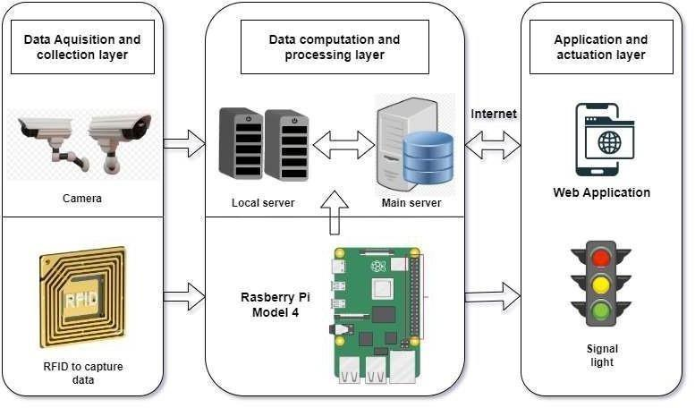

Figure 5.1: Architecture of the proposed system

The architecture of Smart Traffic Management System model is depicted in figure. The first step is to collect suitable information using Cameras etc in the data Acquisition and Collection Layer. The Collected data is then fed to the Data Computation and Processing Layer. The Computed data in the computation layer outputs the suitable change in the traffic signal using certain congestion control techniques thus causing the changes in an application as shown in the figure.

System Flowchart
The flowchart of Smart Traffic Management System is depicted below. The standard real time for traffic change is taken and suitable signal change is calculated based on congestion in the traffic.

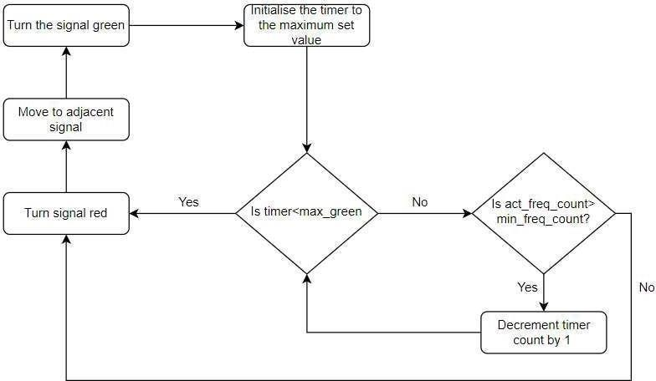

Figure 5.2: System Flowchart

Implementation

Chapter 6

6.1 Pseudo code

int r1 = 13; int y1 = 2; int g1 = 3; int r2 = 4; int y2 = 5; int g2 = 6; int r3 = 7; int y3 = 8; int g3 = 9; int r4 = 10; int y4 = 11; int g4=12;

void setup()
{
pinMode(r1,OUTPUT); pinMode (y1, OUTPUT); pinMode (g1, OUTPUT); pinMode (r2, OUTPUT); pinMode (y2, OUTPUT); pinMode (g2, OUTPUT); pinMode (r3, OUTPUT); pinMode (y3, OUTPUT); pinMode (g3, OUTPUT); pinMode (r4, OUTPUT); pinMode (y4, OUTPUT);
pinMode(g4,OUTPUT);

digitalWrite(g1, LOW); digitalWrite(g2, LOW); digitalWrite(g3, LOW);
digitalWrite(r1, LOW); digitalWrite(r2, LOW); digitalWrite(r3, LOW); digitalWrite(y1, LOW); digitalWrite(y2, LOW);
digitalWrite(y3, LOW);
}

void loop()
{
digitalWrite(r1, LOW); digitalWrite(g1, HIGH); digitalWrite(r2, HIGH); digitalWrite(r3, HIGH); digitalWrite(r4, HIGH); delay(9000); digitalWrite(g1, LOW); digitalWrite(r2, LOW); digitalWrite(y1, HIGH); digitalWrite(y2, HIGH); delay(3000); digitalWrite(y1, LOW); digitalWrite(y2, LOW); digitalWrite(r1, HIGH); digitalWrite(g2, HIGH);
delay(9000); digitalWrite(g2, LOW); digitalWrite(r3, LOW);

digitalWrite(y2, HIGH); digitalWrite(y3, HIGH); delay(3000); digitalWrite(y2, LOW); digitalWrite(y3, LOW);

digitalWrite(r2, HIGH); digitalWrite(g3,HIGH);
digitalWrite(r4, HIGH); delay(9000); digitalWrite(g3, LOW); digitalWrite(r4, LOW);
digitalWrite(y3, HIGH); digitalWrite(y4, HIGH); delay(3000); digitalWrite(y3, LOW); digitalWrite(y4, LOW); digitalWrite(r3, HIGH); digitalWrite(g4, HIGH); delay(9000); digitalWrite(r3, LOW); digitalWrite(g4, LOW); digitalWrite(r1, LOW); digitalWrite(y1, HIGH); digitalWrite(y4, HIGH); delay(3000); digitalWrite(y1, LOW); digitalWrite(y4, LOW);
}
Chapter 7

System Testing, Results and Discussion

System Testing
Table 7.1: Unit test cases

Test case number | Input | Stage | Expected behavior | Observed behavior | Status P=Pass F=Fail
1 | Working | Detection | If detected, | As expected | P
 | of all the | using | the led
 | LEDs | suitable  connection | blinks
 |  | with
 |  | Arduino
2 | Working of | Detection | The status | As expected | P
 | Arduino board | using | led of
 | corresponding to the board | power supply and suitable connection | Arduino glows alongside all the LEDs

Table 7.1 shows results of the test conducted using the proposed model. As we conducted several test and our model is responding properly to required output.
In First test case we detected the working of all LED,s via suitable connections to the Arduino.
In Second test case we detected the working of arduino to the relative code via suitable connections.

Result Analysis

Figure 7.1 shows the overall assembly of the smart traffic management system where all the LEDs and microcontroller board are assembled in a systematic way.
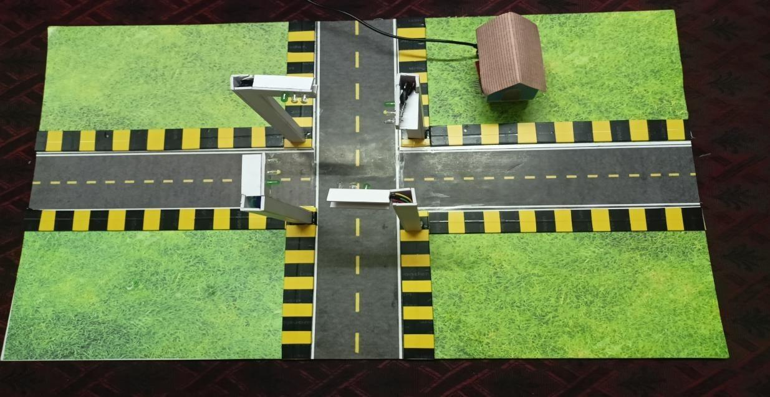
Figure 7.1: Overall architecture of Smart Traffic Management System

Figure 7.2 shows the Arduino connectivity to the various LED’s.

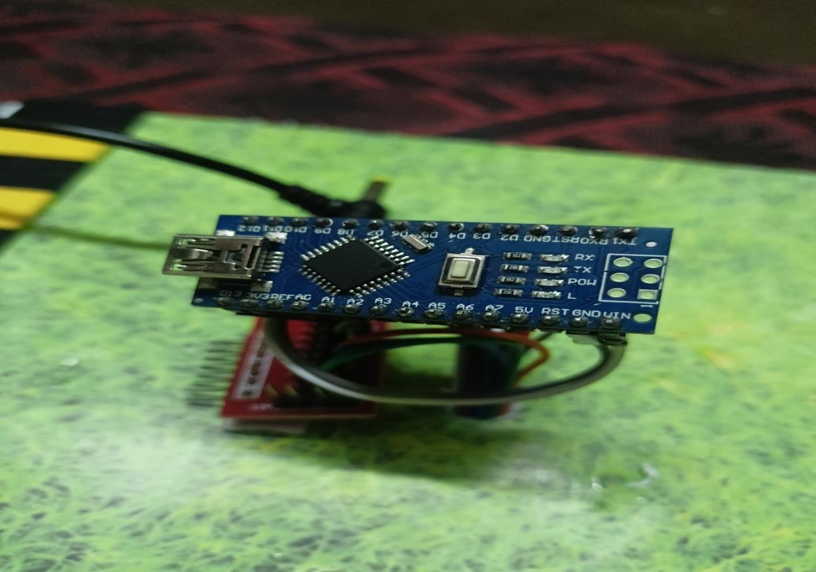

Figure 7.2: Arduino Connectivity to LED’s
Figure7.3 shows the connection of Cable to Stabilizer and further connections to Arduino board.
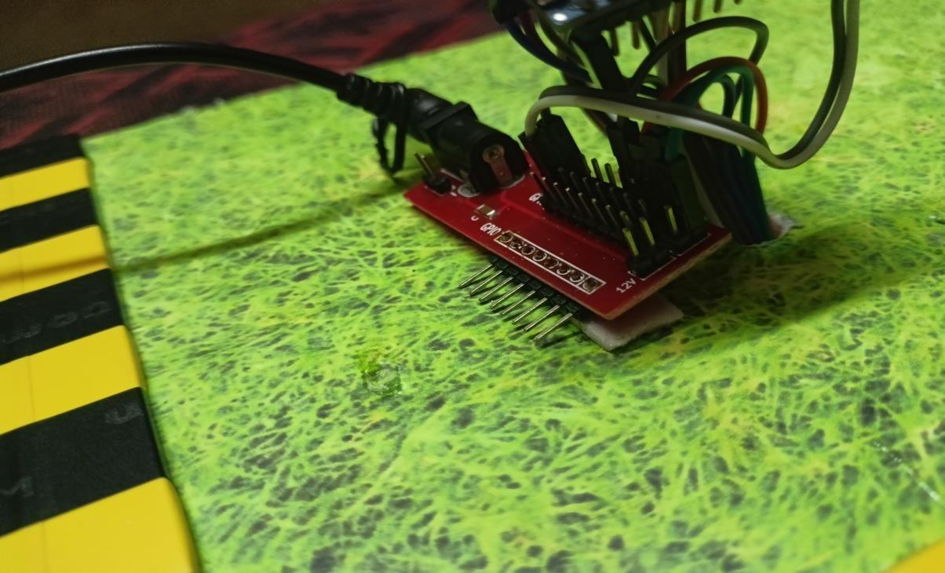
Figure 7.3: Connections to Stabilizer

Figure7.4 shows the working of four way traffic control system with suitable traffic control signal.

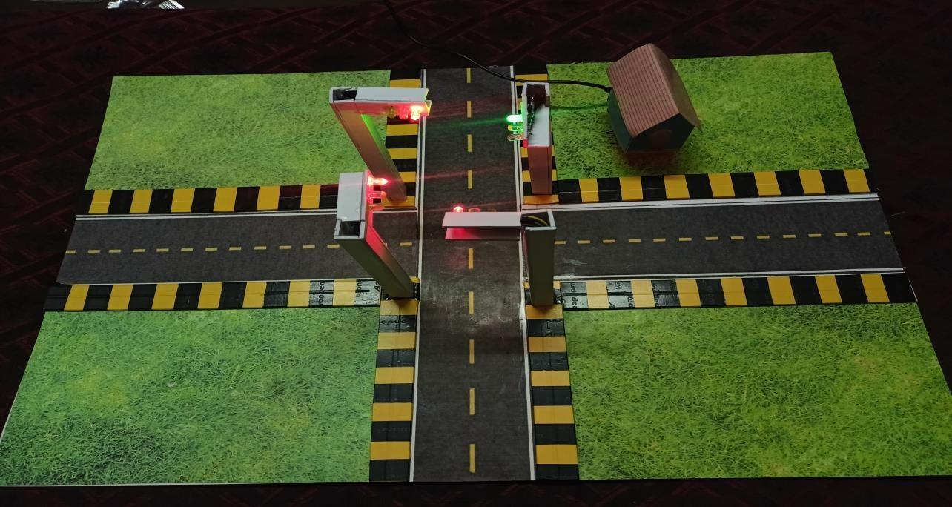

Figure7.4: Four way traffic control system
Figure7.5 shows the working of Green light when other lights are turned red.

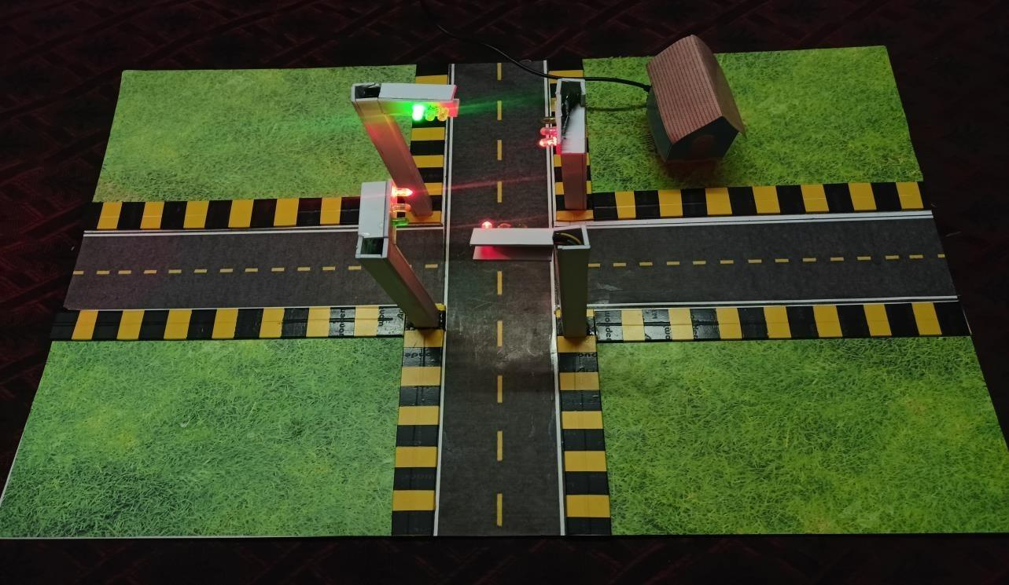
Figure 7.5: Working of green light

Figure7.6 shows the working of white light before turning red.

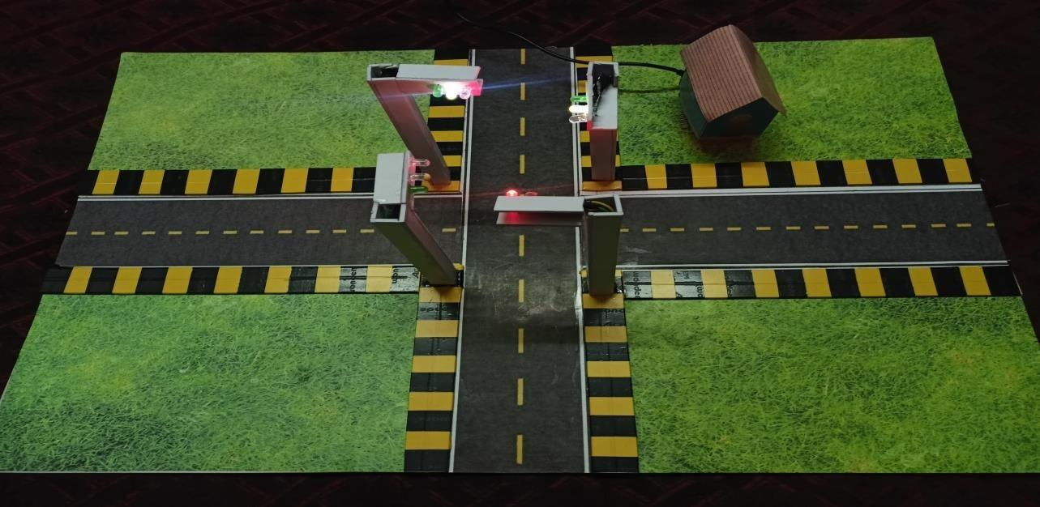

Figure7.6: Working of White light
Figure 7.7 shows the working of red light for a proposed time.

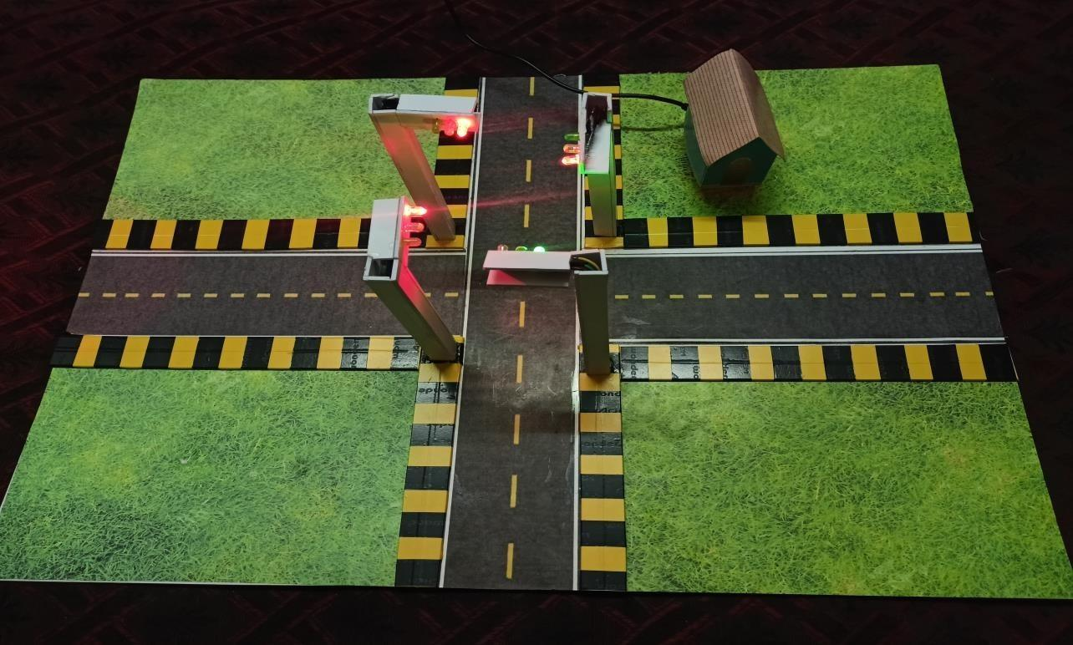
Figure 7.7: Working of Red light

Summary
India's biggest issues with traffic congestion are primarily related to one or more of the following, such as poor traffic management practices, insufficient law enforcement, and signal failures. There shouldn't be any traffic jams because it greatly slows the speed of freight vehicles, lengthens lines at checkpoints and toll booths, costs untold numbers of productive man-hours in lost travel time, and causes physical and emotional exhaustion in people. Aside from that, the vehicles stuck traffic problems results roughly 40% higher pollution than individuals who regularly travel on roadways by way of additional fuel is consumed and therefore causing far to much carbon dioxide emissions, which would necessitate periodic maintenance. Our trials based on current data show that the suggested strategy can shorten the consumer's travel and waiting times. To address the sub risks to humanity, we devised a technical work around employing IoT.
Chapter 8

Conclusion and Scope for Future Work

Conclusion
Our work presents a real-time traffic information collection and monitoring system to solve the problem of real-time monitoring and controlling road vehicles through traffic signals by predicting a number of vehicles. The lifestyle of people in metro cities where there is a large volume of population which is equally affected by various application and service systems. Consequently, most of the cities are in the process of transforming their cities into smart cities by adopting automated systems in all sectors. Therefore, considering the above we have developed an algorithm which reduces traffic rate and waiting time to reach the destination in the best possible way.

Scope for Future Work
The goal of the study is to examine the potential benefits of STMS adoption in different countries. This paper also looks into the possible positives of utilizing STMS. Additionally, this section examines the technical barriers.

REFERENCES

    - Gustav Nilsson, Giacomo Como, On Generalized Proportional Allocation Policies for Traffic Signal Control, International Federation of Automatic Control, 50(1) (2017), pp 9643–9648
    - https://www.researchgate.net/publication/360031924_A_Dynamic_Model_and_Al gorithm_for_RealTime_Traffic_Management
    - https://www.researchgate.net/publication/351858120_A_Review_on_Smart_Traffi c_Management_System
    - https://www.semanticscholar.org/paper/Real-time-smarttraffic-management- system-for smart Rizwan Suresh/39472fda71f6b53cfe59c4a2461b111f9c7 ed 09.
    - https://www.researchgate.net/publication/325116849_IoT_based_smart_traffic_sig nal_monitoring_system_using_vehicle s_counts
    - Amudapuram Mohan Rao and KalagaRamchandraRao, Measuring Urban Traffic Congestion A Review,IJTTE, 2012, 2(4), pp 286 – 305
    - Gadiyar, H. M. T., Goudar, K., Thyagaraju, G. S., Harshitha, K., Kurdekar, M. J., & Manjushree, K. (2016). DETECTING ANOMALOUS ACTIVITIES IN SPATIOTEMPORAL REGION.
    - Ksiksi, S. Al Shehhi, and R. Ramzan, “Intelligent Traffic Alert System for Smart Cities,” 2015 IEEE International Conference on Smart City/SocialCom/SustainCom (SmartCity), Dec. 2015
    - Chandrasekhar.M, Saikrishna.C, Chakradhar.B, phaneendrakumar.p, sasanka.c, Traffic Control UsingDigital Image Processing, International Journal of Advanced Electrical and Electronics Engineering ISSN 2278-8948, 2, May 2013
    - X. Wang, “Calibration of Big Traffic Data for a TransportSmart City,” CICTP 2015, Jul. 2015.

Publication Details
M P Saketh Rao, Swaroop K Gudigar , Varun S, Bhavish Samani, H Manoj T Gadiyar,"Smart Traffic Management System using IOT" has been accepted for publication in the International Journal of Engineering Applied Sciences and Technology(IJEAST) during May 2023.

Personal Profile

Mr. Arjun K, Asst. Prof. Project Guide | Mr. Arjun K received B.E degree in Computer Science & Engineering from University of MITK Kundapura Engineering College in the year 2010, and M.Tech degree in Computer Science from VTU PG center Belagavi in 2012.  His area of interest include Java, C, programming, IOT, Computer Graphics.  Mr. Arjun K is a life member of Indian Society for Technical Education(ISTE).  E-mail ID: arjunk@sdmit.in Contact Phone No: 9449406858
Name: Swaroop K USN: 4SU19CS105
Address: Sri Nidhi compound Vidyanagara, Kunjarpa, Ujire
E-mail ID: swaroopkgudigar123@gmail.com
Contact Phone No: 7676828150

Name: Varun S USN: 4SU19CS110
Address: Tippu nagar, Chikmagalur 577101 E-mailID: varundevadiga18@gmail.com Contact Phone No: 8105451236
Name: Bhavish N Samani USN: 4SU19CS116
Address: Karambaru beedu house and Village, tenkakarandoor post, belthangady tq-574217
E-mail ID: bhavishsamani247@gmail.com
Contact Phone No: 7760743141

