FUTURISTIC TRENDS IN UNDERSTANDING SCAPULAR DYSKINESIS AND ITS RELATION TO SHOULDER PAIN
Anam Khan¹, Sahar Zaidi^{2*}, Huma Parveen¹, Adeeba Ali¹, Afsha Wali¹, Deepika Singla³

Authors’ Affiliation:
¹Student Researcher, Department of Physiotherapy, Jamia Hamdard, New Delhi, India 110062
^{2,CA}Assistant professor, Department of Physiotherapy, Jamia Hamdard, New Delhi, India 110062
ORCID ID: 0000-0002-1950-1150
E-Mail ID: sahar@jamiahamdard.ac.in
³Assistant professor, Department of Physiotherapy, Jamia Hamdard, New Delhi, India 110062

ABSTRACT-
Scapular dyskinesis is known as a change in the scapula's typical position or motion during paired scapulohumeral movements. It frequently results from injuries that inhibit or disorganize activation patterns in scapular stabilizing muscles. Additionally, it happens in a high percentage of shoulder joint injuries. Changing the normal scapular function during coupled scapulohumeral motions may exacerbate the functional deficiency related to shoulder injury. Since no particular pattern of dyskinesis is connected to a specific shoulder diagnosis, scapular dyskinesis is a general reaction to shoulder dysfunction. Patients with a shoulder injury should be suspected of having it, and a specialized physical examination can help identify and classify it. The goal of this review is to assess the relationship between scapular dyskinesis and shoulder pain. Treatment for scapular dyskinesis focuses on addressing the underlying problems and recovering function. We also discuss its management, the impact of scapular dyskinesia on quality of life and the disability associated with scapular dyskinesia. The scapula is a critical connecting element of the kinetic chain that transfers the strength from the body core to the arm. Even though SD may be initially asymptomatic, the likelihood of shoulder pain increases.

INTRODUCTION-
First, we have to see the normal scapular function to understand scapular dyskinesis. A primary role of the scapula is that it is integral to the glenohumeral articulation, which kinematically is a ball-and-socket configuration. The second role of the scapula is to provide motion along the thoracic wall. The final role that the scapula plays in shoulder function is as a link in proximal-to-distal sequencing of velocity, energy, and forces of shoulder function.[1]

Scapular dyskinesis is defined as the change in rest position and dysfunctional motion of the scapula. It is best described as an impairment of optimal shoulder function rather than pathology, as it can also be seen in asymptomatic individuals.[2]

During linked scapulohumeral movements, the scapula's typical position or motion is altered. It occurs in a variety of shoulder joint injuries and is frequently brought on by wounds that impede or disrupt the activation patterns of the scapular stabilising muscles.

By changing the normal scapular function during coupled scapulohumeral motions, it may worsen the functional impairment brought on by shoulder injury. Scapular dyskinesis appears to be a nonspecific response to shoulder dysfunction because no specific pattern of dyskinesis is associated with a specific shoulder diagnosis. Patients with shoulder injury are highly suspects of scapular dyskinesis and can be identified and classified by specific physical examination.[1]

The etiology of SD can be neurological, such as cervical radiculopathy, long thoracic palsy, which can lead to serratus anterior weakness, or spinal accessory nerve palsy, which impairs trapezius muscle function. Additionally, there are musculoskeletal causes, such as tightness of the pectoralis minor and biceps short head, posterior shoulder inflexibility, periscapular muscle lesions, muscular activation alterations and strength imbalances, clavicle fracture, and acromioclavicular and glenohumeral joint instability. Posture abnormalities like thoracic kyphosis can also be related to SD.

SD is a clinical diagnosis. To determine all potential causes of dyskinesis, a thorough physical exam must be conducted. However, there is no established technique for diagnosing SD at this time. Clinical examination is preferred to static imaging modalities to diagnose SD due to its crucial dynamic component. In the presence of suggestive symptoms, computed tomography or magnetic resonance imaging scans can help find an aetiological diagnosis of SD. [2]

The glenohumeral articulation, which kinematically has a ball-and-socket configuration, is one of the scapula's principal functions. The scapula's second function is to allow motion along the thoracic wall. The scapula's final contribution to shoulder function is a link in the proximal-to-distal sequencing of velocity, energy, and forces. SD can be found in healthy individuals, but the prevalence rate is higher in overhead (61%) than in non-overhead athletes (33%). Elderly people have a higher prevalence of SD because they are more likely to sustain overuse injuries and develop shoulder degenerative disease.[2]
Studies on swimmers at various level have demonstrated that the prevalence of dyskinesis increases throughout the duration of a single training session amongst young competitive swimmers and more specifically, pain-free competitive swimmers including individuals at the collegiate level, although this may be a consequence of building fatigue.[3]
Types-
Based on the medial border of the scapula with the arm at rest or during arm motion in forward flexion, there are four types of SD:-
Type I = inferior angle prominence,
Type II = medial border prominence
Type III = excessive superior border elevation.
The normal, symmetric scapular motion was considered Type IV.[4]
Signs and symptoms-
Scapular dyskinesia can be symptomatic, but there is also the possibility that shoulder symptoms are absent.
There are the following common symptoms of scapular dyskinesia:
When the patient raises his arm and lifts weights, he feels pain and tenderness around the shoulder blade.
When the patient moves their shoulder, they feel a snap or pop.
Feeling the loss of strength in the affected arm and shoulder.
Some postural changes in the shoulder appear.
Some patients feel like their shoulder blade is out of place.
SD, when symptomatic, clinically manifests as SICK syndrome, characterized by-
S-scapular malposition,
I-inferior medial border prominence,
C-coracoid pain and malposition, and
K-dyskinesis of scapular motion.[2]
When we try to see the cause of scapular dyskinesia along with this, so, we see that the causes of scapular dyskinesia can be split into three groups:
(a) Shoulder-related;
(b) Neck-related;
(c) Posture-related.
a) Shoulder-related causes of scapular dyskinesia:
Shoulder pathologies are the most common origin of complaints. Almost all shoulder pathologies are accompanied by some degree of dyskinesis.
The most common pathologies that are associated with some form of scapular dyskinesis are:
Acromioclavicular instability
Shoulder impingement
Rotator cuff injuries,
Glenoid labrum injuries,
Clavicle fracture and,
Nerve-related.
The common characteristic of all these pathologies is the disturbance of the scapulohumeral rhythm.
Shoulder impingement is associated with greater scapular protraction (in the resting positions), more significant posterior tilt (during abduction) and greater internal rotation (during plane elevation).
Furthermore, when the scapular plane is elevated, the scapula shows less upward rotation. The scapula has a different performance pattern in shoulder instability; it shows:
Reduced rotation when the arm is elevated,
Increased internal rotation when the scapular plane is raised.
In a frozen shoulder, the scapula externally rotates earlier and at a greater degree than a normal scapula. However, research has failed to show that the increased mobility of the scapula is a compensatory mechanism.
As mentioned earlier in the Biomechanics section, the scapulohumeral rhythm can be disturbed by two factors: an inappropriate pattern of muscle activation (too slow or too fast) or an inappropriate force of muscle contraction (too strong or too weak). The scapula is influenced by numerous muscles that work in various directions, therefore it seems sense that the time and intensity of muscular activity govern its mobility.
Fatigue is an important determinant of muscle performance. McQuade et al. have shown that the scapulohumeral rhythm is less effective with increasing fatigue.
It would be interesting if the same experimental setup were extended to more complex activities, including more muscles. That way, researchers could observe the following:
1) Muscle fatigue following real-life movements,
2) Which muscles were more susceptible to fatigue and
3) If muscles assume dominance once the synergists are fatigued.
There have been reports of other muscle issues, like latissimus dorsi tightness, affecting scapula rotation and pushing the bone superiorly. Both shoulder impingement and instability have been associated with the development of dyskinesis in the trapezius and serratus anterior muscles. The serratus anterior, upper and lower trapezius, and their activation patterns have all changed during impingement, with the trapezius displaying stronger activation than the serratus anterior. In comparison to symptomatic patients, rotator cuff arthropathy encourages enhanced motion from the rotator cuff muscles, supraspinatus and infraspinatus, and from the upper trapezius.[5]
b) Neck-related:
Two subtypes of neck pathologies can affect the shoulder:
1) "mechanical neck pain" syndromes and
2) cervical nerve root-related syndromes.
"Mechanical neck pain" syndromes are defined as a group of pathologies affecting the joints (degenerative changes) and muscles (e.g., fatigue or imbalance) of the neck. How the symptoms get referred to the shoulder has yet to be established, but one can appreciate the proximity of such structures to the area.
It has been suggested that posture has an impact on muscle strength. Patients develop a "slouched" posture as a result of the Western way of life and widespread computer use. The higher thoracic and cervical spines lose their normal curvatures as a result.
Conversely, the link between nerve pathologies (e.g., nerve root compression or avulsion) at the neck and shoulder-related complaints is well established. All the nerves that provide sensory and motor supply to the shoulder originate from the brachial plexus, especially from the C5 and C6 roots, and the accessory nerve (it transverses from the upper portions of the spinal cord and the lower parts of the brain towards the sternocleidomastoid muscle.
Pathologies arise when the nerves inappropriately activate one or more nerves around the scapula and disorganize the rhythm of scapular movements relative to the main skeleton or the upper limb. As will be discussed later, the pattern of muscle activation is a crucial component of clinical assessment and rehabilitation.[5]
c) Posture-related causes of scapular dyskinesis:
Excessive thoracic kyphosis and cervical lordosis alter the resting position of the scapula. Athletes are more susceptible to these changes. Depending on their sport, they develop core muscle imbalances that alter spinal curvatures and soft tissue tensions.[5]
DIAGNOSIS-
Eighty-three percent of patients with shoulder pain visit the doctor for treatment because they cannot achieve their desired function in important activities – they perceive a dysfunction they wish to be addressed.

Function can be modelled as anatomy being affected by physiology to provide mechanics that make it easier to complete a particular activity. According to this theory, dysfunction is the outcome of different pathoanatomy, pathophysiology, and pathomechanics configurations that result in poor or inefficient decompensations or potential injuries that show up as symptoms. The clinical evaluation process may benefit from using this model as a framework.

Systematic reviews have attempted to compile and critique the value of examination maneuvers and have concluded that there needs to be more clinical utility, stark contrasts in methodologies between studies, and less-than-optimal levels of critical appraisal results.

It's interesting that the emphasis on clinical usefulness is at odds with scapular dyskinesis because clinical utility is the most reliable diagnostic standard to identify the condition. Because scapular dyskinesis is an impairment rather than a diagnosis, clinical utility cannot be achieved.

There is no consistent acceptable gold standard to compare the impairment, leading to difficulty in establishing diagnostic accuracy for an impairment. Although several attempts have been made to utilize biomechanical assessments (i.e., 3-dimensional analysis) as a gold standard, the establishment of where anatomical landmarks reside in space in relation to the equipment based on surface markers are, in essence, surrogates for the actual location.
Bone pin studies that insert sterile pins directly into the bone are likely best characterized as a gold standard. However, their invasive nature and difficulty in utilization prevent them from being routine clinical tools.

Currently, the best clinical tools for identifying alterations are qualitative assessments of scapular position and motion, although there are inherent concerns with the subjective nature of the assessments.
The examination is conducted by:
First, the patient raises their arms in forward flexion to maximum elevation and then lowers them, repeating it 3-5 times (figure 1). If the clinician is not sure if an alteration of motion is present, then the test is repeated with 3-5pound weights in each hand and by performing up to 10 repetitions of arm elevation.
Finding any altered motion may be aided by the heavier load and more repetitions. Scapular dyskinesis is easier to see during the arm's downward phase of motion, as was previously mentioned.
The outcome is measured by seeing the prominence of any aspect of the medial scapular border on the symptomatic side and recorded as "yes" (prominence detected) or "no" (prominence not detected).
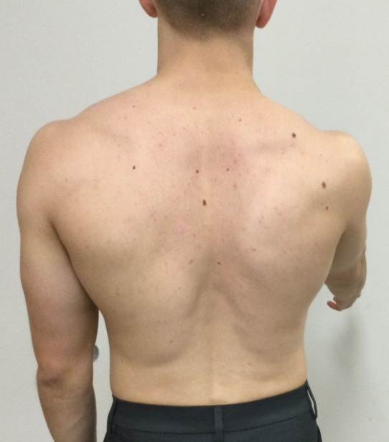

Figure 1: Scapular dyskinesis test. The patient elevates the arms overhead 3-5 times while the examiner visually observes the scapular movement.[6]
Three muscle tests:
(1) Manual resistance of the arm at 130° of flexion (targets the serratus anterior),
(2) Manual resistance of the arm at 130-150° of abduction (targets the lower and middle trapezius) and,
(3) Extension of the arm at the side (targets the rhomboids) should be performed.
The distinction between these testing maneuvers and other muscle tests for the shoulder is that – in this maneuver, the clinician attempts to "break" the patient's arm position and observe if the scapula is visibly moving out of position.
Result – a combination of a break in position and movement of the scapula suggests scapular muscle weakness. Finally, corrective maneuvers should be performed to "correct" the scapular motion and positioning.
• The scapular assistance test- helps evaluate scapular contributions to shoulder pain based on motion alterations,
• The scapular retraction test - evaluates scapular contributions to rotator cuff strength,
• The low row evaluates contributions to arm strength.
• The scapular assistance test - the examiner applies pressure to the medial aspect of the inferior angle of the scapula to assist scapular upward rotation and posterior tilt as the patient elevates the arms (figure 2). A positive result occurs when the painful arc during arm motion is relieved, and the arc of motion increases.
• The scapular retraction test - is performed when the examiner first grades the strength in forward flexion using standard manual muscle testing procedures with the patient in their normal posture (figure 3A). The examiner then places and manually stabilizes the medial border of the scapula in a retracted position while retesting the arm strength (figure 3B). A positive result occurs when the demonstrated strength increases while the scapula is in the retracted position and stabilized by the clinician.
• The low row test - The patient is asked to place his or her arm in slight humeral extension and then instructed to resist movement of the arm into forward flexion (figure 4). The examiner (positioned posterior to the patient) then instructs the patient to contract the gluteal muscles while applying the same anterior force on the arm. If strength increases with the gluteal contraction, this indicates that scapular and shoulder muscle activation may be facilitated by involving hip and core strength, which suggests lower extremity/core strengthening should be included in the treatment plan for the shoulder. A successful corrective manoeuvre alerts the clinician that the main emphasis of the patient's rehabilitation should be on improving the patient's scapular mobility, scapular strength, or core strength rather than on activating or strengthening the rotator cuff.
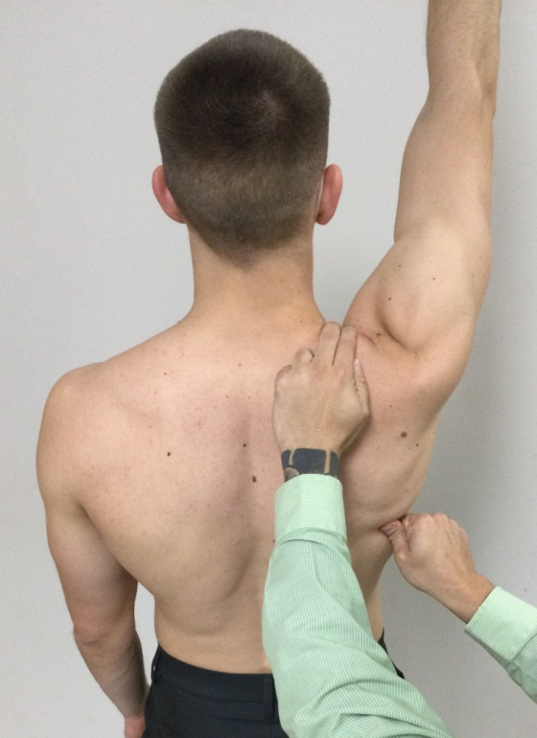
Figure 2: Scapular Assistance Test. The scapula is stabilized with one hand and the other hand assists the scapula through its correct motion plane.[6]
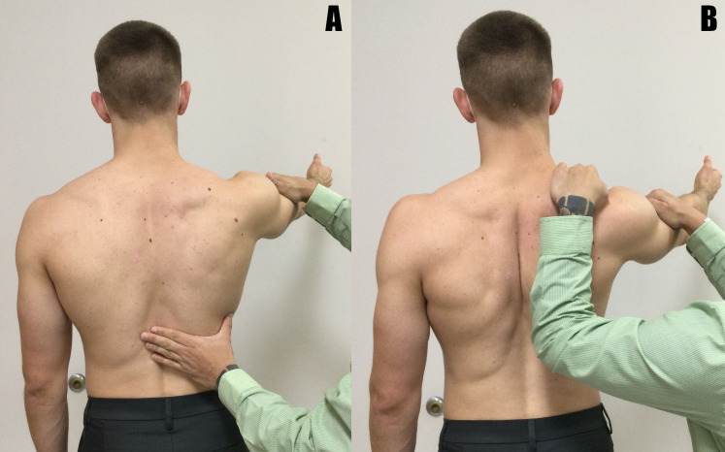
Figure 3: Scapular Retraction Test. The examiner first performs a traditional flexion manual strength test (a). The examiner stabilizes the medial border of the scapula and repeats the test (b).[6]

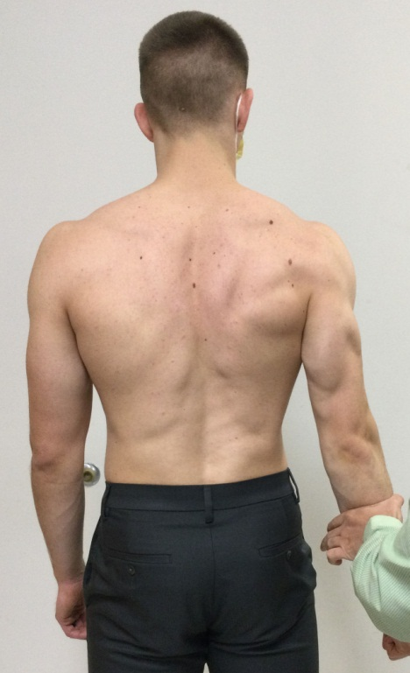
Figure 4: Low Row Test. The examiner manually resists arm extension without followed by with gluteal muscle activation.[6]
This qualitative approach is based on recent proposals on applying a classification system based on movement impairments rather than pathoanatomy in the clinical setting.
Depending on the results of the assessment, the system can be subclassified. The system's main goal is to discover dysfunction's root causes so that it can be treated more effectively. For example, suppose altered scapular motion is identified via the scapular dyskinesis test. In that case, the clinician should initially identify the specific observable components (i.e., medial border prominence, scapular body positioning) and simultaneously find the likely cause of the alteration (i.e., deficiencies in mobility, strength, and motor control or overt anatomical injury). Additional examination components of the corrective maneuvers, mobility, strength, and kinetic chain testing would help the clinician better identify the contributing cause.
All of these initiatives have been made to establish the clinical diagnosis of dyskinesis and pinpoint the anatomical (pathoanatomy) and physiological (pathophysiology) causes of the observed changes in position and motion as a foundation for creating treatment procedures.
An unpublished survey from our institution of 462 consecutive patients with shoulder pain who met the algorithm stage 1 and stage 2 criteria were examined for all causative factors using the step-wise testing protocols.[6]
This survey revealed that –
34.7% of the patients had a pathoanatomical basis for dyskinesis (clavicle fractures, acromioclavicular joint disorders, glenohumeral joint internal derangements, neurological injury, and periscapular muscle injury). In comparison, 65.3 % had a pathophysiological basis (muscle imbalance, inhibition, tightness/inflexibility, serratus anterior/lower trapezius insufficiency).
In addition, some of the conditions with a pathoanatomical basis also have primary or secondary pathophysiology. These results propose a two-part evaluation procedure for patients with clinically relevant scapular dyskinesis.
One part included patients whose dyskinesis is secondary to identified pathoanatomy. Treatment may include rehabilitation but frequently will require surgical means of restoration of the anatomy. Those whose dyskinesis is secondary to pathophysiology will need treatment based on a comprehensive evaluation process to understand the muscular alterations.
Scapular dyskinesis associated with clinical symptoms results from pathoanatomy in roughly 1/3 of the cases. The evaluation procedure should be directed towards a thorough evaluation of the various potential modifications of physiology because the absence of demonstrable pathoanatomy is prevalent. [6]
MANAGEMENT OF SCAPULAR DYSKINESIS
As an impairment, scapular dyskinesis has been posited primarily due to soft-tissue deficiencies. Thus, the treatment focus has centered on mobility and strength enhancement. However, Several research have found that the majority of manual treatment and therapeutic exercise, which are used to address these inadequacies, have little effect on scapular motion.
There are several possible reasons for these findings:
First, mobility alterations are rarely acute in the scapula and shoulder. Although overhead athletes often experience an acute decrease in glenohumeral rotation following a throwing episode/exposure, the decrease in motion can resolve within 24-96 hours on average, both with and without intervention. Second, therapeutic exercises designed to target specific shoulder and scapular muscles have been described, but these were primarily identified with electromyographic methodologies.
Finally, if strength should not be the focus, then scapular dysfunction may be more likely rooted in issues related to motor control. The kind and quantity of feedback a person receives while performing a task is one of the fundamental concepts of motor control. Visual feedback is used for joint alignment and mistake correction in the majority of upper extremity tasks. The scapula, however, cannot be seen because of its posterior placement on the thorax. Lack of visual feedback causes movement changes that show up as scapular dyskinesia.
Clinical recommendations supporting motor control/kinetic chain-based rehabilitation approaches have been made via expert opinion/consensus papers. An example of such a program has been provided with the clinical highlights being:
Short lever progression
Sitting and standing are preferred over prone or supine exercises
Target impairments in the order of mobility, motor control, strength (if necessary) and endurance
Utilize longer lever maneuvers later in the rehabilitation program
Advance to plyometric-based maneuvers just prior to discharge.[6]
To address the functional requirements of each patient as well as the concurrent deficits of nearby structures, such as the neck or shoulder, scapular rehabilitation should be a component of a larger shoulder physiotherapy programme.
Physiotherapy can be used to treat patients' symptoms either alone or as a supplement to surgery for structural injuries. Enhancing the kinematic chain at various levels, from the cervical and thoracic spine to the shoulder, is the major objective of therapy.
The clinical evaluation should determine if the lack of soft tissue mobility or muscular action is the cause of scapular dyskinesis. Different muscle groups and joint elements can be less flexible. Stretching the afflicted structure to lengthen its useful length is the major treatment.
The pectoralis muscle is best stretched by the technique "unilateral corner stretch," a technique that involves the passive abduction of the humerus at 90 degrees from the resting position. The posterior capsule of the glenohumeral joint best responds to techniques such as "sleep stretch" and "cross-body stretch," which improve the mobility of the joint.

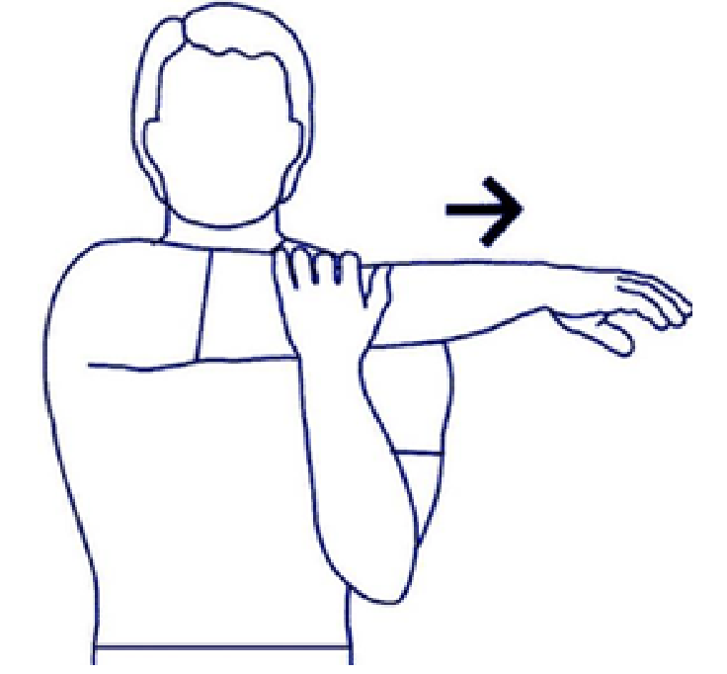
Figure 5: The "cross-body stretch," a helpful technique to relax the posterior capsule of the glenohumeral joint. [5]
Rehabilitation of musculature
The rehabilitation of muscle activation patterns is split into three stages:
(1) "active conscious control,"
(2) "strength and control for daily activities" and
(3) "control in athletic performance."
The muscles involved are the serratus anterior and the three parts of the trapezius (superior, middle, inferior). The average prescribed duration of such a program is 12 weeks, with satisfactory functional outcomes. Specific groups that have higher needs, such as volleyball players, should undergo a longer program, around three months.
Active conscious control
The scapular musculature requires re-orientation to re-engage the correct activation pattern. The inferior part of the trapezius can be orientated with a "scapular orientation exercise" that promotes targeted re-engagement of the muscle under tactile feedback from the other limb. Research has shown that conscious training of the muscles has definite improvements in the kinematic chain, but the results can be reversed. Further to rehabilitating the muscles, the surrounding structures need to be involved. Especially the resting position of the spine needs to be addressed. In order to respect the varied levels of the spine's curvatures, the patient is taught how to maintain a neutral spinal position. This retraining starts with the lumbar spine, moves on to the thoracic spine, and ends with the cervical spine. The result is that the paraspinal stabilising muscles are once again engaged to maintain a neutral spinal posture. It is suggested that the patients repeat this exercise several times each day.
Strength and control for daily activities
The simultaneous activation of muscles to carry out daily tasks is the main idea of this stage. Both "open-chain" and "closed-chain" activities should be included in the prescription. Repeating the workouts under various weight-bearing circumstances is advised. The "Open-Chain" workouts that reactivated the rhomboid muscle included the "low row," "inferior glide," "lawnmower," and "robbery" movements.
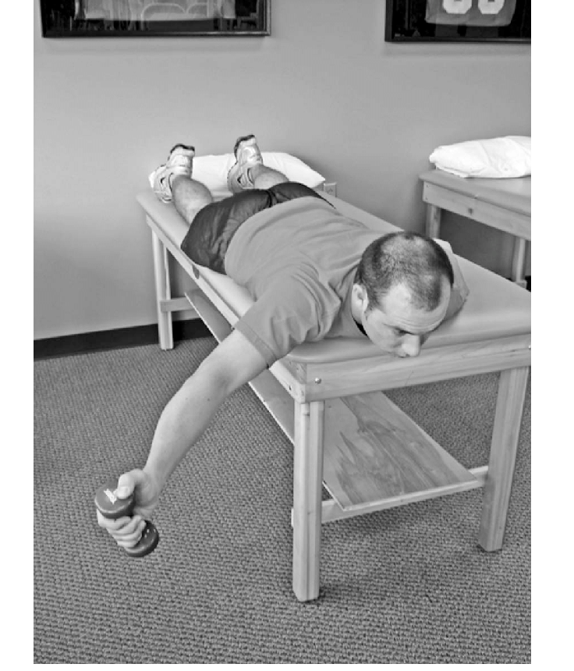
Figure 6: An example of open chain exercise that promotes the rhomboid and the supraspinatus engagement. [5]
The purpose of "Closed Chain" exercises is to improve the rotator cuff muscles' coordination and awareness of their position in space (proprioception). Furthermore, by isolating the weak muscles and reducing the activity of the stronger ones, muscle strength can be attained.
Control in athletic performance
Depending on the sport and the individual's functional needs, a detailed prescription of muscle-strengthening exercises should adhere to the principles of "scapular control" and "task-specific muscle strength."[5]
Scapular dyskinesis rehabilitation is based on a proximal-to-distal strategy. It places a focus on scapular motion that is complete and adequate as well as on integrating that motion with complimentary trunk and hip movements.
Once scapular motion is normalized, these movement patterns serve as the framework for exercises to strengthen the scapular musculature. In this technique, a patient's progress is determined by function rather than by passage of time. To establish proper scapular motion in the early stages of therapy, hip and trunk motions are required. Exercises for the scapula may advance by putting less focus on proximal facilitation as scapular control improves.
As the patient gains more proximal control and moves closer to integrating the scapular exercises with the shoulder and arm exercises, this programme may be viewed as a progression of exercises. Although not yet reported, outcome studies using this rehabilitation regimen are being conducted. Our clinical experience has demonstrated that establishing scapular control, particularly early in rehabilitation, reduces rotator cuff discomfort and enhances rotator cuff function.[1]
Impact of Scapular Dyskinesis on quality of life -
The shoulder joint plays an important role in the function of the upper limb and in the activities of daily living[5].Normally shoulder joint perform: Average shoulder motions required to perform the 10 functional tasks were flexion, 121° ± 6.7°; extension, 46° ± 5.3°; abduction, 128° ± 7.9°; cross-body adduction, 116° ± 9.1°; external rotation with the arm 90° abducted, 59° ± 10°; and internal rotation with the arm at the side, 102° ± 7.7°.
All these movements help to perform the daily activities with comfort , but scapular dyskinesis affect these range of motion of shoulder joint and along with that the activities of daily living.[7]
Scapular dyskinesis is a common disease leading to dysfunction of the shoulder joint and have a significant impact on patients’ daily life. It is more common in overhead athletes and women. Patients often suffer from recurrent pain and limited shoulder movement, which affects daily life and work and brings economic burdens on individuals and societies.[8]
Some studies says that post COVID pandemic lockdown there has been a high prevalence of scapular dyskinesia in healthy individuals between the age of 25-35 years, due to faulty postures and muscular imbalance following the same and it adversely affect the daily life of individuals.
Early detection is essential since it will serve as the starting point for future rehabilitation research. Studies show that scapular dyskinesia affects a population of healthy people with a variety of vocations, including desk employment, housework, and activities requiring prolonged sitting in posture, in addition to athletes.[9]
A number of shoulder pathological conditions may result from abnormal scapular motion by which individuals daily life affect. The most common associated problem with scapular dyskinesia is Subacromial impingement syndrome. It occurs when soft tissues such as supraspinatus, long head of biceps brachii tendon, subacromial bursa and superior joint capsule are impinged in the subacromial space.
Shoulder impingement symptoms might, with time, progress to functional limitations. Additionally, neglected or subpar scapular dyskinesis rehabilitation might result in adhesive capsulitis and SLAP lesions.[10]
If we talk about the complications of scapular dyskinesis which has impacts on our life are:
- Prolonged healing time if not appropriately treated or given adequate time to heal.
- Chronic inflammation or impingement of rotator cuff muscles, causing persistent pain with activity that may progress to constant pain (with or without activity).
- Shoulder stiffness or loss of motion.
- Rotator cuff tendon tear.
- Recurrence of symptoms if activity is resumed too soon, with overuse, or when using poor technique.
Also, Scapular dyskinesis showed increased neck disability and decreased internal rotation ROM and strength, along with reduced pectoralis minor length.[11]
During arm elevation, upper and lower trapezius activities were associated with functional disability in patients with inferior angle and medial border prominence, respectively. Alterations of muscular activation or coordination and tightness of soft tissues have been reported to be associated with scapular dyskinesis.
First, scapular muscles (the upper trapezius, UT; lower trapezius, LT; serratus anterior, SA) are coordinated as force couples in task-specific movements to control the position and motion of the scapula (Magarey and Jones, 2003). Abnormal scapular kinematics can result from uncoordinated force coupling. Excessive activity of the UT muscle combined with reduced activity of the LT and SA muscles have been observed in patients with shoulder impingement.
Second, tightness of the muscles or ligaments may change scapular kinematics. Shortening of the pectoralis minor or the short head of the biceps can result in excessive scapular anterior tilt and downward rotation.
Third, posterior shoulder muscles or capsules can create excessive scapular internal rotation and anterior tilt.[12]

CONCLUSION-
The scapula is a vital link in the kinetic chain that transfers power from the body's center to the arm. Although SD may not initially cause symptoms, it increases the risk of shoulder pain. Because of the changed scapular mobility, there is a decreased subacromial space, which can result in RCT and other common shoulder illnesses. The anterior glenohumeral ligaments are also put under higher strain, and the RC is weakened. Studies have also shown that limitations in the thoracic spine's range of motion (ROM) can cause a greater compensatory reaction from the scapulothoracic and glenohumeral joints, increasing the likelihood of shoulder pain and injury. Early detection is essential since it will serve as a baseline for later research on rehabilitation. Studies show that scapular dyskinesia affects healthy people with a wide range of vocations, including desk employment, housework, and hobbies requiring prolonged sitting in posture and athletics.
References-
1) Kibler BW, McMullen J. Scapular dyskinesis and its relation to shoulder pain. JAAOS-Journal of the American Academy of Orthopaedic Surgeons. 2003 Mar 1;11(2):142-51.
2) Teixeira DC, Alves L, Gutierres M. The role of scapular dyskinesis on rotator cuff tears: a narrative review of the current knowledge. EFORT Open Reviews. 2021 Oct;6(10):932.
3) Welbeck AN, Amilo NR, Le DT, Killelea CM, Kirsch AN, Zarzour RH, Burgi CR, Sell TC, Faherty MS. Examining the link between thoracic rotation and scapular dyskinesis and shoulder pain amongst college swimmers. Physical Therapy in Sport. 2019 Nov 1;40:78-84.
4) McClure P, Tate AR, Kareha S, Irwin D, Zlupko E. A clinical method for identifying scapular dyskinesis, part 1: reliability. Journal of athletic training. 2009 Mar;44(2):160-4.
5) Panagiotopoulos AC, Crowther IM. Scapular Dyskinesia, the forgotten culprit of shoulder pain and how to rehabilitate. SICOT-J. 2019;5.
6) Sciascia A, Kibler WB. Current views of scapular dyskinesis and its possible clinical relevance. International Journal of Sports Physical Therapy. 2022;17(2):117.
7) Namdari S, Yagnik G, Ebaugh DD, Nagda S, Ramsey ML, Williams Jr GR, Mehta S. Defining functional shoulder range of motion for activities of daily living. Journal of shoulder and elbow surgery. 2012 Sep 1;21(9):1177-83.
8) Tang L, Chen K, Ma Y, Huang L, Liang J, Ma Y. Scapular stabilization exercise based on the type of scapular dyskinesis versus traditional rehabilitation training in the treatment of periarthritis of the shoulder: study protocol for a randomized controlled trial. Trials. 2021 Dec;22(1):1-1.
9) Dhami K, Sharma S. A Study to Assess Scapular Dyskinesia in Healthy Individuals Aged 25-35 Years.
10) Thiruvarangan S, Srigrishna P, Thileebphan B. A trial of conservative care for restoring scapular dyskinesis: A clinical series. Journal of Novel Physiotherapy and Rehabilitation. 2020 Jun 8;4(1):011-5.
11) Jung JW, Kim YK. Scapular Dyskinesis in Elite Boxers with Neck Disability and Shoulder Malfunction. Medicina. 2021 Dec 9;57(12):1347.
12) Huang TS, Huang CY, Ou HL, Lin JJ. Scapular dyskinesis: Patterns, functional disability and associated factors in people with shoulder disorders. Manual Therapy. 2016 Dec 1;26:165-71.

