Geospatial Technology for Sustainable Development – A case of Keonjhar District of Odisha
Dr. Adikanda Ojha Dr. Jajnaseni Rout
State Project Officer Assistant Professor
MGNREGS Society Dept. of Geography
Dept. of Panchayatiraj and Drinking Water Ravenshaw University
Odisha Odisha
adikanda.ojha@gmail.com jajnasenirout@gmail.com
Abstract
Economic, social and environment are three dimension s of sustainlibilty that point out by the 2030 agenda for SD. Influence on natural resources through society can be checked by classifying those events that will relate with ecosystem mechanisms. The activities that will interact with ecosystem mechanisms by society can be monitored by identifying, which impact on natural resources. Geospatial technology has used for assessing the communal development works and produces the yield of SD at a district level. The main objective of the study is to show the influence of implementation of SDGs on the development of community livelihood and overall infrastructure Development. The study area has been taken the Keonjhar district of Odisha which was one of the vulnerable district of Odisha. Community works under MGNREGA have improved well in all the 13 blocks of the Keonjhar district. Dashboard (2019) indications that the total number of 2267 village clusters have dynamically contributed in this program. A total number of 575708 Lakhs workers were elaborate in MGNREGA program of this district. The study area contains more than 26389 assets over an area of 653900 Ha of land. The total number of properties developed from the year 2009 till 2019. It is obvious that mostly the assets remained for irrigation, conservation of water, water harvesting structure and drought proofing works. From the year 2017 and 2018, there is mandate and growth in rural sanitation works in the study area
Key words - SDG, MGNREGA, Geospatial, conservation, ecosystem
Introduction
The Millennium Development Goals (MDGs) approved through the UN Millennium Summit on 8th September 2000 was the first integrated stand of the world to free the world of scarcity and increase the lot of mortality. Execution of MDGs was up to 31st December, 2015 and from 1ST January, 2016 SDGs are in force. SD addresses the main cause of poverty, the requirements of the civilization and security of the planet lacking destroying the resources desired for future generations. The 2030 agenda for SD points out that sustainability has three dimensions: economic, social and environment. Impact on natural resources by society can be checked by classifying those activities that will cooperate with ecosystem mechanisms. Earth Observation (EO) system collects the information about the lithosphere, hydrosphere, biosphere, atmosphere and their relations using Remote-Sensing principles, enhanced by in-situ and survey data. Geospatial technologies implant a range of modern tools along with EO data, Global Position Systems (GPS), Geographic Information Systems (GIS) and the Internet to simplify online mapping and investigation of the Earth and human societies (AAAS,

2018). Geospatial technology for detecting the public level improvement works and manufactures the yield of SD at a district level. The study has connected the transparency provisions provided by using ICTs to retrieve the information about the assets (infrastructure at rural communities and household level) that are developed under MGNREGA program. This analysis trusts on logic that the economy contributes essential thrust to the society so that it improvements well within the compass of the environment and later positive conservation of natural resources.
Figure 1 shows the conversation of surpluses between the three pillars of sustainability due programs like MGNREGA. SD can be formed when there is a stable incorporation of environment, society and economy because the economy is measured by society and society is depended on the environment. There are 260 combinations of works which are approved under MGNREGA, mostly these works are related to natural resource management, water facilitation works, agriculture-related, infrastructure expansion, rural connectivity and sanitation and other associated activities (MGNREGA Guide, 2019).
The main objective of the study is to show the impact of implementation of SDGs on the development of community livelihood and overall infrastructure Development.

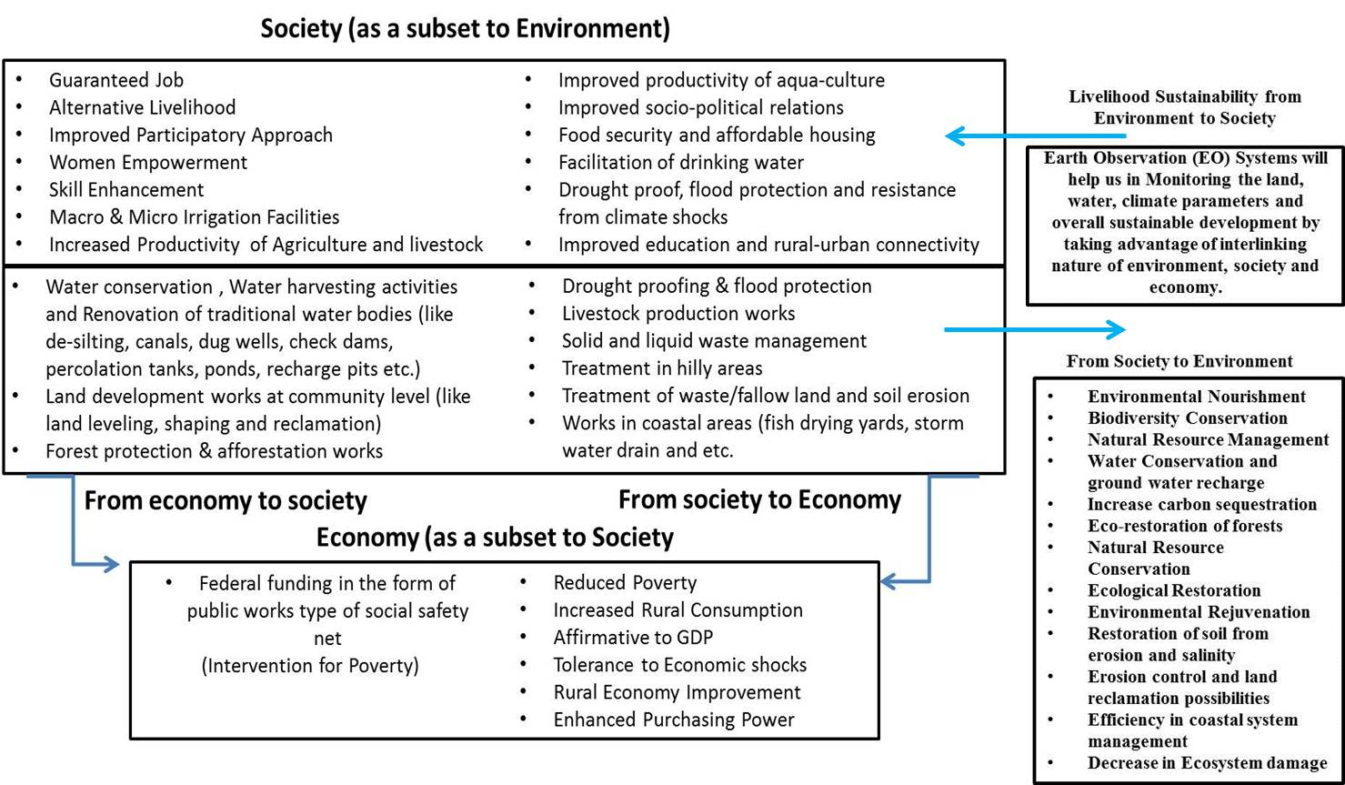
Figure 1 A representation of relations between the three pillars of Sustainable Development due to the interferences like community works on Natural Resources.

ICT was identified as a tool that would allow the transparency in the process of MGNREGA due to the great size of the programme, geographical extent, financial implication, beneficiaries and stakeholders. ICT confirms transparency and supports in information dissemination, facilitates online watching and valuation of the programme (Reddy, 2013). A committed web gateway exists for the social recording of project actions and to provision the ‘Right to Information’ act. The portal offers brief information about the active works, completed mechanism and growth of assets. The backend management information system (MIS) simplifies recording of benefits accrued in the NREGA program (NREGA Web Portal, 2019). The geo-tagged effects have been put in the public area under a portal named GeoMGNREGA which is built on Bhuvan platform developed by Indian Space Research Organisation’s (ISRO). Bhuvan provides essential online geospatial provision to MGNREGA project through an integrated view of asset information. In GeoMGNREGA, there are supplies to envisage properties at the state, district and block level. Properties can be envisaged based on the work category. The dashboard is available at GeoMGNREGA which provides statistical records of the Geo-tagged properties (MGNREGA Dashboard, 2018; GeoMGNREGA Dashboard, 2018; ISRO, 2016). Figure 2 represents the glimpse of Geo-portal which publishes geo-tagged properties information to the public under MGNREGA project.
Study Area
MGNREGA execution is for the entire country with the solitary exclusion of the urban population. Phase I was first executed in 2006 in the 200 poorest districts in India. These districts were precisely targeted by the Planning Commission of India based on their regressive status of Indian districts.

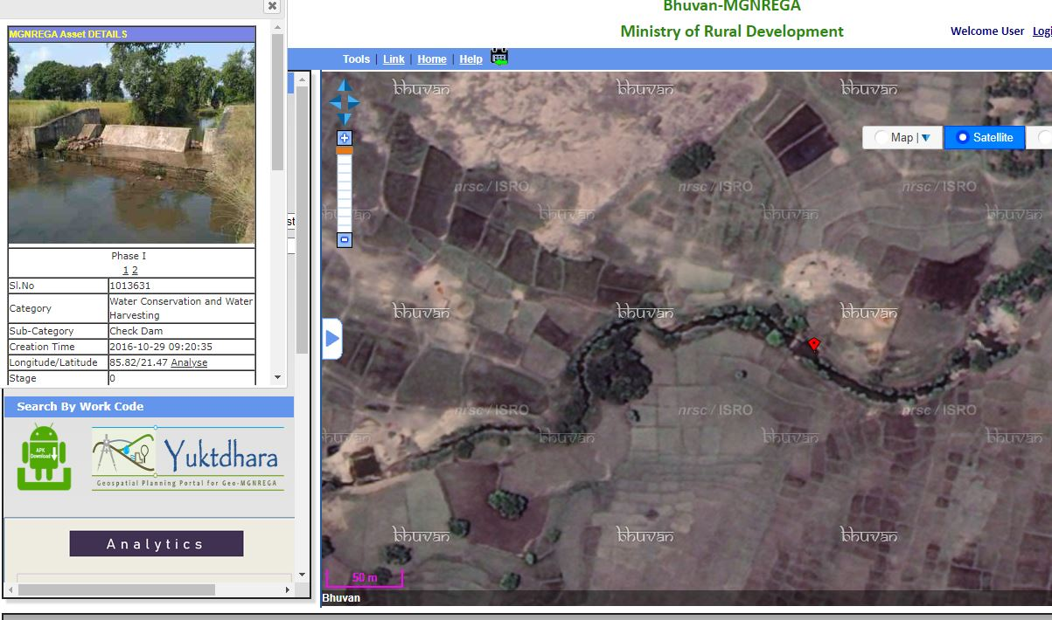
Figure 2 This is photo of GeoMGNREGA web-portal, which enables the MGNREGA with signal of a geo-tagged photograph of the asset.

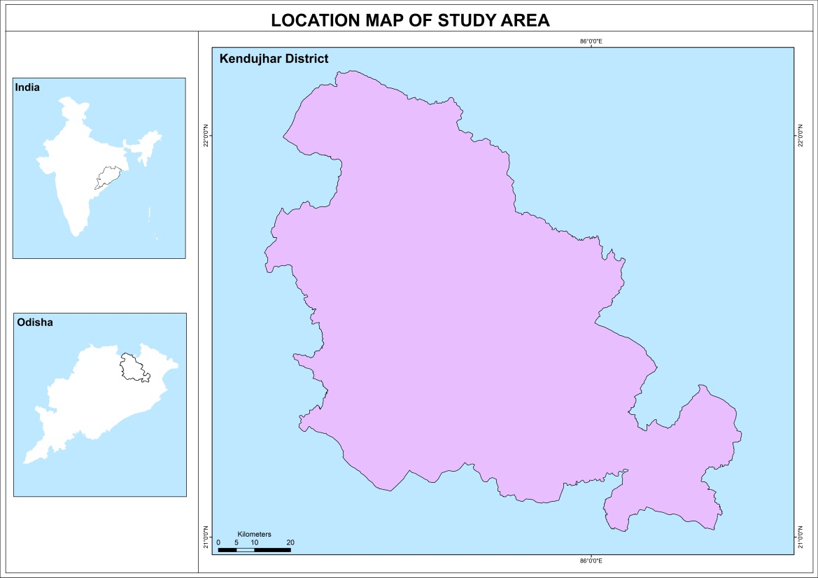

Figure 3. Keonjhar district of Odisha State, India

Keonjhar District is one of the district of Odisha. The district is also one of the fifth Scheduled Areas of Odisha. The Keonjhar town (Kendujhargarh) is the district headquarters of Keonjhar. Anandapur, Champua, and Kendujhar are the three sub-divisions of this district. The half of the eastern part of the district is the plains which is Anandapur. The western part is surrounded with a hills of range containing peaks such as Gandhamardan (3477 ft), Mankadnacha (3639 ft), Gonasika (3219 ft) and Thakurani (3003 ft). The half of the area is covered by forests of Northern tropical deciduous type of trees of the Keonjhar district which are Sal, Asan, Jamu, Arjuna, Kusum, Kangada, Mahua, Mango, Kendu. The highlands encompass of groups of rugged scarps and the mountain tops perform to be suddenly peaked. They have widespread tablelands on their summits. In some areas, isolated hills increase sharply from the plains but most areas have a general elevation of over 600m. The highlands originate the watershed for a number of rivers, including the Baitarani River.
The Geographical area of the district is 8,303 km^{2.} The district situated between 21° 0'46.44"N to 22° 9'34.61"N latitude and 85°11'3.49"E to 86°21'30.93"E longitude. The temperature in the district rise quickly in the spring with the maximum temperatures documented in the month of May rise up to 38 °C. The maximum logged temperature is 43.3 °C. The weather chills during the monsoon in June and residues cool till the end of October. The temperature in the month of December can drip down to 7°C. The minimum temperature documented was 1°C. The average annual rainfall is 1910.1 mm. Keonjhar district total population is 1,801,733 according to the census 2011. The population density of 217 inhabitants per square kilometre (560/sq mi). The concentration of Scheduled Tribes is the highest in the Keonjhar subdivision and lowest in the Anandapur subdivision. The majority of Scheduled Tribes are employed in agriculture, mining or quarrying.
Database and Methodology
EO systems allow catching the data from space, storing/archiving, managing and distributing Remotely Sensed data via web-based GIS. The recent trend of EO technology has the capability to growth the living principles of human beings, development of social economy and influence to the SDGs (Paganini, & Petiteville, 2018). EO satellites attains Very High Spatial Resolution (VHSR) images that are extensively misused to generate land cover maps to compact with agricultural, ecological and socio-economic issues as well as measuring ecosystems position, checking biodiversity and deliver inputs to social problems (Gaetano, Ienco, Ose, & Cresson, 2018). Visual interpretation of high-resolution Remote Sensing (RS) data will capable to identify activities like rural transportation, rural sanitation facilities, irrigation, drought proofing works like afforestation, land development, conservation of water and harvesting. One of the derivable from EO data is the land use and land cover (LULC) change map which can be formed at compulsory intervals, which will not only composition the general view of land cover changes but also can best serve as a planning, monitoring and evaluation tool. Table 1 shows some of the activities of MGNREGA that interrelate with the environment and also the geospatial assessor of the communication.

Table 1 Community works under MGNREGA which relation with Natural Resources and linked Geospatial Assessor
Actions | Relation with Natural Resources | Geospatial Assessor
- Conservation water and harvesting. (check dams, boulder check, underground dyke, farm bunds, earthen dam, percolation tanks, sub surface dam, water absorption trench etc.).  - Watershed management  (contour trench, contour bund, terracing, boulder check, spring-shed treatment etc.).  - Renovation of traditional water  bodies. (De-silting of the water-bodies, removing/cleaning of encroachments, removal of aquatic weeds etc.). | - Enhances and recovers groundwater recharge.  - Decreases, captures soil erosion.  - Advances soil moisture profile.  - Controls the runoffs and decreases amount of siltation.  - Advances assistance of drinking water.  - Advances water facility for livestock.  - Increases bio-mass production.  - Decreases the impact of low rainfall proceedings on agriculture, livestock and drinking water.  - Raises the storing capacity of water bodies.  - Raises the water spread area.  - Raises the flow of water to downstream. | - During the creation phase these activities can be monitored using high resolution satellite data. Geoportals will facilitate to upload geo-tagged photographs through the construction from the field and deliver the position of the work.  - The properties of conservation of water and harvesting structures for groundwater recharge and soil attrition can be analysis using RS methods.  - Soil attrition studies can be done by RS methods. Microwave RS studies have established to be predicting accurate estimates of soil moisture.  - The properties of soil humidity can be correlated with vegetation growth and this phenomenon can be monitored by NDVI techniques.  - National Remote Sensing Centre (NRSC) displays the status of all water bodies in the country using multi-resolution satellite images. The assessed water spread area on the date of image is available in dedicated Water Body Information System (WBIS, 2019).
- Construction and restoration of micro and minor irrigation works (canals, distributary and minor routing canals, alteration of water transmission system, correction of system absences about outlet upto distributaries etc.). | - Water for agriculture purpose.  - Decreases the impact of low rainfall events on the agriculture. | - Before and during the construction phase the activities can be checked using high resolution satellite data.  - Water pressure on agriculture container be done using RS.
- Drought proofing (eco-restoration, reforestation, plantation, block plantation, avenue plantation, afforestation, grass land development, bio-drainage, plantation in government lands) | - Indigenous natural and human manufacture resource base must capable to deliver a certain necessary amount of food, fuel, fodder, drinking water and livelihood incomes through a drought. | - Effects of the studies can be completed using RS Indices along with drought prediction models.  - Studies connected to eco-restoration of forest, afforestation, grass land growth can be done using RS data beside with socio-economic data.
- Springshed development (mountain regions) like trenching, plantation, fodder grasses and gull working. | - To generate source of water supply systems, increase rainfall access, recharge springs and recover dysfunctional traditional water harvesting systems. | - In the mountainous regions, most of the expendable water creates from springs. The insecurity can be checked using RS methods along with digital elevation models.  - Climatic issues, anthropogenic reasons and the landscape, vegetation cover, soil and geology of an area also disturbs the water availability in a region. These influences control the rainfall runoff and groundwater recharge and storage. RS data can be used to monitor springshed management along with other in-situ data.
- Creation of Poultry goat shelter, fodder trough.  - Creation of buildings. | - Accumulate of community level structure.  - Housing facility for marginal and vulnerable groups etc.  - Food storing, security and other based infrastructure. | - High resolution RS data using to know the variation. Information systems will accomplish to gather the filed photographs by measured crowd gaining methods.
- Fisheries (tanks, water harvesting ponds, landscaping of the bed and fish drying yards) | - Helps in boosting fisheries occupation. | - Monitored by RS data with high resolution and multi resolution data for coastal area expansion applications.
- Rural drinking water, rural sanitation, solid and liquid waste management, flood management, irrigation. | - To solve drinking water issues, enable irrigation facilities and control the flood. | - Monitored by high resolution RS data. Water spread areas can be noticed and mapped in RS data using multispectral data.
- Pro-forest activities like tree plantation, grass lands, nursery, afforestation activities etc. | - Rises forest cover and helps in change of wastelands to cultivable lands. | - Portal titled Global Forest Watch can be used to monitor the forest lost and gain events.

Henceforth observing the food safety struggles or agriculture events is one of the important displays for evaluating Social Safety Nets (SSNs). Land expansion works, drought proofing actions, soil conservation approaches and irrigation assistance will be the outcome in advanced agriculture efficiency. The measurement of vegetation crosses using RS databases has become a dangerous way to extent the properties of local and global-scale agricultural production. The common technique for this is the Normalized Difference Vegetation Index (NDVI) method. NDVI signifies the effects of climate and water on vegetation in terms of its absorptive capacity in observable light but little in the near-infrared range. The difference between visible and near-infrared reflectance signifies photo synthetically active vegetation. This information is reused to concept a vegetation index. The lower value of the vegetation index specifies humidity pressure in vegetation, producing from extended water shortage. Higher NDVI values might reproduce ideal rising circumstances if vegetation greenness is higher than that faced in other years. Maximum NDVI provides the maximum NDVI value of the increasing season and signifies highest vegetation photosynthetic action. Maximum NDVI donates the movement of vegetation health for the studies which duration over some years (Burgan, & Hartford, 1993; Bhatt et al., 2017).
Modern RS and GIS methods are very valuable for water resources management and conservation policies (Shakoor, Shehzad, & Asghar, 2006). Satellite-based Water Body Information Systems (WBIS) deliver suitable

information about the water spread area and other resultant information. Usual forms of water bodies are canals, rivers, lakes, aquaculture/pisciculture based water bodies, reservoirs, ponds, irrigation facilities (WBIS, 2019). Most of the water from the water bodies is mainly used for agriculture, drinking water, cottage industries and livestock production drives in the rural areas.
The Rural population regularly appeals upon the outputs of trees and forest in their area for numerous reasons like direct use by the household such as fuel and food, inputs into the agricultural system, such as fodder and protection, causes of income and employment (Wackernagel, & Rees, 1998). Soil conservation works, afforestation, tree plantation, boundary plantation, agro-forestry, block plantation and agro horticulture works includes in the program of this SSN. They have encouraging properties on the forest conservation by straight generous acceptable obtaining power and dropping the dependence on forest resources. Therefore forest area monitoring contributes a proposal of the essential of the peri-rural population on the forest. Figure 4 shows the forest theme based web-GIS portal created called ‘Global Forest Watch’. These types of entries are highly appreciated to display the changes in the forest areas.

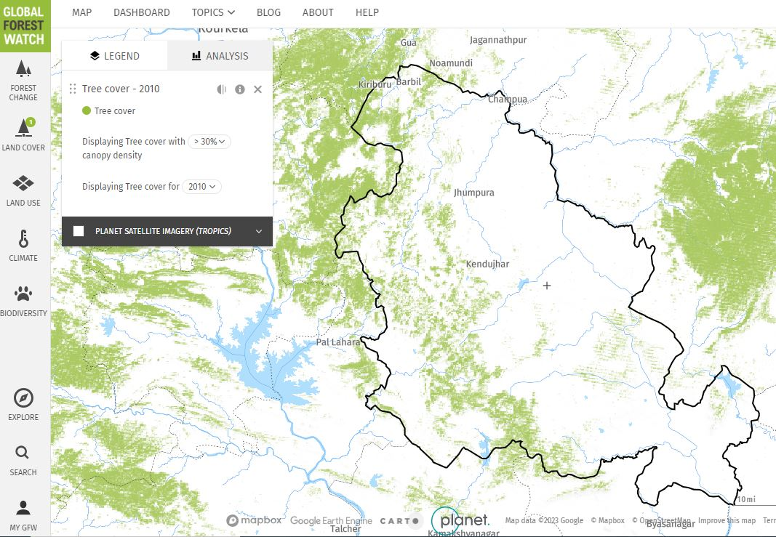
Figure 4 A example of Keonjhar district surroundings with Global Forest Watch on geo-portal

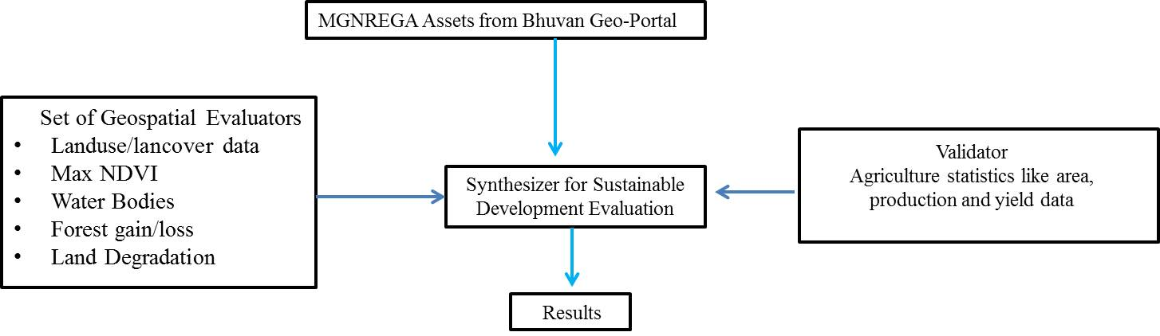

Figure 5. Method for rapid estimation of development through Geospatial assessors and agriculture productivities

- Highest NDVI (Max-NDVI) has been extracted from agricultural lands from the RS imagery from the year 2009-2019 throughout cropping seasons. The density of the resources is relatively significant and appears to be a hotspot.
• Analysis of water bodies was approved out in the study area from the year 2009 till 2019 to be checked for the suggestion of changes due to water gathering and water conservation movement which has sponsored for improved ground water levels and improved water disposal for irrigation.
• Land degradation records were formed for the years 2009 and 2019.
• The forest loss/gain was used as an display to portion the forestry section from global forest watch geo-portal.
Discussion
Public works in MGNREGA have developed well in all the 13 blocks of the Keonjhar district. Dashboard (2019) suggesting that a total number of 2267 village groups have vigorously joined in this platform. A total of 575708 Lakhs workers were intricate in MGNREGA program in this district. The study area covers more than 26389 resources over an area of 653900 Ha. of land. Table 2 depicts the total number of effects established from the year 2009 till 2019. It is evident that generally the resources were for irrigation, water conservation, water harvesting and drought proofing works. From the year 2017 and 2018, there is mandate and growth in rural sanitation works in the study area.

Table 2. MGNREGA resources of Keonjhar District

Year | No. of Assets | Type of Principal Asset
2009-10 | 1646 | Water Conservation and Water Harvesting, Renovation of traditional water bodies
2010-11 | 2832 | Farm Pond, Renovation of traditional water bodies, Bharat Nirman Sewa Kendra
2011-12 | 3725 | Individuals Land (Category IV) work, Bharat Nirman Sewa Kendra, Water Conservation and Harvesting
2012-13 | 2901 | Individuals Land (Category IV) work, Water Conservation and Harvesting, Restoration of traditional water bodies
2013-14 | 4697 | Individuals Land (Category IV) work, Water Conservation and Harvesting, Restoration of traditional water bodies
2014-15 | 1135 | Individuals Land (Category IV) work, Water Conservation and Harvesting
2015-16 | 15466 | Individuals Land (Category IV) work, Development of Land, Drought Proofing
2016-17 | 9587 | Individuals Land (Category IV) work, Drought Proofing, Restoration of traditional water bodies
2017-18 | 34103 | Individuals Land (Category IV) work, Drought Proofing, Restoration of traditional water bodies
2018-19 | 24600 | Individuals Land (Category IV) work, Drought Proofing, Water Conservation and Harvesting

Source: Dashboard of MGNREGA of the year 2018; Dashboard of GeoMGNREGA of the year 2018

Figure 6 shows the LULC map for the year 2009 and 2019. After analysing the temporal LULC maps, approvals which change of pockets of wastelands to agriculture practices. Figure 7 shows the Maximum NDVI resulting from the tested areas at the hotspots that are consuming high strength of land growth activities, irrigation amenities and soil fertility expansion works. The Maximum NDVI values over 250 samples show sharp progress in the vegetation in the study area. The values of Maximum NDVI have enhanced from 0.40 to 0.52 over duration of 10 years. Around 150 water bodies in the study area were analysed. Figure 7 signifies the screenshot of GeoMGNREGA portal to recover the hotspots evidence of the works complete under MGNREGA. Figure 7 signifies the category wise hotspots for numerous resources at block level.

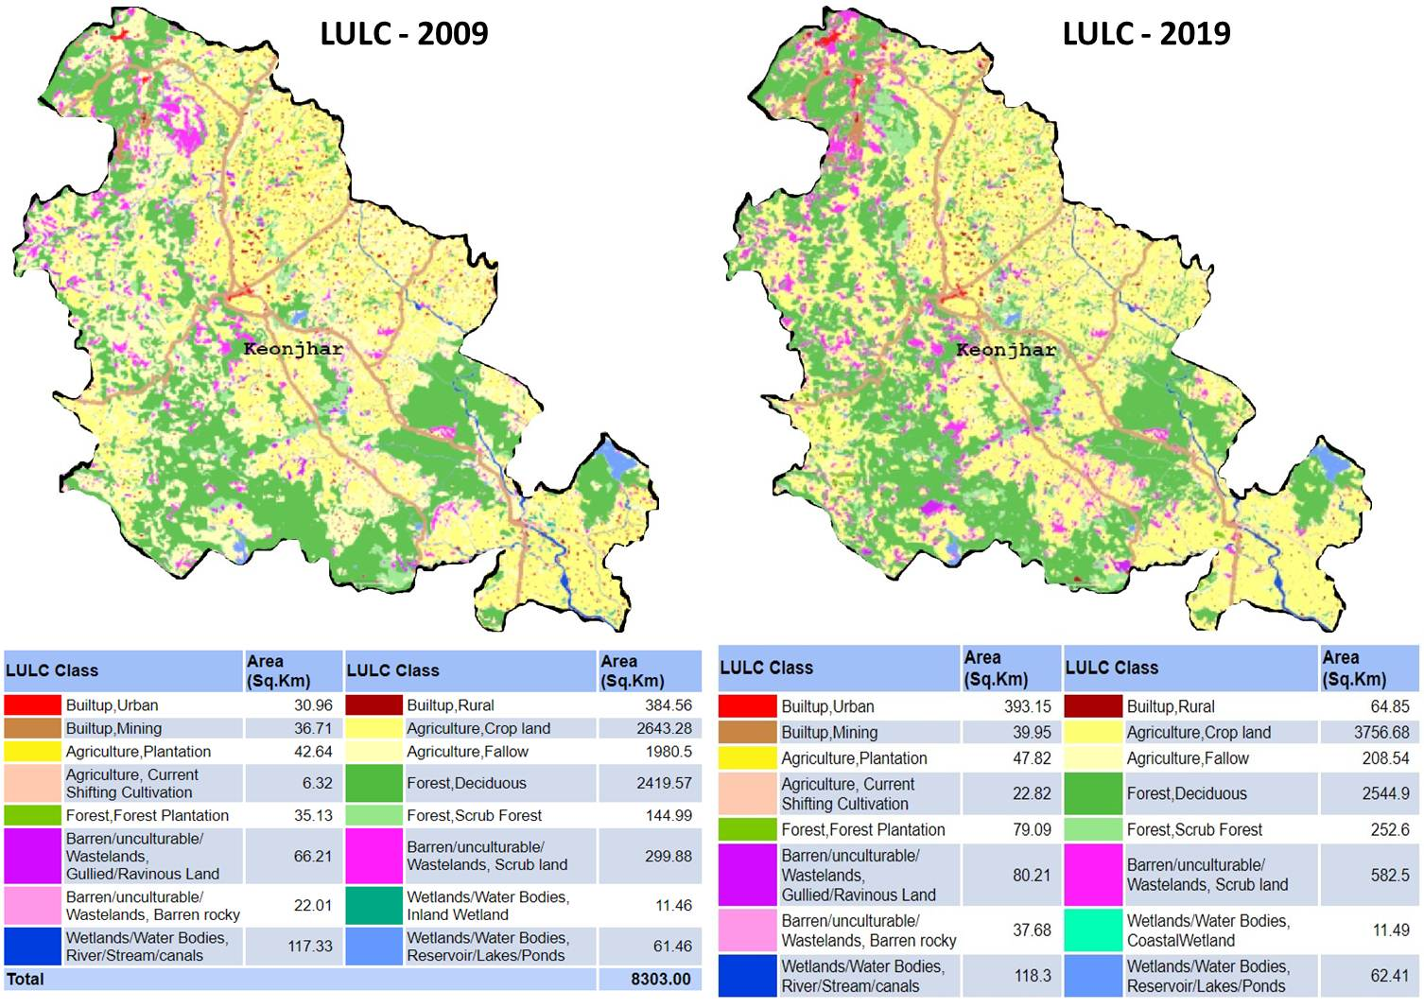
Figure 6. Land Use/Land Cover maps of Keonjhar district (2009 and 2019)

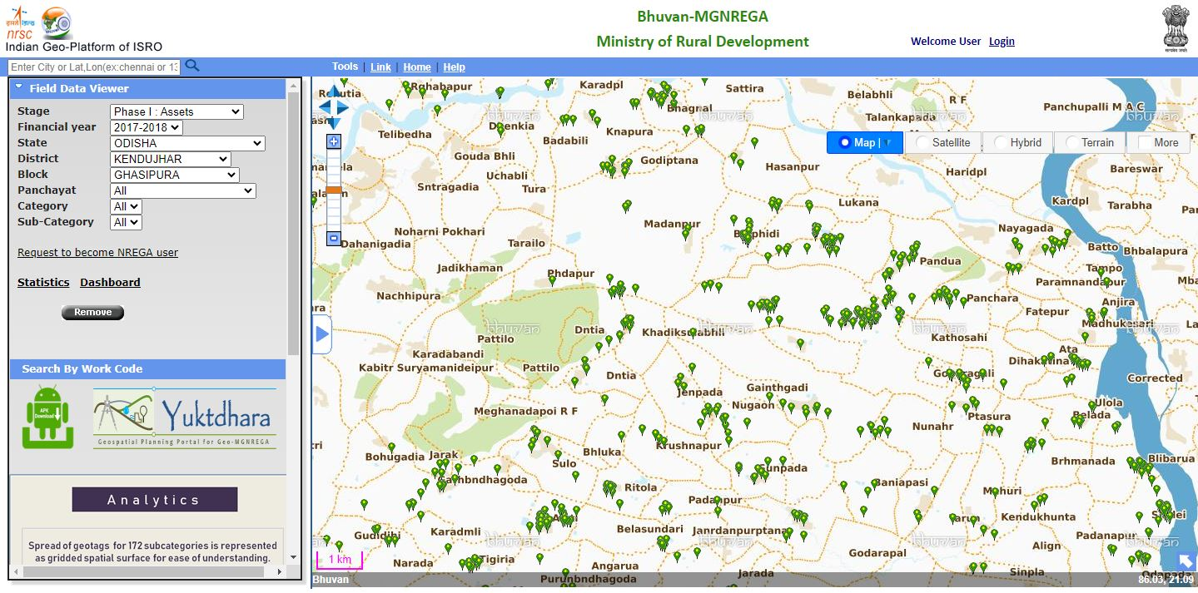
Figure 7. Spatial distribution of resources for the year 2017-2018 in block Ghasipura
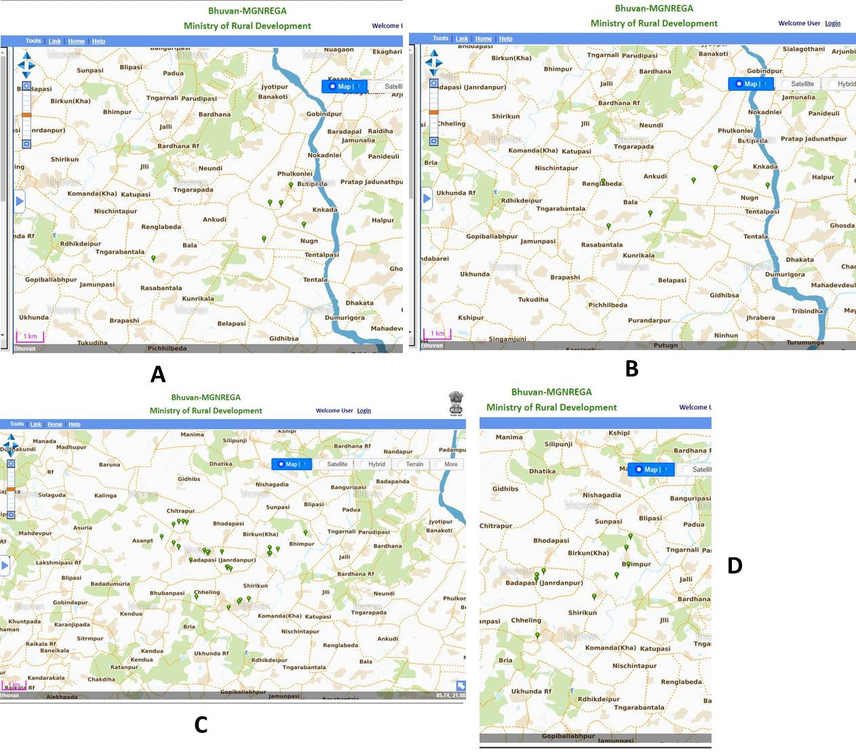
Figure 8. MGNREGA Hotspots of resources in Ghasipura block of Keonjhar district. A - Resources relating to Rural drinking water work. B - Resources relating to Drought proofing. C - Restoration of traditional water bodies. D - Water conservation and harvesting

Table 3. Analysis of dynamics from the geospatial assessors of Keonjhar district (2009 – 2019)
Indicator | Observation
LULC maps for the year 2009 and 2019 | LULC map is resulting through satellite data there is indication of changing wastelands areas into agriculture.
Maximum NDVI at highest cropping season | Maximum NDVI values finished 250 sample points indications sudden development in the vegetation. The ideals NDVI has improved from 0.40 to 0.52 finished the span of 10 years.
Interpretation of waterbodies | About 150 water bodies in the study area where examined. The reflection is the majority of water bodies’ shows outstanding recharge and water spread area.
Analysis of Forest cover of Global forest portal | There is no variation in the forest cover. For the year 2009, the area of the forest cover is 2420 Ha. and is 2545 for 2019.
Land degradation and erosion | Suggestions of enhancement in land deprivation and destruction were detected in the temporal analysis of land degradation data.
Agriculture Productivity | From the statistics of agriculture efficiency, it is noticed that there is major growing in total cropped area, net area irrigated. There is development in total area for food grain and also in productions. The area of principal crop, production and yield were also developed considerably.

Table 4. Agriculture statistics (2009 – 2019) for Keonjhar district

Year | Gross Cropped Area '000 Ha. | Gross Area of Irrigated ' 000 Ha. | Gross Area for food grains '000 ha. | Production in '000 Tonnes | Food grain- Yield Kg per Ha. | Gross area for Rice '000 ha. | Rice Production in '000 tonnes | Rice - Yield Kg per Ha.
2009-10 | 426.26 | 73.86 | 299.74 | 360.17 | 1202 | 195.51 | 282.17 | 1443
2010-11 | 414.28 | 96.26 | 211.32 | 245.41 | 1161 | 181.38 | 191.57 | 1052
2011-12 | 394.63 | 74.37 | 269.63 | 331.74 | 1675 | 171.46 | 293.73 | 1713
2012-13 | 426.26 | 114.23 | 275.14 | 333.01 | 1675 | 170.65 | 283.99 | 1664
2013-14 | 393.33 | 123.55 | 275.6 | 375.84 | 1364 | 175.37 | 272.65 | 1664
2014-15 | 400.27 | 138.33 | 277.89 | 510.62 | 1837 | 175.8 | 412.75 | 2348
2015-16 | 391.92 | 135.55 | 277.29 | 312.06 | 1125 | 182.9 | 206.98 | 1132
2016-17 | 407.43 | 178.22 | 291.6 | 530.67 | 1820 | 192.84 | 422.25 | 2190
2017-18 | 400.29 | 136.62 | 283.35 | 503.44 | 1777 | 188.36 | 395.04 | 2097
2018-19 | 363.68 | 185.55 | 251.36 | 473.69 | 1885 | 160.69 | 367.34 | 2286

Table 3 shows the outcomes achieved for the study. It is detected that there is a development in terms of land growth for agriculture productivity. Analysis shows that the water harvesting actions have an encouraging influence in the study area for providing drinking water and irrigation facilities. The farmers, who face water emergency during drought are now pleased after digging the farm ponds in this area. The farm ponds supported in storing rainwater and gradually higher the groundwater level in surrounding areas. The vital moisture for the fields is accessible throughout the year. Though farmers were responsive of the concept, many were incompetent to appliance the impress assumed the cost of digging ponds previously, but by MGNREGA this was finished promising. The visual interpretation technique is used to study the high-resolution satellite data which indicates the improvement in the renovation of degraded and eroded lands.
Numerous water restoration works were occurred in MGNREGA project in Keonjhar district. The results are marked in the VHSR Remote Sensing data, one example is shown in figure 9 where the renovation works have inclined the water spread area. Likewise, it shows an area where supportable land use pattern have overcome due to land expansion actions.

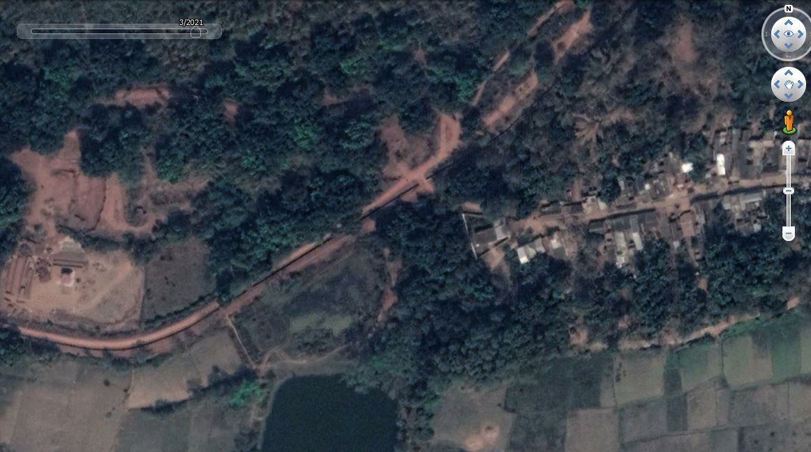
A
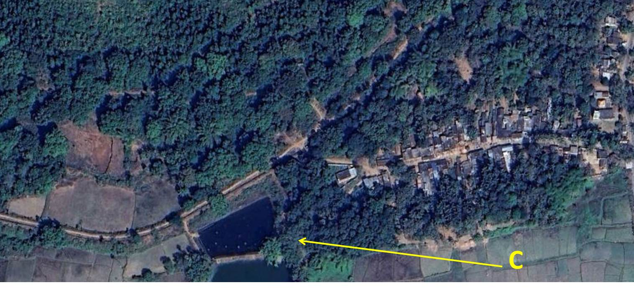
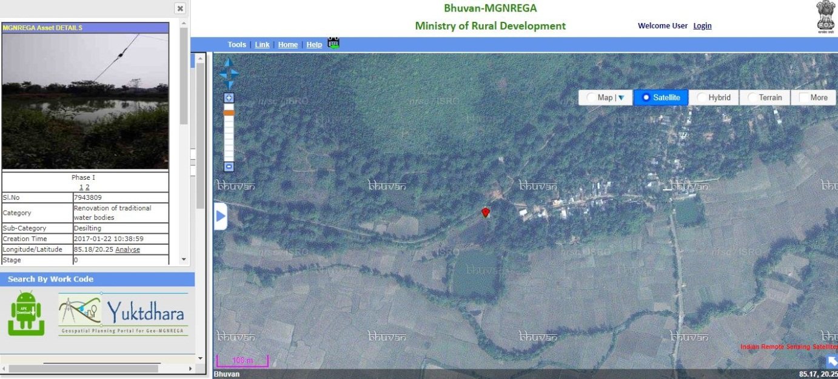
B

Figure 9. Renovation of minor irrigation tank through MGNREGA community work in Keonjhar District. (A) Satellite imagery of March 2017 showing less water spread area in the Reservoir. (B) resources at the reservoir in GeoMGNREGA (C) Satellite imagery of March 2018 with more water spread area.

Conclusion
The study concludes that the benefits that are improved due to resources of MGNREGA community works. The outcomes approve the MGNREGA resources are successfully aiding for educating sustainable living and displays helpful influence on the natural resources. Activities like water conservation and harvesting have produced in assisting irrigation and drinking water in the study area. Restoration process of traditional water bodies and water harvesting structures have controlled to developed water availability and therefore the growth in area under irrigated crop production. Most of the minor irrigation tanks have been restored to their actual ability. The outcomes of this important scheme have facilitated green and blue revolution in this part of the study area. The study describes that the community works under MGNREGA are substantial the confident outcomes in all three proportions of SD in the form of resilient rural infrastructure in the measurement of society, increases the viable eco-restoration procedure for the environmental aspect and spend-ability by rural section rises the economic element at the national scale. The study established the procedure of geospatial technology to extent the profits that are accumulated in terms of environment and socio-economic levels from the public works of MGNREGA.

References

- Allen, P. (1999), “Reweaving the food security safety net: Mediating entitlement and entrepreneurship,” Agriculture and Human values, 16(2), pp:117-129.
- Basiago, A. D. (1998), “Economic, Social, and Environmental Sustainability in Development theory and Urban Planning practice”, Environmentalist, 19(2), pp:145-161.
- Beegle, K., Coudouel, A., & Monsalve, E. (2017), “Realizing the Full Potential of Social Safety Nets in Africa”, World Bank, Washington, DC.
- Bello, O. M., & Aina, Y. A. (2014), “Satellite remote sensing as a tool in disaster management and sustainable development: towards a synergistic approach”, Procedia - Social and Behavioral Sciences, 120, pp: 365-373, https://doi.org/10.1016/j.sbspro.2014.02.114.
- Bhatt, U. S., Walker, D. A., Raynolds, M. K., Bieniek, P. A., Epstein, H. E., Comiso, J. C. … Zhang, J. (2017), “Changing seasonality of panarctic tundra vegetation in relationship to climatic variables”, EnvironmentalResearch Letters, 12(5). https://doi.org/10.1088/1748-9326/aa6b0b.
- Bose, N. (2017), “Raising consumption through India’s national rural employment guarantee scheme”, World Development, 96, pp:245-263. https://doi.org/10.1016/j.worlddev.2017.03.010.
- Burgan, R. E., & Hartford, R. A. (1993), “Monitoring vegetation greenness with satellite data”, General Technical Report INT-297. Ogden, UT: US Department of Agriculture, Forest Service, Intermountain Research Station (13).
- Campagna, M. (2005), “GIS for sustainable development”, CRC Press, Boca Raton.
- Desai, S., Vashishtha, P., & Joshi, O. (2015), “Mahatma Gandhi National Rural Employment Guarantee Act: A Catalyst for Rural Transformation” National Council of Applied Economic Research, (7259), New Delhi.
- Devuyst, D. (2000), “Linking impact assessment and sustainable development at the local level: the introduction of sustainability assessment systems”, Sustainable development, 8(2), pp:67-78. https://doi.org/10.1002/(SICI)1099-1719(200005)8:2<67::AID-SD131>3.0.CO;2-X
- Esteaves, T., Rao, K. V., Sinha, B., & Roy, S. S. (2013), “Environmental Benefits and Vulnerability Reduction Through Mahatma Gandhi NREGS: A Synthesis Report”, Ministry of Rural Development, Government of India and Deutsche GIZ, New Delhi.
- Gaetano, R., Ienco, D., Ose, K., & Cresson, R. (2018), “MRFusion: A Deep Learning architecture to fuse PAN and MS imagery for land cover mapping”, arXiv preprint arXiv:1806.11452.
- Giribabu, D., Mohapatra, C., Reddy, C. S., & Prasada Rao, P. V. V. (2019), “Holistic Correlation of World’s Largest Social Safety Net and its Outcomes with Sustainable Development Goals”, International Journal of Sustainable Development & World Ecology, 26(2), pp:113-128.https://doi.org/10.1080/13504509.2018.1519492.
- Grosh, M.E., Del Ninno, C., Tesliuc, E., & Ouerghi, A. (2008), “For protection and promotion: The design and implementation of effective safety nets”, The World Bank. Washington, DC.
- Indian Planning Commission. (2007), “Eleventh Five Year Plan. Government of India”, OUP, New Delhi. Vol. III.
- ISRO (2016), Retrieved from https://www.isro.gov.in/isros-geo-portal-bhuvan-gateway-to-indian-earth-observation.
- MGNREGA Dashboard (2018), Retrieved from http://mnregaweb4.nic.in/netnrega/nrega-reportdashboard/.
- MGNREGA Guide (2019), “Master Circular - A Guide for Programme Implementation FY 2018-2019” Retrieved from http://nrega.nic.in/Netnrega/WriteReaddata/Circulars/AMC_2018-19_nk_v3_21.03.18.pdf.
- Narain, P., Rai, S. C., & Bhatia, V. K. (1999), “Inter district variation of development in southern region”, Journal of the Indian Society of Agricultural Statistics, 52, pp:106-120.
- Nayyar, R. (2005), “Planning for the Development of Backward Districts (2005)”, Chronic Poverty Research Centre Working Paper. https://dx.doi.org/10.2139/ssrn.1756833.
- Paganini, M., & Petiteville, I. (2018), “Satellite Earth Observations in Support of the Sustainable Development Goals”, European Space Agency.
- Raju, N. A. (2015), “Land capability and suitability in Vizianagaram district of Andhra Pradesh using Remote Sensing and GIS techniques”, IOSR Journal of Humanities and Social Science, 20(7), pp:56-64.
- Ranaware, K., Das, U., Kulkarni, A., & Narayanan, S. (2015), “MGNREGA Works and their impacts”, Economic & Political Weekly, 50(13).
- Rao, S. N. (2014), “Economic restructuring programme: Naidus developmental experiment in Andhra Pradesh, 1995 to 2001” Centre for Political Studies, Jawaharlal Nehru University.
- Shakoor, A., Shehzad, A., & Asghar, M. N. (2006), “Application of remote sensing techniques for water resources planning and management”, In Advances in Space Technologies, 2006. International Conference, IEEE, pp:142-146.
- Singh, R. K., Murty, H. R., Gupta, S. K., & Dikshit, A. K. (2009), “An overview of sustainability assessment methodologies. Ecological indicators”, 9(2), pp: 189-212. https://doi.org/10.1016/j.ecolind.2008.05.011.
- Subbarao, K., Del Ninno, C., Andrews, C., & Rodríguez-Alas, C. (2012), “Public works as a Safety Net: Design,Evidence, and Implementation” The World Bank, Washington, DC.
- Tiwari, R. et al. (2011), “MGNREGA for Environmental Service Enhancement and Vulnerability Reduction : Rapid Appraisal in Chitradurga district, Karnataka”, Economic & Political Weekly, 46(2).

