Grüneisen parameter and Debye temperature under the combined influence of size and pressure
Uma Pachauri^{1*}, Prashant² and Deepika P. Joshi³
¹Shri Ram Murti Smarak College of Engineering & Technology, Bareilly, Uttar Pradesh-243202, India
²Dept. of Physics, BSR Rajkiya Mahavidyalaya, Rikhnikhal, Pauri Garhwal, SDS University, Uttarakhand-246179, India
³Dept. of Physics, G. B. P. U. A. & T., Pantnagar, Uttarakhand-263145, India

Email- umapachauri21@gmail.com
Abstract
A theoretical study has performed on the size and pressure dependence of Debye temperature using size dependent Grüneisen parameter. It is a dimensionless and vital quantity to express the thermodynamic and thermoelastic behaviour of solids and provides information related to lattice anharmonicity. Debye temperature is that temperature at which collective vibrations changes to an independent thermal vibration. For bulk materials, plethora of theoretical and experimental studies are performed on pressure dependence of Debye temperature, but it is difficult to measure it at nano scale. Though in recent years, multiple investigations have been executed on size dependency of the Debye temperature. Still the pressure study of size dependent Debye temperature is not explored yet. For this work, research done by Kumari and Dass is used to study the combined effect of size and pressure on Debye temperature for nanoparticles. It has been observed that Grüneisen parameter reduces under pressure at nano level. Debye temperature displays enhancement for a specific particle size because of variation in unit cell parameter under pressure (up to 1 GPa). The obtained results demonstrate consistency with the extracted data from experimental studies of size and pressure dependent melting temperature. The pressure dependence of Debye temperature is needed to observe the recoilless fraction of γ-ray emission or absorption in the Mӧssbauer effect.
Keywords: Grüneisen parameter, Debye temperature, Anharmonicity, Melting temperature

- Introduction:
Nanomaterials have become important in today’s time due to their distinctive properties and several applications in different areas such as physics, chemistry, engineering and biomedicine etc. Along with the large surface-to-volume ratio, surface, interface, and quantum effects play a significant role which is usually inconsequent for bulk materials. Many researchers have studied theoretically and experimentally the size dependence of thermodynamic and thermoelastic properties such as melting temperature [1-4], bulk modulus [5-6], specific heat [7-8], melting entropy and enthalpy [9-10], Debye temperature [11-12] and Grüneisen parameter [13] of nanomaterials.
Grüneisen parameter (γ) is one of the most important characteristics of crystal lattice dynamics [14]. It represents the measurement of the anharmonicity of the forces acting in a crystal into an equation of state and reflects the characteristics of the phonon spectrum frequency distribution and their variation with pressure [15]. Debye temperature is closely associated with the properties such as thermal expansion, specific heat and vibrational entropy and can be defined as the temperature of crystal's highest normal mode of vibration, i.e., the maximum temperature that can be attained by an individual normal vibration. Generally, the thermodynamic properties under pressure are very important. There exists a number of studies on the pressure dependent Debye temperature and Grüneisen parameter for bulk materials [16-21]. However, as far we are aware of, the collective study of size and pressure on Debye temperature and Grüneisen parameter have not been performed yet. In this work, an attempt is made to study the combined effect of size and pressure on the Grüneisen parameter and Debye temperature. Initially the size dependency of Grüneisen parameter is checked by modifying the bulk definition for nanoparticles and then for size and pressure dependency is observed for Grüneisen parameter and Debye temperature by modifying the relations given by Kumar and Dass for nanoparticles.
- Methods:
2.1 Size and pressure dependent Grüneisen parameter:
Grüneisen parameter can be expressed macroscopically in terms of thermodynamic properties such as heat capacity, thermal expansion, and isothermal bulk modulus. It is difficult to measure Grüneisen parameter experimentally therefore a theoretical expression is modified for nanoparticles.
${ γ}_{n}=\frac{α_{0n}K_{0n}V_{n}}{C_{n}}$ (1)
In the present study, the product of volume thermal expansion coefficient ($α_{0b}$) and isothermal bulk modulus ($K_{0b}$) is considered to be constant for nano and their bulk counterpart respectively ($α_{0b}K_{0b}=α_{0n}K_{0n}$) [14] and γ_{n}, V_{n,} and C_{n} represent the Grüneisen parameter, molar volume and molar specific heat capacity for nanomaterials respectively.
In this work, the unit cell structure is assumed cubic for nanoparticles. Using the expression given by Qi and Wang (2003) [22] for the variation of lattice parameter of an ideal crystal with size the molar volume for nanoparticles can be defined as;
${ V}_{n}={\left(\frac{GD}{E_{S}+GD}\right)}^{3}V$ (2)
Where, G, V and $E_{S}$ symbolise the shear modulus, molar volume and surface energy of bulk material respectively. D denotes the diameter of nanoparticles.
The expression for the specific heat of nanomaterials is built by combining the Qi’s model of melting [23] with the expression of specific heat given by Bhatt et al. [24] as;
$\frac{C_{n}}{C_{b}}=\left(1-\frac{T_{0}}{T_{mb}}\right){\left[1-\frac{{T_{0}}/{T_{mb}}}{\left(1-\frac{2d}{D}\right)}\right]}^{-1}$ (3)
Where, C_{b} and T_{mb} denote the molar specific heat capacity and melting temperature of the bulk material respectively. d and $T_{0}$ represent the atomic diameter of nanoparticles and reference temperature respectively.
Putting eq. (2) and (3) in eq. (1), the expression for size dependent Grüneisen parameter can be given as;
$γ_{n}=\frac{α_{0n}K_{0n}{\left(\frac{GD}{E_{S}+GD}\right)}^{3}V}{C_{b}\left(1-\frac{T_{0}}{T_{mb}}\right){\left[1-\frac{{T_{0}}/{T_{mb}}}{\left(1-\frac{2d}{D}\right)}\right]}^{-1}}$ (4)
For the pressure dependent Grüneisen parameter, the relation derived by Kumari and Dass [17] for bulk materials is modified for nanoparticles as;
$γ_{n}(P)=γ_{n}-ƞP$ (5)
$γ_{n}\left(P\right)$ represents the size and pressure dependent Grüneisen parameter. P denotes the applied pressure. ƞ is pressure independent parameter and is defined as [25];
$ƞ=\frac{β_{T}-β_{S}}{T_{0}α_{0b}K_{0b}}$ (6)
$β_{T} and β_{S}$ are first-order derivatives of isothermal and adiabatic bulk moduli at constant pressure respectively and their difference is approximately equal to 0.1 [14].
Finally putting the value of size dependent Grüneisen parameter and ƞ for nanoparticles given by eq. (4) and eq. (6) in eq. (5), the size and pressure dependent equation for Grüneisen parameter can be expressed as;
$γ_{n}(P)=\frac{α_{0n}K_{0n}{\left(\frac{GD}{E_{S}+GD}\right)}^{3}V}{C_{b}\left(1-\frac{T_{0}}{T_{mb}}\right){\left[1-\frac{{T_{0}}/{T_{mb}}}{\left(1-\frac{2d}{D}\right)}\right]}^{-1}}-ƞP$ (7)
2.2 Size and pressure dependent Debye temperature:
On the basis of Grüneisen parameter, Kumari and Dass (1986) [17] derived the relation for the pressure dependence of Debye temperature for bulk materials. For nanoparticles the expression is modified as;
$\frac{θ_{Dn}\left(P\right)}{θ_{Dn}\left(0\right)}=\left(1+\frac{γ_{n}P}{K_{0n}}\right)$ (8)
Where $θ_{Dn}\left(P\right)$ represents pressure and size-dependent Debye temperature, and $θ_{Dn}\left(0\right)$ represents the size-dependent Debye temperature at zero pressure. Size dependent bulk modulus has been given by Kumar and Kumar (2010) [26] as; $K_{0n}=K_{0b}\left(1-\frac{2d}{D}\right)$. After including the values of size dependent Grüneisen parameter $\left(γ_{n}\right)$ (using equation 4) and bulk modulus (K_{0n}) we get the final expression for combined effect of size and pressure on Debye temperature as equation (9).
$\frac{θ_{Dn}\left(P\right)}{θ_{Dn}\left(0\right)}=\left(1+\frac{\left(\frac{α_{0n}K_{0n}{\left(\frac{GD}{E_{S}+GD}\right)}^{3}V}{C_{b}\left(1-\frac{T_{0}}{T_{mb}}\right){\left[1-\frac{{T_{0}}/{T_{mb}}}{\left(1-\frac{2d}{D}\right)}\right]}^{-1}}\right)P}{K_{0b}\left(1-\frac{2d}{D}\right)}\right)$ (9)
As the experimental studies for the pressure effect on Debye temperature for nanoparticles are lacking, therefore size and pressure dependent Debye temperature are extracted from the pressure dependent experimental studies of melting temperature for nanomaterials to show the consistency of the proposed equation. For this, the Lindemann’s theory of melting for bulk materials [27] is used and modified.
At zero pressure: $T_{mn}(0)∝{V_{0n}}^{\frac{2}{3}}{\left\{θ_{Dn}\left(0\right)\right\}}^{2}$ (10)
At pressure P: $T_{mn}(P)∝{V_{n}}^{\frac{2}{3}}{\left\{θ_{Dn}\left(P\right)\right\}}^{2}$ (11)
Combining equations (10) and (11) we get the size and pressure dependent Debye temperature as;
$\frac{θ_{Dn}\left(P\right)}{θ_{Dn}\left(0\right)}=\sqrt{\frac{T_{mn}\left(P\right)}{T_{mn}\left(0\right)}{\left(\frac{V_{0}}{V}\right)}_{n}^{2/3}}$ (12)
Where T_{mn}(P) indicates the size and pressure dependent melting temperature and T_{mn}(0) represents the size dependent melting temperature at zero pressure. (V/V₀)_{n} is volume compression for nanomaterials, calculated with the help of Birch-Murnaghan EOS [28] which is modified for nanomaterials by including size dependent bulk modulus and can be written as;
$P=\frac{3}{2}K_{0b}\left(1-\frac{2d}{D}\right)\left[{\left(\frac{V_{0}}{V}\right)}_{n}^{7/3}-{\left(\frac{V_{0}}{V}\right)}_{n}^{5/3}\right]$ (13)
Here in the present study, first order pressure derivative of bulk modulus is considered to be constant ${(K}_{0}^{'}$ = 4).
- Results and Discussion:
Under pressure, the mechanical and thermodynamic properties change so high-pressure study is necessary to understand the applications of materials. Pressure influenced properties of the materials are of great importance in many applications [29-30] like pressure dependent Debye temperature is very important to study the recoilless fraction in Mӧssbauer experiment [17]. Therefore, in this work, size dependent Debye temperature as a function of pressure has been studied for two nanometals Al and Pb, with the help of size dependence of Grüneisen parameter and bulk modulus. In the quasi-harmonic Debye model, the Grüneisen parameter is of great significance. It depicts the anharmonic effect of the crystal lattice thermal vibration and has been extensively used to describe the thermodynamic behaviour of a material under pressure. In the present study the size dependence of Grüneisen parameter is understood with the help of the equation (4). Figure 1 [(a) and (b)] represent the variation of Grüneisen parameter with size for Al and Pb nanoparticles respectively. Grüneisen parameter shows decrement with the decrease in size of the nanoparticle. On moving towards the nano level, the reduction in lattice parameter [22] and enhancement in specific heat [24] result in the decrement in Grüneisen parameter. The same decreasing behaviour is also noticed in the previous theoretical study [13]. The combined effect of size and pressure on Grüneisen parameter is also studied with the help of equation (7). Figure 2[(a) and (b)] show the variation of Grüneisen parameter with pressure (up to 1 GPa) for Al (37 nm) and Pb (6.7 nm) respectively. It reveals that the Grüneisen parameter decreases with pressure for a particular size of nanoparticles. With increase in pressure, it is expected that anharmonic effects decrease because of an expansion of the temperature domain where zero-point vibrations are greater than thermal vibrations. The pressure variation of size dependent Debye temperature for Al (37 nm) and Pb (6.7 nm) is calculated with the help of equation (9) and the obtained results are demonstrated in Figure 3[(a) and (b)] respectively. The results are in close agreement with the available experimental data extracted from the size and pressure dependent melting temperature [31, 32] by modifying Lindemann’s theory of melting for size and pressure dependent melting temperature given as eq. (12). It is found that the Debye temperature increases linearly with increasing pressure as also observed in the bulk materials at a given temperature [17-18]. The most predominant effect caused by applied external pressure is the stiffening of the lattice [33]. A change in crystal volume would naturally affect the frequencies of the normal modes of vibrations. At Debye temperature the wavelength of the phonon vibrations is equivalent to the lattice parameter [34]. Under the effect of pressure, there is an increase in the frequency of vibrations which results in increase of Debye temperature.
- Conclusion:
A combined study of size and pressure on Grüneisen parameter and Debye temperature is done on the basis of the quasi-harmonic Debye model. Results confirm that Grüneisen parameter decreases with decreasing size due to decrement in lattice constant and increment in specific heat. Pressure dependent Grüneisen parameter decreases linearly with pressure for a particular size. Size-dependent Debye temperature enhances due to increment in lattice vibration frequency when external pressure is applied. Pressure-dependent Debye temperature is used to calculate the recoil-free fraction in Mӧssbauer effect which is useful to probe the tiny changes in the energy levels of an atomic nucleus.
Table 1: Input parameters used for the present study
Input Parameters | Al |  | Pb
Atomic diameter (d) | 0.246 nm [38] |  | 0.35 nm [36]
Specific heat (C_{b}) | 24.3 J/mol/K [39] |  | 26.9 J/mol/K [39]
Surface energy (E_{s}) | 1.16 J/m² [37] |  | 0.593 J/m² [37]
Coefficient of thermal expansion (α) | 23.1*10⁻⁶ K⁻¹ [35] |  | 28.9*10⁻⁶ K⁻¹ [35]
Bulk modulus (K_{0b}) | 75.2 GPa [35] |  | 45.8 GPa [35]
Molar volume (V) | 10 cm³/mol [35] |  | 18 cm³/mol [35]
Shear modulus (G) | 26 GPa [35] |  | 5.59 GPa [35]
Bulk Melting temperature (T_{mb}) | 933.47 K [36] |  | 600.61 K [36]
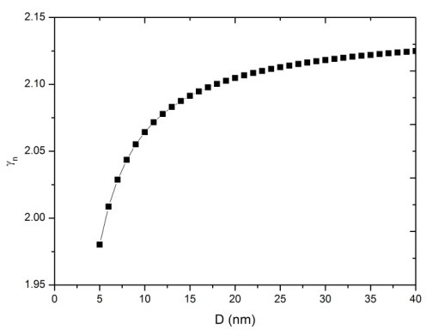 |  | 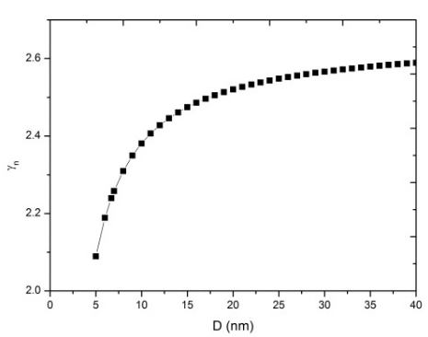
1(a) |  | 1(b)
Fig. 1: Variation of Grüneisen parameter with size for (a) Al and (b) Pb nanoparticles respectively
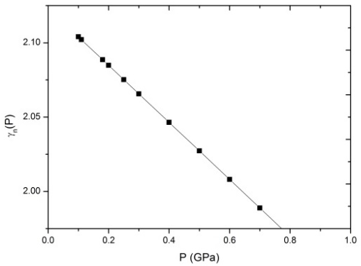 |  | 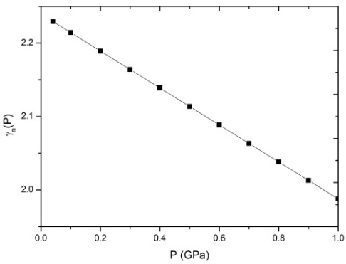
2(a) |  | 2(b)
Fig. 2: Variation of Grüneisen parameter with pressure for (a) Al (37 nm) and (b) Pb (6.7 nm) nanoparticles respectively
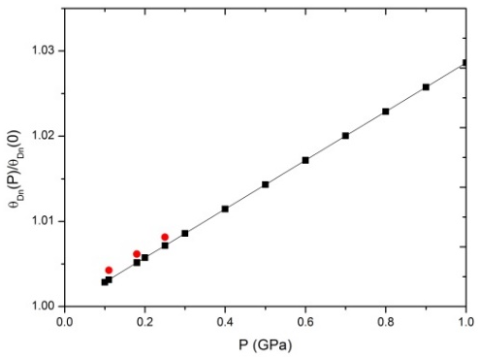 |  | 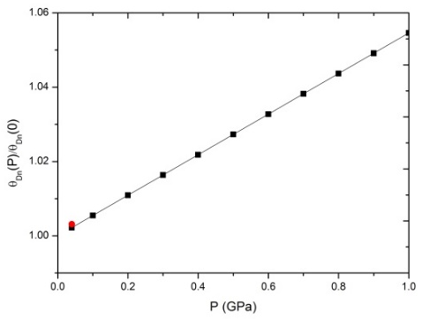
3(a) |  | 3(b)
Fig. 3: Variation of Debye temperature ratio with pressure for (a) Al (37 nm) and (b) Pb (6.7 nm) nanoparticles respectively
*In the above figures black symbols denote the calculated values of Debye temperature ratio by eq. (9) while the red symbols represent the calculated values by eq. (12) in which size and pressure dependent melting temperature is extracted from the available experimental data [31-32].

References
¹Lai, S.L., Guo, J.Y., Petrova, V., Ramanath, G. & Allen, L.H. Size-Dependent Melting Properties of Small Tin Particles : Nanocalorimetric Measurements. Phys. Rev. Lett. 77(1) (1996) 99–102. DOI: 10.1103/PhysRevLett.77.99.
²Buffat, Ph. & Borel, J.-P. Size effect on the melting temperature of gold particles. Phys. Rev. A 13(6) (1976) 2285-2297. DOI: https://doi.org/10.1103/PhysRevA.13.2287.
³Olson, E.A., Efremov, M.Y., Zhang, M., Zhang, Z. & Allen, L.H. Size-dependent melting of Bi nanoparticles. J. Appl. Phys. 97(3)(2005) 034304 (1–9). DOI: https://doi.org/10.1063/1.1832741.
⁴Arora, N. & Joshi, D.P. A theoretical approach to study the melting temperature of metallic nanowires. In: AIP Conf. Proc. DAE Solid State Physics Symposium 1731 (2015) 050054(1-3). DOI: 10.1063/1.4947708.
⁵Gu, Q.F., Krauss, G. & Steurer, W. Unexpected High Stiffness of Ag and Au Nanoparticles. Phys. Rev. Lett. 045502 (2008) 1–4. DOI: https://doi.org/10.1103/PhysRevLett.100.045502.
⁶Bhatt, J.C. & Kholiya, K. Effect of size on the elastic and thermodynamic properties of nanomaterials. I.J.P.A.P. 52(9) (2014) 604–608.
⁷Gafner, Y.Y., Gafner, S.L., Zamulin, I.S., Redel, L.V. & Baidyshev, V.S. Analysis of the Heat Capacity of Nanoclusters of FCC Metals on the Example of Al, Ni, Cu, Pd, and Au. Phys. Met. Metallog. 116(6) (2015) 568-575. DOI: https://doi.org/10.1134/S0031918X15040055.
⁸Wang, L., Tan, Z., Meng, S., Liang, D. & Li, G. Enhancement of molar heat capacity of nanostructured Al₂O₃. J. NanoParticle Res. 3 (2001) 483–487.
⁹Fu, Q., Zhu, J., Xue, Y. & Cui, Z. Size- and shape-dependent melting enthalpy and entropy of nanoparticles. J. Mater. Sci. 52(4) (2016) 1911-1918. DOI: 10.1007/s10853-016-0480-9.
¹⁰Singh, M., Lara, S. & Tlali, S. Effects of size and shape on the specific heat, melting entropy and enthalpy of nanomaterials. J. Taibah. Univ. Sci. 11(6) (2016) 922–929. DOI: https://doi.org/10.1016/j.jtusci.2016.09.011.
¹¹Balerna, A. & Mobilio, S. Dynamic properties of Debye temperatures of bulk Au and Au clusters studied using extended X-ray-absorption fine-structure spectroscopy. Phys. Rev. B 34(4) (1986) 2293-2298.
¹²Arora, N., Joshi, D.P. & Pachauri U. Size and shape dependent Debye temperature of Nanomaterials. ScienceDirect Mater Today: Proc. 4(9) (2017) 10450–10454. DOI: https://doi.org/10.1016/j.matpr.2017.06.398.
¹³Abdullah, B.J. & Omar, M.S. Grüneisen Parameter and Its Related Thermodynamic Parameters Dependence on Size of Si Nanoparticles. Z.J.P.A.S. 28(4) (2016) 126-132. DOI: https://doi.org/10.21271/ZJPAS.28.4.17.
¹⁴Anderson, O.L. Equations of state of solids for geophysics and ceramic science, New York, Oxford University Press (1994).
¹⁵Liu, Q. & Chen, L.R. Pressure dependence of the Grüneisen parameter and thermal expansion coefficients of solids. I.J.P.A.P. 55 (2017) 368-371.
¹⁶Sirdeshmukh, D.B. & Subhadra, K.G. The pressure dependence of Debye temperatures of alkali halides. Phys. Stat. sol. (b) 150 (1988) K11-K14.
¹⁷Kumari, M. On the Pressure Dependence of Grüneisen Parameter in solids. Phys. Stat. sol. (b) 133 (1986) 101-110.
¹⁸Fang, Z.-H. On the Pressure Dependence of the Debye Temperature in Solids. Phys. Stat. sol. (b) 222 (2000) 451-456.
¹⁹Barton, M.A. & Stacey, F.D. The Grüneisen parameter at high pressure: a molecular dynamical study. Phys. Earth Planet. In. 39 (1985) 167-177.
²⁰Fang, Z.-H. Pressure dependence of Grüneisen parameter in solids. Phys. Stat. sol. (b) 197 (1996) 39-43.
²¹Rai, H.K., Shukla, S.P., Mishra, A.K. & Pandey, A.K. Pressure dependence of Grüneisen parameter of some transition metals. J. Chem. Pharm. Res. 2(4) (2010) 343-356.
²²Qi, W.H. & Wang, M.P. Size and shape dependent melting temperature of metallic nanoparticles. Mater. Chem. Phys. 88(2–3) (2004) 280–284. DOI: 10.1016/j.matchemphys.2004.04.026.
²³Qi, W.H. Size effect on melting temperature of nanosolids. Phys. B 368 (2005) 46–50. DOI: 10.1016/j.physb.2005.06.035.
²⁴Bhatt, S., Kumar, R. & Kumar, M. Specific heat and thermal conductivity of nanomaterials. Mod. Phys. Lett. B 1750011 (2017) 1–13. DOI: 10.1142/S0217984917500117.
²⁵Dixit, S. & Shanker, J. On the pressure and volume dependence of the Grüneisen parameter and Debye temperature for NaCl crystals. Phys. Stat. Sol. (b) 187 (1995) 497-500.
²⁶Kumar, R. & Kumar, M. Size dependence of thermoelastic properties of nanomaterials. Int. J. Nanosci. 9(5) (2010) 537-542. DOI: 10.1142/S0219581X10007113.
²⁷Lindemann, F.A. The calculation of molecular vibrational frequencies. Phys. Z. 11 (1910) 609-612.
²⁸Birch, F. Finite Elastic Strain of Cubic Crystals. Phys. Rev. 71(11) 1947 809-824. DOI: 10.1103/physrev.71.809.
²⁹Obiekea, K., Aku, S.Y. & Yawas, D.S. Influence of pressure on the mechanical properties and grain refinement of die cast aluminum A1350 alloy. Pelagia Research Library Adv. Appl. Sci. Res. 3(6) (2012) 3663-3673.
³⁰de Freitas, C.R.D., de Góis, M.M., Da Silva, R.B., da Costa, J.A.P. & Soares, J.M. Influence of pellet compaction pressure on the physical properties of La_{0.7}Ba_{0.3}Mno₃manganite. Mater. Res. 21(1) (2018) 1–7. DOI: https://doi.org/10.1590/1980-5373-MR-2017-0197.
³¹Mei, Q.S, Wang, S.C., Cong, H.T., et al. Pressure induced superheating of Al nanoparticles encapsulated in Al₂O₃ shells without epitaxial interface. Acta. Mater. 53 (2005) 1059-1066. DOI: 10.1016/j.actamat.2004.11.003.
³²Wang, H. & Zhu, H. Melting of Pb nanocrystals embedded in Al, Si, and Cu matrices. Nano. Res. Lett. 10 (2015) 487. DOI: 10.1186/s11671-015-1196-5.
³³Suleiman, B.M., Gustafsson, S.E. & Lunden, A. Uniaxial Pressure Dependence of the Debye Temperature in Metals. Int. J. Thermophysi. 18(6) (1997) 1527-1537.
³⁴Garai, J. Physics behind the Debye temperature. arXiv:physics/0703001[physics.chem-ph].
³⁵Brandes, E.A. & Brook, E.B. Smithells metals reference book, butterworths, London, 7th Ed. (1983).
³⁶Mirjalili, M. & Khaki, J.V. Prediction of nanoparticles size-dependent melting temperature using mean coordination number concept. J. Phys. Chem. Sol. 69 (2008) 2116-2123. DOI: 10.1016/j.jpcs.2008.03.014.
³⁷Tyson, W.R. & Miller, W.A. Surface free energies of solid metals estimation from liquid surface tension measurements. Surf. Sci. 62 (1977) 267-276. DOI: 10.1016/0039-6028(77)90442-3.
³⁸Li, Y.J., Qi, W.H., Huang, B.Y., et al. Modeling the melting temperature of metallic nanowires. Mod. Phys. Lett. B 24 (2010) 2345 -2356. DOI: 10.1142/S0217984910024699.
³⁹Kittel, C. Introduction to Solid State Physics. 5th ed. Wiley. New York. (1976).

