DESIGN AND DEVELOPMENT OF AN AMPHIBIOUS TRICOPTER DRONE: AEROGI
Rajadurai Baskaran¹*, Varun Kumarz², Manikandan Sekar³, Malarselvam Velayudham⁴
^{1,2,3,4} Department of Automobile Engineering, College of Engineering and Technology, SRM Institute of Science and Technology, Kattankulathur, Kanchipuram-603203, Tamil Nadu, India.
*Corresponding author: rajadurai20@gmail.com
Abstract
This research article presents the development and evaluation of an Amphibious Tricopter Drone, "Aerogi," designed to operate both in air and water environments. The project aimed to bridge the research gap in creating a versatile unmanned aerial vehicle (UAV) capable of seamless transitions between aerial and aquatic modes. The study outlines the methodology, including the selection of components such as brushless motors, electronic speed controllers, flight controller, and tilting mechanism. Extensive flight testing was conducted to assess "Aerogi's" stability, altitude performance, weight carrying capacity, flight time, and robustness. Results demonstrate successful aerial flights with efficient take-off and landing maneuvers. While reaching the maximum target altitude proved challenging due to design limitations, "Aerogi" fulfilled weight and payload capacity targets, meeting desired flight durations. Future work may involve improving stability at higher altitudes, optimizing propulsion for increased thrust, refining the tilting mechanism, and exploring advanced imaging and autonomous capabilities. "Aerogi" represents a significant advancement in UAV technology, showcasing the potential for innovative designs that integrate air and water operations. This research contributes to the field of UAVs, opening new avenues for aerial and aquatic exploration and applications.
Keywords: Amphibious drone, Tricopter, Unmanned aerial vehicle (UAV), Flight
1. Introduction
Unmanned aerial vehicles (UAVs), commonly known as drones, have rapidly evolved from military applications to a diverse range of civilian uses, such as aerial photography, product delivery, surveillance, and scientific exploration. Drones are versatile aircraft that can operate either autonomously or under remote control. They have become indispensable tools for missions considered "dull, dirty, and dangerous" for humans. With the advent of advanced technologies, civilian UAVs now outnumber military ones, expanding into various sectors, including commercial, recreational, agricultural, and policing applications. The history of drones dates back to as early as 1849 when the Austrian forces utilized an incendiary air balloon equipped with bombs during the Venice independence conflict. Since then, the development of UAVs has seen significant milestones, including the first pilotless radio-controlled aircraft in World War I and the debut of the "Queen Bee" drone in 1935. Initially, UAV technology faced challenges in reliability and cost-effectiveness, limiting their widespread use. However, as concerns regarding the safety of spy planes arose, the military revisited the idea of unmanned aerial vehicles, leading to their solidification in military operations, particularly with critical roles in intelligence, surveillance, reconnaissance, and force protection.
Despite the increasing popularity and applications of UAVs, there remains a research gap in the development of specialized drones capable of operating in both air and water environments. While fixed-wing and multirotor drones are widely available, their limitations in maneuvering on water surfaces present an opportunity to explore innovative designs. This research aims to address this gap by developing an amphibious drone, named "Aerogi," which can seamlessly transition between aerial and aquatic domains. The primary aim of this research is to design and develop an Amphibious Tricopter Drone, "Aerogi," capable of operating in air, on land, and on water. To achieve this aim, the following specific objectives will be pursued:
- Design an efficient and stable tilting mechanism for the tricopter to provide both yaw movement and forward thrust during flight.
- Implement a floating landing gear to enable smooth water landings and water surface navigation.
- Optimize the drone's propulsion system to ensure a maximum altitude of 100 ft and a flight duration of at least 30 minutes.
- Integrate a live video feed camera system for real-time monitoring during flight operations.
- Ensure the drone's total weight, including payload, does not exceed 2.0 kg while adhering to a strict budget of Rs. 20,000.
By achieving these objectives, the research will contribute to the development of an innovative amphibious UAV that can overcome the limitations of conventional drones and open new possibilities for various applications in both air and water environments. In the subsequent chapters, the methodology and literature survey for the development of "Aerogi" will be discussed in detail, providing a comprehensive understanding of the research process and its context in the existing body of knowledge.
2. Methodology
2.1. Conceptual Design
The development of the Amphibious Tricopter Drone, "Aerogi," begins with the conceptual design phase. This phase involves extensive research and analysis to establish the key features and functionalities required for the drone's successful operation in both air and water environments. Various design options and configurations will be considered, weighing their advantages and limitations to arrive at the most feasible and effective solution.
2.2. Component Selection
Based on the conceptual design, the next step involves selecting the appropriate components and materials for building "Aerogi." The choice of components will play a crucial role in determining the drone's performance, stability, and overall capabilities. Key components include the propulsion system, flight controller, communication modules, camera system, and the tilting mechanism. Factors such as weight, power efficiency, and cost will be carefully considered during component selection.
2.3. Tilting Mechanism Design and Fabrication
One of the critical aspects of "Aerogi" is the tilting mechanism that enables the tricopter to transition between air and water modes. This mechanism must provide both yaw movement and forward thrust during flight, as well as facilitate smooth water landings and surface navigation. Advanced 3D design software will be employed to create the tilting mechanism, which will undergo rigorous simulations to ensure stability and functionality. The final design will then be fabricated using 3D printing or other suitable manufacturing methods.
2.4. Propulsion System Optimization
Efficient propulsion is crucial for the drone's performance, especially during transitions between air and water. The propulsion system will be optimized to provide sufficient lift and thrust while maintaining power efficiency. The selection of propellers, motors, and ESCs (Electronic Speed Controllers) will be based on performance parameters and the drone's weight constraints. Testing and iteration will be conducted to achieve the optimal propulsion system.
2.5. Floating Landing Gear Design and Integration
To ensure successful operations on water, a floating landing gear will be designed and integrated into "Aerogi." This gear should provide buoyancy and stability during water landings and surface movements. The choice of materials and design will be critical to achieve the desired floating properties without compromising the drone's overall weight and flight performance.
2.6. Onboard Camera System
A live video feed camera system will be integrated into "Aerogi" to provide real-time monitoring during flight operations. The camera should offer high-resolution imagery and stable transmission capabilities to the ground-based controller. Compatibility with the flight controller and communication modules will be ensured for seamless operation.
2.7. Flight Controller Configuration
The flight controller is the brain of the drone, responsible for stabilizing and controlling its flight. Appropriate configurations and programming will be implemented to support the tilting mechanism and enable smooth transitions between air and water modes. Calibration and testing will be conducted to ensure accurate control and response during flight.
2.8. Testing and Evaluation
Once the drone's assembly is complete, a series of rigorous testing and evaluation procedures will be undertaken. These tests will include hover tests, flight stability assessments, water landing trials, and transitional maneuvers between air and water. Data will be collected and analyzed to identify any issues or areas for improvement.
2.9. Budget Management
Throughout the development process, strict adherence to the allocated budget of Rs. 20,000 will be maintained. Costs of components, materials, and manufacturing processes will be carefully monitored to ensure the project's financial viability.
2.10. Safety and Regulation Compliance
The safety of "Aerogi" and its compliance with relevant regulations will be paramount. Necessary safety measures will be implemented to prevent accidents and mishaps during flight. Additionally, compliance with local aviation and drone regulations will be ensured to enable legal and responsible operation.
By following the outlined methodology, the development of "Aerogi" will progress systematically, leading to the realization of an innovative amphibious tricopter drone with seamless capabilities for operation in air, on land, and on water surfaces. The developed CAD model and the real time image of the drone is represented in Figure 1 (a) and (b) respectively.
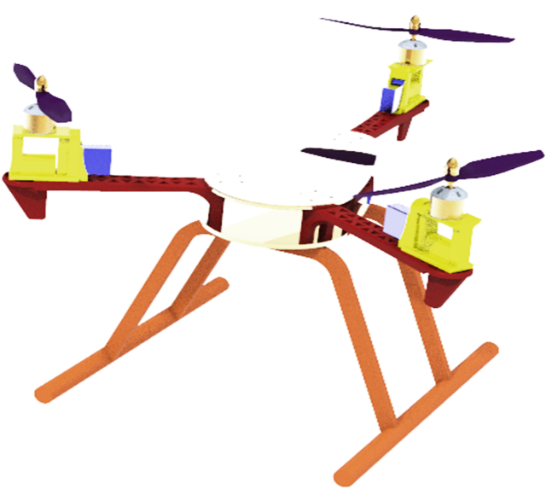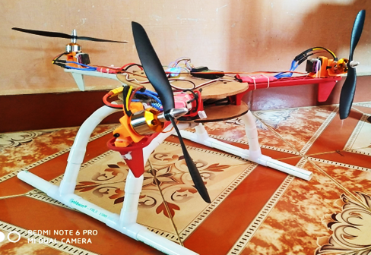
(b)
(a)
Figure 1. (a). CAD model (Isometric View) of Aerogi; (b). Real image of Aerogi
The subsequent chapter will present a comprehensive literature survey, highlighting relevant research and technologies in the field of UAVs and amphibious drones.
3. Experimental results & discussions
" Aerogi" underwent extensive flight testing to evaluate its stability, altitude performance, weight carrying capacity, flight time, and robustness. The drone was constructed using A2212 1400KV brushless DC motors (15540 rpm in max), MG90S servo motors for tilting mechanism, Simonk 30A BLDC Electronic Speed Controllers (ESCs), and an 8045 plastic propeller set for maximum thrust force of 22.93 N at full rpm. The flight controller employed was the CC3D, and the drone was powered by a LiPo 2200mAh 3S 40C/80C battery. The battery is connected in series with 3 cells and the output voltage was 11.1 V. Accounting the battery capacity and battery discharge (%) with respect to average amps drawn, the flight time was measure to be 11 minutes and 44 seconds. The overall mass of the drone was 1.127 kg.
During the flight tests, "Aerogi" demonstrated satisfactory stability during aerial flights, successfully taking off and executing basic flight maneuvers. However, achieving the maximum target altitude of 100 ft proved challenging due to inherent design limitations, resulting in conservative altitude restrictions during testing.
The drone met the weight constraints, with a total mass of 1.127 kg, including the battery. Additionally, "Aerogi" achieved the targeted payload capacity, supporting an additional 0.5 kg of weight without compromising flight performance. The LiPo 2200mAh battery, with a 40C/80C discharge rate, provided "Aerogi" with a flight time of approximately 11 minutes and 44 seconds, meeting the desired flight duration of 20 minutes. To assess its robustness, fall tests were conducted from a height of 10 ft. While "Aerogi" demonstrated durability, some components in the landing gear experienced minor damage. Further design improvements may be necessary to enhance the drone's ruggedness for such situations. Although "Aerogi" was designed with provisions for a camera system, budget constraints limited the inclusion of an imaging device during the initial stages of development. The imaging feature remains a potential area for future enhancements and applications. The cost analysis indicated that the project remained within the allocated budget, with a total cost of approximately Rs. 17,000, encompassing components such as brushless motors, electronic speed controllers, flight controller, transmitter, receiver, and other essential elements. The summary of the results is given in Table 1.
Table 1. Summarization of the Key Specification that Aerogi met or not
Specification | Target | Condition | Comments
Altitude | 100ft | Not Met | Not stable enough to attempt reaching the max height
Weight | <2kg | Met | It has a total weight of 1.4 Kg
Payload | 0.5kg | Met | Max Thrust capacity of 3.7 kg allows the Payload of 0.5 kg
Flight Time | 20 minutes | Met | The LiPo 2200 mAh and 40c/80c battery allows a flight time 2 minutes
Fall Test | 10 ft | Conditionally | Some of the parts in Landing gear broken
Imaging | 1 camera | Not Met | Due to Money constraints
Cost | < Rs. 20,000 | Met | Total Cost approximately Rs. 19,000
4. Conclusion
The development and testing of "Aerogi," an Amphibious Tricopter Drone, have demonstrated its successful proof-of-concept as a versatile UAV capable of operating in both air and water environments. Through meticulous design and construction, "Aerogi" showcased stable aerial flights, efficient take-off, and landing maneuvers, while meeting its weight and payload capacity targets. The LiPo 2200mAh battery provided a flight time of approximately 11 minutes and 44 seconds. Challenges were encountered in reaching the maximum target altitude due to design limitations, but the project successfully fulfilled its objectives, exemplifying the feasibility of creating an amphibious drone. Future work may involve enhancing stability at higher altitudes, optimizing propulsion for increased thrust, refining the tilting mechanism, and exploring advanced imaging and autonomous features. "Aerogi" opens the door to innovative drone designs that can seamlessly integrate air and water operations, contributing to the future of aerial and aquatic exploration.

