An Integrated Autism Management Platform for readiness of inclusive schooling

Arpita Mazumdarª, Mallika Banerjee^{b}, Biswajoy Chatterjee^{c}
a. Research Scholar, University of Engineering & Management, Kolkata, arpitamazumdar.hit@gmail.com
b. Emeritus Professor, West Bengal State University, Kolkata.
c. Professor, University of Engineering & Management, Kolkata.

Abstract

The researchers have designed and developed a comprehensive approach for managing autism in this study. An automated, time-saving mobile application for autism screening is included in the product. The implementation of a user-friendly, time-efficient assessment tool mobile application with a visual depiction of a child's progress profile is also included. For children between the ages of 2 and 6 years, a social and culturally relevant early educational intervention software application is also deployed to facilitate continuous monitoring, detect
learning patterns, and provide parent education. The overall goal of the current research is to create an accessible software product that would make it easier to educate and manage the problematic behavior of children with autism. It also acts as a first-hand tool to screen and manage autism and helps to avoid unnecessary costly tests and procedures.

Keywords:- Autism spectrum disorder, ASD screening, autism intervention, educational assessment

Introduction
The right to an equal education, regardless of gender or how it interacts with other criteria like age, race, poverty, or disability, is still a struggle for women and girls, despite advancements. This covers obstacles in education systems, institutions, and classrooms as well as obstacles to access quality education at all levels.
The international community has recognized the equal right to quality education of everyone and committed to achieve gender equality in all fields, including education, through their acceptance of international human rights law.[1]
Out of 121 crore people, 2.68 crore in India have disabilities, as per the 2011 census report. On the disability spectrum, autism spectrum disorder (ASD) affects around 1% of the world's population. Focused measures for the welfare of people with disabilities are crucial in a time when "inclusive education" is being promoted as the best path towards "sustainable development" [2] because every student can learn, even if not on the same day or in the same way. This field requires specialised research, especially in India where there is a dearth of work in this area. There aren't enough inclusive, high-quality learning settings in Indian society, and the infrastructure for public schools is inadequate and unsafe, including the lack of cleanliness. No formal ALL INCLUSIVE autism management platform is available in Indian context which address right from screening of autism, their assessment to intervention program.
The authors focused on an integrated Autism Management program for children with autism. The programme makes the process of categorising a child according to his or her level of autism easier and simpler. This work also assists educators in visualising and analysing ongoing assessments, which may aid in the creation of "Individualised Education Plans" (IEPs). It is also aimed to develop a social & cultural appropriate early educational intervention application. The overall goal of the current research was to create an accessible smartphone application that would make it easier to educate and manage the problematic behaviour of children with autism.
From different software trials it has been observed that children with autism, their mother or guardians and other care givers participated spontaneously. The autism screening app acts as a first-hand tool for trained parents to understand the wellbeing of their child suffering from autism related symptoms. By providing appropriate learning opportunities that are easily accessible to children with ASD, the mobile application significantly improved early intervention programs for these kids. During the pandemic period, the mobile applications engaged the children and their parents specially the mothers and made the learning a fun.
The paper is organised as follows :- section 2 illustrates the autism management platform in detail, software trials and its outcome is discussed in section 3, section 4 summarizes the Implications for rehabilitation .

About the Autism Management Platform

Students with autism may frequently display some strange as well as challenging behaviours. And no one intervention technique is effective in every situation [3]. Consequently, it is essential to create a methodical approach for each pupil. Even an instructor finds it difficult to monitor his or her own progress because it takes so much time and energy. Teachers and other care givers are better prepared to handle difficult conduct when given the right information and technical support. The authors' proposed platform for managing autism is intended to support parents, psychologists, and special educators during the critical phases of diagnosis and early educational intervention. A child is initially screened by the application software (in the form of a mobile application) according to their level of autism. The following step is to evaluate him or her using the proper educational assessment method. The assessment programme assists the instructor in periodically visualising and analysing the data on learning progress, which aids in the continuing development of the Individualised Education Plan (IEP). The pre-academic activities-based fundamental educational intervention application serves as effective teaching and learning content. With such settings, interaction between parents and children is simple, and learning is made enjoyable. Additionally, it makes the process of continual monitoring easier and aids in recognising the pattern of learning. The workflow of the current project is shown in the schematic below (see Fig. 1).

An Integrated Autism Management Platform
Diagnosis by
Autism screening App
Assessment of child
with Autism by Assessment tool App
Execution of Individualized
Education Plan(IEP) by Educational Intervention App
Progress Analysis
Performance Analysis
Prediction of future learning trend

Classify a child according to the degree of severity of autism by ML

Figure 1 : Workflow of the proposed methodology

About Autism Screening App

The National Trust for the Welfare of Persons with Autism in India created the ISAA (Indian Scale for Assessment of Autism) [4] as a standardised diagnostic instrument for autism. Assessment is done on the basis of observation, clinical evaluation of behaviour after interaction with the subject and also on information supplemented by parents or caregivers.
    - Aim
- Our main objective is to support parents and special educators during the challenging times around diagnosis and the start of formal therapy.
- To enhance easiness, to improve accuracy & make it time efficient.
    - Features of the application

- 40 items under 6 domains are rated in 5 point scale ranging from 1 (never) to 5 (always) in ISAA.

- A special educator must enter the level of each activity in our application based on careful observation and data provided by parents or other carers.

- The ISAA tool provides information about a child's level of autism as well as the percentage of disability based on the score. We now have a new function called domain-specific degree of impairment. (See Figure 2)
    - Benefits
i. The user-friendly app will assist in determining the child's strengths and weaknesses in a certain domain. ii. Prior to a formal intervention programme, a baseline evaluation may use this information as a guideline.

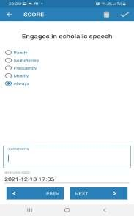
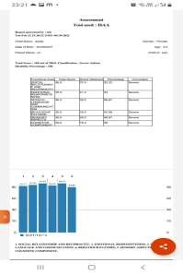
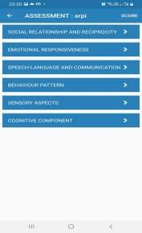
Report screen
Speech-language & communication

Domains for assessment

Fig 2. Screenshots of the ISAA app

    - Trials taken

- By using the app, the ISAA tool has diagnosed about 152 children.
- Parents value the report the software generates because it allows them to identify their child's strengths and weaknesses in a methodical way.

Description of Educational Assessment tool App
    - Aim
- To enhance easiness, to improve accuracy & make it time efficient.
- To assist educators in creating individualised education programmes (IEPs) by helping them visualise and analyse periodic assessments.
    - Features of the application
- All activities irrespective of assessment tools like “Indian Portage guide” [5] developed by CBR network, “Behavioural assessment scales for Indian Children with mental retardation (Basic-MR)” [6], “FACP (Functional Assessment Checklist for Programming)[7] (Part A/B)” etc. are rated on a 6-point rating scale (0-5). The adjustments are made to keep the instruments consistent, track a child's development, and quantify qualitative data.
- The teacher must keep track of the student's performance level while observing their behaviour and activities. The analysis of the performance data will produce the learning pattern at regular intervals.

Benefits

- Domain-wise percentage shows the performance levels, their strengths, and their weaknesses. Also help to customize the Individualized Education Plan (IEP).

- The report incorporates graphical representation mentioning the comparison with previous assessment done (if any) (Refer Fig. 3)

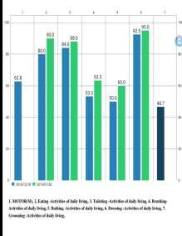
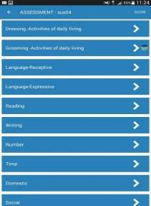
- Data collected from the application shall be analysed against different features & progress to be evaluated at regular interval.
Fig. 3 Screenshots of Assessment App

    - Trials taken
Through the app, 51 students were evaluated using Portage Guide, Basic MR (Part A), and FACP (Pre-Primary). The design iterations were prompted by the excellent feedback we got.

An Early Educational Intervention apps for age group of 2-6 years

    - Aim
- Ease the process of continuous monitoring
- Identify the Learning pattern
- Offer Parent Education

    - Features of the application

- Culture appropriate content and activities for each 3 major functional area ( Pre- academics skill, Self help skill, social skill )

- Pre academics functional area comprising of 4 sub domains viz. pre math skill, pre reading skill, pre writing skill and functional literacy skill.

- The pre math skill comprises of various age appropriate interactive activities for developing matching, grouping, classification, sequencing, pattern making, conservation idea of a child. ( Refer Fig 4)

- Pre reading skill includes sight word matching, identification of words, reading words, matching colors, fruits, picture reading.

- Pre-writing skill activities follow the conventional approach of writing such as scribbling, tracing, dot joining, copying, writing from memory.
- Functional literacy skill helps the child to learn the alphabets A-Z and numerals 1-10.
- To monitor the progress of a child performance metrics like completed learn units, throughput and pace are calculated.

    - Benefits
Performance data collected from the intervention app will lead to construct the learning pattern.
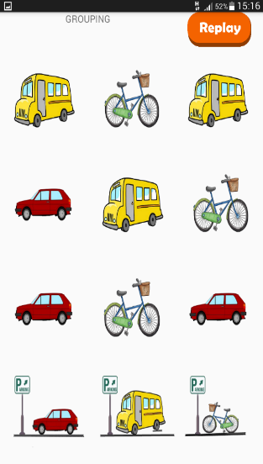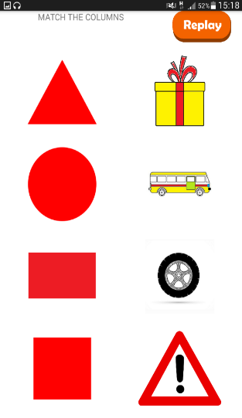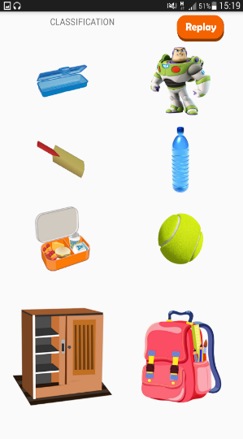
Pre Math skill- Conservation
Pre Math skill- Classification
Pre Math skill- Matching
Pre Math skill- Grouping

Fig. 4 Snap shots from early intervention app

- Software trials and outcome

The "Indian Scale for Assessment of Autism (ISAA)"-based autism screening tool application has evaluated about 152 students. With the use of the assessment application, 51 of them have received various forms of educational evaluations. With the use of an intervention app, instructors and psychologists may visualise and study the learning activities of their pupils . It is possible due to the comprehensive way of representation of performance data by utilising summarization, visualisation, and user-friendly interfaces. For early intervention, three software trials have been done with students with between the ages of 3 and 13. Among them 31 are male and 20 are female. Their learning trajectory is observed, and a learning progress profile is then created for each individual. In addition, a useful workshop was held to teach the parents how to prepare their children for pre-reading and pre-writing exercises. Mothers were eager to carry out the learning sessions at home after extensive demonstrations from the teachers.
From qualitative feedback collected from trained parents’ majority of whom were mothers and other women care giver, it is noteworthy to mention that the autism screening mobile app assisted them at the critical juncture of early diagnosis and educational intervention. Being in close contact with their children, mother’s observation may be considered as the best observation . Instead of being confused/panic they can monitor their child’s symptoms by using the app. The textual and graphical output may inform them about the degree of autism. The software also focuses on providing parents with a methodical way to identify their child's strengths and weaknesses.

Implications for rehabilitation

    - Due of its accessibility and user-friendliness, the mobile application is essential for usage as an educational intervention programme for autistic children.
    - In order to measure the performance characteristics and afterwards track and assess the student's progress, educators need a mobile application.
    - Overall, the goal of the research was to create an accessible app that would make it simpler and more affordable to educate children with autism and deal with their troublesome behaviour.

Acknowledgement

The instructors, the children (Pradip Centre for Autism Management) and their parents who voluntarily participated in this research study and made the research possible are all thanked on behalf of the authors.

References

- Women and girls | Right to Education Initiative (right-to-education.org)
- Disabled persons in India a statistical profile 2016, Social Statistics Division, Govt. of India, Retrieved from http://www.mospi.gov.in
- Teaching students with autism: resource guide for schools. Ministry of Education, British Columbia, 2000, pp 27–56
- Ministry of Social Justice and Empowerment, Government of India 2009, New Delhi. ISAA. Report on assessment tool for autism: Indian scale for assessment of autism. Untitled-1 (thenationaltrust.gov.in)
- Indumathi Rao (2010), Portage to Early Childhood Education, JAIISH, Vol. 29(1), 128- 130.
- Reeta P., Venkatesan S. (1992), Behavioural assessment scales for Indian Children with Mental Retardation (BASIC-MR), Retrieved from http://www.niepid.nic.in/Behavioural assessment scales for Indian children-basic- mr.pdf
- Functional Assessment Checklist for Programming, Department of Special Education, National Institute for Mentally Handicapped, Secunderabad, Retrieved from http:// www.niepid.nic.in/facp.pdf

