Name of Author- Ajay Kumar Yadav (MBA)

RSMT UP College Varanasi (AKTU Lucknow)

Ex- Faculty Jeevandeep Group of Educational Institutions Badalalpur Varanasi Ex- DSR Castrol India Ltd Faridabad Haryana
Postal Address- SA 3/160 C3N Bhakti Nagar Colony Gate No. 2 LalpurPandeypur Varanasi. Pin Code- 221002
Mob No. 9565190110, 7084777303

Email- ajayk.yadav25@gmail.com

Role of Strategic Management for Building and Sustaining
Businesses in a Disruptive World

Conference Track- CORPORATE SOCIAL RESPONSIBILITY

TITLE OF THE PAPER - CORPORATE SOCIAL RESPONSIBILITY PRACTICES IN ASIA

ABSTRACT

Corporate Social Responsibility (CSR) has been attracting attention recently by the corporate world worldwide. The corporations discharge their CSR through social development in various ways in varying degree. However the practice of CSR has also attracted controversy and criticism. There are two opposing arguments namely (i) the corporations profit in manifold ways by spending on CSR projects; and (ii) CSR is criticized and opposed in that it makes the corporations deviate from their primary economic roles in doing business. This has given fillip to corporate CSR initiatives in a big way, which have, in many cases, gone beyond the requirements of the law. There have also been efforts, in tune with the global practice, to make CSR part of the corporate strategy and as a tool for attaining and sustaining competitive edge in the market place. The proposed paper will trace the evolution of CSR in India, Government initiatives to make CSR a part of corporate functioning in the country and the emerging trends in Indian business sector which look at CSR as a tool for competitive strategy.
The last half decade has witnessed a remarkable resurgence of attention among practitioners and scholars to understanding the ability of corporate social responsibility (CSR) to address environmental and social problems. While significant advances have been made, assessing the forms, types and impacts on intended objectives is impeded by the conflation of distinct phenomena, which has created misunderstandings about why firms support CSR, and the implications of this support, or lack thereof, for the potential effectiveness of innovative policy options. As a corrective, we offer seven categories that distinguish efforts promoting learning and stakeholder engagement from those requiring direct on-the-ground behavior changes. Better accounting for these differences is critical for promoting a research agenda that focuses on the evolutionary nature of CSR innovations including whether specific forms are likely to yield marginal or transformative results.
The field of Corporate Social Responsibility (CSR) has been developing exponentially over the past decade. There are endless contradictory views of the role of CSR in society and discrepancies as to whether the various level of risk management should be interrelated with it. The International Journal of Corporate Social Responsibility (JCSR) offers a unique platform for the latest theoretical and empirical research and for innovative concepts for sustainable business strategies which create value for business and society (shared value). It contains best practices, literature reviews and leading foresight thinking in the field of business and society. It makes latest innovative management approaches accessible to academics from various disciplines, business leaders and interested research students alike. JCSR aims to bridge gaps from various perspectives on sustainability challenges (financial crises, climate change, demographics, business disruptions etc.) from all over the world and contributes to a broad trans-disciplinary and intercultural discussion on the role of business in society. In addition, its goal is to develop sound academic concepts as well as empirical data with the idea of creating value for business and society at the same time. It aims to become the leading platform for the latest management thinkers by providing articles not published before and approved by an international scientific community. The purpose of this empirical study is to undertake a comparative analysis of the South Asian and Western food companies based on their corporate social responsibility (CSR) adoption and impact on firm performance. We conducted a survey of 24 South Asian and 20 Western companies. Later, we performed independent samples t-tests and ordinary least squares (OLS) regression. Furthermore, we applied Kingdon’s agenda and green consumer theories to explain how CSR in Western food companies could be advanced than the food companies in South Asia. Based on the aforementioned tests, the Western food companies obtained better scores than their counterparts in South Asia. Traditional economic system has brought important negative implications regarding environmental development, as well as an unequal distribution of wealth, which has led to ecological disasters and population imbalances. Considering the existence of unequal opportunities and access to resources in a global economy, it would be relevant to study the interrelations between the concepts of Sustainability and Corporate Social Responsibility (CSR). The country with the most publications and citations is the United States, and the most productive institution is Universidad de Salamanca. Future lines of research should focus on the social dimension and its possibilities in the field of Circular Economy.
Keywords: Corporate Social Responsibility, Firms Objectives, Companies Act 2013, Corporate Social Responsibility, Board’s Responsibility in CSR implementation, CSR Committee, CSR Impact, Codes of conduct, environmental management, partnerships.
FULL PAPER CONTENT

Introduction

Corporate social responsibility, or CSR, refers to the belief that businesses have an obligation to society beyond their commitments to their stockholders or investors. In addition to generating profits, companies are expected to have some responsibility to stakeholders such as employees, customers, communities, and the environment. CSR includes corporations being economically responsible, improving labor practices, embracing fair trade, mitigating environmental damage, giving back to the community, and increasing employee satisfaction.
This guide provides an overview of CSR. It is not intended to be comprehensive; rather, the goal of this guide is to provide credible starting points for research, and to assist in further study of this topic.
American President Calvin Coolidge said in the 1920s that “the chief business of the American people is business.” It was a popular observation in a time of economic prosperity, when issues such as energy security and climate change were practically nonexistent.
Almost a century later, things are very different. Now, more than ever, private enterprise is being called upon to exercise social responsibility, especially when it comes to the environment. This trend reflects the view that companies ought to do more than simply meet the letter of the law and the bare minimum of ethical business behavior. Today we discuss the idea of “corporate social responsibility.”
President Coolidge, like many American presidents before and since, kept government out of the affairs of business as much as possible. But starting in the 1960s and 1970s, the environmental impact of an ever-expanding economy was generating more and more protest from citizens. The result was a wave of legislation designed to reduce the pollution produced by business activity. Those laws had positive effects and are now vital parts of the American regulatory framework. But despite these regulations, controlling pollution continues to be a challenge. And now there are even larger problems on the horizon.
Starting a few years ago, many citizens in the U.S. and around the world began calls for more action from private enterprise on these social issues—beyond compliance with regulations and traditional charity-related work. The result was a new movement known as corporate social responsibility, or CSR.

CSR Defined
Corporate social responsibility (CSR) can be simply and broadly defined as the ethical role of the corporation in society. The aim of CSR is to increase long-term profits and shareholder trust through positive public relations and high ethical standards to reduce business and legal risk by taking responsibility for corporate actions. It isn’t enough for companies to generate a profit and merely meet the letter of the law in their business operations.
CSR strategies encourage the company to make a positive impact on the environment and stakeholders—that is, all of the parties who have a stake in the performance and output of the corporation. Stakeholders include the company’s employees, unions, investors, suppliers, consumers, local and national governments, and communities that may be affected by corporate activities such as construction, manufacturing, and pollution. For some companies, CSR means manufacturing their products in a way that doesn’t harm the environment and protects the consumer from potentially hazardous materials. One such company that has staked it reputation on ethical manufacturing is LUSH Cosmetics.
Corporate social responsibility (CSR) is also often referred to as business responsibility and an organisation's action on environmental, ethical, social and economic issues. The terms in the area can seem confusing if you don't know the jargon - but don't be put off by this.

THEORETICAL GROUNDING AND LITERATURE REVIEW

A researcher starts his research by reading & exploring the problem of his research for which it is important for him to be aware & familiar with both previous theories and researches published in the previous investigation & studies. So, in order to assure its familiarity, they have to maintain the accumulated and recorded previous information. Every research requires the review of related literature for identifying the smooth contours for finding the correct direction of conducting the research. The term literature review is combining the two words: Review and Literature. Research, review means synthesis of the available knowledge of specific area & literature refers to the knowledge & information about the concepts, definition, and theories used in the concerned field of investigation. The review of literature helps a researcher to know the facts & evidences available to solve the research problem. Review of literature is also helps in framing hypothesis, data sources & appropriate statistical techniques to solve the problem further, the review provides to analyze the gaps, defining the objectives, formulating hypothesis, analysis & interpretations. In context of researcher the depth and breadth of the review emphasizes the credibility of the author (s) in the concerned field & for the professionals these are useful reports to keep them up date with their field. In a nutshell, with the help of literature review, researcher can identify, appropriate methodology, suitable research design, methods of measuring the variables, techniques of analysis and performing various field observations to illuminate the darkness in the area of his research.
The current belief that corporations have a responsibility towards society is not new. In fact, it is possible to trace the business’ concern for society several centuries back (Carroll 2008). However, it was not until the 1930’s and 40’s when the role of executives and the social performance of corporations begun appearing in the literature (Carroll 1999) and authors begun discussing what were the specific social responsibilities of companies. In the following decades, the social expectations towards corporate behavior changed and so did the concept of Corporate Social Responsibility (CSR). The aim of this article is to find out which have been the main factors and/or events that have influenced the evolutionary process of CSR and how they have shaped the understanding of the concept. This will allow to recognize CSR as a concept that reflects the social expectations of each decade and be able to explore if it will remain relevant in the near future.
There are several theories that emerged to explain the reasons behind environmental reporting over the time. These are:
Operational Efficiency Theory
Operational Efficiency occurs when the right combination of people, process, and technology to boost the productivity and value of any business operation, while reducing cost of routine operations to a desired level. In the context of CSR, operational efficiencies can be achieved through managing impending risks and liabilities more effectively and efficiently through CSR tools and perspectives by reducing costs; streaming information to stakeholders concerning the investment community for better transparency and by using corporate responsibility and sustainability approaches within business decision-making to result in new market opportunities, newly developed manufacturing processes that can be expanded to other plants, regions or markets as advocated by S. B. Banerjee (2007).
Social Contract Theory
The current practice of CSR by corporations was explained by O. O. Amao (2007) under the social contract theory. This theory dates from the classic period of history but took its modern form in the 16th and 18th centuries with best known philosophers like Thomas Hobbes, John Locke and Jean Jacques Rousseau who talk on social contract. Rousseau, in fact, conceptualised the individual-society relationship as a symbiotic situation whereby the two parties mutually confer some right to the state in order to maintain social order which makes human life and cohabitation better and to gain benefits of community and safety. In parallel to the social contract, the corporate social theory, pertaining to a firm’s indirect social obligations, is advanced where businesses are bound by the social contract to perform various socially desired actions in return for approval of their objectives and other rewards.
Legitimacy Theory
Similar to the social contract theory, the legacy theory was adopted by corporations to ensure that operations are within the limits and norms of their respective societies and the outside parties perceive their activities as being legitimate.
“Society grants legitimacy and power to business. In the long run, those who do not use power in a manner which society considers responsible will tend to lose it.” This principle developed by Davis (1973) is commonly known as the Iron Law of Responsibility. It expresses legitimacy as a societal-level concept and describes the responsibility of business as a social institution that must avoid abusing its power. Thus, this principle expresses a prohibition rather than an affirmative duty, and it applies equally to all companies, regardless of their particular circumstances.
According to A.K.H. Khor (2004), the legitimacy theory is fundamentally a system-oriented theory where organisations are viewed as components of the larger social environment within which they exist.
Stakeholder Theory
A key feature of CSR involves the way that a company engages, involves, and collaborates with its stakeholders including shareholders, employees, debt-holders, suppliers, customers, communities, non-governmental organisations, and governments. M. C. Branco and L. L. Rodrigues (2007) argued that companies need to use stakeholder engagement to internalise society’s needs, hopes, circumstances into their corporate views and decision-making. While there are many questions about how far a company’s responsibilities extend into communities relative to the roles of governments and individual citizens, there is a strong argument that CSR can effectively improve a company’s relations with communities and thereby produce some key features that will improve business prospects for its future.
Agency Theory
This theory comes to explain the relationship that exists between the owners/shareholders and the management. The latter is the agent appointed by the principal (owner/subsidiary). In such an agent-principal relationship, problems such as the potential moral hazard and conflict of interest are likely to occur. CSR comes as a middle way so that both parties can maximise their gains. As such, when CFP is strong, managers may reduce social expenditures in order to maximise their own short term private gains whereas when CFP weakens, managers will try to offset their disappointing results by engaging in conspicuous social programs, hence increasing their own wealth and that of shareholders as well, pursuant to the managerial opportunism hypothesis by Preston & O’Bannon (1997).
OBJECTIVE OF THE STUDY

The study is aimed to explore and elaborate upon the current deployment of strategic Corporate Social Responsibility (CSR), and sustainability in India. The study will examine how the companies in India view and conduct their CSR and sustainable business practices, identifying their correlation in creating a “shared value” or “value maximization” for various stakeholders, maps these against Global Reporting Initiative standards [ Most prominent reporting formats include Global Reporting Initiative standards and ISO 26000 standards]. The study will also evaluate how CSR and sustainability contributed shared value is leading to market competitiveness and performance for the companies.
Objectives:
- To explore whether the combination of Strategic Sustainability and Corporate Social Responsibility create “shared value” and a win-win situation for all.
- To find out the competitive benefits gained by the shared value creation by the Corporates.
- To examine the most prevalent CSR and sustainability reporting practices that is mostly used for communications in the target companies.
- To present a business case for adoption of effective Strategic Sustainability and Corporate Social Responsibility under the mandatory CSR laws under the companies act.
- To suggest measures to companies that can help them enhance their effienciency through shared value creation.
- To study the compliance of mandatory CSR norms under section 135 of companies act 2013 by the companies.
- To provide a neutral and credible platform to all stakeholders engaged in CSR best practices for capturing relevant issues to foster sustainable growth.
- To provide research, training, practice, capacity building, standard setting, advocacy, rating, monitoring, recognition and related support in the field of CSR.
- To facilitate exchange of experiences and ideas between various stakeholders for developing a framework for strengthening of CSR indicatives.
- To facilitate any other assistance directly or indirectly for activities which seek to promote CSR practices.
- To establish and deepen links with the organisations in various parts of the world which promote CSR practices for exchange of ideas and for collaborative actions and programmes.
- To collaborate and to support, directly or indirectly, the initiative of any individual, group, organisation or institution in promoting good practices in CSR.
- To establish a database of credible implementing outfits with whom the corporate entities as well as the donor organisations can collaborate and work.
- To create CSR fund with contribution of Government PSUs and private sector companies and channelize the CSR fund for optimum utilisation through a sustainable mechanism.
- To implement various CSR projects of state importance through credible implementing agencies in that area.
- To conduct activities relating to
  - Public health in general but preventive health care and sanitation in particular

RESEARCH METHODOLOGY
A. Data Collection Method-
Corporate Social Responsibility (CSR) reporting is becoming increasingly important for US and global firms who want to manage their long-term risks and develop new business opportunities.
A recent study revealed that three of the four biggest CSR reporting challenges for companies concern the data set used in CSR reports. According to the survey carried out earlier this year, more than 50 percent of respondents claimed that availability and accuracy of data are the top challenges they face, while close to half have difficulty obtaining external buy-in to disclose data.
Finally, less than 10 percent of respondents feel that the level of resources available during the reporting process is an issue. Data management processes are typically manual and are frequently time consuming and prone to error. The difficulties related to data gathering include, but are not limited to:
- Acquisition of needed information from suppliers and/or internal stakeholders
- Physical limitations of dispersed geographical operations
- Data quality and variability
- Roll-up of data
Given that a CSR report is generally signed by the CEO and illustrates the vision for the long-term viability of a company, these challenges pose a significant problem for companies. Accessing quality data whose source is verified and whose pertinence can be trusted is essential to these reports. Currently, the most common method of housing and tracking data from a variety of sources is by using spreadsheets.
Another recent study revealed that the patchwork of IT programs or legacy systems is the most significant barrier for companies who want to create integrated CSR reports. In addition, large IT solutions can also lead to problems of their own. On average, according to a 2012 study, large IT programs deliver 56 percent less value than expected while running 45 percent over budget and 7 percent behind schedule.
As CSR reporting becomes a critical business element, organizations will need to address these data challenges to better analyze and use their data. The CSR Reporting Solution is further enhanced with our Data Collection Solution, which addresses each of the challenges mentioned, so your company can efficiently and accurately share its vision for the future with its stakeholders.
Sampling Method-
Sampling Technique- A purposive sampling method has been used for data-collection.
Sample size- The sample consists of 105 industries of Haryana state and 118(with few extended plants of some industries) total no of respondents from the universe. The sample has been selected from the universe.The sample has been selected from the updated source list available from federation of Haryana industries, Data base of industries in Haryana from Industrial commissioner , Directories of Industries of various districks in Haryana and data available through the net.
A thorough knowledge in terms of understanding sampling and sampling techniques has been of paramount importance for CSR researchers before they aim to conduct field research using quantitative study. The current chapter discusses sampling and sampling techniques that are essential for designing a quantitative research method. After studying the chapter, readers are expected to understand the necessity of sampling, different types of sampling techniques, merits and demerits of different sampling methods such as probability and non-probability sampling, situations where one sampling method is preferable than another in the case of a CSR research project, the recent trends of sampling techniques and how to select a suitable sampling design in the CSR research.
Path Analysis and Hypothesis Testing
Hypotheses Thisstudy is going to achieve following objectives; a) To examine the casual relationship among CSR and financial performance. b) To assess the impact of CSR to the financial performance Based on the above objectives, followinghypothesis were developed Ha1: There is a relationship between company CSR activities to the Financial Performance. Hb1: There is an impact of company CSR activities to Financial Performance.
RQ1:Does the implementation of a CSR programme contribute in a meaningful way to the company?
H1:CSR practices and reputation has a positive impact on the economic value indicators of the company
RQ2:What pro-active environmental actions of CSR create value for the company?
H2: Ecological practices influences financial savings improve reputation.
RQ3:What social policies create value for the company?
H3:Good Human resorce policies influence an increase in sales &income per employee.
RQ4:Is there a positive cor-relation between the company’s investment in CSR and its value –added?
H4:The implementation of CSR policies influences the impact on the brand image of the company.
Measurement Scales
Corporate social responsibility (CSR) is one of the most prominent concepts in the literature and, in short, indicates the positive impacts of businesses on their stakeholders. Despite the growing body of literature on this concept, the measurement of CSR is still problematic. Although the literature provides several methods for measuring corporate social activities, almost all of them have some limitations. The purpose of this study is to provide an original, valid, and reliable measure of CSR reflecting the responsibilities of a business to various stakeholders. Based on a proposed conceptual framework of CSR, a scale was developed through a systematic scale development process. In the study, exploratory factor analysis was conducted to determine the underlying factorial structure of the scale. Data was collected from 269 business professionals working in Turkey. The results of the analysis provided a four-dimensional structure of CSR, including CSR to social and nonsocial stakeholders, employees, customers, and government.

Table, Graph and Figures
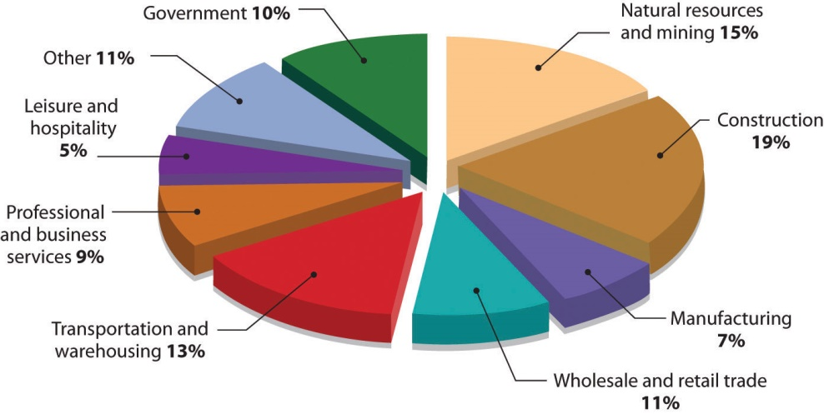

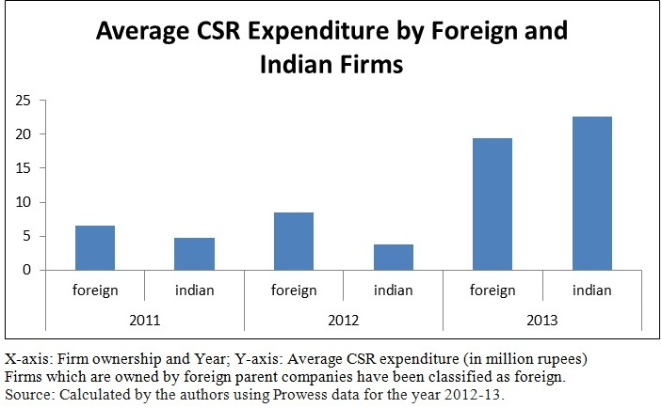

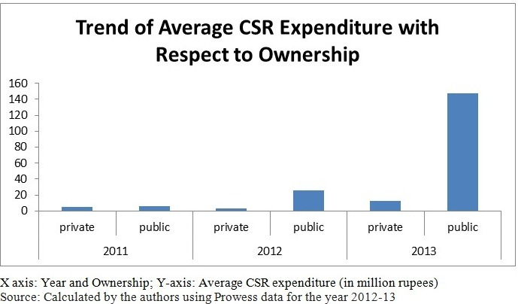

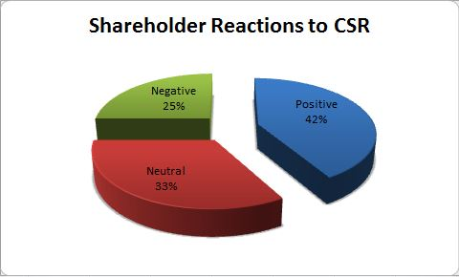

Demographic Profile of Respondents
Corporate Social Responsibility was an implicit duty of the company throughout the world. There was a rapid development in business. Likewise, company would like to maintain good images or reputations. In many cases, social responsibility was customer ecstasy. As a result, some companies were taking social responsibility to a new level of approach. This practice was attributed to increase revenue at the same time for social and environmental awareness. CSR might be the unusual approach in strategy. The company spent some sort of money to establish its reputation publicly or a call of responsibility. At any rate, this CSR had a positive impact to the internal and external environments of the company. Somewhat it creates customer loyalty and ecstasy. Business considered as a profit-oriented and/or service oriented. Thus, it was an opportunity to gain profit without giving up the responsibilities in environment as well as the society. A major challenge for business reached to face tough opportunities and decisions for CSR of the company. But organization concerned more on the profit and/or performing its role in the society and environment for general welfare. As of today, corporate social responsibility offered more opportunities to telecommunication companies in the Kingdom of Bahrain. Its technology addressed the needs of the society. The rapid changes and fast development of technologies connotes the advance modernization approach in which it gave another practices of CSR. The industry was aware of what was happening around the country. It was important to be a leader in the market and drive to corporate social responsibility as competitive advantage.
Discussion and Conclusion
The findings highlighted that the CSR activities are affected to the Financial Performance of listed financial companies. This study provides evidence that firms which spent on CSR have significance effect to the Financial Performance of companies. According to the results of this research, the independent variables of CSR (ENV, EMP and COM) are highly significant (p < 0.05). It implies that, CSR necessarily have a profit increasing or performance enhancing ability of financial companies. Empirical research did not find much evidence to support the impact of CSR on the market value of firms. But the significant relationship between CSR and firm performance in Sri Lanka is due to a number of reasons. Firstly, CSR activities were considered to be philanthropy by most firms because Sri Lanka has a long history of charitable giving, but only a few companies had a strategy or policy for CSR (International-Alert 2005) during the period studied. Secondly, it depended on how the firm communicates and reports their CSR practices in the media. Therefore, a lack of visibility of CSR may not have an impact on corporate reputation. Finally, it may not have been possible to prove the impact of CSR activities on market value, due to the volatile economic and political situation in Sri Lanka and the 2004 tsunami.
According to the correlation analysis all the variables of CSR (ENV, EMP, and COM) obtain positive correlation. Therefore those are highly correlated with the depending variable (ROA). Hence according to the findings ‘Ho’ is rejected and ‘H1’ is accept

Reference
[1] Carroll, A. (1991). The Pyramid of Corporate Social Responsibility and Firm Financial Performance.Academy of Management Journal.
[2] Clarkson, M. (1995). A Stakeholder frame work for analysing and evaluating Corporate Social Performance.
[3] Griffin, J., & Mahon, J. (1997). The Corporate Social Performance and Corporate Financial performances Debate.
[4] Hillman, A., &Keim, G. (2001). Share holder value, Stake holder Management and Social issues: What's the bottom line? Strategic Management Journal,22(2) , 125-139.
[5] Mitchell, R., Agle, B., & Wood, D. (1997). Toeard a Theory of stakeholder identification and salience.pp. 853- 886.
[6] Nelling, E., & Webb, E. (2009). Corporate Social Responsibility and Financial Performance: the "Virtue Circle" revisted. Review of Quantitative Finance and Accounting .
[7] Porter, M., & Kramer, M. (2006). Strategy & Society: The link between Competitive Advantage and Corporate Social responsibility. Harvard Business Review , pp. 80-90.
[8] Porter, M., & Van der Linde, C. (1995). Green and Competitive: Ending the Statement. Harvard Business Review 73(15) , pp. 120-134.
[9] Preston, L., & O'Bannon, D. (1997). The Corporate Social Financial Performance relationship.
[10] Ruf, M., Muralidhar, K., Brown, R., Janney, J., & Paul, K. (2001). An Empirical Investigation of the Relationship between change in Corporate Social Performance: A Stakeholder theory perspective. Journal of Business Ethics , 143-156.
[11] Simpson, G. W., &Kohers, T. (2002). The Link between Corporate Social and Financial Performance: evidence from banking industry. Journal of Business Ethics .
[12] Spicer, B. (1978). Investors' Corporate Social Performance and Information Disclosure. pp. 94-11.
[13] Vance, S. (1975). Are Socially Responsible corporations Good Investment Risks? pp. 18-24.
[14] Waddock, S., & Graves, S. (1997). Industry Performance and Investment in R&D and Capital Goods. Journal of High Technology Management Research , 1-17.
[15] Sharma N., 2013. Web-based Disclosures and Their Determinants: Evidence from Listed Commercial Banks in Nepal. Accounting and Finance Research, 2(3): 1-13.
[16] Sobhani F.A., Arman A., and Zainuddin Y., 2012. Sustainability Disclosure in Annual Repors and Websites: a Study of the Banking Industry in Bangladesh. Journal of Cleaner Production, 23: 75-83.
[17] Sweeney L., and Coughlan J., 2008. Do Different Industries Report Corporate Social Responsibility Differently? An Investigation Through the Lens of Stakeholder Theory. Journal of Marketing Communications, 14(2): 113-124.
[18] Uwuigbe U. and Egbidge B.C., 2012. Corporate Social Responsibility Disclosures in Nigeria: A Study of Listed Financial and Non-Financial Firms. Journal of Management and Sustainability, 2 (1): 160-169.
[19] Van Staden C.J. and Hooks J., 2007. A Comprehensive Comparison of Corporate Environmental Reporting and Responsiveness. The British Accounting Review, 39: 197-210.
[20] Wijesinghe K.N., 2012. Current Context of Disclosure of Corporate Social Responsibility in Sri Lanka. Procedia Economics and Finance, 2: 171-178.
[21] Wise V. and Ali M.M., 2009. Corporate Governance and Corporate Social Responsibility in Bangladesh with Special Reference to Commercial Banks. AIUB Bus Econ Working Paper Series, 2009-05: 1-19.

