DESIGN AND IMPLEMENTATION OF REALTIME MONITORING OF BRIDGE USNG MACHINE LEARNING
Nataraja N  Assistant Professor  Department of ECE  Atria Institute of Technology  Bangalore  nataraja.sp85@gmail.com | Dr.Satyasrikanth P  Associate Professor  Department of ECE  Atria Institute of Technology  Bangalore  satyarikanth123@yahoo.in | Dr.Dileep Reddy Bolla  Associate Professor  Department of CSE  Nitte Meenakshi Institute of TEchnology  Bangalore  dileep.bolla@gmail.com | Dr. Keshavamurthy  Professor  Department of ECE  Atria Institute of Technology  Bangalore  keshavamurthy_s@yahoo.com

INTRODUCTION
Bridges are vital components of transportation systems, facilitating safe passage for vehicles, pedestrians, and goods. However, they face numerous environmental and structural challenges, such as temperature fluctuations, heavy traffic, wind, and seismic events. Over time, these factors can lead to wear and tear, potentially causing structural damage that jeopardizes safety and escalates maintenance costs.
Traditionally, bridge inspection and maintenance relied on manual and visual assessments, which were often time-consuming, expensive, and not entirely reliable. Moreover, these methods might not identify structural changes until they reached a critical stage. To overcome these limitations, there has been a growing interest in the development of automated bridge monitoring systems using advanced technologies like sensors, data analytics, and machine learning. These systems continuously monitor bridge conditions, detect potential issues in real-time, and promptly alert maintenance teams, thereby reducing safety risks.
The objective of this project is to design and implement a real-time bridge monitoring system based on machine learning. The system comprises a network of sensors installed on the bridge, collecting continuous data on parameters like temperature, deformation, vibration, and movement. The collected data undergoes pre-processing to eliminate noise or anomalies and is then prepared for analysis using machine learning algorithms. These algorithms are trained on historical data to learn normal and abnormal patterns and characteristics of bridge behavior. Subsequently, the algorithms analyze real-time sensor data, detecting potential problems such as cracks, deformation, or excessive vibration.
Additionally, the system generates real-time alerts and notifications for maintenance personnel, enabling them to address issues before safety risks escalate. By adopting this approach, maintenance teams can implement corrective measures promptly, ensuring the bridge's safety and reliability. The project aims to offer an efficient, cost-effective, and reliable method for monitoring bridge structures using machine learning. It empowers bridge owners and operators to optimize maintenance schedules, minimize downtime, and mitigate the risk of catastrophic failure, ultimately enhancing transportation system safety and efficiency.
The problem this project tackles is the need for a more efficient and reliable bridge monitoring approach. Traditional inspection methods, like manual and visual assessments, often lack objectivity and depend on the inspector's expertise. Moreover, these methods are time-consuming, expensive, and do not provide real-time monitoring capabilities. Therefore, developing automated systems that can monitor bridges' structural condition in real-time, identify potential problems before they become safety hazards, and deliver early warnings and alerts to maintenance personnel is imperative. Hence, the project's goal is to design and develop a real-time bridge monitoring system utilizing machine learning algorithms. This system continuously monitors the bridge's structural condition, detects potential problems in real-time, and comprises hardware components (such as sensors) for data collection and software components for data analysis using machine learning algorithms.
To achieve this, the system collects data from sensors installed on the bridge, pre-processes it to ensure accuracy, and leverages machine learning algorithms for analysis. The collected data encompasses various parameters like temperature, deformation, vibration, and movement. After pre-processing to remove noise or outliers, the data is analyzed using machine learning algorithms specifically developed to identify potential structural issues.
By training these algorithms on a historical dataset, they can learn normal and abnormal patterns and characteristics of bridge behavior. Subsequently, the algorithms are employed to analyze real-time data collected by the sensors, identifying potential problems such as cracks, deformation, or excessive vibration.
The chapter involves implementing the real-time monitoring system on an actual bridge and evaluating its performance. The system is installed on the bridge, continually monitoring its structural condition. The system's effectiveness is assessed based on its ability to detect potential problems in real-time and provide early warnings and alerts to maintenance personnel. Furthermore, the system promptly notifies maintenance personnel when anomalies are detected. It generates real-time alerts and notifications to ensure that maintenance workers can implement corrective measures before safety risks escalate, guaranteeing the bridge's safety and reliability.
The deterioration of bridges presents a substantial risk to public safety and can lead to significant economic consequences. Traditional approaches to bridge monitoring, such as visual inspections and manual observations, suffer from subjectivity, labor-intensiveness, and the potential to overlook subtle or underlying defects that could result in catastrophic failures. Moreover, these methods lack real-time monitoring capabilities and early warning systems, leading to delays in maintenance or repairs.
To overcome these challenges, there is an urgent need to develop a more efficient and reliable method of bridge monitoring that leverages cutting-edge technologies, including sensors, data analytics, and machine learning algorithms. Such a system would enable continuous monitoring of bridges' structural health in real-time, detect potential issues before they escalate into safety hazards, and promptly alert maintenance personnel. By harnessing these advanced technologies, the system could enhance the safety and efficiency of bridge infrastructure, reduce maintenance costs, and enhance the overall reliability and performance of the transportation system.
Real-time monitoring systems using machine learning algorithms have emerged as a promising solution to enhance bridge safety. This essay explores the principles and techniques of real-time bridge monitoring using machine learning, along with the benefits it offers over traditional methods.
Sensor Selection and Implementation:
To monitor the structural behavior of bridges, appropriate sensors are crucial. Accelerometers, strain gauges, and temperature sensors are commonly employed for bridge monitoring. These sensors capture key parameters such as vibrations, deformation, and temperature variations, enabling the detection of potential structural issues. Proper sensor placement and calibration techniques are essential to ensure accurate and reliable data collection. Implementing these sensors on the bridge, following best practices, ensures comprehensive data acquisition.
Data Collection and Preprocessing:
Real-time monitoring systems continuously collect data from the installed sensors. However, this data often contains noise and outliers, which can impact analysis accuracy. Data preprocessing techniques, including cleaning, filtering, and normalization, are applied to remove anomalies and ensure data integrity. By preparing the data in an optimal state, subsequent analysis and machine learning algorithms can provide more reliable results.
Machine Learning Algorithms for Analysis:
Machine learning algorithms play a vital role in analyzing the collected sensor data and detecting potential structural issues in real-time. Supervised learning techniques, such as regression and classification, are employed to identify anomalies and deviations from expected behavior. Time-series analysis algorithms, such as Long Short-Term Memory (LSTM) and Convolutional Neural Networks (CNN), capture temporal patterns and enable predictions based on historical data. These algorithms leverage the power of machine learning to continuously monitor the bridge's condition and detect early signs of deterioration or damage.
Real-Time Monitoring System Implementation:
The development of a real-time monitoring system involves both software and hardware components. The software component includes the design and implementation of algorithms for data analysis, anomaly detection, and alert generation. It also encompasses the creation of user-friendly interfaces for visualization and monitoring. The hardware component involves the installation of sensors, data acquisition systems, and communication infrastructure to ensure seamless data transfer and processing.

Performance Evaluation and Alert System Development:
Testing and evaluating the real-time monitoring system's performance are critical to ensure its effectiveness and reliability. Metrics such as response time, accuracy, and false positive/negative rates are used to assess the system's performance. Furthermore, an alert system is developed to provide early warnings and notifications to maintenance personnel in case of abnormalities or potential structural issues. By integrating the alert system with the monitoring system, timely actions can be taken to mitigate risks and ensure the safety of the bridge.
Comparing with Traditional Methods and Documentation:
The real-time bridge monitoring system using machine learning algorithms offers several advantages over traditional methods. It provides continuous, automated monitoring, eliminating the limitations of manual inspections, which are periodic and time-consuming. Machine learning algorithms can analyze vast amounts of data and detect subtle changes or patterns that may go unnoticed by human inspectors. Additionally, comprehensive documentation, including technical specifications, operating procedures, and maintenance guidelines, ensures the system's proper implementation, operation, and maintenance.
Real-time bridge monitoring with machine learning algorithms presents a powerful solution for enhancing structural safety. By implementing appropriate sensors, collecting and preprocessing data, developing machine learning algorithms, and creating an alert system, bridges can be continuously monitored, potential issues detected in real-time, and early warnings provided to maintenance personnel. This approach surpasses traditional methods by providing more accurate and timely insights into the structural condition of bridges, ensuring public safety and enabling proactive maintenance. The ongoing advancements in machine learning techniques hold the promise of further improving the effectiveness of real-time bridge monitoring systems in the future.
The system you described is a wireless sensor network-based solution for monitoring the health of bridges. It aims to replace the existing wired network system, which is complicated and costly. This new system utilizes sensors placed on bridges to gather real-time data about their condition.
The data collected by the sensors is transmitted wirelessly to a common server, where it is stored for analysis. This server is connected to multiple bridges, allowing centralized monitoring of various bridge structures. The real-time data is continuously monitored, and if any sensor data exceeds a predetermined threshold, an alert signal is sent to the company head.
Upon receiving an alert, the company can assign an employee to service the bridge that requires attention. Additionally, the status of each bridge can be displayed on the server, allowing users to easily determine the condition of the bridge.
By implementing this wireless sensor network system, bridge health can be continuously monitored, allowing for early detection of potential issues or failures. This proactive approach can help prevent accidents and ensure the safety of people using the bridges.
It's worth noting that while this system can improve bridge monitoring and maintenance, it does not directly address the causes of bridge failures such as scour or flooding. Those issues need to be addressed through proper design, construction, and ongoing maintenance practices. However, the wireless sensor network system can provide valuable data for identifying and mitigating such risks.
In addition, the environmental impact of construction projects like buildings, dams, and bridges should be considered. These structures can indirectly affect the environment through factors such as land use, resource consumption, and alteration of natural habitats. It is important for engineers and planners to adopt sustainable practices to minimize the environmental impact of these projects.

RELATED WORK

The paper [1] presents a study on a data acquisition system designed for highway bridge health monitoring, leveraging Internet of Things (IoT) technology. The objective of this system is to gather and analyze various data types from sensors installed on bridges, including vibration, temperature, and humidity, to effectively monitor the structural health of the bridge and detect potential issues.It outlines the system architecture, which comprises three layers: the sensing layer, the network layer, and the application layer. In the sensing layer, a range of sensors such as accelerometers, strain gauges, and temperature sensors are connected to a microcontroller. The network layer incorporates a wireless communication module, enabling data transmission to a cloud-based platform via the Internet. The application layer provides a web-based interface for bridge engineers and maintenance personnel to access and analyze real-time data.
Throughout the paper, the authors address challenges encountered during the system's implementation, including power management, network coverage, and data security. They propose solutions to tackle these challenges, such as utilizing low-power sensors, optimizing network topology, and implementing encryption and authentication mechanisms. To validate the effectiveness of their proposed system, the authors present a prototype installed on a highway bridge. The system successfully collects and processes data from sensors, providing real-time monitoring and generating alerts when necessary. By employing this system, bridge engineers and maintenance personnel can promptly identify potential issues and take appropriate corrective actions, thus ensuring the safety and reliability of these critical infrastructures. The manuscript describes the design and implementation of a data acquisition system for highway bridge health monitoring, based on IoT technology. The system demonstrates its ability to collect, process, and analyze sensor data, facilitating real-time monitoring and proactive maintenance. This solution offers valuable insights for enhancing the safety and reliability of bridge structures.
The author in [2] presents the development of a remote structural health monitoring system for bridges using wireless sensor networks (WSN). The system utilizes various sensors, including temperature, humidity, and vibration sensors, strategically placed at different locations on the bridge to monitor its structural health. The collected data from these sensors are wirelessly transmitted to a central monitoring system, where they are stored and analyzed using algorithms to detect any abnormalities in the bridge's structural behavior.
To evaluate the system's performance, the authors conducted several experiments. The results demonstrate the system's capability to accurately detect changes in the structural health of the bridge, such as deformation and cracks. Furthermore, the system provides real-time monitoring and alerts. The authors emphasize that this remote monitoring system can assist bridge engineers and maintenance personnel in promptly identifying potential problems and initiating corrective actions to prevent disasters. The development of a remote structural health monitoring system for bridges, leveraging wireless sensor networks. The system incorporates various sensors to monitor temperature, humidity, and vibration, among other parameters. It wirelessly transmits data to a central monitoring system, enabling real-time analysis and detection of anomalies. The proposed system aims to enhance the efficiency of bridge maintenance, allowing for timely interventions to ensure the safety and longevity of these crucial infrastructure assets
The paper [3] introduces a novel machine-learning-based approach for automating the processing of modal analysis data to detect damage in bridges. Modal analysis is a technique used to identify a structure's natural frequencies and mode shapes, which provide valuable insights into its dynamic behavior and health.The authors propose a methodology that leverages machine learning algorithms to automatically process modal analysis data and extract relevant features for damage detection. The methodology encompasses various steps, including data acquisition, modal parameter estimation, feature extraction, and classification. Manuscript presents a machine-learning-based approach for automating the processing of modal analysis data in bridge damage detection. The methodology showcases promising results in accurately identifying and locating damage, even in challenging scenarios. By employing this methodology, bridge engineers and maintenance personnel can effectively monitor bridge health and take proactive measures to ensure the safety and dependability of these essential structures. Additionally, the methodology holds potential for broader applications in diverse structural contexts
The paper [4] explores the utilization of statistical machine learning algorithms for the classification of bridge deformation data sets. The focus is on analyzing data collected from sensors installed on bridges, which measure the deformation caused by external factors like vehicles and weather conditions. The proposed methodology involves preprocessing the data to eliminate noise and outliers, followed by the application of various machine learning algorithms to classify the data into distinct deformation categories.
The authors conduct a comparative analysis of different algorithms, including support vector machines, decision trees, and neural networks. They evaluate the performance of these algorithms in terms of accuracy, precision, and recall. Additionally, the authors investigate the impact of various parameters, such as the number of features, the size of the training set, and the threshold values utilized for classification. The paper presents a methodology for classifying bridge deformation data sets using statistical machine learning algorithms. The authors compare the performance of various algorithms and study the impact of different parameters. This research contributes to the advancement of bridge monitoring and maintenance practices by enhancing the classification accuracy of deformation data.
In the work [5] author presented a design that focused on cloud computing and data communication interface for enhancing bridge safety. The proposed system aimed to evaluate fundamental factors of a bridge utilizing Zigbee technology. However, one limitation of the design was the relatively slow communication speed associated with Zigbee technology. The authors recognized the importance of cloud computing and data communication in ensuring bridge safety. They proposed the utilization of Zigbee technology to monitor and assess essential factors related to the bridge's structural integrity. Zigbee is a wireless communication technology commonly used for low-power, low-data-rate applications. Despite the potential benefits offered by Zigbee technology, one drawback highlighted in the paper was its relatively slow communication speed. This limitation could impact the real-time monitoring and assessment capabilities of the system. It's important to note that this limitation may have implications for the system's ability to provide timely alerts or responses to critical bridge conditions. However, the paper does not elaborate on specific alternatives or potential solutions to address the slow communication speed of Zigbee technology in this context. The proposed design aimed to improve bridge safety through cloud computing and data communication, the identified drawback of slow communication speed associated with Zigbee technology should be considered for the system's effectiveness and real-time monitoring capabilities.
In their design proposal [6], introduced a system to detect cracks in bridges using IoT technology. The primary objective of the system was to identify cracks in the bridge structure and send relevant information to a server for further analysis and action. The detection of cracks was achieved through the utilization of flex sensors. The system operates by placing flex sensors at strategic points on the bridge. These sensors are designed to measure the degree of flexion or deformation in the bridge structure. If the sensor readings surpass a predetermined threshold, it indicates the presence of a crack. Once a crack is detected, the system triggers a response mechanism, such as sending an alert to the server. This information can then be relayed to relevant authorities or individuals, enabling them to take appropriate action. For instance, people approaching the bridge can be notified to halt their vehicles until necessary repairs or inspections have been conducted. The proposed design addresses the critical issue of crack detection in bridges and aims to enhance safety by providing real-time information about potential hazards. By leveraging IoT technology and flex sensors, the system offers a proactive approach to minimize risks associated with bridge deterioration. It is important to note that while the design proposes a mechanism for crack detection and alerts, it does not specify the remedial actions or repair processes that would follow the detection. However, the system's ability to notify people and prompt them to stop their vehicles contributes to ensuring public safety until appropriate measures can be taken to address the identified cracks.
In their paper [7], author proposed a three-level structure for monitoring bridges. The structure consists of a local controller, a central server, and an intelligent acquisition mode. The authors focused on verifying the water level parameter using a water level sensor as part of their design. The proposed monitoring system comprises three key components. Firstly, a local controller is responsible for collecting data from various sensors installed on the bridge, including the water level sensor. This controller serves as a local processing unit for initial data analysis and validation. Secondly, a central server acts as the main hub for data storage and analysis. The data collected by the local controller is transmitted to the central server for further processing and storage. Here, more advanced analysis techniques can be applied to the data to extract meaningful insights and identify patterns or anomalies related to the bridge's water level. Lastly, an intelligent acquisition mode enhances the system's capabilities by incorporating intelligent algorithms or decision-making processes. This mode may involve employing machine learning techniques or rule-based systems to provide more sophisticated analysis and interpretation of the water level data. By focusing on the water level parameter, the authors address an important aspect of bridge monitoring. Water levels can impact the structural integrity and safety of bridges, making it crucial to continuously monitor and analyze this parameter. It's important to note that the paper does not elaborate on the specific implementation details of the proposed three-level structure or provide further insights into the data analysis techniques utilized. However, the design presented offers a framework for bridge monitoring with a particular emphasis on verifying the water level parameter using dedicated sensors and a multi-level system architecture.
In the design work [8], researchers introduced a system for monitoring cracks, beams, and bends on railway tracks. The design incorporated the use of IoT technology to facilitate communication over a large distance, enabling data transmission from a local controller to a central server. The primary objective of the system was to monitor the condition of railway tracks and detect any cracks, beams, or bends that could pose safety risks. IoT technology was leveraged to establish connectivity between the local controller, which is responsible for data collection and initial analysis, and the central server, where the collected data is transmitted and stored. By implementing IoT-based communication, the system allowed for real-time or near-real-time transmission of monitoring data over a considerable distance. This enabled railway authorities or maintenance personnel to receive timely information about the condition of the tracks, facilitating appropriate actions to address any identified issues. The design proposal focused specifically on the monitoring of cracks, beams, and bends on railway tracks, highlighting the significance of regular inspection and maintenance to ensure safe and reliable rail transportation. It is important to note that the paper does not delve into specific implementation details or the intricacies of data analysis techniques employed in the system. Nonetheless, the proposed design provides a framework for utilizing IoT technology to enhance monitoring capabilities and facilitate efficient communication between a local controller and a central server for railway track condition monitoring.
In their research paper [9], the researchers proposed a design for monitoring bridges, which involved monitoring various parameters such as water level, air quality, and pipelines. Additionally, the design included the continuous capture of images of the bridge, which were then transmitted to a server for analysis. The proposed monitoring system aimed to assess multiple aspects of bridge health and safety. Monitoring water levels is crucial as it helps detect potential flood risks or scouring effects on bridge foundations. Air quality monitoring can provide insights into the environmental conditions surrounding the bridge, including pollution levels that may affect its structural integrity. The monitoring of pipelines helps identify any leaks or damages that could impact the bridge's stability or functionality. Furthermore, capturing continuous images of the bridge serves as a visual monitoring technique. These images are transmitted to a server where they undergo analysis. Image analysis techniques can be applied to identify any visible signs of deterioration, structural damage, or anomalies that may require further inspection or maintenance. While the research paper mentions the proposed design for monitoring bridges and the collection of various data parameters, it does not provide specific details regarding the implementation, such as the sensors or imaging technologies used. Additionally, the analysis methods applied to the collected data are not elaborated upon. Nonetheless, the design presents a holistic approach to bridge monitoring by considering multiple factors such as water levels, air quality, pipelines, and visual inspections. This integrated monitoring system can help bridge engineers and maintenance personnel make informed decisions regarding maintenance and repair activities, thereby ensuring the structural integrity and safety of the bridges.
In the manuscript [10], the author proposed a design that utilizes two wireless sensors to gather information about the bridge structure. The sensors employed in this design are ultrasonic sensors and accelerometer sensors. These sensors play a critical role in collecting data related to the bridge's condition and behavior. The ultrasonic sensors are responsible for measuring distances by emitting ultrasonic waves and analyzing the reflected signals. They can provide valuable insights into parameters such as bridge deflection, displacement, or deformation. On the other hand, the accelerometer sensors are designed to measure the acceleration forces acting on the bridge. This information can be utilized to evaluate the bridge's dynamic behavior, including vibrations, oscillations, or other dynamic forces acting on the structure. Once the data is collected by the sensors, it is wirelessly transmitted to a central station or central monitoring system. The central station serves as a hub for receiving and processing the sensor data. The collected data can be further analyzed and used to assess the structural health, performance, and safety of the bridge. While the paper outlines the design utilizing ultrasonic and accelerometer sensors for data collection and transmission to a central station, it does not elaborate on the specific implementation details or the analysis methods employed at the central station. Overall, the proposed design offers a wireless sensor-based approach to bridge monitoring, utilizing ultrasonic and accelerometer sensors to gather essential data about the bridge structure. This enables centralized data collection and analysis, facilitating a better understanding of the bridge's behavior and enabling appropriate maintenance and management decisions.
In their proposed system [11], author focused on monitoring bridges by incorporating sensors to measure wind speed, vibration, and temperature. The system aimed to generate an alert whenever the sensor readings exceeded a predefined threshold. The design included the deployment of sensors capable of measuring wind speed, which is crucial for assessing the impact of wind forces on bridge structures. Vibration sensors were also utilized to monitor the dynamic behavior of the bridge and detect any excessive vibrations that could indicate structural issues. Additionally, temperature sensors were employed to monitor temperature variations, which can affect the material properties of the bridge. Once the sensors collected data on wind speed, vibration, and temperature, the system analyzed the readings. If any of the sensor readings exceeded a predetermined threshold, an alert was generated. This alert could be transmitted to relevant personnel or a centralized monitoring system, allowing prompt attention to potential issues. While the paper highlights the system's purpose of monitoring bridges and the specific sensor measurements involved, it does not delve into the technical details of the sensor deployment or the specific threshold values set for generating alerts. Overall, the proposed system offers a comprehensive approach to bridge monitoring by utilizing sensors to measure wind speed, vibration, and temperature. By setting thresholds and generating alerts, the system enables proactive monitoring, enabling timely intervention and maintenance actions to ensure the safety and reliability.
In their proposed system [12], author introduced a design for measuring weight and water level in a specific context. The system incorporates a WiFi module for transmitting the collected data wirelessly. To indicate alertness, the design utilizes an auto barrier and a buzzer. The primary objective of the system is to measure weight and water level, both of which are crucial parameters in certain applications or scenarios. The weight measurement component allows for monitoring load variations or changes, providing insights into the load-bearing capacity of a structure or a specific area. The water level measurement feature enables monitoring and managing water levels in tanks, reservoirs, or other water-related environments. The collected data from the weight and water level sensors is transmitted using a WiFi module, which enables wireless communication and data transfer to a central monitoring system or a user interface. In terms of alertness, the design incorporates an auto barrier and a buzzer. These elements serve as indicators or warning mechanisms that can be triggered based on predefined conditions or thresholds. For example, if the weight or water level exceeds a certain limit, the auto barrier may activate to restrict access or signal potential risks. Simultaneously, the buzzer can provide an audible alert to draw attention to the situation. While the paper introduces the proposed system for measuring weight and water level and mentions the utilization of a WiFi module for data transmission, it does not provide specific details about the implementation of the auto barrier or the integration of the buzzer into the system. Overall, the proposed system offers a solution for measuring weight and water level, utilizing WiFi communication for data transmission. The inclusion of an auto barrier and a buzzer enhances the system's alertness features, facilitating timely responses or actions based on the collected data.

METHODOLOGY

A real-time bridge monitoring system is a crucial component in maintaining the safety and integrity of bridges. In this proposed system, various sensors and components are used to monitor different aspects of the bridge's condition. The system includes a vibration sensor to detect excessive movement or shaking, an IR sensor to identify cracks or damage, two ultrasonic sensors - one for measuring water level and the other for detecting approaching ships, a load cell to measure the weight of the bridge, a flex sensor to monitor deformation or bending, a buzzer for audible alerts, and a Wiper motor with a relay to control the bridge's lifting mechanism as shown in Fig 1.
The first step in implementing this system is to install the sensors and components on the bridge. The vibration sensor is typically placed on the bridge's superstructure to detect any abnormal movement. The IR sensor is positioned on the bridge's surface to identify cracks or other damage. Ultrasonic sensors are mounted on the sides of the bridge, one to measure water level and the other to detect approaching ships. The load cell is installed on the lifting mechanism to measure the bridge's weight. The flex sensor is placed on the underside of the bridge to monitor deformation. The buzzer is strategically positioned to provide audible alerts in case of emergencies. Finally, the Wiper motor and relay are integrated into the lifting mechanism to control the bridge's movement.

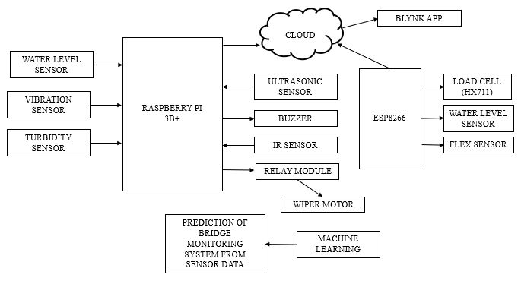
Figure 1: Proposed Methodology
Once the sensors and components are in place, the system starts collecting real-time data. The vibration sensor records any movement or shaking, which is then analyzed to determine if it falls within acceptable limits. The IR sensor detects cracks or damage, and the data is assessed to identify the need for repairs. The ultrasonic sensor measuring water level alerts personnel to rising water levels that may lead to flooding. The ultrasonic sensor detecting approaching ships sends a signal to the control system to initiate the lifting mechanism, allowing ships to pass. The load cell measures the bridge's weight, ensuring it remains within the maximum weight capacity. The flex sensor monitors any deformation, triggering alerts if safe limits are exceeded.
The collected data is analyzed to predict the bridge's condition. Machine learning algorithms can be employed to identify patterns in the data that indicate potential issues. If the vibration sensor detects excessive movement, an alert or alarm is triggered, prompting inspections or repairs. Similarly, cracks detected by the IR sensor beyond a certain size may trigger an alarm for repairs. The load cell data helps predict the bridge's maximum weight capacity, while the flex sensor data predicts the maximum deformation limits. The ultrasonic sensors can also be used to predict traffic patterns on the bridge.
To ensure timely action, the system generates alerts when sensor values exceed threshold levels. Alerts are sent to relevant personnel through messaging systems or alert systems. These alerts contain details about the exceeded threshold, severity of the issue, and recommended actions.
Additionally, the system stores and analyzes historical data for trend analysis. Historical data helps identify patterns and root causes of issues, enabling proactive maintenance and prevention of future problems. By analyzing historical data, maintenance personnel can identify trends, forecast future behavior, and take preventive actions.
The system also offers a user-friendly interface for monitoring and analyzing data. Maintenance personnel can access the interface to make informed decisions and track the bridge's condition. The proposed real-time bridge monitoring system includes a range of sensors and components to monitor various aspects of the bridge's condition. Data analysis and machine learning algorithms aid in predicting the bridge's health and generating alerts when necessary. Historical data helps identify trends and root causes of issues. The system promotes safety, reduces repair costs, and minimizes the risk of accidents.

IMPLEMENTATION

Raspberry Pi 3 Model B+
The Raspberry Pi 3 Model B+ is a highly versatile and popular single-board computer that was released in March 2018. It serves as the third generation of the Raspberry Pi family, known for its affordability, ease of use, and versatility as shown in Fig 2.
The Raspberry Pi 3 Model B+ is equipped with a 1.4GHz 64-bit quad-core ARM Cortex-A53 CPU, making it faster than its predecessor. With 1GB of RAM, it offers sufficient memory for most applications. It also features built-in Bluetooth 4.2 and dual-band 802.11ac wireless LAN, enhancing its connectivity options.
An outstanding improvement of the Raspberry Pi 3 Model B+ lies in its networking capabilities. It incorporates a Gigabit Ethernet port, providing faster Ethernet connectivity compared to the previous model. Additionally, the dual-band wireless LAN enables faster data transfer rates.
The single-board computer is furnished with a microSD card slot for storage, four USB 2.0 ports, and a full-size HDMI port, facilitating connections to various peripherals. Its 40-pin GPIO header allows for seamless interfacing with sensors, displays, and other electronics.
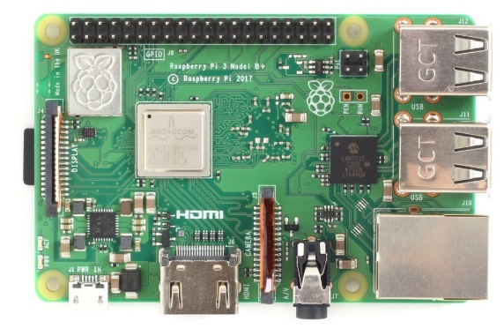
Figure 2: Raspberry Pi 3
The Raspberry Pi 3 Model B+ is commonly employed as a media center, enabling users to stream music and video, play games, and serve as a home theater PC. To facilitate media center applications, the Raspberry Pi Foundation offers a pre-built operating system called OSMC, tailored specifically for use with the Raspberry Pi.
Another popular application of the Raspberry Pi 3 Model B+ is retro gaming, where it can run emulators for classic gaming consoles such as the NES, SNES, and Sega Genesis. The Raspberry Pi Foundation provides a dedicated pre-built operating system called RetroPie, which includes a range of emulators and a user-friendly interface for easy navigation.
Hobbyists and DIY enthusiasts also favor the Raspberry Pi 3 Model B+ due to its GPIO header, allowing for seamless integration with a wide array of sensors and electronics. This makes it an ideal choice for robotics projects, home automation systems, and other DIY endeavors.
The Raspberry Pi 3 Model B+ is an affordable and adaptable single-board computer suitable for a range of applications. Its improved networking capabilities, faster CPU, and expanded GPIO header make it a popular choice among hobbyists and DIY enthusiasts. Whether used for learning coding, electronics projects, or recreational activities like media centers and retro gaming, the Raspberry Pi 3 Model B+ is a versatile and valuable option. Here are some key features of the Raspberry Pi 3 Model B+: Processor: It is powered by a 1.4 GHz 64-bit quad-core ARM Cortex-A53 processor, which provides a significant performance boost over its predecessors.
RAM: It comes with 1 GB of LPDDR2 SDRAM, which allows for smooth multitasking and running various applications.
Connectivity: The Raspberry Pi 3 Model B+ has built-in Wi-Fi 802.11ac and Bluetooth 4.2/BLE, enabling wireless connectivity for internet access, remote control, and communication with other devices.
Ethernet: It has a Gigabit Ethernet port, providing fast wired networking capabilities.
USB ports: There are four USB 2.0 ports available for connecting peripherals such as keyboards, mice, external storage devices, and other USB-powered devices.
GPIO pins: The Raspberry Pi 3 Model B+ has a 40-pin GPIO header, which allows for interfacing with a wide range of external components and sensors.
Video and Audio: It features a full-size HDMI port for connecting to displays, a combined 3.5mm audio jack for audio output and microphone input, and a CSI camera port for connecting a Raspberry Pi Camera Module.
Storage: It uses a microSD card slot for storage, allowing you to use an SD card as the primary storage medium.
Operating system: The Raspberry Pi 3 Model B+ supports various operating systems, including the official Raspberry Pi OS (formerly called Raspbian), as well as third-party operating systems like Ubuntu, Kali Linux, and others.
Power: It requires a 5V micro USB power supply for operation.
The Raspberry Pi 3 Model B+ is widely used for various applications, including home automation, robotics, IoT projects, media centers, retro gaming consoles, and learning programming and electronics.
ESP 8266
The ESP8266 has emerged as a leading microcontroller for IoT projects due to its low cost, Wi-Fi capability, and adaptability. Introduced by Espressif Systems in 2014, it has gained popularity for its user-friendly nature and versatile functionality.
A key advantage of the ESP8266 is its integrated Wi-Fi module, which enables seamless connectivity to Wi-Fi networks, facilitating remote control and monitoring of IoT devices. Its cost-effectiveness, compact size, and energy efficiency make it an ideal choice for IoT applications.

‘

Figure 3: ESP 8266
Powered by the Xtensa LX106 processor, a 32-bit RISC processor with a clock speed of up to 80 MHz, the ESP8266 also features 80KB of RAM and 4MB of flash memory, allowing for efficient storage of code and data.
Programming the ESP8266 is flexible, with support for various languages such as C++, Lua, and Micro Python. The Arduino IDE is particularly popular for programming the ESP8266, catering to both novices and experienced developers.
The ESP8266 finds utility across a wide range of projects, including home automation, sensor monitoring, and data logging. Moreover, it can serve as the foundation for Wi-Fi-enabled devices like smart thermostats, door locks, and security cameras.
One notable feature of the ESP8266 is its capability to function as a web server, hosting web pages accessible by any device on the network. This grants users the ability to control the ESP8266 and connected devices via web browsers or mobile apps.
Furthermore, the ESP8266 supports MQTT, a lightweight messaging protocol for IoT devices. This facilitates efficient communication and interaction with other devices and services.
In summary, the ESP8266 is an affordable, Wi-Fi-enabled microcontroller that has gained prominence in the realm of IoT projects. Its built-in Wi-Fi module, economical power consumption, and compatibility with multiple programming languages make it an excellent choice for diverse applications. With its capacity to act as a web server and support for MQTT, the ESP8266 provides ample scope for creating connected devices and establishing a connected home.
Ultrasonic sensor
Ultrasonic sensors as shown in Fig 4 are advanced devices that utilize sound waves to gauge the separation between objects. This technology finds widespread application in areas like robotics, automation, and security systems. By emitting high-frequency sound waves and analyzing the time it takes for these waves to rebound from an object, ultrasonic sensors achieve a process akin to echolocation, which bats employ for navigation.
Typically composed of a transducer and a receiver, ultrasonic sensors operate as follows: the transducer, often a piezoelectric crystal, generates sound waves when subjected to electrical currents of high frequency. The receiver, also a piezoelectric crystal, transforms the echoes of the sound waves into electrical signals.
Operating at frequencies outside the human auditory range (usually between 20 kHz and 40 kHz), ultrasonic sensors emit sound waves that bounce off objects and return to the receiver. By calculating the time it takes for the sound waves to travel to the object and back, the sensor determines the object's distance.
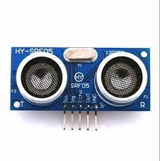
Figure 4: Ultrasonic Sensor
Ultrasonic sensors offer numerous advantages over alternative sensor types. Their non-contact nature makes them well-suited for environments that are dirty or dangerous, as they can measure objects without physical contact. Additionally, these sensors exhibit remarkable precision and accuracy in detecting objects. Ultrasonic sensors have versatile applications, such as measuring distances, detecting object presence, and monitoring liquid levels.
Parking sensors for cars represent a common application of ultrasonic sensors. They enable the detection of distances between vehicles and obstacles like walls, alerting the driver through visual or audible cues when they approach too closely. Robotics benefit from ultrasonic sensors for obstacle detection and avoidance. By identifying objects in the robot's path, these sensors facilitate adjustments to the robot's trajectory.
Ultrasonic sensors also find application in liquid level measurement. By emitting sound waves that bounce off the liquid surface and are detected by the receiver, these sensors determine the distance to the liquid surface, providing a reliable reading of the liquid level. However, ultrasonic sensors possess certain limitations. Temperature and humidity variations can affect measurement accuracy. Additionally, materials such as foam or porous surfaces can absorb sound waves, diminishing the sensor's range.
To summarize, ultrasonic sensors represent a versatile and extensively used sensor technology that employs sound waves to measure distances between objects. Their numerous advantages, including non-contact measurement and high accuracy, make them invaluable in various fields such as robotics, automation, and security systems. Nonetheless, they are susceptible to temperature and humidity variations and can be influenced by certain materials.
Load cell
A load cell shown in Fig 5 serves as a transducer, converting mechanical force or weight into an electrical signal. It finds wide application in diverse industrial settings for measuring force, weight, and pressure accurately. Typically, a load cell consists of a metallic body with one or more strain gauges attached to it. These strain gauges are electrical devices that alter their electrical resistance in proportion to the applied strain. When a load is exerted on the load cell, the strain gauge(s) connected to the metal body undergo deformation, causing a change in their resistance. This change is then converted into an electrical signal that can be measured and analyzed.
Different types of load cells are available, including hydraulic, pneumatic, and strain gauge load cells. Hydraulic and pneumatic load cells utilize fluid pressure to measure the applied force, whereas strain gauge load cells rely on the variation in resistance of the strain gauge to measure the force.
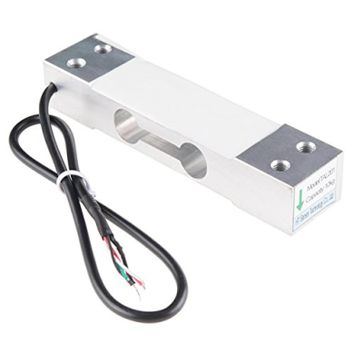
Figure 5: Load Cell
The accuracy and precision of a load cell depend on various factors, such as its type, design, material composition, strain gauge sensitivity, and calibration method. Load cells can be calibrated using a calibration weight or by applying known loads and comparing the obtained readings.
Load cells have extensive applications across various industries, including automotive, aerospace, construction, medical, and food processing. They are commonly employed for force and weight measurement in industrial scales, process control systems, material testing machines, and medical equipment like patient weighing scales.
Certain load cells are specifically designed for particular applications, such as high-temperature load cells for extreme heat conditions or low-profile load cells for limited-space applications. Load cells can also be customized according to specific requirements, such as size, shape, capacity, and output signal. To summarize, load cells function as transducers, converting mechanical force or weight into an electrical signal. They are widely utilized in industrial settings for precise force and weight measurements. Load cells are available in different types, designs, and capacities, and they can be customized to meet specific needs. Accurate and meticulous calibration is crucial to ensure measurement precision with load cells.
IR sensor
An infrared (IR) sensor shown in Fig 6 is a device capable of detecting infrared radiation, which falls within the electromagnetic spectrum with wavelengths longer than those of visible light but shorter than those of microwaves. These sensors find application across various industries, including industrial automation, medical equipment, and consumer electronics. One valuable use of IR sensors is in identifying cracks within structures such as buildings, bridges, and pipelines.
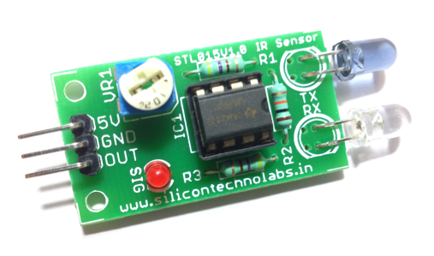
Figure 6: IR Sensor
The presence of cracks in structures poses significant safety hazards and financial liabilities if left unnoticed. IR sensors can effectively detect cracks by measuring temperature variations between the crack and its surrounding material. When a crack forms, it can allow the entry of air or moisture, thereby altering the temperature of the surrounding material. By leveraging an IR sensor, these temperature changes can be identified, prompting maintenance personnel to take action upon detecting a crack.
Choosing the most suitable IR sensor depends on the specific application and the desired level of sensitivity. For instance, in areas with substantial temperature fluctuations, a thermal IR sensor might not possess the required sensitivity to discern the temperature difference caused by the crack. In such cases, a quantum IR sensor might be a preferable alternative.
Several factors influence the accuracy of crack detection apart from the type of sensor used. The size of the crack, the material properties of the surrounding structure, and the environmental conditions all play significant roles. If the crack is too small, it may not produce a noticeable temperature difference detectable by the sensor. Similarly, if the surrounding material has high thermal conductivity, the temperature variation caused by the crack may dissipate rapidly, making detection more challenging.
Vibration Sensor
Vibration sensors as shown in Fig 7 play a crucial role in bridge monitoring systems by detecting and measuring the vibrations that occur within the bridge structure. These sensors provide valuable information about the bridge's health and structural integrity by capturing both the amplitude and frequency of the vibrations.
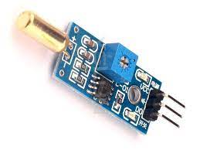
Figure 7: Vibration Sensor
Several types of vibration sensors are commonly employed in bridge monitoring systems. Accelerometers are widely used due to their ability to measure the acceleration of the bridge structure in all directions. This comprehensive measurement enables a thorough understanding of the bridge's response to vibrations. Piezoelectric sensors, on the other hand, generate an electrical charge when exposed to mechanical stress or vibration, allowing them to capture and quantify the vibrations experienced by the bridge. Strain gauges are also utilized and measure the strain or deformation of the bridge structure caused by vibrations, providing insights into the structural behavior.
Placement of vibration sensors is strategically done on the bridge, typically at support structures or critical points where stresses are expected to be highest. By collecting data from these sensors, engineers can analyze it in real-time or store it for later analysis. This data analysis yields valuable insights into the bridge's performance and condition over time. Monitoring and analyzing vibration data enable engineers to identify any changes in the bridge's structural behavior promptly. By detecting anomalies or signs of deterioration, engineers can take proactive measures to maintain the safety and integrity of the bridge. Timely maintenance and intervention based on vibration data contribute to the long-term sustainability and reliability of the bridge infrastructure.
Flex Sensor
As shown in Fig 8 Flex sensors are a valuable type of sensor utilized in bridge monitoring systems to assess the deflection or bending of bridge structures. Constructed with thin and flexible materials like polyester or polyimide, these sensors can bend and flex under mechanical stress.
The functionality of flex sensors relies on their ability to modify their resistance when subjected to bending or deflection. When the sensor bends, the resistance of the material alters, and this alteration in resistance can be measured to determine the extent of bending or deflection.
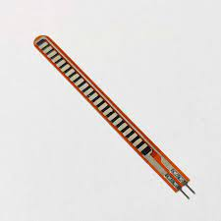
Figure 8: Flex Sensor
Within bridge monitoring systems, flex sensors can be strategically positioned at critical points along the bridge structure, such as the center of the span or the supports. This placement allows for the measurement of deflection or bending under various loading conditions. The collected data can then be employed to evaluate the structural integrity of the bridge and identify any changes or damage that may occur over time.
Flex sensors offer a practical option for large-scale bridge monitoring systems due to their simplicity and low cost. However, it is important to note that they generally provide less precision compared to other sensor types, such as strain gauges. Calibration may be necessary to ensure accurate readings from flex sensors
Magnetic Float sensor
A magnetic float sensor as shown in Fig 9 is an effective liquid level sensor that utilizes a magnetic float to detect the level of liquid within a container. It comprises a float containing a magnet and a reed switch, an electrical switch activated by a magnetic field.
Typically, the float is placed inside the container, and as the liquid level changes, the float moves correspondingly. Positioned outside the container, the reed switch is triggered by the magnet within the float as it passes by.
As the float rises or falls with the liquid level, the magnet's proximity to the reed switch changes, modifying the switch's electrical state. This alteration in the switch's state serves as an indication of the liquid level in the container. The information obtained from the sensor can be monitored and controlled by an electronic circuit or microcontroller
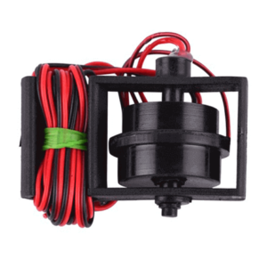
Figure 9: Magnetic Float sensor
Magnetic float sensors find widespread application across various industries, including industrial process control, water and wastewater treatment, oil and gas production, and food and beverage processing. They are favored for their reliability and accuracy in liquid level measurement. Additionally, they are favored over alternative level sensors due to their simplicity, ease of installation, and minimal maintenance requirements
Turbidity sensor
A turbidity sensor in Fig 10 is an essential component in the project titled 'Design and Implementation of Realtime Monitoring of Bridge Using Machine Learning'. It serves the purpose of evaluating the condition of the water flowing beneath the bridge by measuring the extent to which the water has lost its transparency due to suspended particles. Monitoring the turbidity of the water provides valuable insights into water quality, the presence of pollutants, and the overall ecosystem health. This information aids in decision-making regarding bridge maintenance, repairs, and assessing the bridge's impact on the environment.
The functioning of a turbidity sensor involves passing light through a water sample and measuring the amount of light scattered by the suspended particles. The degree of light scattering is directly proportional to the particle concentration, which is then used to calculate the turbidity of the water. Nephelometers and turbidimeters are examples of turbidity sensors, utilizing different methods to measure light scattering—nephelometers measure scattered light, while turbidimeters measure transmitted light through the water.
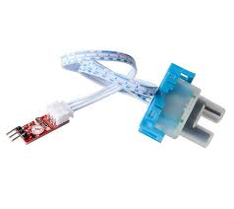
Figure 10: Turbidity sensor
To integrate a turbidity sensor into a real-time monitoring system for a bridge, it is necessary to select a suitable sensor based on factors such as accuracy, sensitivity, and cost. Once a sensor is chosen, it needs to be interfaced with a microcontroller or data acquisition device to collect and process the sensor data. This data can then be transmitted to a central database or cloud platform using wireless communication protocols like Wi-Fi, Bluetooth, or cellular data.
In addition to turbidity sensors, other environmental sensors can also be integrated into the real-time monitoring system for the bridge. These may include sensors for temperature, humidity, pH, dissolved oxygen, and other relevant parameters. By combining data from multiple sensors and applying machine learning algorithms, a more comprehensive understanding of the environmental conditions surrounding the bridge can be obtained. This enables informed decisions regarding maintenance, repairs, and addressing potential issues before they escalate.
Incorporating a turbidity sensor into a real-time monitoring system for a bridge offers valuable insights into the water quality underneath the bridge. This data empowers decision-making regarding maintenance, repairs, and environmental impact. By applying machine learning algorithms to the collected sensor data, patterns and trends can be identified, allowing proactive measures to address environmental changes and prevent potential problems..
Software
Raspberry Pi OS
Raspberry Pi OS, shown in Fig 11 formerly known as Raspbian OS, is an open-source operating system specifically developed for the Raspberry Pi series of single-board computers. It is based on the popular Debian Linux distribution and is optimized to provide a lightweight and efficient environment for running applications on the Raspberry Pi.
Raspberry Pi OS is designed with the unique hardware capabilities of the Raspberry Pi in mind. It offers a user-friendly desktop environment and a wide range of pre-installed software packages, making it accessible and convenient for users, including beginners and hobbyists. The operating system provides a familiar desktop interface similar to traditional desktop environments, allowing users to navigate and interact with the system easily.
Figure 11: Raspberry Pi OS
One of the notable features of Raspberry Pi OS is its compatibility with a vast selection of software applications and libraries. It supports various programming languages such as Python, C/C++, Java, and more, allowing developers to work with their preferred programming languages and frameworks. This compatibility enables users to leverage existing tools and resources while developing applications for the Raspberry Pi.
Additionally, Raspberry Pi OS comes with a package manager called "apt" (Advanced Package Tool), which simplifies the installation and management of software packages. Users can easily install, update, and remove applications from a vast repository of available software packages. This feature streamlines the software management process and ensures that users have access to a wide range of software options.
Raspberry Pi OS also includes numerous built-in applications, utilities, and development tools. These include web browsers, text editors, office productivity software, image editing tools, programming environments, and more. These pre-installed applications provide users with a solid foundation for various tasks and development projects.
Furthermore, Raspberry Pi OS supports a wide range of hardware peripherals and interfaces, including GPIO (General Purpose Input/Output) pins, HDMI, USB, Ethernet, Wi-Fi, and Bluetooth. This extensive hardware support enables users to connect and control external devices, sensors, and modules, expanding the capabilities and potential applications of the Raspberry Pi.
The operating system receives regular updates and improvements from the Raspberry Pi Foundation and the open-source community. These updates often include bug fixes, performance enhancements, security patches, and new features, ensuring that users can benefit from the latest developments and advancements in the Raspberry Pi ecosystem. Raspberry Pi OS is a versatile and user-friendly operating system tailored for the Raspberry Pi. With its optimized performance, extensive software compatibility, pre-installed applications, hardware support, and regular updates, it provides an excellent platform for a wide range of projects and applications, including home automation, robotics, IoT (Internet of Things), education, and more

Geany IDE
Geany is a lightweight and open-source integrated development environment (IDE) that is popular among programmers, particularly for those working with languages like C, C++, Python, and PHP. It provides a simple and user-friendly interface while offering essential features for coding and software development as in Fig 12.
One of the main advantages of Geany is its lightweight nature. It is designed to be fast and efficient, making it suitable for systems with limited resources or older hardware. This characteristic allows for a quick startup time and smooth performance, enhancing productivity during programming sessions.
Geany offers a range of features that facilitate coding and development tasks. It includes syntax highlighting for various programming languages, making code more readable and easier to navigate. Auto-completion is available, which suggests code snippets and completes variable or function names as you type, saving time and reducing errors.
Figure 12: Geany IDE
The IDE also provides project management capabilities, allowing developers to organize their code into projects and work on multiple files simultaneously. The side panel displays a tree-like structure of project files, enabling easy navigation and access to different components of the project.
Geany supports code folding, enabling the collapsing and expanding of sections of code, which is particularly useful for large and complex projects. It also includes a built-in terminal, enabling developers to run commands, compile code, and view the output within the IDE itself.
The IDE incorporates basic debugging functionality, such as breakpoints and stepping through code, helping developers identify and fix issues during the development process. It also includes support for version control systems like Git, making it convenient to manage code changes and collaborate with others.
Customization options are available in Geany, allowing users to personalize the IDE to suit their preferences. Users can choose from different color schemes, configure keybindings, and install plugins to extend the functionality of the IDE further.
Overall, Geany provides a lightweight, user-friendly, and feature-rich IDE that caters to the needs of programmers working with various languages. Its simplicity and efficiency make it an excellent choice for developers seeking a straightforward and reliable coding environment.
Arduino IDE
The Arduino Integrated Development Environment (IDE) shown in Fig 13 is a versatile open-source software platform that enables the programming of microcontroller boards like the Arduino Uno. Widely favored by electronics enthusiasts and professionals, the Arduino IDE serves as an essential tool for the project titled "Design and Implementation of Realtime Monitoring of Bridge using Machine Learning." By utilizing the IDE, programmers can code the microcontroller board responsible for gathering sensor data from the bridge, processing it, and transmitting it to a central server.
To embark on the project, the initial step involves installing the Arduino IDE on a computer. This software is freely available on the official Arduino website. Once the installation is complete, the next course of action is to establish a physical connection between the Arduino Uno board and the computer using a USB cable. The IDE offers an intuitive interface that facilitates code writing, compilation, and uploading to the board.
Figure 13: Arduino IDE
The Arduino IDE can also be employed to incorporate machine learning algorithms into the design of the real-time bridge monitoring system. Through the utilization of these algorithms, the collected sensor data—such as that from accelerometers, strain gauges, and temperature sensors—can be analyzed. This analysis enables the identification of any irregularities or alterations in the bridge's structural behavior. Early detection of potential issues through this method permits timely intervention to prevent serious damage.
The Arduino IDE supports several programming languages, including C++ and C, rendering the implementation of machine learning algorithms within the code more accessible. Additionally, the IDE comes equipped with libraries for various sensors, communication protocols, and other functions. These libraries streamline the development process and contribute to a more efficient workflow.
To facilitate real-time monitoring, it is possible to connect the microcontroller board to a wireless communication module, such as Wi-Fi or Bluetooth, which can transmit the collected data to a central server for processing and analysis. The Arduino IDE can be instrumental in creating the server-side application that is responsible for receiving and processing this transmitted data.
The Arduino IDE stands as a potent tool for designing and implementing real-time monitoring systems, especially when combined with machine learning algorithms. With its user-friendly interface, support for multiple programming languages, and an assortment of libraries, the IDE proves to be a versatile platform for the development of microcontroller-based applications
Advanced IP scanner
Advanced IP Scanner shown in Fig 14 is a versatile network scanning tool that enables efficient discovery of connected devices within a network. Its intuitive interface and robust capabilities make it an invaluable asset for real-time monitoring of a bridge, especially when combined with machine learning techniques. By employing Advanced IP Scanner, administrators can gain insights into the network topology by sending ping requests to each IP address and analyzing the resulting responses. This enables the identification of various devices connected to the network, including routers, switches, printers, and computers. These details are crucial for establishing a comprehensive view of the network's components and their corresponding IP addresses.
Figure 14: Advanced IP scanner
In the project's context, the network scanner serves as a valuable data source for machine learning algorithms implemented to analyze network traffic and detect anomalies. By leveraging the real-time information provided by Advanced IP Scanner regarding devices connected to the bridge, machine learning algorithms can process and interpret traffic patterns effectively. Through this analysis, the algorithms can identify abnormal activities such as sudden spikes in traffic or the presence of unrecognized devices, indicating potential security threats.
Additionally, Advanced IP Scanner offers the ability to monitor the status of network devices. By detecting offline or disconnected devices, the scanner facilitates proactive measures such as triggering alerts, initiating device restarts, or notifying the IT department. This proactive approach helps ensure smooth network operation and timely response to any disruptions.Advanced IP Scanner is an indispensable tool for real-time monitoring of a bridge when combined with machine learning capabilities. Its ability to provide comprehensive information about connected devices, IP addresses, and device status serves as a foundation for detecting security breaches, optimizing network performance, and ensuring uninterrupted bridge operation.
VNC Connect
VNC (Virtual Network Computing) shown in Fig 15 is a versatile and cross-platform screen-sharing system designed to facilitate remote control of computers or devices. Its client/server model allows users to seamlessly connect and share screens across different operating systems and devices. To establish a connection, the VNC server component is installed on the computer or device that the user intends to control remotely. On the user's device, a VNC viewer or client is installed to initiate the connection. Once connected, the server transmits a real-time replica of the remote computer's screen to the viewer, enabling the remote user to see and interact with the remote device's display.
Figure 15: VNC Connect
VNC goes beyond mere screen viewing by also empowering remote users to control the mouse and keyboard of the remote computer. This feature grants complete control over the remote device, enabling users to perform tasks as if they were physically present at the remote location. This capability proves particularly valuable for utilizing specific software or applications on the remote device without needing physical access.
Overall, VNC offers a powerful solution for screen sharing and remote control across diverse platforms. By leveraging its client/server architecture, users can remotely access and control computers or devices from their own devices, facilitating collaboration, troubleshooting, and efficient access to software and resources.

SIMULATION RESULT

The bridge monitoring system acts as a vigilant safeguard, promptly detecting any indications of structural damage or hazards that could compromise the safety of the bridge and its users. If the system identifies signs such as cracks in the bridge structure, abnormal vibrations, poor water quality surrounding the bridge, or rising water levels, it initiates immediate alert signals to notify the relevant authorities. These timely alerts enable the authorities to swiftly respond, take necessary precautions, and thoroughly investigate the causes of these issues. By doing so, they can prevent potential accidents and hazards, ensuring the safety of people and ships crossing the bridge.

In addition to alerts, the bridge monitoring system ensures the proper functioning of the bridge's opening and closing mechanism, particularly if it accommodates ship traffic. It diligently assesses the opening and closing process, considering factors such as structural damage, vibrations, water quality, and water levels. If any anomalies or malfunctions that could impact the bridge's operation are detected, the system promptly notifies the authorities. In response, the authorities may temporarily close the bridge or implement other safety measures to maintain its reliability and functionality.
The bridge monitoring system also offers the valuable capability of providing real-time data on the bridge's flexibility and load through a Blynk app. This app allows authorities to access crucial information about the bridge's behavior and load dynamics. If excessive flexure affects the bridge, the Blynk app displays this data, enabling authorities to take immediate action to prevent potential damage. This could involve implementing additional support systems or adjusting traffic flow to minimize stress on the bridge's structure.
Furthermore, the bridge monitoring system continuously monitors the load acting on the bridge. If the load surpasses the designated limit, the system rapidly sends an alert to the relevant authorities via the Blynk app. This alert serves as a vital notification, prompting authorities to take swift action to reduce the load on the bridge. By doing so, they effectively prevent accidents, preserve the bridge's structural integrity, and prioritize the safety of individuals and vehicles crossing the bridge.
The bridge monitoring system combined with the Blynk app, and the results are shown in Fig 16-27 plays a crucial role in ensuring the safety and structural soundness of bridges. Through real-time data display and timely alerts, the system empowers authorities to address potential safety hazards, investigate issues promptly, and undertake appropriate measures to prevent accidents. By leveraging these monitoring technologies, the bridge monitoring system becomes an indispensable tool for maintaining the safety and reliability of bridges in different environmental conditions and under various load scenarios.
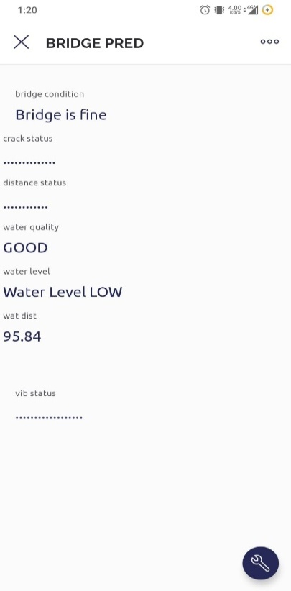
Figure 16:Crack detection Figure 17: Water level Low
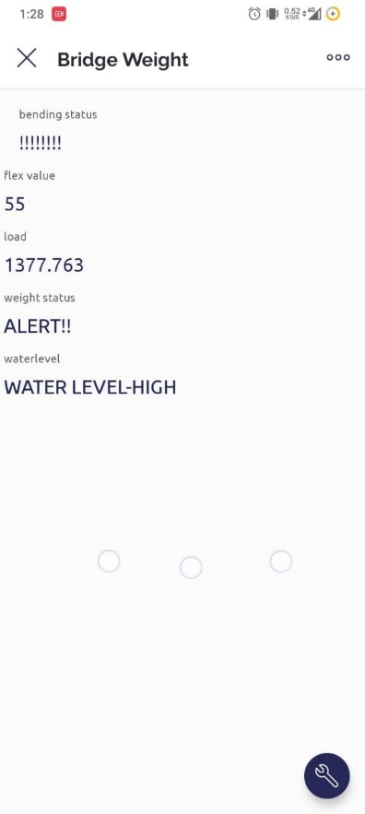
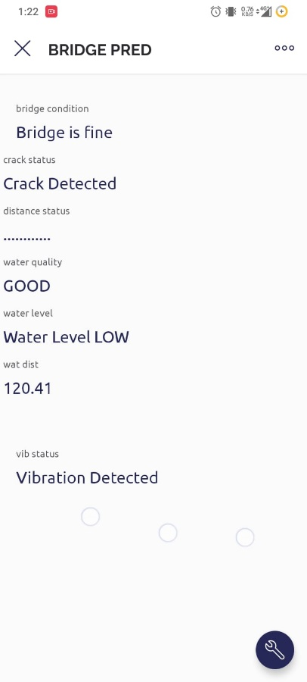

Figure 18:Water level High Figure 19: Vibration Detected
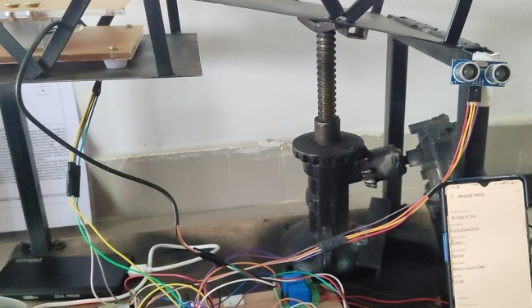

Figure 21: Bridge is opening up

Figure 20: The bent status of the bridge
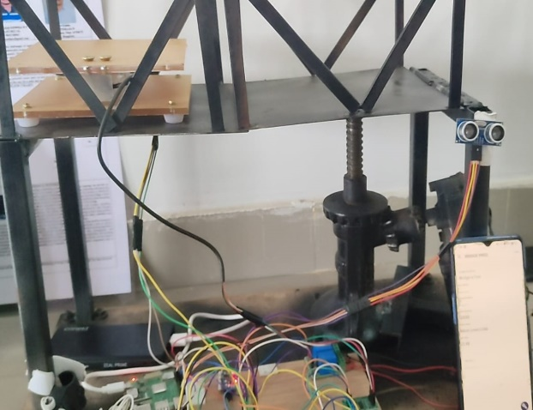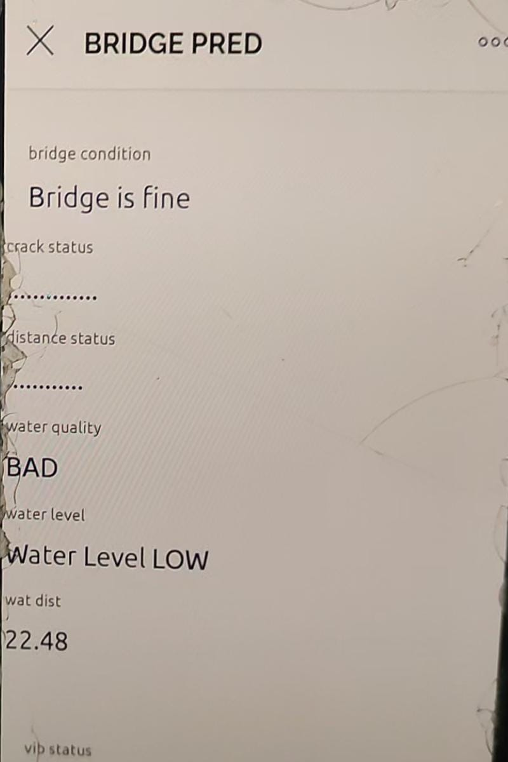
Figure 22 : Bridge is closed Figure 23: Water Quality – Bad
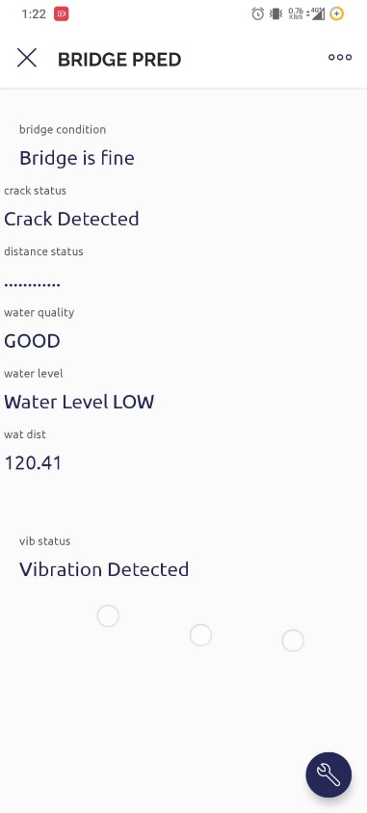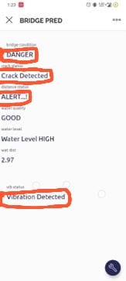
Figure 24: Water Quality – Good Figure 25: Bridge is in Danger
Figure 26: Load on the bridge is more

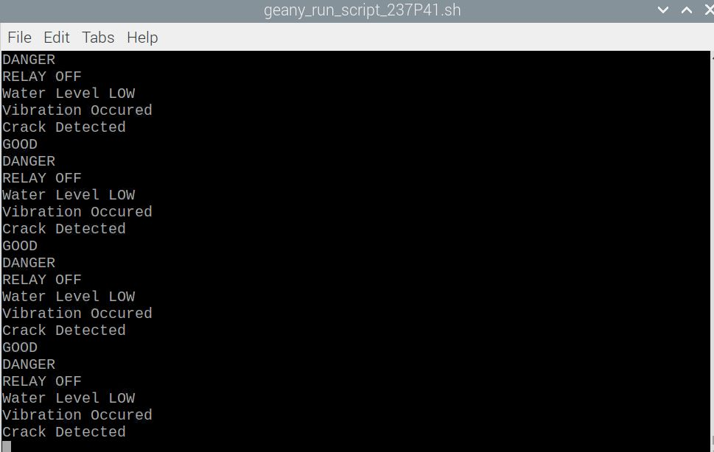
Figure 27: Changes in the state of the bridge is also shown in the Terminal

CONCLUSION

A real-time bridge monitoring system utilizing machine learning offers numerous benefits compared to traditional inspection methods, including enhanced safety, reduced maintenance costs, and improved decision-making. Continuous data collection and analysis enable early detection of structural changes, leading to proactive measures and the prevention of safety risks. Targeted repairs can minimize expensive and time-consuming maintenance, extending the life of the bridge and saving costs. Moreover, machine learning can identify patterns and trends, aiding in informed decision-making for maintenance and repairs. However, challenges exist, such as installation complexity, data quality, false positives, and cybersecurity risks. Despite these challenges, the system's advantages justify the investment.

In the future, several advancements can be made to further enhance the capabilities of real-time bridge monitoring systems using machine learning. Integration with technologies like drones, LiDAR, and satellite imagery can provide a comprehensive understanding of the bridge's condition. Advanced machine learning algorithms, including deep learning, can improve analysis accuracy and speed, enabling predictive maintenance and component life prediction. Smart sensor technology can enable self-diagnosis and calibration, reducing manual maintenance needs. Predictive analytics can anticipate problems based on historical data, while better data management through cloud-based solutions can enhance processing speed, storage capacity, and security. Continuous improvement through feedback from maintenance personnel can refine algorithms and system performance.

The future scope of real-time bridge monitoring systems using machine learning is promising. Advancements in technology, algorithms, sensor capabilities, predictive analytics, data management, and user feedback will further enhance safety, reliability, and longevity of critical infrastructure like bridges. Investing in research, development, and continuous improvement will drive significant advancements in bridge monitoring and maintenance practices.

REFERENCES

- T. Li and Y. Hongyan, "Design of Data Acquisition System for Highway Bridge Health Monitoring Based on Internet of Things," 2020 IEEE International Conference on Industrial Application of Artificial Intelligence (IAAI), 2020, pp. 113-118
- Hoang, T., Fu, Y., Mechitov, K. et al. Autonomous end-to-end wireless monitoring system for railroad bridges. ABEN1, 17 (2020). https://doi.org/10.1186/s43251-020-00014-7
- E. Favarelli and A. Giorgetti, "Machine Learning for Automatic Processing of Modal Analysis in Damage Detection of Bridges," in IEEE Transactions on Instrumentation and Measurement, vol. 70, pp. 1-13, 2021, Art no. 2504013, doi 10.1109/TIM.2020.3038288.
- J. C. Avendano, L. D. Otero and C. Otero, "Application of Statistical Machine Learning Algorithms for Classification of Bridge Deformation Data Sets," 2021 IEEE International Systems Conference (SysCon), 2021, pp. 1-7, doi: 10.1109/SysCon48628.2021.9447056
- S. Xi, “Notice of Retraction The research of Bridge state monitoring system based on IOT technology,” Adv. Manag. Sci. (ICAMS), 2010 IEEE Int. Conf., vol.3, 2010, doi: 10.1109/ICAMS.2010.5553282 M4 -Citavi.
- M. A. D. Sonawane, and M. N. Ms. Pooja. P.Vichare, Mr. Shubham. S. Patil, and P. Chavande, “Bridge Monitoring System Using IOT,” MAT Journals, J. Adv. Electr. Devices, vol. Volume 3, no.Issue 2, pp. 1–3, 2018.
- S. K. P. Muddala, Divya, Dhanashree Kamble, Pooja Nimbalkar, Ravina Patil, “IOT Based Bridge Monitoring System,” Int. J. Res. Appl. Sci. Eng. Technol., vol. 5, no. 2, pp. 2044–2047, 2019, doi:10.22214/ijraset.2019.4420.
- A. R, S. S. Mesta, V. A U, R. G, and H. K. Sivaranan,“Brigde monitoring system using wireless networks,” Ijariie, vol. 2, no. 5, pp. 107–111, 2017.
- J. L. Lee, Y. Y. Tyan, M. H. Wen, and Y. W. Wu, “Development of an ioT-based bridge safety monitoring system,” Proc. 2017 IEEE Int. Conf. Appl. Syst. Innov. Appl. Syst. Innov. Mod. Technol. ICASI 2017, no. 1, pp. 84–86, 2017, doi: 10.1109/ICASI.2017.7988352.
- P. K. Patil, “bridges,” pp. 371–375, 2017.
- P. D. A. Jakkan and A. Pic, “Bridge Monitoring System using IoT Technology,” vol. VIII, no. Ii, pp. 182–184, 2019.
- P. S. A. K. Amrita Argade, Sanika Chiplunkar, Rohini Kumbhar, Varsha Kusal, “REAL TIME BRIDGE MONITORING AND ALERT GENERATION SYSTEM USING IoT,” OAIJSE, vol. 3, no. 5, pp. 52– 55, 2018.

