Performance Improvement in solar water heater using various methods: A review
Punam Agade Dr. Rahul Agrawal
Ph.D Scholar, Associate Professor
Department of Mechanical Engineering Department of Mechanical Engineering
Madhyanchal Professional University, Bhopal, Poornima University, Jaipur
Madhya Pradesh, India Rajasthan, India
agade.punam288@gmail.com rahul.agrawal@poornima.edu.in
Contact No: 8770524995 Contact No: 9982006374

ABSTRACT
An inexpensive and environmentally favourable human development system in the present period is the solar water heater (SWH). Both homes and businesses utilise SWH. This review study provides an overview of several SWH efficiency estimates, including how thermal parameters like enthalpy and entropy are calculated as well as heat loss coefficient. It provides academics from different countries with a thorough and organised examination of the solar energy equations. The creation of SWH's efficiency equations is covered in this essay, along with the effectiveness of SWH's numerous components and the technology used to comprehend the values of SWH equations and its many building methods.
Keywords: Efficiency. Solar water heater, Energy, Productivity, Water

- INTRODUCTION
Solar energy is freely available and abundant to us. The solar energy that strikes the earth's surface may easily be put to use for the good of human civilisation. Solar hot water systems (SHWS) are among the commonly used solar energy harvesting equipment [1]. The most effective alternative energy source is solar energy. Solar energy is viewed as an appealing form of renewable energy that may be utilised for water hearing in both households and industries due to increased energy demand and the expense of fossil fuels (such as petrol or oil). Nearly 20% of a typical family's energy use goes towards heating water [2]. The least expensive and most accessible sustainable energy option for households, solar water heating systems may provide the majority of the hot water a family needs.
Solar water heaters (SWH) are basically a system that uses the sun radiations in order to heat water or air which can be used in domestics or industries. It is not a new technology since it was used in the 19th century, where they painted tanks with black paints in order to absorb sun energy. But the disadvantage back then was the lack of insulation, which led to loss of heat rapidly [3]. Year after year, many improvements happened to this technology, starting from increasing the efficiency of the system by adding a metal panel to the tank by Clarence Kemp in 1891, then in 1909 a large quantity of SWH were being sold by William Bailey because of his model that contained a coiled pipe collector inside a box covered with glass and comes along with an insulated indoor storage tank for heated water [3]. Nowadays, more of this technology is being used because of the growing energy crisis, as the fuel prices are sky rocketing, also the increase of CO2 emission which very dangerous for the future of the planet’s environment.
- TYPES OF SOLAR WATER HEATING SYSTEMS
There are two types of solar water heaters:
- Active SWH
- Direct-Circulation Systems: the water is circulated using a pump through the collectors into the home, and it is used mainly in places that rarely freezes. [4]
- Indirect circulation systems: a non- freezing, heat-transfer fluid is circulated using a pump through the collectors and a heat exchanger, which heats the water used into the house. This type is mainly used in freezing temperatures. [5]
- Passive SWH
- Thermosiphon Systems: In this type, water rises naturally from the collectors to the storage tank, after the water is heated it rises in the tank and the cooler water sinks down and it requires no external force to move the water such as a pump. [5]
- Integral Collector- storage Passive Systems: water flows in large tubes within the collector by the pressure of normal water and stays in the tubes to heat which work also as a storage for the water. When the hot water is required, the heated one is circulated by cold pressure that replaces it in the tubes [5], the following figures 2, 3 summarizes the different between active and passive solar water heaters.
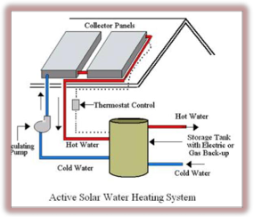
Fig.1 Active Solar Water Heater [6]

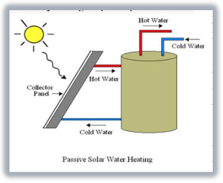
Fig. 2 Passive Solar Water Heater [6]
- Types of Collectors in SWH
There are two main types:
- Non-Concentrating Collectors
- Flat Plate Collector (FPC)
- Evacuated Tube Collector
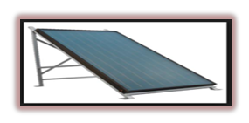
Fig. 3 Flat Plate Collector
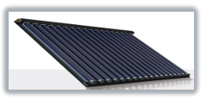
Fig. 4 Evacuated Tube Collector
- Concentrating Collectors
- Parabolic Trough:
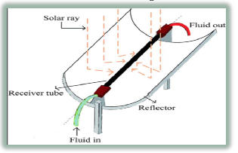
Fig. 5 Parabolic Trough
- LITERATURE REVIEW
A overview of the numerous solar thermal collector types and uses is provided by Kalogirou et al.in their article [7]. The solar collectors utilised in these systems, such as flatplate, compound parabolic, evacuated tube, parabolic trough, Fresnel lens, parabolic dish, and heliostat field collectors, are essential to all solar systems that harness solar energy. Domestic, commercial, and industrial uses all encompass solar collectors. These include solar water heating, which includes the thermosiphon, integrated collector storage, direct and indirect systems, and air systems; space heating and cooling; space heating and service hot water; air and water systems; heat pumps; refrigeration; industrial process heat; desalination; thermal power systems; the parabolic trough; power tower and dish systems; and solar florescence.
Using experimental research, Mustafa AKTA et al. [8] present the best fin size that may be employed in heat exchangers for solar energy systems. Two systems, one traditional and the other finned, were created specifically for this purpose. The six-day-long testing tests show that the fin-equipped system is 7% more effective than the conventional approach. Therefore, it has been determined that using fins in solar energy systems of the right size is beneficial.
The design of solar water heaters to provide hot water for home and industrial uses is covered in Patil et al. [9]. To ensure that consumers receive the most possible advantage from a solar water heating system, designers pay close attention to and analyse the absorber plate materials, absorber and glazing coating, as well as any modifications to the design. The proper choice of each component of the desired capacity and installation location for the solar water heater to produce hot water is necessary when designing a solar water system. We quickly address a number of variables and correlations that affect collector, storage tank, and insulating material design. It is important to acquire superior thermal performance, as demonstrated by the precisely specified operating features and constructional elements of flat plate solar collectors.
By altering the shape of the fin, Ganesh et al. [10] performed experimental research on solar flat plate collectors. Different types of fins, including standard fins (900 area of contact), inverted riser tubes with standard fins, riser tubes with modified fins (2700 area of contact), and inverted riser tubes with modified fins, have been utilised to increase the rate of heat transmission. Experimental studies were done on the system to compare the thermal performance of plain and finned tube absorber plates. The finned tube absorber plate gave greater output water temperature than plain tubes, according to the results. More outlet water temperature is provided by standard fins than by plain tubes, but less so than by modified raiser tube fins. More outlet water temperature comparisons are made with an inverted modified raiser tube. More thermal performance is always provided by expanding here.
Chittireddy et al. [11] investigated the use of an air conditioning radiator in conjunction with a flat plate solar collector as a heat sink for a home water heater. The radiator from an air conditioner was used to make the reception plate (see fig 6). The collector's efficiency will depend on the number of layers and the kind of glassing used, varying with each.
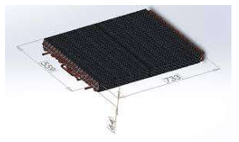
Fig. 6 Air conditioning radiator coupled with a flat plate solar collector
In their experiment study of a flat plate collector and performance comparison with a tracking collector, Prasad et al. [12] describe their findings. To carry out the experimental work, a flat plate water heater that is commercially available and has a capacity of 100 liters/day is instrumented and converted into a test-rig. Data was gathered for both the fixed and tracked states of the flat plate collector during experiments that lasted for a week with nearly consistent air conditions. The findings indicate that the output temperature has increased by an average of 40C. The efficiency of both circumstances was assessed, and a comparison of the results reveals a 21% gain in efficiency overall.
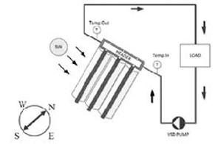
Fig. 7 Diagram of Test Arrangement [5]

- CONSTRUCTIONAL FEATURES OF SWH
- Parts used to build Flat Plate Collector

Table 1. Different components for building the FPC
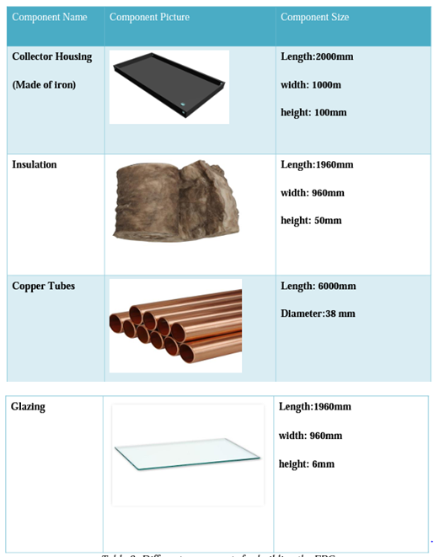

- Construction of the flat plate collector
It consists of a solar thermal panel in which collector is used to collect, capture and retain the heat radiations from the sun.
The heat exchanger is made up of coil of copper pipes and is kept inside the water tank.
Heat exchanger is used to transfer the heat energy from the hot water passing through the copper pipe in the heat exchanger to the cold water in the water tank.
An electric pump is used to pump the cold water coming out from the heat exchanger to the collector of the thermal panel.
The total system is controlled by the controller unit, which is used to
- Fill the water with Auto cut-off in the tank.
- (ii) Switch on/off the electric pup, whenever required.
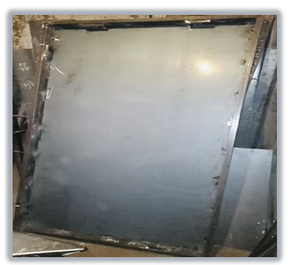
Fig. 8 Collector housing

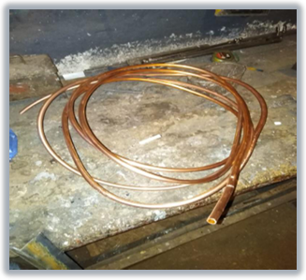
Fig. 9 Meter Copper Tube
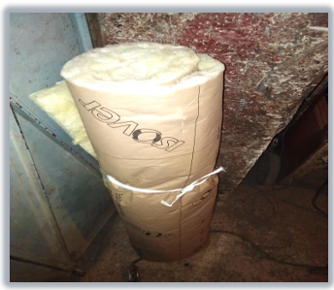
Fig. 10 Insulation Material
As we can see from the two figures 9 and 10, the insulation is of the purpose to decrease thermal losses and absorb the some of the energy lost and increase the flat plate collector efficiency. The copper tubes will circulate the water inside the collector and absorb the sun rays and turn them into useful heat for water. To increase the absorption rate of the copper tubes, they will be painted in black because black color has high absorption of sun rays. The copper tubes will be bended and reformed as a serpentine inside the collector. The final part is the glazing of the collector which is the cover glass that will cover the flat plate collector and protect the system form rain or snow. The type of glass to be used is the toughened glass of a thickness of 6 mm.

- Advantages and disadvantages of FPC

Table 2: Advantages/ Disadvantages of the FPC [19]
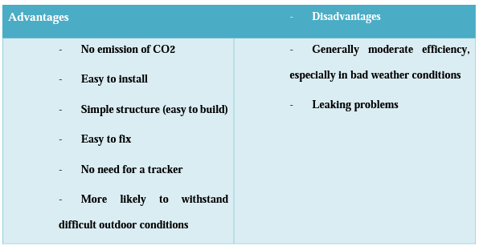

- EFFICIENCY OF SOLAR WATER HEATERS
Although solar water heaters have the same method of capturing solar radiations and transferring it into heating energy for various liquids, still each type differ from the other in the thermal efficiency rate because of its components, and materials that was used in order to build it. Each type of collectors has its own efficiency depending on the ambient temperature, where we distinguish three types of temperatures as follows:
Low- temperature systems:
- Usually uses unglazed collector.
- Operates at low temperatures areas where it is up to 10 °C.
- Often used for heating swimming pools.
Mid- temperature systems:
- Usually uses flat plates collector.
- Operates at temperatures between 10 °C and 50 °C.
- Used for indoor heating system and liquid heating.
High- temperature systems:
- Usually uses evacuated tubes collector.
- Operates at temperatures more than 50 °C.
- Generally used for absorption cooling, electricity generation and also as a water heating system.
So, for the thermal efficiency it depends on the temperature of the collector in relative with the ambient air temperature, the following figure 8 summarizes the efficiency of each of the above collectors:
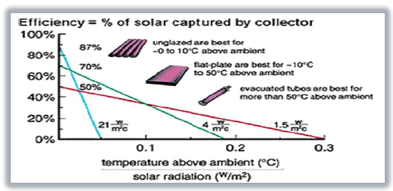
Fig. 8 Efficiency of the Unglazed, Flat Plate and Evacuated tubes collector [10]
- THERMAL EFFICIENCY OF THE COLLECTOR
After building the collector comes the calculations part, where we can estimate the thermal efficiency of the collector using some formulas. Thermal efficiency of solar water heaters is not static. It is calculated by the division of “useful energy out” over “energy available”. Energy available is the radiation arriving to the collector’s surface. And it is symbolled as AI Useful energy out is the net thermal energy embodied in the hot fluid leaving the collector outlet pipe.
The thermal efficiency can be calculated using the formula:
$ƞ= \frac{Q}{AI}$ [1]
Where, Q is the useful energy out, A is the area of the collector in [m²], I is the solar radiation in the collector plane in [W/m²]
The following equation is used to determine how quickly heat is transferred through each riser tube [13-14]:
$Q= {mc}_{p}\left(T_{out}-T_{in}\right)= U_{o}A_{o}(T_{wo}-T_{m}$) (2)

Where the following equation, which connects the heat transfer rate Q to total heat transfer, has been used to get the internal convective heat transfer coefficient:
$Q=$ $U_{o}A_{o}(T_{wo}-T_{m})$ (3)

Where
$$\frac{1}{{(U}_{O}A_{O})}= \frac{1}{{(h}_{i}A_{i})} + \frac{in(\frac{D_{o}}{D_{i}})}{(2πk_{w}L)} (4)$$

Conclusion:
Climate, financial constraints, and water use needs are three crucial considerations when choosing the best solar water heating system for a company. Solar water heating systems are cost-effective, particularly in commercial buildings where a lot of energy is required to heat the water. Although the sun may heat water, when many elements like safety, maintainability, and system efficiency are taken into account, its uses in water heating will be considerably more successful. Systems for heating water with solar energy are now installed with various settings and agreements. Research into the core technology of these devices reveals the necessity to improve the created layout approach in order to choose, install, and monitor the solar water heating scheme in accordance with accessibility.
REFERENCES
- Mohamed Abu Waseem, "Numerical analysis of absorber tube of solar parabolic trough collector with and without insertion by using Ansys Fluent", Journal of Engineering Research and Application, Vol. 8, Issue 12, Dec 2018, pp 01-04.
- S. Sadhishkumar, "Thermal performance of water-in-glass evacuated tube solar Collector with and without phase change material", Indian Journal Sciences, 20(2), 193-201, 2018.
- K.Balaji , S.Iniyan and A.Idrish khan Thermodynamic analysis of a solar flat plate water heater using extended surface absorber tube (2015)
- Energy.gov. (2019). Solar Water Heaters. [online] Available at: https://www.energy.gov/energysaver/water-heating/solar-water-heaters [Accessed 11 Feb. 2019].
- Gujarat, A. (n.d.). Solar Collector - Solar Flat Plate Collector Manufacturer from Ahmedabad. [online] https://www.dimanoverseas.net/solar-collector.html#solar-flat-plate-collector.
- Jignesh A. Patel, Tejendra B. Patel, Sadanand Namjoshi,"Comparative Study of Thermal Performance of Spiral Tube Solar Water Heater with Straight Tube Solar Water Heater", International Journal for Scientific Research & Development, Vol. 3, Issue 03, 2015.
- Soteris A. Kalogirou, ―Solar thermal collectors and applications.‖, Progress in Energy and Combustion Science 30 (2004) 231–295.
- Mustafa AKTAẞ, Olhan CEYLAN,Hikmet DOĞAN ― The Thermal Effectiveness Compression Of The Classical And Finned Solar System‖ Isı Bilimi ve Tekniği Dergisi, 26, 2, 29-33, 2006. J. of Thermal Science and Technology ©2006 TIBTD Printed in Turkey ISSBN 1300-3615.
- Ankit S. Gujrathi, Sachin P. Ingale, Sudhir U. Patil, "Analysis of Parabolic Trough Collector using Ansys Fluent Software", Volume 5, Issue 4 December 2017.
- Ganesh K. Badgujar, Sachin Nimbulkar, Rajesh Dahibhate, "Experimental Investigations on Solar Flat Plate Collector by changing Geometry of Fin", Journal of Mechanical Engineering, Vol 2, 2017, Pages 52-62.
- Vikas Reddy Chittireddy, Ahmed ElSawy and Stephen Idem study of a flat plate solar collector with an air conditioner radiator as a heat absorber for a domestic water heater March 2018
- P.Rhushi Prasad, H.V. Byregowda, P.B.Gangavati, ―Experiment Analysis of Flat Plate Collector and Comparison of Performance with Tracking Collector‖ European Journal of Scientific Research, ISSN 1450216X Vol.40 No.1 (2010), pp.144 -155, EuroJournals Publishing, Inc. 2010.
- Varun, K., U.C. Arunachala, D.N. Elton. Trade-off between wire matrix and twisted tape: SOLTRACE® based indoor study of parabolic trough collector Renewable Energy 156 (2020): 478-492, https://doi.org/10.1016/j.renene.2020.04.093.
- Hong, Y., J. Du, S. Wang, W.B. Ye, S.M. Huang. Turbulent thermal-hydraulic and thermodynamic characteristics in a traverse corrugated tube fitted with twin and triple wire coils International Journal of Heat and Mass Transfer 130 (2019): 483-495, https://doi.org/10.1016/j.ijheatmasstransfer.2018.10.087.

